|  |  |  |
| --- | --- | --- |
|  |  | Getting Started with Kafka in Spring Boot | E4developer |

  

Contents

Reactive Spring - WebFlux 4

Traditional Spring REST API Design 7

Callback Hell and Reactive Patterns 9

Reactive Programming 13

Project Reactor 19

Building Reactive RESTFUL APIs using Spring Boot/ WebFlux 24

Spring Boot 2 – Quick Introduction 52

Spring WebFlux – Functional Web 58

Spring WebFlux – Behind the Scenes 63

Application Overview 71

Reactive API Endpoints 81

Reactive API using the Functional Web Module 89

Non Blocking Client using WebClient 96

Handling Exceptions in WebFlux 106

Streaming Endpoints ( Server Sent Events ) 111

Build the Stream Endpoint using Functional Web 119

Webflux Kafka – Completely Reactive?? 122

Reactive Spring Security 122

Spring Data Reactive Repositories 122

Reactive Programming 123

Reactive Manifesto 123

WebFlux vs Project Reactor vs RxJava vs Kotlin 124

Spring WebFlux Reactor 124

Spring Boot Reactor Netty 139

Servlet 4 and 5 139

Netty and Servlet 4 - 5 140

Spring OAuth 2.0 140

OAuth 2.0 140

Introduction 140

Roles 143

Client Types 146

Access Token 147

Open ID Connect 150

Source Code 152

Grant Types and Authorization Flows 154

Introduction 154

Authorization Code Grant 155

Authorization Code Grant 155

Auth Code Demo 158

Exchange code for Access Token 161

Proof Key for Code Exchange 162

PKCE Enhanced Authorization Code 162

Generating Code Verifier - PKCE 167

Generating Code Challenge - PKCE 167

Requesting Authorization Code – PKCE Demo 168

Exchanging Code for Access Token – PKCE 171

Client Credentials 173

Client Credentials - Machine to Machine Requests 173

Client Credentials Grant Type - Demo 174

Password Credentials Flow 175

Password Credentials Flow 175

Demo 176

Refreshing Access Token 177

Refresh Access Token 177

Refresh Token that never Expires 179

Refresh Access Token with Refresh Token 180

Authorization Server - KeyCloak 181

Introduction 181

Install Standalone Keycloak Authorization Server 183

Creating a Initial Admin User 185

Creating a new User 187

Creating a new OAuth Client Application 191

Configuring Client Application Secrets 193

Requesting Access & Refresh Token 195

OAuth 2.0 Client Scopes 202

Resource Server 204

Introduction 204

Creating Project 204

Accessing with Access Token 208

Accessing Principal & JWT Claims 210

Resource Server – Scope Based Access Control 214

Introduction 214

Create WebSecurityConfigurerAdapter and enable Web Security 218

Configure Scope Based Access Control 220

Role Based Access Control with Keycloak 225

Creating User Role 227

Method Level Security 234

Resource Server behind API Gateway 253

Spring Cloud API Gateway 255

Multiple Resource Server 260

Eureka Discovery Service 272

Eureka Client 278

Load Balancing 281

Configuring API Gateway as Eureka Client 285

Configuring API Gateway Routes 286

Return the Running Port 287

OAuth 2 - MVC Web App 289

OAuth 2 Provider Properties 294

Reading JWT Access Token 294

HTTP Request to an Internal Resource Server 298

WebClient Approach 299

OAuth 2 – Social Login 304

Protected Resource Controller Class 305

Working with Okta 318

Configuring Logout Functionality 322

OIDC End Sesion Endpoint 323

Keycloak Remote User Authentication 326

Solution Overview 333

# Reactive Spring - WebFlux

We'll talk about why reactive programming is needed before we jump into the reactive programming part. Let's talk about how the programming in general have evolved and what is the current state of programming. Let's go back into 15 years ago the application that we used to build was a giant monolith applications the applications run an application servers. This model does not embrace the distributed systems at all. Let's talk about the current state of the applications. We are living in the world of Microservices and Microservices embrace the cloud infrastructure where the applications will run in the cloud environment. And it also embraces the concept of distributed systems.

To put it in a nutshell the application that we build today is split into micro applications and interact together in real time to deliver the business objective The web usage in general is increased compared to 10 to 15 years ago and the expectations of the app that we build also changed. Let's take a look at the expectations for any app that we build today.

Scaling - The application should scale according to the load. What do we mean by that. Let's say we have an online shopping application. If the number of users increase than the expected value then the application should scale its resources to handle the load. Basically there shouldn't be any downtime. Use the resources efficiently. What do we mean by that. Let's say you make a call to the database or an external service to get some beta and during these scenarios we wait until the responses are returned from the external resources waiting on something. In general is not effective resource utilization. We will be talking about this in detail in the future part of the course. The next key characteristic is a latency.

Latency - What is Latency? Latency is nothing but the response time of the request. The response time should be faster to meet the customer need. So the API should perform as fast as possible now let's switch gears and talk about how the cost and response flows between the client and the server for any app that's built using the Spring MVC and Spring Boot. Spring MVC is a module that we use today in spring to build a REST API.

Reactive programming is about **Non-Blocking Applications** that are **Asynchronous** and **Event**-**Driven** and require a small number of threads to scale vertically ( i.e. within the JVM ) rather than horizontally ( i.e. through clustering ). A key aspect of reactive applications is the concept of **Backpressure** which is a mechanism to ensure producers don’t overwhelm consumers. For example in a pipeline of reactive components extending from the database to the HTTP response when the HTTP connection is too slow the data repository can also slow down or stop completely until network capacity frees up. Reactive programming also leads to a major shift from imperative to declarative async composition of logic. It is comparable to writing **Blocking** **Code** vs using the **CompletableFuture** from Java 8 to compose follow-up actions via lambda expressions.

Specification, Implementations, Libraries, and Spring WebFlux

Reactive Programming, Reactive Streams, and Reactor: What do they have to do with each other? We often see these terms used interchangeably, but they are not exactly the same thing. So, just to get a clearer view of them, let's summarize:

**Reactive Programming**: This is the paradigm, the model, that dictates the reason for the existence of the other terms below.

**Reactive Streams**: This is a specification that defines how an API that implements and follows the Reactive Programming paradigm should work. By the way, JDK 9 comes already prepared with it.

**Reactor**: This is a Java implementation of the Reactive Streams specification.

Spring WebFlux is the "reaction" of Spring for this paradigm to use on web applications.

It is a web framework that brings support for the reactive programming model. Spring WebFlux is implemented using the Project Reactor, the library chosen by Spring. WebFlux is not a replacement for Spring MVC — they can actually complement each other, working together on the same solution.

We are going to use it in our sample to better understand how everything works.

The floor diagram of the traditional REST API on how it receives a request from the client and how it sends a response back to the client.

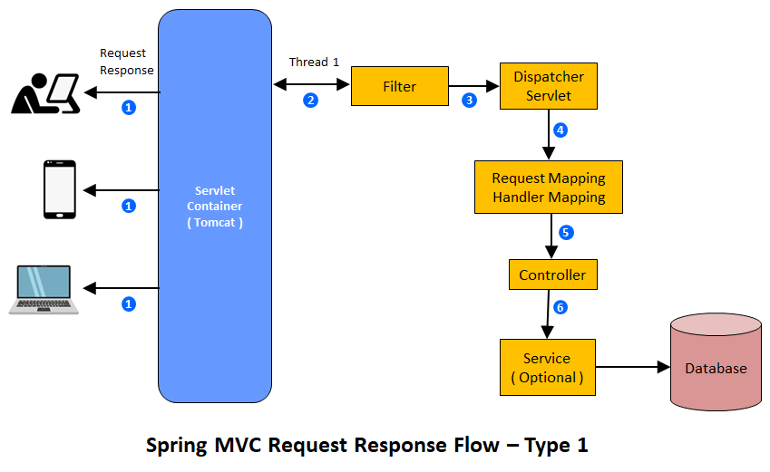

This is just to brush up the knowledge on how the request and response is handled in Spring MVC in this flow diagram the numbers between the arrow represents the flow of evens which starts with 1 and ends with 7. Now let's talk about the different layers, the http request goes through before the response is sent to the client. When the client makes a http request, the request comes to the server, which has the embedded Tomcat by default which is nothing but the servlet container in this case.

The servlet container has a dedicated thread pool to handle the attribute request, for each http request we assign a thread, this is called thread per request model. This particular thread is responsible for handling the request end to end. The next layer is a filter layer and then it goes through the Dispatcher servlet layer and then it goes through the request mapping handler mapping layer where the call is actually directed to the controller, which has the appropriate URL mapping and then it goes through the service layer and then it connects to the database. Once the results are retrieved then the service layer applies some kind of data transformation and then the response will be sent to the client.

The example that I presented here in the slide has a DB as the backend. Let's go and take a look at the next example.

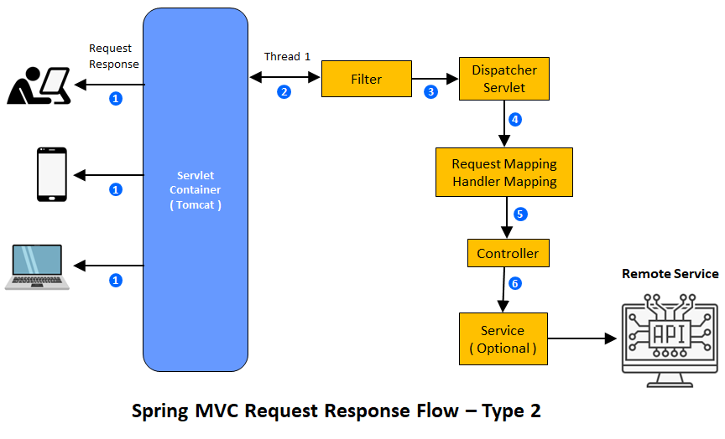

So here all the components are the same except the back end, it is the External API Service instead of the remote database. And I have one more other type of API, that we build today, it is the combination of remote database and remote api saving the client makes a call.

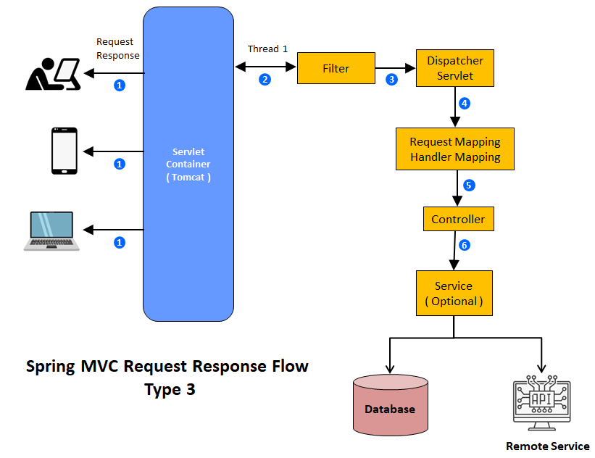

We talk to both the external services to collect the data based on the request and then send the response to the client. Predominantly, these are the three common patterns that are available in today's rest api development.

Handling Concurrent Requests

Now let's talk about how the traditional RESTful API handle the concurrent request. The model that we have today is a thread per request model. For each iterative request, the Tomcat is going to take a thread from the thread pool and assign the thread to that attribute request. Each allocated thread is responsible to handle the lifecycle of that HTTP request. As you see in the example the threads can be extended only to a value off N which is nothing but the thread pool size because that is the one which is going to decide how many number of concurrent users can be handled at any given time. How can we increase or decrease the thread pool size.

**Thread per Request Model**

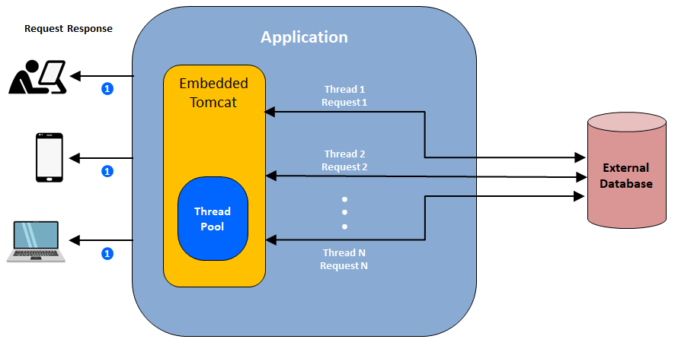

There is a handy property that can be used in order to manage that value, the thread pool size is managed by the server.tomcat.max-threads value. This can be overridden in the application.properties or the application.yml file. So by default it can handle 200 connections. So in theory it can handle only 200 concurrent users, and this value can be overridden in the application.properties file or application.yml file in Spring Boot application. Just because we have an option to override the value, does not mean you can set a larger value for the property. Let's understand this on the memory aspect.

Each thread takes up some memory, the common stock size is 1 MB. So the higher the thread pool size the higher the memory consumed for the instance. What will happen in that case is that if you have a larger thread pool basically that leaves you with very less memory for the application processing, which eventually means the application will perform poor.

How do we make sure the application scales and handled the load today, there are many ways to handle the load but the most popular approach that is done today is by using horizontal scaling. This means we will spin up more instances of the application, based on the load.

So here in this example we have three instances of the application. Basically this means, the load is three times more than the expected value. That's the reason why we have three instances up and running here. So how can this happen. How can we achieve this.

|  |  |
| --- | --- |
|  | If your application is running in some kind of Kubernetes or some other container orchestration environment then this is possible. In real time we will have a load balancer sitting in front of our application, which will take care of distributing the http request to the applications. This model works perfect and this model will work in the future too. But if you take a look at it, spinning up more instances and the cloud is going to add some kind of additional cost to the organization. So with this what we can summarize is that we have a limitation when it comes to handling many concurrent users but  reactive programming - the idea is to move away from the thread per request model and handle a higher load of requests with less number of threads. |

Let's talk about more in detail about how this can be achieved in the future part of the course. I want to discuss something important before we wind up this video.

Does this mean the traditional RESTful API that we have been building for so many years is obsolete. The answer is No.

Does it mean all the API, that we have been building should be moved to a new model which is not the Thread per Request model. The answer is No. This model works perfect for many use cases and many API is in the future will be built with the same design and supported.

## Traditional Spring REST API Design

Here is a example of a traditional REST API endpoint.

@GetMapping("/v1/items/{id}")

public ResponseEntity<Item> getItemFromExternalServices(@PathVariable Integer id){

// 1st DB call – A Blocking Call

Price price = priceRepository.findById(id).get();

// 2nd REST call – A Synchronous REST call – Blocking Call

ResponseEntity<Location> locationEntity = restTemplate.getForEntity(locationUrl, Location.class)

Item item = buildItem(price, locationEntity.getBody());

return ResponseEntity.ok(item);

}

Here is an example of a traditional REST API endpoint. The API that we have here relates to the retail industry. This endpoint gets the ID as an input from the client and then returns a response entity of type Item. Item has two additional details. One is a price and the location where this item is available. To return the item with all the information, first we make a database call and get the price of the item and then we make the rest call to get the location of this item available and then they build the item together with the price and the location information that we got from the service and respond that to the client.

This kind of coding is called **Imperative Style Coding** and the API is called **Imperative Style API**, where the execution goes from top down approach. What do we mean by that. Here we made the database call followed by that we made the REST call to get the location. We went one by one and then we had build the item and responded that to the client. Imperative style APIs by their nature are synchronous and blocking.

Let's dig deep to understand what do we exactly mean by blocking in this code. We make a database call right after the remote database call is made. We have to wait until the responses it received from the database. Let's take a look at the same concept in a flow diagram. So here we made the request and then we got a thread assigned to that request by the Tomcat and we made the call to the database. So after the call is made we are in a state called blocking state.

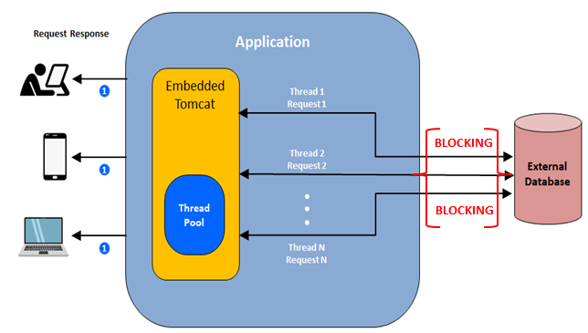

Basically the thread doesn't do anything until the response is received from the database.

What this means is that imperative style of programming leads to an inefficient use of resources. This is one of the problem with the traditional REST API design. So if you go back to the code here we are blocked and then once the response is received then we make the call to the restful API and then return the response to the client.

Now let's talk about the synchronous aspect of the traditional API. Let's assume the latency of this endpoint is 2 millisecond. The database call takes 1 millisecond followed by that the rest api call takes 1 millisecond, which sums up to 2 millisecond. Here we have a simple use case, but in reality you might be doing a lot of external resource calls before responding to a client's request. Let's say you want to improve the response time of this endpoint. Then we need to make these calls asynchronous. Basically what does it mean. We need to make these calls non blocking. How can we do that?

Currently in Java, we have two options - Callbacks and Future.

Let's touch base on these options – Callbacks by its nature they are complex and they are not a great option. Callbacks does not return any value but it does take the instance of Callback as an parameter. The callback code has a nature of handling exceptions at each level and the code itself is hard to read and maintain. It will quickly lead to a famous term called "callback hell".

Let's take a look at the Future option. The future is another alternative for asynchronous code in Java. Future returns the future instance and we can use the future instance to check whether the data is available. We have handy methods to call and check whether the data is available or not, but it's hard to compose the multiple asynchronous operations with Future.

Considering these limitations we have a advanced future API that got introduced as part of Java 8 which is the CompletableFuture. Certainly only the CompletableFuture API is simple to work with and it has the support for the functional style API. It is easy to compose the multiple asynchronous request, but CompletableFuture is not a great fit for asynchronous methods which involves multiple items in the response and the error handling is not that great too. So we need to do a lot of plumbing to make it work right. So it is not easy to improve the latency with the traditional rest API design which uses the imperative style of programming. Let's take a look at another example. This end point returns a list of items.

@GetMapping(“/v1/items”)

public ResponseEntity<List<Item>> getAllItems(){

List<Item> items = itemRepository.getAllItems();

return ResponseEntity.ok(items);

}

Consider some of the top retail chains such as Amazon Alibaba target are Walmart and if this end point is going to return all the items in the inventory. Then think about the response object size, and if this endpoint is bombarded with many request then as a result of this, two things can happen. This might blow up the heap and application might crash with out of memory exception. Or, the client will be provided with such a huge response which the client might not be able to handle. So I would like to highlight one more aspect before we get into the summary partner. How do we avoid this from happening. If there is a way for the app to communicate to the source which is DB, in this scenario and provide a feedback. Hey DB, can you slow down. You are sending too much data and I'm not able to handle it. Please slow down. This concept is called BackPressure.

|  |  |
| --- | --- |
|  | Don't worry about it. For now, we will be discussing this concept in detail once we get into the reactive programming part. But with the imperative style of programming or with the imperative style API. The app does not have a way to communicate to the DB to slow down or reduce the size of the payload. So no back pressure compatibility in traditional REST API design. Let's summarize what we've discussed so far. First there is a limit on serving the number of concurrent users that are synchronous and non blocking and imperative style APIs requires a lot of work to do in order to make it asynchronous. And the last is there is no Back Pressure support. |

**Does this mean the traditional API design is not recommended**. The answer is definitely no. Spring MVC module will still be a part of the spring ecosystem and continue to be supported and enhanced. Traditional REST API design fits for many use cases so we will continue to build those fully API is in the future too.

Now let's talk about what is a better API design then, fundamentally asynchronous and non blocking move away from the thread per request model. Use fewer threads to serve many request and back pressure compatible. Let's talk about what is reactive programming and how reactive programming is going to solve the limitations, that we have with the traditional REST API design.

## Callback Hell and Reactive Patterns

<https://dzone.com/articles/callback-hell-and-reactive-patterns>

One of the ways that I have better understood the usefulness of a Reactive Streams-based approach is how it simplifies a non-blocking IO call. Lets do a quick walkthrough of the kind of code involved in making a synchronous remote call. Then, we will demonstrate how layering in non-blocking IO, though highly efficient in the use of resources (especially threads), introduces complications referred to as a callback hell and how a Reactive Streams-based approach simplifies the programming model.

**Target Service**

Since I will be writing a client call, my target service representing the details of a City has two endpoints. One returning a list of city id's when called with a URI of type — /cityids and a sample result looks like this:

[

1,

2,

3,

4,

5,

6,

7

]

And an endpoint returning the details of a city given its ID, for example, when called using an ID of 1 - "/cities/1":

{

"country": "USA",

"id": 1,

"name": "Portland",

"pop": 1600000

}

The client's responsibility is to get the list of city ID's, and then for each city, the ID gets the detail of the city and puts it together into a list of cities.

**Synchronous Call**

I am using Spring Framework's RestTemplate to make remote call. A Kotlin function to get the list of cityIds looks like this:

private fun getCityIds(): List<String> {

val cityIdsEntity: ResponseEntity<List<String>> =

restTemplate.exchange("http://localhost:$localServerPort/cityids", HttpMethod.GET,

null, object : ParameterizedTypeReference<List<String>>() {})

return cityIdsEntity.body!!

}

And to get the details of a city:

private fun getCityForId(id: String): City {

return restTemplate.getForObject("http://localhost:$localServerPort/cities/$id",

City::class.java)!!

}

Given these two functions, it is easy to compose them so that a list of cities is returned:

val cityIds: List<String> = getCityIds()

val cities: List<City> = cityIds.stream()

.map<City> { cityId -> getCityForId(cityId) }

.collect(Collectors.toList())

cities.forEach { city -> LOGGER.info(city.toString()) }

The code is very easy to understand; however, there are eight blocking calls involved:

1. To get the list of seven city ids and then to get the details for each

2. To get the details of each of the 7 cities

Each of these calls would have been on a different thread.

**Using Non-Blocking IO With callback**

I will be using a library called AsyncHttpClient to make a non-blocking IO call.

AyncHttpClient returns a ListenableFuture type when a remote call is made.

val responseListenableFuture: ListenableFuture<Response> =

asyncHttpClient.prepareGet("http://localhost:$localServerPort/cityids")

.execute()

A callback can be attached to a ListenableFuture to act on the response when available.

responseListenableFuture.addListener(Runnable {

val response: Response = responseListenableFuture.get()

val responseBody: String = response.responseBody

val cityIds: List<Long> = objectMapper.readValue<List<Long>>(responseBody,

object : TypeReference<List<Long>>() {})

....

}

Given the list of cityIds, I want to get the details of the city, so from the response, I need to make more remote calls and attach a callback for each of the calls to get the details of the city along these lines:

val responseListenableFuture: ListenableFuture<Response> = asyncHttpClient

.prepareGet("http://localhost:$localServerPort/cityids")

.execute()

responseListenableFuture.addListener(Runnable {

val response: Response = responseListenableFuture.get()

val responseBody: String = response.responseBody

val cityIds: List<Long> = objectMapper.readValue<List<Long>>(responseBody,

object : TypeReference<List<Long>>() {})

cityIds.stream().map { cityId ->

val cityListenableFuture = asyncHttpClient

.prepareGet("http://localhost:$localServerPort/cities/$cityId")

.execute()

cityListenableFuture.addListener(Runnable {

val cityDescResp = cityListenableFuture.get()

val cityDesc = cityDescResp.responseBody

val city = objectMapper.readValue(cityDesc, City::class.java)

LOGGER.info("Got city: $city")

}, executor)

}.collect(Collectors.toList())

}, executor)

This is a gnarly piece of code; there is a set of callbacks within a callback, which is very difficult to reason with and make sense of — hence why it is referred to as the "Callback Hell."

**Using Non-Blocking IO With Java CompletableFuture**

This code can be improved a little by returning Java's CompletableFuture as the return type instead of the ListenableFuture. CompletableFuture provides operators that allow the return type to be modified and returned.

This is Kotlin code

As an example, consider the function to get the list of city ids:

private fun **getCityIds():** CompletableFuture<List<Long>> {

return asyncHttpClient.prepareGet("http://localhost:$localServerPort/cityids")

.execute()

.toCompletableFuture()

.thenApply { response ->

val s = response.responseBody

val l: List<Long> =

objectMapper.readValue(s, object : TypeReference<List<Long>>() {})

l

}

}

Here, I am using the thenApply operator to transform CompletableFuture<Response> " to CompletableFuture<List<Long>> .

And similarly, to get the detail, a city:

private fun **getCityDetail(cityId: Long):** CompletableFuture<City> {

return asyncHttpClient.prepareGet("http://localhost:$localServerPort/cities/$cityId")

.execute()

.toCompletableFuture()

.thenApply { response ->

val s = response.responseBody

LOGGER.info("Got {}", s)

val city = objectMapper.readValue(s, City::class.java)

city

}

}

This is an improvement from the Callback-based approach. However, CompletableFuture lacks sufficient operators, say, in this specific instance, where all the city details need to be put together:

val cityIdsFuture: CompletableFuture<List<Long>> = **getCityIds()**

val citiesCompletableFuture: CompletableFuture<List<City>> =

cityIdsFuture

.thenCompose { l ->

val citiesCompletable: List<CompletableFuture<City>> =

l.stream()

.map { cityId ->

getCityDetail(cityId)

}.collect(toList())

val citiesCompletableFutureOfList: CompletableFuture<List<City>> =

CompletableFuture.allOf(*citiesCompletable.toTypedArray())

.thenApply { _: Void? ->

citiesCompletable

.stream()

.map { it.join() }

.collect(toList())

}

citiesCompletableFutureOfList

}

I have used an operator called CompletableFuture.allOf, which returns a "Void" type and has to be coerced to return the desired type of CompletableFuture<List<City>>.

**Using Project Reactor**

Project Reactor is an implementation of the Reactive Streams specification. It has two specialized types to return a stream of 0/1 item and a stream of 0/n items — the former is a Mono, the latter a Flux.

Project Reactor provides a very rich set of operators that allow the stream of data to be transformed in a variety of ways. Consider first the function to return a list of City ids:

This is in Kotlin

private fun getCityIds(): Flux<Long> {

return webClient.get()

.uri("/cityids")

.exchange()

.flatMapMany { response ->

LOGGER.info("Received cities..")

response.bodyToFlux<Long>()

}

}

I am using Spring's excellent WebClient library to make the remote call and get a Project Reactor Mono<ClientResponse> type of response, which can be modified to a Flux<Long> type using the flatMapMany operator.

Along the same lines to get the detail of the city, given a city id:

private fun getCityDetail(cityId: Long?): Mono<City> {

return webClient.get()

.uri("/cities/{id}", cityId!!)

.exchange()

.flatMap { response ->

val city: Mono<City> = response.bodyToMono()

LOGGER.info("Received city..")

city

}

}

Here, a Project Reactor Mono<ClientResponse> type is being transformed to Mono<City> type using the flatMap operator. And the code to get the cityIds and then the City's from it:

val cityIdsFlux: Flux<Long> = getCityIds()

val citiesFlux: Flux<City> = cityIdsFlux

.flatMap { this.getCityDetail(it) }

return citiesFlux

This is very expressive — contrast the mess of a callback-based approach and the simplicity of the Reactive Streams-based approach.

In my mind, this is one of the biggest reasons to use a Reactive Streams-based approach, and in particular, Project Reactor for scenarios that involve crossing asynchronous boundaries like in this instance to make remote calls. It cleans up the mess of callbacks and callback hells and provides a natural approach of modifying/transforming types using a rich set of operators.

Also see

<https://blog.avenuecode.com/callback-hell-promises-and-async/await>

<https://spring.io/guides/gs/async-method/>

<https://www.baeldung.com/java-asynchronous-programming>

## Reactive Programming

So what is Reactive programming. This is a new programming paradigm and it is going to be a complete shift from the way we have been building things in Java. The definition as per the documentation is that this programming style is fundamentally asynchronous and non blocking, and data is going to flow as an event driven stream. Don't worry if you're not able to wrap your head around what it means. You just got to wait a little bit more. I'll be discussing about these concepts in detail and Reactive Programming provides functional style API just like the stream API that got introduced as part of Java 8 and it also supports back pressure on the event driven data streams.

|  |  |
| --- | --- |
|  | In this light let's understand how the reactive programming works using a simple example. Here I have two friends texting each other friend 1 and Friend 2 for the sake of this example let's assume friend 1 is watching TV and Friend 2 is busy outside with his family for dinner. Friend one decides to text a friend too. In reality after the message is sent, friend 1 is not going to wait and block until the response is received from this friend. As per the example here after the “Hey what's up” messages sent from friend 1 basically friend 1 is going to continue watching TV. This kind of communication is called asynchronous and non blocking. The ideas and not to wait and block on anything. Now friend 2 came home from his dinner after sometime and gets a chance to respond to a friend 1 with a message “just came back from dinner” and they continue the conversation in a similar fashion which is asynchronous and non blocking. Once they are done with the conversation they're going to do what they were planning to do. |

In addition to the asynchronous and non blocking aspect this kind of communication is called a Message or Event driven communication. So in a nutshell this is how reactive programming works. Now let's get into the detail of how the data is going to flow as an event driven stream. In reality let's take a look at an example. Before we get into the reactive programming part let's quickly touch base on how does the data is going to flow in that imperative. The code here uses JPA to make a call to the database to retrieve data. In reality left side represents the app and right side represents the database.

|  |  |
| --- | --- |
|  | First we make the call to the database to get the data and then basically the app waits before it gets the data from the database. It goes into the blocked and waiting state and in this example we are retrieving the list of items from the database so we will be blocked until the complete list of items are retrieved. This is the way we have been coding for many many years in Java. This programming model is also called a synchronous and blocking communication model. How does this work in the reactive programming world. In reactive programming world the data is going to flow as an event are message stream. A quick note here of when I say event or message both refers to the same thing. |

So basically the data is going to flow as an event stream. So we are going to receive one event for every resource item from their data source. The data source could be a database or an external service or an external file etc. Once all the data is evented out to the caller, then we are going to receive a completion event. If there is an error in retrieving the data from the external source then we are going to receive an error event. Now let's take a look at the same concept that I explained using a floor diagram that will give you a good understanding of what do we mean by event driven stream.

|  |  |
| --- | --- |
|  | The query here is going to retrieve a list of items from the database, the rear source that I have here in this example is a database so it could be anything. Basically it could be external servers or a file or anything like that. So the first step is we are making the call to retrieve the list of items as I mentioned in the example, the call returns immediately, the reason being this is asynchronous and non blocking the interesting behavior is that, the data will be pushed to the application as a stream and as it is available one by one, meaning one event for every single item in the resultset. As you see here we receive on next call from the database layer to the application layer for every single item and this will be continued until all the items are pushed to the application and this data flow is called event driven stream. Basically you are not being blocked and the data is pushed to the application. |

|  |  |  |
| --- | --- | --- |
| Now once all that it is pushed we receive an event called onComplete, that means hey I have pushed all the items it is in on completion event which tells you I don't have any more data. For now let's focus on how the flow works in general. What we saw so far is a happy path. Let's talk about the unhappy path where some kind of error after the retrieval. We make the call to the database as like the previous example and the call returns immediately after the first result item after the first on next call which gave you the first item because of some reason we got an exception. In that case instead of abruptly exiting the execution flow which is how the imperative programming still works, here it is going to send you an error event to let the application know something unexpected happened. So after this event was received we can take care of handling how you want to recover from that exception. | |  |
|  | Now let's talk about the No data flow where for a given search query there is no result, then in that case we just get the onComplete() event from the database layer. Now let's talk about the safe flow where the return type is void. The example here makes a call to the database, to see if the item in those kind of scenarios if the save is successful they get it onComplete event are if the service unsuccessful for some reason then we get an onError. Even so this is how the data flows in the reactive programming world. So in a nutshell there are three things when it comes to data communication and reactive programming. | |







We will be exploring all these in code in the future part of the course. Now let's take a look at the next aspect of reactive programming which is the functional style called reactive programming embraces the concept of functional style code. If we have worked with Java 8 streams API then you might be able to relate what I'm talking about. The code that we write and reactive programming makes it easy to work with lambdas. Here is an example of the code that we will be writing in the future part of the course. The example that we have here is a put end point, that talks to the DB and perform some kind of transformation operations and returns a response to the client.

@PutMapping(“{id}”)

public Mono<ResponseEntity<Item>> updateOfficer(@PathVariable(value=”id”) String id,

@RequestBody Item item) {

return itemRepository.findById( id )

.flatMap( currentItem -> {

currentItem.setPrice( item.getPrice() );

return itemRepository.save( currentItem );

}) // Mono<item>

.log()

.map( updateItem -> // Mono<ResponseEntity<item>>

new ResponseEntity<>( updateItem, HttpStatus.OK) )

.log()

.defaultIfEmpty( new ResponseEntity<>(HttpStatus.NOT_FOUND) );

// Mono<ResponseEntity<item>>

}

|  |  |
| --- | --- |
|  | We will be building the reactive non-blocking restful endpoints. Let's talk about the next aspect of the reactive programming which is the Back Pressure. Reactive programming supports back pressure. If the data source is producing more data than we expected, then there is a way for the application to provide a feedback to the data source stating you need to slow down until I catch up. This option is handy when it comes to building stable systems using reactive programming. So we talked about the different aspects that form the foundation of reactive programming. We will dig into the details of how all of these concepts can be implemented using code in the following tutorials but thus we came to the end of this material. |

**Reactive Streams Specification**

In the previous tutorial we talked about a data flowing as an event driven stream, meaning requesting for data and the data flowing to the application as an event driven stream which is otherwise called as a Reactive Stream. So now we know what is the Reactive stream.

**What is a Reactive stream Specification** - A reactive stream specification is nothing but the specification or rules for a Reactive stream to follow.

|  |  |
| --- | --- |
| Reactive event stream | If you think about object oriented programming we have principles such as inheritance encapsulation polymorphism and abstraction. Whatever code that we write in object oriented programming should relate to these concepts. Likewise this specification has rules on how the reactive programming code, that we write should follow. Who created this specification? Engineers from major companies like Pivotal, Netflix, Light Bend and Twitter got together and created the Reactive Stream Specification. So what does the reactor's stream's specification have the specification is very simple and it has four interfaces which are named as **Publisher,** **Subscriber,** **Subscription** and **Processor**. All of these interfaces talk to each other in order for the whole reactor stream to flow.  Let's discuss about the interfaces one by one and finally I'll put it together so that everything will make more sense. |

Let's talk about the publisher first. This is a simple interface with a single method called subscribe which accepts the subscriber instance by making this call the subscriber registers to the publisher. Publishers are generally the data producers. Basically they are data sources.

public interface Publisher<T> {

public void subscribe(Subscriber<? super T> s);

}

The examples of publishers or database are any of the remote service or anything external. The next one is the subscriber interface which has formats on subscribe on next on error and on complete. If you recall from the previous chapter we have already discussed about the onNext, onComplete and onError. Let me quickly explain the significance of these methods onNext is nothing but the data stream onComplete is the signal for no more data onError is a signal that some error happened. The only new method is the onSubscribe which has the subscription object as an input. What does the purpose of the onSubscribe method. You just gotta wait a little more to understand that.

public interface Subscriber<T> {

public void onSubscribe(Subscription s);

public void onNext(T t);

public void onError(Throwable t);

public void onComplete();

}

**onSubscribe** - is to be called by the Publisher before the processing starts and is used to pass a Subscription object from the Publisher to the Subscriber

**onNext** - is used to signal that a new item has been emitted

**onError** - is used to signal that the Publisher has encountered a failure and no more items will be emitted

**onComplete** - is used to signal that all items were emitted sucessfully

Next we'll talk about the Subscription interface. The subscription interface has to meet its request and cancel. Now let's try to put everything together.

The subscriptions holds methods that enables the client to control the Publisher's emission of items (i.e. providing backpressure support).

public interface Subscription {

public void request(long n);

public void cancel();

}

I have a publisher at the top and a subscriber at the bottom. He can relate this to up pops up model. As I mentioned before publisher is the data producer or the data emitter. Subscriber is a one which is going to read the data from the publisher. Basically Subscriber is synonymous to consumer. OK now, let's go through the flow diagram, the numbers between the arrow represents the flow of events, it has a total of five types of evens strip.

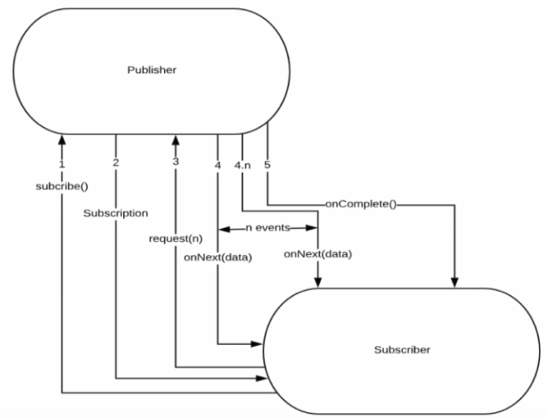

The subscriber is going to invoke the subscribe method of the publisher and as the instance of the subscriber as an input. After that the publisher is going to send a subscription object to the subscriber conforming the subscription is successful. If we are able to recall from the previous slide the subscription has two methods. One is the request and cancel. Let's talk about the request method for now and we will talk about the cancel in a bit. By default the request method is going to request for all the data whatever data that you have give it to me.

Let's say the publisher is a database and it is going to read a hundred items. In that case there will be hundred onNext event with each event representing a row, will be sent to the Subscriber. Once all the data is sent then we will be receiving onComplete event that will be sent to the subscriber. There is an option for the subscriber to provide a number for the publisher asking for a specific number of data. If you take a look at it it takes a parameter and for example let's say out of the hundred matching items you just need two of the items from the publisher. In that case you'll pass a value as two in the request call and then it is just going to give you two onNext event and followed by that you will get the onComplete event. Basically this concept is called Back Pressure. The subscriber has a control on how much data it needs from the Publisher. This is one of the concept which I was highlighting in the prior videos. So there is a way for the application to talk back to the database. In our example here, I am requesting for the amount of data that it needs for processing. If there is any error in this whole workflow then we will be receiving an onError event.

Next we we'll talk about the **cancel** method and the **Subscription** interface. The subscriber has the option to call the cancel limited on the subscription that is received from the publisher.

Subscription

request - allows the Subscriber to inform the Publisher on how many additional elements to be published

cancel - allows a subscriber to cancel further emission of items by the Publisher

|  |  |
| --- | --- |
| package org.reactivestreams;  public interface **Subscription** {  public void request(long n);  public void cancel();  } | package org.reactivestreams;  public interface **Processor**<T, R> **extends Subscriber<T>, Publisher<R>** {  } |

|  |  |
| --- | --- |
|  | The publisher sends a subscription rate, it has two methods, one is a **request** method. That's what we have seen in the slide just before. This one is a **cancel** method. What happens after we call the cancel method. Basically what this means is we are canceling the subscription and the publisher is not going to publish any event to the subscriber. Next we'll talk about the **Processor** interface. This interface is nothing but the combination of both the subscriber and publisher interface. That's why you do not see any specific methods for this one.  So whatever we have seen until now is just a contract meaning they are just interfaces and just method declarations that are part of the reactive stream specification. We did not see the implementation of these interfaces. |

If you search for reactor stream specification - <https://github.com/reactive-streams/reactive-streams-jvm> and read the Readme.MD file. There you go you see the reactor's stream specification consists of the following parts. One is the API and the API is the one which we discussed just now. Those are the four interfaces and the next one is their technology compatibility kit - TCK (Technology Compatibility Kit), basically this is for the reactor library creators. The system makes sure the library, whatever that you are writing, is going to make sure it is going to follow all the rules that are part of the Reactive Stream Specification.

**Reactive Libraries**

Lets talk about the popular Reactive libraries and the library that we are going to use, to write the Reactive programming code for this course. So what is a Reactive library in general. It is nothing but the implementation of the Reactive stream's specification which is nothing but the

* Publisher
* Subscriber
* Subscription and
* Processor.

So what are the reactor libraries that we have today. We have Rx Java, Reactor and **JDK** itself as theFlow **class** ( JDK 9 ) which includes the Reactor Stream's Specification. So out of all these options what is the library that we are going to use for this course. We are going to use the Reactor which is nothing but Project Reactor. Reactor is built and maintained by pivotal basically the team behind the Spring and Spring Boot Project. Reactor is a default library that comes with Spring Boot for writing Reactor programming code or building non blocking RESTful APIs in spring. Let's go ahead and check what do we have in Project Reactor.

<https://projectreactor.io/>

So this is the home page for the project reactor. Let's look at some of the things that are highlighted here. Reactor as a fourth generation Reactor library for building non blocking applications on the JVM, based on the Reactive Streams Specification and they have the Reactor Core - Reactor as a fully non blocking Foundation that a efficient demand management, it directly interacts with a general functional API, Completable Futures, Stream and Duration. They have flux and mono. These two are the fundamental thing which we need if we are going to work with Project reactor. We'll be exploring that also in the future part of the course. Non blocking IO - This is perfectly suited for micro services architecture. Reactor offers Back Pressure ready network engines for HTTP, if we go a little bit down we can read through all these things and have a very good documentation. Let's click on this [reference guide](https://projectreactor.io/docs/core/release/reference/). If we go to the reference guide this [reference guide](https://projectreactor.io/docs/core/release/reference/) is very neatly documented and if you want to know anything about Project reactor this is the place to go and the documentation is very verbose. And it covers a lot of areas that are needed in order to get yourself more comfortable with the project reactor and to have a [active community](https://gitter.im/reactor/reactor) also if you want to just connect to the [community](https://gitter.im/reactor/reactor)  - you just go to this link and then add yourself to this group. So this one is for the community where if we have any doubts or something you can reach out to this community they will help you out.

## Project Reactor

In this tutorial we'll talk about the Project Reactor and the different modules that are present in the Project Reactor. Let's go to the home page and then check the different modules that are available and project reactor. I have the browser open and I'm going to go to the home page of the home page. Click on this documentation link when you go to the documentation link. This is where all the different modules that are supported by Project reactor is available. So if you go a little bit down.

* Reactor Core
* Reactor Test
* Reactor Extra
* Reactor Netty.
* Reactive Kafka
* Reactive RabbitMQ
* And it has four or five more.

<https://projectreactor.io/>

Our goal for this course is not to explore all the modules that are present in this project reactor - for this course we are going to explore the following modules. Reactor core, Reactor Test and Reactor Netty. These are the three modules that will be covered as part of this course. And these are the three modules which are necessary in order to build the non blocking reactive RESTful API.

Reactor Core

From the name of it we can say this is the core library of project reactor. This library has the implementation of the Reactive Streams Specification, in order to work with the Reactor Core we need at least Java 8 running in your machine. Let's dig deep and look at the implementation of the Reactor Stream's Specification. We have seen this flow diagram in one of the previous video and we talked about how the Reactor streams should flow and the different types of events that are involved in it. Flux and Mono are two classes which are implementation of the reactor stream's specification in Project Reactor. These are the only two classes which you need to know in order to work with Project reactor. These are the Reactor types of project reactor. Flux is a class which represents 0 to N elements. Mono is a class which represent a 0 to 1 element. We will talk about specific use cases on when to use mono and when to use Flux in a bit.

Flux – 0 to N

Let's start with Flux, the reactor types in Project reactor are explained using the marble diagrams we have the marbles on the top and then operator in the middle and then marble diagrams at the bottom.

|  |  |
| --- | --- |
| The vertical line here represents the on complete event, meaning there is no more data. I'm done with the request, there is no more data to send to you and the X represents there is some kind of error happened in one of the above events. | So the marble diagrams to the left represents actual data and the operator in middle represents filtering, transformation and a lot of other operations, to transform data from its raw form to another form, it goes through the operator layer one by one and then the marble diagram below represents the final output which will be sent to the Subscriber.  To summarize the whole flow, so we have those marble diagrams which is going to flow one by one which is going to be passed to the operator layer one by one and then the final output will be sent to the subscriber. Let's take a look at a quick example and then I will show you the documentation on this one. |

So the example here is like we have a flux of three elements.

Flux.just( "Spring", "Spring Boot", "Reactive Spring Boot" )

.map( s -> s.concat("flux") )

.subscribe( System.out:println )

In reality, we might be pulling this data from a database, in order to give this example simple we have this flux created using this just method. This is one of the ways we can create a flux. What happens is this flux has three elements and all these elements will be sent one by one. So the map here is one of the method which is part of the reactive API which is going to convert the Spring to Spring Flux and Spring Boot to Spring Boot Flux and then Reactive Spring Boot to Reactive Spring Boot flux. Basically it appends the string flux to the elements in the flux and then we have the subscribe attached to it. This is nothing but the subscriber and the use case is really simple. We are just printing over here.

Let's summarize this. So we are going to get the Spring, Spring boot and Reactive Spring Boot each and every element passing down to the next layer which is the major player in the map layer. We are just concatenating in the "flux" to the each and every element and then it goes through the subscribe method and then the subscribe method to just printing that value. Now let's go ahead and take a look at the documentation for this flux.

<https://projectreactor.io/docs/core/release/api/reactor/core/publisher/Flux.html>

This page as a complete information on boot flux. If you remember this is a module diagram which we just discussed. And then if you go a little bit down, these are the [different kinds of methods](https://projectreactor.io/docs/core/release/api/reactor/core/publisher/Flux.html#method.summary) that are supported by the flux API. When you say method these are the different operators. So we saw the map method in our example right. Likewise it has lots and lots of methods and it can change many different operators to follow pipeline too. So that's the way we normally code, we'll be exploring all those examples. For now let's take a look at one of the example, I'm gonna take this buffer int my size as an example, if we go here we have in this example the top layer represents actual data.

Flux<List<T>> buffer(int maxSize)

Collect incoming values into multiple List buffers that will be emitted by the returned [Flux](https://projectreactor.io/docs/core/release/api/reactor/core/publisher/Flux.html) each time the given max size is reached or once this Flux completes.

|  |  |
| --- | --- |
|  | As I explained and then in the buffer for what we have is a max size of three. So it's going to buffer until the size is reached and then it's going to send the output as a combined output of three elements to the subscriber. And if you take a look at it we have only 5. So here are the two elements we receive then on onComplete event. So the buffer is smart enough to know that there is no more data for this. So its going to combine those 2 as output and send it to the subscriber. So these marble diagrams are handy and you can refer to each and every operator that we have here. And then the marble diagrams will give you a pictorial representation of how it's going to work. So this is all about flux. |

Mono – 0 to 1 elements

Now let's go ahead and explore the model. The model here is the representation of zero to one element actually. So here if you take a look at it we have one marble at the top and one marble at the bottom.

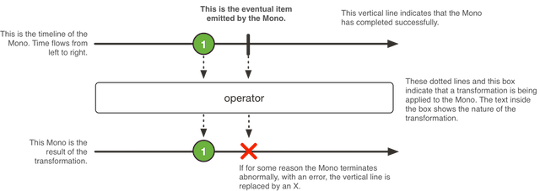

So that's what is model support after this one element we are going to receive onComplete event. So the X here represents some kind of error happened in the Mono, so Mono is a use case let's say you are requesting for only one data from one database or only one data from the rest endpoint. So in those kind of cases you can use Mono and whenever you see more than one elements then we will use the Flux. Now let's go to the example. So here this example is similar to the one which we discussed for the flux. So here we have Mono.just() and then only one element. You cannot provide multiple element as an input to this just method if you're using Mono, if you do that you're going to get compilation issues, followed by that we are performing the map operation and then we are transforming the original value which is "spring" to "spring flux" and then we have a subscribe method here. So that’s how you attach a subscriber and then we are printing that value in the console just for the simple use case we have here.

Mono.just("Spring")

.map(s -> s.concat("flux"))

.subscribe(System.out::println)

Project Setup

The first steps we are going to go to the spring initializr website. So this is a website which we are going to use in order to build a base Spring Boot Project. I'm gonna name this group name as com.learnreactivespring. So that's a group name I'm gonna click on this switch to full version and I'm gonna name the artifact ID as learn-reactivespring. OK. And then I'm gonna keep the package name as com.learnreactivespring and a java version that I'm using is Java 8 so Java 8 is a base version for Spring Boot 2. So now we need to select the dependencies we are going to build non blocking API right. So in that case we need to select the reactive web. So if we take a look at it this is a reactive web development with Netty and Spring Web Flux. We're gonna select that, followed it by the DB component that we're going to use is a Mongo DB, going to select a reactive Mongo DB. There you go and followed by that we're going to do we are going to select Project Lombok as a dependency okay and our product we are going to select Embedded Mongo DB so Embedded Mongo DB is for writing the integration test cases.

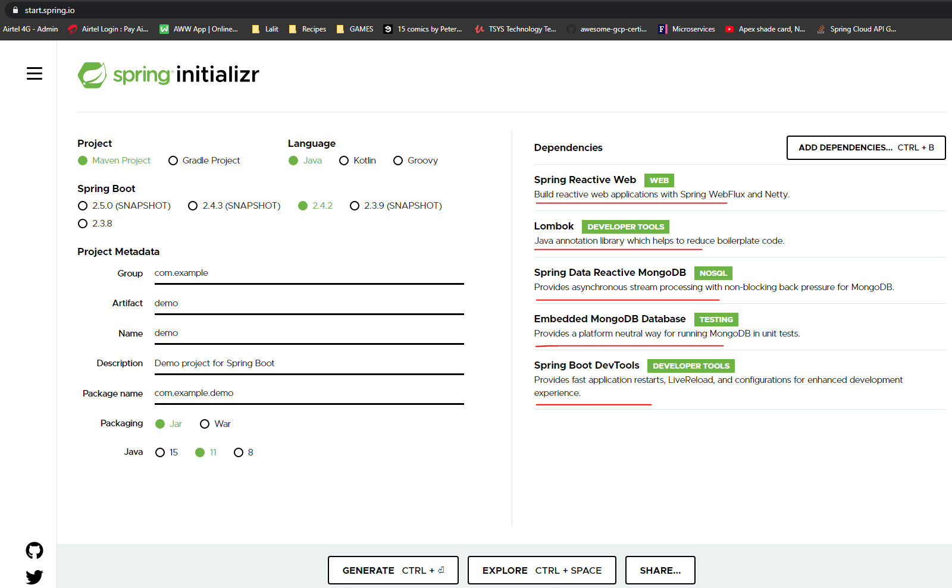

We have three dependencies. One is a project reactor core which has all the flux and model reactor types and other one is a reactor test. That is for testing the flux and mono because you cannot just write junit test cases the way you have been writing before. In order to test the non blocking sequences, they have given us specific reactive library for us. We have this reactor netty, so this is a wrapper which is built on top of netty. In order for netty to understand the flux and mono reactor types. So these are the dependencies that we selected from the springboot, lets initialize the page.

<dependencies>

<dependency>

<groupId>org.springframework.boot</groupId>

<artifactId>spring-boot-starter-data-mongodb-reactive</artifactId>

</dependency>

<dependency>

<groupId>org.springframework.boot</groupId>

<artifactId>spring-boot-starter-webflux</artifactId>

</dependency>

<dependency>

<groupId>io.projectreactor</groupId>

<artifactId>reactor-test</artifactId>

<scope>test</scope>

</dependency>

<dependency>

<groupId>org.projectlombok</groupId>

<artifactId>lombok</artifactId>

<optional>true</optional>

</dependency>

<dependency>

<groupId>org.springframework.boot</groupId>

<artifactId>spring-boot-starter-test</artifactId>

<scope>test</scope>

<exclusions>

<exclusion>

<groupId>org.junit.vintage</groupId>

<artifactId>junit-vintage-engine</artifactId>

</exclusion>

</exclusions>

</dependency>

<dependency>

<groupId>de.flapdoodle.embed</groupId>

<artifactId>de.flapdoodle.embed.mongo</artifactId>

<scope>test</scope>

</dependency>

</dependencies>

We have one final task before we complete the project setup, so we have Lombok selected right. We need to enable Lombok for this workspace. The first steps you need to check whether you have the Lombok plug in, click on this and then select the preferences. So first thing you need to go to the plugins search for Lombok. I have the Lombok plugin normally. So you need to click on that there will be an install button in the place of upgrade you have to install this and restart the in. So how the Lombok plugin already available. The next step is I need to enable this for this particular project. How do we do it. I have to search far on operation as soon as a search phone rotation you get this option call up a new bill on rotation processors and this option will be unchecked by default. So you have to check this one and then click OK. Hey upload button will be enabled or you can click OK by making this you are enabling the Lombok plug in for this project so you can use that as a 4G annotation you can use all those Lombok related annotations for this project.

**Installing Lombok on Eclipse**

If we're using Eclipse IDE, we need to get the Lombok jar first. The latest version is located on [Maven Central](https://search.maven.org/search?q=g:org.projectlombok%20AND%20a:lombok&core=gav). For our example, we're using [lombok-1.18.4.jar](https://search.maven.org/remotecontent?filepath=org/projectlombok/lombok/1.18.4/lombok-1.18.4.jar).

Next, we can run the jar via java -jar command and an installer UI will open. This tries to automatically detect all available Eclipse installations, but it's also possible to specify the location manually.

Once we've selected the installations, then we press the Install/Update button:

[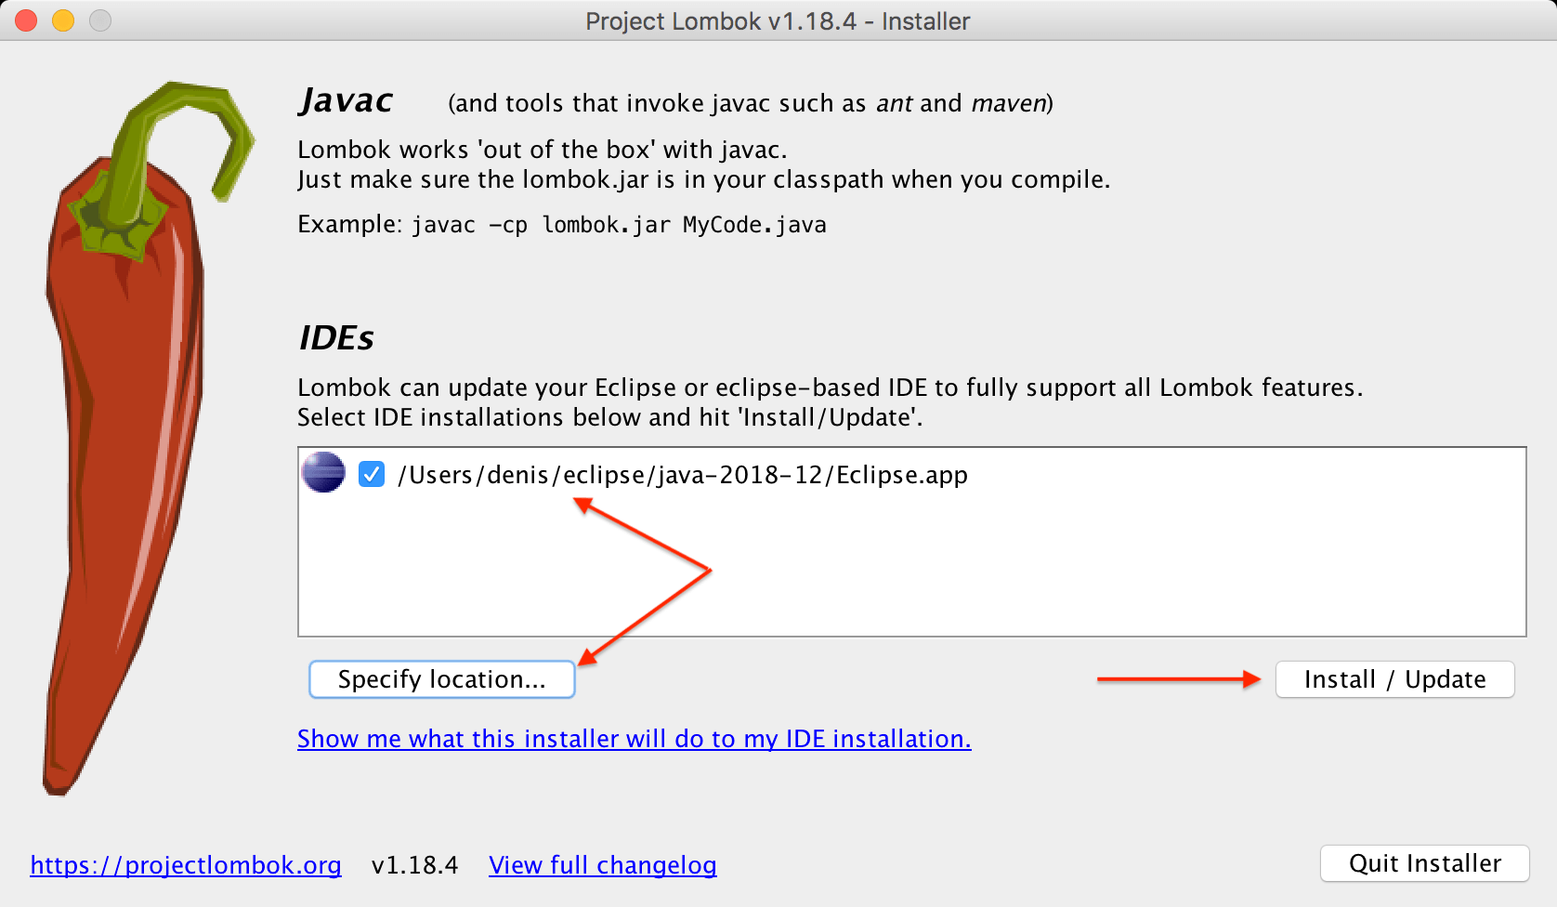](https://www.baeldung.com/wp-content/uploads/2019/01/lombok6.png)

If the installation is successful, we can exit the installer.

After installing the plugin, we need to restart the IDE and ensure that Lombok is correctly configured. We can check this in the About dialog:

[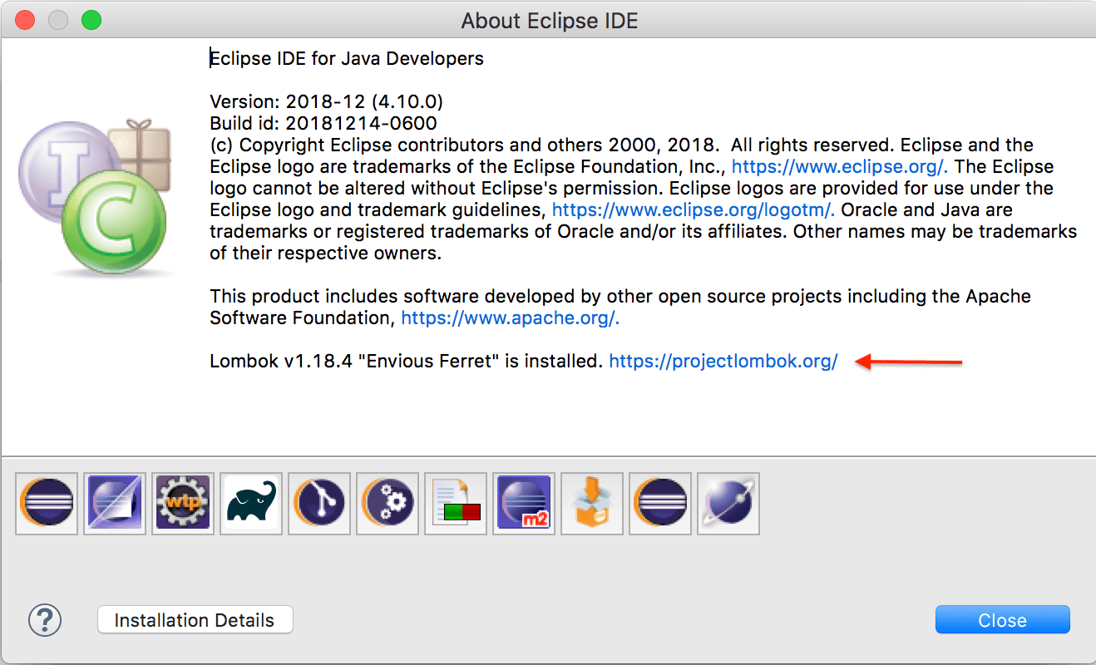](https://www.baeldung.com/wp-content/uploads/2019/01/lombok7.png)

**Adding Lombok to the Compile Classpath**

The last remaining part is to ensure that Lombok binaries are on the compiler classpath. Using Maven, we can add the dependency to the pom.xml:

<dependencies>

<dependency>

<groupId>org.projectlombok</groupId>

<artifactId>lombok</artifactId>

<version>1.18.10</version>

<scope>provided</scope>

</dependency>

</dependencies>

The most recent version is located on [Maven Central](https://search.maven.org/search?q=g:org.projectlombok%20AND%20a:lombok&core=gav).

Everything should be fine now, the source code below should be shown without errors in the IDE, correctly compiled and executed:

public class UserIntegrationTest {

@Test

public void givenAnnotatedUser_thenHasGettersAndSetters() {

User user = new User();

user.setFirstName("Test");

assertEquals(user.gerFirstName(), "Test");

}

@Getter

@Setter

class User {

private String firstName;

}

}

## Building Reactive RESTFUL APIs using Spring Boot/ WebFlux

We will explore the flux and Mono now by writing code

Expand the test package and in the com.learnreactivespring.fluxandmono package and lets create a test case now called FluxAndMonoTest. Create a test method inside it called

import org.junit.jupiter.api.Test;

import reactor.core.publisher.Flux;

public class FluxAndMonoTest {

@Test

public void fluxTest() {

Flux<String> stringFlux = Flux.just("Spring", "Spring Boot", "Reactive Spring");

stringFlux.subscribe(System.out::println);

}

}

The only way to access the elements in a flux is by subscribing to it. We will now use the reference of the flux and subscribe to it – so that the subscriber can read all the values in it. When we subscribe only then the values would be emitted to the subscriber. The subscriber has many versions overloaded, it will read all the values from the Flux. We are now just getting the value and printing to the console now. When you run this the values are printed one by one.

stringFlux.subscribe( System.out::println, e -> System.err.println(e.getMessage()) );

Now the next thing is let's see if there is some kind of error happened in that case, how do we know? So in that case subscribe has a overloaded version of handling that, so it takes a second parameter to the subscribe method and then it takes an exception ( we took a Lambda Consumer here ) and it can handle the exception in whatever way you want.

**Attaching error to the Flux**

Flux<String> stringFlux = Flux.*just*("Spring", "Spring Boot", "Reactive Spring")

.concatWith( Flux.error(RuntimeException("Some error occurred")));

When we do this, we are basically throwing a exception and attaching that to the Flux. Here we have the exception as new RuntimeException("Some error occurred") and pass the error message to it.

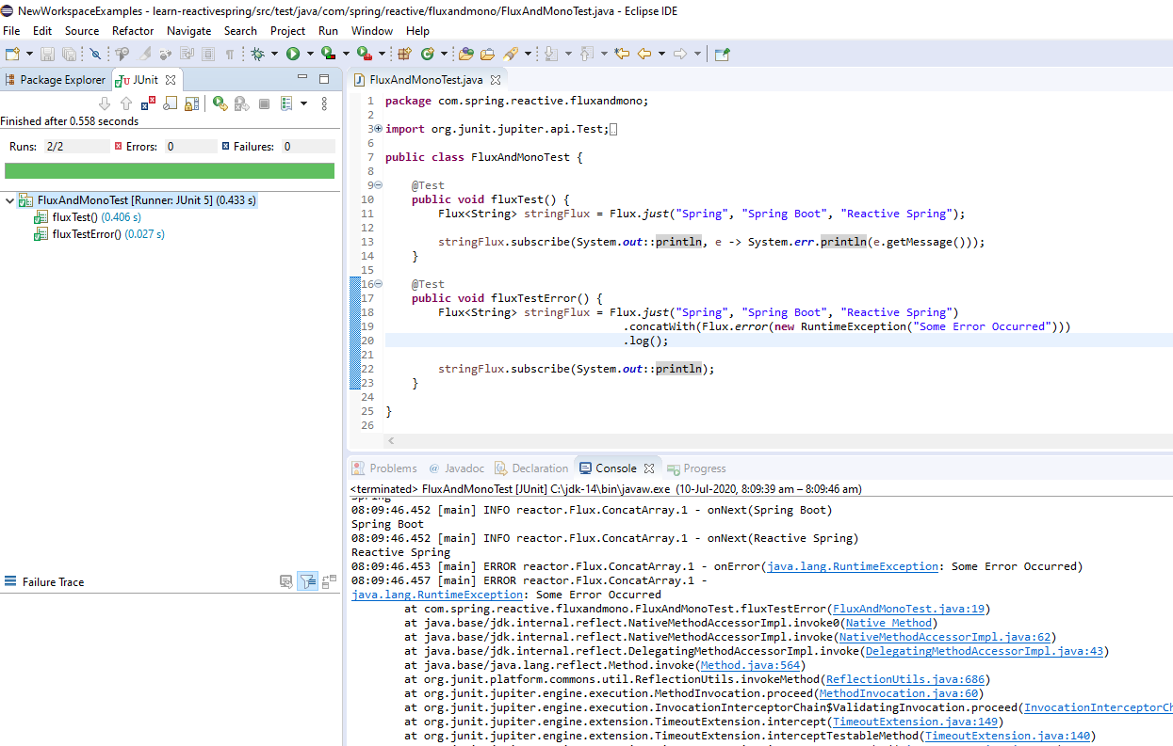

How do we know is it really happening in order to make sure that we are seeing all those events. In order to make sure that we are getting the error lets use a handy method called log(). Flux has this method that allows us to log all the events that happen behind the scenes when we call the subscribe method of Flux.

If we look at the logs we have a onSubscribe call first

08:11:26.630 [main] DEBUG reactor.util.Loggers$LoggerFactory - Using Slf4j logging framework

Spring

Spring Boot

Reactive Spring

08:11:26.657 [main] INFO reactor.Flux.ConcatArray.1 - onSubscribe(FluxConcatArray.ConcatArraySubscriber)

08:11:26.660 [main] INFO reactor.Flux.ConcatArray.1 - request(unbounded)

08:11:26.661 [main] INFO reactor.Flux.ConcatArray.1 - onNext(Spring)

Spring

08:11:26.661 [main] INFO reactor.Flux.ConcatArray.1 - onNext(Spring Boot)

Spring Boot

08:11:26.661 [main] INFO reactor.Flux.ConcatArray.1 - onNext(Reactive Spring)

Reactive Spring

08:11:26.662 [main] ERROR reactor.Flux.ConcatArray.1 - onError(java.lang.RuntimeException: Some Error Occurred)

08:11:26.664 [main] ERROR reactor.Flux.ConcatArray.1 -

java.lang.RuntimeException: Some Error Occurred

at com.spring.reactive.fluxandmono.FluxAndMonoTest.fluxTestError(FluxAndMonoTest.java:19)

at java.base/jdk.internal.reflect.NativeMethodAccessorImpl.invoke0(Native Method)

at java.base/jdk.internal.reflect.NativeMethodAccessorImpl.invoke(NativeMethodAccessorImpl.java:62)

at java.base/jdk.internal.reflect.DelegatingMethodAccessorImpl.invoke(DelegatingMethodAccessorImpl.java:43)

at java.base/java.lang.reflect.Method.invoke(Method.java:564)

If we look at the logs the first step is onSubscribe(). That's what this call is and followed by that there is a onRequest call meaning the request call with unbounded. Basically, the subscribe request for - give me whatever data you have. The unbounded relates to Long.Max value. So that's a value it is requesting the flux, to emit as soon as it receives the flux receives the request unbounded call. It's going to send the element one by one. That's why you see that onNext on NEXT. And then it pauses element and then we are printing it here.

Now we will comment this line and run this again, and we will see that instead of onError we would have a call to onComplete

@Test

**public** **void** fluxTestError() {

Flux<String> stringFlux = Flux.*just*("Spring", "Spring Boot", "Reactive Spring")

// .concatWith(Flux.error(new RuntimeException("Some Error Occurred")))

.log();

stringFlux.subscribe(System.***out***::println);

}

Now the log goes as

08:16:52.949 [main] DEBUG reactor.util.Loggers$LoggerFactory - Using Slf4j logging framework

Spring

Spring Boot

Reactive Spring

08:16 [main] INFO reactor.Flux.Array.1 - | onSubscribe([Synchronous Fuseable] FluxArray.ArraySubscription)

08:16 [main] INFO reactor.Flux.Array.1 - | request(unbounded)

08:16 [main] INFO reactor.Flux.Array.1 - | onNext(Spring)

Spring

08:16 [main] INFO reactor.Flux.Array.1 - | onNext(Spring Boot)

Spring Boot

08:16 [main] INFO reactor.Flux.Array.1 - | onNext(Reactive Spring)

Reactive Spring

08:16 [main] INFO reactor.Flux.Array.1 - | onComplete()

There is no exception here now, because we haven’t attached the .concatWith(…) method, we commented that out.

import org.junit.jupiter.api.Test;

import reactor.core.publisher.Flux;

public class FluxAndMonoTest {

@Test

public void fluxTest() {

Flux<String> stringFlux = Flux.just("Spring", "Spring Boot", "Reactive Spring");

stringFlux.subscribe(System.out::println, e -> System.err.println(e.getMessage()));

}

@Test

public void fluxTestError() {

Flux<String> stringFlux = Flux.just("Spring", "Spring Boot", "Reactive Spring")

// .concatWith(Flux.error(new RuntimeException("Some Error Occurred")))

.log();

stringFlux.subscribe( System.out::println );

}

}

Lets add another element after the error and see if Flux emits that as a event or not

@Test

public void fluxTestError() {

Flux<String> stringFlux = Flux.*just*("Spring", "Spring Boot", "Reactive Spring")

.concatWith( Flux.*error*(new RuntimeException("Some Error Occurred")))

.concatWith( Flux.*just*("After Error Element") )

.log();

stringFlux.subscribe(System.out::println,

e -> System.err.println("Exception: "+e.getMessage()));

}

After error the element newly added is not printed, if you comment the error then it will be printed. Flux will stop emitting data if there is a error.

The subscribe method takes another parameter, which is the onComplete event. We will use a Lambda to print some message on the onComplete event.

@Test

public void fluxTestComplete() {

Flux<String> stringFlux = Flux.just("Spring", "Spring Boot", "Reactive Spring")

// .concatWith(Flux.error(new RuntimeException("Some Error Occurred")))

.concatWith(Flux.just("After Error Element"))

.log();

stringFlux.subscribe(System.out::println,

e -> System.err.println("Exception: "+e.getMessage()),

() -> System.out.println("Event Completed"));

}

This will not print right now as we have attached a Exception with .concatWith(Flux.error(…). Comment that line and then it should print the onComplete system out. And the log says this now

08:28:59.997 [main] DEBUG reactor.util.Loggers$LoggerFactory - Using Slf4j logging framework

*Spring*

*Spring Boot*

*Reactive Spring*

08:29:00.015 [main] INFO reactor.Flux.ConcatArray.1 - onSubscribe(FluxConcatArray.ConcatArraySubscriber)

08:29:00.017 [main] INFO reactor.Flux.ConcatArray.1 - request(unbounded)

08:29:00.017 [main] INFO reactor.Flux.ConcatArray.1 - onNext(Spring)

Spring

08:29:00.017 [main] INFO reactor.Flux.ConcatArray.1 - onNext(Spring Boot)

Spring Boot

08:29:00.017 [main] INFO reactor.Flux.ConcatArray.1 - onNext(Reactive Spring)

Reactive Spring

08:29:00.018 [main] INFO reactor.Flux.ConcatArray.1 - onNext(After Error Element)

After Error Element

08:29:00.018 [main] INFO reactor.Flux.ConcatArray.1 - onComplete()

Event Completed

Basically this block gets executed whenever there is a complete event from the flux. So this is to make sure whenever you want to do some kind of activity after the flux terminated meaning the flux has no more data to emit, then in that case you can use this third parameter as part of the subscribe method. So you might be wondering, we explored all the internals and how the data flows from the flux to the subscriber right. Now we didn't write any test cases basically, we didn’t assert anything on it. Right. So reactor test has a module dedicated for testing these fluxes. So testing the flux is totally different from the way we have been coding so far in Java so we will see those techniques on how to test a flux next.

In order to test the elements we would use a reactive test package – it has something called as a StepVerifier. So what we are expecting is the values to be printed in the order of "Spring", "Spring Boot" and then "Reactive Spring"

The last step would be to verify the complete with the function verifyComplete(). Note that if you do not put this step the data will not be flow and the test case will succeed.

import org.junit.jupiter.api.Test;

import reactor.core.publisher.Flux;

import reactor.test.StepVerifier;

public class FluxAndMonoTest {

@Test

public void fluxTestWithoutError() {

Flux<String> stringFlux = Flux.just("Spring", "Spring Boot", "Spring Reactive")

.log();

StepVerifier.create(stringFlux)

.expectNext("Spring")

.expectNext("Spring Boot")

.expectNext("Spring Reactive");

.verifyComplete();

}

}

The last event is verifyComplete so we are checking for that too.

08:49:12.891 [main] DEBUG reactor.util.Loggers$LoggerFactory - Using Slf4j logging framework

08:49:12.912 [main] INFO reactor.Flux.Array.1 - | onSubscribe([Synchronous Fuseable] FluxArray.ArraySubscription)

08:49:12.915 [main] INFO reactor.Flux.Array.1 - | request(unbounded)

08:49:12.916 [main] INFO reactor.Flux.Array.1 - | onNext(Spring)

08:49:12.916 [main] INFO reactor.Flux.Array.1 - | onNext(Spring Boot)

08:49:12.916 [main] INFO reactor.Flux.Array.1 - | onNext(Spring Reactive)

08:49:12.916 [main] INFO reactor.Flux.Array.1 - | **onComplete()**

The test case will still pass in this case as we have all the right values mentioned here, change a value to something else ( or change the order of expectNext ) and the test case will fail and logs would be as below.

08:45:56.131 [main] DEBUG reactor.util.Loggers$LoggerFactory - Using Slf4j logging framework

08:45:56.152 [main] INFO reactor.Flux.Array.1 - | onSubscribe([Synchronous Fuseable] FluxArray.ArraySubscription)

08:45:56.155 [main] INFO reactor.Flux.Array.1 - | request(unbounded)

08:45:56.155 [main] INFO reactor.Flux.Array.1 - | onNext(Spring)

08:45:56.155 [main] INFO reactor.Flux.Array.1 - | onNext(Spring Boot)

08:45:56.155 [main] INFO reactor.Flux.Array.1 - | onNext(Spring Reactive)

08:45:56.158 [main] INFO reactor.Flux.Array.1 - | **cancel()**

In the previous test case we had the subscribe method which is going to start the whole flow of the Flux to pass the elements from the Flux to the Subscriber.

@Test

public void fluxTestError() {

Flux<String> stringFlux = Flux.just("Spring", "Spring Boot", "Reactive Spring")

.concatWith( Flux.error(new RuntimeException("Some Error Occurred")))

.concatWith( Flux.just("After Error Element"))

.log();

stringFlux.subscribe(System.out::println, e -> System.err.println("Exception: "+e.getMessage()));

}

In this one the StepVerifier takes care of subscribing to the Flux to start it and then asserting the value on the Flux. If we do not make a call to verifyComplete() here then we do not have any events flowing, so this is the one that calls subscribe for us to trigger things up.

@Test

public void fluxTestWithoutError() {

Flux<String> stringFlux = Flux.just("Spring", "Spring Boot", "Spring Reactive")

.log();

StepVerifier.create(stringFlux)

.expectNext("Spring")

.expectNext("Spring Boot")

.expectNext("Spring Reactive")

.verifyComplete();

}

Always end up the test case with a verify call in this case.

Lets explore the case of Exception in the Flux now

@Test

public void fluxTestElementsWithoutError() {

Flux<String> stringFlux = Flux.just("Spring", "Spring Boot", "Spring Reactive")

.concatWith(Flux.error(new RuntimeException("Runtime Exception occurred")))

.log();

StepVerifier.create(stringFlux)

.expectNext("Spring")

.expectNext("Spring Boot")

.expectNext("Spring Reactive")

.verifyError();

}

This case would have failed had we not replaced verifyComplete with verifyError.

StepVerifier.create(stringFlux)

.expectNext("Spring")

.expectNext("Spring Boot")

.expectNext("Spring Reactive")

.expectError( RuntimeException.class )

.verify();

We can validate the exception with the expectError(<Exception>.class) as well. Note that the verifyError method will not work in this case, we just need to use the verify() method

StepVerifier.create(stringFlux)

.expectNext("Spring")

.expectNext("Spring Boot")

.expectNext("Spring Reactive")

.expectErrorMessage("Runtime Exception occurred")

.verify();

The above will test for the error message, it will test whether we got the expected error message.

We cannot have both the expectError and expectErrorMessage together.

To validate the number of elements in the Flux we could do as following

@Test

public void fluxTestElementsCount() {

Flux<String> stringFlux = Flux.just("Spring", "Spring Boot", "Spring Reactive")

.concatWith( Flux.error(new RuntimeException("Runtime Exception")) )

.log();

StepVerifier.create(stringFlux)

.expectNextCount(5)

.expectError();

}

}

We can also specify all the elements on the same line instead of separate lines used in earlier examples

@Test

public void fluxTestElements() {

Flux<String> stringFlux = Flux.just("Spring", "Spring Boot", "Spring Reactive")

.log();

StepVerifier.create(stringFlux)

.expectNext("Spring", "Spring Boot", "Spring Reactive")

.verifyComplete();

}

Exploring the Mono Reactive Type

Lets create a Mono test now. Mono represents one element, so we would provide just 1 element.

@Test

public void monoTest() {

Mono<String> stringMono = Mono.just("Spring");

StepVerifier.create( stringMono.log() )

.expectNext( "Spring" )

.verifyComplete();

}

As we can see the approach is the same.

Note that we also added the logger .log() method with the stringMono, to be able to log.

The difference in the console output before and after adding the log() method is as below

**Before**

08:31:29.377 [main] DEBUG reactor.util.Loggers$LoggerFactory - Using Slf4j logging framework

**After**

08:31:48.864 [main] DEBUG reactor.util.Loggers$LoggerFactory - Using Slf4j logging framework

08:31:48.886 [main] INFO reactor.Mono.Just.1 - | onSubscribe([Synchronous Fuseable] Operators.ScalarSubscription)

08:31:48.889 [main] INFO reactor.Mono.Just.1 - | request(unbounded)

08:31:48.889 [main] INFO reactor.Mono.Just.1 - | onNext(Spring)

08:31:48.889 [main] INFO reactor.Mono.Just.1 - | onComplete()

Testing with the error now

@Test

public void monoTestWithError() {

StepVerifier.create( Mono.error(new RuntimeException("My Error") ).log())

.expectError(RuntimeException.class)

.verify();

}

Note that we did not do Mono.just here as Mono expects only a single element, so we rather attached the error directly to the StepVerifier.create method. Also note how we added the .log() method to this. We expect a error here as a RuntimeException.class and finally don’t forget to call the .verify() method.

Call the .log() on the Flux or the Mono to notice all the events flowing between the Subscriber and the Mono.

Flux/ Mono – Exploring the Factory Methods

**Flux from a Iterable**

We can pass a Interable to the Flux method as in example below

public class FluxAndMonoFactoryMethods {

List<String> names = Arrays.asList( "Adam", "Anna", "Jack", "Jenny" );

@Test

public void fluxUsingIterable() {

Flux<String> namesFlux = Flux.fromIterable( names );

StepVerifier.create( namesFlux.log() )

.expectNext( "Adam", "Anna", "Jack", "Jenny" )

.verifyComplete();

}

}

**Using an array now**

@Test

public void fluxUsingArray() {

String[] namesStrArray = new String[]{ "Adam", "Anna", "Jack", "Jenny" };

Flux<String> namesFlux = Flux.fromArray( namesStrArray );

StepVerifier.create(namesFlux.log())

.expectNext( "Adam", "Anna", "Jack", "Jenny" )

.verifyComplete();

}

**Using a Stream now**

@Test

public void fluxUsingStream() {

List<String> theNamesList = Arrays.asList("Adam", "Anna", "Jack", "Jenny");

Flux<String> namesFlux = Flux.fromStream(theNamesList.stream());

StepVerifier.create( namesFlux.log() )

.expectNext("Adam", "Anna", "Jack", "Jenny")

.verifyComplete();

}

**Creating a Mono using null – Empty Mono**

@Test

public void monoUsingJustEmpty() {

Mono<String> mono = Mono.justOrEmpty(null);

// There is no data to emit so can't do expect, just do verifyComplete

StepVerifier.create(mono)

.verifyComplete();

}

**Mono using a Supplier**

@Test

public void monoUsingSupplier() {

Supplier<String> stringSupplier = () -> "Returned String";

// This is how we get a value from a supplier usually

System.out.println(stringSupplier.get());

Mono<String> stringMono = Mono.fromSupplier( stringSupplier ).log();

// There is no data to emit so can't do expect, just do verifyComplete

StepVerifier.create( stringMono )

.expectNext("Returned String")

.verifyComplete();

}

**Flux Range** ( remember we use Flux for multiple values and Mono for one value )

@Test

public void fluxUsingRange() {

Flux<Integer> integerFlux = Flux.range(1, 5);

StepVerifier.create( integerFlux )

.expectNext(1, 2, 3, 4, 5)

.verifyComplete();

}

**Filtering a Reactive Stream**

Filtering using a Reactive Stream example as below

import org.junit.jupiter.api.Test;

import reactor.core.publisher.Flux;

import reactor.test.StepVerifier;

public class FluxAndMonoFilterTest {

@Test

public void filterTest() {

List<String> names = Arrays.asList( "Amit", "Ravi", "Kiran", "Sumit", "Aaryan" );

// Passing a predicate to filter

Flux<String> stringFlux = Flux.fromIterable( names )

.filter( e -> e.toLowerCase().startsWith("a") )

.log();

StepVerifier.create(stringFlux )

.expectNext("Amit", "Aaryan")

.verifyComplete();

}

}

We could have also used the other methods for example to filter in the predicate based on length etc.

**Transform a Flux from one form to another form**

**Using Map**

So in Project reactor there is a handy method called map using that we can convert a flux from one form to another form.

Flux<String> source = Flux.just("John", "Monica", "Mark", "Cloe", "Frank", "Casper")

.filter( name -> name.length() == 4 )

.map( String::toUpperCase );

More examples

import org.junit.jupiter.api.Test;

import reactor.core.publisher.Flux;

import reactor.test.StepVerifier;

public class FluxAndMonoTransformTest {

List<String> namesList = Arrays.asList("Adam", "Anna", "Jack", "Jenny");

@Test

public void transformUsingMap() {

// Using map function from Project Reactor to convert Flux from one form to another.

Flux<String> stringFlux = Flux.fromIterable( namesList )

.filter( e -> e.toLowerCase().startsWith("a") )

.map( e -> e.toUpperCase())

.log();

StepVerifier.create( stringFlux )

.expectNext("ADAM", "ANNA")

.verifyComplete();

}

@Test

public void transformUsingMapExampleTwo() {

// Using map function from Project Reactor to convert Flux from one form to another.

Flux<Integer> stringFlux = Flux.fromIterable(namesList)

.filter( e -> e.toLowerCase().startsWith("a") )

.map( e -> e.length() )

.log();

StepVerifier.create( stringFlux )

.expectNext( 4, 4 )

.verifyComplete();

}

}

There is a repeat method available in Flux if we want to repeat the operation stated number of times.

List<String> namesList = Arrays.asList("Adam", "Anna", "Jack", "Jenny");

@Test

public void transformUsingMapExampleTwo() {

// Using map function from Project Reactor to convert Flux from one form to another.

Flux<Integer> stringFlux = Flux.fromIterable( namesList )

.filter( e -> e.toLowerCase().startsWith("a") )

.map( e -> e.length() )

.repeat( 1 )

.log();

StepVerifier.create(stringFlux)

.expectNext(4, 4)

.verifyComplete();

}

This will fail because we are repeating the flux 1 more time so that values that would come to us wouldn’t be 4,4 rather they would be 4, 4, 4, 4

This example fails and so we expectError()

List<String> namesList = Arrays.asList("Adam", "Anna", "Jack", "Jenny");

@Test

public void repeatFluxFailingExample() {

// Using map function from Project Reactor to convert Flux from one form to another.

Flux<Integer> stringFlux = Flux.fromIterable( namesList )

.filter( e -> e.toLowerCase().startsWith("a") )

.map( e -> e.length() )

.log();

StepVerifier.create(stringFlux.repeat(1))

.expectNext(4, 4)

.expectError();

}

This example passes and so we verifyComplete()

@Test

public void repeatFluxPassingExample() {

// Using map function from Project Reactor to convert Flux from one form to another.

Flux<Integer> stringFlux = Flux.fromIterable(namesList)

.filter( e -> e.toLowerCase().startsWith("a") )

.map( e -> e.length())

.log();

StepVerifier.create(stringFlux.repeat(1))

.expectNext(4, 4, 4, 4) // due to repeat values would be 4, 4, 4, 4

.verifyComplete();

}

**Using flatMap**

A simple example

@Test

public void testingThis() {

List<List<String>> myList = Arrays.asList( Arrays.asList("a", "b"), Arrays.asList("c", "d") );

Flux<String> myStringFlux = Flux.fromIterable( myList ) // Flux<List<String>>

.log()

.flatMap( s -> Flux.fromIterable( s ) ); // Flux<String>

myStringFlux.subscribe( System.out::println );

}

Note I have added the .log() method immediately after the flux creation to see all the logs of what happens

2021-01-20 INFO 9520 --- [main] reactor.Flux.Iterable.1 : | onSubscribe([Synchronous Fuseable] FluxIterable.IterableSubscription)

2021-01-20 INFO 9520 --- [main] reactor.Flux.Iterable.1 : | request(256) 1st List

2021-01-20 INFO 9520 --- [main] reactor.Flux.Iterable.1 : | onNext([a, b])

String

String

2021-01-20 INFO 9520 --- [main] reactor.Flux.Iterable.1 : | request(1) 2nd List

2021-01-20 INFO 9520 --- [main] reactor.Flux.Iterable.1 : | onNext([c, d])

String

String

2021-01-20 INFO 9520 --- [main] reactor.Flux.Iterable.1 : | request(1) Complete

2021-01-20 INFO 9520 --- [main] reactor.Flux.Iterable.1 : | onComplete()

The flatMap() methods transform the elements asynchronously into Publishers, then flatten these inner publishers into a single Flux through merging.

Notice how the log changes when I move the .log() method after flatMap ( now logging after the flatMap operation ). So it matters where you put the .log() operations, it logs from there.

2021-01-20 07:10:51.279 INFO 8608 --- [main] reactor.Flux.FlatMap.1 : onSubscribe(FluxFlatMap.FlatMapMain)

2021-01-20 07:10:51.280 INFO 8608 --- [main] reactor.Flux.FlatMap.1 : request(unbounded)

2021-01-20 07:10:51.280 INFO 8608 --- [main] reactor.Flux.FlatMap.1 : onNext(a) String 1

String

2021-01-20 07:10:51.280 INFO 8608 --- [main] reactor.Flux.FlatMap.1 : onNext(b) String 2

String

2021-01-20 07:10:51.281 INFO 8608 --- [main] reactor.Flux.FlatMap.1 : onNext(c) String 3

String

2021-01-20 07:10:51.281 INFO 8608 --- [main] reactor.Flux.FlatMap.1 : onNext(d) String 4

String

2021-01-20 07:10:51.281 INFO 8608 --- [main] reactor.Flux.FlatMap.1 : onComplete()

@Test

public void transformUsingFlatMap() {

Flux<Integer> stringFlux =

Flux.fromIterable( Arrays.asList("A", "B", "C") ) // Flux<String>

.log()

.flatMap( s -> {

return Flux.fromIterable(convertToList(s)); // Flux<List<String>>

}); // Flux<String>

StepVerifier.create(stringFlux)

.expectNextCount(6)

.verifyComplete();

}

private Iterable convertToList(String s) {

// Introducing delay of 1 second for each element, notice how consumption is slowed down

try {

Thread.sleep(1000);

} catch (Exception e) {

e.printStackTrace();

}

return Arrays.asList(s, "newValue");

}

In the above code we first create a Flux from a Iterable which is a List<String> so it gives us Flux<String>. We enable log() on the Flux. We then apply a flatMap that takes a String which is converted to List<String> by the convertToList() method and converted back to Flux<String> as we are creating a Flux using fromIterable() method

Notice how it slowed down the consumption as we introduced a delay of 1 second. How do we make this faster? Lets write a function that calls the same convertToList() method but can execute in parallel faster

map() and flatMap() APIs stem from functional languages. In Java 8, you can find them in Optional, Stream and in CompletableFuture (although under slightly different name).

**Just for understanding**

Flux.*fromIterable*( Arrays.*asList*( "A","B","C","D","E","F" ) ) // Flux<String>

.log()

.window(2) // Flux<Flux<String>>

.flatMap( s -> s ) // Flux<String>

.subscribe();

Streams represent a sequence of objects, whereas optionals are classes that represent a value that can be present or absent. Among other aggregate operations, we have the map() and flatMap() methods.

Lets understand the code example below

@Test

public void tranformUsingFlatMap_usingparallel(){

Flux<String> stringFlux =

Flux.fromIterable( Arrays.asList("A","B","C","D","E","F") ) // Flux<String>

.window(2) // Flux<Flux<String>> -> (A,B),(C,D)..

.flatMap(s -> s.map(this::convertToList) // Passes string to convertToList

.subscribeOn( Schedulers.parallel() ) // Flux<List<String>>

)

.flatMap( s -> Flux.fromIterable(s) ) // Flux<String>

.log();

StepVerifier.create(stringFlux)

.expectNextCount(12)

.verifyComplete();

}

private List<String> convertToList(String s) {

try {

Thread.sleep(1000); // delay of 1 second

} catch (Exception e) {

e.printStackTrace();

}

return Arrays.asList(s, "newValue");

}

Flux.fromIterable( Arrays.asList(… )) … helps us create a Flux from a Iterable object i.e. List created by Arrays.asList

window(2) - will wait for 2 elements & then process next instruction so we get elements in form Flux<Flux<String>>

.flatMap(s -> s.map(this::convertToList) takes Flux<Flux<String>> flattens it & passes String to convertToList()

convertToList() converts the String to List<String> also adding a new element of “newValue” for each element it gets

.subscribeOn(Schedulers.parallel()) iterates on Flux<List<String>> and in a parallel fashion

.flatMap(s -> Flux.fromIterable(s)) iterates on each List<String> received here

.log() helps log the process so that we can see whats happening

Log is as below. Note that this is a parallel operation so the order of elements is random here.

2021-01-20 07:42:34.928 INFO 6248 --- [ main] reactor.Flux.Iterable.1 : | onSubscribe([Synchronous Fuseable] FluxIterable.IterableSubscription)

2021-01-20 07:42:34.930 INFO 6248 --- [ main] reactor.Flux.FlatMap.2 : onSubscribe(FluxFlatMap.FlatMapMain)

2021-01-20 07:42:34.931 INFO 6248 --- [ main] reactor.Flux.FlatMap.2 : request(unbounded)

2021-01-20 07:42:34.932 INFO 6248 --- [ main] reactor.Flux.Iterable.1 : | request(64)

2021-01-20 07:42:34.932 INFO 6248 --- [ main] reactor.Flux.Iterable.1 : | onNext(A)

2021-01-20 07:42:34.940 INFO 6248 --- [ main] reactor.Flux.Iterable.1 : | onNext(B)

2021-01-20 07:42:34.940 INFO 6248 --- [ main] reactor.Flux.Iterable.1 : | onNext(C)

2021-01-20 07:42:34.940 INFO 6248 --- [ main] reactor.Flux.Iterable.1 : | onNext(D)

2021-01-20 07:42:34.940 INFO 6248 --- [ main] reactor.Flux.Iterable.1 : | onNext(E)

2021-01-20 07:42:34.940 INFO 6248 --- [ main] reactor.Flux.Iterable.1 : | onNext(F)

2021-01-20 07:42:34.940 INFO 6248 --- [ main] reactor.Flux.Iterable.1 : | onComplete()

2021-01-20 07:42:35.947 INFO 6248 --- [ parallel-1] reactor.Flux.FlatMap.2 : onNext(A)

2021-01-20 07:42:35.947 INFO 6248 --- [ parallel-1] reactor.Flux.FlatMap.2 : onNext(newValue)

2021-01-20 07:42:36.958 INFO 6248 --- [ parallel-1] reactor.Flux.FlatMap.2 : onNext(B)

2021-01-20 07:42:36.958 INFO 6248 --- [ parallel-1] reactor.Flux.FlatMap.2 : onNext(newValue)

2021-01-20 07:42:37.972 INFO 6248 --- [ parallel-2] reactor.Flux.FlatMap.2 : onNext(C)

2021-01-20 07:42:37.972 INFO 6248 --- [ parallel-2] reactor.Flux.FlatMap.2 : onNext(newValue)

2021-01-20 07:42:38.986 INFO 6248 --- [ parallel-2] reactor.Flux.FlatMap.2 : onNext(D)

2021-01-20 07:42:38.986 INFO 6248 --- [ parallel-2] reactor.Flux.FlatMap.2 : onNext(newValue)

2021-01-20 07:42:39.999 INFO 6248 --- [ parallel-3] reactor.Flux.FlatMap.2 : onNext(E)

2021-01-20 07:42:39.999 INFO 6248 --- [ parallel-3] reactor.Flux.FlatMap.2 : onNext(newValue)

2021-01-20 07:42:41.014 INFO 6248 --- [ parallel-3] reactor.Flux.FlatMap.2 : onNext(F)

2021-01-20 07:42:41.014 INFO 6248 --- [ parallel-3] reactor.Flux.FlatMap.2 : onNext(newValue)

2021-01-20 07:42:41.014 INFO 6248 --- [ parallel-3] reactor.Flux.FlatMap.2 : onComplete()

Another example

@Test

public void tranformUsingFlatMapUsingParallelTwo(){

Flux<String> stringFlux = Flux.fromIterable( Arrays.asList("A","B","C","D","E","F") )

.log()

.window(2) // Flux<Flux<String> -> (A,B), (C,D), (E,F)

.concatMap( s -> s.map(this::convertToList) // Flux<List<String>>

.subscribeOn(Schedulers.parallel())) // Flux<String>

.flatMap(s -> Flux.fromIterable(s));

StepVerifier.create(stringFlux)

.expectNextCount(12)

.verifyComplete();

}

Another example

@Test

public void tranformUsingFlatMapUsingParallelAndMaintainOrder(){

Flux<String> stringFlux =

Flux.fromIterable( Arrays.asList("A","B","C","D","E","F") ) // Flux<String>

.window(2) // Flux<Flux<String> -> (A,B), (C,D), (E,F)

.flatMapSequential(s ->

s.map(this::convertToList).subscribeOn( Schedulers.parallel() ))

.flatMap(s -> Flux.fromIterable(s)) // Flux<String>

.log();

StepVerifier.create(stringFlux)

.expectNextCount(12)

.verifyComplete();

}

The only difference here is that we are using the flatMapSequential method to maintain the order of the elements. In the log you would be able to see that the elements appear in the expected order. How many threads does the Project Reactor utilize here, we will see that later.

The above examples were taking 6 seconds to execute, this one is taking 2 seconds to execute and can be seen in the logs that it switches from the main thread to the parallel thread

08:13:54.562 [main] DEBUG reactor.util.Loggers$LoggerFactory - Using Slf4j logging framework

08:13:54.745 [main] INFO reactor.Flux.FlatMap.1 - onSubscribe(FluxFlatMap.FlatMapMain)

08:13:54.779 [main] INFO reactor.Flux.FlatMap.1 - request(unbounded)

08:13:55.891 [parallel-1] INFO reactor.Flux.FlatMap.1 - onNext(A)

08:13:55.893 [parallel-1] INFO reactor.Flux.FlatMap.1 - onNext(newValue)

08:13:56.894 [parallel-1] INFO reactor.Flux.FlatMap.1 - onNext(B)

08:13:56.895 [parallel-1] INFO reactor.Flux.FlatMap.1 - onNext(newValue)

08:13:56.895 [parallel-1] INFO reactor.Flux.FlatMap.1 - onNext(C)

08:13:56.896 [parallel-1] INFO reactor.Flux.FlatMap.1 - onNext(newValue)

08:13:56.896 [parallel-1] INFO reactor.Flux.FlatMap.1 - onNext(D)

08:13:56.896 [parallel-1] INFO reactor.Flux.FlatMap.1 - onNext(newValue)

08:13:56.897 [parallel-1] INFO reactor.Flux.FlatMap.1 - onNext(E)

08:13:56.897 [parallel-1] INFO reactor.Flux.FlatMap.1 - onNext(newValue)

08:13:56.898 [parallel-1] INFO reactor.Flux.FlatMap.1 - onNext(F)

08:13:56.898 [parallel-1] INFO reactor.Flux.FlatMap.1 - onNext(newValue)

08:13:56.900 [parallel-1] INFO reactor.Flux.FlatMap.1 - onComplete()

We can break it up as below

@Test

public void tranformUsingFlatMapJustABreakUp(){

Flux<String> stringFlux = Flux.fromIterable( Arrays.asList("A","B","C","D","E","F") );

Flux<Flux<String>> fluxOfFluxOfString = stringFlux.window(2);

Flux<List<String>> fluxOfListOfString = fluxOfFluxOfString.flatMapSequential(

s -> s.map(this::convertToList).subscribeOn( Schedulers.parallel() ));

Flux<String> fluxOfString = fluxOfListOfString.flatMap(s -> Flux.fromIterable(s));

fluxOfString.log();

StepVerifier.create(fluxOfString.log())

.expectNextCount(12)

.verifyComplete();

}

Notice that I had to pass the fluxOfString instead of stringFlux to the StepVerifier as it needs to complete the operation till here. Also added .log() inside the StepVerifier.create(…) method itself.

Another way would have been to collect Flux<String> again after log() method call and then pass that e.g.

Flux<String> fluxOfString = fluxOfListOfString.flatMap(s -> Flux.fromIterable(s));

Flux<String> fluxOfStringWithLog = fluxOfString.log();

StepVerifier.create(fluxOfStringWithLog))

.expectNextCount(12)

.verifyComplete();

How to combine more than one Publisher

How do we combine more than one publisher which is a Flux or a Mono into one publisher that is a Flux or a Mono using operators available in Project Reactor

import org.junit.jupiter.api.Test;

import reactor.core.publisher.Flux;

import reactor.test.StepVerifier;

public class FluxAndMonoCombineTest {

@Test

public void combineUsingMerge() {

Flux<String> flux1 = Flux.just("A", "B", "C");

Flux<String> flux2 = Flux.just("D", "E", "F");

Flux<String> mergedFlux = Flux.merge(flux1, flux2);

mergedFlux.subscribe(System.out::println);

StepVerifier.create(mergedFlux)

.expectSubscription()

.expectNext("A", "B", "C", "D", "E", "F")

.verifyComplete();

}

}

**Introducing delay**

@Test

public void combineUsingMergeWithDelay() {

Flux<String> flux1 = Flux.just("A", "B", "C").delayElements(Duration.ofSeconds(1));

Flux<String> flux2 = Flux.just("D", "E", "F").delayElements(Duration.ofSeconds(1));

Flux<String> mergedFlux = Flux.merge(flux1, flux2);

mergedFlux.subscribe(System.out::println);

StepVerifier.create(mergedFlux)

.expectSubscription()

.expectNext("A", "B", "C", "D", "E", "F")

.verifyComplete();

}

It just printed two elements on the Console logs

08:41:13.135 [main] DEBUG reactor.util.Loggers$LoggerFactory - Using Slf4j logging framework

08:41:13.255 [main] INFO reactor.Flux.Merge.1 - onSubscribe(FluxFlatMap.FlatMapMain)

08:41:13.265 [main] INFO reactor.Flux.Merge.1 - request(unbounded)

08:41:13.655 [main] INFO reactor.Flux.Merge.1 - onSubscribe(FluxFlatMap.FlatMapMain)

08:41:13.663 [main] INFO reactor.Flux.Merge.1 - request(unbounded)

08:41:14.611 [parallel-1] INFO reactor.Flux.Merge.1 - onNext(A)

A

08:41:14.619 [parallel-2] INFO reactor.Flux.Merge.1 - onNext(D)

D

08:41:14.665 [parallel-3] INFO reactor.Flux.Merge.1 - onNext(A)

08:41:14.666 [parallel-3] INFO reactor.Flux.Merge.1 - onNext(D)

08:41:14.695 [parallel-3] INFO reactor.Flux.Merge.1 - cancel()

The Flux emitted A and then didn’t wait for B and C, it started emitting D – this is said to be the Flux emitting the elements in the InterLeaved sequence. It didn’t wait for all of the flux1 elements.

So that is to be kept in the mind that merge doesn’t return all the elements to you when delaying.

So that didn’t work, replace the merge method with concat method and see

@Test

public void combineUsingConcatWithDelay() {

Flux<String> flux1 = Flux.just("A", "B", "C").delayElements(Duration.ofSeconds(1));

Flux<String> flux2 = Flux.just("D", "E", "F").delayElements(Duration.ofSeconds(1));

Flux<String> mergedFlux = Flux.concat(flux1, flux2).log();

StepVerifier.create(mergedFlux)

.expectSubscription()

.expectNext("A", "B", "C", "D", "E", "F")

// .expectCount(6)

.verifyComplete();

}

08:49:20.044 [main] DEBUG reactor.util.Loggers$LoggerFactory - Using Slf4j logging framework

08:49:20.266 [main] INFO reactor.Flux.ConcatArray.1 - onSubscribe(FluxConcatArray.ConcatArraySubscriber)

08:49:20.292 [main] INFO reactor.Flux.ConcatArray.1 - request(unbounded)

08:49:21.541 [parallel-1] INFO reactor.Flux.ConcatArray.1 - onNext(A)

08:49:22.547 [parallel-2] INFO reactor.Flux.ConcatArray.1 - onNext(B)

08:49:23.548 [parallel-3] INFO reactor.Flux.ConcatArray.1 - onNext(C)

08:49:24.559 [parallel-4] INFO reactor.Flux.ConcatArray.1 - onNext(D)

08:49:25.565 [parallel-5] INFO reactor.Flux.ConcatArray.1 - onNext(E)

08:49:26.567 [parallel-6] INFO reactor.Flux.ConcatArray.1 - onNext(F)

08:49:26.570 [parallel-6] INFO reactor.Flux.ConcatArray.1 - onComplete()

It took more time than merge but it maintained the order and got all the elements when introducing delay unlike merge which did not get all the elements and didn’t maintain order therefore

There is another handy method of merging call zip

**zip**

zip is another way of merging

@Test

public void combineUsingZipWithDelay() {

Flux<String> flux1 = Flux.just("A", "B", "C").delayElements(Duration.ofSeconds(1));

Flux<String> flux2 = Flux.just("D", "E", "F").delayElements(Duration.ofSeconds(1));

Flux<String> mergedFlux = Flux.zip(flux1, flux2, (f1, f2) -> { // A,D : B,E : C,F

return f1.concat(f2); // returns AD, BE, CF

});

StepVerifier.create(mergedFlux)

.expectSubscription()

.expectNext("AD", "BE", "CF")

// .expectNextCount(10)

.verifyComplete();

}

Zip wouldn’t return the merged elements directly to you so we are taking two elements and concatenating here.

Logs as below

09:01:51.746 [main] DEBUG reactor.util.Loggers$LoggerFactory - Using Slf4j logging framework

09:01:51.937 [main] INFO reactor.Flux.Zip.1 - onSubscribe(FluxZip.ZipCoordinator)

09:01:51.963 [main] INFO reactor.Flux.Zip.1 - request(unbounded)

09:01:53.185 [parallel-2] INFO reactor.Flux.Zip.1 - onNext(AD)

09:01:54.203 [parallel-4] INFO reactor.Flux.Zip.1 - onNext(BE)

09:01:55.210 [parallel-6] INFO reactor.Flux.Zip.1 - onNext(CF)

09:01:55.212 [parallel-6] INFO reactor.Flux.Zip.1 - onComplete()

**Handling Errors in a Reactive Stream**

The following test case would pass as the execution stops after the error

**Using the onErrorResume operator**

@Test

public void fluxErrorHandling() {

Flux<String> stringFlux = Flux.just("A", "B", "C")

.concatWith(Flux.error(new RuntimeException("Exception Occurred")))

.concatWith(Flux.just("D"))

.log();

StepVerifier.create( stringFlux )

.expectSubscription()

.expectNext("A", "B", "C")

.expectError(RuntimeException.class)

.verify();

}

Log is as below

13:10:30.685 [main] DEBUG reactor.util.Loggers$LoggerFactory - Using Slf4j logging framework

13:10:30.852 [main] INFO reactor.Flux.OnErrorResume.1 - onSubscribe(FluxOnErrorResume.ResumeSubscriber)

13:10:30.879 [main] INFO reactor.Flux.OnErrorResume.1 - request(unbounded)

13:10:30.900 [main] INFO reactor.Flux.OnErrorResume.1 - onNext(A)

13:10:30.901 [main] INFO reactor.Flux.OnErrorResume.1 - onNext(B)

13:10:30.903 [main] INFO reactor.Flux.OnErrorResume.1 - onNext(C)

Exception Occurred

13:10:30.909 [main] INFO reactor.Flux.OnErrorResume.1 - onNext(default)

13:10:30.911 [main] INFO reactor.Flux.OnErrorResume.1 - onNext(default1)

13:10:30.916 [main] INFO reactor.Flux.OnErrorResume.1 - onComplete()

**Using the onErrorReturn operator**

@Test

public void fluxErrorHandlingOnErrorReturn() {

Flux<String> stringFlux = Flux.just("A", "B", "C")

.concatWith(Flux.error(new RuntimeException("Exception Occurred")))

.concatWith(Flux.just("D"))

.onErrorReturn( "default" ) // return a fall back value

.log();

StepVerifier.create( stringFlux )

.expectSubscription()

.expectNext("A", "B", "C")

.expectNext("default")

.verifyComplete();

}

Log is as below

13:08:30.738 [main] DEBUG reactor.util.Loggers$LoggerFactory - Using Slf4j logging framework

13:08:30.934 [main] INFO reactor.Flux.OnErrorResume.1 - onSubscribe(FluxOnErrorResume.ResumeSubscriber)

13:08:30.954 [main] INFO reactor.Flux.OnErrorResume.1 - request(unbounded)

13:08:30.960 [main] INFO reactor.Flux.OnErrorResume.1 - onNext(A)

13:08:30.960 [main] INFO reactor.Flux.OnErrorResume.1 - onNext(B)

13:08:30.960 [main] INFO reactor.Flux.OnErrorResume.1 - onNext(C)

13:08:30.965 [main] INFO reactor.Flux.OnErrorResume.1 - onNext(default)

13:08:30.967 [main] INFO reactor.Flux.OnErrorResume.1 - onComplete()

**Map Error Method**

@Test

public void fluxErrorHandlingOnErrorMap() {

Flux<String> stringFlux = Flux.just("A", "B", "C")

.concatWith(Flux.error(new RuntimeException("Exception Occurred")))

.concatWith(Flux.just("D"))

.onErrorMap( e -> new CustomException("Custom Exception") )

// assign exception from 1 type to another

.log();

StepVerifier.create( stringFlux )

.expectSubscription()

.expectNext("A", "B", "C")

.expectError(CustomException.class)

.verify();

}

private class CustomException extends RuntimeException {

public CustomException(String message) {

super(message);

}

}

13:16:04.936 [main] DEBUG reactor.util.Loggers$LoggerFactory - Using Slf4j logging framework

13:16:05.143 [main] INFO reactor.Flux.OnErrorResume.1 - onSubscribe(FluxOnErrorResume.ResumeSubscriber)

13:16:05.160 [main] INFO reactor.Flux.OnErrorResume.1 - request(unbounded)

13:16:05.165 [main] INFO reactor.Flux.OnErrorResume.1 - onNext(A)

13:16:05.165 [main] INFO reactor.Flux.OnErrorResume.1 - onNext(B)

13:16:05.165 [main] INFO reactor.Flux.OnErrorResume.1 - onNext(C)

13:16:05.336 [main] ERROR reactor.Flux.OnErrorResume.1 - onError(com.spring.reactive.fluxandmono.FluxAndMonoErrorTest$CustomException: Custom Exception)

13:16:05.347 [main] ERROR reactor.Flux.OnErrorResume.1 -

com.spring.reactive.fluxandmono.FluxAndMonoErrorTest$CustomException: Custom Exception

at com.spring.reactive.fluxandmono.FluxAndMonoErrorTest.lambda$1(FluxAndMonoErrorTest.java:53)

at reactor.core.publisher.Flux.lambda$onErrorMap$28(Flux.java:6504)

at reactor.core.publisher.FluxOnErrorResume$ResumeSubscriber.onError(FluxOnErrorResume.java:88)

at reactor.core.publisher.Operators$MultiSubscriptionSubscriber.onError(Operators.java:2021)

at reactor.core.publisher.Operators.error(Operators.java:196)

**Retrials**

Lets say we are making calls to the database and for each and every database call we might get a intermittent database issue, so we need to retry n number of times before we end that flux with an error

@Test

public void fluxErrorHandlingWithRetry() {

Flux<String> stringFlux = Flux.just("A", "B", "C")

.concatWith(Flux.error(new RuntimeException("Exception Occurred")))

.concatWith(Flux.just("D"))

.onErrorMap( e -> new CustomException(e) )

// assign exception from 1 type to another

.retry(3)

.log();

StepVerifier.create( stringFlux )

.expectSubscription()

.expectNext("A", "B", "C")

.expectError(CustomException.class)

.verify();

}

java.lang.AssertionError: expectation "expectError(Class)" failed (expected: onError(CustomException); actual: onNext(A))

at reactor.test.MessageFormatter.assertionError(MessageFormatter.java:115)

at reactor.test.MessageFormatter.failPrefix(MessageFormatter.java:104)

at reactor.test.MessageFormatter.fail(MessageFormatter.java:73)

at reactor.test.MessageFormatter.failOptional(MessageFormatter.java:88)

at reactor.test.DefaultStepVerifierBuilder.lambda$expectError$6(DefaultStepVerifierBuilder.java:366)

at reactor.test.DefaultStepVerifierBuilder$SignalEvent.test(DefaultStepVerifierBuilder.java:2213)

at reactor.test.DefaultStepVerifierBuilder$DefaultVerifySubscriber.onSignal(DefaultStepVerifierBuilder.java:1485)

So this fails because it expected error but got onNext(A) again, reason being because we are retrying we are getting the sequence two more times because of 2 retries due to exception

The following should pass now

@Test

public void fluxErrorHandlingWithRetry() {

Flux<String> stringFlux = Flux.just("A", "B", "C")

.concatWith(Flux.error(new RuntimeException("Exception Occurred")))

.concatWith(Flux.just("D"))

.onErrorMap( e -> new CustomException(e) )

.retry(2)

.log();

StepVerifier.create( stringFlux )

.expectSubscription()

.expectNext("A", "B", "C")

.expectNext("A", "B", "C")

.expectNext("A", "B", "C")

.expectError(CustomException.class)

.verify();

}

13:55:35.576 [main] DEBUG reactor.util.Loggers$LoggerFactory - Using Slf4j logging framework

13:55:35.780 [main] INFO reactor.Flux.Retry.1 - onSubscribe(FluxRetry.RetrySubscriber)

13:55:35.801 [main] INFO reactor.Flux.Retry.1 - request(unbounded)

13:55:35.810 [main] INFO reactor.Flux.Retry.1 - onNext(A)

13:55:35.811 [main] INFO reactor.Flux.Retry.1 - onNext(B)

13:55:35.811 [main] INFO reactor.Flux.Retry.1 - onNext(C)

13:55:35.930 [main] INFO reactor.Flux.Retry.1 - onNext(A)

13:55:35.931 [main] INFO reactor.Flux.Retry.1 - onNext(B)

13:55:35.931 [main] INFO reactor.Flux.Retry.1 - onNext(C)

13:55:35.932 [main] INFO reactor.Flux.Retry.1 - onNext(A)

13:55:35.933 [main] INFO reactor.Flux.Retry.1 - onNext(B)

13:55:35.936 [main] INFO reactor.Flux.Retry.1 - onNext(C)

13:55:35.938 [main] ERROR reactor.Flux.Retry.1 - onError(com.spring.reactive.fluxandmono.FluxAndMonoErrorTest$CustomException: java.lang.RuntimeException: Exception Occurred)

13:55:35.949 [main] ERROR reactor.Flux.Retry.1 -

com.spring.reactive.fluxandmono.FluxAndMonoErrorTest$CustomException: java.lang.RuntimeException: Exception Occurred

at com.spring.reactive.fluxandmono.FluxAndMonoErrorTest.lambda$2(FluxAndMonoErrorTest.java:78)

When a database exception occurs, we wouldn’t throw the exception here and the way we handle it would be different, meaning in the place of expect error we would be having the verifyComplete

**Retry Backoff**

What we are doing here is performing a backoff of 5 seconds before we retry

@Test

public void fluxErrorHandlingWithRetryBackoff() {

Flux<String> stringFlux = Flux.just("A", "B", "C")

.concatWith(Flux.error(new RuntimeException("Exception Occurred")))

.concatWith(Flux.just("D"))

.onErrorMap( e -> new CustomException(e) )

.retryBackoff(2, Duration.ofSeconds(5), Duration.ofSeconds(6))

.log();

StepVerifier.create( stringFlux )

.expectSubscription()

.expectNext("A", "B", "C")

.expectNext("A", "B", "C")

.expectNext("A", "B", "C")

.expectError(CustomException.class)

.verify();

}

retryBackoff – retry 2 times and backoff for 5 seconds for first retry then backoff for 6 seconds for the second retry

The log gives the following

14:02:59.877 [main] DEBUG reactor.util.Loggers$LoggerFactory - Using Slf4j logging framework

**14:03:00**.065 [main] INFO reactor.Flux.RetryWhen.1 - onSubscribe(SerializedSubscriber)

14:03:00.081 [main] INFO reactor.Flux.RetryWhen.1 - request(unbounded)

14:03:00.129 [main] INFO reactor.Flux.RetryWhen.1 - onNext(A)

14:03:00.130 [main] INFO reactor.Flux.RetryWhen.1 - onNext(B)

14:03:00.131 [main] INFO reactor.Flux.RetryWhen.1 - onNext(C)

**14:03:05**.946 [parallel-1] INFO reactor.Flux.RetryWhen.1 - onNext(A)

14:03:05.949 [parallel-1] INFO reactor.Flux.RetryWhen.1 - onNext(B)

14:03:05.949 [parallel-1] INFO reactor.Flux.RetryWhen.1 - onNext(C)

**14:03:11**.599 [parallel-2] INFO reactor.Flux.RetryWhen.1 - onNext(A)

14:03:11.600 [parallel-2] INFO reactor.Flux.RetryWhen.1 - onNext(B)

14:03:11.600 [parallel-2] INFO reactor.Flux.RetryWhen.1 - onNext(C)

14:03:11.622 [parallel-2] ERROR reactor.Flux.RetryWhen.1 - onError(reactor.core.Exceptions$RetryExhaustedException: Retries exhausted: 2/2)

14:03:11.633 [parallel-2] ERROR reactor.Flux.RetryWhen.1 -

reactor.core.Exceptions$RetryExhaustedException: Retries exhausted: 2/2

at reactor.core.Exceptions.retryExhausted(Exceptions.java:291)

Our test case failed, notice that it throws a RetryExhaustedException instead of the CustomException we expected.

The following code would pass because we expect a IllegalStateException here

@Test

public void fluxErrorHandlingWithRetryBackoff() {

Flux<String> stringFlux = Flux.just("A", "B", "C")

.concatWith(Flux.error(new RuntimeException("Exception Occurred")))

.concatWith(Flux.just("D"))

.onErrorMap( e -> new CustomException(e) )

.retryBackoff(2, Duration.ofSeconds(5), Duration.ofSeconds(6))

.log();

StepVerifier.create( stringFlux )

.expectSubscription()

.expectNext("A", "B", "C")

.expectNext("A", "B", "C")

.expectNext("A", "B", "C")

.expectError(IllegalStateException.class)

.verify();

}

14:06:38.599 [main] DEBUG reactor.util.Loggers$LoggerFactory - Using Slf4j logging framework

14:06:38.866 [main] INFO reactor.Flux.RetryWhen.1 - onSubscribe(SerializedSubscriber)

14:06:38.889 [main] INFO reactor.Flux.RetryWhen.1 - request(unbounded)

14:06:38.927 [main] INFO reactor.Flux.RetryWhen.1 - onNext(A)

14:06:38.928 [main] INFO reactor.Flux.RetryWhen.1 - onNext(B)

14:06:38.929 [main] INFO reactor.Flux.RetryWhen.1 - onNext(C)

14:06:45.166 [parallel-1] INFO reactor.Flux.RetryWhen.1 - onNext(A)

14:06:45.171 [parallel-1] INFO reactor.Flux.RetryWhen.1 - onNext(B)

14:06:45.172 [parallel-1] INFO reactor.Flux.RetryWhen.1 - onNext(C)

14:06:50.731 [parallel-2] INFO reactor.Flux.RetryWhen.1 - onNext(A)

14:06:50.732 [parallel-2] INFO reactor.Flux.RetryWhen.1 - onNext(B)

14:06:50.733 [parallel-2] INFO reactor.Flux.RetryWhen.1 - onNext(C)

14:06:50.752 [parallel-2] ERROR reactor.Flux.RetryWhen.1 - onError(reactor.core.Exceptions$RetryExhaustedException: Retries exhausted: 2/2)

14:06:50.766 [parallel-2] ERROR reactor.Flux.RetryWhen.1 -

reactor.core.Exceptions$RetryExhaustedException: Retries exhausted: 2/2

at reactor.core.Exceptions.retryExhausted(Exceptions.java:291)

at reactor.util.retry.RetryBackoffSpec.lambda$static$0(RetryBackoffSpec.java:66)

**Infinite Reactive Streams**

import org.junit.jupiter.api.Test;

import reactor.core.publisher.Flux;

public class FluxAndMonoWithTimeTest {

@Test

public void infiniteSequenceTest() {

// Infinity sequence starting at 0 ....

Flux<Long> infiniteFlux = Flux.interval( Duration.ofMillis(200) )

.log();

infiniteFlux.subscribe( l -> System.out.println("Value is -> " + l) );

}

}

Flux.interval( Duration.ofMillis(200) ) would emit the long value starting from 0 to infinite, and then we are just printing it.

So we ran this and nothing happened.

14:53:04.339 [main] DEBUG reactor.util.Loggers$LoggerFactory - Using Slf4j logging framework

14:53:04.457 [main] INFO reactor.Flux.Interval.1 - onSubscribe(FluxInterval.IntervalRunnable)

14:53:04.469 [main] INFO reactor.Flux.Interval.1 - request(unbounded)

This is the behaviour of a non blocking code, it is asynchronous and non blocking by default it just came out quickly. Lets add a sleep of 3 seconds and see how it behaves then.

@Test

public void infiniteSequenceTest() {

// Infinity sequence starting at 0 ....

Flux<Long> infiniteFlux = Flux.interval( Duration.ofMillis(200) )

.log();

infiniteFlux.subscribe( l -> System.out.println("Value is -> " + l) );

try {

Thread.sleep(3000);

} catch(Exception e) { }

}

The log gives this now

14:57:28.538 [main] DEBUG reactor.util.Loggers$LoggerFactory - Using Slf4j logging framework

14:57:28.657 [main] INFO reactor.Flux.Interval.1 - onSubscribe(FluxInterval.IntervalRunnable)

14:57:28.672 [main] INFO reactor.Flux.Interval.1 - request(unbounded)

14:57:28.890 [parallel-1] INFO reactor.Flux.Interval.1 - onNext(0)

Value is -> 0

14:57:29.082 [parallel-1] INFO reactor.Flux.Interval.1 - onNext(1)

Value is -> 1

14:57:29.281 [parallel-1] INFO reactor.Flux.Interval.1 - onNext(2)

Value is -> 2

14:57:29.481 [parallel-1] INFO reactor.Flux.Interval.1 - onNext(3)

Value is -> 3

. . .

Value is -> 11

14:57:31.283 [parallel-1] INFO reactor.Flux.Interval.1 - onNext(12)

Value is -> 12

14:57:31.480 [parallel-1] INFO reactor.Flux.Interval.1 - onNext(13)

Value is -> 13

14:57:31.680 [parallel-1] INFO reactor.Flux.Interval.1 - onNext(14)

Value is -> 14

This time it waited for 3 seconds before coming out of the infinite call for the sequence. The test case is running in the main thread but the actual emission of the elements is running in a parallel thread. That’s why the main method had completed earlier but none of the values being emitted were being printed.

This is one of the behavior of a reactive programming basically asynchronous and unblocking.

We cannot use the Thread.sleep method in the test case however, lets see how to write a test case for a infinite sequence

@Test

public void infiniteSequenceTest() {

// Infinity sequence starting at 0 ....

Flux<Long> infiniteFlux = Flux.interval( Duration.ofMillis(200) )

.take(3)

.log();

StepVerifier.create(infiniteFlux)

.expectSubscription()

.expectNext(0L, 1L, 2L)

.verifyComplete();

}

15:09:09.253 [main] DEBUG reactor.util.Loggers$LoggerFactory - Using Slf4j logging framework

15:09:09.454 [main] INFO reactor.Flux.Take.1 - onSubscribe(FluxTake.TakeSubscriber)

15:09:09.470 [main] INFO reactor.Flux.Take.1 - request(unbounded)

15:09:09.681 [parallel-1] INFO reactor.Flux.Take.1 - onNext(0)

15:09:09.879 [parallel-1] INFO reactor.Flux.Take.1 - onNext(1)

15:09:10.079 [parallel-1] INFO reactor.Flux.Take.1 - onNext(2)

15:09:10.083 [parallel-1] INFO reactor.Flux.Take.1 - onComplete()

**Using Map for transforming the values**

So we requested to take just the first 3 elements and then we verified that we got 3 elements and then we checked for completion.

@Test

public void infiniteSequenceWithMap_WithDelay() {

// Infinity sequence starting at 0 ....

// Converting these longs to integer values before take

Flux<Integer> infiniteFlux = Flux.interval( Duration.ofMillis(200) )

.delayElements( Duration.ofSeconds(1) )

.map( l -> l.intValue() )

.take(3)

.log();

StepVerifier.create(infiniteFlux)

.expectSubscription()

.expectNext(0, 1, 2)

.verifyComplete();

}

We just converted the values from long to int before doing a take(3) on it. Also introduced a delay of 1 second using the delayElements operator

15:18:24.167 [main] DEBUG reactor.util.Loggers$LoggerFactory - Using Slf4j logging framework

15:18:24.387 [main] INFO reactor.Flux.Take.1 - onSubscribe(FluxTake.TakeSubscriber)

15:18:24.406 [main] INFO reactor.Flux.Take.1 - request(unbounded)

15:18:25.889 [parallel-2] INFO reactor.Flux.Take.1 - onNext(0)

15:18:26.895 [parallel-3] INFO reactor.Flux.Take.1 - onNext(1)

15:18:27.901 [parallel-4] INFO reactor.Flux.Take.1 - onNext(2)

15:18:27.904 [parallel-4] INFO reactor.Flux.Take.1 - onComplete()

Every second we received a event with the value

Back Pressure on Reactive Data Streams

|  |  |
| --- | --- |
|  |  |

One important concept is the concept of the backpressure. This is a mechanism that must ensure producers don't overwhelm consumers. So, for instance, if a consumer can't handle more than 100 HTTP requests per second, if this eventually occurs, the consumer must slow the flow, or even stop for a moment, until the situation gets normalized again. Hence, in order to deal with an enormous flow of data, this is an important aspect to take into consideration.

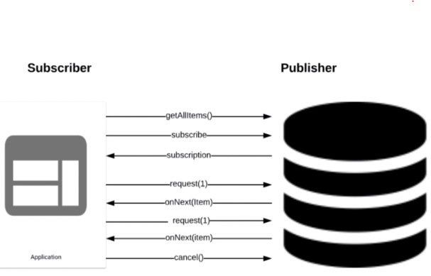

Backpressure is a technique through which the Subscriber gets control of the data flow from the Publisher. The first 3 steps in diagram above would be the same, the subscriber doesn’t need all 10 data items at once. So its making the onNext call for just N item followed by another onNext call for N items and then finally calling the cancel method.

Lets do the same using code now

@Test

public void backPressureTest() {

Flux<Integer> integerFlux = Flux.range(1, 10)

.log();

StepVerifier.create(integerFlux)

.expectSubscription()

.thenRequest(1)

.expectNext(1)

.thenRequest(1)

.expectNext(2)

.thenCancel()

.verify();

}

Here we had the Test case acting as the subscriber, lets see how we would implement this using the subscriber method

@Test

public void backPressure() {

// This wont be a test case, just showing how to use a subscriber

Flux<Integer> finiteFlux = Flux.range(1, 10)

.log();

finiteFlux.subscribe( e -> System.out.println("Element is: "+e), // Do this with the elements

ex -> System.err.println("Exception is "+ex), // When we get a exception

() -> System.out.println("Done!"), // After it is complete

subscription -> subscription.request(2) // handle to subscriber

);

}

The first parameter is a consumer that prints out the elements, the 2nd parameter is a exception consumer, the 3rd parameter allows to do something when this completes and the 4th parameter gives us a handle to subscription and we specify via that parameter that we need 2 elements at a time.

In the logs we see the following

17:13:43.955 [main] DEBUG reactor.util.Loggers$LoggerFactory - Using Slf4j logging framework

17:13:44.002 [main] INFO reactor.Flux.Range.1 - | onSubscribe([Synchronous Fuseable] FluxRange.RangeSubscription)

17:13:44.011 [main] INFO reactor.Flux.Range.1 - | request(2)

17:13:44.013 [main] INFO reactor.Flux.Range.1 - | onNext(1)

Element is: 1

17:13:44.013 [main] INFO reactor.Flux.Range.1 - | onNext(2)

Element is: 2

Done would have been printed had this completed, this did not complete but in here there is no cancel as well right. After the 2 elements are emitted by Flux it is done.

Lets check with cancel now

Flux<Integer> finiteFlux = Flux.range(1, 10)

.log();

finiteFlux.subscribe( e -> System.out.println("Element is: "+e), // Do this with the elements

ex -> System.err.println("Exception is "+ex), // When we get a exception

() -> System.out.println("Done!"), // After it is complete

subscription -> subscription.cancel // handle to subscriber

);

It prints nothing on the console when we cancel here instead of request(2) earlier.

Lets compare the logs on the previous way we wrote it ( i.e. with the request(2) ) and then with the cancel() one

17:20:36.306 [main] INFO reactor.Flux.Range.2 - | onSubscribe([Synchronous Fuseable] FluxRange.RangeSubscription)

17:20:36.316 [main] INFO reactor.Flux.Range.2 - | request(1)

17:20:36.316 [main] INFO reactor.Flux.Range.2 - | onNext(1)

17:20:36.317 [main] INFO reactor.Flux.Range.2 - | request(1)

17:20:36.318 [main] INFO reactor.Flux.Range.2 - | onNext(2)

17:20:36.320 [main] INFO reactor.Flux.Range.2 - | cancel()

17:20:36.320 [main] INFO reactor.Flux.Range.2 - | request(unbounded)

17:20:36.337 [main] INFO reactor.Flux.Range.3 - | onSubscribe([Synchronous Fuseable] FluxRange.RangeSubscription)

17:20:36.337 [main] INFO reactor.Flux.Range.3 - | cancel()

The call to cancel was immeidately done after the subscribe method as we can see in the 2nd block of log after the 1st one

Lets see how to have more control of the Data Flow now

@Test

public void customizedBackPressure() {

// This wont be a test case, just showing how to use a subscriber

Flux<Integer> finiteFlux = Flux.range(1, 10)

.log();

finiteFlux.subscribe(

new BaseSubscriber<Integer>() {

@Override

protected void hookOnNext(Integer value) {

// super.hookOnNext(value);

request(1);

System.out.println("Value received is: " + value);

if (value == 4) {

cancel();

}

};

}

);

}

So we have subscribed to the flux here and provided it a BaseSubscriber and overridden the method hookOnNext that provides us the Integer value and this is one way of taking more control on the flow of data. So here what we will do is validate the data and if the value is 4 then we cancel. So to request a value we call request(1) first and then we print the value received and then if it is 4 we call cancel.

Lets look at the logs now

17:32:21.403 [main] DEBUG reactor.util.Loggers$LoggerFactory - Using Slf4j logging framework

17:32:21.454 [main] INFO reactor.Flux.Range.1 - | onSubscribe([Synchronous Fuseable] FluxRange.RangeSubscription)

17:32:21.465 [main] INFO reactor.Flux.Range.1 - | request(unbounded)

17:32:21.467 [main] INFO reactor.Flux.Range.1 - | onNext(1)

17:32:21.467 [main] INFO reactor.Flux.Range.1 - | request(1)

Value received is: 1

17:32:21.468 [main] INFO reactor.Flux.Range.1 - | onNext(2)

17:32:21.468 [main] INFO reactor.Flux.Range.1 - | request(1)

Value received is: 2

17:32:21.469 [main] INFO reactor.Flux.Range.1 - | onNext(3)

17:32:21.469 [main] INFO reactor.Flux.Range.1 - | request(1)

Value received is: 3

17:32:21.469 [main] INFO reactor.Flux.Range.1 - | onNext(4)

17:32:21.470 [main] INFO reactor.Flux.Range.1 - | request(1)

Value received is: 4

17:32:21.472 [main] INFO reactor.Flux.Range.1 - | cancel()

It cancelled once it received the value of 4, it was just a way of illustrating how we can how more control on the flow of data.

Project Reactor Communication Model

The reactive programming paradigm is often presented in object-oriented languages as an extension of the Observer design pattern. You can also compare the main reactive streams pattern with the familiar Iterator design pattern, as there is a duality to the Iterable-Iterator pair in all of these libraries. One major difference is that, while an Iterator is pull-based, reactive streams are push-based.

Using an iterator is an imperative programming pattern, even though the method of accessing values is solely the responsibility of the Iterable. Indeed, it is up to the developer to choose when to access the next() item in the sequence. In reactive streams, the equivalent of the above pair is Publisher-Subscriber. But it is the Publisher that notifies the Subscriber of newly available values as they come, and this push aspect is the key to being reactive. Also, operations applied to pushed values are expressed declaratively rather than imperatively: The programmer expresses the logic of the computation rather than describing its exact control flow.

In addition to pushing values, the error-handling and completion aspects are also covered in a well defined manner. A Publisher can push new values to its Subscriber (by calling onNext) but can also signal an error (by calling onError) or completion (by calling onComplete). Both errors and completion terminate the sequence. This can be summed up as follows:

onNext x 0..N [onError | onComplete]

This approach is very flexible. The pattern supports use cases where there is no value, one value, or n values (including an infinite sequence of values, such as the continuing ticks of a clock).

Reactive Programming

This all works in a message-driven way. Through the use of event-loops and only a couple of Threads, Project Reactor will make only the Fluxes that have work to be done do any work. This is done through having upstream Fluxes pass data to downstream Fluxes that will react to the new events streaming in. The Subscribers have an “onNext”, “onComplete”, and “onError” method that can be used to pass new data on.

The “onNext” method will pass on a new bit of data like some user input, so the Flux can act on it. The “onComplete” method will be called when the Upstream filter has finished, like at the end of streaming the dataset of a query. Finally the “onError” method can be called in case an error condition occurs upstream.

This setup works very well, and offers a lot of scalability. Especially when dealing with a “slow producer” like for example a user’s keyboard, or a file being loaded, data can be processed fast.

That’s different when we deal with slow consumers, however. Take for example a computationally expensive mapping function, an update in a database or saving a file. In this case, so much data might be streamed into the consumer that it completely “chokes up” on all the data that flows in, and crashes with an OutOfMemoryException.

This is prevented by Project Reactor through the use of backpressure. When a Consumer subscribes itself on a Producer, it will get a Subscription. This will enable a feedback mechanism from the Consumer of the datastream to its Producer. Through it, the Consumer can signal how many data events he’s able to handle.

When the Consumer signals it can handle 5 data events, the Producer will at a maximum call the Consumer 5 times with an onNext method. After consuming these 5 events, the Consumer will ask the Producer for extra events, until an onComplete or onError call occurs instead.

[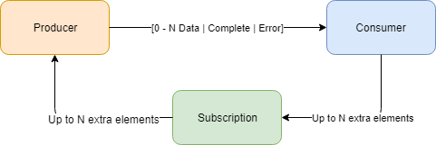](https://www.reactiveprogramming.be/wp-content/uploads/2018/11/backpressure.png)

Because of this feedback method, a Consumer will never be overloaded by messages from a Producer, but can instead work through them at his own pace. When the Consumer goes through the events it gets passed quickly, it will start asking them at a faster pace, until an equilibrium is reached.

When a Producer is a Consumer as well like in the case of most Fluxes, it will of course also have backpressure built in. This means that the concept of backpressure runs through the entire Reactive Pipeline, making the Reactive Stream slow down to the speed of the Consumer.

There are many extra ways to configure how your Reactive Streams handle backpressure from downstream Subscribers. A buffer size can be supplied, with different strategies that should be triggered in case an overflow would happen, like ERROR, DROP_LATEST, and DROP_OLDEST.

We can conclude that the concept of backpressure is essential to Project Reactor. By enabling a feedback mechanism in the messaging within the Reactive Pipeline components, it offers much extra stability and flexibility within our Reactive applications.

Cold and Hot Publisher Test

import java.time.Duration;

import org.junit.jupiter.api.Test;

import reactor.core.publisher.Flux;

public class ColdAndHotPublisherTest {

@Test

public void coldPublisherTest() {

Flux<String> stringFlux = Flux.just("A", "B", "C", "D", "E", "F")

.delayElements(Duration.ofSeconds(1))

.log();

stringFlux.subscribe( s -> System.out.println("Subscriber 1: "+s));

try {

Thread.sleep(2000);

} catch(Exception e) { }

stringFlux.subscribe( s2 -> System.out.println("Subscriber 2: "+s2));

try {

Thread.sleep(4000);

} catch(Exception e) { }

}

}

We have introduced a delay of 1 seconds and we have 2 subscribers here instead of 1. The logs are as under

08:18:04.213 [main] DEBUG reactor.util.Loggers$LoggerFactory - Using Slf4j logging framework

08:18:04.341 [main] INFO reactor.Flux.ConcatMap.1 - onSubscribe(FluxConcatMap.ConcatMapImmediate)

08:18:04.349 [main] INFO reactor.Flux.ConcatMap.1 - request(unbounded)

08:18:05.519 [parallel-1] INFO reactor.Flux.ConcatMap.1 - onNext(A)

Subscriber 1: A

08:18:06.515 [main] INFO reactor.Flux.ConcatMap.1 - onSubscribe(FluxConcatMap.ConcatMapImmediate)

08:18:06.515 [main] INFO reactor.Flux.ConcatMap.1 - request(unbounded)

08:18:06.524 [parallel-2] INFO reactor.Flux.ConcatMap.1 - onNext(B)

Subscriber 1: B

08:18:07.517 [parallel-3] INFO reactor.Flux.ConcatMap.1 - onNext(A)

Subscriber 2: A

08:18:07.526 [parallel-4] INFO reactor.Flux.ConcatMap.1 - onNext(C)

Subscriber 1: C

08:18:08.520 [parallel-5] INFO reactor.Flux.ConcatMap.1 - onNext(B)

Subscriber 2: B

08:18:08.529 [parallel-6] INFO reactor.Flux.ConcatMap.1 - onNext(D)

Subscriber 1: D

08:18:09.523 [parallel-7] INFO reactor.Flux.ConcatMap.1 - onNext(C)

Subscriber 2: C

08:18:09.532 [parallel-8] INFO reactor.Flux.ConcatMap.1 - onNext(E)

Subscriber 1: E

08:18:10.525 [parallel-1] INFO reactor.Flux.ConcatMap.1 - onNext(D)

Subscriber 2: D

08:18:10.533 [parallel-2] INFO reactor.Flux.ConcatMap.1 - onNext(F)

Subscriber 1: F

08:18:10.534 [parallel-2] INFO reactor.Flux.ConcatMap.1 - onComplete()

So everytime a new subscriber gets assigned it would emit a value from the beginning. This is called as a cold publisher, all the examples that we have seen so far are cold publishers.

Hot publisher is exactly the opposite, it would not emit the values from the beginning, lets see this now

@Test

public void hotPublisherTest() {

Flux<String> stringFlux = Flux.just("A", "B", "C", "D", "E", "F")

.delayElements(Duration.ofSeconds(1))

.log();

ConnectableFlux<String> connectableFlux = stringFlux.publish();

connectableFlux.connect();

connectableFlux.subscribe( s -> System.out.println("Subscriber 1: "+s));

try {

Thread.sleep(3000);

} catch(Exception e) { }

connectableFlux.subscribe( s2 -> System.out.println("Subscriber 2: "+s2));

try {

Thread.sleep(4000);

} catch(Exception e) { }

}

For a hot publisher we have to use something known as a ConnectableFlux and subscribe to that. Lets look at the logs now

08:28:34.131 [main] DEBUG reactor.util.Loggers$LoggerFactory - Using Slf4j logging framework

08:28:34.275 [main] INFO reactor.Flux.ConcatMap.1 - onSubscribe(FluxConcatMap.ConcatMapImmediate)

08:28:34.294 [main] INFO reactor.Flux.ConcatMap.1 - request(256)

08:28:35.441 [parallel-1] INFO reactor.Flux.ConcatMap.1 - onNext(A)

Subscriber 1: A

08:28:35.445 [parallel-1] INFO reactor.Flux.ConcatMap.1 - request(1)

08:28:36.446 [parallel-2] INFO reactor.Flux.ConcatMap.1 - onNext(B)

Subscriber 1: B

08:28:36.447 [parallel-2] INFO reactor.Flux.ConcatMap.1 - request(1)

08:28:37.448 [parallel-3] INFO reactor.Flux.ConcatMap.1 - onNext(C)

Subscriber 1: C

Subscriber 2: C

08:28:37.449 [parallel-3] INFO reactor.Flux.ConcatMap.1 - request(1)

08:28:38.452 [parallel-4] INFO reactor.Flux.ConcatMap.1 - onNext(D)

Subscriber 1: D

Subscriber 2: D

08:28:38.453 [parallel-4] INFO reactor.Flux.ConcatMap.1 - request(1)

08:28:39.455 [parallel-5] INFO reactor.Flux.ConcatMap.1 - onNext(E)

Subscriber 1: E

Subscriber 2: E

08:28:39.456 [parallel-5] INFO reactor.Flux.ConcatMap.1 - request(1)

08:28:40.459 [parallel-6] INFO reactor.Flux.ConcatMap.1 - onNext(F)

Subscriber 1: F

Subscriber 2: F

08:28:40.460 [parallel-6] INFO reactor.Flux.ConcatMap.1 - request(1)

08:28:40.462 [parallel-6] INFO reactor.Flux.ConcatMap.1 - onComplete()

Virtualizing time in JUnit

The following test case does not use a virtualized time, first look at this one

public class VirtualizingTimeInJUnit {

@Test

public void testWithoutVirtualTime() {

Flux<Long> longFlux = Flux.interval(Duration.ofSeconds(1))

.take(3)

.log();

StepVerifier.create(longFlux)

.expectSubscription()

.expectNext(0L, 1L, 2L)

.verifyComplete();

}

}

08:51:17.565 [main] DEBUG reactor.util.Loggers$LoggerFactory - Using Slf4j logging framework

08:51:17.809 [main] INFO reactor.Flux.Take.1 - onSubscribe(FluxTake.TakeSubscriber)

08:51:17.825 [main] INFO reactor.Flux.Take.1 - request(unbounded)

08:51:18.869 [parallel-1] INFO reactor.Flux.Take.1 - onNext(0)

08:51:19.832 [parallel-1] INFO reactor.Flux.Take.1 - onNext(1)

08:51:20.833 [parallel-1] INFO reactor.Flux.Take.1 - onNext(2)

08:51:20.836 [parallel-1] INFO reactor.Flux.Take.1 - onComplete()

So we emitted a event at a interval duration of every 1 seconds and then took just 3 of them. So this test case took about 3 seconds to execute and now imagine there might be a 100 test cases and if they all take their own time, the test bundle would take a huge time to execute.

We can virtualize the clock, there is a option available in the Project Reactor time library.

We called the VirtualTimeScheduler.getOrSet() and then called a method that takes in a supplier ( supplier takes nothing and supplies something as we know ) StepVerifier.withVirtualTime( () -> longFlux )

@Test

public void testWithtVirtualTime() {

VirtualTimeScheduler.getOrSet();

Flux<Long> longFlux = Flux.interval(Duration.ofSeconds(1))

.take(3)

.log();

StepVerifier.withVirtualTime( () -> longFlux );

StepVerifier.create(longFlux)

.expectSubscription()

.thenAwait(Duration.ofSeconds(3))

.expectNext(0l, 1l, 2l)

.verifyComplete();

}

And here is the log, this one uses virtual time using the time libraries from Project Reactor and so we see that this one does not wait for so long

This stayed stuck when I provided the expectNext with 0L, 1L and worked with 0l, 1l … So this finishes instantly doesn’t wait for the 3 seconds duration. It is using the virtual time here. We can reduce the build time like this to fasten the test case execution.

/*

* This will take just a second to complete & execute even if we have a 1 sec delay for each element

* This blocks if we give a thenAwait of less than 6 seconds, got stuck when i gave 1 second

*/

@Test

public void combineUsingConcatWithDelay() {

VirtualTimeScheduler.getOrSet();

Flux<String> flux1 = Flux.just("A", "B", "C").delayElements(Duration.ofSeconds(1));

Flux<String> flux2 = Flux.just("D", "E", "F").delayElements(Duration.ofSeconds(1));

Flux<String> mergedFlux = Flux.concat(flux1, flux2).log();

StepVerifier.withVirtualTime(() -> mergedFlux.log())

.expectSubscription()

.thenAwait(Duration.ofSeconds(6))

.expectNextCount(6)

.verifyComplete();

}

Best place for documentation is the reference guide here -> <https://projectreactor.io/docs/core/release/reference/>

Best place to discuss on project reactor -> <https://gitter.im/reactor/reactor>

Also see Which operator do I need: <https://projectreactor.io/docs/core/release/reference/#which-operator>

## Spring Boot 2 – Quick Introduction

<https://spring.io/>

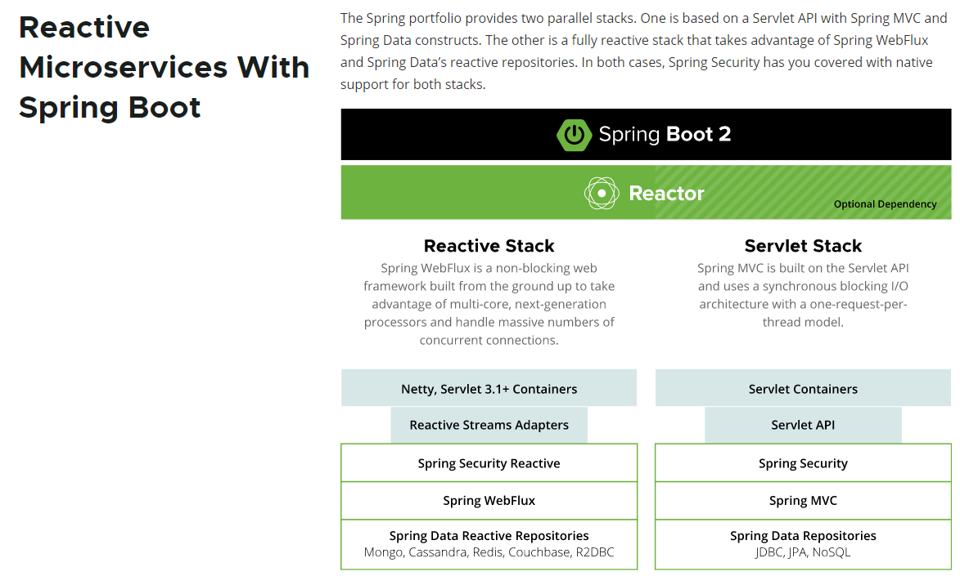

One is a Reactive stack and another one is a Servlet Stack which refers to the spring the flux and the Soviet stock refers to the spring MVC. Let's talk about the Reactive Stack.

First spring web flux is non blocking which refers to the non blocking way of communicating over the network. To facilitate this communication, we need a non blocking server such as Nettie or Servlet 3.1 or above containers. In Reactor stack there is no place for server. So that's a complete shift because we are going to have non blocking interactions over the network. So we are going to have a Reactive Stream Adapters. Even the security layer has to be non blocking, so we have a brand new security model specifically for this purpose and then we have the Spring WebFlux which has the annotated controllers and functional web endpoints to handle the HTTP requests in order to work with the databases in a non blocking way.

We have reactive models for Cassandra, Redis, MongoDB etc. We do not see any RDBMSs in this, we might be wondering why, Non-blocking approach is still in early stages of development and there is a significant amount of work in progress to develop libraries for relational databases. See <https://github.com/r2dbc> ( Reactive Relational Database Connectivity )

The other side here is the Servlet stack which is the Servlet MVC and this is the thread based connection model that uses Servlet behind the scenes.

Reactor is at the top of both Reactive and Servlet stack because it can be used for both the cases.

Web on Reactive Stack - <https://docs.spring.io/spring/docs/current/spring-framework-reference/web-reactive.html>

Building the Simple Non Blocking APIs

package com.spring.reactive;

import org.springframework.http.MediaType;

import org.springframework.web.bind.annotation.GetMapping;

import org.springframework.web.bind.annotation.RestController;

import reactor.core.publisher.Flux;

import java.time.Duration;

@RestController

public class FluxAndMonoController {

@GetMapping("/flux")

public Flux<Integer> returnFlux(){

return Flux.just( 1, 2, 3, 4 )

.delayElements( Duration.ofSeconds(1) )

.log();

}

@GetMapping(value = "/fluxstream", produces = **MediaType.APPLICATION_STREAM_JSON_VALUE**)

public Flux<Integer> returnFluxStream(){

return Flux.just( 1, 2, 3, 4, 5, 6, 7, 8, 9, 10, 11, 12, 13, 14, 15 )

.delayElements( Duration.ofSeconds(1) )

.log();

}

}

When we call this via the UI using the context here called /fluxstream

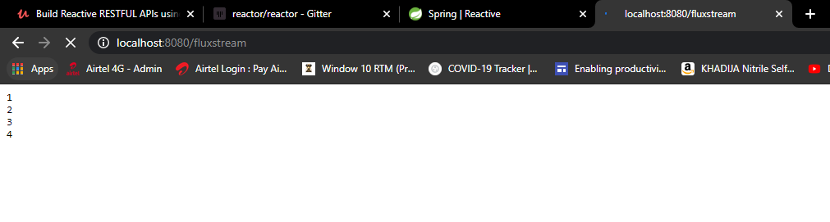

This will continously emit after every second to the browser and on the server the logs would show the emit being done too as below. It keeps emitting till all the elements are done i.e. upto 15

2020-07-17 13:09:31.412 INFO 9164 --- [ctor-http-nio-2] reactor.Flux.ConcatMap.2: onSubscribe(FluxConcatMap.ConcatMapImmediate)

2020-07-17 13:09:31.412 INFO 9164 --- [ctor-http-nio-2] reactor.Flux.ConcatMap.2: request(1)

2020-07-17 13:09:32.413 INFO 9164 --- [ parallel-8] reactor.Flux.ConcatMap.2: onNext(1)

2020-07-17 13:09:33.415 INFO 9164 --- [ parallel-1] reactor.Flux.ConcatMap.2: onNext(2)

2020-07-17 13:09:34.419 INFO 9164 --- [ parallel-2] reactor.Flux.ConcatMap.2: onNext(3)

2020-07-17 13:09:35.422 INFO 9164 --- [ parallel-3] reactor.Flux.ConcatMap.2: onNext(4)

2020-07-17 13:09:36.425 INFO 9164 --- [ parallel-4] reactor.Flux.ConcatMap.2: onNext(5)

2020-07-17 13:09:37.428 INFO 9164 --- [ parallel-5] reactor.Flux.ConcatMap.2: onNext(6)

When the browser hit this endpoint the browser is like a subscriber asking for data and it starts emitting to the browser

The difference between the /flux and the /fluxstream is that we are using the Media type as JSON in there

The output on the browser for the first method call was

[1,2,3,4]

The output on the browser for the first method call was a continous stream emitting numbers 1 by 1 after 1 second

1

2

3

. . .

15

The request took like 4 seconds to display for the /flux endpoint and the difference there was we did not mention the media type returned there. By default it is going to return a JSON, so here the browser thinks I am just going to get a JSON, so it just waits for all data and then displays it. The Browser is a blocking client, it doesn’t care about a Flux or anything like that. Here it just returns a JSON after it has all the elements.

In the 2nd example we used a MediaType.APPLICATION_STREAM_JSON_VALUE so we told it to return a stream of JSON. This one is **APPLICATION_STREAM_JSON_VALUE “application/stream+json”** if we open the MediaType class. Hence we get a stream of values one by one till the data completes.

Writing a JUnit test case for the above class

package com.spring.reactive.rest;

import org.junit.jupiter.api.Test;

import org.junit.runner.RunWith;

import org.springframework.beans.factory.annotation.Autowired;

import org.springframework.boot.test.autoconfigure.web.reactive.WebFluxTest;

import org.springframework.http.MediaType;

import org.springframework.test.context.junit4.SpringRunner;

import org.springframework.test.web.reactive.server.WebTestClient;

import reactor.core.publisher.Flux;

import reactor.test.StepVerifier;

@RunWith(SpringRunner.class)

@WebFluxTest // 🡨 will not scan classes for @Component, @Service etc

public class FluxAndMonoControllerTest {

@Autowired

WebTestClient webTestClient;

@Test

public void flux_approach1(){

// Create a Flux using the webTestClient that is autowired

Flux<Integer> streamFlux = webTestClient.get().uri("/flux")

.accept( MediaType.APPLICATION_JSON )

.exchange() // invokes the endpoint

.expectStatus().isOk() // expect status as OK

.returnResult( Integer.class ) // expect return as Intg

.getResponseBody(); // response body as Flux

// Use StepVerifier and subscribe to the created Flux

StepVerifier.create(streamFlux)

.expectSubscription()

.expectNext(1)

.expectNext(2)

.expectNext(3)

.expectNext(4)

.verifyComplete();

}

}

The first step is to use the @RunWith(SpringRunner.class) annotation. The @WebFluxTest annotation got introduced in Spring 5 and what it does is scan for all the classes that are annotated with @RestController, @Controller and more but this is not going to scan classes annotated with @Service, @Component. Lets say if this test case was connecting to the database then this wouldn’t work. We will see how to do that later. Spring introduce the @WebTestClient which is a non blocking client to test the REST Endpoints. We can relate this to TestRestTemplate in Spring MVC, but this is a non blocking client for us. We have autowired this here, the @WebFlux annotation that we added is responsible for creating the client for this.

Note that we are returning the responseBody here and specifying the returnResult as Integer.class just before that in the webTestClient call. This would then return a Flux<Integer>. StepVerifier.create will the create the Flux defined and subscribe to it and check the expected results and finally verifyComplete

Now use the @Test usual approach to write the test case.

.exchange() – this is the one that invokes the endpoint

.expectStatus().isOK() – expect status as OK

.returnResult( Integer.class ) – expect a Integer to be returned

.getResponseBody – get the response now

Logs as below

2020-07-17 13:45:45.796 INFO 5476 --- [ main] c.s.r.rest.FluxAndMonoControllerTest :

Starting FluxAndMonoControllerTest on DESKTOP-PEI24P3 with PID 5476 (started by Dimpu in D:\2Study\NewWorkspaceExamples\SpringReactive\learn-reactivespring)

2020-07-17 13:45:45.799 INFO 5476 --- [ main] c.s.r.rest.FluxAndMonoControllerTest :

No active profile set, falling back to default profiles: default

2020-07-17 13:45:46.948 INFO 5476 --- [ main] c.s.r.rest.FluxAndMonoControllerTest :

Started FluxAndMonoControllerTest in 1.571 seconds (JVM running for 3.048)

2020-07-17 13:45:47.393 INFO 5476 --- [ parallel-1] reactor.Flux.ConcatMap.1 : onSubscribe(FluxConcatMap.ConcatMapImmediate)

2020-07-17 13:45:47.396 INFO 5476 --- [ parallel-1] reactor.Flux.ConcatMap.1 : request(unbounded)

2020-07-17 13:45:48.402 INFO 5476 --- [ parallel-2] reactor.Flux.ConcatMap.1 : onNext(1)

2020-07-17 13:45:49.404 INFO 5476 --- [ parallel-3] reactor.Flux.ConcatMap.1 : onNext(2)

2020-07-17 13:45:50.406 INFO 5476 --- [ parallel-4] reactor.Flux.ConcatMap.1 : onNext(3)

2020-07-17 13:45:51.408 INFO 5476 --- [ parallel-5] reactor.Flux.ConcatMap.1 : onNext(4)

2020-07-17 13:45:51.409 INFO 5476 --- [ parallel-5] reactor.Flux.ConcatMap.1 : onComplete()

**Another approach to test is as below**

@Test

public void flux_approach2(){

webTestClient.get().uri( "/flux" )

**.accept( MediaType.APPLICATION_JSON )**

**.exchange()**

**.expectStatus().isOk()**

**.expectHeader().contentType( MediaType.APPLICATION_JSON )**

**.expectBodyList( Integer.class )**

**.hasSize(4);**

}

In the previous approach we had used the StepVerifier to validate, here we used another approach, if we change the hasSize to 5 instead of 4, this test case would fail.

**Another approach – collecting the result**

@Test

public void flux_approach3(){

List<Integer> expectedIntegerList = Arrays.asList( 1,2,3,4 );

**EntityExchangeResult**<List<Integer>> entityExchangeResult = webTestClient.get().uri( "/flux" )

.accept( MediaType.APPLICATION_JSON )

.exchange()

.expectStatus().isOk()

.expectHeader().contentType( MediaType.APPLICATION_JSON )

.expectBodyList( Integer.class )

.returnResult();

assertEquals( expectedIntegerList, entityExchangeResult.getResponseBody() );

}

Earlier approach we were returning the responseBody and getting a Flux out of that, and here we are returning the result with returnResult – so this returns EntityExchangeResult< List<Integer> >

**Another approach of using consumeWith is as below**

@Test

public void flux_approach4(){

List<Integer> expectedIntegerList = Arrays.asList(1,2,3,4);

EntityExchangeResult<List<Integer>> entityExchangeResult =

webTestClient.get().uri( "/flux" )

.accept( MediaType.APPLICATION_JSON )

.exchange()

.expectStatus().isOk()

.expectHeader().contentType( MediaType.APPLICATION_JSON )

**.expectBodyList( Integer.class )**

**.consumeWith(**

response -> assertEquals( expectedIntegerList,

response.getResponseBody() )

);

}

Maven Dependencies

Our pom.xml is as below

<?xml version="1.0" encoding="UTF-8"?>

<project

xmlns="http://maven.apache.org/POM/4.0.0" xmlns:xsi="http://www.w3.org/2001/XMLSchema-instance"

xsi:schemaLocation="http://maven.apache.org/POM/4.0.0 https://maven.apache.org/xsd/maven-4.0.0.xsd">

<modelVersion>4.0.0</modelVersion>

<parent>

<groupId>org.springframework.boot</groupId>

<artifactId>spring-boot-starter-parent</artifactId>

<version>2.3.1.RELEASE</version>

<relativePath/> <!-- lookup parent from repository -->

</parent>

<groupId>com.spring</groupId>

<artifactId>reactive</artifactId>

<version>0.0.1-SNAPSHOT</version>

<name>learn-reactivespring</name>

<description>Demo project for Spring Reactive</description>

<properties>

<java.version>1.13</java.version>

</properties>

<dependencies>

<dependency>

<groupId>org.springframework.boot</groupId>

<artifactId>spring-boot-starter-data-mongodb-reactive</artifactId>

</dependency>

<dependency>

<groupId>org.springframework.boot</groupId>

<artifactId>spring-boot-starter-webflux</artifactId>

</dependency>

<dependency>

<groupId>org.projectlombok</groupId>

<artifactId>lombok</artifactId>

<optional>true</optional>

</dependency>

<dependency>

<groupId>org.springframework.boot</groupId>

<artifactId>spring-boot-starter-test</artifactId>

<scope>test</scope>

<!-- <exclusions>

<exclusion>

<groupId>org.junit.vintage</groupId>

<artifactId>junit-vintage-engine</artifactId>

</exclusion>

</exclusions> -->

</dependency>

<dependency>

<groupId>de.flapdoodle.embed</groupId>

<artifactId>de.flapdoodle.embed.mongo</artifactId>

<scope>test</scope>

</dependency>

<dependency>

<groupId>io.projectreactor</groupId>

<artifactId>reactor-test</artifactId>

<scope>test</scope>

</dependency>

<!-- <dependency>

<groupId>junit</groupId>

<artifactId>junit</artifactId>

<scope>test</scope>

</dependency> -->

</dependencies>

<build>

<plugins>

<plugin>

<groupId>org.springframework.boot</groupId>

<artifactId>spring-boot-maven-plugin</artifactId>

</plugin>

</plugins>

</build>

</project>

Infinite Non Blocking Sequence API using WebTestClient

@GetMapping(value = "/fluxstreamtwo", produces = MediaType.APPLICATION_STREAM_JSON_VALUE)

public Flux<Long> returnFluxStreamTwo(){

return Flux.interval( Duration.ofSeconds(1) )

.log();

}

This will continue emitting the events indefinitely.

If you send in another browser request ( another client ), it will start all over again for that client. If we connect three clients its going to start new for each client and if you close the browser after some time it would call the cancel() method and stop then.

The above were examples of a cold publisher in reactive programming – it’s a infinite stream, it won’t stop at all. When we kill the application on the server side it would send the cancel events to the browser for a graceful stop communicating that no more events would be sent to them. The client comes to know that it is not going to get any more events.

We are going to get a lot of events for a infinite stream so we need not write a lot of expectNexts, so we create a few here and then called thenCancel() & then called verify(). If we got 3 events very likely we will get all of them, so test only for a few.

@Test

public void fluxStream() {

Flux<Long> longStreamFlux = webTestClient.get().uri("/fluxstreamtwo")

.accept( MediaType.APPLICATION_JSON )

.exchange() // invokes the endpoint

.expectStatus().isOk() // expecting status OK

.returnResult(Long.class) // expecting return as Long

.getResponseBody(); // get response body – we get Flux here

StepVerifier.create(longStreamFlux)

.expectNext(0l)

.expectNext(1l)

.expectNext(2l)

.thenCancel()

.verify();

}

The test case fails on running it with following error

java.lang.AssertionError: Status expected:<200 OK> but was:<406 NOT_ACCEPTABLE>

> GET /fluxstreamtwo

> WebTestClient-Request-Id: [1]

> Accept: [application/json]

No content

< 406 NOT_ACCEPTABLE Not Acceptable

< Content-Type: [application/json]

< Content-Length: [143]

{"timestamp":"2020-07-17T11:48:54.535+00:00","path":"/fluxstreamtwo","status":406,"error":"Not Acceptable","message":"","requestId":"58463322"}

The error indicates that we didn’t get the type we wanted – we are accepting APPLICATION_JSON instead of APPLICATION_STREAM_JSON, when this is changed the test case runs successfully.

Build a Simple Non Blocking Mono

@GetMapping("/mono")

public Mono<Integer> returnMono(){

return Mono.just( 1 )

.log();

}

delayElement doesn’t make sense here since Mono is going to return only a single element.

Requesting on <http://localhost:8080/mono> will return a value of 1 on the browser

Lets say we are requesting for a single resource and in a non blocking way, in that case we would need a Mono. Writing a test case for this now as below

@Test

public void monoTest() {

webTestClient.get().uri("/mono")

.accept( MediaType.APPLICATION_JSON )

.exchange()

.expectStatus()

.isOk()

.expectBody( Integer.class )

.consumeWith( response ->

assertEquals( Integer.valueOf(1), response.getResponseBody() ));

}

## Spring WebFlux – Functional Web

The idea behind this module is to use functions to route the request and response – the functional part consists of two parts – **RouterFunction** and **HandlerFunction**

Lets take a look at how the router and handler functions would be handled

|  |  |
| --- | --- |
|  | The request will be forwarded to the router function first and if it has an appropriate mapping then the request will be forwarded to the handler function. The handler function is the one which is going to do the complete processing of reading the request, processing the request and sending the response back to the server.  In a nutshell the router function takes care of routing the request on the handler function is a one which is going to handle the request. |

Let's talk about the router function first as I mentioned in the previous slide that older function is going to route the incoming request.

|  |  |
| --- | --- |
| **Router Function**   * Used to route the incoming request * Similar to the @RequestMapping annotation |  |

|  |  |
| --- | --- |
| **Handler Function**   * Handles the request and the response * Similar to the body of @RequestMapping annotation |  |

The original web framework included in the Spring Framework, Spring Web MVC, was purpose-built for the Servlet API and Servlet containers.

The reactive-stack web framework, Spring WebFlux, was added later in version 5.0. It is fully non-blocking, supports Reactive Streams back pressure, and runs on such servers as Netty, Undertow, and Servlet 3.1+ containers. Both web frameworks mirror the names of their source modules ( spring-webmvc and spring-webflux ) and co-exist side by side in the Spring Framework. Each module is optional.

Applications can use one or the other module or, in some cases, both — for example, Spring MVC controllers with the reactive WebClient.

Spring WebFlux framework is part of Spring 5 and provides reactive programming support for web applications. Spring WebFlux internally uses Project Reactor and its publisher implementations – Flux and Mono.

The new framework supports two programming models:

* Annotation-based reactive components
* Functional routing and handling

Here, we're going to be focusing on the Annotation-based reactive components, as we already explored the functional style – routing and handling.

Let's start with the spring-boot-starter-webflux dependency, which actually pulls in all other required dependencies:

* spring-boot and spring-boot-starter for basic Spring Boot application setup
* spring-webflux framework
* reactor-core that we need for reactive streams and also reactor-netty

<dependency>

<groupId>org.springframework.boot</groupId>

<artifactId>spring-boot-starter-webflux</artifactId>

<version>2.2.2.RELEASE</version>

</dependency>

**Why was Spring WebFlux created?**

Part of the answer is the need for a non-blocking web stack to handle concurrency with a small number of threads and scale with fewer hardware resources. Servlet 3.1 did provide an API for non-blocking I/O. However, using it leads away from the rest of the Servlet API, where contracts are synchronous ( Filter, Servlet ) or blocking ( getParameter, getPart ). This was the motivation for a new common API to serve as a foundation across any non-blocking runtime.

That is important because of servers ( such as Netty ) that are well-established in the async, non-blocking space.

The other part of the answer is functional programming. Much as the addition of annotations in Java 5 created opportunities (such as annotated REST controllers or unit tests), the addition of lambda expressions in Java 8 created opportunities for functional APIs in Java. This is a boon for non-blocking applications and continuation-style APIs ( as popularized by CompletableFuture and ReactiveX ) that allow declarative composition of asynchronous logic. At the programming-model level, Java 8 enabled Spring WebFlux to offer functional web endpoints alongside annotated controllers.

**The Handler Function**

The Handler Function has two classes – ServerRequest and ServerResponse which represent the HttpRequest and HttpResponse.

Code Example

import org.springframework.http.MediaType;

import org.springframework.web.reactive.function.server.ServerRequest;

import org.springframework.web.reactive.function.server.ServerResponse;

import reactor.core.publisher.Flux;

import reactor.core.publisher.Mono;

@Component

public class SampleHandlerFunction {

public Mono<ServerResponse> flux(ServerRequest servletRequest) {

return ServerResponse.ok()

.contentType( MediaType.APPLICATION_JSON )

.body(

Flux.just( 1, 2, 3, 4 )

.log(), Integer.class

);

}

}

The response is to be returned as the part of the body.

Annotate this class with @RouterConfiguration, this will behave like a configuration file and it’s a class responsible to map the incoming request to appropriate handler. We will create a bean, that returns a RouterFunction. RouterFunction is a class that is going to return the Server Response and this route method is going to take in a input as a handler function.

import org.springframework.context.annotation.Bean;

import org.springframework.context.annotation.Configuration;

import org.springframework.http.MediaType;

import org.springframework.web.reactive.function.server.RouterFunction;

import org.springframework.web.reactive.function.server.RouterFunctions;

import org.springframework.web.reactive.function.server.ServerResponse;

import com.spring.reactive.example.handler.SampleHandlerFunction;

import static org.springframework.web.reactive.function.server.RequestPredicates.GET;

import static org.springframework.web.reactive.function.server.RequestPredicates.accept;

@Configuration

public class RouterFunctionConfig {

@Bean

public RouterFunction< ServerResponse > route(SampleHandlerFunction handlerFunction) {

return RouterFunctions.route(

GET("/functional/flux").and(accept( MediaType.APPLICATION_JSON )),

handlerFunction::flux );

}

}

Run the app and on requesting <http://localhost:8080/functional/flux> we get the response as below

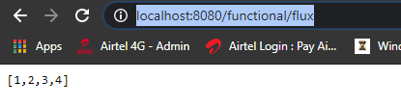

The request that we did from the browser to /functional/flux was picked up by the handler mapping specified in the configuration that returned the handlerFunction::flux method mapped to it as RouterFunctions and this made it invoke the flux method that returned Flux.just(1, 2, 3, 4) as a part of the body

Lets take a Mono Example now

import org.springframework.context.annotation.Bean;

import org.springframework.context.annotation.Configuration;

import org.springframework.http.MediaType;

import org.springframework.web.reactive.function.server.RouterFunction;

import org.springframework.web.reactive.function.server.RouterFunctions;

import org.springframework.web.reactive.function.server.ServerResponse;

import com.spring.reactive.example.handler.SampleHandlerFunction;

import static org.springframework.web.reactive.function.server.RequestPredicates.GET;

import static org.springframework.web.reactive.function.server.RequestPredicates.accept;

@Configuration

public class RouterFunctionConfig {

@Bean

public RouterFunction<ServerResponse> route(**SampleHandlerFunction** handlerFunction) {

return RouterFunctions

.route( GET("/functional/flux").and(accept( MediaType.APPLICATION_JSON )),

handlerFunction::flux )

.andRoute( GET("/functional/mono").and(accept( MediaType.APPLICATION_JSON )),

handlerFunction::mono );

}

}

And lets provide the method as well for this

import org.springframework.http.MediaType;

import org.springframework.stereotype.Component;

import org.springframework.web.reactive.function.server.ServerRequest;

import org.springframework.web.reactive.function.server.ServerResponse;

import reactor.core.publisher.Flux;

import reactor.core.publisher.Mono;

@Component

public class **SampleHandlerFunction** {

public Flux<ServerResponse> flux(ServerRequest servletRequest) {

return ServerResponse.ok()

.contentType( MediaType.APPLICATION_JSON )

.body( Flux.just( 1, 2, 3, 4 ).log(), Integer.class );

}

public Mono<ServerResponse> mono(ServerRequest servletRequest) {

return ServerResponse.ok()

.contentType( MediaType.APPLICATION_JSON )

.body( Mono.just( 1 ).log(), Integer.class );

}

}

This will return a single element when the call is done to it for the mono. We have built a simple endpoint using the functional approach.

We have to build the test cases for these now

import org.junit.Test;

import org.junit.runner.RunWith;

import org.springframework.beans.factory.annotation.Autowired;

import org.springframework.boot.test.autoconfigure.web.reactive.AutoConfigureWebTestClient;

import org.springframework.boot.test.autoconfigure.web.reactive.WebFluxTest;

import org.springframework.boot.test.context.SpringBootTest;

import org.springframework.http.MediaType;

import org.springframework.test.annotation.DirtiesContext;

import org.springframework.test.context.junit4.SpringRunner;

import org.springframework.test.web.reactive.server.WebTestClient;

import reactor.core.publisher.Flux;

import reactor.test.StepVerifier;

import static org.junit.Assert.assertEquals;

@RunWith(SpringRunner.class)

public class SampleHandlerFunctionTest {

@Autowired

WebTestClient webTestClient;

@Test

public void flux_approach1(){

Flux<Integer> intergerFlux = webTestClient.get().uri( "/functional/flux" )

.accept( MediaType.APPLICATION_JSON_UTF8 )

.exchange()

.expectStatus().isOk()

.returnResult( Integer.class )

.getResponseBody();

StepVerifier.create( integerFlux )

.expectSubscription()

.expectNext(1)

.expectNext(2)

.expectNext(3)

.expectNext(4)

.verifyComplete();

}

}

This test case will fail – it will not scan and load the endpoint, we know that the above doesn’t detect the @Component, @Repository classes and our REST endpoint has the annotation of @Component so to detect that we would provide it with the annotation @SpringBootTest.

On providing this we run into another error that no qualifying bean of WebTestClient found. That client is created by the @WebFluxTest so to overcome this provide it with the annotation @AutoConfigureWebTestClient and it will configure the client for you then. Works after we add the two annotations.

@RunWith( SpringRunner.class )

@SpringBootTest

@AutoConfigureWebTestClient

public class SampleHandlerFunctionTest {

@Autowired

WebTestClient webTestClient;

@Test

public void flux_approach1(){

*.. code as above ...*

}

}

For the mono we would write the test case as below

@RunWith(SpringRunner.class)

@SpringBootTest

@AutoConfigureWebTestClient

public class SampleHandlerFunctionTest {

@Test

public void mono(){

Integer expectedValue = new Integer(1);

webTestClient.get().uri("/functional/mono")

.accept( MediaType.APPLICATION_JSON )

.exchange()

.expectStatus().isOk()

.expectBody( Integer.class )

.consumeWith(

(response) -> { assertEquals(expectedValue, response.getResponseBody());

});

}

}

**PS:** In case of web flux we use the @WebFluxTest but in case of the functional web we use couple of other annotations like

@RunWith(SpringRunner.class)

@SpringBootTest

@AutoConfigureWebTestClient

## Spring WebFlux – Behind the Scenes

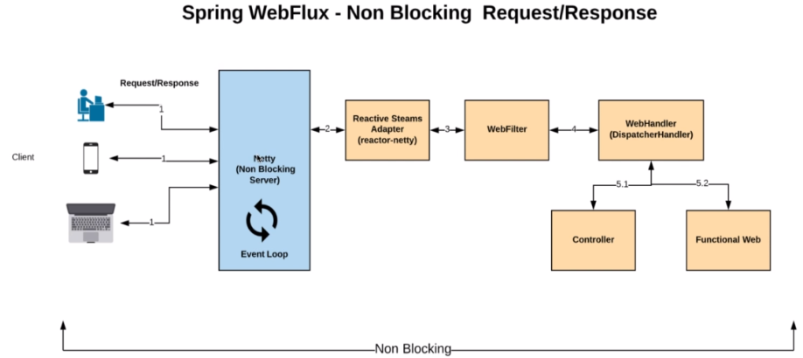

The request is first received by the server. I have a Netty here which is the default server for handling the request and response in spring web flux. Netty is a non blocking server and it is widely used by companies like Netflix, Facebook Twitter and etc. Netty handles the request by using event loop. We'll talk about the event loop threads and it is execution model later. After the request is received by the server Netty event loop takes that request and it goes through a layer called reactive streams adapter. The purpose of this layer is to understand the Flux and Mono types that are send by the client and server. The reactive streams adapter for Netty is Reactor Netty.

Reactor Netty comes as a default with the flux and Spring Boot. If you are using some other server then you need to add the appropriate reactor streams adapter in our build file. You can find those in the spring webflux documentation page

The next one in request processing flow is a WebFilter which applies any kind of filtering operations in a non blocking fashion.

The next one is the WebHandler which is nothing but the dispatcher handler which is responsible for calling the appropriate rest end points, it checks at classes that are annotated with the @RestController annotation and the functional end points.

And if it finds an appropriate mapping then the appropriate request will be forwarded to that end point and the response will be sent as a reactive stream to the client.

Each and every layer in spring WebFlux is non blocking meaning its flux or Mono end to end to support react streams.

Now we know the layers behind spring of flux that takes care of handling the request and response in a non blocking fashion. Now let's take a look at a simple endpoint that recorded in the previous tutorial and understand how it works.

@GetMapping( “/flux” )

public Flux<Integer> returnFlux(){

return Flux.just( 1,2,3,4 )

.delayElements( Duration.ofSeconds( 1 ) )

.log();

}

This is going to take 4 seconds when requesting from the Browser as the Browser is a blocking client.

It shows us that Netty is started on port 8080

2020-07-18 11:58:13.431 INFO 13120 --- [ main] org.mongodb.driver.cluster : Cluster created with settings {hosts=[localhost:27017], mode=SINGLE, requiredClusterType=UNKNOWN, serverSelectionTimeout='30000 ms'}

2020-07-18 11:58:13.679 INFO 13120 --- [ main] o.s.b.web.embedded.netty.NettyWebServer : Netty started on port(s): 8080

2020-07-18 11:58:13.691 INFO 13120 --- [ main] c.s.r.f.FluxAndMonoApplication : Started FluxAndMonoApplication in 1.827 seconds (JVM running for 2.189)

2020-07-18 11:58:17.538 INFO 13120 --- [localhost:27017] org.mongodb.driver.cluster : Exception in monitor thread while connecting to server localhost:27017

When we request for <http://localhost:8080/flux> it returns the following

2020-07-18 11:59:07.303 INFO 13120 --…2] reactor.Flux.ConcatMap.1 : onSubscribe(FluxConcatMap.ConcatMapImmediate)

2020-07-18 11:59:07.304 INFO 13120 --- [ctor-http-nio-2] reactor.Flux.ConcatMap.1 : request(unbounded)

2020-07-18 11:59:08.307 INFO 13120 --- [ parallel-1] reactor.Flux.ConcatMap.1 : onNext(1)

2020-07-18 11:59:09.308 INFO 13120 --- [ parallel-2] reactor.Flux.ConcatMap.1 : onNext(2)

2020-07-18 11:59:10.309 INFO 13120 --- [ parallel-3] reactor.Flux.ConcatMap.1 : onNext(3)

2020-07-18 11:59:11.312 INFO 13120 --- [ parallel-4] reactor.Flux.ConcatMap.1 : onNext(4)

2020-07-18 11:59:11.312 INFO 13120 --- [ parallel-4] reactor.Flux.ConcatMap.1 : onComplete()

Note the order of the events raised – first it raises onSubscriber then request unbounded – why unbounded because it needs all the elements together from the browser. OnComplete is a signal to the browser that data has been sent.

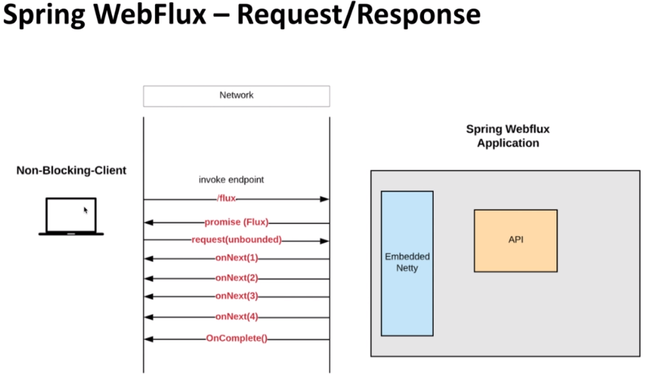

We have used the browser as a client which is a blocking client and that's why it had to wait for for 4 seconds and then display the result. Right. If you are consuming data from a non blocking application then you have to have a non blocking client. We have used the WebTestClient in our test cases which is a non blocking client, if you are thinking about something like a RestTemplate then we have to have a class called WebClient which is a non blocking client.

We will see examples on how to connect to a non blocking API in the future part of the course in the left corner. Let's assume we have a non blocking client which is the WebClient and in the right corner we have the actual spring the flux application and in the middle we have the network.

The first thing the call comes from the client which includes the end point /flux and what we get as a response, the response is nothing but the promise. So once that connection is established we get a promise which is nothing but the flux and after we get the promise a call goes from the client which is a request unbounded, what does it mean, It means give me all the data that we have in that flux and after that that particular endpoint which is giving you a flux as a response it is going to emit all the values using the onNext method.

The onNext method is going to have the elements emitted one by one until all the elements are emitted, once all the elements are emitted, it is going to send an event called onComplete which is a signal to the client “Hey I'm done with the data”. Go ahead and close this connection. This is what happens behind the scenes of each request that comes through the server and keeping your mind all these events after the endpoint is invoked is taken care by the framework itself.

Netty and Internals of Netty

Netty is an asynchronous event-driven network application framework for rapid development of maintainable high performance protocol servers & clients.

Netty is a NIO client server framework which enables quick and easy development of network applications such as protocol servers and clients. It greatly simplifies and streamlines network programming such as TCP and UDP socket server.

'Quick and easy' doesn't mean that a resulting application will suffer from a maintainability or a performance issue. Netty has been designed carefully with the experiences earned from the implementation of a lot of protocols such as FTP, SMTP, HTTP, and various binary and text-based legacy protocols. As a result, Netty has succeeded to find a way to achieve ease of development, performance, stability, and flexibility without a compromise.

Netty is built on top of Java – used by Facebook, Google, Instagram, Twitter, Apache Cassandra etc. Protocols supported are FTP, HTTP, SMTP, WebSocket etc.

Netty is asynchronous and event driven

Non Blocking Client Blocking Client

Returning a Future Returning a Response

( something guaranteed to execute later )

|  |  |
| --- | --- |
|  |  |

The benefit of being asynchronous is that we would have Non Blocking calls that would allow us to handle a large number of Connections then.

Events in Netty

* Client requesting for a new Connection is treated as a event
* Client requesting for data is also treated as a event
* Client posting data is also treated as a event
* Errors are also treated as a event

Netty Channel and Events

Channel represents a connection between the Client and the Server

|  |  |
| --- | --- |
|  | When a channel is created and it's active, that's when the client and the server can interact. The event that goes from the client to the server are called inbound events and the events that go from the server to the client are called as Outbound events. |

Inbound Events ( Inbound to the Server )

* Requesting for Data
* Posting Data etc

OutBound Events ( Outbound to the Server )

* Opening or Closing a Connection
* Sending response to the Client

|  |  |
| --- | --- |
| What deals with the Events?  Event Loop   * Loop that looks for the events. * Event Loop is registered with a single dedicated Thread. |  |

It has a dedicated event queue and Event loop. Event Queue will have all the items fall into it, based on the type of the event if its inbound or outbount, they will be taken care. Appropriate action will be taken, the event loop will take care of executing the events one by one. If you take a look at this example even one is taken care and event 2 will come to the top of the queue and followed by that event three will come to the top of the queue and followed by that the event four and the process continues

Because computers with multiple cores or CPUs are commonplace, most modern applications employ sophisticated multithreading techniques to make efficient use of system resources. By contrast, our approach to multithreading in the early days of Java wasn’t much more than creating and starting new Threads on demand to execute concurrent units of work, a primitive approach that works poorly under heavy load. Java 5 then introduced the Executor API, whose thread pools greatly improved performance through Thread caching and reuse.

The basic thread pooling pattern can be described as:

* A Thread is selected from the pool’s free list and assigned to run a submitted task (an implementation of Runnable).
* When the task is complete, the Thread is returned to the list and becomes available for reuse.

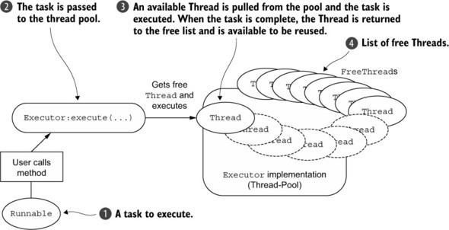

Pooling and reusing threads is an improvement over creating and destroying a thread with each task, but it doesn’t eliminate the cost of context switching, which quickly becomes apparent as the number of threads increases and can be severe under heavy load. In addition, other thread-related problems can arise during the lifetime of a project simply because of the overall complexity or concurrency requirements of an application. In short, multithreading can be complex.

**Interface EventLoop**

Running tasks to handle events that occur during the lifetime of a connection, a basic function of any networking framework. The corresponding programming construct is often referred to as an event loop, a term Netty adopts with interface io.netty.channel.EventLoop. The basic idea of an event loop is illustrated in the following listing, where each task is an instance of Runnable

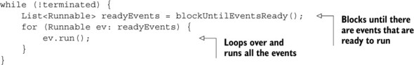

Netty’s EventLoop is part of a collaborative design that employs two fundamental APIs: concurrency and networking. First, the package io.netty.util.concurrent builds on the JDK package java.util.concurrent to provide thread executors. Second, the classes in the package io.netty.channel extend these in order to interface with Channel events.

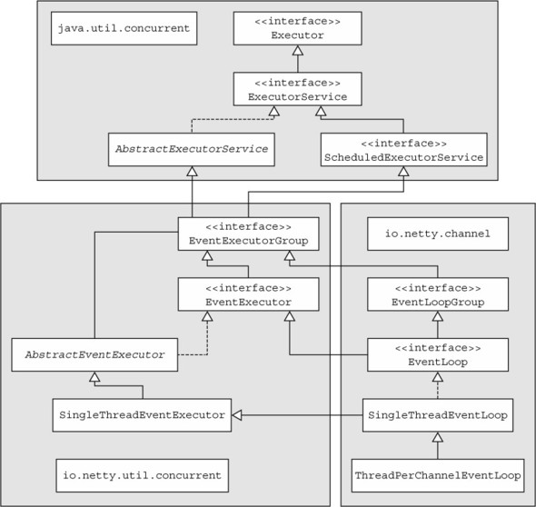

In this model, an EventLoop is powered by exactly one Thread that never changes, and tasks ( Runnable or Callable ) can be submitted directly to EventLoop implementations for immediate or scheduled execution.

Depending on the configuration and the available cores, multiple EventLoops may be created in order to optimize resource use, and a single EventLoop may be assigned to service multiple Channels.

Note that Netty's EventLoop, while it extends ScheduledExecutorService, defines only one method, parent().[[1](https://livebook.manning.com/book/netty-in-action/chapter-7/25#!/book/netty-in-action/chapter-7/ch07fn01)] This method, shown in the following code snippet, is intended to return a reference to the EventLoopGroup to which the current EventLoop implementation instance belongs.

This method overrides the EventExecutor method EventExecutorGroup parent().

public interface EventLoop extends EventExecutor, EventLoopGroup {

@Override

EventLoopGroup parent();

}

Channel Lifecycle

|  |  |
| --- | --- |
|  | Channel goes through different states before sending the request and receiving the response from the server. The first state is the channel create state. This means the server accepted the connection and created the channel.  Once that is done it goes through the channel registered state which means the channel is registered with the event loop. This is needed because entity handles request and response in an asynchronous manner and a single event loop in reality can handle many channels meaning many clients. So the event loop should know which channel it needs to send the response, based on and even to.  The next state of the channel is the channel active state. This is a state which means a client and the server are connected and the client and the server can interact with each other.  Once the client and the server are done extending the data the channel goes to a channel inactive state which means the channel is closed.  The next state as a channel unregistered which means the channel is unregistered from the event loop. |

End to End, Threads and the Execution Model

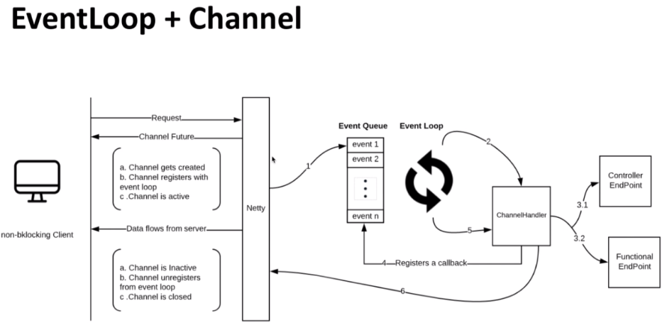

Let's start with the end to end flow of request and response in Netty. The first step is the client makes the request to the server. As we know it is asynchronous so what it gets in response is a channel Future. This means the channel is not activated. So the next step is the channel gets created and then the channel registers with the Event Loop and it goes into the active state. So now we have this inbound event waiting in the event queue which is picked up by the event loop.

The event loops role is to pick the event and hand this to a new thing called Channel handler.

Channel handler as a concept and nifty which takes care of handling all the inbound and outbound events. As soon as the channel handler received the inbound event it is going to invoke the appropriate endpoint. So these are the endpoints which coded earlier.

Since we know we are going to use a Flux and Mono which is asynchronous by nature, the call will be returned immediately and then it registers a callback with the event loop and the event loop thread is released. The event loop now will take care of handling the next event from the even queue.

What of in case we are not using Flux and Mono and in that case this call will be blocked, meaning the whole event loop thread will be blocked, which means that event loop will not be able to process any events that are waiting in the queue. This is a big problem.

So that's the reason why it is not recommended to put any long processing logic or any blocking code that's going to block the event loop thread.

It is always recommended to run any blocking code or any blocking logic in a separate thread which is going to release the event loop thread.

As the data is ready the data will be added to the event queue and it is a outbound event. So it is picked up by the channel handler and then the response will be sent to the client and data is going to flow from the server. The channel handler is something which gets assigned when the channel is created right. When it is done producing the data basically the onComplete event will be pushed through the even queue that will be picked up by the event loop and it will be sent to the client which means there is no more data and the channel is going to go into the inactive state and channel under registers from event loop and then the channel will be closed.

This is how the data flows between the client and the server in a non blocking way.

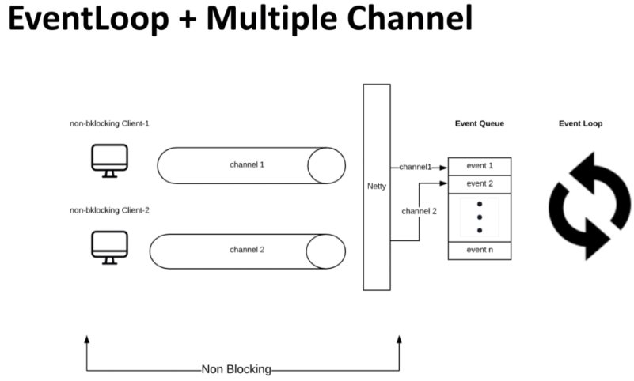

In reality there will be more clients right then it means there will be more channels, a single event loop by its nature can handle more than one channel which means multiple channels can be registered with the same event loop. Event loop is a way to differentiate between each channel based on the event in the new and Queue. In order to keep things simple I have two channels here, both the channels are registered with the same event loop. As we know by now events are published to the server through the channel and then it's going to reach the event queue.

When the event loop picks up an event from the event queue it knows from which channel that particular event originates from and to which channel it needs to send the response back. The reason why I am highlighting this is because the channel should get the correct response as per the request. It should not get mixed up meaning Channel 1 should not receive the response from the request of Channel 2, since the same event loop handles both the channels.

If we have any experience working with Node JS the execution model of Node JS is also done by event loop. It asks a single event loop and it does handle incredible number of incoming connection. The next question is “Is it possible to have more than one event loop?”. The answer is yes.

The number of event loops for a given Netty server is equal to two times the number of processors that are available for a given virtual machine.

No of event loops = 2 X number of processors for the virtual machine

How do you calculate the number of processors that are available for a given machine. If you run the code and print in your console you'll be able to see the number of available processors.

Runtime.getRuntime().availableProcessors();

I'm going to introduce you to a new concept called EventLoop Group.

Event loops are grouped together to form something called EventLoop Groups. In Netty there will be two EventLoop Groups,

1. One EventLoop Group is to accept new connections and create channels and the

2. Other EventLoop Group is to handle the Events for the accepted channels

It means that the channel creation happens in the first event loop and the channel registration and channel handling happens in the second event loop group. Basically all Inbound and Outbound events will be handled by the second EventLoop Group.

So how many threads are available for Netty. As I mentioned previously each EventLoop Group is powered by one we wanted. So the number of threads is equal to two times the number of processors in a given virtual machine. That's all Netty needs to store large volume of incoming connections. The idea is if we use the resources efficiently we can serve a large number of incoming connections with less number of threads and Netty does the that really well.

## Application Overview

The application we are going to build is for a retail company. So basically it's going to be a reactive API which means a non blocking end to end. The API is going to maintain the inventory of the items for the company, meaning adding a new item removing an item, updating an item and reading an item. Basically this is going to be a Reactive CRUD API. In a nutshell we are going to use Spring flux and the backend is going to be a Mongo DB. I mentioned earlier about why we are using Mongo DB instead of a relational database in one of the previous slide but I will highlight this one more time. In order to build an API which is end to end non blocking we need reactive adapters to talk to the DB, so that we can talk to the DB in a reactive way, meaning writing and reading the data from the Mongo DB in a Non Blocking way.

|  |  |
| --- | --- |
|  | Interacting with Mongo DB is as easy as interacting with relational databases from a coding perspective. We will be using the repository classes. That's part of the Reactor Mongo Spring Boot library that we added during the project's set up. Reactive adapters for the relational databases are still in the early stages of development. Once the production grade reactive adapters are out for the relational databases then I'll be updating this course on how to interact with the relational database is in a reactive way. |

Setting up MongoDB

If we look at our pom.xml file we have the dependency mentioned for

<!-- This one will try to connect to MongoDB at the start itself -->

<dependency>

<groupId>org.springframework.boot</groupId>

<artifactId>spring-boot-starter-data-mongodb-reactive</artifactId>

</dependency>

<!-- This one will try to connect to MongoDB at the start itself -->

<dependency>

<groupId>de.flapdoodle.embed</groupId>

<artifactId>de.flapdoodle.embed.mongo</artifactId>

<scope>test</scope>

</dependency

When we run the project as a Spring Application we get a socket error even though the application is working, that socket error is different it is when the above tries to connect to MongoDB and does not find it open.

com.mongodb.MongoSocketOpenException: Exception opening socket at com.mongodb.connection.netty.NettyStream$OpenChannelFutureListener.operationComplete(NettyStream.java:416) ~[mongodb-driver-core-4.0.4.jar:na]

We do not have Mongo installed and running right now ( running mongo or mongod at the command prompt gives error )

C:\>mongo --version

'mongo' is not recognized as an internal or external command, operable program or batch file.

Mongo is a document database. A record in a MongoDB is a JSON document. Lets install MongoDB from [here](https://www.mongodb.com/try/download/community) ( On premises, community server ). Add the MongoDB installation path\bin to the path

C:\> mongo --version

MongoDB shell version v4.2.8

git version: 43d25964249164d76d5e04dd6cf38f6111e21f5f

allocator: tcmalloc

modules: none

build environment:

distmod: 2012plus

distarch: x86_64

target_arch: x86_64

Run the MongoDB daemon

c:\>mongod

2020-07-18T16:55:14.642+0530 I CONTROL [main] Automatically disabling TLS 1.0, to force-enable TLS 1.0 specify --sslDisabledProtocols 'none'

. . .

2020-07-18T16:55:28.038+0530 I NETWORK [conn1] received client metadata from 127.0.0.1:12503 conn1: { driver: { name: "mongo-java-driver|reactive-streams|spring-boot", version: "4.0.4" }, os: { type: "Windows", name: "Windows 10", architecture: "amd64", version: "10.0" }, platform: "Java/Oracle Corporation/14+36-1461" }

Run the Mongo Shell

c:\>mongo

Show Databases

> show databases

Restart the Spring Application now and you wouldn’t get the socket error now

2020-07-18 17:04:54.609 INFO 9264 --- [ main] c.s.r.f.FluxAndMonoApplication : Starting FluxAndMonoApplication on DESKTOP-PEI24P3 with PID 9264 (D:\2Study\NewWorkspaceExamples\SpringReactive\learn-reactivespring\target\classes started by Dimpu in D:\2Study\NewWorkspaceExamples\SpringReactive\learn-reactivespring)

2020-07-18 17:04:54.635 INFO 9264 --- [ main] c.s.r.f.FluxAndMonoApplication : No active profile set, falling back to default profiles: default

2020-07-18 17:04:57.519 INFO 9264 --- [ main] .s.d.r.c.RepositoryConfigurationDelegate : Bootstrapping Spring Data Reactive MongoDB repositories in DEFAULT mode.

2020-07-18 17:04:57.634 INFO 9264 --- [ main] .s.d.r.c.RepositoryConfigurationDelegate : Finished Spring Data repository scanning in 93ms. Found 0 Reactive MongoDB repository interfaces.

2020-07-18 17:05:02.562 INFO 9264 --- [ main] org.mongodb.driver.cluster : Cluster created with settings {hosts=[localhost:27017], mode=SINGLE, requiredClusterType=UNKNOWN, serverSelectionTimeout='30000 ms'}

2020-07-18 17:05:03.380 INFO 9264 --- [localhost:27017] org.mongodb.driver.connection : Opened connection [connectionId{localValue:1, serverValue:3}] to localhost:27017

2020-07-18 17:05:03.416 INFO 9264 --- [localhost:27017] org.mongodb.driver.cluster : Monitor thread successfully connected to server with description ServerDescription{address=localhost:27017, type=STANDALONE, state=CONNECTED, ok=true, minWireVersion=0, maxWireVersion=8, maxDocumentSize=16777216, logicalSessionTimeoutMinutes=30, roundTripTimeNanos=27044100}

2020-07-18 17:05:03.954 INFO 9264 --- [ main] o.s.b.web.embedded.netty.NettyWebServer : Netty started on port(s): 8080

2020-07-18 17:05:04.007 INFO 9264 --- [ main] c.s.r.f.FluxAndMonoApplication : Started FluxAndMonoApplication in 11.24 seconds (JVM running for 13.763)

Spring Profiles

Lets configure Spring Profiles now, the advantage of Spring profiles is that it would allow you to maintain configuration for different environments at the same place. Spring did mention in the log above that no active profile is set, so it did a fallback to default. This means that we do not have a profile configured in Spring.

We will use the application.yml file for this, we will delete the application.properties file from the src/main/resources and put the yaml file here instead i.e. the application.yml file

In the application.yml file we have, so we can see 3 different profiles being maintained in the application.yml file here

spring:

profiles:

active:

---

spring:

profiles: dev

---

spring:

profiles: nonprod

---

spring:

profiles: prod

We will configure the Mongo DB local environment as Dev here now. In reality we would have different configurations ( host and port in this case ) for different environments, but just for illustration sake we give the same values here

spring:

profiles:

active: dev

---

spring:

profiles: dev

data.mongodb:

host: localhost

port: 27017

database: local

---

spring:

profiles: nonprod

data.mongodb:

host: localhost

port: 27017

database: local

---

spring:

profiles: prod

data.mongodb:

host: localhost

port: 27017

database: local

The active profile now here is dev. Restart the application and see the log, default profile is now dev. To validate that it is indeed using this, provide a incorrect hostname and it should give a error again on restart.

2020-07-18 17:16:57.352 INFO 13628 --- [ main] c.s.r.f.FluxAndMonoApplication : Starting FluxAndMonoApplication on DESKTOP-PEI24P3 with PID 13628 (D:\2Study\NewWorkspaceExamples\SpringReactive\learn-reactivespring\target\classes started by Dimpu in D:\2Study\NewWorkspaceExamples\SpringReactive\learn-reactivespring)

2020-07-18 17:16:57.369 INFO 13628 --- [ main] c.s.r.f.FluxAndMonoApplication : The following profiles are active: dev

2020-07-18 17:17:00.728 INFO 13628 --- [ main] .s.d.r.c.RepositoryConfigurationDelegate : Bootstrapping Spring Data Reactive MongoDB repositories in DEFAULT mode.

2020-07-18 17:17:00.813 INFO 13628 --- [ main] .s.d.r.c.RepositoryConfigurationDelegate : Finished Spring Data repository scanning in 63ms. Found 0 Reactive MongoDB repository interfaces.

2020-07-18 17:17:06.729 INFO 13628 --- [ main] org.mongodb.driver.cluster : Cluster created with settings {hosts=[localhost:27017], mode=SINGLE, requiredClusterType=UNKNOWN, serverSelectionTimeout='30000 ms'}

2020-07-18 17:17:07.819 INFO 13628 --- [localhost:27017] org.mongodb.driver.connection : Opened connection [connectionId{localValue:1, serverValue:4}] to localhost:27017

2020-07-18 17:17:07.866 INFO 13628 --- [localhost:27017] org.mongodb.driver.cluster : Monitor thread successfully connected to server with description ServerDescription{address=localhost:27017, type=STANDALONE, state=CONNECTED, ok=true, minWireVersion=0, maxWireVersion=8, maxDocumentSize=16777216, logicalSessionTimeoutMinutes=30, roundTripTimeNanos=29603800}

2020-07-18 17:17:08.334 INFO 13628 --- [ main] o.s.b.web.embedded.netty.NettyWebServer : Netty started on port(s): 8080

Build the project and do not run the test cases, else we have a lot of test cases and it will take some good amount of time then.

To pass the active profile from the command prompt use the following command

$ java –jar -Dspring.profiles.active=prod target/learn-reactivespring.0.0.1-SNAPSHOT.jar

D:\learn-reactivespring>java -jar -Dmaven.test.skip=true -Dspring.profiles.active=prod target\reactive-0.0.1-SNAPSHOT.jar

See the test cases folder here

. ____ _ __ _ _

/\\ / ___'_ __ _ _(_)_ __ __ _ \ \ \ \

( ( )\___ | '_ | '_| | '_ \/ _` | \ \ \ \

\\/ ___)| |_)| | | | | || (_| | ) ) ) )

' |____| .__|_| |_|_| |_\__, | / / / /

=========|_|==============|___/=/_/_/_/

:: Spring Boot :: (v2.3.1.RELEASE)

2020-07-19 13:56:12.427 INFO 6936 --- [ main] c.s.r.f.FluxAndMonoApplication : Starting FluxAndMonoApplication v0.0.1-SNAPSHOT on DESKTOP-PEI24P3 with PID 6936 (D:\2Study\NewWorkspaceExamples\SpringReactive\learn-reactivespring\target\reactive-0.0.1-SNAPSHOT.jar started by Dimpu in D:\2Study\NewWorkspaceExamples\SpringReactive\learn-reactivespring)

2020-07-19 13:56:12.432 INFO 6936 --- [ main] c.s.r.f.FluxAndMonoApplication : The following profiles are active: prod

2020-07-19 13:56:13.478 INFO 6936 --- [ main] .s.d.r.c.RepositoryConfigurationDelegate : Bootstrapping Spring Data Reactive MongoDB repositories in DEFAULT mode.

We will code the Item document for our reactive API

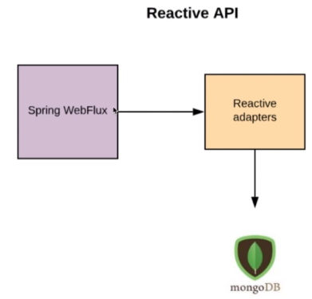

**Item.class**

import org.springframework.data.annotation.Id;

import org.springframework.data.mongodb.core.mapping.Document;

import lombok.AllArgsConstructor;

import lombok.Data;

import lombok.NoArgsConstructor;

@Document // MongoDB document

@Data // @Data annotation gives the getters/ setters

@AllArgsConstructor

@NoArgsConstructor

public class Item {

@Id

private String id;

private String description;

private Double price;

}

**ItemReactiveRepository Interface**

import org.springframework.data.mongodb.repository.ReactiveMongoRepository;

import com.spring.reactive.app.item.Item;

public interface ItemReactiveRepository extends ReactiveMongoRepository<Item, String> {

}

The Item indicates the Document for MongoDB and the String indicates what is the type of the id in the document

Lets write the test class now for the ItemRepository

Writing a Reactive test case using JUnit ( Observe we use @DataMongoTest and @RunWith( SpringRunner.class ). We did not have these in the previous test cases. No annotations were used other than the @Test annotation on the test methods.

This therefore requires us to uncomment the following from the pom.xml for this to work.

<dependency>

<groupId>org.springframework.boot</groupId>

<artifactId>spring-boot-starter-test</artifactId>

<scope>test</scope>

<!-- <exclusions>

<exclusion>

<groupId>org.junit.vintage</groupId>

<artifactId>junit-vintage-engine</artifactId>

</exclusion>

</exclusions> -->

</dependency>

**ItemRepositoryTest.java**

import org.junit.Test;

import org.junit.runner.RunWith;

import org.springframework.beans.factory.annotation.Autowired;

import org.springframework.boot.test.autoconfigure.data.mongo.DataMongoTest;

import org.springframework.test.context.junit4.SpringRunner;

import com.spring.reactive.app.item.Item;

import reactor.core.publisher.Flux;

import reactor.test.StepVerifier;

@DataMongoTest

@RunWith( SpringRunner.class )

public class ItemRepositoryTest {

@Autowired

ItemReactiveRepository itemReactiveRepository;

@Test

public void testGetAllItems() {

Flux<Item> fluxItems = itemReactiveRepository.findAll();

StepVerifier.create( fluxItems )

.expectSubscription()

.expectNextCount( 0 )

.verifyComplete();

}

}

@DataMongoTest helps us load only the required classes for the Mongo test case to run. It wouldn’t load the whole Spring Context but only the required classes would be loaded to run this Mongo test case.

We have autowired the ItemReactiveRepository and using this we can perform all the required tests for Item.

Expective 0 items right now and the call to complete as there is nothing in the MongoDB repository

Start MongoDB daemon process ( server )

C:\> mongod

Run the Application

D:\ >java -jar -Dspring.profiles.active=Dev target\reactive-0.0.1-SNAPSHOT.jar

If you look at the logs it is actually using the Embedded MongoDB, its not connecting to the actual Mongo DB. Whenever we run the test cases, it is going to use the MongoDB ( embedded one ) that we added in the pom.xml file. This is the one that gets invoked during test case execution, so even though you don’t have MongoDB on your machine, these test cases would still be able to use the embedded MongoDB

<dependency>

<groupId>de.flapdoodle.embed</groupId>

<artifactId>de.flapdoodle.embed.mongo</artifactId>

<scope>test</scope>

</dependency>

Lets put the setup method in place for our test case, the @Before annotation helps us do that, so this method would get executed before any test case is executed

@DataMongoTest

@RunWith(SpringRunner.class)

public class ItemRepositoryTest {

@Autowired

ItemReactiveRepository itemReactiveRepository;

/* Ids for Item are auto-generated so passed as null here */

List<Item> itemsList = Arrays.asList(

new Item(null, "Samsung TV", 400.0),

new Item(null, "LG TV", 420.0),

new Item(null, "Apple Watch", 299.99),

new Item(null, "Beats Headphones", 149.99)

);

@Before // Setup – before any test cases run

public void setup() {

itemReactiveRepository.deleteAll() // Clear all data first

.thenMany( Flux.fromIterable( itemsList )) // Flux<Item>

.flatMap( itemReactiveRepository::save ); // Item

.doOnNext( item -> System.out.println("Item inserted is -> " +item) )

.blockLast(); // Wait for all operations to complete

}

@Test

public void testGetAllItems() {

StepVerifier.create( itemReactiveRepository.findAll() )

.expectSubscription()

.expectNextCount( 4 )

.verifyComplete();

}

}

The blockLast() call would make the test wait till the above mentioned operations are complete. NEVER use the blockLast() call in your actual code, it is recommended for test cases only.

The doOnNext() method checks whether the item got inserted, it will just print them out and we should see a auto generated id assigned to each item inserted.

Note that when using the @DataJpaTest like this with @RunWith(SpringRunner.class) like this we need to have the Main class in the same package hierarchy ( can be at a base package level too but not in different package altogether ). So we have the below in

**package** com.spring.reactive.app;

@SpringBootApplication

public class FluxAndMonoApplication {

public static void main(String[] args) {

System.out.println("See the test cases folder here");

SpringApplication.run(FluxAndMonoApplication.class, args);

}

}

And our test case above is in

**package** com.spring.reactive.app.item.repository;

So then that works as it is in the base package com.spring.reactive.app

If this is not followed then we get the error -> java.lang.IllegalStateException: Unable to find a @SpringBootConfiguration, you need to use @ContextConfiguration or @SpringBootTest(classes=...) with your test

package com.spring.reactive.app.item.repository;

import java.util.Arrays;

import java.util.List;

import org.junit.Before;

import org.junit.Test;

import org.junit.runner.RunWith;

import org.springframework.beans.factory.annotation.Autowired;

import org.springframework.boot.test.autoconfigure.data.mongo.DataMongoTest;

import org.springframework.test.context.junit4.SpringRunner;

import com.spring.reactive.app.item.Item;

import reactor.core.publisher.Flux;

import reactor.test.StepVerifier;

/*

* Reactive Mongo Test cases using JUnit

*/

@DataMongoTest

@RunWith( SpringRunner.class )

public class ItemRepositoryTest {

@Autowired

ItemReactiveRepository itemReactiveRepository;

/* Ids for Item are auto-generated so passed as null here */

List<Item> itemsList = Arrays.asList(

new Item(null, "Samsung TV", 400.0),

new Item(null, "LG TV", 420.0),

new Item(null, "Apple Watch", 299.99),

new Item(null, "Beats Headphones", 149.99),

new Item("ABC", "Bose Headphones", 149.99)

);

@Before

public void setup() {

// clear all data first

itemReactiveRepository

.deleteAll()

.thenMany( Flux.fromIterable( itemsList ) ) // Flux<Item>

.flatMap( itemReactiveRepository::save ) // Item

.doOnNext( item -> System.out.println("Item inserted is -> " +item) )

.blockLast(); // Wait until all operations above are completed

}

@Test

public void testGetAllItems() {

StepVerifier.create( itemReactiveRepository.findAll() )

.expectSubscription()

.expectNextCount(5)

.verifyComplete();

}

@Test

public void testGetItemById() {

StepVerifier.create( itemReactiveRepository.findById("ABC") ) // findById returns a Mono

.expectSubscription() // Step<Item>

.expectNextMatches( i -> i.getDescription().equalsIgnoreCase("Bose Headphones"))

.verifyComplete();

}

}

Note that the itemReactiveRepository is returning a Flux to us in this case, we then create that Flux using StepVerifier and subscribe, check expectations and verifyCompletion

expectNextMatches takes a Predicate

Check the StepVerifier.java class

<https://projectreactor.io/docs/test/release/api/reactor/test/StepVerifier.html>

If we do not specify the id for a item, it is auto generated else it takes what we provide.

Finding Items in MongoDB

Lets say we want to retrieve items based on something in their description, so for that we do not have a method ootb so we would need to write a method for it

Lets modify the interface

**ItemReactiveRepository.java**

package com.reactive.app.item.repository;

import org.springframework.data.mongodb.repository.ReactiveMongoRepository;

import com.reactive.app.item.Item;

import reactor.core.publisher.Flux;

public interface ItemReactiveRepository extends ReactiveMongoRepository<Item, String> {

Flux<Item> findByDescription(String description);

}

Write a method in the test case now

@DataMongoTest

@RunWith( SpringRunner.class )

public class ItemRepositoryTest {

@Autowired

ItemReactiveRepository itemReactiveRepository;

/* Ids for Item are auto-generated so passed as null here */

List<Item> itemsList = Arrays.asList(

new Item(null, "Samsung TV", 400.0),

new Item(null, "LG TV", 420.0),

new Item(null, "Apple Watch", 299.99),

new Item(null, "Beats Headphones", 149.99),

new Item("ABC", "Bose Headphones", 149.99)

);

@Before

public void setup() {

// clear all data first

itemReactiveRepository

.deleteAll()

.thenMany( Flux.fromIterable( itemsList ) ) // Flux<Item>

.flatMap( itemReactiveRepository::save) // Item

.doOnNext( item -> System.out.println("Item inserted is -> " +item) )

.blockLast(); // Wait until all operations above are completed

}

@Test

public void findItemByDescription() {

StepVerifier.*create*( itemReactiveRepository.findByDescription( "Bose Headphones" )

.log( "findItemByDescription " ))

.expectSubscription()

.expectNextCount( 1 )

.verifyComplete();

}

}

We could do a log to see this more clearly in the logs

2020-07-22 07:58:50.966 INFO 13272 --- [ Thread-74] o.s.b.a.mongo.embedded.EmbeddedMongo : 2020-07-22T07:58:50.961+0530 I COMMAND [conn6] command local.$cmd command: update { update: "item", ordered: true, updates: [ { q: { _id: "ABC" }, u: { _id: "ABC", description: "Bose Headphones", price: 149.99, _class: "com.reactive.app.item.Item" }, upsert: true } ] } numYields:0 reslen:106 locks:{ Global: { acquireCount: { r: 1, w: 1 } }, Database: { acquireCount: { w: 1 }, acquireWaitCount: { w: 1 }, timeAcquiringMicros: { w: 241835 } }, Collection: { acquireCount: { w: 1 } } } protocol:op_query 243ms

Item inserted is -> Item(id=ABC, description=Bose Headphones, price=149.99)

Item inserted is -> Item(id=5f17a4621a8efc64b8162230, description=Apple Watch, price=299.99)

Item inserted is -> Item(id=5f17a4621a8efc64b8162231, description=Beats Headphones, price=149.99)

Item inserted is -> Item(id=5f17a4621a8efc64b816222e, description=Samsung TV, price=400.0)

Item inserted is -> Item(id=5f17a4621a8efc64b816222f, description=LG TV, price=420.0)

2020-07-22 07:58:51.027 INFO 13272 --- [ main] findItemByDescription: onSubscribe(FluxOnErrorResume.ResumeSubscriber)

2020-07-22 07:58:51.031 INFO 13272 --- [ main] findItemByDescription: request(unbounded)

2020-07-22 07:58:51.113 INFO 13272 --- [ntLoopGroup-2-4] findItemByDescription: onNext(Item(id=ABC, description=Bose Headphones, price=149.99))

2020-07-22 07:58:51.114 INFO 13272 --- [ntLoopGroup-2-4] findItemByDescription: onComplete()

2020-07-22 07:58:51.157 INFO 13272 --- [extShutdownHook] org.mongodb.driver.connection : Closed connection [connectionId{localValue:6, serverValue:6}] to localhost:27017 because the pool has been closed.

What if we just pass the “Headphones” as a value rather than “Bose Headphones” – the test case will fail, it’s a exact match.

ReactiveCrudRepository.java

See the class [ReactiveCrudRepository](https://github.com/spring-projects/spring-data-commons/blob/master/src/main/java/org/springframework/data/repository/reactive/ReactiveCrudRepository.java).java

@NoRepositoryBean

public interface [ReactiveCrudRepository](https://github.com/spring-projects/spring-data-commons/blob/master/src/main/java/org/springframework/data/repository/reactive/ReactiveCrudRepository.java)<T, ID> extends Repository<T, ID> {

<S extends T> Mono<S> save(S entity);

<S extends T> Flux<S> saveAll(Iterable<S> entities);

<S extends T> Flux<S> saveAll(Publisher<S> entityStream);

Mono<T> findById(ID id);

Mono<T> findById(Publisher<ID> id);

Mono<Boolean> existsById(ID id);

Mono<Boolean> existsById(Publisher<ID> id);

Flux<T> findAll();

Flux<T> findAllById(Iterable<ID> ids);

Flux<T> findAllById(Publisher<ID> idStream);

Mono<Long> count();

Mono<Void> deleteById(ID id);

Mono<Void> deleteById(Publisher<ID> id);

Mono<Void> delete(T entity);

Mono<Void> deleteAll(Iterable<? extends T> entities);

Mono<Void> deleteAll(Publisher<? extends T> entityStream);

Mono<Void> deleteAll();

}

Insert Operation Example

Lets write the test case for this now, we have to use the method save from above.

@Test

public void saveItem() {

Item item = new Item(null, "Google Home Mini", 30.00);

// The save method of repository returns a Mono<Item>

Mono<Item> savedItemMono = itemReactiveRepository.save(item).log(“Saved Item”);

StepVerifier.create(savedItemMono)

.expectSubscription()

.expectNextMatches( itemCtr -> itemCtr.getId() != null

&& itemCtr.getDescription().equalsIgnoreCase("Google Home Mini") )

.verifyComplete();

}

We can check the logs with .log() method added here.

Update Operation Example

@Test

public void updateItem() {

double itemPrice = 520.00;

Flux<Item> itemFlux = itemReactiveRepository.findByDescription("LG TV")

.log("Updating Item")

.map( item -> {

item.setPrice(itemPrice);

return item;

})

.flatMap( item -> itemReactiveRepository.save(item) );

StepVerifier.create( itemFlux )

.expectSubscription()

.expectNextMatches( itemCtr -> itemCtr.getPrice() == itemPrice )

.verifyComplete();

}

2020-07-22 08:31:41.329 INFO 404 --- [ main] Updating Item : onSubscribe(FluxOnErrorResume.ResumeSubscriber)

2020-07-22 08:31:41.332 INFO 404 --- [ main] Updating Item : request(256)

2020-07-22 08:31:41.389 INFO 404 --- [ntLoopGroup-2-4] Updating Item : onNext(Item(id=5f17ac144a670c40c4d0ed0e, description=LG TV, price=420.0))

2020-07-22 08:31:41.395 INFO 404 --- [ntLoopGroup-2-4] Updating Item : onComplete()

Delete Operation Example

@Test

public void deleteItem() {

Mono<Void> itemMono = itemReactiveRepository.findById("ABC").log("Deleting Item")

.map( item -> item.getId())

.flatMap( id -> itemReactiveRepository.deleteById(id));

// In above delete returns Mono<Void>

StepVerifier.create( itemMono ) // We get a void it returns nothing

.expectSubscription()

.verifyComplete();

// Checking result for null after deletion of item with id ABC

StepVerifier.create( itemReactiveRepository.findById( "ABC" ).log( "Deleting Item" ) )

.expectSubscription()

.expectNextMatches( i -> i == null );

}

The delete operation returns a Mono<Void> as there is nothing to return.

So in the StepVerifier we accepted the Mono<Void> itemMono and then expected a subscription and verified it completed. I also added another check here for checking with the id again on whether the item exists after deletion – expectNext doesn’t work here as that checks for a Item, use the expectNextMatches which takes a predicate to check for null value

We could have also checked for the count after deletion to verify this or a expectCount(0) instead of the expectNextMatches( <Predicate> )

// Checking result for 0 count when finding item with id ABC

StepVerifier.create( itemReactiveRepository.findById("ABC").log("Deleting Item") )

.expectSubscription()

.expectNextCount( 0 );

## Reactive API Endpoints

The code is self explanatory

import static com.reactive.app.item.ItemConstants.ITEM_END_POINT_V1;

import org.springframework.beans.factory.annotation.Autowired;

import org.springframework.web.bind.annotation.GetMapping;

import org.springframework.web.bind.annotation.RestController;

import com.reactive.app.item.Item;

import com.reactive.app.item.repository.ItemReactiveRepository;

import lombok.extern.slf4j.Slf4j;

import reactor.core.publisher.Flux;

@RestController // REST endpoint

@Slf4j // enabled logging

public class ItemController {

@Autowired

ItemReactiveRepository itemReactiveRepository;

@GetMapping(ITEM_END_POINT_V1) // GET endpoint

public Flux<Item> getAllItems() {

return itemReactiveRepository.findAll();

}

}

import org.springframework.data.mongodb.repository.ReactiveMongoRepository;

import com.reactive.app.item.Item;

import reactor.core.publisher.Flux;

public interface ItemReactiveRepository extends ReactiveMongoRepository<Item, String> {

Flux<Item> findByDescription(String description);

}

When we run this we get a exception

*com.mongodb.MongoSocketOpenException: Exception opening socket*

If we get this issue when MongoDB is started then restart it, if you haven’t started MongoDB then start it

Run this url <http://localhost:8080/v1/items> and we get a blank JSON string in the browser because we do not have any data in MongoDB yet

[]

**Initialize some data using the Command Line Runner**

import org.springframework.beans.factory.annotation.Autowired;

import org.springframework.boot.CommandLineRunner;

import org.springframework.stereotype.Component;

import com.reactive.app.item.Item;

import com.reactive.app.item.repository.ItemReactiveRepository;

import reactor.core.publisher.Flux;

@Component

public class ItemDataInitializer implements CommandLineRunner {

@Autowired

ItemReactiveRepository itemReactiveRepository;

@Override

public void run(String... args) throws Exception {

**initialDataSetup();**

}

public List<Item> data() {

List<Item> dataList = Arrays.asList(

new Item(null, "Apple IPhone", 92.00),

new Item(null, "HP Laptop", 92.00),

new Item(null, "Bose Headphone", 92.00),

new Item(null, "Mercedez Benz", 999992.00)

);

return dataList;

}

private void **initialDataSetup()** {

itemReactiveRepository.deleteAll()

.thenMany( Flux.fromIterable( data() ))

.flatMap( itemReactiveRepository::save )

.thenMany( itemReactiveRepository.findAll() )

.subscribe( item -> System.out.println("Item inserted -> "+item) );

}

}

@Component so that the class gets scanned

The class implements a CommandLineRunner so that we can initialize it with some data, we are required to override the method called run(), this in turn calls the initialDataSetup method

First we delete all the records then we iterate over many passing the Flux.fromIterable and do a flatMap and save that using the repository. We then again do a thenMany and pass it the List<Items> returned from findAll method of itemReactiveRepository and then subscribe to the flux created and print them out.

We get a log as follows on running the application

2020-07-26 12:00:43.472 INFO 4216 --- [ntLoopGroup-3-2] reactor.Flux.ConcatArray.1 : onComplete()

2020-07-26 12:00:43.481 INFO 4216 --- [ntLoopGroup-3-3] org.mongodb.driver.connection : Opened connection [connectionId{localValue:3, serverValue:13}] to localhost:27017

2020-07-26 12:00:43.482 INFO 4216 --- [ntLoopGroup-3-4] org.mongodb.driver.connection: Opened connection [connectionId{localValue:4, serverValue:14}] to localhost:27017

2020-07-26 12:00:43.484 INFO 4216 --- [ntLoopGroup-3-5] org.mongodb.driver.connection : Opened connection [connectionId{localValue:5, serverValue:15}] to localhost:27017

Item inserted -> Item(id=5f1d2313a0d6c511c2b40d79, description=Apple IPhone, price=92.0)

Item inserted -> Item(id=5f1d2313a0d6c511c2b40d7a, description=HP Laptop, price=92.0)

Item inserted -> Item(id=5f1d2313a0d6c511c2b40d7b, description=Bose Headphone, price=92.0)

Item inserted -> Item(id=5f1d2313a0d6c511c2b40d7c, description=Mercedez Benz, price=999992.0)

Requesting through the browser now with url <http://localhost:8080/v1/items> gives

[{"id":"5f1d2313a0d6c511c2b40d79","description":"Apple IPhone","price":92.0},

{"id":"5f1d2313a0d6c511c2b40d7a","description":"HP Laptop","price":92.0},

{"id":"5f1d2313a0d6c511c2b40d7b","description":"Bose Headphone","price":92.0},

{"id":"5f1d2313a0d6c511c2b40d7c","description":"Mercedez Benz","price":999992.0}]

Lets write a test case for ItemController now

Create the same package hierarchy in the src/main/test package

import java.util.Arrays;

import java.util.List;

import org.junit.Before;

import org.junit.Test;

import org.junit.runner.RunWith;

import org.springframework.beans.factory.annotation.Autowired;

import org.springframework.boot.test.autoconfigure.web.reactive.AutoConfigureWebTestClient;

import org.springframework.boot.test.context.SpringBootTest;

import org.springframework.http.MediaType;

import org.springframework.test.annotation.DirtiesContext;

import org.springframework.test.context.junit4.SpringRunner;

import org.springframework.test.web.reactive.server.WebTestClient;

import com.reactive.app.item.Item;

import com.reactive.app.item.ItemConstants;

import com.reactive.app.item.repository.ItemReactiveRepository;

import reactor.core.publisher.Flux;

@SpringBootTest

@RunWith( SpringRunner.class )

@DirtiesContext

@AutoConfigureWebTestClient

public class ItemControllerTest {

@Autowired

WebTestClient webTestClient;

@Autowired

ItemReactiveRepository itemReactiveRepository;

private List<Item> data() {

return Arrays.asList(

new Item(null, "Apple IPhone", 92.00),

new Item(null, "HP Laptop", 92.00),

new Item(null, "Bose Headphone", 92.00),

new Item(null, "Mercedez Benz", 999992.00)

);

}

@Before

public void setup() {

itemReactiveRepository.deleteAll()

.thenMany( Flux.fromIterable( data() ) )

.log()

.flatMap( itemReactiveRepository::save )

.blockLast();

}

@Test

public void findAll() {

webTestClient.get().uri( ItemConstants.ITEM_END_POINT_V1 )

.exchange()

.expectStatus().isOk()

.expectHeader().contentType( MediaType.APPLICATION_JSON )

.expectBodyList( Item.class )

.hasSize( 4 );

}

}

Run the test case with Run As > JUnit Test case ( either on the test case or on the project )

If you are getting problems in starting MongoDB server and cannot connect it too then try the following

**> db.shutdownServer()**

shutdown command only works with the admin database; try 'use admin'

**> use admin**

switched to db admin

**> db.shutdownServer()**

2020-07-26T12:22:32.505+0530 I NETWORK [js] DBClientConnection failed to receive message from 127.0.0.1:27017 - HostUnreachable: Connection reset by peer

server should be down...

2020-07-26T12:22:32.510+0530 I NETWORK [js] trying reconnect to 127.0.0.1:27017 failed

2020-07-26T12:22:34.514+0530 I NETWORK [js] reconnect 127.0.0.1:27017 failed failed

We notice a problem in the logs that we see the records being inserted twice now, once by the CommandLineRunner and once by the test case @Before setup method, we don’t want that to happen, so we create another profile of Spring

spring:

profiles:

active: dev

---

spring:

profiles: prod

data.mongodb:

host: localhost

port: 27017

database: local

---

spring:

profiles: test

and in the test cases we should put the following

@SpringBootTest

@RunWith(SpringRunner.**class**)

@DirtiesContext

@AutoConfigureWebTestClient

@ActiveProfiles("test")

public class ItemControllerTest {

...

}

And in the command line runner we put the following to make it run only for specific profiles

@Component

@Profile("!test")

public class ItemDataInitializer implements CommandLineRunner {

. . .

}

* Now it wouldn’t run this twice when we run the test cases. We are restricting the command line runner to not run when we are executing the test cases. If you are wondering why we are doing this, we are doing this because we are using the @DataMongoTest which is not going to load the whole application context of Spring.

See the other test cases that we had built earlier

@DataMongoTest

@RunWith(SpringRunner.class)

public class ItemRepositoryTest {

. . .

}

Another approach to testing this

@Test

public void getAllItemsApproachTwo() {

webTestClient.get().uri( ItemConstants.ITEM_END_POINT_V1 )

.exchange()

.expectStatus().isOk()

**.expectHeader().contentType( MediaType.APPLICATION_JSON )**

**.expectBodyList( Item.class )**

**.hasSize(4)**

**.consumeWith( response -> {**

List<Item> itemList = response.getResponseBody();

itemList.forEach( item -> assertTrue( item.getId() != null ) );

});

}

Another approach to this – Approach Three

@Test

public void getAllItemsApproachThree() {

Flux<Item> itemsFlux = webTestClient.get().uri( ItemConstants.ITEM_END_POINT_V1 )

.exchange()

.expectStatus().isOk()

.expectHeader().contentType( MediaType.APPLICATION_JSON )

.returnResult( Item.class )

.getResponseBody();

StepVerifier.create( itemsFlux.log() )

.expectSubscription()

.expectNextCount(4)

.verifyComplete();

}

Returning a Single Item

@RestController

@Slf4j

public class ItemController {

@Autowired

ItemReactiveRepository itemReactiveRepository;

@GetMapping(ITEM_END_POINT_V1)

public Flux<Item> getAllItems() {

return itemReactiveRepository.findAll();

}

@GetMapping(ITEM_END_POINT_V1 + "/id")

public Mono<ResponseEntity<Item>> getOneItem(@PathVariable String id) {

return itemReactiveRepository

.findById(id)

.map( item -> new ResponseEntity<>( item, HttpStatus.OK ) )

.defaultIfEmpty( new ResponseEntity<>( HttpStatus.NOT_FOUND ) );

}

}

Printing all the Items

webTestClient.get().uri( ItemConstants.ITEM_END_POINT_V1 )

.exchange()

.returnResult( Item.class )

.getResponseBody()

.subscribe( item -> System.out.println("Item is: "+item));

Lets also write a case for a invalid id, a id that doesn’t exist

@Test

public void getNonExistingItem() {

webTestClient.get().uri(ItemConstants.ITEM_END_POINT_V1.concat("/SOMEID"))

.exchange()

.expectStatus()

.is4xxClientError();

}

Or

webTestClient.get().uri(ItemConstants.ITEM_END_POINT_V1.concat("/SOMEID"))

.exchange()

.expectStatus()

.isNotFound();

ReactiveCrudRepository

Look into the ReactiveCrudRepository.java and you would notice that findById returns a Mono<T>

@NoRepositoryBean

public interface ReactiveCrudRepository<T, ID> extends Repository<T, ID> {

<S extends T> Mono<S> save(S entity);

<S extends T> Flux<S> saveAll(Iterable<S> entities);

<S extends T> Flux<S> saveAll(Publisher<S> entityStream);

Mono<T> findById(ID id);

Mono<T> findById(Publisher<ID> id);

Mono<Boolean> existsById(ID id);

Mono<Boolean> existsById(Publisher<ID> id);

Flux<T> findAll();

Flux<T> findAllById(Iterable<ID> ids);

Flux<T> findAllById(Publisher<ID> idStream);

Mono<Long> count();

Mono<Void> deleteById(ID id);

Mono<Void> deleteById(Publisher<ID> id);

Mono<Void> delete(T entity);

Mono<Void> deleteAll(Iterable<? extends T> entities);

Mono<Void> deleteAll(Publisher<? extends T> entityStream);

Mono<Void> deleteAll();

}

Creating a Item

@RestController

@Slf4j

public class ItemController {

. . .

@PostMapping( ITEM_END_POINT_V1 )

@ResponseStatus( HttpStatus.CREATED )

public Mono<Item> createItem( @RequestBody Item item ) {

return itemReactiveRepository.save( item );

}

}

Notice that the save method returns a Mono in the Spring ReactiveCrudRepository code above. And the test case for it as below.

@SpringBootTest

@RunWith( SpringRunner.class )

@DirtiesContext

@AutoConfigureWebTestClient

@ActiveProfiles("test")

public class ItemControllerTest {

. . .

@Test

public void createItem() {

Item item = new Item(null, "A New Item", 21.11);

webTestClient.post().uri( ItemConstants.ITEM_END_POINT_V1 )

.contentType( MediaType.APPLICATION_JSON )

.body( Mono.just( item ), Item.class )

.exchange()

.expectStatus().isCreated();

}

}

Here are more checks that can be added

@Test

public void createItem() {

Item item = new Item(null, "A New Item", 21.11);

webTestClient.post().uri(ItemConstants.ITEM_END_POINT_V1)

.contentType( MediaType.APPLICATION_JSON )

.body(Mono.just(item), Item.class)

.exchange()

.expectStatus().isCreated()

.expectBody()

.jsonPath("$.id").isNotEmpty()

.jsonPath("$.description").isEqualTo("A New Item")

.jsonPath("$.price").isEqualTo(21.11);

}

Deleting a Item

@RestController

@Slf4j

public class ItemController {

@DeleteMapping( ITEM_END_POINT_V1 + "/id" )

public Mono<Void> deleteItem(@PathVariable String id) {

return itemReactiveRepository.deleteById(id);

}

}

Note that this returns a Mono<void> as can be seen in the ReactiveCrudRepository

Now to write a test case for this

@Test

public void deleteItem() {

webTestClient.post().uri( ItemConstants.ITEM_END_POINT_V1.concat("/MBZ") )

.accept( MediaType.APPLICATION_JSON )

.exchange()

.expectStatus().isOk()

.expectBody( Void.class );

}

Updating a Item

@PutMapping(ITEM_END_POINT_V1 + "/id")

public Mono<ResponseEntity<Item>> updateItem(@PathVariable String id, @RequestBody Item item) {

return itemReactiveRepository.findById( id )

.flatMap( currentItem -> {

currentItem.setPrice( item.getPrice() );

currentItem.setDescription( item.getDescription() );

return itemReactiveRepository.save( currentItem );

})

.map( updatedItem -> new ResponseEntity<>(updatedItem, HttpStatus.OK) )

.defaultIfEmpty( new ResponseEntity<>(HttpStatus.NOT_FOUND) );

}

Writing the JUnit for this

@Test

public void updateItem() {

double newPrice = 129.99;

Item item = new Item( null, "Beats Headphones", newPrice );

webTestClient.put().uri( ItemConstants.ITEM_END_POINT_V1.concat("{id}"), "MBZ" )

.contentType( MediaType.APPLICATION_JSON )

.body( Mono.just(item), Item.class)

.exchange()

.expectStatus().isOk()

.expectBody()

.jsonPath("$.price").isEqualTo(129.99);

}

Writing a test case for updating a item that doesn’t exist

@Test

public void updateNonExistingItem() {

double newPrice = 129.99;

Item item = new Item(null, "Beats Headphones", newPrice);

webTestClient.put().uri( ItemConstants.ITEM_END_POINT_V1.concat("{id}"), "SOMEID")

.contentType( MediaType.APPLICATION_JSON )

.body( Mono.just(item), Item.class )

.exchange()

.expectStatus().isNotFound();

}

## Reactive API using the Functional Web Module

Setting up the Router and the Handler function for the Reactive API

ItemsRouter.java

import org.springframework.context.annotation.Bean;

import org.springframework.context.annotation.Configuration;

import org.springframework.web.reactive.function.server.RouterFunction;

import org.springframework.web.reactive.function.server.ServerResponse;

import com.reactive.app.item.handler.ItemsHandler;

@Configuration

public class ItemsRouter {

@Bean

public RouterFunction<ServerResponse> itemsRoute( ItemsHandler itemsHandler ) {

return null;

}

}

ItemsHandler.java

import org.springframework.beans.factory.annotation.Autowired;

import org.springframework.http.MediaType;

import org.springframework.stereotype.Component;

import org.springframework.web.reactive.function.server.ServerRequest;

import org.springframework.web.reactive.function.server.ServerResponse;

import com.reactive.app.item.Item;

import com.reactive.app.item.repository.ItemReactiveRepository;

import reactor.core.publisher.Mono;

@Component

public class ItemsHandler {

@Autowired

ItemReactiveRepository itemReactiveRepository;

public Mono<ServerResponse> getAllItems( ServerRequest serverRequest ) {

return ServerResponse.ok()

.contentType( MediaType.APPLICATION_JSON )

.body( itemReactiveRepository.findAll(), Item.class );

}

}

Now we need to wire the Router with the Handler as below

import org.springframework.context.annotation.Bean;

import org.springframework.context.annotation.Configuration;

import org.springframework.http.MediaType;

import org.springframework.web.reactive.function.server.RequestPredicates;

import org.springframework.web.reactive.function.server.RouterFunction;

import org.springframework.web.reactive.function.server.RouterFunctions;

import org.springframework.web.reactive.function.server.ServerResponse;

import static com.reactive.app.item.ItemConstants.ITEM_FUNCTIONAL_END_POINT_V1;

import com.reactive.app.item.handler.ItemsHandler;

@Configuration

public class ItemsRouter {

@Bean

public RouterFunction<ServerResponse> itemsRoute(ItemsHandler itemsHandler) {

return RouterFunctions.route(

RequestPredicates.GET( ITEM_FUNCTIONAL_END_POINT_V1 )

.and( RequestPredicates.accept(MediaType.APPLICATION_JSON)),

itemsHandler::getAllItems );

}

}

So RouterFunctions.route accepts two methods RouterFunctions.route(RequestPredicates.<Method>, Handler)

Lets connect to this endpoint from our browser now

<http://localhost:8080/v1/fun/items>

Response is as below

[

{"id":"5f22819811e15d3a74ffafdf","description":"Apple IPhone","price":92.0},

{"id":"5f22819811e15d3a74ffafe0","description":"HP Laptop","price":92.0},

{"id":"5f22819811e15d3a74ffafe1","description":"Bose Headphone","price":92.0},

{"id":"5f22819811e15d3a74ffafe2","description":"Mercedez Benz","price":999992.0}

]

JUnit test case for this will be as below

@SpringBootTest

@RunWith(SpringRunner.class)

@AutoConfigureWebTestClient

@DirtiesContext

@ActiveProfiles("test")

public class ItemHandlerTest {

@Autowired

WebTestClient webTestClient;

@Autowired

ItemReactiveRepository itemReactiveRepository;

private List<Item> data() {

return Arrays.asList(

new Item(null, "Apple IPhone", 92.00),

new Item(null, "HP Laptop", 92.00),

new Item(null, "Bose Headphone", 92.00),

new Item("MBZ", "Mercedez Benz", 999.00)

);

}

@Before

public void setup() {

itemReactiveRepository.deleteAll()

.thenMany( Flux.fromIterable( data() ) )

.log()

.flatMap( itemReactiveRepository::save )

.blockLast();

}

@Test

public void getAllItems() {

webTestClient.get().uri( ItemConstants.ITEM_FUNCTIONAL_END_POINT_V1 )

.exchange()

.expectStatus().isOk()

.expectHeader().contentType( MediaType.APPLICATION_JSON )

.expectBodyList( Item.class )

.hasSize( 4 );

}

}

The other two approaches of writing the same test case is as below

@Test

public void testGetAllItems_approach2() {

webTestClient.get().uri(ItemConstants.ITEM_FUNCTIONAL_END_POINT_V1)

.accept( MediaType.APPLICATION_JSON )

.exchange()

.expectStatus().isOk()

.expectHeader().contentType( MediaType.APPLICATION_JSON )

.expectBodyList( Item.class )

.hasSize( 4 )

.consumeWith( response -> {

List<Item> items = response.getResponseBody();

items.forEach(item1 -> {

assertTrue(item1.getId() != null);

});

});

}

@Test

public void testGetAllItems_approach3() {

Flux<Item> itemsFlux = webTestClient.get()

.uri( ItemConstants.ITEM_FUNCTIONAL_END_POINT_V1 )

.accept( MediaType.APPLICATION_JSON )

.exchange()

.expectStatus().isOk()

.expectHeader()

.contentType( MediaType.APPLICATION_JSON )

.returnResult( Item.class )

.getResponseBody();

StepVerifier.create( itemsFlux )

.expectNextCount( 4 )

.verifyComplete();

}

Get a Single Item – Functional Endpoint

Add more routes to the Router, we can add as many as we want

@Configuration

public class ItemsRouter {

@Bean

public RouterFunction<ServerResponse> itemsRoute(ItemsHandler itemsHandler) {

return RouterFunctions

.route(

RequestPredicates.GET( ITEM_FUNCTIONAL_END_POINT_V1)

.and( RequestPredicates.accept( MediaType.APPLICATION_JSON ) ),

itemsHandler::getAllItems )

.andRoute(

RequestPredicates.GET( ITEM_FUNCTIONAL_END_POINT_V1 + "/{id}" )

.and( RequestPredicates.accept( MediaType.APPLICATION_JSON ) ),

itemsHandler::getItem );

}

}

Enhance our Handler class

import org.springframework.beans.factory.annotation.Autowired;

import org.springframework.http.MediaType;

import org.springframework.stereotype.Component;

import org.springframework.web.reactive.function.server.ServerRequest;

import org.springframework.web.reactive.function.server.ServerResponse;

import com.reactive.app.item.Item;

import com.reactive.app.item.v1.repository.ItemReactiveRepository;

import reactor.core.publisher.Mono;

@Component

public class ItemsHandler {

@Autowired

ItemReactiveRepository itemReactiveRepository;

public Mono<ServerResponse> getAllItems( ServerRequest serverRequest ) {

return ServerResponse.ok()

.contentType( MediaType.APPLICATION_JSON )

.body( itemReactiveRepository.findAll(), Item.class );

}

public Mono<ServerResponse> getItem( ServerRequest serverRequest ) {

String id = serverRequest.pathVariable("id");

return ServerResponse.ok()

.contentType( MediaType.APPLICATION_JSON )

.body( itemReactiveRepository.findById(id), Item.class );

}

}

<http://localhost:8080/v1/fun/items/5f22c9752669ce716eb66ff5>

returns

{"id":"5f22c9752669ce716eb66ff5","description":"Mercedez Benz","price":999992.0}

A Continous Stream example

/* A Continous Stream Example */

@GetMapping( value = "/temperatures", produces = MediaType.TEXT_EVENT_STREAM_VALUE )

public Flux<Integer> getTemperature() {

Random r = new Random();

int low = 0;

int high = 50;

return Flux.fromStream( Stream.generate( () -> r.nextInt( high – low ) + low)

.map( s -> String.valueOf( s ) )

.peek( ( msg ) -> { System.out.println( msg ); }))

.map( s -> Integer.valueOf( s ) )

.delayElements( Duration.ofSeconds(1) );

}

Infinite stream using Stream.iterate

@GetMapping( value = "/temperatures", produces = MediaType.TEXT_EVENT_STREAM_VALUE )

public Flux<Integer> getTemperature() {

Random r = new Random();

int low = 0;

int high = 50;

return Flux.fromStream( Stream.iterate( 0, i -> i ) // no increment

.limit( Long.MaxValue ) // will never reach here

. . .

.delayElements( Duration.ofSeconds( 1 ) );

}

Observe that we are not incrementing I, so it will never reach the MaxValue

Insert a Item – Functional Endpoint

Lets add the routing to the Router class as below

@Configuration

public class ItemsRouter {

@Bean

public RouterFunction<ServerResponse> itemsRoute(ItemsHandler itemsHandler) {

return

RouterFunctions.route( RequestPredicates.GET( ITEM_FUNCTIONAL_END_POINT_V1 )

.and( RequestPredicates.accept( MediaType.APPLICATION_JSON ) ),

itemsHandler::getAllItems )

.andRoute( RequestPredicates.GET(ITEM_FUNCTIONAL_END_POINT_V1 + "/{id}")

.and(RequestPredicates.accept( MediaType.APPLICATION_JSON )),

itemsHandler::getItem )

.andRoute( RequestPredicates.POST(ITEM_FUNCTIONAL_END_POINT_V1 )

.and(RequestPredicates.accept( MediaType.APPLICATION_JSON )),

itemsHandler::createItem );

}

}

Lets modify the handler method now

@Component

public class ItemsHandler {

@Autowired

ItemReactiveRepository itemReactiveRepository;

public Mono<ServerResponse> getAllItems(ServerRequest serverRequest) {

return ServerResponse.ok()

.contentType( MediaType.APPLICATION_JSON )

.body( itemReactiveRepository.findAll(), Item.class);

}

public Mono<ServerResponse> getItem(ServerRequest serverRequest) {

String id = serverRequest.pathVariable("id");

return ServerResponse.ok()

.contentType( MediaType.APPLICATION_JSON )

.body( itemReactiveRepository.findById(id), Item.class);

}

public Mono<ServerResponse> createItem(ServerRequest serverRequest) {

Mono<Item> itemToCreate = serverRequest.bodyToMono( Item.class );

return itemToCreate.flatMap( item -> ServerResponse.ok()

.contentType( MediaType.APPLICATION_JSON )

.body( itemReactiveRepository.save(item), Item.class));

}

}

We are returning a Mono<ServerResponse> and accepting a ServerRequest. Then we use the serverRequest.bodyToMono method to get the Item from the body – that’s the only json value coming in the body – received as a Mono<Item>. We then do a flatMap – pick the item, ServerResponse.ok() and specify content type as APPLICATION_JSON and then invoke the body method that calls the itemReactiveRepository.save method by providing it the Item.class

Delete a Item – Functional Endpoint

In the router introduce a new method for delete as below

@Configuration

public class ItemsRouter {

@Bean

public RouterFunction<ServerResponse> itemsRoute(ItemsHandler itemsHandler) {

return RouterFunctions.*route*( RequestPredicates.*GET*( *ITEM_FUNCTIONAL_END_POINT_V1*)

.and( RequestPredicates.*accept*( MediaType.*APPLICATION_JSON*) ),

itemsHandler::getAllItems )

.andRoute( RequestPredicates.GET( *ITEM_FUNCTIONAL_END_POINT_V1* + "/{id}" )

.and( RequestPredicates.*accept*( MediaType.*APPLICATION_JSON*) ),

itemsHandler::getItem )

.andRoute( RequestPredicates.POST( *ITEM_FUNCTIONAL_END_POINT_V1* )

.and( RequestPredicates.*accept*( MediaType.*APPLICATION_JSON*) ),

itemsHandler::createItem )

.andRoute( RequestPredicates.DELETE( *ITEM_FUNCTIONAL_END_POINT_V1* )

.and( RequestPredicates.*accept*( MediaType.APPLICATION_JSON ) ),

itemsHandler::deleteItem );

}

}

In the handler lets define the method for this now

@Component

public class ItemsHandler {

@Autowired

ItemReactiveRepository itemReactiveRepository;

. . .

public Mono<ServerResponse> deleteItem(ServerRequest serverRequest) {

String idOfItemToDelete = serverRequest.pathVariable("id");

Mono<Void> deleteItem = itemReactiveRepository.deleteById(idOfItemToDelete);

return ServerResponse.*ok*()

.contentType( MediaType.*APPLICATION_JSON* )

.body(deleteItem, Void.class);

}

}

Adding the test case for this now as follows

@SpringBootTest

@RunWith(SpringRunner.class)

@DirtiesContext

@AutoConfigureWebTestClient

@ActiveProfiles("test")

public class ItemHandlerTest {

@Autowired

WebTestClient webTestClient;

@Autowired

ItemReactiveRepository itemReactiveRepository;

@Test

public void testDeleteOneItem() {

webTestClient.delete().uri( ItemConstants.*ITEM_FUNCTIONAL_END_POINT_V1*.concat("/{id}"), "ABC")

.accept( MediaType.APPLICATION_JSON )

.exchange()

.expectStatus().isOk()

.expectBody( Void.class );

}

}

}

Update a Item – Functional Endpoint

Picked up the Item from body, did a flatMap and searched the item via the itemReactiveRepository. Did a flatMap again after that and updated the item found with the details from the item found in request and then called the itemReactiveRepository.save(..) method and then returned a Mono<Item>. Finally we returned a ServerResponse.ok() with contentType as APPLICATION_JSON and attached the item to the body and switched to notFound in case it wasn’t found.

@Component

public class ItemsHandler {

@Autowired

ItemReactiveRepository itemReactiveRepository;

static Mono<ServerResponse> *notFound* = ServerResponse.notFound().build();

. . .

public Mono<ServerResponse> updateItem(ServerRequest serverRequest) {

String idOfItemToUpdate = serverRequest.pathVariable("id");

Mono<Item> itemToUpdate =

serverRequest.bodyToMono( Item.class )

.flatMap( item -> {

Mono<Item> monoItem = itemReactiveRepository.findById(idOfItemToUpdate)

.flatMap( currentItem -> {

currentItem.setDescription( item.getDescription() );

currentItem.setPrice( item.getPrice() );

return itemReactiveRepository.save( currentItem );

});

return monoItem;

});

return ServerResponse.*ok*()

.contentType( MediaType.APPLICATION*_*JSON )

.body( itemToUpdate, Item.class )

.switchIfEmpty( notFound );

}

}

Test cases for above are as below

@Test

public void testUpdateItem() {

double newPrice = 129.99;

Item item = new Item(null, "Beats HeadPhones", newPrice);

webTestClient.put().uri(ITEM_FUNCTIONAL_END_POINT_V1.concat("/{id}"), "ABC")

.contentType( MediaType.APPLICATION_JSON_UTF8 )

.accept( MediaType.APPLICATION_JSON_UTF8 )

.body( Mono.just(item), Item.class )

.exchange()

.expectStatus().isOk()

.expectBody()

.jsonPath( "$.price", newPrice );

}

@Test

public void testUpdateItem_notFound() {

double newPrice = 129.99;

Item item = new Item(null,"Beats HeadPhones", newPrice);

//no record with this ids

webTestClient.put().uri( ITEM_FUNCTIONAL_END_POINT_V1.concat("/{id}"), "DEF" )

.contentType( MediaType.APPLICATION_JSON_UTF8 )

.body( Mono.just(item), Item.class )

.exchange()

.expectStatus().isNotFound();

}

## Non Blocking Client using WebClient

We will create a new project – <https://start.spring.io/>

Our pom.xml file is like this

<?xml version="1.0" encoding="UTF-8"?>

<project xmlns="http://maven.apache.org/POM/4.0.0" xmlns:xsi="http://www.w3.org/2001/XMLSchema-instance" xsi:schemaLocation="http://maven.apache.org/POM/4.0.0 https://maven.apache.org/xsd/maven-4.0.0.xsd">

<modelVersion>4.0.0</modelVersion>

<parent>

<groupId>org.springframework.boot</groupId>

<artifactId>spring-boot-starter-parent</artifactId>

<version>2.3.3.RELEASE</version>

<relativePath/> <!-- lookup parent from repository -->

</parent>

<groupId>com.reactive.spring</groupId>

<artifactId>spring-reactive-item-client</artifactId>

<version>0.0.1-SNAPSHOT</version>

<name>spring-reactive-item-client</name>

<description>Learn Reactive Spring - Item Client</description>

<properties>

<java.version>11</java.version>

</properties>

<dependencies>

<dependency>

<groupId>org.springframework.boot</groupId>

<artifactId>spring-boot-starter-webflux</artifactId>

</dependency>

<dependency>

<groupId>org.springframework.boot</groupId>

<artifactId>spring-boot-starter-data-mongodb-reactive</artifactId>

</dependency>

<dependency>

<groupId>org.projectlombok</groupId>

<artifactId>lombok</artifactId>

<optional>true</optional>

</dependency>

<dependency>

<groupId>org.springframework.boot</groupId>

<artifactId>spring-boot-starter-test</artifactId>

<scope>test</scope>

<exclusions>

<exclusion>

<groupId>org.junit.vintage</groupId>

<artifactId>junit-vintage-engine</artifactId>

</exclusion>

</exclusions>

</dependency>

<dependency>

<groupId>io.projectreactor</groupId>

<artifactId>reactor-test</artifactId>

<scope>test</scope>

</dependency>

</dependencies>

<build>

<plugins>

<plugin>

<groupId>org.springframework.boot</groupId>

<artifactId>spring-boot-maven-plugin</artifactId>

</plugin>

</plugins>

</build>

</project>

We created a Controller class and a domain Item class as below

ItemController.java

import org.springframework.web.bind.annotation.RestController;

@RestController

public class ItemController {

}

Item.java

import org.springframework.data.annotation.Id;

import org.springframework.data.mongodb.core.mapping.Document;

import lombok.AllArgsConstructor;

import lombok.Data;

import lombok.NoArgsConstructor;

@Document

@Data

@AllArgsConstructor

@NoArgsConstructor

public class Item {

@Id

private String id;

private String description;

private Double price;

// @Data annotation gives the getters/ setters

}

We will start building the client and then get it to talk to the Item Reactive API – we had the class written as below earlier

ItemsRouter.java

import static com.reactive.app.item.ItemConstants.ITEM_FUNCTIONAL_END_POINT_V1;

import org.springframework.context.annotation.Bean;

import org.springframework.context.annotation.Configuration;

import org.springframework.http.MediaType;

import org.springframework.web.reactive.function.server.RequestPredicates;

import org.springframework.web.reactive.function.server.RouterFunction;

import org.springframework.web.reactive.function.server.RouterFunctions;

import org.springframework.web.reactive.function.server.ServerResponse;

import com.reactive.app.item.v1.handler.ItemsHandler;

@Configuration

public class ItemsRouter {

@Bean

public RouterFunction<ServerResponse> itemsRoute(ItemsHandler itemsHandler) {

return RouterFunctions.route( RequestPredicates.GET( ITEM_FUNC_END_POINT_V1 )

.and( RequestPredicates.accept( MediaType.APPLICATION_JSON) ),

itemsHandler::getAllItems )

.andRoute( RequestPredicates.GET( ITEM_FUNC_END_POINT_V1 + "/{id}" )

.and( RequestPredicates.accept( MediaType.APPLICATION_JSON) ),

itemsHandler::getOneItem )

.andRoute( RequestPredicates.POST( ITEM_FUNC_END_POINT_V1 )

.and( RequestPredicates.accept( MediaType.APPLICATION_JSON) ),

itemsHandler::createItem )

.andRoute( RequestPredicates.DELETE( ITEM_FUNC_END_POINT_V1 + "/{id}" )

.and( RequestPredicates.accept( MediaType.APPLICATION_JSON) ),

itemsHandler::deleteItem )

.andRoute( RequestPredicates.PUT( ITEM_FUNC_END_POINT_V1 + "/{id}" )

.and( RequestPredicates.accept( MediaType.APPLICATION_JSON) ),

itemsHandler::updateItem );

}

}

And the Handler as below

import org.springframework.beans.factory.annotation.Autowired;

import org.springframework.http.MediaType;

import org.springframework.stereotype.Component;

import org.springframework.web.reactive.function.server.ServerRequest;

import org.springframework.web.reactive.function.server.ServerResponse;

import com.reactive.app.item.Item;

import com.reactive.app.item.v1.repository.ItemReactiveRepository;

import reactor.core.publisher.Mono;

@Component

public class ItemsHandler {

@Autowired

ItemReactiveRepository itemReactiveRepository;

static Mono<ServerResponse> notFound = ServerResponse.notFound().build();

public Mono<ServerResponse> getAllItems(ServerRequest serverRequest) {

return ServerResponse.ok()

.contentType( MediaType.APPLICATION_JSON )

.body( itemReactiveRepository.findAll(), Item.class);

}

public Mono<ServerResponse> getOneItem(ServerRequest serverRequest) {

String id = serverRequest.pathVariable( "id" );

return ServerResponse.ok()

.contentType( MediaType.APPLICATION_JSON )

.body( itemReactiveRepository.findById( id ), Item.class)

.switchIfEmpty( notFound );

}

public Mono<ServerResponse> createItem( ServerRequest serverRequest ) {

Mono<Item> itemToCreate = serverRequest.bodyToMono( Item.class );

return itemToCreate.flatMap( item -> ServerResponse.ok()

.contentType( MediaType.APPLICATION_JSON )

.body( itemReactiveRepository.save(item), Item.class));

}

public Mono<ServerResponse> deleteItem( ServerRequest serverRequest ) {

String idOfItemToDelete = serverRequest.pathVariable( "id" );

Mono<Void> deleteItem = itemReactiveRepository.deleteById( idOfItemToDelete );

return ServerResponse.ok()

.contentType( MediaType.APPLICATION_JSON )

.body( deleteItem, Void.class );

}

public Mono<ServerResponse> updateItem(ServerRequest serverRequest) {

String idOfItemToUpdate = serverRequest.pathVariable("id");

Mono<Item> itemToUpdate = serverRequest

.bodyToMono( Item.class )

.flatMap( item -> {

Mono<Item> monoItem =

itemReactiveRepository.findById(idOfItemToUpdate)

.flatMap( currentItem -> {

currentItem.setDescription( item.getDescription() );

currentItem.setPrice( item.getPrice() );

return itemReactiveRepository.save( currentItem );

}

);

return monoItem;

});

return ServerResponse.ok()

.contentType( MediaType.APPLICATION_JSON )

.body( itemToUpdate, Item.class )

.switchIfEmpty( notFound );

}

}

Lets go to resources and open the application.properties file and specify the following

application.properties

server.port = 8081

Since we have the reactive api using the default port of 8080 so we specified 8081 for the client

Modify the ItemController – the getAllItemsUsingRetrieve method in this calls the Item Reactive API in turn

@RestController

public class ItemController {

// Item Reactive APIs host and port

WebClient webClient = WebClient.create("http://localhost:8080");

@GetMapping("/client/retrieve")

public Flux<Item> getAllItemsUsingRetrieve() {

return webClient.get()

.uri( "/v1/items" )

.retrieve()

.bodyToFlux( Item.class )

.log();

}

}

On requesting we would get data as below

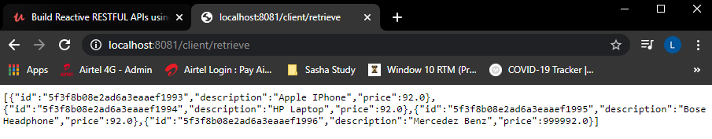

Pulled the data as below

2020-08-21 14:23:43.207 INFO 11756 --- [ main] c.r.s.itemclient.ItemClientApplication : Started ItemClientApplication in 7.44 seconds (JVM running for 8.968)

2020-08-21 14:24:52.010 INFO 11756 --- [ctor-http-nio-2] reactor.Flux.MonoFlatMapMany.1 : onSubscribe(MonoFlatMapMany.FlatMapManyMain)

2020-08-21 14:24:52.012 INFO 11756 --- [ctor-http-nio-2] reactor.Flux.MonoFlatMapMany.1 : request(unbounded)

2020-08-21 14:25:01.207 INFO 11756 --- [ctor-http-nio-4] reactor.Flux.MonoFlatMapMany.1 : onNext(Item(id=5f3f8b08e2ad6a3eaaef1993, description=Apple IPhone, price=92.0))

2020-08-21 14:25:01.209 INFO 11756 --- [ctor-http-nio-4] reactor.Flux.MonoFlatMapMany.1 : onNext(Item(id=5f3f8b08e2ad6a3eaaef1994, description=HP Laptop, price=92.0))

2020-08-21 14:25:01.209 INFO 11756 --- [ctor-http-nio-4] reactor.Flux.MonoFlatMapMany.1 : onNext(Item(id=5f3f8b08e2ad6a3eaaef1995, description=Bose Headphone, price=92.0))

2020-08-21 14:25:01.210 INFO 11756 --- [ctor-http-nio-4] reactor.Flux.MonoFlatMapMany.1 : onNext(Item(id=5f3f8b08e2ad6a3eaaef1996, description=Mercedez Benz, price=999992.0))

2020-08-21 14:25:01.212 INFO 11756 --- [ctor-http-nio-4] reactor.Flux.MonoFlatMapMany.1 : onComplete()

The second method that we have is the exchange method as below – in previous one, we used retrieve

The only difference is that the exchange method is going to give you the ServerResponse and not the body

public interface WebClient {

RequestHeadersUriSpec<?> get();

RequestHeadersUriSpec<?> head();

RequestBodyUriSpec post();

RequestBodyUriSpec put();

RequestBodyUriSpec patch();

RequestHeadersUriSpec<?> delete();

RequestHeadersUriSpec<?> options();

RequestBodyUriSpec method(HttpMethod method);

Builder mutate();

static WebClient create() {

return new DefaultWebClientBuilder().build();

}

static WebClient create(String baseUrl) {

return new DefaultWebClientBuilder().baseUrl(baseUrl).build();

}

static WebClient.Builder builder() {

return new DefaultWebClientBuilder();

}

interface Builder {

Builder baseUrl(String baseUrl);

. . .

}

interface RequestHeadersSpec<S extends RequestHeadersSpec<S>> {

. . .

ResponseSpec retrieve();

Mono<ClientResponse> exchange();

}

. . .

}

So we have to use this as below – use the flatMapMany operator and using that we will get access to the clientResponse object and then we can use the bodyToFlux method to get the Item

@RestController

public class ItemController {

// Item Reactive APIs host and port

WebClient webClient = WebClient.create("http://localhost:8080");

@GetMapping("/client/retrieve")

public Flux<Item> getAllItemsUsingRetrieve() {

return webClient.get()

.uri("/v1/items")

.retrieve()

.bodyToFlux(Item.class)

.log("Items in the client project - retrieve way");

}

@GetMapping("/client/exchange")

public Flux<Item> getAllItemsUsingExchange() {

return webClient.get()

.uri("/v1/items")

.exchange()

.flatMapMany( clientResponse -> clientResponse.bodyToFlux(Item.class))

.log("Items in the client project - exchange way");

}

}

Path variables using WebClient

How do we pass the path variable using the WebClient

@RestController

public class ItemController {

// Item Reactive APIs host and port

WebClient webClient = WebClient.create("http://localhost:8080");

. . .

@GetMapping("/client/singleitem")

public Flux<Item> getOneItemUsingExchangeAndPathVariable() {

String id = "MBZ";

return webClient.get()

.uri("/v1/fun/items/{id}", id)

.exchange()

.flatMapMany( clientResponse -> clientResponse.bodyToFlux(Item.class))

.log("Items in the client project - exchange way");

}

}

POST call using the WebClient

@RestController

public class ItemController {

WebClient webClient = WebClient.create("http://localhost:8080");

. . .

@PostMapping("/client/createItem")

public Mono<Item> createItemRequestBody(@RequestBody Item item) {

Mono<Item> monoItem = Mono.just(item);

return webClient.post().uri( "/v1/fun/items" )

.contentType( MediaType.APPLICATION_JSON )

.body( monoItem, Item.class )

.retrieve()

.bodyToMono( Item.class )

.log( "Created a Item" );

}

}

Use postman to post to the method

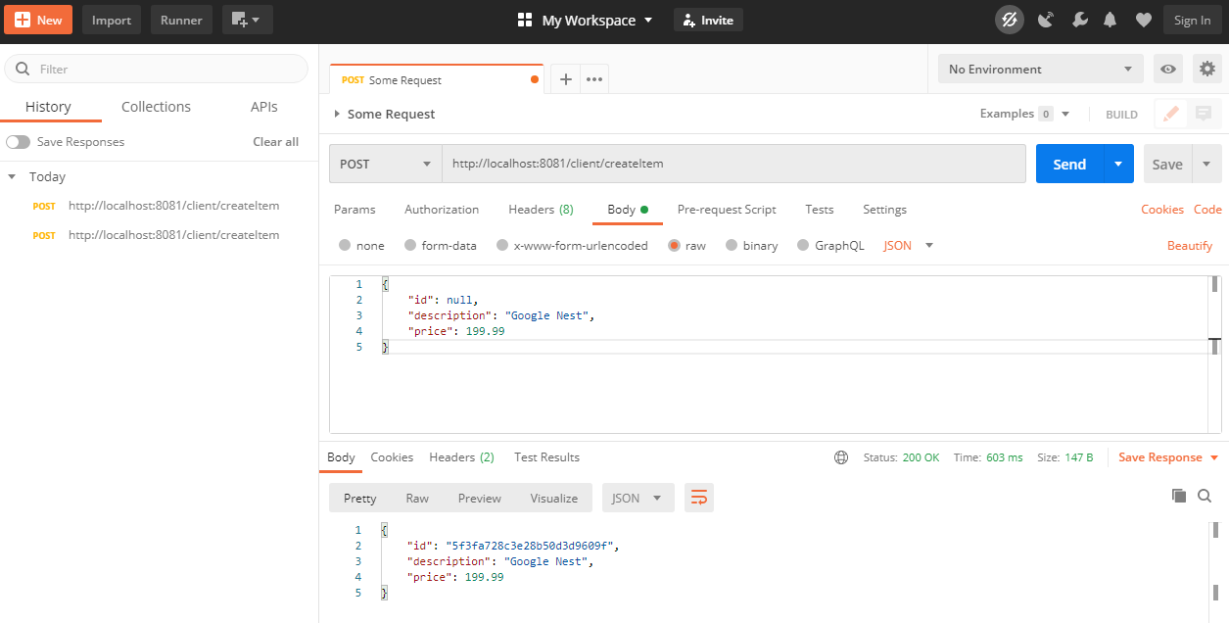

The curl command for posting this would be as below

$ curl –d "{"id": null, "description": "Google Nest","price": 199.99}" –H "Content-Type: application/json" –X post http://localhost:8081/client/createItem

Id is passes as null as the Mongo DB would be generating the id for it.

PUT call using the WebClient

@RestController

public class ItemController {

WebClient webClient = WebClient.create("http://localhost:8080");

. . .

@PutMapping("/client/updateItem/{id}")

public Mono<Item> updateItem(@PathVariable String id, @RequestBody Item item) {

Mono<Item> monoItem = Mono.just( item );

return webClient.put().uri( "/v1/fun/items/{id}", id )

.body( monoItem, Item.class)

.retrieve()

.bodyToMono( Item.class)

.log( "Updated Item is: " );

}

}

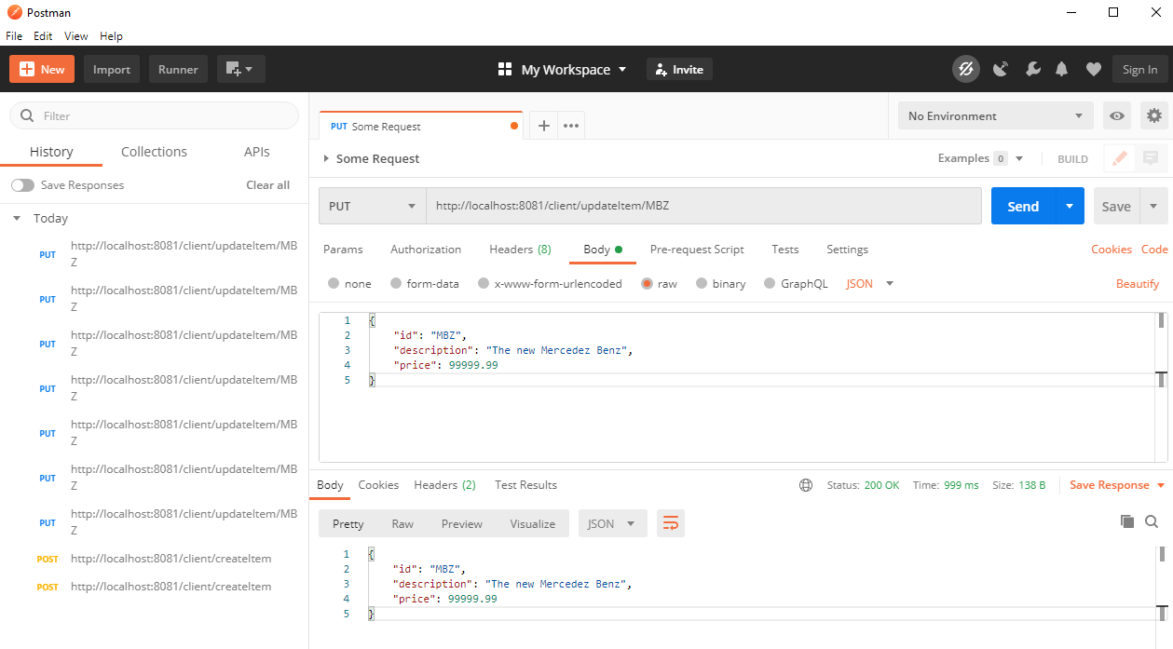

The curl command to do this would be as below

$ curl –d "{"id": "MBZ", "description": "The new Mercedez Benz","price": 999999.99}" –H "Content-Type: application/json" –X put http://localhost:8081/client/updateItem/MBZ

Do a retrieve and check the record is updated with the following command

C:\Users\Dimpu> curl http://localhost:8081/client/retrieve

[{"id":"5f3fb7a8192fe22c77f33170","description":"Apple IPhone","price":92.0},{"id":"5f3fb7a8192fe22c77f33171","description":"HP Laptop","price":92.0},{"id":"5f3fb7a8192fe22c77f33172","description":"Bose Headphone","price":92.0},{"id":"MBZ","description":"The new Mercedez Benz","price":99999.99}]

DELETE call using the WebClient

@RestController

public class ItemController {

WebClient webClient = WebClient.create("http://localhost:8080");

. . .

@DeleteMapping( "/client/deleteItem/{id}" )

public Mono<Void> deleteItem( @PathVariable String id ) {

return webClient.delete().uri( "/v1/fun/items/{id}", id )

.retrieve()

.bodyToMono( Void.class )

.log( "Updated Item is: " );

}

}

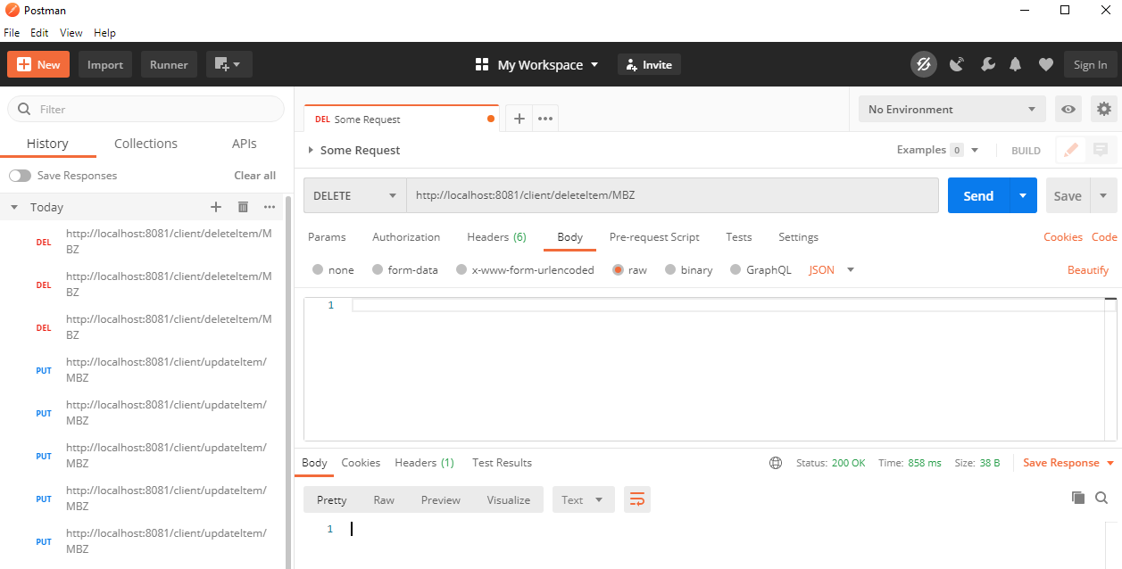

$ curl –X "DELETE" <http://localhost:8081/client/deleteItem/MBZ>

$ curl <http://localhost:8081/client/retrieve>

[{"id":"5f3fbd817b271d29e5490e0d","description":"Apple IPhone","price":92.0},{"id":"5f3fbd817b271d29e5490e0e","description":"HP Laptop","price":92.0},{"id":"5f3fbd817b271d29e5490e0f","description":"Bose Headphone","price":92.0}]

Handling Exceptions

Lets introduce a new method to illustrate how to handle exceptions now. Lets build a endpoint that is going to intentionally throw a RuntimeException

@RestController

@Slf4j

public class ItemController {

. . .

@GetMapping(ITEM_END_POINT_V1 + "/runtimeException")

public Flux runtimeException() {

return itemReactiveRepository.findAll()

.concatWith( Mono.error( new RuntimeException( "Runtime Exception occurred" ) ) );

}

}

Requesting on this link we would get the following response

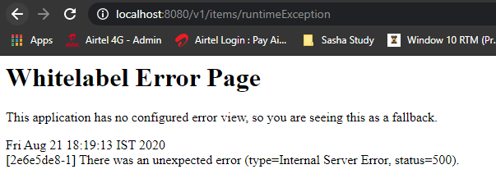

We get the following in the logs

java.lang.RuntimeException: Runtime Exception occurred

at com.reactive.app.item.controller.v1.ItemController.runtimeException(ItemController.java:63) ~[classes/:na]

Suppressed: reactor.core.publisher.FluxOnAssembly$OnAssemblyException:

Error has been observed at the following site(s):

|_ checkpoint ⇢ Handler com.reactive.app.item.controller.v1.ItemController#runtimeException() [DispatcherHandler]

|_ checkpoint ⇢ HTTP GET "/v1/items/runtimeException" [ExceptionHandlingWebHandler]

Lets add a Exception Handler now

@RestController

@Slf4j

public class ItemController {

@Autowired

ItemReactiveRepository itemReactiveRepository;

. . .

@ExceptionHandler(RuntimeException.class)

public ResponseEntity<String> handleRuntimeException(RuntimeException rtException) {

log.error("Exception caught in handleRuntimeException {} ", rtException);

return ResponseEntity.status( HttpStatus.INTERNAL_SERVER_ERROR )

.body( rtException.getMessage() );

}

. . .

}

Lets see the response now

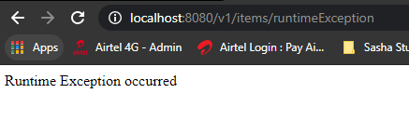

$ curl http://localhost:8080/v1/items/runtimeException

Runtime Exception occurred

If we have multiple controllers then we wouldn’t want to duplicate this for all the Controllers so lets see how to write this as a common code.

Write a class called ControllerExceptionHandler

import org.springframework.http.HttpStatus;

import org.springframework.http.ResponseEntity;

import org.springframework.web.bind.annotation.ControllerAdvice;

import org.springframework.web.bind.annotation.ExceptionHandler;

import lombok.extern.slf4j.Slf4j;

@ControllerAdvice

@Slf4j

public class ControllerExceptionHandler {

@ExceptionHandler(RuntimeException.class)

public ResponseEntity<String> handleRuntimeException(RuntimeException rtException) {

log.error("RuntimeException caught in Controller Advice: ", rtException);

return ResponseEntity.status(HttpStatus.INTERNAL_SERVER_ERROR)

.body("From Controller Advice: " + rtException.getMessage());

}

@ExceptionHandler(Exception.class)

public ResponseEntity<String> handleException(Exception exception) {

log.error("Exception caught in Controller Advice: ", exception);

return ResponseEntity.status("From Controller Advice: " + HttpStatus.INTERNAL_SERVER_ERROR)

}

}

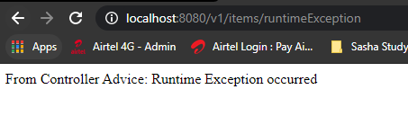

Comment the previous @ExceptionHandler method that we had put into the Controller class for this to work from @ControllerAdvice

JUnit test case for Exception scenarios

import static org.junit.Assert.assertTrue;

import java.util.Arrays;

import java.util.List;

import org.junit.Before;

import org.junit.Test;

import org.junit.runner.RunWith;

import org.springframework.beans.factory.annotation.Autowired;

import org.springframework.boot.test.autoconfigure.web.reactive.AutoConfigureWebTestClient;

import org.springframework.boot.test.context.SpringBootTest;

import org.springframework.http.HttpStatus;

import org.springframework.http.MediaType;

import org.springframework.test.annotation.DirtiesContext;

import org.springframework.test.context.ActiveProfiles;

import org.springframework.test.context.junit4.SpringRunner;

import org.springframework.test.web.reactive.server.WebTestClient;

import com.reactive.app.item.Item;

import com.reactive.app.item.ItemConstants;

import com.reactive.app.item.v1.repository.ItemReactiveRepository;

import reactor.core.publisher.Flux;

import reactor.core.publisher.Mono;

import reactor.test.StepVerifier;

@SpringBootTest

@RunWith(SpringRunner.class)

@DirtiesContext

@AutoConfigureWebTestClient

@ActiveProfiles("test")

public class ItemControllerTest {

@Autowired

WebTestClient webTestClient;

@Autowired

ItemReactiveRepository itemReactiveRepository;

. . .

@Test

public void runTimeException() {

webTestClient.get()

.uri(ItemConstants.ITEM_END_POINT_V1 + "/runtimeException")

.exchange()

.expectStatus().is5xxServerError()

.expectBody(String.class)

.isEqualTo("From Controller Advice: Runtime Exception occurred");

}

}

## Handling Exceptions in WebFlux

Lets see how the exception handling works in the functional web module. Lets create a error route in the ItemsRouter class

import static com.reactive.app.item.ItemConstants.ITEM_FUNCTIONAL_END_POINT_V1;

import org.springframework.context.annotation.Bean;

import org.springframework.context.annotation.Configuration;

import org.springframework.http.MediaType;

import org.springframework.web.reactive.function.server.RequestPredicates;

import org.springframework.web.reactive.function.server.RouterFunction;

import org.springframework.web.reactive.function.server.RouterFunctions;

import org.springframework.web.reactive.function.server.ServerResponse;

import com.reactive.app.item.v1.handler.ItemsHandler;

@Configuration

public class ItemsRouter {

@Bean

public RouterFunction<ServerResponse> itemsRoute(ItemsHandler itemsHandler) {

return RouterFunctions

.route( RequestPredicates.GET( ITEM_FUNCTIONAL_END_POINT_V1)

.and( RequestPredicates.accept( MediaType.APPLICATION_JSON ) ),

itemsHandler::getAllItems )

.andRoute( RequestPredicates.GET( ITEM_FUNCTIONAL_END_POINT_V1 + "/{id}" )

.and( RequestPredicates.accept( MediaType.APPLICATION_JSON ) ),

itemsHandler::getOneItem )

.andRoute( RequestPredicates.POST( ITEM_FUNCTIONAL_END_POINT_V1 )

.and( RequestPredicates.accept( MediaType.APPLICATION_JSON ) ),

itemsHandler::createItem )

.andRoute( RequestPredicates.DELETE( ITEM_FUNCTIONAL_END_POINT_V1 + "/{id}" )

.and( RequestPredicates.accept( MediaType.APPLICATION_JSON ) ),

itemsHandler::deleteItem )

.andRoute( RequestPredicates.PUT(ITEM_FUNCTIONAL_END_POINT_V1 + "/{id}")

.and( RequestPredicates.accept( MediaType.APPLICATION_JSON ) ),

itemsHandler::updateItem );

}

@Bean

public RouterFunction<ServerResponse> errorRoute(ItemsHandler itemsHandler) {

return RouterFunctions.route( RequestPredicates.GET("/fun/items/runtimeException")

.and( RequestPredicates.accept(

MediaType.APPLICATION_JSON)),

itemsHandler::itemsException);

}

}

We have added another @Bean configuration to specify error routes above. Lets create the method itemsException in the itemsHandler now

import org.springframework.beans.factory.annotation.Autowired;

import org.springframework.http.MediaType;

import org.springframework.stereotype.Component;

import org.springframework.web.reactive.function.server.ServerRequest;

import org.springframework.web.reactive.function.server.ServerResponse;

import com.reactive.app.item.Item;

import com.reactive.app.item.v1.repository.ItemReactiveRepository;

import reactor.core.publisher.Mono;

@Component

public class ItemsHandler {

@Autowired

ItemReactiveRepository itemReactiveRepository;

static Mono<ServerResponse> notFound = ServerResponse.notFound().build();

public Mono<ServerResponse> getAllItems(ServerRequest serverRequest) {

return ServerResponse.ok()

.contentType( MediaType.APPLICATION_JSON )

.body( itemReactiveRepository.findAll(), Item.class );

}

public Mono<ServerResponse> getOneItem(ServerRequest serverRequest) {

String id = serverRequest.pathVariable("id");

return ServerResponse.ok()

.contentType( MediaType.APPLICATION_JSON)

.body( itemReactiveRepository.findById( id ), Item.class)

.switchIfEmpty( notFound );

}

public Mono<ServerResponse> createItem(ServerRequest serverRequest) {

Mono<Item> itemToCreate = serverRequest.bodyToMono( Item.class );

return itemToCreate.flatMap( item -> ServerResponse.ok()

.contentType( MediaType.APPLICATION_JSON )

.body( itemReactiveRepository.save(item), Item.class));

}

public Mono<ServerResponse> deleteItem(ServerRequest serverRequest) {

String idOfItemToDelete = serverRequest.pathVariable("id");

Mono<Void> deleteItem = itemReactiveRepository.deleteById( idOfItemToDelete );

return ServerResponse.ok()

.contentType( MediaType.APPLICATION_JSON )

.body( deleteItem, Void.class );

}

public Mono<ServerResponse> updateItem(ServerRequest serverRequest) {

String idOfItemToUpdate = serverRequest.pathVariable("id");

Mono<Item> itemToUpdate =

serverRequest.bodyToMono( Item.class )

.flatMap( item -> {

Mono<Item> monoItem =

itemReactiveRepository.findById( idOfItemToUpdate )

.flatMap( currentItem -> {

currentItem.setDescription(

item.getDescription() );

currentItem.setPrice( item.getPrice() );

return itemReactiveRepository.save(currentItem);

});

return monoItem;

});

return ServerResponse.ok()

.contentType( MediaType.APPLICATION_JSON )

.body( itemToUpdate, Item.class )

.switchIfEmpty( notFound );

}

public Mono<ServerResponse> itemsException(ServerRequest serverRequest) {

throw new RuntimeException("From ItemsHandler.itemsException method:

Runtime Exception Occurred");

}

}

We have specified the uri as /fun/items/runtimeException instead of v1/fun/items/runtimeException as it was taking the runtimeException as a id due to our urls of /v1/fun/items/{id} in other Rest endpoints

$ curl http://localhost:8080/fun/items/runtimeException

{"timestamp":"2020-08-25T03:21:18.414+00:00","path":"/fun/items/runtimeException","status":500,"error":"Internal Server Error","message":"","requestId":"71d71910-3"}

So which class is responsible for populating these values, there is a class called DefaultErrorWebExceptionHandler that is responsible for populating the error values in the error response by default.

public class DefaultErrorWebExceptionHandler extends AbstractErrorWebExceptionHandler {

private static final MediaType TEXT_HTML_UTF8 = new MediaType("text", "html", StandardCharsets.UTF_8);

private static final Map<HttpStatus.Series, String> SERIES_VIEWS;

static {

Map<HttpStatus.Series, String> views = new EnumMap<>(HttpStatus.Series.class);

views.put(HttpStatus.Series.CLIENT_ERROR, "4xx");

views.put(HttpStatus.Series.SERVER_ERROR, "5xx");

SERIES_VIEWS = Collections.unmodifiableMap(views);

}

private final ErrorProperties errorProperties;

. . .

}

Lets try to override the default behavior of this class using the AbstractErrorWebExceptionHandler class now

import java.util.Map;

import org.springframework.boot.autoconfigure.web.ResourceProperties;

import org.springframework.boot.autoconfigure.web.reactive.error.AbstractErrorWebExceptionHandler;

import org.springframework.boot.web.reactive.error.ErrorAttributes;

import org.springframework.context.ApplicationContext;

import org.springframework.http.HttpStatus;

import org.springframework.http.MediaType;

import org.springframework.http.codec.ServerCodecConfigurer;

import org.springframework.stereotype.Component;

import org.springframework.web.reactive.function.BodyInserters;

import org.springframework.web.reactive.function.server.RequestPredicates;

import org.springframework.web.reactive.function.server.RouterFunction;

import org.springframework.web.reactive.function.server.RouterFunctions;

import org.springframework.web.reactive.function.server.ServerRequest;

import org.springframework.web.reactive.function.server.ServerResponse;

import lombok.extern.slf4j.Slf4j;

import reactor.core.publisher.Mono;

@Component

@Slf4j

public class FunctionalErrorWebExceptionHandler extends AbstractErrorWebExceptionHandler {

public FunctionalErrorWebExceptionHandler(ErrorAttributes errorAttributes,

ApplicationContext applicationContext,

ServerCodecConfigurer serverCodecConfigurer) {

super(errorAttributes, new ResourceProperties(), applicationContext);

super.setMessageWriters(serverCodecConfigurer.getWriters());

super.setMessageReaders(serverCodecConfigurer.getReaders());

// TODO Auto-generated constructor stub

}

@Override

protected RouterFunction<ServerResponse> getRoutingFunction(ErrorAttributes errorAttributes) {

// TODO Auto-generated method stub

return RouterFunctions.route(RequestPredicates.all(), this::renderErrorResponse);

}

private Mono<ServerResponse> renderErrorResponse(ServerRequest serverRequest) {

Map<String,Object> errorAttributesMap = getErrorAttributes(serverRequest,

ErrorAttributeOptions.defaults());

log.info("ErrorAttributesMap: "+errorAttributesMap);

errorAttributesMap.put("message", "From FunctionalWebExceptionHandler: A Runtime

Exception has Occurred");

return ServerResponse.*status*(HttpStatus.*INTERNAL_SERVER_ERROR*)

.contentType( MediaType.APPLICATION_JSON )

.body(BodyInserters.*fromValue*("From FunctionalWebExceptionHandler: A Runtime

Exception has Occurred"));

}

}

We extended the AbstractErrorWebExceptionHandler. We called the super constructor passing the errorAttributes a new ResourceProperties object and the applicationContext. We then set the MessageReaders and MessageWriters using the serverCodecConfigurer. Note that we use the constructor that populates ServerCodecConfigurer, ApplicationContext and ErrorAttributes. In the renderErrorResponse method we return the server response with internal server error and specify the content type as json and in the body we use the BodyInserters.fromObject and just pass the message only from the errorAttributesMap. So this is how we have customized the exception handler.

We just got the message of Runtime Exception occurred now as compared to the previous one in screenshot below

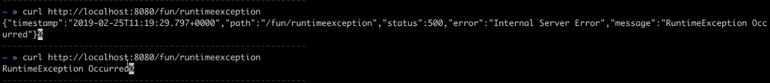

In the log we can see the ErrorAttributesMap:

From ItemsHandler.itemsException method: Runtime Exception Occurred

2020-08-25 20:49:52.111 INFO 6764 --- [ctor-http-nio-7] i.v.e.FunctionalErrorWebExceptionHandler : ErrorAttributesMap: {timestamp=Tue Aug 25 20:49:52 IST 2020, path=/fun/items/runtimeException, status=500, error=Internal Server Error, message=RuntimeException Occurred, requestId=c2a6d9f4-6}

2020-08-25 20:49:52.112 ERROR 6764 --- [ctor-http-nio-7] a.w.r.e.AbstractErrorWebExceptionHandler : [c2a6d9f4-6] 500 Server Error for HTTP GET "/fun/items/runtimeException"

JUnit Test cases for Error Response being returned to us

In the ItemHandlerTest.java file

@SpringBootTest

@RunWith(SpringRunner.class)

@DirtiesContext

@AutoConfigureWebTestClient

@ActiveProfiles("test")

public class ItemHandlerTest {

@Autowired

WebTestClient webTestClient;

@Autowired

ItemReactiveRepository itemReactiveRepository;

. . .

@Test

public void runtimeException() {

webTestClient.get().uri("/fun/items/runtimeException")

.exchange()

.expectStatus().is5xxServerError()

.expectBody()

.jsonPath("$.message", "A Runtime Exception has Occurred");

}

}

The test case passed.

Handling Errors in WebClient - retrieve()

Lets explore the approaches of handling the error response code using the client

In the ItemControllerClient class.

@RestController

public class ItemControllerClient {

// Item Reactive APIs host and port

WebClient webClient = WebClient.create("http://localhost:8080");

. . .

public Flux<Item> errorRetrieve() {

return webClient.get().uri("/v1/items/runtimeException")

.retrieve()

.onStatus( HttpStatus::is5xxServerError, clientResponse -> {

Mono<String> errorMono = clientResponse.bodyToMono( String.class );

return errorMono.flatMap( errorMessage -> {

//TODO: Change this to log.error()

System.err.println( "ItemControllerCLient caught this exception:" );

throw new RuntimeException( "A Runtime Exception Occurred" );

});

})

.bodyToFlux( Item.class );

}

}

$ curl http://localhost:8080/fun/items/runtimeException

A Runtime Exception has Occurred

$ curl http://localhost:8081/client/retrieve/error

{"timestamp":"2020-08-26T03:31:01.666+00:00","path":"/client/retrieve/error","status":500,"error":"Internal Server Error","message":"","requestId":"ff1d8f3c-1"}

And in the logs we would see the below

ItemControllerCLient caught this exception: From FunctionalWebExceptionHandler: A Runtime Exception has Occurred

2020-08-26 09:05:55.934 ERROR 4700 --- [ctor-http-nio-3] a.w.r.e.AbstractErrorWebExceptionHandler : [b5953de9-2] 500 Server Error for HTTP GET "/client/retrieve/error"

java.lang.RuntimeException: A Runtime Exception has Occurred

at com.reactive.spring.itemclient.controller.ItemControllerClient.lambda$errorRetrieve$2(ItemControllerClient.java:101) ~[classes/:na]

Suppressed: reactor.core.publisher.FluxOnAssembly$OnAssemblyException:

Error has been observed at the following site(s):

|_ checkpoint ⇢ 500 from GET http://localhost:8080/fun/items/runtimeException [DefaultWebClient]

|_ checkpoint ⇢ Handler com.reactive.spring.itemclient.controller.ItemControllerClient#errorRetrieve() [DispatcherHandler]

|_ checkpoint ⇢ HTTP GET "/client/retrieve/error" [ExceptionHandlingWebHandler]

Lets see how to handle this using the exchange method now

Handling Errors in WebClient - exchange()

Lets code for the exchange method now which is slightly different than the retrieve method

@GetMapping("/client/exchange/error")

public Flux<Item> errorExchange() {

return webClient.get()

.uri("/fun/items/runtimeException")

.exchange()

.flatMapMany( clientResponse -> {

if (clientResponse.statusCode().is5xxServerError()) {

return clientResponse.bodyToMono(String.class)

.flatMap( errorMessage -> {

log.error("Error message in errorExchange method: "+ errorMessage);

throw new RuntimeException(errorMessage);

});

} else {

return clientResponse.bodyToFlux(Item.class);

}

});

}

On requesting using the curl command we get

$ curl http://localhost:8081/client/exchange/error

{"timestamp":"2020-08-27T02:15:55.963+00:00","path":"/client/exchange/error","status":500,"error":"Internal Server Error","message":"","requestId":"cac6325d-1"}

In the logs we see

java.lang.RuntimeException: From FunctionalWebExceptionHandler: A Runtime Exception has Occurred

at com.reactive.spring.itemclient.controller.ItemControllerClient.lambda$6(ItemControllerClient.java:120) ~[classes/:na]

Suppressed: reactor.core.publisher.FluxOnAssembly$OnAssemblyException:

Error has been observed at the following site(s):

|_ checkpoint ⇢ Handler com.reactive.spring.itemclient.controller.ItemControllerClient#errorExchange() [DispatcherHandler]

|_ checkpoint ⇢ HTTP GET "/client/exchange/error" [ExceptionHandlingWebHandler]

So this was about how to handle the error on the client side.

## Streaming Endpoints ( Server Sent Events )

What is the meaning of a Streaming Endpoint – It means that it is a endpoint that is going to keep pushing the data to the client as the new data is available in a continous fashion. The regular non blocking – non streaming endpoing behaves like this. This is the type of endpoint that we have been coding so far.

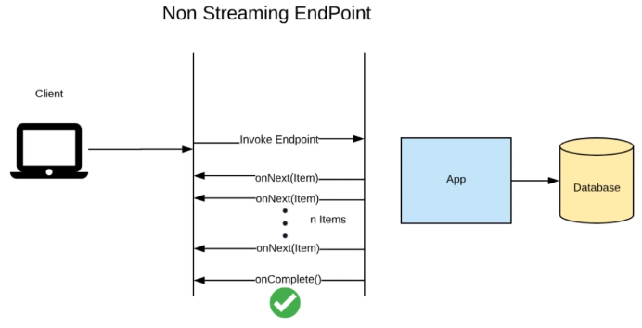

In case of a Streaming endpoint – once the connection is established with the server, it remains open and new data is sent to the client as it is added to the client.

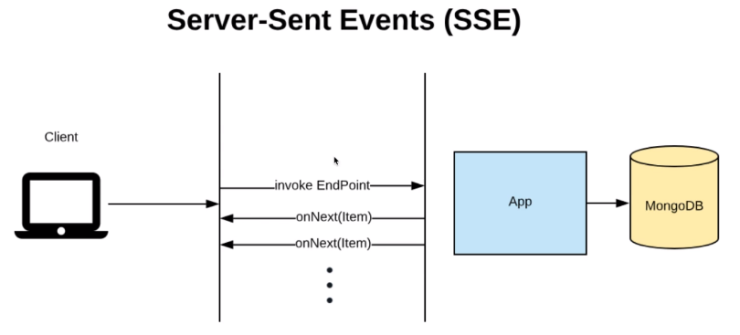

The use cases for real time streaming are many like the following

* Stock Tickers
* Weather Updates
* Flight Arrivals/ Departure/ Delay updates in Airports

Setting up the Capped Collection in MongoDB

There are some new terminologies in MongoDB

**Tailable Cursor** –

By default MongoDB closes the connection after all the data is received for current request. A tailable cursor will keep the connection open even when there is no data for a give request. As and when the new data is available then the cursor would return the data. See <http://docs.mongodb.com/manual/core/tailable-cursors/index.html>

By default, MongoDB will automatically close a cursor when the client has exhausted all results in the cursor. However, for [capped collections](https://docs.mongodb.com/manual/core/capped-collections/) you may use a Tailable Cursor that remains open after the client exhausts the results in the initial cursor. Tailable cursors are conceptually equivalent to the tail Unix command with the -f option (i.e. with “follow” mode). After clients insert new additional documents into a capped collection, the tailable cursor will continue to retrieve documents.

Use tailable cursors on capped collections that have high write volumes where indexes aren’t practical. For instance, MongoDB [replication](https://docs.mongodb.com/manual/replication/) uses tailable cursors to tail the primary’s [oplog](https://docs.mongodb.com/manual/reference/glossary/#term-oplog).

**Capped Collections** –

Collection of fixed-side in MongoDB is a Capped Collection. They are there for fast retrieval and insertion, they preserve the insertion order – we can read more on capped collections here. <https://docs.mongodb.com/manual/core/capped-collections/>

Capped collections are fixed-size collections that support high-throughput operations that insert and retrieve documents based on insertion order. Capped collections work in a way similar to circular buffers: once a collection fills its allocated space, it makes room for new documents by overwriting the oldest documents in the collection.

We have been using the following document so far in all our examples above ( just created a different project for streaming examples and renamed Item to ItemCapped ). We will use this to create a Capped Collection

* Never ever use a capped collection for permanent storage.

import org.springframework.data.annotation.Id;

import org.springframework.data.mongodb.core.mapping.Document;

import lombok.AllArgsConstructor;

import lombok.Data;

import lombok.NoArgsConstructor;

@Document

@Data

@AllArgsConstructor

@NoArgsConstructor

public class ItemCapped {

@Id

private String id;

private String description;

private Double price;

// @Data annotation gives the getters/ setters

}

Lets look at the code example now.

Created a new project with following dependencies

<?xml version="1.0" encoding="UTF-8"?>

<project xmlns="http://maven.apache.org/POM/4.0.0"

xmlns:xsi="http://www.w3.org/2001/XMLSchema-instance"

xsi:schemaLocation="http://maven.apache.org/POM/4.0.0 https://maven.apache.org/xsd/maven-4.0.0.xsd">

<modelVersion>4.0.0</modelVersion>

<parent>

<groupId>org.springframework.boot</groupId>

<artifactId>spring-boot-starter-parent</artifactId>

<version>2.3.3.RELEASE</version>

<relativePath/> <!-- lookup parent from repository -->

</parent>

<groupId>com.reactive.spring</groupId>

<artifactId>spring-reactive-streaming</artifactId>

<version>0.0.1-SNAPSHOT</version>

<name>spring-reactive-streaming</name>

<description>Learn Reactive Spring - Streaming Endpoint</description>

<properties>

<java.version>11</java.version>

</properties>

<dependencies>

<dependency>

<groupId>org.springframework.boot</groupId>

<artifactId>spring-boot-starter-webflux</artifactId>

</dependency>

<dependency>

<groupId>org.springframework.boot</groupId>

<artifactId>spring-boot-starter-data-mongodb</artifactId>

</dependency>

<dependency>

<groupId>org.springframework.boot</groupId>

<artifactId>spring-boot-starter-data-mongodb-reactive</artifactId>

</dependency>

<dependency>

<groupId>org.springframework.data</groupId>

<artifactId>spring-data-mongodb</artifactId>

</dependency>

<dependency>

<groupId>org.projectlombok</groupId>

<artifactId>lombok</artifactId>

<optional>true</optional>

</dependency>

<dependency>

<groupId>org.springframework.boot</groupId>

<artifactId>spring-boot-starter-test</artifactId>

<scope>test</scope>

<exclusions>

<exclusion>

<groupId>org.junit.vintage</groupId>

<artifactId>junit-vintage-engine</artifactId>

</exclusion>

</exclusions>

</dependency>

<dependency>

<groupId>io.projectreactor</groupId>

<artifactId>reactor-test</artifactId>

<scope>test</scope>

</dependency>

</dependencies>

<build>

<plugins>

<plugin>

<groupId>org.springframework.boot</groupId>

<artifactId>spring-boot-maven-plugin</artifactId>

</plugin>

</plugins>

</build>

</project>

Created a Capped Item as below.

import org.springframework.data.annotation.Id;

import org.springframework.data.mongodb.core.mapping.Document;

import lombok.AllArgsConstructor;

import lombok.Data;

import lombok.NoArgsConstructor;

@Document

@Data

@AllArgsConstructor

@NoArgsConstructor

public class ItemCapped {

@Id

private String id;

private String description;

private Double price;

// @Data annotation gives the getters/ setters

}

Created a ItemDataInitializer as below

import java.util.Arrays;

import java.util.List;

import org.springframework.beans.factory.annotation.Autowired;

import org.springframework.boot.CommandLineRunner;

import org.springframework.context.annotation.Profile;

import org.springframework.data.mongodb.core.CollectionOptions;

import org.springframework.data.mongodb.core.MongoOperations;

import org.springframework.stereotype.Component;

import com.reactive.spring.streaming.domain.Item;

import com.reactive.spring.streaming.domain.ItemCapped;

import com.reactive.spring.streaming.repository.ItemReactiveRepository;

import reactor.core.publisher.Flux;

@Component

@Profile("!test")

public class ItemDataInitializer implements CommandLineRunner {

@Autowired

ItemReactiveRepository itemReactiveRepository;

@Autowired

MongoOperations mongoOperations;

@Override

public void run(String... args) throws Exception {

initialDataSetup();

createCappedCollection();

}

public List<Item> data() {

List<Item> dataList = Arrays.asList(

new Item(null, "Apple IPhone", 92.00),

new Item(null, "HP Laptop", 92.00),

new Item(null, "Bose Headphone", 92.00),

new Item("MBZ", "Mercedez Benz", 999992.00)

);

return dataList;

}

private void initialDataSetup() {

itemReactiveRepository.deleteAll()

.thenMany( Flux.fromIterable( data() ))

.log()

.flatMap( itemReactiveRepository::save )

.thenMany( itemReactiveRepository.findAll() )

.subscribe( item -> System.out.println("Item inserted -> "+item) );

}

private void createCappedCollection() {

mongoOperations.dropCollection(ItemCapped.class);

// build dependency error somehow

mongoOperations.createCollection(ItemCapped.class, CollectionOptions

.empty()

.maxDocuments(20)

.size(50000)

.capped());

}

}

So as we can see we are using the MongoOperations class ( it gets created during the application startup so we autowired it ) that is Autowired into this class to inject many records returned by the method data(), which in turn get converted to Iterable using Flux.fromIterable and then get logged and saved by doing a flatMap. We then just find them again via the itemReactiveRepository.findAll() method and subscribe and print them out.

After that we called a createCappedCollection() method that droppedCollection using the ItemCapped.class and then created the collection using mongoOperations. We started with CollectionOptions.empty() with maxDocuments and size specified and then mentioned it to be a capped collection.

* Never ever use a capped collection for permanent storage.

Lets create the ItemCappeRepository now as below. We will create a Tailable Cursor in that repository ( it provides the stream kind of output for the repository ). This is part of the mongodb repository in spring framework.

import org.springframework.data.mongodb.repository.ReactiveMongoRepository;

import org.springframework.data.mongodb.repository.Tailable;

import com.reactive.spring.streaming.domain.ItemCapped;

import reactor.core.publisher.Flux;

public interface ItemReactiveRepository extends ReactiveMongoRepository<ItemCapped, String> {

@Tailable

Flux<ItemCapped> findItemsBy();

}

We already have a data setup for Item, we now need it for the ItemCapped collection in the class ItemDataInitializer, see code above.

import java.time.Duration;

import java.util.Arrays;

import java.util.List;

import org.springframework.beans.factory.annotation.Autowired;

import org.springframework.boot.CommandLineRunner;

import org.springframework.context.annotation.Profile;

import org.springframework.data.mongodb.core.CollectionOptions;

import org.springframework.data.mongodb.core.MongoOperations;

import org.springframework.stereotype.Component;

import com.reactive.spring.streaming.domain.Item;

import com.reactive.spring.streaming.domain.ItemCapped;

import com.reactive.spring.streaming.repository.ItemReactiveCappedRepository;

import com.reactive.spring.streaming.repository.ItemReactiveRepository;

import reactor.core.publisher.Flux;

@Component

@Profile("!test")

public class ItemDataInitializer implements CommandLineRunner {

@Autowired

ItemReactiveRepository itemReactiveRepository;

@Autowired

ItemReactiveCappedRepository itemReactiveCappedRepository;

@Autowired

MongoOperations mongoOperations;

@Override

public void run(String... args) throws Exception {

initialDataSetup();

createCappedCollection();

}

public List<Item> data() {

List<Item> dataList = Arrays.asList(

new Item(null, "Apple IPhone", 92.00),

new Item(null, "HP Laptop", 92.00),

new Item(null, "Bose Headphone", 92.00),

new Item("MBZ", "Mercedez Benz", 999992.00)

);

return dataList;

}

private void dataSetupForCappedCollection() {

Flux<ItemCapped> itemCappedFlux = Flux.interval( Duration.ofSeconds(1))

.map(i ->

new ItemCapped(null, "Random Item "+i, 100.00 + i));

itemReactiveCappedRepository.insert(itemCappedFlux)

.subscribe( itemCapped ->

System.out.println("Inserted item is: " + itemCapped) );

}

private void initialDataSetup() {

itemReactiveRepository.deleteAll()

.thenMany( Flux.fromIterable( data() ))

.log()

.flatMap( itemReactiveRepository::save )

.thenMany( itemReactiveRepository.findAll() )

.subscribe( item -> System.out.println("Item inserted -> "+item) );

}

private void createCappedCollection() {

mongoOperations.dropCollection(ItemCapped.class);

// build dependency error somehow

mongoOperations.createCollection(ItemCapped.class, CollectionOptions

.empty()

.maxDocuments(20)

.size(50000)

.capped());

}

}

The method dataSetupForCappedCollection keeps creating a CappedItem after every 1 second duration and we have inserted that item ( note that it uses the itemCappedFlux and not just the itemCapped ) subscribed to it below and then just printed out the item. Since we are tailing we should get the items as they are inserted.

2020-09-05 14:25:20.467 INFO 8836 --- [ntLoopGroup-3-4] reactor.Flux.ConcatArray.1 : request(1)

2020-09-05 14:25:20.472 INFO 8836 --- [ntLoopGroup-3-2] reactor.Flux.ConcatArray.1 : onComplete()

Item inserted -> Item(id=5f53527875142a4870a89ef8, description=Apple IPhone, price=92.0)

Item inserted -> Item(id=5f53527875142a4870a89ef9, description=HP Laptop, price=92.0)

Item inserted -> Item(id=5f53527875142a4870a89efa, description=Bose Headphone, price=92.0)

Item inserted -> Item(id=MBZ, description=Mercedez Benz, price=999992.0)

Inserted item is: ItemCapped(id=5f53527975142a4870a89efb, description=Random Item 0, price=100.0)

Inserted item is: ItemCapped(id=5f53527a75142a4870a89efc, description=Random Item 1, price=101.0)

Inserted item is: ItemCapped(id=5f53527b75142a4870a89efd, description=Random Item 2, price=102.0)

Inserted item is: ItemCapped(id=5f53527c75142a4870a89efe, description=Random Item 3, price=103.0)

Inserted item is: ItemCapped(id=5f53527d75142a4870a89eff, description=Random Item 4, price=104.0)

Inserted item is: ItemCapped(id=5f53527e75142a4870a89f00, description=Random Item 5, price=105.0)

Inserted item is: ItemCapped(id=5f53527f75142a4870a89f01, description=Random Item 6, price=106.0)

Inserted item is: ItemCapped(id=5f53528075142a4870a89f02, description=Random Item 7, price=107.0)

Inserted item is: ItemCapped(id=5f53528175142a4870a89f03, description=Random Item 8, price=108.0)

Inserted item is: ItemCapped(id=5f53528275142a4870a89f04, description=Random Item 9, price=109.0)

Inserted item is: ItemCapped(id=5f53528375142a4870a89f05, description=Random Item 10, price=110.0)

Inserted item is: ItemCapped(id=5f53528475142a4870a89f06, description=Random Item 11, price=111.0)

Inserted item is: ItemCapped(id=5f53528575142a4870a89f07, description=Random Item 12, price=112.0)

Inserted item is: ItemCapped(id=5f53528675142a4870a89f08, description=Random Item 13, price=113.0)

Inserted item is: ItemCapped(id=5f53528775142a4870a89f09, description=Random Item 14, price=114.0)

**Lets code a Streaming endpoint for our ItemCapped Collection now**

import org.springframework.beans.factory.annotation.Autowired;

import org.springframework.http.MediaType;

import org.springframework.web.bind.annotation.GetMapping;

import org.springframework.web.bind.annotation.RestController;

import com.reactive.spring.streaming.domain.ItemCapped;

import com.reactive.spring.streaming.repository.ItemReactiveCappedRepository;

import reactor.core.publisher.Flux;

@RestController

public class ItemStreamController {

@Autowired

ItemReactiveCappedRepository itemReactiveCappedRepository;

@GetMapping(value = ItemConstants.ITEM_STREAM_END_POINT,

produces=MediaType.APPLICATION_STREAM_JSON_VALUE)

public Flux<ItemCapped> getItemsStream() {

return itemReactiveCappedRepository.findItemsBy();

}

}

Remember that our ItemReactiveCappedRepository class contains a method that is @Tailable returning the end rows as inserted.

import org.springframework.data.mongodb.repository.ReactiveMongoRepository;

import com.reactive.spring.streaming.domain.Item;

import com.reactive.spring.streaming.domain.ItemCapped;

import reactor.core.publisher.Flux;

public interface ItemReactiveCappedRepository extends ReactiveMongoRepository<ItemCapped, String> {

@Tailable

Flux<ItemCapped> findItemsBy();

}

Run the application and we can see the data being streamed to a browser as below

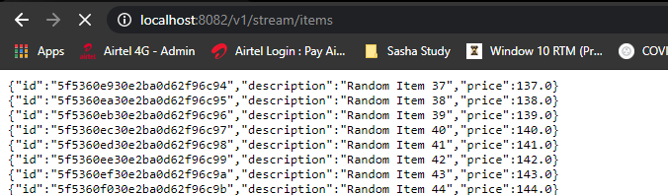

If you reload the browser you would start to see values staring from say 42, reload again then say from 59 and so on.

The JUnit test case for this would be as below

import java.time.Duration;

import org.junit.Before;

import org.junit.Test;

import org.junit.runner.RunWith;

import org.springframework.beans.factory.annotation.Autowired;

import org.springframework.boot.test.autoconfigure.web.reactive.AutoConfigureWebTestClient;

import org.springframework.boot.test.context.SpringBootTest;

import org.springframework.data.mongodb.core.CollectionOptions;

import org.springframework.data.mongodb.core.MongoOperations;

import org.springframework.test.annotation.DirtiesContext;

import org.springframework.test.context.ActiveProfiles;

import org.springframework.test.context.junit4.SpringRunner;

import org.springframework.test.web.reactive.server.WebTestClient;

import com.reactive.spring.streaming.domain.ItemCapped;

import com.reactive.spring.streaming.repository.ItemReactiveCappedRepository;

import reactor.core.publisher.Flux;

import reactor.test.StepVerifier;

@SpringBootTest

@RunWith(SpringRunner.class)

@DirtiesContext

@AutoConfigureWebTestClient

@ActiveProfiles("test")

public class ItemStreamControllerTest {

@Autowired

ItemReactiveCappedRepository itemReactiveCappedRepository;

@Autowired

MongoOperations mongoOperations;

@Autowired

WebTestClient webTestClient;

@Before

public void setUp() {

mongoOperations.dropCollection(ItemCapped.class);

mongoOperations.createCollection(ItemCapped.class, CollectionOptions.empty()

.maxDocuments(20)

.size(50000)

.capped());

Flux<ItemCapped> itemCappedFlux = Flux.interval(Duration.ofMillis(100))

.map(i -> new ItemCapped(null, "Random Item " + i, (100.00 + i)))

.take(5);

itemReactiveCappedRepository

.insert(itemCappedFlux)

.doOnNext((itemCapped -> {

System.out.println("Inserted Item in setUp " + itemCapped);

}))

.blockLast();

}

@Test

public void testStreamAllItems(){

Flux<ItemCapped> itemCappedFlux = webTestClient.get().uri(ItemConstants.ITEM_STREAM_END_POINT)

.exchange()

.expectStatus().isOk()

.returnResult((ItemCapped.class))

.getResponseBody()

.take(5);

StepVerifier.create(itemCappedFlux)

.expectNextCount(5)

.thenCancel()

.verify();

}

}

## Build the Stream Endpoint using Functional Web

Lets write the Streaming Controller first

import org.springframework.beans.factory.annotation.Autowired;

import org.springframework.http.MediaType;

import org.springframework.web.bind.annotation.GetMapping;

import org.springframework.web.bind.annotation.RestController;

import com.reactive.spring.streaming.domain.ItemCapped;

import com.reactive.spring.streaming.repository.ItemReactiveCappedRepository;

import reactor.core.publisher.Flux;

@RestController

public class ItemStreamController {

@Autowired

ItemReactiveCappedRepository itemReactiveCappedRepository;

@GetMapping(value = ItemConstants.ITEM_STREAM_END_POINT,

produces=MediaType.APPLICATION_STREAM_JSON_VALUE)

public Flux<ItemCapped> getItemsStream() {

return itemReactiveCappedRepository.findItemsBy();

}

}

We will then write the Router now

import org.springframework.context.annotation.Bean;

import static org.springframework.http.MediaType.*;

import static org.springframework.http.HttpMethod.*;

import org.springframework.context.annotation.Configuration;

import static org.springframework.web.reactive.function.server.RequestPredicates.*;

import org.springframework.web.reactive.function.server.RouterFunctions;

import org.springframework.web.reactive.function.server.ServerResponse;

@Configuration

public class ItemsRouter {

@Bean

public RouterFunction<ServerResponse> itemStreamRouter(ItemsHandler itemsHandler) {

return RouterFunctions.route(

GET(ItemConstants.ITEM_STREAM_FUNCTIONAL_ENDPOINT)

.and(accept(APPLICATION_JSON)), itemsHandler::itemsStream);

}

}

Lets write the handler now

import static org.springframework.http.MediaType.APPLICATION_STREAM_JSON;

import org.springframework.beans.factory.annotation.Autowired;

import org.springframework.stereotype.Component;

import org.springframework.web.reactive.function.server.ServerRequest;

import org.springframework.web.reactive.function.server.ServerResponse;

import com.reactive.spring.streaming.domain.ItemCapped;

import com.reactive.spring.streaming.repository.ItemReactiveCappedRepository;

import reactor.core.publisher.Mono;

@Component

public class ItemsHandler {

@Autowired

ItemReactiveCappedRepository itemReactiveCappedRepository;

public Mono<ServerResponse> itemsStream(ServerRequest request) {

return ServerResponse.ok()

.contentType(APPLICATION_STREAM_JSON)

.body(itemReactiveCappedRepository.findItemsBy(), ItemCapped.class);

}

}

In the ItemConstants lets define the path now

public interface ItemConstants {

String ITEM_STREAM_FUNCTIONAL_ENDPOINT = "/v1/fun/stream/items";

}

Lets define the Repository class

import org.springframework.data.mongodb.repository.ReactiveMongoRepository;

import org.springframework.data.mongodb.repository.Tailable;

import com.reactive.spring.streaming.domain.ItemCapped;

import reactor.core.publisher.Flux;

public interface ItemReactiveCappedRepository extends ReactiveMongoRepository<ItemCapped, String> {

@Tailable

Flux<ItemCapped> findItemsBy();

}

**ItemCapped.java**

import org.springframework.data.annotation.Id;

import org.springframework.data.mongodb.core.mapping.Document;

import lombok.AllArgsConstructor;

import lombok.Data;

import lombok.NoArgsConstructor;

@Document

@Data

@AllArgsConstructor

@NoArgsConstructor

public class ItemCapped {

@Id

private String id;

private String description;

private Double price;

// @Data annotation gives the getters/ setters

}

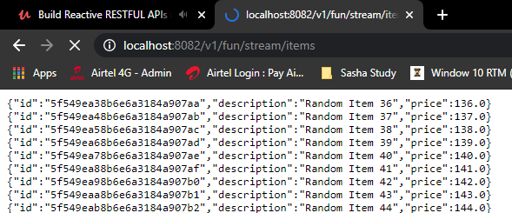

Writing a JUnit test for this now as below

import java.time.Duration;

import org.junit.Before;

import org.junit.Test;

import org.junit.runner.RunWith;

import org.springframework.beans.factory.annotation.Autowired;

import org.springframework.boot.test.autoconfigure.web.reactive.AutoConfigureWebTestClient;

import org.springframework.boot.test.context.SpringBootTest;

import org.springframework.data.mongodb.core.CollectionOptions;

import org.springframework.data.mongodb.core.MongoOperations;

import org.springframework.test.annotation.DirtiesContext;

import org.springframework.test.context.ActiveProfiles;

import org.springframework.test.context.junit4.SpringRunner;

import org.springframework.test.web.reactive.server.WebTestClient;

import com.reactive.spring.streaming.ItemConstants;

import com.reactive.spring.streaming.domain.ItemCapped;

import com.reactive.spring.streaming.repository.ItemReactiveCappedRepository;

import reactor.core.publisher.Flux;

import reactor.test.StepVerifier;

@SpringBootTest

@RunWith(SpringRunner.class)

@DirtiesContext

@AutoConfigureWebTestClient

@ActiveProfiles("test")

public class ItemStreamsHandlerTest {

@Autowired

ItemReactiveCappedRepository itemReactiveCappedRepository;

@Autowired

MongoOperations mongoOperations;

@Autowired

WebTestClient webTestClient;

@Before

public void setUp() {

mongoOperations.dropCollection(ItemCapped.class);

mongoOperations.createCollection(ItemCapped.class,

CollectionOptions.empty().maxDocuments(20).size(50000).capped());

Flux<ItemCapped> itemCappedFlux = Flux.interval(Duration.ofMillis(100))

.map(i -> new ItemCapped(null, "Random Item " + i, (100.00 + i)))

.take(5);

itemReactiveCappedRepository

.insert(itemCappedFlux)

.doOnNext((itemCapped -> {

System.out.println("Inserted Item in setUp " + itemCapped);

}))

.blockLast();

}

@Test

public void testStreamAllItems(){

Flux<ItemCapped> itemCappedFlux = webTestClient.get().uri(

ItemConstants.ITEM_STREAM_FUNCTIONAL_ENDPOINT)

.exchange()

.expectStatus().isOk()

.returnResult((ItemCapped.class))

.getResponseBody()

.take(5);

StepVerifier.create(itemCappedFlux)

.expectNextCount(5)

.thenCancel()

.verify();

}

}

This was the test case for a streaming endpoint that we built using functional web.

## Webflux Kafka – Completely Reactive??

## Reactive Spring Security

<TBD>

<https://dzone.com/articles/reactive-spring-security-for-webflux-rest-web-serv>

<https://medium.com/zero-equals-false/protect-rest-apis-with-spring-security-reactive-and-jwt-7b209a0510f1>

# Spring Data Reactive Repositories

<TBD>

# Reactive Programming

## Reactive Manifesto

Organisations working in disparate domains are independently discovering patterns for building software that look the same. These systems are more robust, more resilient, more flexible and better positioned to meet modern demands.

These changes are happening because application requirements have changed dramatically in recent years. Only a few years ago a large application had tens of servers, seconds of response time, hours of offline maintenance and gigabytes of data. Today applications are deployed on everything from mobile devices to cloud-based clusters running thousands of multi-core processors. Users expect millisecond response times and 100% uptime. Data is measured in Petabytes. Today's demands are simply not met by yesterday’s software architectures.

We believe that a coherent approach to systems architecture is needed, and we believe that all necessary aspects are already recognised individually:

Reactive Systems. - Systems that are Message Driven, Elastic, Responsive & Resilient - (MERR)

Reactive programming is about Non-Blocking Applications that are Asynchronous and Event-Driven and require a small number of threads to scale vertically (i.e. within the JVM) rather than horizontally (i.e. through clustering). A key aspect of reactive applications is the concept of Backpressure which is a mechanism to ensure producers don’t overwhelm consumers. For example in a pipeline of reactive components extending from the database to the HTTP response when the HTTP connection is too slow the data repository can also slow down or stop completely until network capacity frees up. Reactive programming also leads to a major shift from imperative to declarative async composition of logic. It is comparable to writing Blocking Code vs using the CompletableFuture from Java 8 to compose follow-up actions via lambda expressions.

Systems built as Reactive Systems are more flexible, loosely-coupled and scalable. This makes them easier to develop and amenable to change. They are significantly more tolerant of failure and when failure does occur they meet it with elegance rather than disaster. Reactive Systems are highly responsive, giving users effective interactive feedback.

Reactive Systems are:

**Responsive:**The system responds in a timely manner if at all possible. Responsiveness is the cornerstone of usability and utility, but more than that, responsiveness means that problems may be detected quickly and dealt with effectively. Responsive systems focus on providing rapid and consistent response times, establishing reliable upper bounds so they deliver a consistent quality of service. This consistent behaviour in turn simplifies error handling, builds end user confidence, and encourages further interaction.

**Resilient:**The system stays responsive in the face of failure. This applies not only to highly-available, mission-critical systems — any system that is not resilient will be unresponsive after a failure. Resilience is achieved by replication, containment, isolation and delegation. Failures are contained within each component, isolating components from each other and thereby ensuring that parts of the system can fail and recover without compromising the system as a whole. Recovery of each component is delegated to another (external) component and high-availability is ensured by replication where necessary. The client of a component is not burdened with handling its failures.

**Elastic:**The system stays responsive under varying workload. Reactive Systems can react to changes in the input rate by increasing or decreasing the resources allocated to service these inputs. This implies designs that have no contention points or central bottlenecks, resulting in the ability to shard or replicate components and distribute inputs among them. Reactive Systems support Predictive, as well as Reactive, Scaling algorithms by providing relevant live performance measures. They achieve elasticity in a cost-effective way on commodity hardware and software platforms.

**Message Driven:**Reactive Systems rely on asynchronous message-passing to establish a boundary between components that ensures loose coupling, isolation and location transparency. This boundary also provides the means to delegate failures as messages. Employing explicit message-passing enables load management, elasticity, and flow control by shaping and monitoring the message queues in the system and applying back-pressure when necessary. Location transparent messaging as a means of communication makes it possible for the management of failure to work with the same constructs and semantics across a cluster or within a single host. Non-blocking communication allows recipients to only consume resources while active, leading to less system overhead.

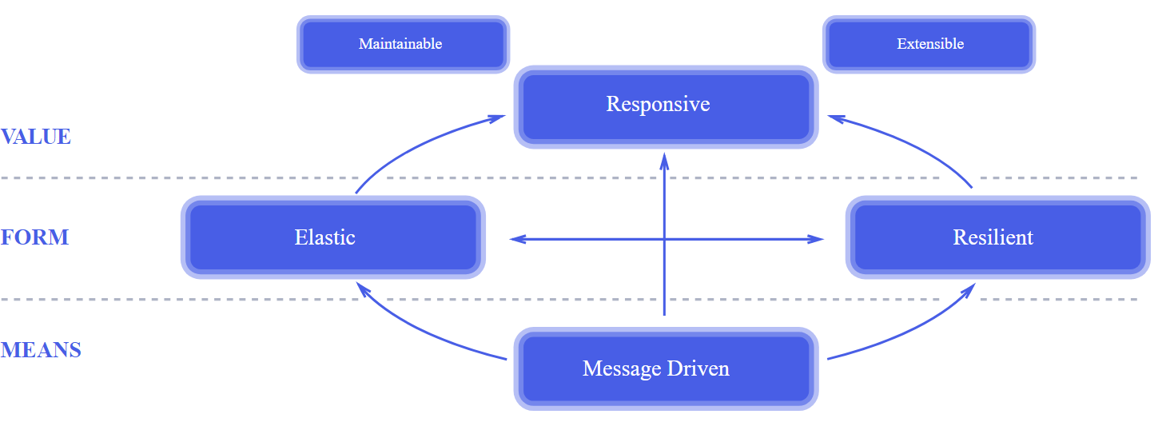

Large systems are composed of smaller ones and therefore depend on the Reactive properties of their constituents. This means that Reactive Systems apply design principles so these properties apply at all levels of scale, making them composable. The largest systems in the world rely upon architectures based on these properties and serve the needs of billions of people daily. It is time to apply these design principles consciously from the start instead of rediscovering them each time.

## WebFlux vs Project Reactor vs RxJava vs Kotlin

## Spring WebFlux Reactor

Reactive programming represents a change in how we think about an application’s execution model.

In a Reactive application, execution does not follow a linear model where one request is handled by one thread, instead, multiple requests are handled in an event-driven and non-blocking manner.

Reactive programming provides an event-based, asynchronous, and streaming programming model that can handle a large volume of concurrent requests coming from a single or multiple clients. Reactive applications usually require a small number of threads to scale vertically, rather than scaling horizontally. Designing and implementing applications using Reactive programming enables the application to maximize its use of the CPU, allowing the application to be more performant and efficient than traditional Java web applications.

**Reactive programming promotes**

1. Asynchronous

2. Non-blocking

3. Event-driven approach to data processing (event-driven architecture)

The term, “reactive,” refers to programming models that are built around reacting to change like network components reacting to I/O events, UI controllers reacting to mouse events, and others. In that sense, non-blocking is reactive, because, instead of being blocked, we are now in the mode of reacting to notifications as operations complete or data becomes available.

**Background**

The origins of Reactive Programming can probably be traced to the 1970s or even earlier.

As a first step in the direction of reactive programming, Microsoft created the Reactive Extensions (Rx) library in the .NET ecosystem. **Rx** was ported to several languages and platforms, including JavaScript, Python, C++, Swift, and Java, of course, called RxJava

The fundamental idea of ReactiveX is that events are data and data are events.

In the JVM world, there are few implementations based on Reactive programming paradigm

1. Reactive Streams

2. RxJava 2.0 ( Original developed by Netflix and later open-sourced )

3. Project Reactor (This is our topic)

4. Vert.x

Why Project Reactor?

Reactor is a fourth-generation reactive library, based on the Reactive Streams specification, for building non-blocking applications on the JVM

Features :

1. Asynchronous and Non-Blocking I/O operations

2. Backpressure saving subscribers from drowning (using reactor netty server)

3. Error handling channels

4. handle a large volume of concurrent requests coming from a single or multiple clients.

5. Functional style programming

6. Reactive streams are push-based which improves performance

**7.** Simple **to use** API’sMono**(for** [0|1] **elements) and**Flux**(for** [N] **elements)**

*Last Point should be the main reason to choose project reactor over other implementations*

1. Non-Blocking for I/O calls

**The key expected benefit of reactive and non-blocking is the ability to scale with a small, fixed number of threads and less memory.**

Blocking Can Be Wasteful

There are, broadly, two ways one can improve a program’s performance:

**parallelize** to use more threads and more hardware resources.

**seek more efficiency** in how current resources are used.

Blocking wastes resources. If you look closely, as soon as a program involves some latency (notably I/O, such as a database request or a network call), resources are wasted because threads (possibly many threads) now sit idle, waiting for data.

**Blocking request processing**

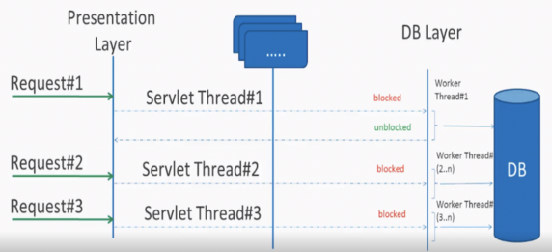

**One thread per connection**

**Non-blocking async request processing**

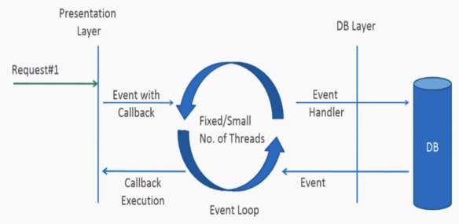

**Single Thread for multiple connections**

Key points:

1. Context Switching using on publisher method on flux/mono
2. Event handler/ event loop

Event handling is achieved by using: Channel**,** BufferandSelector**.**

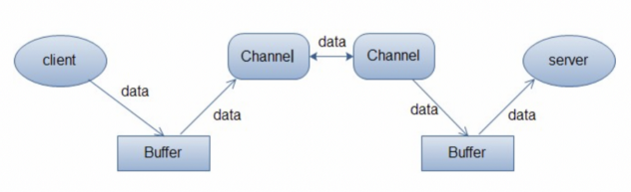

Some commonly used Channels are listed below:

* FileChannel → read and write through file
* SocketChannel → read and write through TCP socket
* ServerSocketChannel →Listen to the TCP connection from clients, create new SocketChannel for each TCP connection
* DatagramChannel →read and write through UDP protocol

**Buffer** can be considered as a data container, which could be implemented by an array. Either reading from a channel or writing to a channel, data must be put into the buffer first.

|  |  |
| --- | --- |
|  | **Selector** is the core class in Java NIO, it monitors and processes interested IO events that happened in multiple registered Channels. Through this mechanism, we could maintain multiple connections by just one thread. Only when the IO events actually happen among these connections, the IO process logic are truly invoked. There’s no need to start a new thread each time when a new connection comes in, therefore it would significantly reduce the system load.  In company with Selector, the SelectionKey is another important class, which represents an arrived event. These two classes constitute the key logic of the NIO server[10]. |

The figure above shows the monitoring of multiple channels (or connections) by a Selector running on a single thread.

More here: <http://tutorials.jenkov.com/java-nio/selectors.html>

1. **Reactor Pattern**

**a. Reactor**

A Reactor runs in a separate thread, and its job is to react to IO events by dispatching the work to the appropriate handler. It’s like a telephone operator in a company who answers calls from clients and transfers the line to the appropriate contact.

**b. Handlers**

A Handler performs the actual work to be done with an I/O event, similar to the actual officer in the company the client wants to speak to.

A reactor responds to I/O events by dispatching the appropriate handler. Handlers perform non-blocking actions.

In the reactor world, we achieve Asynchronous and Non-Blocking by

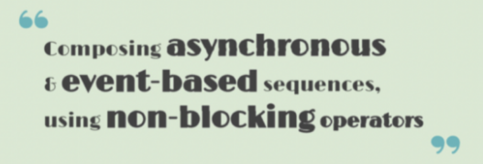

Asynchronous composing API’s: Flux and Mono ( will see examples)

1. **Backpressure saving subscribers from drowning**

The concept of backpressure in Reactive Streams is as elegant as it is powerful. It will enable the use of slow Consumers within Reactive applications without them “choking up” on too much information. The unprocessed data can be buffered.

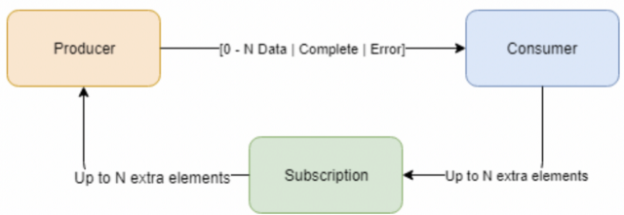

When a Consumer subscribes itself on a Producer, it will get a Subscription. This will enable a feedback mechanism from the Consumer of the datastream to its Producer. Through it, the Consumer can signal how many data events he’s able to handle.

When the Consumer signals it can handle 5 data events, the Producer will at a maximum call the Consumer 5 times with an onNext method. After consuming these 5 events, the Consumer will ask the Producer for extra events, until an onComplete or onError call occurs instead.

1. *Error handling channels*

In Reactive Streams, errors are terminal events. As soon as an error occurs, it stops the sequence and gets propagated down the chain of operators to the last step

Ex:

Flux.just( 1, 2, 0)

.map( i -> "100 / " + i + " = " + (100 / i) ) //this triggers an error with 0

.onErrorReturn( "Divided by zero!" ); // error handling example

Error Handling Operators

Static Fallback Value

The equivalent of “Catch and return a static default value” is onErrorReturn. The following example shows how to use it:

try {

return doSomethingDangerous(10);

}

catch (Throwable error) {

return "RECOVERED";

}

The following example shows the Reactor equivalent:

Flux.just( 10 )

.map( this::doSomethingDangerous )

.onErrorReturn( "RECOVERED" );

You also have the option of applying a Predicate on the exception to decide whether or not to recover, as the following example shows:

Flux.just( 10 )

.map( this::doSomethingDangerous )

.onErrorReturn( e -> e.getMessage().equals("boom10" ), "recovered10" );

Recover only if the message of the exception is **"boom10"**

Fallback Value

If you want more than a single default value and you have an alternative (safer) way of processing your data, you can use onErrorResume. This would be the equivalent of “Catch and execute an alternative path with a fallback method”.

For example, if your nominal process is fetching data from an external and unreliable service but you also keep a local cache of the same data that *can* be a bit more out of date but is more reliable, you could do the following:

String v1;

try {

v1 = callExternalService("key1");

}

catch (Throwable error) {

v1 = getFromCache("key1");

}

String v2;

try {

v2 = callExternalService("key2");

}

catch (Throwable error) {

v2 = getFromCache("key2");

}

The following example shows the Reactor equivalent:

Flux.just( "key1", "key2" )

.flatMap( k -> callExternalService(k)

.onErrorResume( e -> getFromCache(k) )

);

1. For each key, asynchronously call the external service.
2. If the external service call fails, fall back to the cache for that key. Note that we always apply the same fallback, whatever the source error, **e**, is.

Like **onErrorReturn**, **onErrorResume** has variants that let you filter which exceptions to fall back on, based either on the exception’s class or on a **Predicate**. The fact that it takes a **Function** also lets you choose a different fallback sequence to switch to, depending on the error encountered. The following example shows how to do so:

Flux.just("timeout1", "unknown", "key2")

.flatMap(k -> callExternalService(k)

.onErrorResume(error -> {

if ( error instanceof TimeoutException )

return getFromCache(k);

else if ( error instanceof UnknownKeyException )

return registerNewEntry(k, "DEFAULT");

else

return Flux.error( error );

})

);

1. The function allows dynamically choosing how to continue.
2. If the source times out, hit the local cache.
3. If the source says the key is unknown, create a new entry.
4. In all other cases, “re-throw”.

|  |
| --- |
|  |

Dynamic Fallback Value

Even if you do not have an alternative (safer) way of processing your data, you might want to compute a fallback value out of the exception you received. This would be the equivalent of “Catch and dynamically compute a fallback value”.

For instance, if your return type (**MyWrapper**) has a variant dedicated to holding an exception (think **Future.complete(T success)** versus **Future.completeExceptionally(Throwable error)**), you could instantiate the error-holding variant and pass the exception.

An imperative example would look like the following:

try {

Value v = erroringMethod();

return MyWrapper.fromValue(v);

}

catch (Throwable error) {

return MyWrapper.fromError(error);

}

You can do this reactively in the same way as the fallback method solution, by using **onErrorResume**, with a tiny bit of boilerplate, as follows:

erroringFlux.onErrorResume(error -> Mono.just(

MyWrapper.fromError(error)

));

Since you expect a MyWrapper representation of the error, you need to get a Mono<MyWrapper> for onErrorResume. We use Mono.just() for that.

We need to compute the value out of the exception. Here, we achieved that by wrapping the exception with a relevant MyWrapper factory method.

Catch and Rethrow

"Catch, wrap to a **BusinessException**, and re-throw" looks like the following in the imperative world:

try {

return callExternalService(k);

}

catch (Throwable error) {

throw new BusinessException("oops, SLA exceeded", error);

}

In the “fallback method” example, the last line inside the **flatMap** gives us a hint at achieving the same reactively, as follows:

Flux.just( "timeout1" )

.flatMap( k -> callExternalService(k) )

.onErrorResume( original -> Flux.error( new BusinessException("oops, SLA exceeded", original) )

);

However, there is a more straightforward way of achieving the same effect with **onErrorMap**:

Flux.just("timeout1")

.flatMap(k -> callExternalService(k) )

.onErrorMap( original -> new BusinessException("oops, SLA exceeded", original) );

Log or React on the Side

For cases where you want the error to continue propagating but still want to react to it without modifying the sequence (logging it, for instance), you can use the **doOnError** operator. This is the equivalent of “Catch, log an error-specific message, and re-throw” pattern, as the following example shows:

try {

return callExternalService(k);

}

catch (RuntimeException error) {

*//make a record of the error*

log("uh oh, falling back, service failed for key " + k);

throw error;

}

The doOnError operator, as well as all operators prefixed with doOn , are sometimes referred to as having a “side-effect”. They let you peek inside the sequence’s events without modifying them.

Like the imperative example shown earlier, the following example still propagates the error yet ensures that we at least log that the external service had a failure:

LongAdder failureStat = new LongAdder();

Flux<String> flux = Flux.just( "unknown" )

.flatMap( k -> callExternalService(k)

.doOnError( e -> {

failureStat.increment();

log("uh oh, falling back, service failed for key " + k);

})

);

1. The external service call that can fail…
2. . . . is decorated with a logging and stats side-effect…
3. . . . after which, it still terminates with an error, unless we use an error-recovery operator here.

We can also imagine we have statistic counters to increment as a second error side-effect.

Using Resources and the Finally Block

The last parallel to draw with imperative programming is the cleaning up that can be done either by using a “Use of the **finally** block to clean up resources” or by using a “Java 7 try-with-resource construct”, both shown below:

**Example 14. Imperative use of finally**

Stats stats = new Stats();

stats.startTimer();

try {

doSomethingDangerous();

}

finally {

stats.stopTimerAndRecordTiming();

}

**Example 15. Imperative use of try-with-resource**

try (SomeAutoCloseable disposableInstance = new SomeAutoCloseable()) {

return disposableInstance.toString();

}

Both have their Reactor equivalents: **doFinally** and **using**.

**doFinally** is about side-effects that you want to be executed whenever the sequence terminates (with **onComplete** or **onError**) or is cancelled. It gives you a hint as to what kind of termination triggered the side-effect. The following example shows how to use **doFinally**:

**Reactive finally: doFinally()**

Stats stats = new Stats();

LongAdder statsCancel = new LongAdder();

Flux<String> flux = Flux.just("foo", "bar")

.doOnSubscribe(s -> stats.startTimer())

.doFinally(type -> {

stats.stopTimerAndRecordTiming();

if (type == SignalType.CANCEL)

statsCancel.increment();

})

.take(1);

1. doFinally consumes a SignalType for the type of termination.
2. Similarly to finally blocks, we always record the timing.
3. Here we also increment statistics in case of cancellation only.
4. take(1) cancels after one item is emitted.

On the other hand, **using** handles the case where a **Flux** is derived from a resource and that resource must be acted upon whenever processing is done. In the following example, we replace the **AutoCloseable** interface of “try-with-resource” with a **Disposable**:

**Example 16. The Disposable resource**

AtomicBoolean isDisposed = new AtomicBoolean();

Disposable disposableInstance = new Disposable() {

@Override

public void dispose() {

isDisposed.set( true );

}

@Override

public String toString() {

return "DISPOSABLE";

}

};

Now we can do the reactive equivalent of “try-with-resource” on it, which looks like the following:

**Example 17. Reactive try-with-resource: using()**

Flux<String> flux = Flux.using( () -> disposableInstance,

disposable -> Flux.just( disposable.toString() ),

Disposable::dispose

);

Flux.just takes in 3 arguments

1. The first lambda generates the resource. Here, we return our mock Disposable.
2. The second lambda processes the resource, returning a Flux<T>.
3. The third lambda is called when the Flux from <2> terminates or is cancelled, to clean up resources.
4. After subscription and execution of the sequence, the isDisposed atomic boolean becomes true.

|  |
| --- |
|  |
|  |
|  |
|  |

Demonstrating the Terminal Aspect of **onError**

In order to demonstrate that all these operators cause the upstream original sequence to terminate when an error happens, we can use a more visual example with a **Flux.interval**. The **interval** operator ticks every x units of time with an increasing **Long** value. The following example uses an **interval** operator:

Flux<String> flux = Flux.interval( Duration.ofMillis( 250 ) )

.map( input -> {

if (input < 3) return "tick " + input;

throw new RuntimeException("boom");

})

.onErrorReturn( "Uh oh" );

flux.subscribe( System.out::println );

Thread.sleep(2100);

Note that interval executes on a timer Scheduler by default. If we want to run that example in a main class, we would need to add a sleep call here so that the application does not exit immediately without any value being produced.

The preceding example prints out one line every 250ms, as follows:

tick 0

tick 1

tick 2

Uh oh

Even with one extra second of runtime, no more tick comes in from the **interval**. The sequence was indeed terminated by the error.

Retrying

There is another operator of interest with regards to error handling, and you might be tempted to use it in the case described in the previous section. **retry**, as its name indicates, lets you retry an error-producing sequence.

The thing to keep in mind is that it works by **re-subscribing** to the upstream **Flux**. This is really a different sequence, and the original one is still terminated. To verify that, we can re-use the previous example and append a **retry(1)** to retry once instead of using **onErrorReturn**. The following example shows how to do sl:

Flux.interval( Duration.ofMillis(250) )

.map( input -> {

if (input < 3) return "tick " + input;

throw new RuntimeException("boom");

}

)

.retry(1)

.elapsed()

.subscribe( System.out::println, System.err::println );

Thread.sleep(2100);

1. elapsed associates each value with the duration since previous value was emitted.
2. We also want to see when there is an onError.
3. Ensure we have enough time for our 4x2 ticks.

|  |
| --- |
|  |
|  |
|  |

The preceding example produces the following output:

259,tick 0

249,tick 1

251,tick 2

506,tick 0

248,tick 1

253,tick 2

java.lang.RuntimeException: boom

A new interval started, from tick 0. The additional 250ms duration is coming from the 4th tick, the one that causes the exception and subsequent retry.

As you can see from the preceding example, **retry(1)** merely re-subscribed to the original **interval** once, restarting the tick from 0. The second time around, since the exception still occurs, it gives up and propagates the error downstream.

There is a more advanced version of retry (called **retryWhen**) that uses a “companion” **Flux** to tell whether or not a particular failure should retry. This companion **Flux** is created by the operator but decorated by the user, in order to customize the retry condition.

The companion **Flux** is a **Flux<RetrySignal>** that gets passed to a **Retry** strategy/function, supplied as the sole parameter of retryWhen. As the user, you define that function and make it return a new **Publisher<?>**. The **Retry** class is an abstract class, but it offers a factory method if you want to transform the companion with a simple lambda ( **Retry.from(Function)** ).

Retry cycles go as follows:

1. Each time an error happens (giving potential for a retry), a **RetrySignal** is emitted into the companion **Flux**, which has been decorated by your function. Having a **Flux** here gives a bird eye’s view of all the attempts so far. The **RetrySignal** gives access to the error as well as metadata around it.
2. If the companion **Flux** emits a value, a retry happens.
3. If the companion **Flux** completes, the error is swallowed, the retry cycle stops, and the resulting sequence completes, too.
4. If the companion **Flux** produces an error (**e**), the retry cycle stops and the resulting sequence errors with **e**.

The distinction between the previous two cases is important. Simply completing the companion would effectively swallow an error. Consider the following way of emulating **retry(3)** by using **retryWhen**:

Flux<String> flux = Flux

.<String>error( new IllegalArgumentException() )

.doOnError( System.out::println )

.retryWhen( Retry.from( companion -> companion.take(3) ) );

1. This continuously produces errors, calling for retry attempts.
2. doOnError before the retry lets us log and see all failures.
3. The Retry is adapted from a very simple Function lambda
4. Here, we consider the first three errors as retry-able (take(3)) and then give up.

In effect, the preceding example results in an empty **Flux**, but it completes successfully. Since **retry(3)** on the same **Flux** would have terminated with the latest error, this **retryWhen** example is not exactly the same as a **retry(3)**.

Getting to the same behavior involves a few additional tricks:

AtomicInteger errorCount = new AtomicInteger();

Flux<String> flux = Flux.<String>error( new IllegalArgumentException() )

.doOnError( e -> errorCount.incrementAndGet() )

.retryWhen( Retry.from( companion ->

companion.map( rs -> {

if (rs.totalRetries() < 3) return rs.totalRetries();

else throw Exceptions.propagate(rs.failure());

})

));

1. We customize Retry by adapting from a Function lambda rather than providing a concrete class
2. The companion emits RetrySignal objects, which bear number of retries so far and last failure
3. To allow for three retries, we consider indexes < 3 and return a value to emit (here we simply return the index).
4. In order to terminate the sequence in error, we throw the original exception after these three retries.
5. One can use the builders exposed in Retry to achieve the same in a more fluent manner, as well as more finely tuned retry strategies. For example: errorFlux.retryWhen(Retry.max(3));.
6. You can use similar code to implement an “exponential backoff and retry” pattern, as shown in the FAQ.

The core-provided **Retry** helpers, **RetrySpec** and **RetryBackoffSpec**, both allow advanced customizations like:

* setting the **filter(Predicate)** for the exceptions that can trigger a retry
* modifying such a previously set filter through **modifyErrorFilter(Function)**
* triggering a side effect like logging around the retry trigger (ie for backoff before and after the delay), provided the retry is validated (**doBeforeRetry()** and **doAfterRetry()** are additive)
* triggering an asynchronous **Mono<Void>** around the retry trigger, which allows to add asynchronous behavior on top of the base delay but thus further delay the trigger (**doBeforeRetryAsync** and **doAfterRetryAsync** are additive)
* customizing the exception in case the maximum number of attempts has been reached, through **onRetryExhaustedThrow(BiFunction)**. By default, **Exceptions.retryExhausted(…​)** is used, which can be distinguished with **Exceptions.isRetryExhausted(Throwable)**
* activating the handling of *transient errors* (see below)

Transient error handling in the **Retry** specs makes use of **RetrySignal#totalRetriesInARow()**: to check whether to retry or not and to compute the retry delays, the index used is an alternative one that is reset to 0 each time an **onNext** is emitted. This has the consequence that if a re-subscribed source generates some data before failing again, previous failures don’t count toward the maximum number of retry attempts. In the case of exponential backoff strategy, this also means that the next attempt will be back to using the minimum **Duration** backoff instead of a longer one. This can be especially useful for long-lived sources that see sporadic bursts of errors (or *transient* errors), where each burst should be retried with its own backoff.

AtomicInteger errorCount = new AtomicInteger();

AtomicInteger transientHelper = new AtomicInteger();

Flux<Integer> transientFlux = Flux.<Integer>generate( sink -> {

int i = transientHelper.getAndIncrement();

if (i == 10) {

sink.next(i);

sink.complete();

}

else if (i % 3 == 0) {

sink.next(i);

}

else {

sink.error(new

IllegalStateException("Transient error at "

+ i));

}

})

.doOnError(e -> errorCount.incrementAndGet());

transientFlux.retryWhen( Retry.max(2).transientErrors(true) )

.blockLast();

assertThat(errorCount).hasValue(6);

1. We will count the number of errors in the retried sequence.
2. We generate a source that has bursts of errors. It will successfully complete when the counter reaches 10.
3. If the transientHelper atomic is at a multiple of 3, we emit onNext and thus end the current burst.
4. In other cases we emit an onError. That’s 2 out of 3 times, so bursts of 2 onError interrupted by 1 onNext.
5. We use retryWhen on that source, configured for at most 2 retry attempts, but in transientErrors mode.
6. At the end, the sequence reaches onNext(10) and completes, after 6 errors have been registered in errorCount.

Without the **transientErrors(true)**, the configured maximum attempt of **2** would be reached by the second burst and the sequence would fail after having emitted **onNext(3)**.

Handling Exceptions in Operators or Functions

In general, all operators can themselves contain code that potentially trigger an exception or calls to a user-defined callback that can similarly fail, so they all contain some form of error handling.

As a rule of thumb, an unchecked exception is always propagated through **onError**. For instance, throwing a **RuntimeException** inside a **map** function translates to an **onError** event, as the following code shows:

Flux.just( "foo" )

.map( s -> { throw new IllegalArgumentException(s); } )

.subscribe( v -> System.out.println("GOT VALUE"),

e -> System.out.println("ERROR: " + e) );

The preceding code prints out the following:

ERROR: java.lang.IllegalArgumentException: foo

You can tune the Exception before it is passed to onError, through the use of a hook.

Reactor, however, defines a set of exceptions (such as **OutOfMemoryError**) that are always deemed to be fatal. See the **Exceptions.throwIfFatal** method. These errors mean that Reactor cannot keep operating and are thrown rather than propagated.

Internally, there are also cases where an unchecked exception still cannot be propagated (most notably during the subscribe and request phases), due to concurrency races that could lead to double onError or onComplete conditions. When these races happen, the error that cannot be propagated is “dropped”. These cases can still be managed to some extent by using customizable hooks. See Dropping Hooks.

You may ask: “What about checked exceptions?”

If, for example, you need to call some method that declares it **throws** exceptions, you still have to deal with those exceptions in a **try-catch** block. You have several options, though:

1. Catch the exception and recover from it. The sequence continues normally.
2. Catch the exception, wrap it into an *unchecked* exception, and then throw it (interrupting the sequence). The **Exceptions** utility class can help you with that (we get to that next).
3. If you need to return a **Flux** (for example, you are in a flatMap), wrap the exception in an error-producing **Flux**, as follows: returnFlux.error(checkedException). (The sequence also terminates.)

Reactor has an **Exceptions** utility class that you can use to ensure that exceptions are wrapped only if they are checked exceptions:

* Use the **Exceptions.propagate** method to wrap exceptions, if necessary. It also calls **throwIfFatal** first and does not wrap **RuntimeException**.
* Use the **Exceptions.unwrap** method to get the original unwrapped exception (going back to the root cause of a hierarchy of reactor-specific exceptions).

Consider the following example of a **map** that uses a conversion method that can throw an **IOException**:

public String convert(int i) throws IOException {

if (i > 3) {

throw new IOException("boom " + i);

}

return "OK " + i;

}

Now imagine that you want to use that method in a **map**. You must now explicitly catch the exception, and your map function cannot re-throw it. So you can propagate it to the map’s **onError** method as a **RuntimeException**, as follows:

Flux<String> converted = Flux

.range(1, 10)

.map(i -> {

try { return convert(i); }

catch (IOException e) { throw Exceptions.propagate(e); }

});

Later on, when subscribing to the preceding **Flux** and reacting to errors (such as in the UI), you could revert back to the original exception if you want to do something special for IOExceptions. The following example shows how to do so:

converted.subscribe(

v -> System.out.println("RECEIVED: " + v),

e -> {

if (Exceptions.unwrap(e) instanceof IOException) {

System.out.println("Something bad happened with I/O");

} else {

System.out.println("Something bad happened");

}

}

);

Contents from Project Reactor Reference : <https://projectreactor.io/docs/core/release/reference/>

To Know more point 4, 5 and 6, Please visit [project-reactor](https://projectreactor.io/),

I will jump directly to**Point 7,**which is the interesting part of this blog

1. *handle a large volume of concurrent requests coming from a single or multiple clients.*
2. *Function style programming*
3. *reactive streams are push-based which improves performance*
4. *7. Simple to use API’s Mono (for [0|1] elements) and Flux (for [N] elements)*

Spring Framework:

Spring Boot comparison of reactive (Spring Webflux using project reactor) vs non-reactive stack

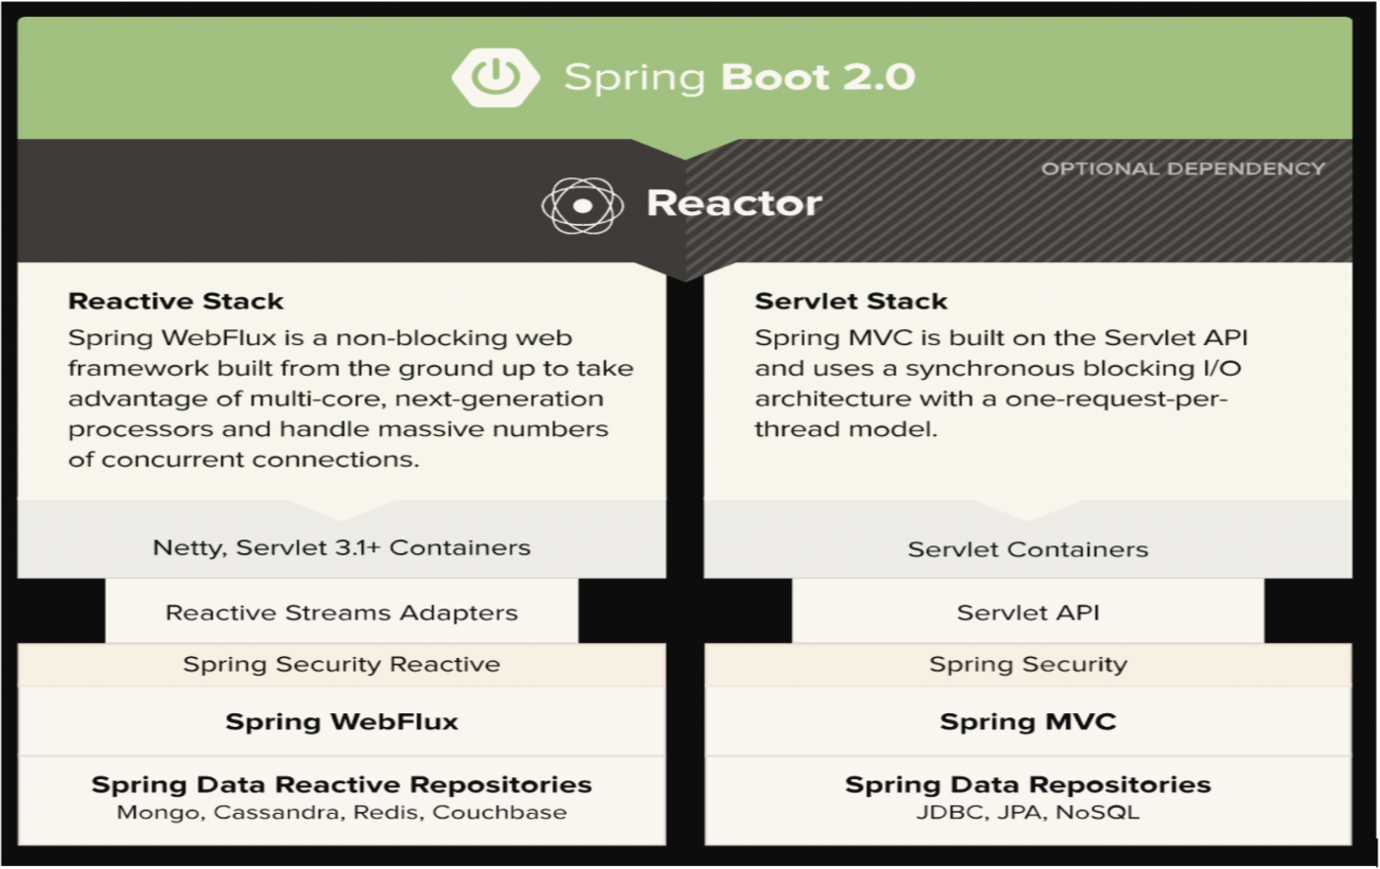

Reactor Netty Server

Reactor Netty is an [asynchronous event-driven network application framework](https://projectreactor.io/docs/netty/snapshot/reference/index.html#getting-started). It provides non-blocking and backpressure-ready TCP, HTTP, and UDP clients and servers. As the name implies, it’s based on the [Netty framework](https://www.baeldung.com/netty).

Spring WebFlux revolves around 2 API’s Flux and Mono that’s it…

Flux, an Asynchronous Sequence of 0-N Items

The following image shows how a **Flux** transforms items:

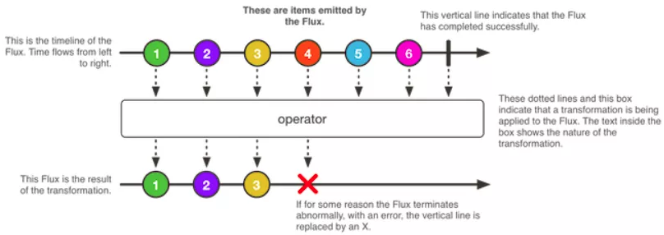

A Flux is a standard Publisher representing an asynchronous sequence of 0 to N emitted items, optionally terminated by either a completion signal or an error. These three types of signal translate to calls to a downstream subscriber’s onNext, onComplete, or onError methods.

Flux flux1 = Flux.just("foo", "bar", "foobar");

Flux flux2 = Flux.fromIterable( Arrays.asList( "A", "B", "C" ) );

Flux flux3 = Flux.range( 5, 3 );

// subscribe

flux.subscribe();

To subscribe, we need to call the **subscribe** method on **Flux**. There are different variants of the subscribe method available, which we need to use as per the need:

Flux flux1 = Flux.just("foo", "bar", "foobar");

Flux flux2 = Flux.fromIterable( Arrays.asList("A", "B", "C") );

Flux flux3 = Flux.range(5, 3);

// subscribe

flux.subscribe();

So now that we are familiar with Mono and Flux, let’s proceed with how to create a reactive application with Spring WebFlux.

First of all, we need to add the following in pom.xml:

<parent>

<groupId>org.springframework.boot</groupId>

<artifactId>spring-boot-starter-parent</artifactId>

<version>2.1.5.RELEASE</version>

</parent>

<dependencies>

<dependency>

<groupId>org.springframework.boot</groupId>

<artifactId>spring-boot-starter-webflux</artifactId>

</dependency>

<dependencies>

Then, we need to define the main class as follows:

@SpringBootApplication

public class MainApplication {

public static void main(String[] args) {

SpringApplication.run(MainApplication.class, args);

}

}

And then, we need to define the classes for rest APIs. Spring WebFlux comes in two flavors: **functional** and **annotation-based.**

**Annotation-Based**

@RestController

public class UserRestController {

@Autowired

private UserRepository userRepository;

@GetMapping("/users")

public Flux getUsers() {

return userRepository.findAll();

}

@GetMapping("/users/{id}")

public Mono getUserById(@PathVariable String id) {

return userRepository.findById(id);

}

@PostMapping("/users")

public Mono addUser(@RequestBody User user) {

return userRepository.save(user);

}

}

**Functional**

In the functional variant, we keep the routing configuration separate from the actual handling of the requests. We have defined UserRouter for defining routes and UserHandler to handle the request.

**UserRouter:**

@Configuration

public class UserRouter {

@Bean

public RouterFunction userRoutes(UserHandler userHandler) {

return RouterFunctions

.route( RequestPredicates.POST( "/users").and( accept( MediaType.APPLICATION_JSON )),

userHandler::addUser )

.andRoute( RequestPredicates.GET( "/users").and( accept( MediaType.APPLICATION_JSON )),

userHandler::getUsers)

.andRoute( RequestPredicates.GET("/users/{id}").and( accept(MediaType.APPLICATION_JSON )),

userHandler::getUserById);

}

}

**UserHandler:**

@Component

public class UserHandler {

@Autowired

private UserRepository userRepository;

public Mono addUser(ServerRequest request) {

Mono userMono = request.bodyToMono( User.class );

return ServerResponse.ok()

.contentType( MediaType.APPLICATION_JSON )

.body( fromPublisher( userMono.flatMap( userRepository::save ),

User.class ) );

}

public Mono getUsers(ServerRequest request) {

return ServerResponse.ok()

.contentType( MediaType.APPLICATION_JSON )

.body( userRepository.findAll(), User.class )

.switchIfEmpty( ServerResponse.notFound().build() );

}

public Mono getUserById(ServerRequest request) {

String id = request.pathVariable("id");

return ServerResponse.ok()

.contentType( MediaType.APPLICATION_JSON )

.body( userRepository.findById(id), User.class )

.switchIfEmpty( ServerResponse.notFound().build() );

}

}

Now, run the application:

mvn spring-boot:run

## Spring Boot Reactor Netty

## Servlet 4 and 5

# Netty and Servlet 4 - 5

<https://netty.io/wiki/user-guide-for-4.x.html>

Java Servlet Specs 4.0 and 5.0

# Spring OAuth 2.0

## OAuth 2.0

### Introduction

We will learn how to use OAuth 2.0 in the Spring MVC Web Application or the collection of Spring Boot Microservices running behind an API Gateway.

We will look at

* What is OAuth 2?
* OAuth 2 Roles
* OAuth 2 Client Types
* OAuth 2 Access Tokens
* OAuth 2 and Open ID Connect

OAuth 2 is an authorization framework and there are different authorization flows for different types of applications.

Before writing any code we need to learn how each of the authorization flow works and how your application can get an access token. We will go through each authorization flow step by step, and you will learn how to prepare each request, what request parameters to include and what your application will get back in the response.

You will learn how to start up and how to configure your own standalone authorization server, we will then create a very simple Spring Boot application. And we will configure it as a resource server. We will learn how it works together by letting user authenticate with our authorization server and acquiring an access token. And then we will use this access token when sending http requests to a resource server. We will then dive a little bit deeper into security of our resources and we will learn how to use SQL based access control.

|  |  |
| --- | --- |
|  | We will then dive a little bit deeper into security of our resources and we will learn how to use Scope based access control. And once that is clear, we will also learn how to use user role based access control. |

You will learn how to secure your resource server web service endpoints based on the role that currently authenticated user has. Often, projects have more than one resource. For example, if it is an online photo printing service, then there might be Photos resource server and there might be a separate order resource server.

|  |  |
| --- | --- |
| To learn how these kind of projects work with those two, you'll learn about micro services, architecture and how to start up on how to configure your own Spring Cloud API Gateway. This will allow your project to have a single entry point to all the resource servers that are running behind an API Gateway. |  |

You will also learn how to start up Eureka service registry and this will help you resource servers register their locations on the network with Eureka Service API. API gateway can then learn from Eureka what resource servers are running, where exactly in the network each resource server is located on what port? You will then be able to route incoming requests to destination resource servers.

You will also learn how to configure your resource servers to run on the random port numbers and how to configure your API gateway to do the load balancing of incoming traffic and on the running resource servers. And then, instead of using post managed to be your client, you will learn how to create and configure Spring MVC Web application that will work with the authorization server to authenticate user and acquire an access token. And then fetch data from protected resource servers via the Sprint Cloud API Gateway.

|  |  |
| --- | --- |
|  | So what is oauth, OAuth stands for open authorization, the first letter in the word i.e. o stands for open and the rest i.e. auth stands for authorization. So ouath stands for open authorization and the 2.0 stands for the version. There was version OAuth 1.0, and since about 2013, there is now oauth version 2.0. There are many differences between these two versions. And today most of the developers use a newer version, which is OAuth 2.0. |

So OAuth to is now an industry standard protocol for authorization, and it provides specific authorization flows for different types of applications that developers create. For example, there is an authorization flow that is good for Web applications and there is authorization flow that is good to use for mobile application, for example, or for smart devices. So it is not one particular way of authorization, but there are different authorization ways for different types of applications that developers create.

OAuth 2 is the authorization framework that enables applications to access user data or perform some operation on user behalf. Let's have a look at a little example. With the help of OAuth, you as a user can grant another application access to a data that is stored in another application.

|  |  |
| --- | --- |
| On my slide here, you see a little diagram where we have a user on the left side, then we have a mobile application in the middle and we have a Facebook service on the right. So let's assume we have a user who is using a mobile application and that this mobile application is a photo app that allows a user to access their Facebook for us. |  |

Unless this mobile application acquires user permissions, it will not be able to access user for us because Facebook will not allow it. And this is where the authorization framework comes. An Authorization framework can help user to grant their permission to a third party application like this mobile application, for example, or a website to access their user data on Facebook on their behalf and to let this third party application to access their data and Facebook the user will not need to give to this mobile application their Facebook username and password. There is a specific authorization flow that you can use to implement it. And in this video, of course, you will learn about it.

OAuth is also called delegated authorization framework would be helpful with users can authorize a third party application to access their data or to perform certain operations without giving away their username and password. And the good news is that with the help of both authorized applications, they can have only limited access to users data or can perform only a limited set of operations on user's behalf.

|  |  |
| --- | --- |
| Let's have a look at how we used to log in to social networks to access user data in earlier days before using our framework. So before OAuth framework was designed, applications needed to access user data on the one of social networks would create a log in for them that looks similar to the one on my slide. The user was invited to select one social network account they would like to use to login into an application, and then the user would provide the user name and password for that selected social network, having a, quote, username and password. |  |

The mobile application or a website will then use it to send the request to a social network that this user has selected or even the worse the mobile application would store username and password in its database, so that they can access user data any time it needs it. And this approach is very insecure. The first reason why this approach is very insecure is because a user has given away their actual username and password to this third party application and now having users username and password. This third party application can access any data of this user at any time. If initially the user provided their username and password to let this mobile application access their photos. Now, when mobile application has users username and password, it can actually access a user data and it can access at any time it needs it.

Another reason why this approach is insecure is because the user is not aware how secure their username and password are stored in this mobile application or a websites database. What if the database of this application is not secure and one day becomes compromised? And when more and more websites on the Internet ask user for their Google password, for example, and then store a copy of user's password in their local databases, then the chances that user's password will eventually get stolen are very high.

So our framework was designed to solve this problem. Instead of giving away their user name & password to a third party mobile application or a website without a framework, the user will be redirected to a Google login page instead. So user will use Google login page to login with Google credentials and they will enter their username and password into a login page that was designed and created by Google. The third party mobile application does not get to know users Google password, and if the login is successful, then the Authorization server or in this case it is Google Authorization server. It will ask users if they allow this Third-Party application to view their user photos and if user taps on allow button and grant their permission, then Google will pass a special access token to this third party mobile application that it can use to access user data.

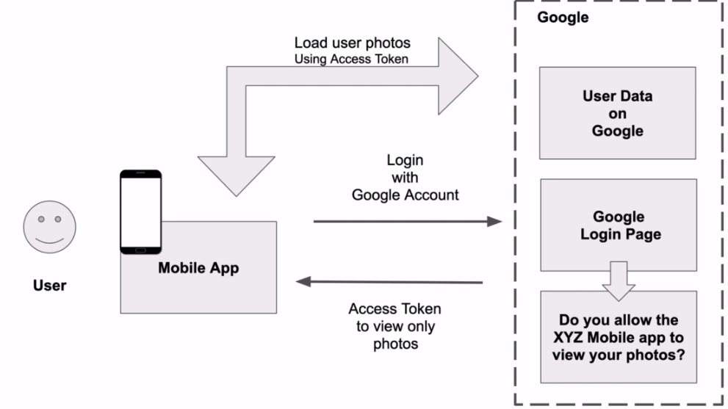

And this approach is much more secure. And this is because the user does not give away their username and password to a third party application. And because this third party application is not aware of users actual username and password, it cannot store it in its database and it cannot have an unlimited access to any user data. Instead, it can access only a limited set of users data and for a limited time on. Also, because the user has granted a read on the access to their phone as these Third-Party mobile application will not be able to use this same access token to access user email messages, for example, or to access users Google documents from Google Drive.

So this is only a high level overview of how it works. The following sections you will learn in much greater details how different authorization flows work, when and how to use different authorization flows, and how to actually execute that request and this different authorization flows.

### Roles

Lets learn about different actors in the framework and the rules.

The first actor in our framework is called Resource Owner

Resource is the information or the data that is being accessed and the owner is whoever owns that information. If the information that is being accessed is owned by a person, then we call the resource owner a user. So resource owner is a user who owns the information and is capable of granting access to this information.

Then we have a Client, a client, an application that is access information on user's behalf, and this application can be a Web application or it can be a mobile application or it could be even a post managed to be client that is being used to send a request to access users information.

ResourceOwner is a user who is using ClientApplication to access their information on resource server.

ResourceServer is a server that is hosting user information, it could be a Google server or it could be a Facebook server or it could be your own server that stores user data and users data on a resource server is usually available via an API. So resource server is not necessarily hardware. If you are a developer who is building monolythic Springboot RESTful Web application, then a resource server will be your Analytic Restful web service application. But if you're a developer who is building RESTful Micro Services, then each microservice in your application will be considered a separate resource server.

And the fourth actor in our framework flow is an AuthorizationServer. The authorization server is the server that issues access tokens to client application after successfully authenticating the resource owner and obtaining authorization. All major players like Google, Facebook, Twitter or Microsoft, they have their own authorization servers.

And this is why we as developers, we can implement functionality to allow users to log in into our apps with Facebook or Google or Twitter accounts.

But we as developers, we can also start up our own authorization servers. For example, there is Spring authorization server and there is Keycloak Authorization Server that we can run in a Docker Container or we can even integrate it in our Springboot application. And there are other authorization servers that can run as standalone server application on our own hardware. And there are other services that are available in the cloud and can be used as a hosted service. For example, there is Amazon Cognito server and there is Microsoft Identity platform and there is OCTA. All right.

So to summarize the four of roles one more time, these are the

* Resource owner
* Client
* Resource server
* Authorization server.

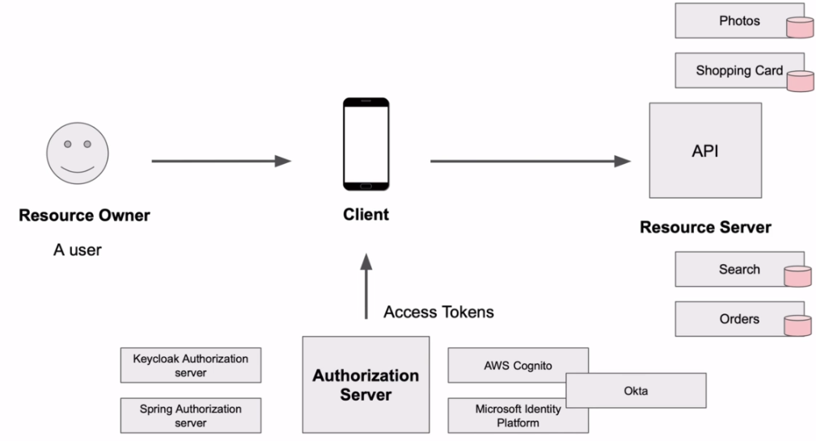

Spring has brought to life a very beautiful and community driven open source project called Spring Security. Over the years, this project matured a lot and it became a very popular project that supports a large portion of our specification. It provides client support. It provides resource service support and the authorization service support all in one single project. And it became so popular that thousands of projects today are powered by Sprint security OAuth. In fact, you are taking this video, of course, most likely because of popularity of Sprint Security OAuth Project, because it is so popular and because it is so widely spread. The knowledge of Sprint security and OAuth is becoming almost a must have skill for Java developers. And because of its significant growth and popularity in 2018, Spring team decided to rewrite the Sprint Security OAuth Project to make it even better and the code base even simpler. So they started working on the new project and eventually they have deprecated the current Sprint Security project in favor of a new one. And if you visit the GitHub page of Sprint Security OAuth Project, you will see the application notice right away. And there's the application. Notice has confused many developers who wanted to start using the so popular Sprint Security OAuth Project. So what do we do now?

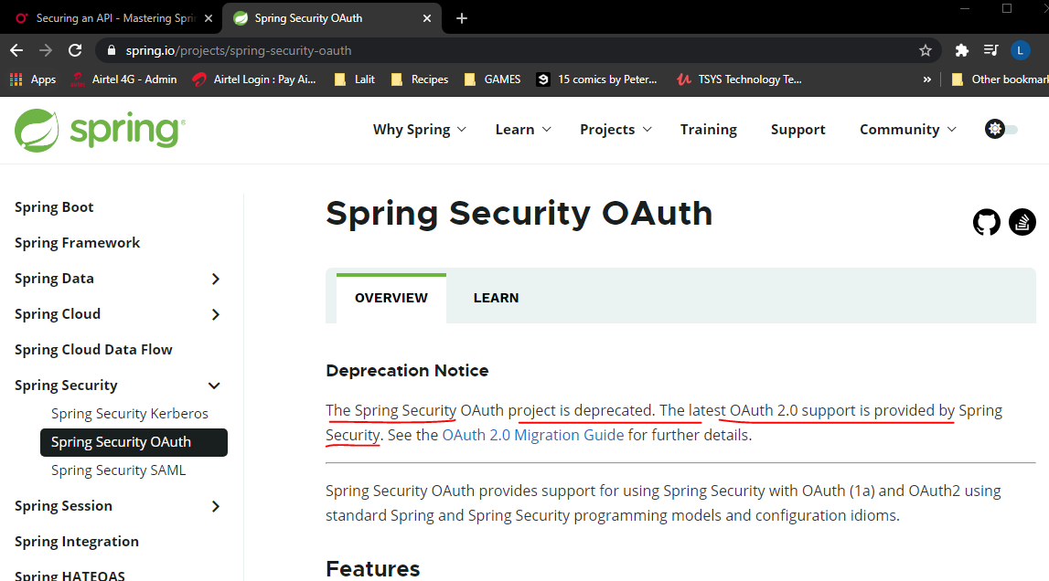

There is an ongoing work on the new version of old support for Sprint security. But meanwhile, the old one, it is still supported, but it is in the maintenance mode, which means that Spring team will still provide patches and security updates for the current Sprint security project, but only until May 2021. And according to the Sprint Security End of Life announcement, the plan is to provide patch and security fixes for the two point four and two point five line until May 2021. And the security fixes will be supported for the 2.5 million until May 2022, at which point the project will have reached its end of life. So you can still use the old Sprint Security project. However, the new one is almost here and you can start learning it already today. And this way, of course, is mostly about the new OAuth support than the Sprint security team and developers around the world are working on these days. So when it comes to the new stock, then the sprint has already provided us with client support, starting from release of Sprint Security version five. And we already have resource server support, starting from Sprint Security 5.1. But the authorization, so support is still in works. And at the time of recording this video isn't it is not fully available yet. The current version of the authorization server is 0.0.1 and the source code can be found on GitHub using the following your [github.com/spring-project-experimental/spring-authorization-server](https://github.com/spring-projects-experimental/spring-authorization-server).

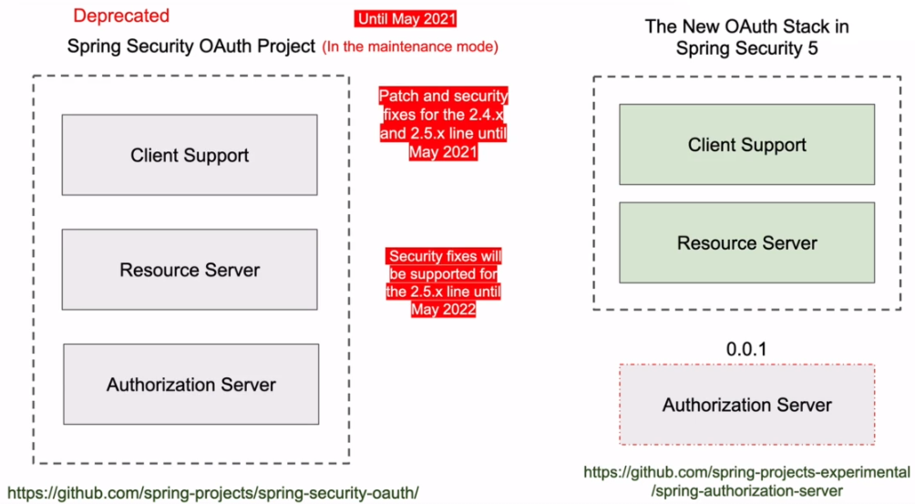

So because the new authorization server is not yet fully available and does not support all of OAuth grant types and authorization flows as an alternative, I will use Keycloak server that you can also download and run on your computer. Keycloak is free and it is open sourced. It supports all of Oauth 2 authorization flows and we can easily use it with the new resource server and Keycloak is a very good server and it has a very friendly web interface that can be used to create and manage applications and users.

And it is very much efficient for us to learn through and how to add our support to our applications. And once the new authorization server from Spring team is ready because it is going to support the same OAuth 2 specification, if needed, we should be able to switch and use the new authorization service support from the Spring team.

### Client Types

OAuth 2 framework defines two different client types based on their ability to authenticate securely with the authorization server. And in this video lesson, you will learn about these two different client types. Let's review both actors one more time, we have a resource owner that is also a user, we have a resource server that can be your monolithic Springboot monolithic application or it can be a set of smaller Springboot micro services. And in case of micro services, each micro service will be a separate resource server. Then we have an authorization server.

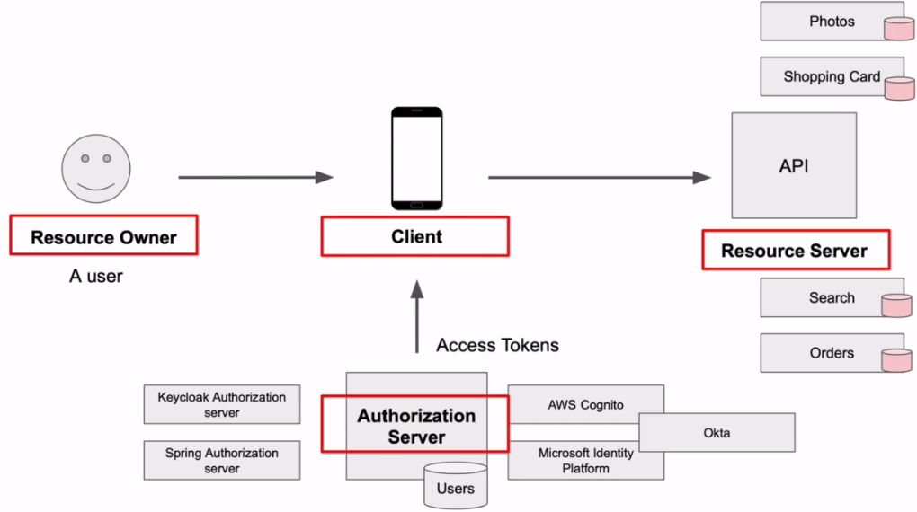

It is an OAuth server that allows users to login with their username and password, and if the login is successful, then it will generate and provide the client application with an access token. And finally, we have a client application that is being used by resource owner to access resource server on user's behalf. All right. So the topic of this video is and is a client application.

An example of client application can be a mobile app that user will use to access their information on a resource server, but there can be different kinds of client applications. For example, it can be a native mobile app or it can be a dynamic JALO website, or it can be a pure terminal based job application running on a Linux server. Or it can be a single JavaScript page application that does not have any backend script and runs entirely in the browser window.

Each of these different client types is capable of sending each request to an authorization server and for a client application to be able to communicate with authorization server. It needs to register with authorization server and get its client ID and client secret key, the client ID and a secret key. They are needed. So that authorization server and the client application, they can communicate with each other securely. And when communicating with the authorization server, the client application, it will need to provide authorization server with its client id and it is needed so that a authorization server can recognize the client application. But sometimes the client application will also need to provide authorization server, with a secret key. But not all of these types of client applications can securely store client security key on their side.

|  |  |
| --- | --- |
| And this is why client applications, they are divided into two different groups, **Confidential Clients** and **Public Clients**.  Confidential Clients – are applications that are able to keep the client secret, key securely and safe on their site. And thus these type of applications. They are registered with authorization server as confidential clients and they are issued as secret access key. And these confidential clients, they are able to securely authenticate with authorization server using their client ID and client secret key.  Public Clients – are applications that cannot guarantee the safety and confidentiality of their client and clients. Secret key by our specification. These can be applications that are browser based and that are run entirely in the browser window. For example, a single page JavaScript application. Or it can be a native application that is installed on user phone or tablet, or it can be even a desktop application running it on user's computer. |  |

So if there is a chance that a client application can be decompiled or its code can be viewed and the client application cannot guarantee the confidentiality of their security. Then it is called public client. And when you register an application with the authorization server as public, then this type of application might not even be issued as secret key at all. And this is because public application cannot guarantee the safety of its security.

All right. So because there are different types of client applications, confidential clients and public clients for different types of client applications, both framework provides different authorization flows. Which authorization for to use will depend on the type of client application that is trying to authenticate with the authorization server. We will learn how to register both public and confidential client applications with the authorization server and also how to use this client applications in different authorization flows.

### Access Token

* Once a user or resource owner successfully authenticates with the authorization server and is granted permission to let third-Party application to access their data, the authorization server will issue an access token and it will pass this access token to a client application.
* The client's application will then use this access token whenever it needs to communicate with the Resource Server to access users data. To check of the access token is valid, and if it can be used to access the requested information resource server will send the request to an authorization server to check if the access token is not fake and it is valid.
* If the authorization server confirms that the access token is valid, then the resource server can process the operation request.

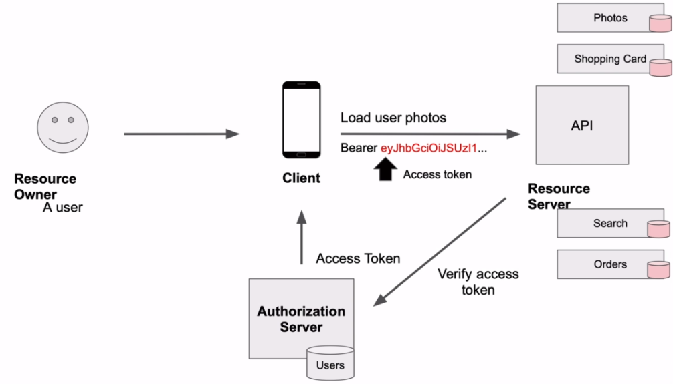

So it is very important to note here that once client application has the access token it can access users data on the resource server on user's behalf without asking user for username and password anymore. And because of these, the access token must be considered by a client application as a sensitive information and it must be kept secure. If the client application needs to store access token, then it must store it in a secure location. And when the access token is being used in http request, these requests must be over a secure SSL connection. It is very important that the access token is kept secure so that it cannot be stolen. And the only parties that are allowed to access the access token are the client's application, the authorization server and the resource server.

There are different types of access tokens, and here's what the oath specification says

|  |  |
| --- | --- |
|  | So the token can be an identifier type or it can be a type that self contains authorization information.  When Token is used as an identifier type, it is usually an alphanumeric string of characters of certain lengths.  How exactly this type of access token is implemented and what its plans will be it's up to authorization server and different authorization servers. |

They might have different implementations of this access token, but this type of access tokens, they will be used as an identifier stored in a database and used to reference additional authorization information associated with this token that is also stored in the database.

The second type of access token will actually self-contained authorization information, and that if the identifier and type token can be just a random string of characters, these self-contained type of token does actually contain much of information in it. And this is why it is much longer than the identifier type. The self-contained type token is actually a JSON object that contains user's authorization information in it. And this JSON object is base64 encoded.

You can take this access token and you can easily decode using many free online tools that help you do base64 decoded encoding. And once you decode this access token, you will actually see the authorization information that it contains. So this is why this type of access tokens, they must never contain as sensitive information, like, for example, a password because almost any developer can easily take this access token and base64 decode and see what's inside of it.

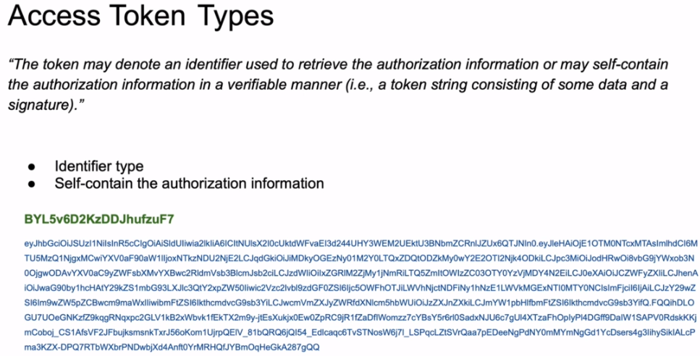

Because an identifier type access token does not contain any authorization information and it is being used to look at this information that is associated with this token in the database table. For example, if we have this particular access token, then we can look up on the database table what scope's or what kind of information the user has authorized the third party application to access.

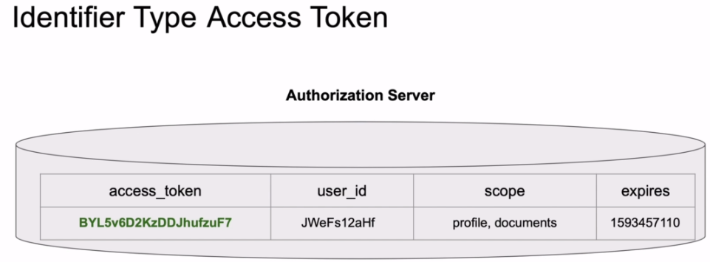

We can see when this access token expires and if we need to pull up user details that we have access to user ID. Now, the database table on my site is just an example and there can be many other fields on the database table that can be associated with an access token. Let's have a look at this self-contained type. Banks have token to learn what type of information can be associated with the access to.

The self-contained access to a JSON object that is base 64 encoded, it is separated into three parts, the header section, the payload section and the signature. If I copy this entire access token and decode, I will see the information that contains and to decode this type of access token. I can use one of online tools by opening the browser window. Once I decode the access token, I will be able to see the information that contains the header section, provides information about how to validate the token, including information about the type of a token and how it was signed.

|  |  |
| --- | --- |
|  |  |

The payload section will contain information or claims that are being transferred in the access token between the two parties. And I did not include the signature part here because the signature is a raw material used to validate the access token. I'm not going to go into details about the values in the header and the payload section in this video lesson, because this is just an introduction and I wanted to give you an overview of the two different types of access tokens. But there will be a standard set of JWT token claims and there will be constant claims. For example, the three values I have highlighted with the green curly brackets on my slide, are not part of the standard JWT claims, but they can also be included in the JWT.

The three values name, preferred user name and family name is information about the currently authenticated user. There could be more or less fields included here, but ideally you do not want to include much of the details information here in the access token as it can become a Privacy Issue. These details are also returned in response to user info point and as a part of another type of token that is called ID token. And there are two reasons why these details are included here and this access token. The first one, because I have configured my OAuth client application to be an open ID client. And the second reason is because I have provided an Open ID scope in my request for an access token.

So what is the Open ID connect and what is an ID token? Let's have a look at that ahead..

### Open ID Connect

We will talk about what is Open ID connect and how it is helpful in our applications. When you hear user authenticates with the authorization server, the authorization server will issue and provide declined application with an access token. Now this access token can be as simple alphanumeric random string of characters that does not contain any details about the currently authenticated user.

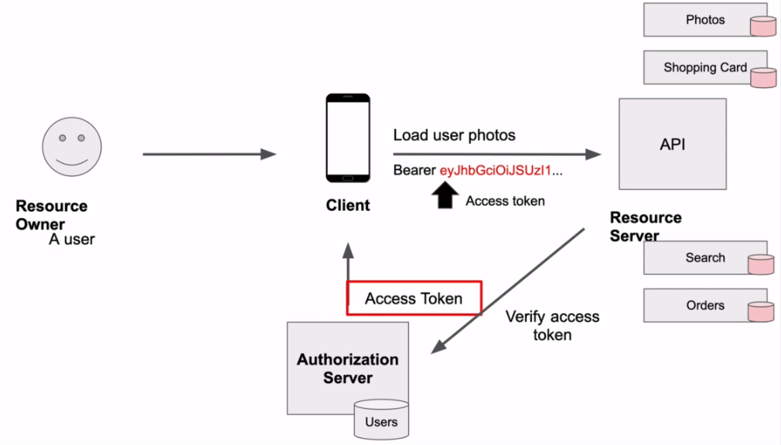

Open ID Connect was designed as an additional layer to provide our client application with information about the currently authenticated user.

|  |  |
| --- | --- |
| So an Open ID Connect comes as an additional layer on top of OAuth 2, and it is an identity layer that can provide the client application with an identity information about the user.  The authorization server that supports open ID Connect and provide the client application with the Identity Information is also called an Identity Provider. You will often hear me referring to the authorization server as an identity provider server as well.  When user authenticates with the authorization server, the authorization server will issue and provide client application with an access token, but with an Open ID connect the authorization server additionally to an access token, will also provide client application with an ID token.  The ID Token contains user identity information and the client application can use this ID token to extract from it some basic information about the current authenticated user. So the client application will now have two tokens the ID token and the access token. |  |

The ID token will be used to validate that a user is who they claim to be

The access token is used to validate if the user is allowed to access a requested resource from the resource server.

Now let's have a look at an example of ID token. Here's an example of decoded access, token payload. It has many useful claims about the access token itself, but it does not have any user profile information ( left screenshot below ).

|  |  |
| --- | --- |
|  |  |

And here the decoded ID token ( right side screenshot ) and payload that was received in this same response as an access token.

And in this payload, we do see basic user profile information like, for example, name preferred user name and family name.

|  |  |
| --- | --- |
|  | **Claims and Scopes in ID Token**  If needed, ID Token can contain more details about the currently authenticated user. There can be standard claims, there can be other claims and there can be custom claims additionally added.  These claims, they can be included into ID token or they can be returned when a request is sent to a user informed point that the identity provider server also exposes.  Now Open ID Connect also provides a set of scopes of the information that could be requested. To request any information about the user from an identity server. And Open ID Scope must be included in the request.  You will learn how to send a request to identity provider server to make it respond with an ID token and also how to request additional user details by sending the request to a user in four Web series and point. |

## Source Code

**Resource Server**

**Repository**: <https://github.com/simplyi/ResourceServer>

**Zip**: <https://github.com/simplyi/ResourceServer/archive/master.zip>

**Albums Resource Server**

**Before configuring it as Eureka Client**

**Repository:** <https://github.com/simplyi/Albums-Resource-Server/tree/Albums-Resource-Server-Before-Eureka-Client>

**Zip:** <https://github.com/simplyi/Albums-Resource-Server/archive/Albums-Resource-Server-Before-Eureka-Client.zip>

**After Configuring Albums Resource Server as Eureka Client**

**Repository:** <https://github.com/simplyi/Albums-Resource-Server/tree/Eureka-Client>

**Zip:**<https://github.com/simplyi/Albums-Resource-Server/archive/Eureka-Client.zip>

**Photos Resource Server**

**Before configuring it as Eureka Client**

**Repository:** <https://github.com/simplyi/Photos-Resource-Server/tree/Photos-Resource-Server-Before-Eureka-Client>

**Zip:**<https://github.com/simplyi/Photos-Resource-Server/archive/Photos-Resource-Server-Before-Eureka-Client.zip>

**After configuring it as Resource Server**

**Repository:** <https://github.com/simplyi/Photos-Resource-Server/tree/Eureka-Client>

**Zip:** <https://github.com/simplyi/Photos-Resource-Server/archive/Eureka-Client.zip>

**API Gateway**

**Repository:** <https://github.com/simplyi/ApiGateway>

**Zip:** <https://github.com/simplyi/ApiGateway/archive/master.zip>

**Discovery Service**

**Repository:** <https://github.com/simplyi/DiscoveryService>

**Zip:**<https://github.com/simplyi/DiscoveryService/archive/master.zip>

**Photo App Spring MVC Web Client Application**

**Repository:** <https://github.com/simplyi/PhotoAppWebClient>

**Zip:** <https://github.com/simplyi/PhotoAppWebClient/archive/master.zip>

**PKCE Example**

**Repository:** <https://github.com/simplyi/PKCE>

**Zip**: <https://github.com/simplyi/PKCE/archive/main.zip>

**Social Login/Logout**

**Repository:** <https://github.com/simplyi/SocialLoginWebClient>

**Zip:**<https://github.com/simplyi/SocialLoginWebClient/archive/master.zip>

**The PKCE-Enhanced Authorization flow in JavaScript application**

**JavaScript application**

**Repository**: <https://github.com/simplyi/spa-example>

**Zip:** <https://github.com/simplyi/spa-example/archive/main.zip>

**API Gateway**(before CORS configuration)

**Repository:** <https://github.com/simplyi/ApiGateway/tree/Before-CORSE-Configuration>

**Zip:** <https://github.com/simplyi/ApiGateway/archive/Before-CORSE-Configuration.zip>

**API Gateway**(after CORS configuration)

**Repository:** <https://github.com/simplyi/ApiGateway/tree/CORS-Configuration>

**Zip:** <https://github.com/simplyi/ApiGateway/archive/CORS-Configuration.zip>

**Resource Server**(before CORS configuration)

**Repository:**<https://github.com/simplyi/ResourceServer/tree/CORS-configuration>

**Zip:**<https://github.com/simplyi/ResourceServer/archive/CORS-configuration.zip>

**Resource Server**((after CORS configuration)

**Repository:**<https://github.com/simplyi/ResourceServer/tree/before-CORS-configuration>

**Zip:**<https://github.com/simplyi/ResourceServer/archive/before-CORS-configuration.zip>

**Keycloak User Storage Provider SPI**

(Remote User Authentication)

**Remote User Storage Provider Implementation**

**Repository**: <https://github.com/simplyi/KeycloakRemoteUserStorageProvider.git>

**Zip:**<https://github.com/simplyi/KeycloakRemoteUserStorageProvider/archive/main.zip>

**Legacy Users Web Service**

**Repository**: <https://github.com/simplyi/LegacyUsersWebService.git>

**Zip:**<https://github.com/simplyi/LegacyUsersWebService/archive/main.zip>

## Grant Types and Authorization Flows

### Introduction

So what is a grant type. A grant type is a way a application can acquire an access token, they can be different applications and depending on the type of grant application and use case, a specific with grant type can be used.

There can be a server side application that is built with Java or PHP, for example, and there is a grant type that is well suited for these type of applications. There can be Server side scripts that have no user interface at all. And this kind of applications, they can use a different grant type to acquire and access to. A client application can also be in the form of a single page JavaScript application. Or it can be a native mobile application, for example, running on iOS or Android device. And there can be also applications that run on TV or gaming PlayStation applications that cannot open up a browser window or execute a script on Server Side.

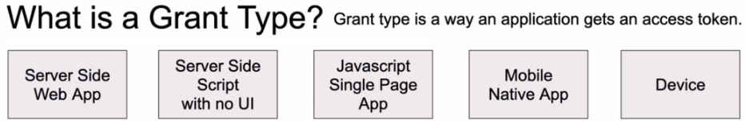

All right, so because there can be different types of applications and because some applications can be less secure than others, there are different Grant types that were designed and each grant type is used to acquire an access token in a slightly different way.

For example, there is a grant type that is called authorization code, and this grant type is often used in server side applications and also in mobile applications. There is also grant type that is called client credentials, and this grant type is often used in service applications that do not have any user interface at all and are not directly available to the end user. There is also an extension to authorization code grant type that is called PKCE Enhanced Authorization Code, and this one is designed to be used in applications that cannot keep their client credentials confidential. This can be JavaScript applications, for example, or also mobile application. And there's also grant type designed to be used on devices that cannot open the browser window, for example, or execute a code on the server side.

So there are different types of client applications and based on their needs and based on their ability to keep client credentials confidential, some grant types are more appropriate than others. And there are also grant types that are deprecated. But you may still come across this grant types as you work with Legacy Project and one of them is in place. The grant type, and it is often used with JavaScript applications or mobile applications were accessed token was returned immediately without an extra authorization code exchange step.

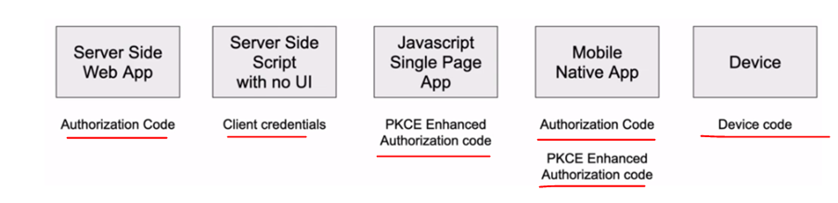

And in an example of a grant type that is being deprecated and is not recommended to be used anymore is called password grant type. This one you can actually see in many different applications and it helps to exchange user credentials for an access token. But because with this grant type, it is the client application that has to collect user password and then send it to that position. So this current type is no longer recommend to be used.

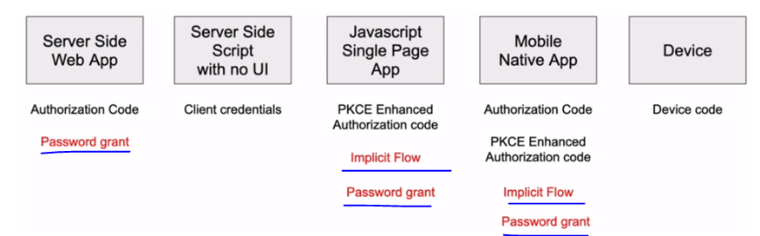

So you will learn about different grant types in more details and you'll see how they're being used to acquire and access to. There is also grant type that is called Refresh Token, and it is used to exchange a refresh token for an access token. Refresh token is a token that has been acquired together with an access token.

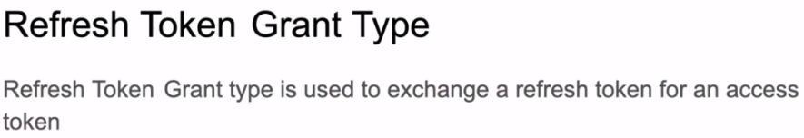

So the refresh token runtime, it allows client applications to refresh and expand access token for a new one, and it allows client applications to continue to have a valid access token without any further interactions with the user. So if an access token gets expired, they can refresh it and continue interacting with the service API using a newly refreshed access token.

## Authorization Code Grant

### Authorization Code Grant

You have experienced this type of authorization flow when granting a mobile application or a Web page to access your Facebook or Google account, for example. And this is a redirection based flow. To use this flow the client application, for example, a website, it must be capable of handling your redirects from the authorization server. And additionally, to be able to handle your redirects, the client application must be able to securely store the client secret that it will be using when exchange in the authorization code for an access token.

And if the client application cannot guarantee the confidentiality of both security, then it should not use the authorization code grant. Instead, it should consider using PKCE enhanced authorization code. And this flow is also pronounced as **PKCE enhanced authorization code**. So the enhanced authorization code flow is also explained in this video, of course.

* So it is recommended that applications like, for example, single page JavaScript application or a mobile application, these types of application, they should use the PKCE enhanced authorization code.
* But if your application is a service side, Web based application, for example, and it is capable of securely storing the security on this server, then the **Authorization Code Grant** can be used.

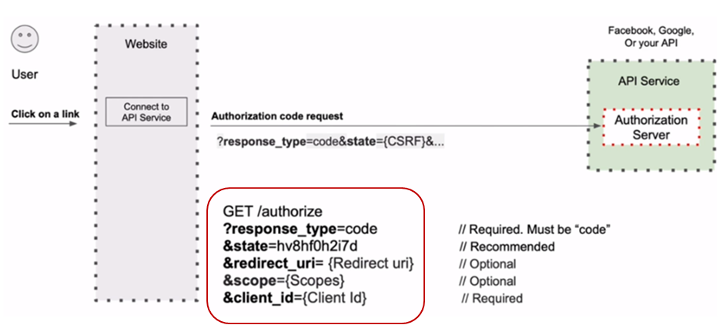

And website visiter decides to allow this website to connect to their Facebook or Google account and fetch some data, so they click on connect my account button and the website will then redirect user to an authorization server URL that contains few request parameters. And I'm not going to go into details about all of them now and we'll just mention a few.

* So the first request parameter is a **response type** and the value of this request parameter will be exactly **'code'**. This code is not a set of digits or and alphanumeric characters. It is exactly a word 'code'. This is why this authorization is called Code Grant, and it will indicate that the client application will expect to receive from authorization server and authorization code in the request parameter that will be included in the request code state and its value is random alphanumeric string of characters that our application will generate and it will include it in to request.
* The authorization server will send us back this **state** parameter and it must be exactly the same. When authorization server response with the state parameter, we will need to compare it and the both values, the value that we have sent and the value that authorization server has responded. As with these value of state request parameter, they must be exactly the same. And if they differ, then someone else has initiated this request.
* The next request parameter is **redirect URI** and this is a URI where the authorization server will redirect user next once authorization successful and the client application must be capable of handling this Redirect
* The next request parameters called **scope**. And it is a list of scope's like for example, read folders or read videos, and it indicates the type of information that the client application should be able to access on behalf of a user once the authorization is successful.
* And then we have a **client ID** and a client ID is a client identifier. This client identifier is not a user ID and it does not identify a user who is trying to log in. In this case, it is an identifier of our client application.
* We will learn how to acquire this identifier because before a client application can communicate with an authorization server, it will need to register with it and acquire an identifier and client secret key.
* So once the authorization server receives and validates this request, it will then present user with a login page where a user will need to provide their username and password to authenticate with the authorization server. And once you're successful, that indicates with the authorization server, the authorization server will generate a short lived authorization code and it will redirect user to a provided redirect URI.

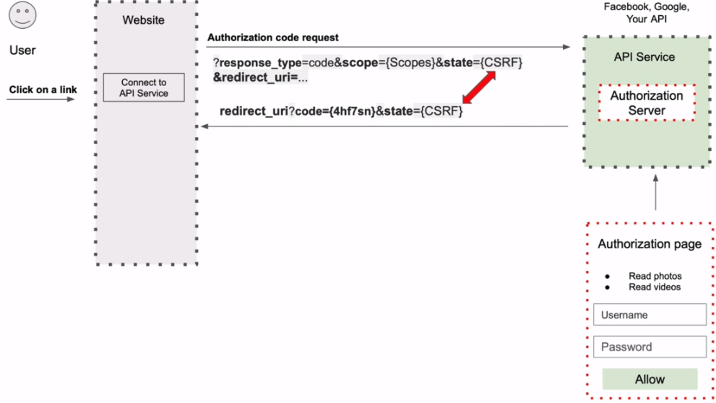

And it will attach to this redirect URI to queries to request parameters. These are code and the state. The code request parameter will contain a short lived code which was generated by the authorization server.

It is recommended that the lifetime of this code is maximum about 10 minutes. It must be unique and it must not be used more than one time. The value of the state parameter will stay the same.

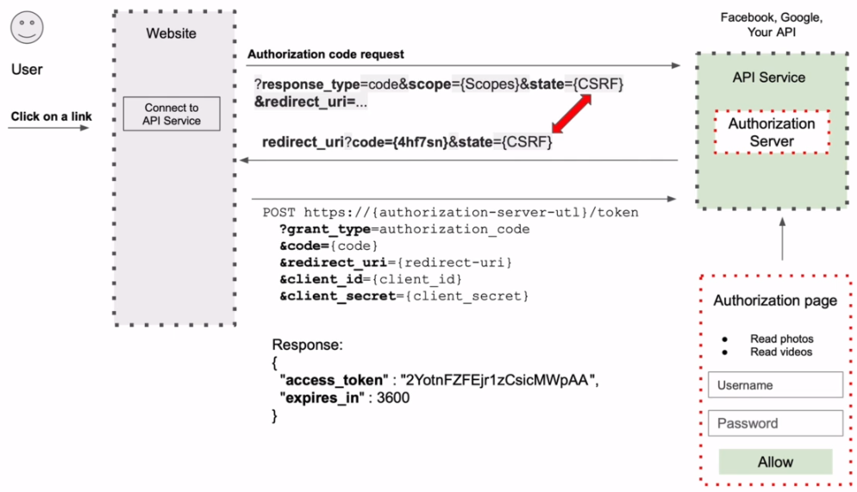

The authorization server will include just the same, the original value of the state request parameter that it has received from the client application in the original request. We must validate that this value is equal to the one that we have given to authorizations that were in the original authorization request.

So now when our client application has the authorization code, it can exchange this authorization code for an access token. It will send the http post request to an authorization server, providing authorization server with the value of authorization code that was generated by the authorization server and providing it with the same value of redirect URI and the authorization server should receive the code that it has generated and also the redirect URI to which it has redirected the code. And then the authorization server will validate this request. And if all is good, it will respond back with a JSON that will contain the access token.

All right. So let's look at this flow using one more diagram.

So here we have four participants of our authorization code for the user on the left side, then we have client application, which is in this case, her website. And on the right side, we have the authorization server and resource server. So the flow begins with a user who clicks on the link to authorize this website to communicate with the authorization server on user's behalf. The website will then redirect this request to authorization server. The authorization server will need to authenticate the user first, so it will present user with the login page and it will ask user to login, so user will log in and if the login and successful, the authorization server will present user with the consent page asking user if the authorized these website to access the information it has requested on user's behalf. The user will click on Allow Button to tell the authorization server that he or she does authorize this website to access the requested information.

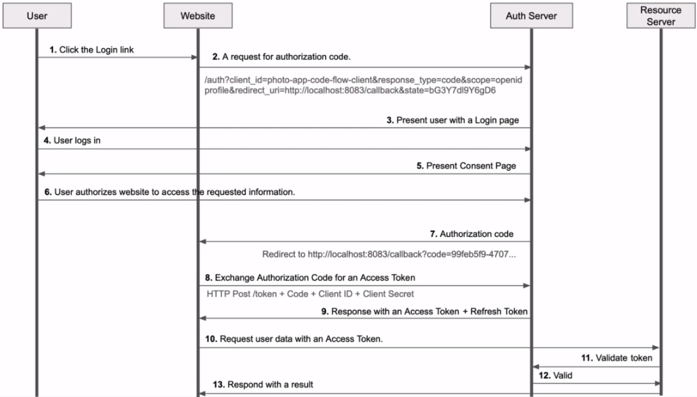

Now, when the authorization server has received users consent, it will generate the authorization code and it will attach this authorization code to a redirect URI it has received in the original request and it will redirect to that redirect to the URI. Now the client application or our website has that authorization code. It will need to exchange this authorization code for an access token. This is going to be HTTP post request and in this request, the client application will need to send to the authorization server the authorization code it has received, as well as its own credentials like client ID and client secret key. The authorization server will validate the request and if all is good, it will respond back with an access token and also a refreshed token. Now, when the client application has an access token, it can send the request to fetch user data from the resource server, or it can request resource server to perform some operation on user's behalf.

All right. So the once resource server receives a request containing an access token, it will need to validate this access token to make sure that it is valid. So Resource Server will contact the authorization server with a request to validate his access to the authorization server, will validate the access token and will notify the resource server about the result. And if the access token is valid, then a resource server will perform the requested application by client application. All right, so this is how it works. It might look very complex, but don't worry to make it all work. There is not much code that you will need to write a lot of the code the framework will do for us behind this scenes.

### Auth Code Demo

We will demonstrate it with HTTP request to an authorization server to request an authorization code so that they can then use it to exchange it for an access token. So it's going to be an actual request that I will send to my authorization server. And for this initial request to work, I need to have an authorization server running. I do have it running already. And later we will see how to start up authorization server and how to configure it, so that it can issue authorization code and access token. But for now, I just wanted to demonstrate how the flow actually works. So I'll start by creating an initial request to request authorization server to issue me an authorization code and to make this process a little bit more visual. I will use postman client. I have it opened on my screen and I zoomed in a little bit and the initial request will need to be http get request. So the drop down menu here in the left will need to be set to get. I will now paste the URL to the authorization server service end point and the URL that I'm using now is the URL to an authorization web service endpoint of Keycloak server.

Keycloak authorization and identity provider server that I'm using and I'm running it right now on my computer on localhost port number 8080. But if you decide not to use Keycloak and will use a different authorization server, then this URL might look slightly different. All right.

* So it is going to be http get request and it is going to be sent to the following URL, which is a URL to an authorization server webservice end point and now will need to provide HTTP request parameters. So I will select the params tab here and the very first request parameter will be a required request parameter, which is called response type. So it is a response_type and it's value must be code, so I will type code here and notice that as I adf request parameters, they are being attached to the URL as URL query string. So I have added response type with a value 'code'. And right away, Postman http client added this response_type request parameter to the URL as a query string request parameter, and this is because it is the biggest request. All right. So let's continue.
* The second required request parameter is going to be client_id and the value of the client_id that my job has is for photo-app-code-flow-rest-client. And later, will show you how to register a new client application with authorization server and I will show you where to find the client ID for that application. So do not worry about this right now. Just try to understand how this works.
* And the next parameter is a recommended parameter and it is called state and its value is a random alphanumeric string of characters that the client application will need to generate. So at this moment, I will just come up with some random value. We did talk about this state request parameter and why we need it in the introduction video, if you need to review it, please review the authorization code, grand introduction later. All right.
* So the next two request parameters are optional and the first one is called scope. As a scope, I will indicate that I would like to use an Open ID, and this is because I'm going to request user information. If your authorization server is an identity provider and it supports open ID connect, then use the scope to indicate that you would like to receive some information about the current authenticated user and then the authorization server, together with an access token it will also provide us with an ID token and the ID token will contain additional user related information. And the second scope value that I will use is profile. The two values will need to be separated with a space, and this profile scope will indicate that I want to receive currently authenticated user profile details.

All right, so the next request parameter that I'm going to provide is a redirect URI. So redirect URI, this is where authorization server will redirect once the user is authenticated and this value must watch the one that you will configure in the authorization server. And again, in one of the later video lessons, I will show you how to configure client application and where to configure the redirect your right in the authorization server. We will start working with authorization server pretty soon. The value of redirect URI that I will use is HTP localhost port number 8083, forward that call back like this and this is it.

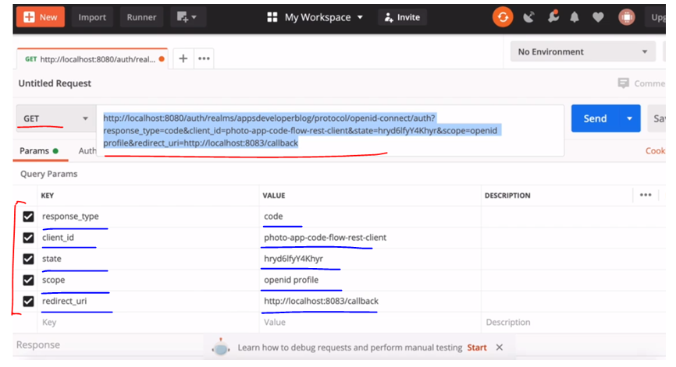

I'm ready to execute this request. But instead of running this request in Postman, I will copy it's you around with all the request parameters attached and I will run it in the browser window. So I will bring in a browser window and I will paste this URL here and will hit run. And now there is a redirect me to user authentication page, I'll need to provide username and password. I don't really have an account, so I will simply log in. But when we start working with authorization server, I'll show you how to create a new account and how to register a new user. So I will log in. And let me actually provide an incorrect password first, so I'll try to log in and it says the password is incorrect. Now I will provide correct password.

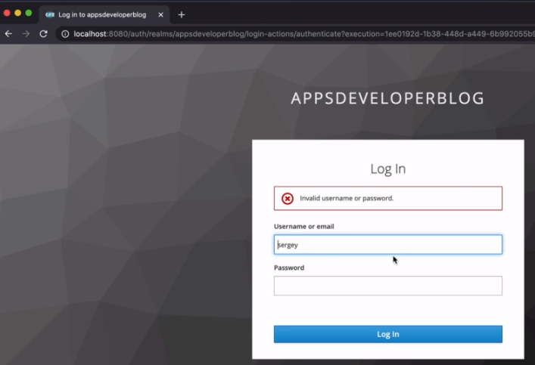 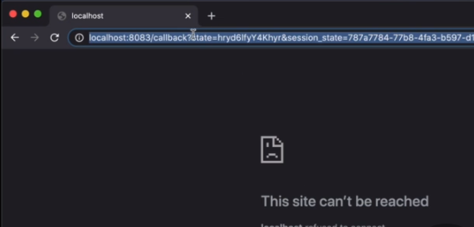

And successfully authenticated, I know that I'm successfully authenticated because of the redirect URI, I see that authorization server redirected me to the reader on its own that I have provided. I don't have client application running, and this is why the page is not found. But if I copy this URL to which the authorization server redirected me to if I copied and pasted into a text editor. Let me zoom in a little bit.

I can see the redirect URL that I have provided and I see that authorization server returned exactly the same state request parameter. I see has attached sessions state. And here is my authorization code.

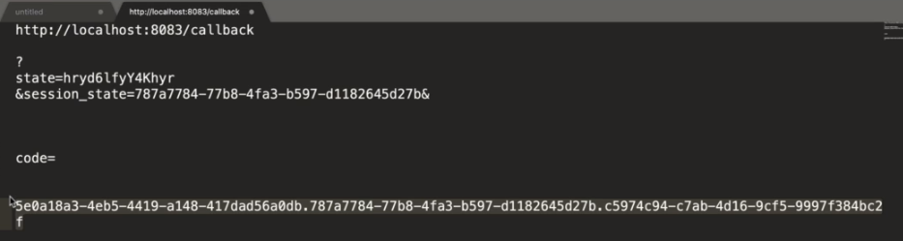

One of the request parameters is code, and here is the value of authorization code that I will need to exchange for an access token. All right. So now let's use this authorization code to exchange it for an access to.

### Exchange code for Access Token

Now, let's try to exchange this authorization code for an access token, and to do that, I will need to create a new request. I will bring in Postman. And I will click on + button here to start a new tab.

This time it will need to be a post request that I need to send to a token web service endpoint. I'll post the URL to the token web service endpoint and again, depending on the authorization server that you'll be using the URL to a token web service endpoint might be slightly different, but for the Keycloak server that I'm running, it looks like there's localhost then port number on which my keycloak is running and then OAuth realm and then realm that they have created protocol openid-connect forward slash token. So this is HTTP Post request and now I will switch to body type and I will select x-www-form-urlencoded and here I'll need to provide request parameters.

So the very first request parameter that I need to provide is called **grant type**. And the value of this request parameter should be '**authorization_code'**.

The next request parameter that I will provide is client_id with this request, I need to provide credentials of my client application, so I'll need to provide **client**_**id** and I will need to provide **client_secret** the value of client they can pick up from my previous request. But the value of client secret, I will copy from my authorization server and will post it here.

I will show you where to find these two values when we started working with the authorization server. So I have provided **grant** **type**, **client** **ID** and **client** **secret** and the next request parameter will be the **code** itself. So I will type code and here I will need to provide the value of authorization code that I have received from authorization server in the previous request.

So I will copy this value and I will paste here, so now because to request this authorization code I have used redirect URI, I will need to provide this request parameter as well. So I'll copy the redirect URI and I will create a new request parameter. This is going to be **redirect URI**. And I will paste its value here, all right, and now I think I'm ready to send this request and see if it works and if a server will give me an access token in exchange for authorization code.

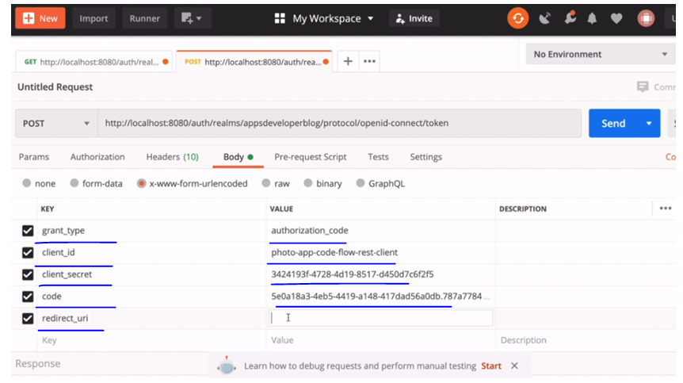

Let's try it. I'll click on send button. And I got 400 bad request. Let's scroll down, the code is not valid. Most likely, this is because my authorization code has already expired. Let's try one more time. I will go back to a previous request. I will copy the request your bring in browser window. Will paste it in. Hit Enter now I am already authenticated, so I get redirected to the redirect where I write the way here is the value of my code. I will copy it. Bring in postman. Switched to my http request to exchange this code for an access token, and now I will replace this code here and try one more time. And now I get a successful response, so if I scroll down, I see an access token, which is base 64 encoded, and then I see when it expires, I see I have a refresh token, the expiry time of a refresh token and I have a token here and all is working.

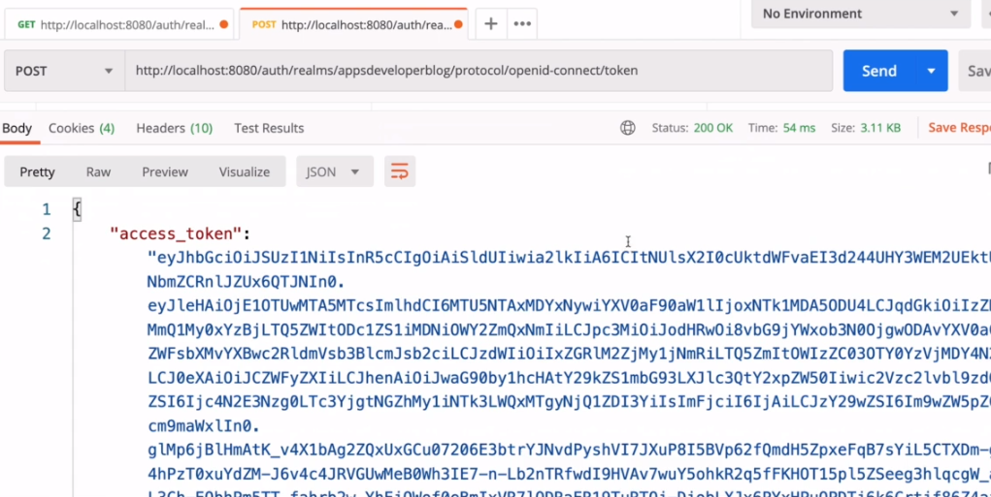 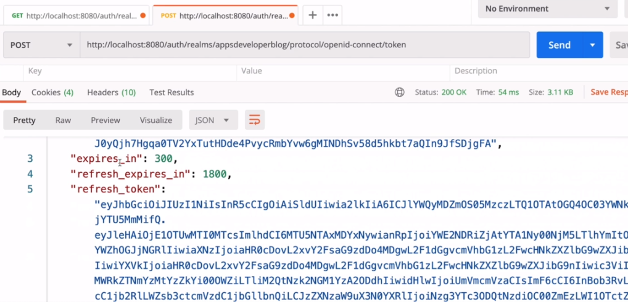

Well, I have my access token. All right. So this is how it works. We will try it one more time later in this video, of course, when we have our authorizations who are running. But now let's continue and let's have a look at how other authorization flows work.

## Proof Key for Code Exchange

### PKCE Enhanced Authorization Code

PKCE stands for proof key for code exchange, and it is also pronounced as Pixie for short. So the Pixie enhanced authorization code grant flow builds upon the standard authorization code flow and the steps in this flow are very similar. This authorization flow is mostly used by native and JavaScript apps and it provides an additional level of security for applications that cannot keep its client secret key safe and a very good example of such application is a single page JavaScript application.

A single page JavaScript application cannot securely store the OAuth client secret key, and it cannot guarantee its confidentiality. And this is because almost any developer who knows how to preview JavaScript in the browser, they can open the page source code and see the old client secret key. So because JavaScript page cannot guarantee the confidentiality of a secret key, it cannot use the secret key. And as an alternative, it makes use of its own secret key, which it will need to generate in a way that the authorization server can verify. So this process is called proof key for code exchange or Pixie enhanced authorization code.

And the steps in this flow are very similar to the regular authorization code flow, except that now the client application will need to generate a couple of additional request parameters. So let's see how it works.

In the pixie enhanced authorization code flow, the client application will need to generate and include in its initial request to the authorization server, additional two request parameters. And these are called **code_challenge** and the **code_challenge_method**. The code challenge is a base 64 encoded value & there is a specific way of generating this value.

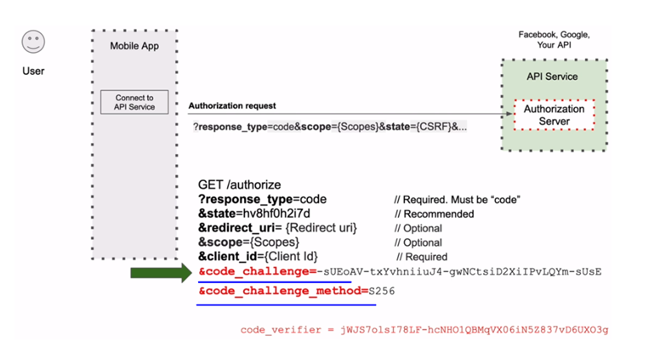

We look at how to generate this a little bit later, but there is a special way of how the client application needs to generate this file. To derive the code challenge value, the client application will need to first generate the code verify value, and it will then use the code_verifier value to derive the code_challenge value. The code verifier value the client application will need to store and then use later in the flow. And I'll show you how to generate both value, the code verifier and the code challenge right after we get familiar with this flow.

So the second parameter in the request is called code_challenge_method. This is the value that will need to be configured in the authorization server for the client application. And it is recommended that this value should be as 256. The code challenge method can actually take two possible values. It can be as 256 bit code, or it can be plain the 256 bit coding it stands for the type of cryptographic hash function that will be used to hash to verify a code. If the plain value is used then no hashing is used, which is insecure and using plain method is discouraged.

PKCE (pronounced "pixy") is a security extension to OAuth 2.0 for public clients on mobile devices, designed to prevent interception of the authorisation code by a malicious application that has sneaked into the same device.

**Why PKCE?**

When building applications and integrating a user signing and getting access to some resource, one of the main go-to standards is OAuth 2 with the usage of the Authorization Code grant type. Those who know the flow of Authz Code grant type knows that the first call (authorization request) is made through a browser(User-Agent) to obtain the authorization code. This makes the authz code susceptible to an “Authorization Code Interception Attack”. In simple, there is a chance some on could steel that authz code (This has happened!).

Couple of ways the authz code can be stolen is by having a malicious app also register a custom URI scheme that matches the response of the Authz Code request. Or by gaining access to the HTTP request/response logs.

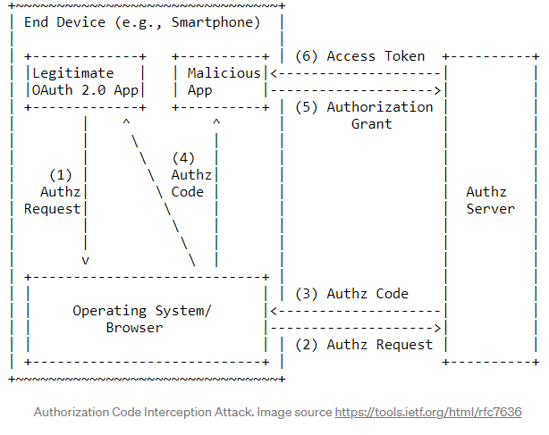

Well, they can’t do anything with the code as long as they don’t have the client credentials right? What if they have that too! This is why I said “…in certain cases” at the beginning. If your app is a mobile app or a Single Page Web App (SPA) chances are that you will be using the same client credentials for every instance of the app and the credentials are hardcoded into the apps. These are the kinds of apps that are known as a public client. Because you can’t really make sure those credentials have been kept secret and no one else already has them. For public clients, it is recommended not to perform any actions based on the availability of the client secret ( by trusting the secret ).

So there’s your problem if you’re having a public client and your using the Authz Code grant then some imposter could be generating and using access tokens without you even knowing!

**How does PKCE prevent this?**

The basic idea behind PKCE is proof of possession. The client app should give proof to the authorization server that the authz code belongs to the client app in order for the authorization server to issue an access token for the client app.

PKCE introduces few new things to the Authz Code flow; a code verifier, a code_challenge and a code_challenge_method. The “code verifier” is a random code which meets a certain requirement. The “code challenge” is a transformation of the code verifier or in some cases can be the code verifier itself (DO NOT use the code verifier itself!!! Please Don’t!). Use of the “code challenge method” is actually optional and it’s used to state the method used to transform the code verifier into the code challenge and if you don’t use it an Authorization Server will assume that the code challenge and the code verifier are the same. Both the code verifier and the code challenge is created by the client app. And each pair is used only once.

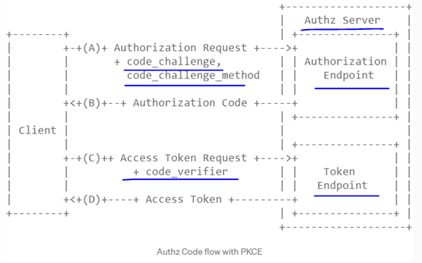

So the basic flow is like this.

1. The client sends the authorization request along with the code_challenge and the code_challenge_method.
2. The Authorisation Server makes note of the code_challenge and the code_challenge_method and issues an authz code.
3. The client sends an access token request along with the code_verifier.
4. The Authorization Server validates the code_verifier with the already received code_challenge and the code_challenge_method and issues an access token if the validation is successful.

This works because the code challenge or the code verifier cannot be intercepted. The code_verifier and the code_challenge should only be used once per token requesting cycle. Every time an authorization request is made a new code challenge should be sent. Since the code challenge is sent through the browser it is VERY important that the code challenge not be the same as the code verifier or else if by some means an attacker has access to the HTTP request; could be through HTTP logs then the use of PKCE will be useless. Of course, this goes without saying the communication between the client and authorization server should be through a secured channel(TLS) so the codes cannot be intercepted.

**Some basic stuff about the code_verifier, code_challenge and the code_challenge_method**

code_verifier — The code verifier should be a high-entropy cryptographic random string with a minimum of 43 characters and a maximum of 128 characters. Should only use A-Z, a-z, 0–9, "-" (hyphen), "." (period), "_" (underscore), "~" (tilde) characters.

code_challenge — The code challenge is created by SHA256 hashing the code_verifier and base64 URL encoding the resulting hash Base64UrlEncode( SHA256Hash( code_verifier ) ). In the case that there is no such possibility ever to do the above transformation it is okay to use the code_verifier itself as the code_challenge.

code_challenge_method — This is an optional parameter. The available values are "S256" when using a transformed code_challenge as mentioned above. Or "plain" when the code_challenge is the same as the code_verifier. Since this is an optional parameter, if not sent in the request the Authorisation Server will assign "plain" as the default value.

So if the request for Pixie enhanced authorization code is successful, then the authorization server will redirect client to redirect URI provided in the request and it will attach to this redirect URI and authorization code. And then this authorization code will need to be used in the following request to exchange it for an access token. So if the authorization request is successful, then the authorization server will respond back with the authorization code and this code will need to be used in the form http request to exchange this authorization code for an access token.

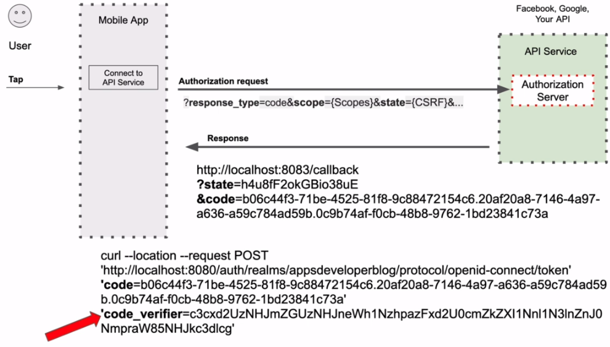

But because this is Pixie enhanced authorization code, a request to exchange the authorization code for an access token, it will need to contain both the authorization code and the **code_verifier** request parameter. The authorization server then will validate the code and it will validate the code verifier values and it will respond with an access token only if it could verify that the value for the provided authorization code is correct.

We will actually perform this request using Postman http client and you will see how it all works in practice. But here's an example of initial request for an authorization code. If you are successful, it authenticates the authorization server will issue an authorization code and it will redirect client application to a redirect array that was provided in the request.

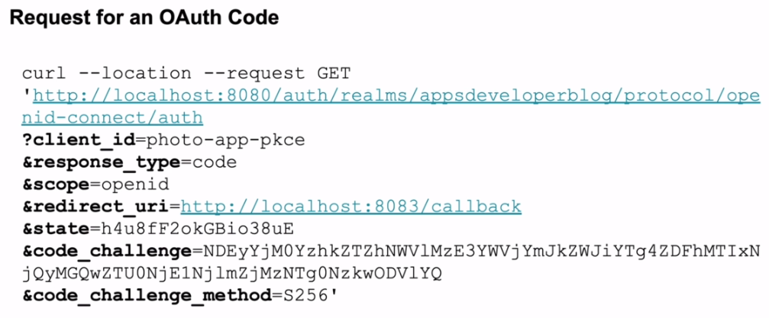

And here is a final request to authorization server to exchange authorization code for an access token. This request must include the code_verifier value that was used to derive the code challenge while the authorization server will validate the code and the code verifier values. And if all is good, it will respond with an access token.

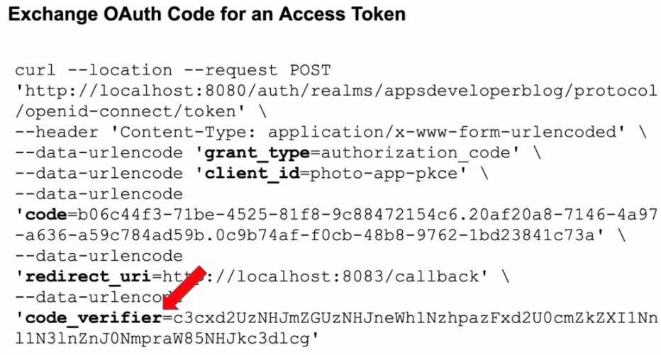

### Generating Code Verifier - PKCE

Lets learn how to generate PKCE code verifier value that will be used to derive the code challenge value. Here's what the OAuth spec says about the generating, the code verifier value

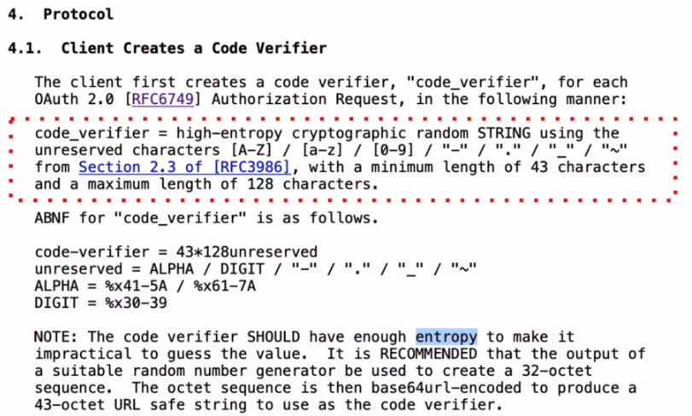

Read it in details, but basically this will need to be an alphanumeric string of random characters with a minimum length of 43 characters and maximum lengths of 128 characters. And this string of characters will need to be URL safe and base64 encoded. And here's how to implement it in Java.

<https://raw.githubusercontent.com/simplyi/PKCE/main/src/main/java/com/appsdeveloperblog/pkce/PkceUtil.java>

**PkceUtil.java**

package com.appsdeveloperblog.pkce;

import java.io.UnsupportedEncodingException;

import java.security.MessageDigest;

import java.security.NoSuchAlgorithmException;

import java.security.SecureRandom;

import java.util.Base64;

public class PkceUtil {

String generateCodeVerifier() throws UnsupportedEncodingException {

SecureRandom secureRandom = new SecureRandom();

byte[] codeVerifier = new byte[32];

secureRandom.nextBytes( codeVerifier );

return Base64.getUrlEncoder().withoutPadding().encodeToString( codeVerifier );

}

}

But basically in this little function I generate random bytes and then I convert bytes to string and then base64 encoded using the base 64 safe URL encode. If you run this function, it will return a string value that looks similar to this one. And this will be the code_verifier value that will need to be used in the request to exchange authorization code for an access token.

### Generating Code Challenge - PKCE

We will learn how to generate code challenge value and to generate the code challenge value you'll need to have the code verifier value generated first. Here's what the OAuth spec says about how to generate the code challenge value, read it in details, but the formula is right here.

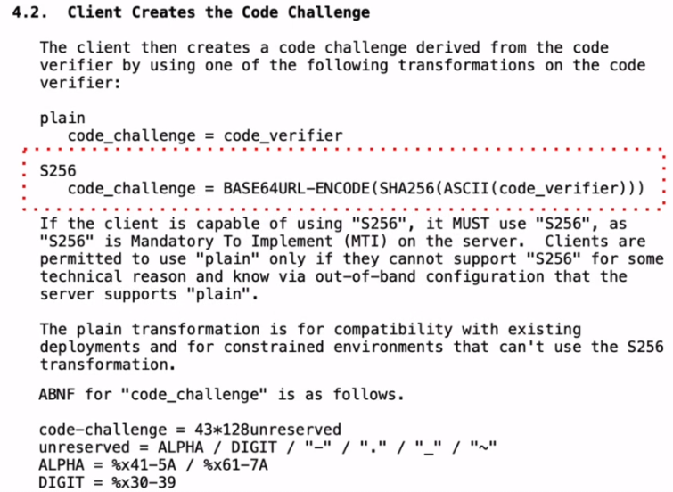

1. The first step is to generate code verifier value.
2. The second step is to encode it using ASCII encoding.
3. The third step is to get the secure hash value of it, using the SHA 256 cryptographic hash function.
4. And the last step is to be base 64 encoded it using base64 encoding.

And here's how to implement it in Java. Have a look at it in details, but again, you do not need to type this code from the screen. I'll make it available for download from the section that contains source code. If you execute this function, providing it with the value of code verifier as method argument, it will return a value that will look similar to this string. And this is how the code challenge value will look like



and you will need to use it in the original request for the authorization code.

<https://raw.githubusercontent.com/simplyi/PKCE/main/src/main/java/com/appsdeveloperblog/pkce/PkceUtil.java>

**PkceUtil.java**

package com.appsdeveloperblog.pkce;

import java.io.UnsupportedEncodingException;

import java.security.MessageDigest;

import java.security.NoSuchAlgorithmException;

import java.security.SecureRandom;

import java.util.Base64;

public class PkceUtil {

String generateCodeChallange(String codeVerifier) throws UnsupportedEncodingException,

NoSuchAlgorithmException {

byte[] bytes = codeVerifier.getBytes("US-ASCII");

MessageDigest messageDigest = MessageDigest.getInstance("SHA-256");

messageDigest.update( bytes, 0, bytes.length );

byte[] digest = messageDigest.digest();

return Base64.getUrlEncoder().withoutPadding().encodeToString(digest);

}

}

### Requesting Authorization Code – PKCE Demo

Lets see how the Pixie ( PKCE ) enhanced authorization code works by generating code verify and code challenge values and by using them in actual http request? And this is just a demonstration of which requests that I use in this flow to give you a better understanding of how this flow works. All right. So the initial http request then, basic flow is http GET request, and it is used to ask the authorization server to give us authorization code, which we can then use to exchange for an access token. And I have Postman open on my screen and I will start by creating a new tab for which I will need to provide the request and provide a URL to authorization and point of my authorization server and notice that the URL to the authorization of web service endpoint in this PKCE enhanced authorization code flow is exactly the same as in the regular authorization code grant flow. So you can use the same URL for both grant flows for PCKE enahnced authorization code and for regular OAuth authorization code. All right.

So now I will start adding request parameters to this request and the first request parameter is client_id. So while my params tab is selected, I will add client_id. And for this demonstration, I have created a new client application with my OAuth authorization server and the new client key is photo_app_pkce. Now the second request parameter is response type and it must be ‘code’ and the response type it must be code, just like with the regular OAuth authorization code Grant Flow. The next request parameter is scope and because I would like my identity provider server to provide me with an id token as well, I will use open ID as a scope. I can provide other scopes as well and just need to separate them with a space, for example, profile, but for this request I will use open id. The next request parameter is redirect_uri. And when registering this new OAuth client application with my Keycloak authorization, etc., I have indicated that the callback url will be http://localhost:8083/callback. All right, so the next request parameter is state, and this is alphanumeric string of random characters that my client application needs to generate and then make sure that authorization server has given me in response to this request exactly the same value. So I will come up with a random volume for now. And the next request parameter is code challenge Method.

And this request parameter is unique to this PKCE enahnced authorization code grant flow. The code_challenge_method, and we did talk about the cold_challenge_method, possible values in the introduction earlier, and if you need to review it, please do so. But basically the only possible value for maximum security in this is S256. And this is a type of cryptographic hash function that will be used to hash the code verifier value. All right. Finally we will need to provide cold challenge for you. And if you recall from previous chapter, there is a special way of how this value needs to be generated by our client application. And I have created the little Java code for this, with your class.

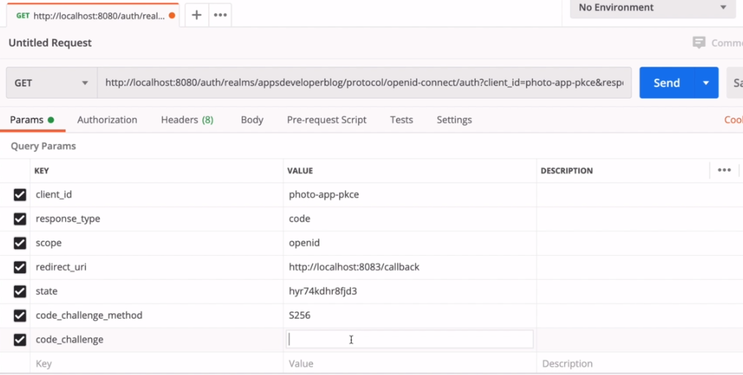

<https://raw.githubusercontent.com/simplyi/PKCE/main/src/main/java/com/appsdeveloperblog/pkce/PkceExample.java>

**PKCEExample.java**

/*

* To change this license header, choose License Headers in Project Properties.

* To change this template file, choose Tools | Templates

* and open the template in the editor.

*/

package com.appsdeveloperblog.pkce;

import java.io.UnsupportedEncodingException;

import java.security.NoSuchAlgorithmException;

import java.util.logging.Level;

import java.util.logging.Logger;

public class PkceExample {

public static void main(String[] args) {

try {

PkceUtil pkce = new PkceUtil();

String **codeVerifier** = pkce.generateCodeVerifier();

System.out.println("Code verifier: " + codeVerifier);

String codeChallenge = pkce.generateCodeChallange(**codeVerifier**);

System.out.println("Code challenge: " + codeChallenge);

} catch (UnsupportedEncodingException | NoSuchAlgorithmException ex) {

Logger.getLogger(PkceExample.class.getName()).log(Level.SEVERE, null, ex);

}

}

}

So basically I have one public static void main function here that makes use of PKCE utility class. This is a custom class I have created and its file is right next to the main job application i.e. PKCEExample.java file above. The PKCEUtility class has two functions. One function is to generate code verifier value and another function is to generate code challenge value. So going back to my main java application file, I'm creating a new instance of this utility class. And then I call the first function to generate called verifier value. And I printed out and then I'm using code verifier value to derive code challenge value. So I'm providing code verifier value as a parameter to generate code challenge method and then I print out the generated value.

You just need to run this application to get these both values printed. So I will run and I have the two values printed. For the http request, I will need to use code challenge value, so I will copy it. I'll go back to my request and I will paste the generated value here. And for every new authorization code that I'm requesting from authorization server, I'll need to generate a new code verifier value and code challenge value, right? So this is a simplified demonstration.

I have run this code manually, but you cannot find this code manually in a real project.

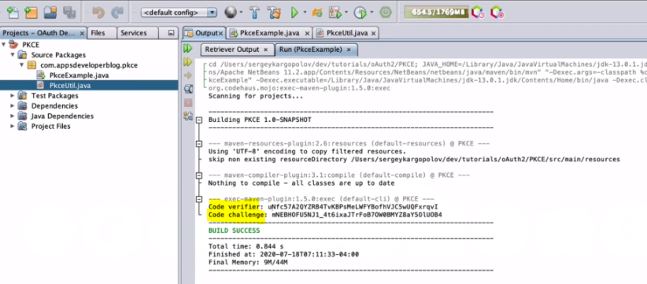

But you can use both of these little functions that I have created for you. To add them to your java application and use them to generate this code verifier and code challenge values in your project. All right. So my HTTP request I can run it, but I will not run it in the Postman client. I will run it in a browser window. So I will copy the entire URL.

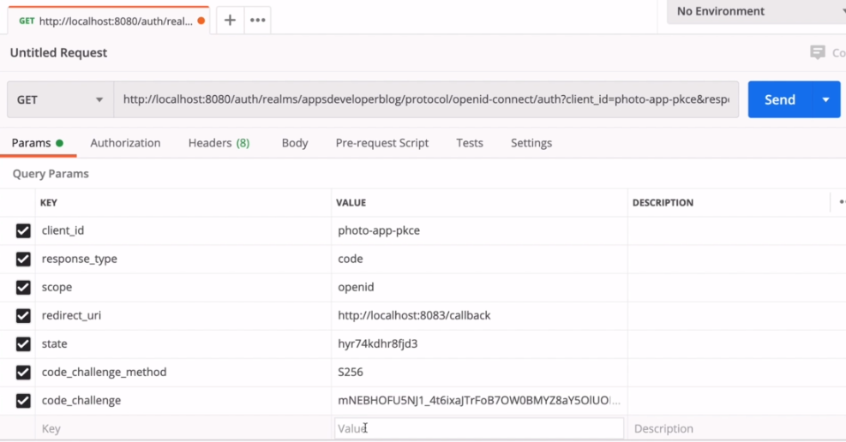

That includes all the request parameters I have created. I will bring in browser window. I will start a new incognito window and paste this URL here and hit enter, and now I'm redirected to authorization server and I will need to authenticate how provide username and password login. And the indication is successful.

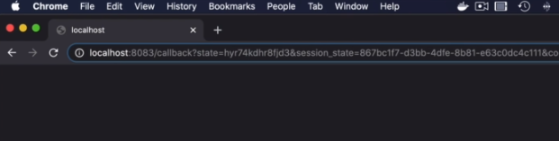

And again, I know that I have been successfully authenticated because I see the authorization, whoever has redirected me to call back your role. And here's the value of the authorization code that it has issued to me and has attached it to the redirect. All right. All right. So now let's learn how to exchange this authorization code for an access token in the pixie enhanced code for.

### Exchanging Code for Access Token – PKCE

We are going to exchange the received authorization code in the previous request for an access token, and this time it's going to be HTTP post request sent to a forward slash talk. Start a new tab and paste the URL to a token Web service endpoint. And for this administration, I'm using Keycloak identity provider and access management server. And if you are using a different server, then this URL to a token endpoint might be slightly different than this one, right? So it's going to be HTTP post request and I will need to select the HTTP request method post and it's going to be sent to this URL. Now I will need to switch to body section and then select the www-url-encoded option and the first request parameter will be granted type. And the value of this this parameter should be authorization_code. Next, I'll need to provide the client ID , can copy from the previous request – it is photo-app-pkce. And the client_secret_value, lets copy from my Keycloak server. Again, and this is just a demonstration of how this flow works, and I did not show you yet how to start up and configure Keycloak server, but in the video you will learn how to configure the server and how to generate new client secret one as well. All right. And the next request parameter is called code. And this is the authorization code that we have received in a previous request. So let me bring up the browser window and copy the code value from here and pasted here. All right. Although I think that by now this authorization code has already explained. So we will most probably need to generate a new one. And the next request parameter is redirect URI. And the redirect URI must match the value we have used in the previous request, so I'll simply copy it from the previous request and paste it here. All right. And finally, the code verifier value. And this is the value that we have used to generate the code challenge value that was used in the previous request. All right. So I will not use this code challenge value because most likely my authorization code has expired already and that I will need to generate the new values. So let's do that. I will run my project to generate code verifier and code challenge value one more time.

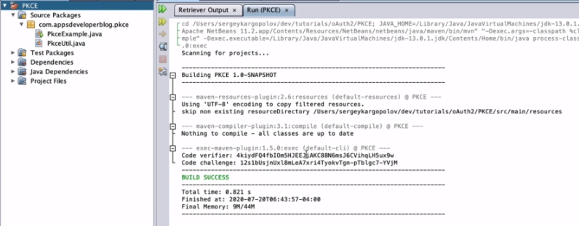

I will copy the new code challenge value and I will paste it into my initial request, I will repeat it to generate a new authorization code value and now I will copy the entire request URL, together with all the request parameters and I will repeat this request to generate a new authorization code. So I'll start a new incognito window based and run it again. I will grab that authorization code that was generated and now I will go back to my HTTP postman client switch to post the request and the will replace the old authorization code with a new value that I have just acquired.

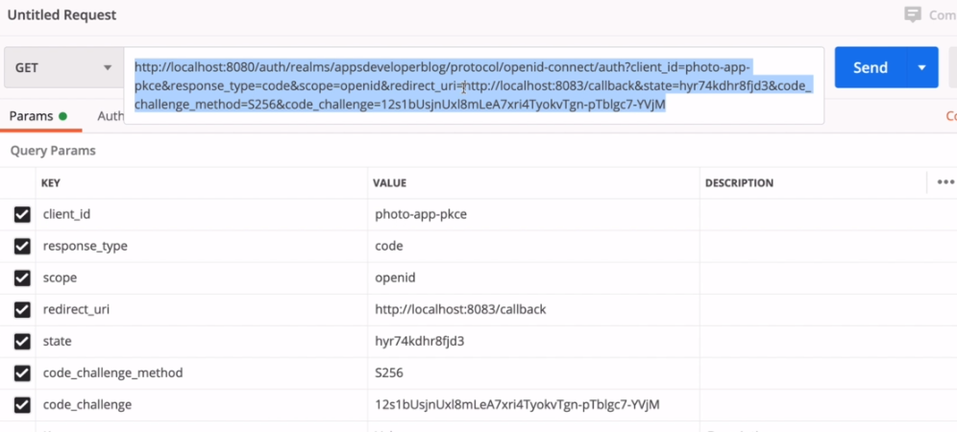

And finally, I will provide a new code verifier value that I have just generated and that was used to generate the code change value, going back to my postman pasted here. All right. And now my HTTP request looks like ready. Let's try sending it. And I got to 200 HTTP status code. Everything is OK. I have access, token, refreshe token and everything looks to be working well. We have our access token. And now you know how to create requests for the PKCE Enhanced Authorization Code Grant type as well.

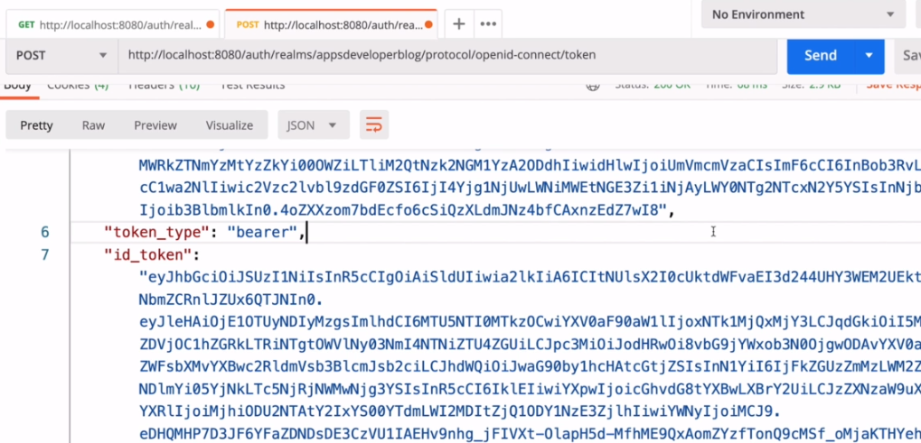

## Client Credentials

### Client Credentials - Machine to Machine Requests

This authorization flow is used when one application needs to send request to another application. There is no user involved in this and there is no login page for user to type in their username and password, but will use client credentials grant type to authorize machine to machine request.

**Client Credentials** application grant type is used mostly in machine to machine communication. This means that the client application will most likely be an application running on the server side. This can be, for example, a springboot micro service application that needs to request data from another Sprint Boot Microservice. If one service that needs to communicate with another micro service and does not have an access token. It will then send the request to authorization server to request an access token.

This time, the client application will send the post request directly to a token endpoint and it will specify the client credentials as the grant type. And optionally, it will provide a scope of access and for authorization server to be able to authenticate this client the request will also need to contain the client credentials. And these are client ID and client secret. And if all is good with the request and the client credentials get successfully validated by the authorization server, the authorization server will respond back with an access token right away. And having received an access token, the client application can then send a request to a resource server using that access to.

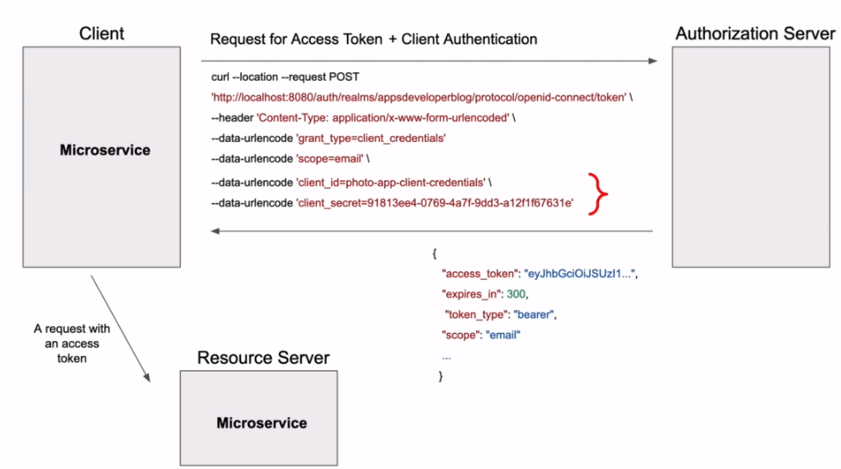

The Client Credentials grant is used when applications request an access token to access their own resources, not on behalf of a user.

**Request Parameters**

* grant_type ( required )

The grant_type parameter must be set to client_credentials.

* scope ( optional )

Your service can support different scopes for client credentials grant. In practice, not many services actually support this.

* Client Authentication ( required )

The client needs to authenticate themselves for this request. Typically the service will allow either additional

request parameters client_id and client_secret, or accept the client ID and secret in the HTTP Basic auth header.

**Example**

The following is an example authorization code grant the service would receive.

POST /token HTTP/1.1

Host: authorization-server.com

grant_type=client_credentials

&client_id=xxxxxxxxxx

&client_secret=xxxxxxxxxx

With machine-to-machine (M2M) applications, such as CLIs, daemons, or services running on your back-end, the system authenticates and authorizes the app rather than a user. For this scenario, typical authentication schemes like username + password or social logins don't make sense. Instead, M2M apps use the Client Credentials Flow, in which they pass along their Client ID and Client Secret to authenticate themselves and get a token

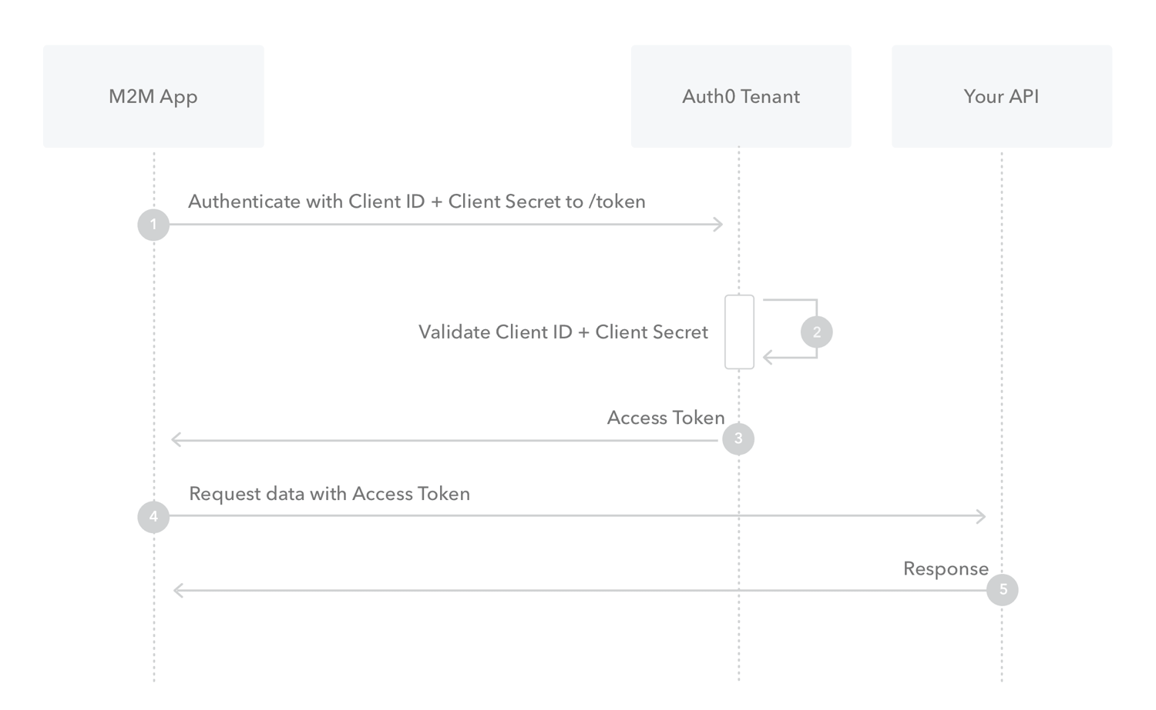

### Client Credentials Grant Type - Demo

Lets see how to prepare a request that uses client credentials grant type, and I will use postman client and I will start with a new tab by clicking on this button. And this is going to be a post request. So from the list of methods here, I'll need to select HTTP post, the URL to a token web endpoint is going to be just the same as in all previous examples. So I will just copy and paste it here. And it is exactly the same URL that I have used in PKCE Enhanced Authorization Code grant type and with the regular authorization code grant type as well. All right. So next I will switch to the body part here and I will select the x-www-form-urlencoded option. And now I'm ready to provide request parameters.

The first request parameter that I will specify is the grant_type. So it is grant_type and the value of this request parameter for the client_credentials. Now, because this is Client Credentials grant type, I'll need to include the OAuth client credentials to this request and these are the client_id and the client_secret. So the first request parameter is the client ID. And for this demonstration, I have registered the client application with my Keycloak server. So the new client ID that I have is for our client credentials like this. Now, the next request parameter is client_secret, client_secret and the value of client secret. I will copy from my server and I will paste it here as well. And the final request parameter that I will need to specify is scope. With this request, I would like to request an access token that allows my client application to request user's email address. So the value of this scope request that I will provide will be email and this is it. I think my request looks good.

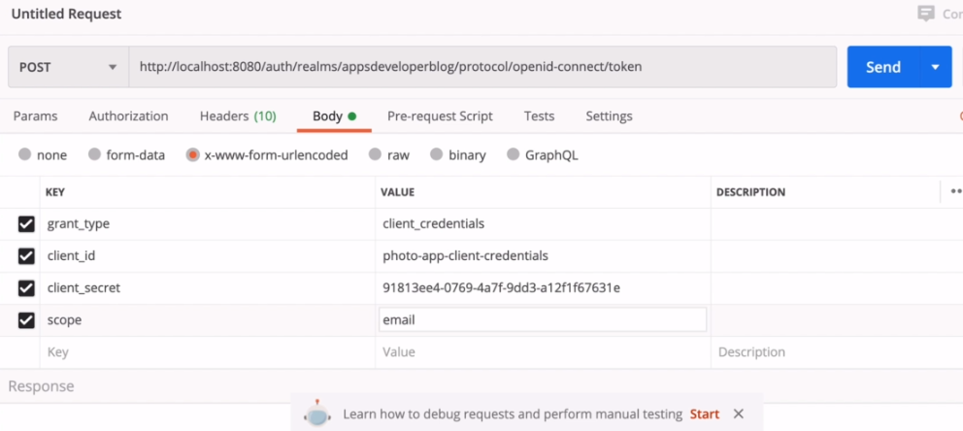

Ready and I can send it. So let's try. And I get back to status 200, and if I scroll down, I see the access token and a refresh token and all is good. All right, so the request is successful. We cut back our access token right away. And now you know how to use the OAuth Client Credentials grant type as well.

Spring Security 5 – Java Implementation

<https://auth0.com/docs/quickstart/backend/java-spring-security5/01-authorization>

Also see:

SPA - <https://github.com/auth0-samples/auth0-react-samples/tree/master/Sample-01>

Regular Java Applications - <https://auth0.com/docs/quickstart/webapp/java>

## Password Credentials Flow

### Password Credentials Flow

The Password grant type is a way to exchange a user's credentials for an access token. Because the client application has to collect the user's password and send it to the authorization server, it is not recommended that this grant be used at all anymore.

Lets learn how to use the password credentials authorization flow to request an access token and also refresh token from the authorization server.

The password grant type should only be used **if your application does not support redirects**. Otherwise, if your application is a web application or a mobile application and it does support redirects, then it is recommended to use the authorization code grant flow or the PKCE enhanced authorization code grant flow.

But if your application is a secure application and a user does have an absolute trust for your application and user is ready to provide your application with username and password, then a password grant flow can be used. Although in latest security best practices, the document disallows the password grant flow entirely.

The password grant flow can also be useful when you need to migrate existing clients by converting the store credentials to an OAuth access token. In the password grant flow the resource owner or the user will need to provide client application with their username and password, the client application will then use this username and password to acquire an access token from an authorization server.

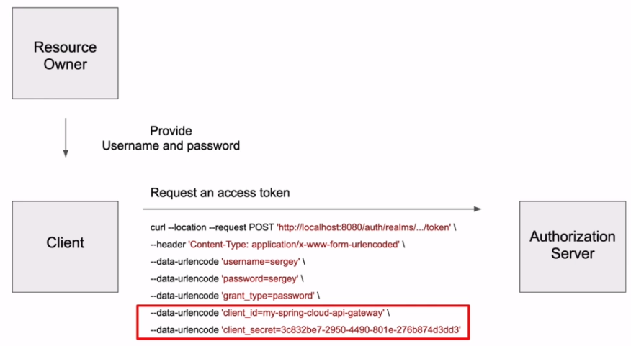

To get an access token from authorisation server the client application will send http post request that will contain the following request parameters. It will need to include resource owner, username and password. It will specify that the grant_type of this request is password, and the client application will also need to include into the request its own credentials, like client ID and client secret. And if the request is successful and the resource owner's username and password were successfully verified, then the authorization server will respond back with an access token.

* Note: grant_type here is 'password'

### Demo

Lets see how to prepare a request for the password runtime and I will use Postman client, and this is going to be HTTP post request. So from the list of methods here, I will select post. Now, the request URL for a token access endpoint is going to be just the same. So I will copy and paste it here and now I'll switch to the body tab here, we will select x-www-form-urlencoded and will start providing request parameters. The first request parameter that I will provide will be the grant type grant_type. And for this flow the value is password. Now, because this is password grant type, in this request don't include the resource owners or users username and password. So the next request parameter will be username. And the value is the actual user name of the user, who has an account with my authorization server, so I have a user with user names here, the next request parameter is password. And this is user's password, so the password for users is also Serguei.

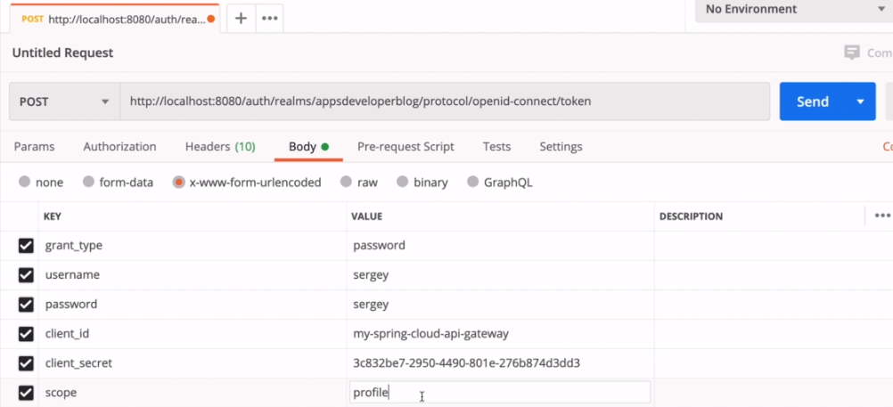

I have a user with username serguei and password serguei. And once again in this phone, we use the actual username and password of a user who is using our application to communicate with the resources on their behalf. So we're going to exchange the actual username and password for an access token. All right. So the next two request parameters are client_id and client_secret. And these are the credentials of our client application that is performing this request and is also registered with the authorization server. So the next request parameter is client_id. And for this request I'll use a new client application. And the value for client ID is my-spring-cloud-api-gateway. All right. So the next request parameter is client secret. And the value of client_secret, I can copy from catalog server and paste it here, and finally I will specify the scope of access. So the next request parameter will be scope. And the value for this will be profile. And this is it, my request is now ready and I can try send in it and see if it works. All right, so I got http 200 status, and if I scroll down, I have my access token, I have my refresh token and everything looks like is working. All right.

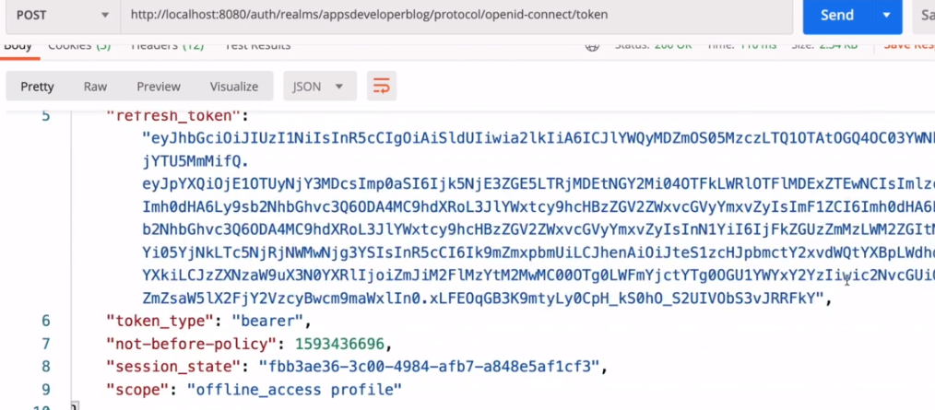

So now you know how to prepare a request for the old password. Grant flow as well.

Read these articles of OAuth 2.0 - <https://oauth.net/articles/>

## Refreshing Access Token

### Refresh Access Token

Lets see how to refresh an access token using a refresh token. Let's have a look at this little background on the left side. We have a client application and on the right side we have an authorization server, for a client application to be able to communicate with a resource server. It will need to acquire a access token from an authorization server. So the client application will send the request to an authorization server to request an access token. This request can be used in any grant types that we have discussed in previous lessons. And if all is good with the request, if the user authentication is successful and if a user has granted our application to access their data, the authorization server will respond back with an access token and with a refresh token. Now, when the client application has an access token, it can send the request to a resource server requesting a protected resource. And if all is good with the request, the resource server will respond back with a protected resource.

* When the access tokens expire, and it is suggested that the maximum lifetime of an access token is about 10 minutes. Let's assume that a few hours later, during the day, the client application sends a new request to resources to fetch user data one more time. And because it has passed a few hours already, the access token will be already expired. And because the access token has expired, the resource server will respond with an invalid token error. Ideally, declined.

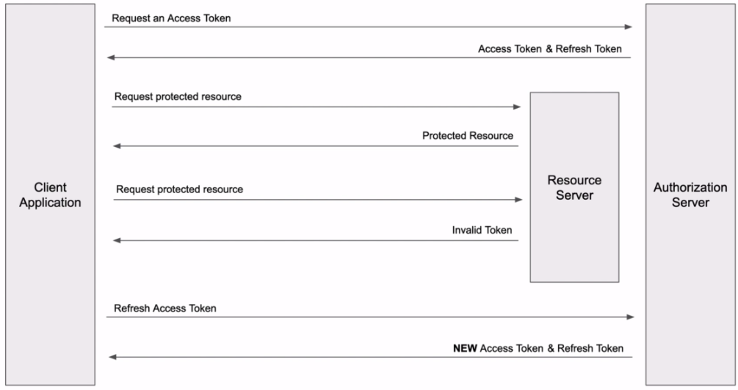

Applications should check if access token has not expired and if it has, it should not even send the request. So what should we do if an access token has expired, when client application learns that the access token has expired? It should send the request to an authorization server to refresh an access token. And it is. in this request that the client application will use a refresh token, which it has acquired when asking for an access token.

* So an access token is a short-lived token that is valid for about 10 minutes. And a refresh token is used to refresh or renew an existing access token. Now, when we refresh an access token, we will actually get back a new access token and optionally a new refresh token.

So if your client application stores this while you send a database, then old values, they will need to be replaced with new ones. When we receive a refresh token, we can get back refresh token that expires in a certain number of minutes, or we can get back refresh token & that never expires. For e.g, this JSON response, contains a refresh token that expires in 30 minutes.

|  |  |
| --- | --- |
|  | And if we attempt to use this refresh token after it has expired, then we will get back an error message saying that the token is no longer active when working with Authorization service that support Open ID connect we can request a refresh token that never expires.  The expiry time of a refresh token that never expires is zero. To request refresh token that never expires, we will need to include into list of scope's and additional scope that is called offline_access and offline access refresh tokens. They never expire and they need to be treated with special care.  And this is because if this type of refresh token gets stolen, a malicious user can request a new access token & access user data any time they need it, even if they try many days after it was initially issued. |

The refresh and access token, the client application will need to send HTTP post request to a token webservice endpoint. It will need to provide the same client_id and same client security credentials that it has used initially to acquire an access token and a refresh token. And the grant type of this http post request will need to be refresh_token. And because it is the refresh token grant type, we will need to hand a refresh token, a request parameter containing an active refresh token value.

|  |  |
| --- | --- |
|  | And if all is good with our request, then in response back, the authorization server will generate and return as a new access token and optionally a new refresh token. And I say optionally because it is possible that the authorization server will not return as a new value or refresh token. And if the authorization server does not return any value of refresh token then declined application. I assume that the current refresh token will continue to be valid. |

### Refresh Token that never Expires

Lets request for an access token that returns a refreshed token that never expires. So on my screen, I have a request for an access token using the password grant type. The current type of my request is password. I'm not going to go in details about this request and about other request parameters that it has because you are already familiar with it. It is a regular http request for an access token using the password grant type. And the only difference in this request will be that I'm going to add an additional code value to it and it is to request a refresh token that does not expire.

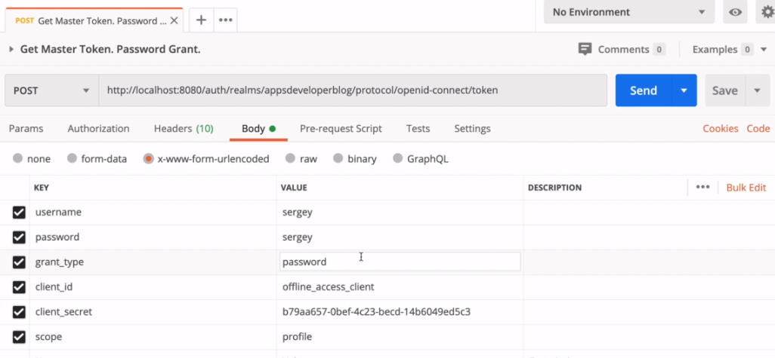

So let's try sending this request first, and as a response we should expect a refresh token that expires in 30 minutes. So I'm going to send it. And if I scroll down, I get back the http status 200, which is OK. And then I have an access token and I have a refresh token that expires in one thousand eight hundred seconds, which is equal to 30 minutes. All right.

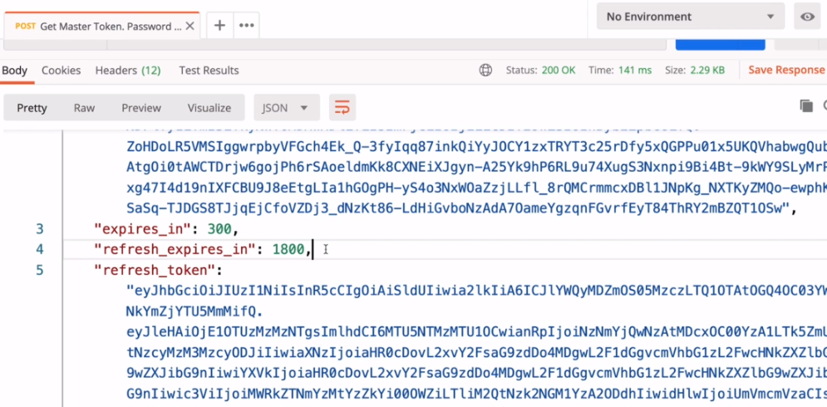

So this one worked and we got back a refresh token that expires in 30 minutes. Now because we are using Keycloak identity provider and access management server that also supports Open ID protocol. I can request a refresh token that never expires. And to do that, I'll need to use an offline access scope. So I will add an additional scope value here, which is offline access, like this. They will need to be separated with the space. So I have profile and then space and then offline_access. Now let's try sending this request. The request is successful.

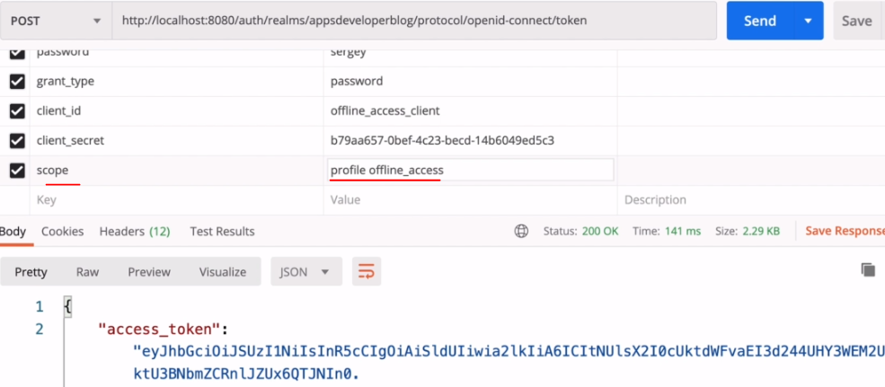

If I scroll down, I have access token and I have a refresh token with an expire time of zero seconds, which also means that this refresh token does not expire. All right. So you now know how to request a refresh token that expires and that does not expire. Let's learn how to refresh the refresh token now.

### Refresh Access Token with Refresh Token

Lets request for refreshing the access token using a refresh token and we'll use the postman client to prepare this new request. And they will start with a new tab. This is going to be HTTP post request to a token webservice endpoint, so from a list of methods I will select post and the token webservice endpoint we can just copy from any of my previous requests that we have used to request an access token is going to be seen. So copy and paste it here. All right.

So to refresh an access token, we will need to send http post request to the same token webservice endpoint. And now we'll switch to the body tab and specify x-www-form-urlencoded option and we'll start providing request parameters. And the very first request parameter that I will provide is grant_type with the value of refresh_token. I will need to provide the same client credentials that were used to acquire an access token, then I'm going to refresh. I have http request open and with this request, I have received an access token and a refresh token. So this refresh token does not expire. Let me send the request for a refresh token that expires.

So I have a refresh token that expires in 30 minutes, now in my request to refresh and access token, I will need to use client credentials, which I have used to acquire this refresh token, so the client and the client secret we will simply copy from this request. So I will switch back to my http request to refresh and access token and we will provide a client_id request parameter and the value as offline_access_client. The next request parameter is client_secret and the value of client I will also copy from my previous request and we'll post it here. All right. And finally, the refresh token request parameter and its value. I will copy from the original request that they have sent to initially acquire an access token. So I will switch to my previous request, will scroll down and will copy the entire value of a refresh token like this. Switch back to my http request to refresh access token and I will place it here and this is at my request, is now ready and I can try sending it.

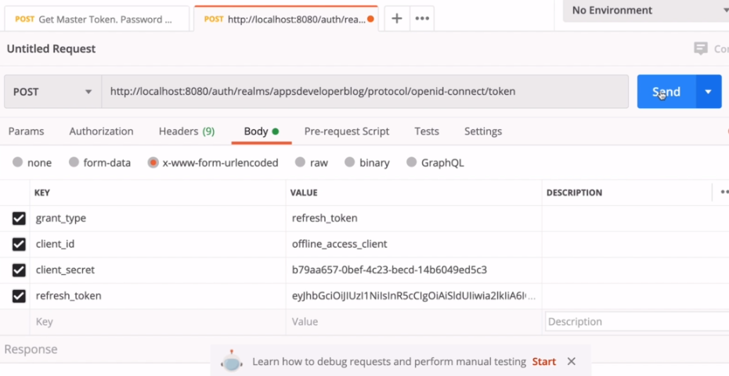

* grant_type is refresh_token

So I will click on Send Button. The request is successful. I could to be starlet's two hundred and if I scroll down I have an access token and I have a refresh token and refresh token by time. So everything is working, the request is successful and you now know how to refresh and access to.

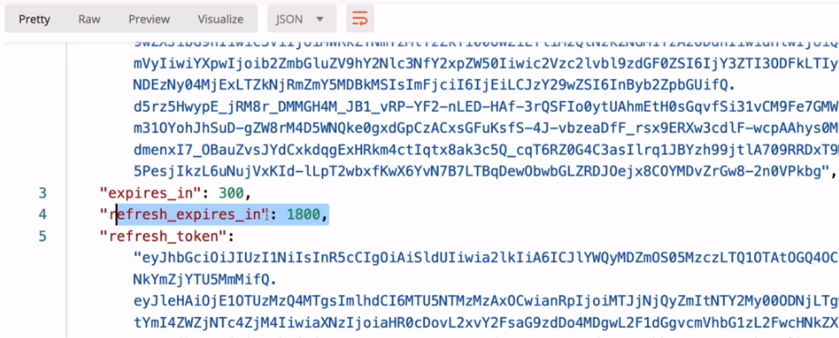

## Authorization Server - KeyCloak

### Introduction

|  |  |
| --- | --- |
| Lets learn about one very popular Identity and Access Management Server that supports Open ID Connect and with the authorization flows and it is called Keycloak. So Keycloak can be used in our application. Here on this slide, I have illustrated four different participants of our flow.  We have resource owner who is also a user. We have a client application that can be a website or a mobile application. |  |

Then we have a resource server and this could be your single spring boot monolithic application that exposes certain endpoints or it could be a set of different small micro services that are running behind an API gateway. And finally, we have the Authorization server that is used to let resource owner or the user to authenticate with their user name and password and issue an access token to a client application. And this is where Keycloak can be used. There are different authorization servers available in the market. There is a AWS Cognito and there is Okta. There is also Microsoft Identity Platform and there is the Spring Authorization Server. And finally, there is Keycloak and there are other authorization servers available out there.

This list is just a few and is very far from being complete. But this is where Keycloak has been used. It can be used with our Spring Boot application as our authorization server. We can use it to let users authenticate with the application and then generate an access token and refresh token. And once the user is authenticated, Keycloak we will generate an access token and refresh token. Keycloak is open source identity and access management solution. And you can use to add authentication to applications and secure services with a minimum amount of work.

Keycloak provides you with both the interface to manage users of your application as well as the rest API that you can use to add new and manage existing users. Keycloak, open source can be downloaded, and you can run it as standalone application on your server. You can integrate it with existing applications and you can also run it as a docker container and you can use it with Kubernetes. Keycloak supports single sign on and sign out, and this means that once a user is looking into one application with the user will not need to log into another application again. And also, if user logs out of one application, they will also be logged out of all other applications. Keycloak also supports social login, and this means that we can let users login into your application with their social network accounts like Facebook, Google, Twitter or GitHub and Keycloak can also authenticate users with existing Open ID Connect or SAML identity providers. And there is not much work that you'll need to do to make it work.

If your organization has an existing user database, then it can also be integrated with Keycloak. Keycloak supports existence LDAP and active directory servers and you can also implement your own provider and integrate Keycloak with existing MySQL database, for example.

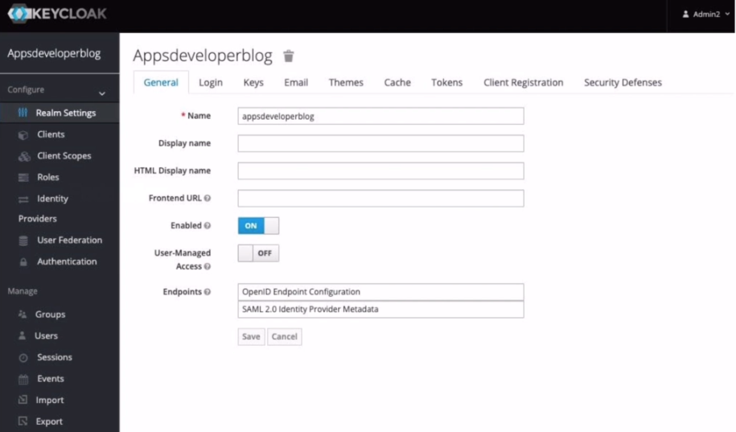

Keycloak has a very user friendly web interface that allows you to manage both client applications, users, their credentials and their rules, you can configure OAuth grant type supported by your application, generate new client secret key, create client scopes and define fine grained authorization policies, all using this web interface. It is a very advanced administration console and has lots of features that allow you to manage a lots of things in one place where this single web interface. All right. So let's learn how to run quickly as a standalone server on our computer.

### Install Standalone Keycloak Authorization Server

Lets go the website and download the Keycloak Authorization server - <https://www.keycloak.org/downloads>

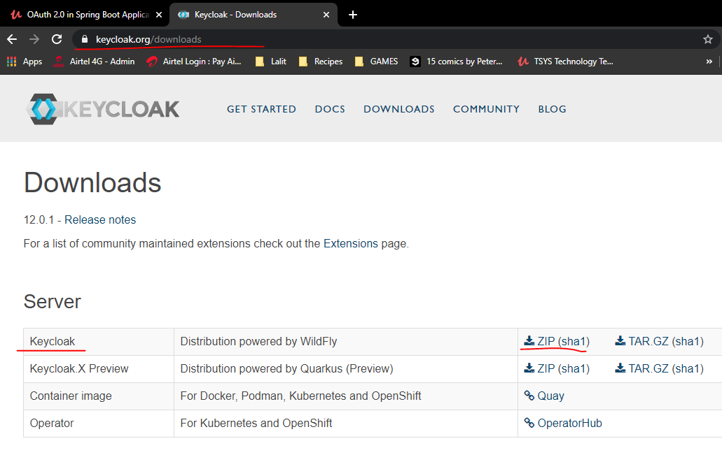

The download will take a few seconds, it's 221 MB, so just let it download. When the file is downloaded, I can unzip it. Here is our Keycloak server.

C:\software\keycloak-12.0.1>dir

Volume in drive C has no label.

Volume Serial Number is 308D-9F0E

Directory of C:\software\keycloak-12.0.1

18-12-2020 09:23 <DIR> .

18-12-2020 09:23 <DIR> ..

18-12-2020 09:23 <DIR> .installation

18-12-2020 09:23 <DIR> .well-known

18-12-2020 09:23 <DIR> bin

18-12-2020 09:23 <DIR> docs

18-12-2020 09:23 <DIR> domain

18-12-2020 09:23 491,664 jboss-modules.jar

18-12-2020 09:23 11,358 LICENSE.txt

18-12-2020 09:23 <DIR> modules

18-12-2020 09:23 <DIR> standalone

18-12-2020 09:23 <DIR> themes

16-12-2020 11:46 26 version.txt

18-12-2020 09:23 <DIR> welcome-content

3 File(s) 503,048 bytes

11 Dir(s) 206,988,972,032 bytes free

To start up Keycloak server we will change current directory to bin directory, which is inside of Keycloak folder. There are many files in the bin folder, but the one that we are looking for is called standalone.bat. So to run Keycloak on my computer, I will use the following command standalone.bat. All right so I can hit enter and that will start Keycloak server by default. Keycloak server will start up on port 80. You will need to give it a few seconds to start up. And when it started you can open up your browser window and try opening http://localhost:8080. I will go to my browser window, start a new tab and go to localhost port number 8080 and then hit enter. And here's my Keycloak homepage.

C:\software\keycloak-12.0.1\bin>standalone.bat –Djboss.socket.binding.port-offset=100

Calling "C:\software\keycloak-12.0.1\bin\standalone.conf.bat"

Setting JAVA property to "C:\jdk-14\bin\java"

===============================================================================

JBoss Bootstrap Environment

JBOSS_HOME: "C:\software\keycloak-12.0.1"

JAVA: "C:\jdk-14\bin\java"

JAVA_OPTS: "-Dprogram.name=standalone.bat -Xms64M -Xmx512M -XX:MetaspaceSize=96M -XX:MaxMetaspaceSize=256m -Djava.net.preferIPv4Stack=true -Djboss.modules.system.pkgs=org.jboss.byteman --add-exports=java.base/sun.nio.ch=ALL-UNNAMED --add-exports=jdk.unsupported/sun.misc=ALL-UNNAMED --add-exports=jdk.unsupported/sun.reflect=ALL-UNNAMED"

. . .

14:07:25,845 INFO [org.jboss.as.server] (Controller Boot Thread) WFLYSRV0212: Resuming server

14:07:25,848 INFO [org.jboss.as] (Controller Boot Thread) WFLYSRV0025: Keycloak 12.0.1 (WildFly Core 13.0.3.Final) started in 13273ms - Started 589 of 867 services (585 services are lazy, passive or on-demand)

14:07:25,851 INFO [org.jboss.as] (Controller Boot Thread) WFLYSRV0060: Http management interface listening on http://127.0.0.1:10090/management

14:07:25,851 INFO [org.jboss.as] (Controller Boot Thread) WFLYSRV0051: Admin console listening on http://127.0.0.1:10090

<http://localhost:8180>

Now if the port number 8080 is taken then you can run Keycloak server on a different port number. And to do that I will go back to my terminal window. I will start up a new tab and then use the same command. I have used to start server on port 8080, but with an additional command line argument. I will repeat the same command standalone.bat and then add to it an additional command line argument which is -D then jboss.socket.binding.port-offset=100. All right, so it does the jboss.socket.binding.port-offset equals and then how much you want to offset the default port? Now, for example, 100. So if the default port number is 8080, then the new port number will be 8180. I'll need to give it a few seconds to start up. And once it has started, I can open a new browser window and try a new poll number.

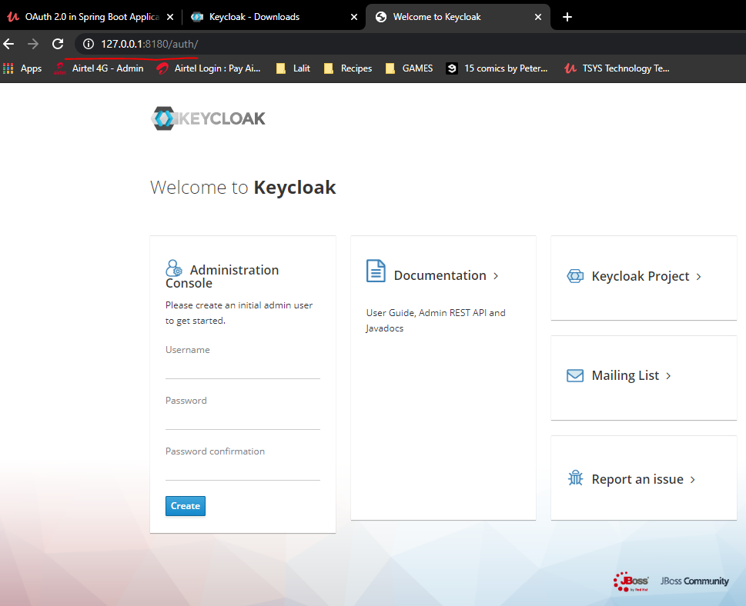 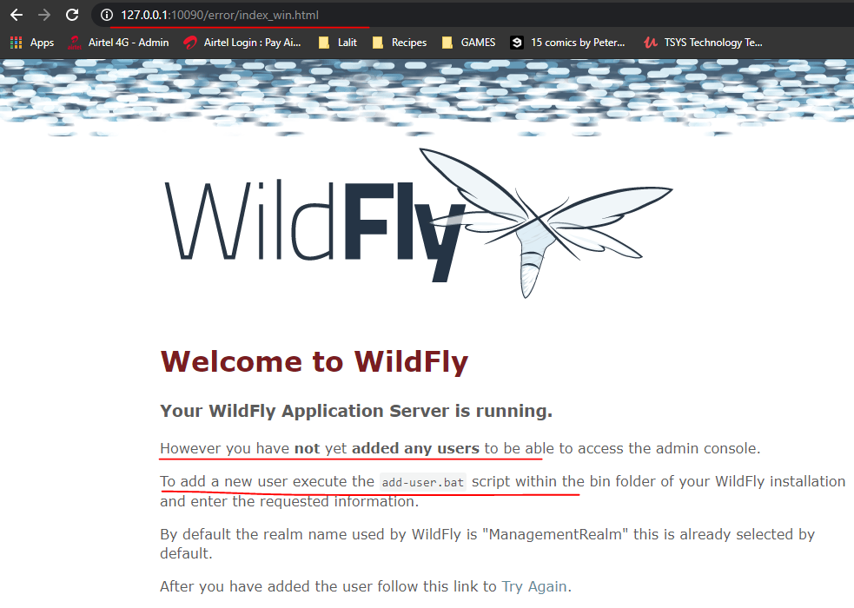

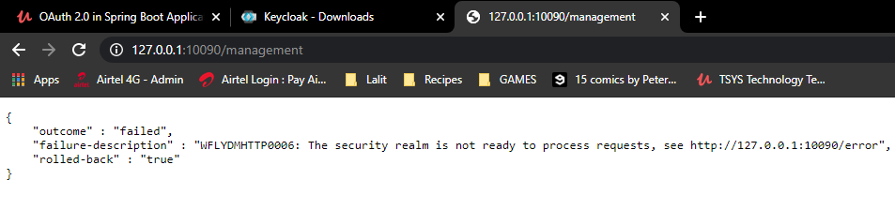

So it's going to be http://localhost:8180 and hit enter and here's my homepage. So I have to Keycloak service running on my computer. One is on Port 8080, which is still working and another on Port 8180, which is also working. All right. So let's go back to a terminal window and then stop Keycloak server. I can simply hold control button on my keyboard and press c. And now the key clock that is running on Port 8180 has stopped. So if I refresh the page, it's no longer running, but the one on 8180 is running. All right. So it is not working. Let's continue.

### Creating a Initial Admin User

When we started Keycloak server for the very first time, there will be no default username and password that we can use to access the server, we will need to create an initial admin user to be able to log in. And right now, I have a Keycloak server running and open its homepage for the very first time. And because this is a brand new installation and there is no admin users at all on homepage, I have a panel to create a new admin user, it is the very first panel on the left side administration console.

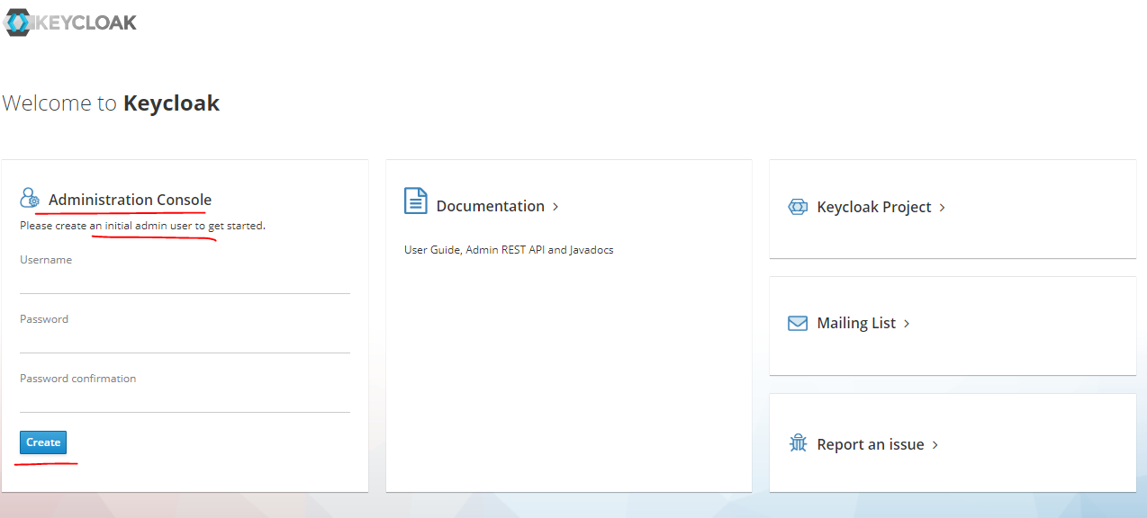

So I'll come up with the username and password to create a new initial admin user. And click on button, all right, so the user is created and it can use its credentials to log into Keycloak Administration Council. Please note that the credentials of this initial admin user, they should not be used by client applications, that we will create and register with this server. We will need to use an initial admin user only to log into our server for the very first time and to create new realm and new regular users and register new client applications. All right. So now we have an initial user. Let's log in and create a new realm and create a new user and then register a new client application.

User is created admin/ admin

We have created an initial admin user, and now if I open the homepage, it will look slightly different. Let's do that. I will go to localhost:8180 and hit enter. Now, there is no longer an option to create a new initial user on this page, but instead we have a link to an administration console and I can use the credentials of a new user to look in into my server and work with it. So let's try. I will click on the administration console and I'm invited to log in.

|  |  |
| --- | --- |
|  | I'll need to use the credentials of the initial admin user ( admin/ admin ) to log in now click on log in and I logged in into a master realm. And I see the name of the realm home in the upper left corner here ( screenshot below ). There is only one realm home that is currently created, which is master, and I can create new realms. So what is a realm, realm is like a tenant in Keycloak server. It is a space that allows us to manage a set of users, their rules and their credentials. So when user logs in they log in into this space, they login into this realm and users in one realm, they are isolated from users from another Realm in the server. So when you start to look for the very first time, Keycloak creates a predefined master realm for us. And in this master realm we have created an initial admin user. So this master realm, is at the top of hierarchy of any other realms and it is reserved for admin accounts, all admin accounts. In this realm, they have permissions to view and manage any other realm. |

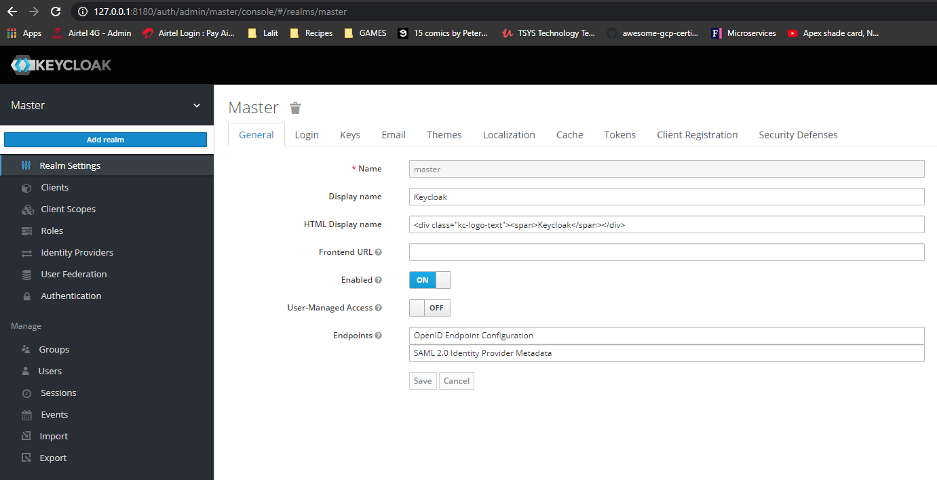

* So because we have logged in with our initial admin user, we are in the Master Realm. By default, it is recommended that we do not use Master Realm to manage regular users in our organization. The master should be reserved for super admins so that they can create and manage other realms in this server. So since Master Realm is reserved for admin users only, we'll need to create a new Realm. And in that realm we can register all regular users of our application. So to create a new Realm, I will need to move mouse over the master and then click on add own button ( see blue button in screenshot above ). Here, I will simply need to provide a name for a new realm. I will call it appsdeveloperblog and click on Create Button.

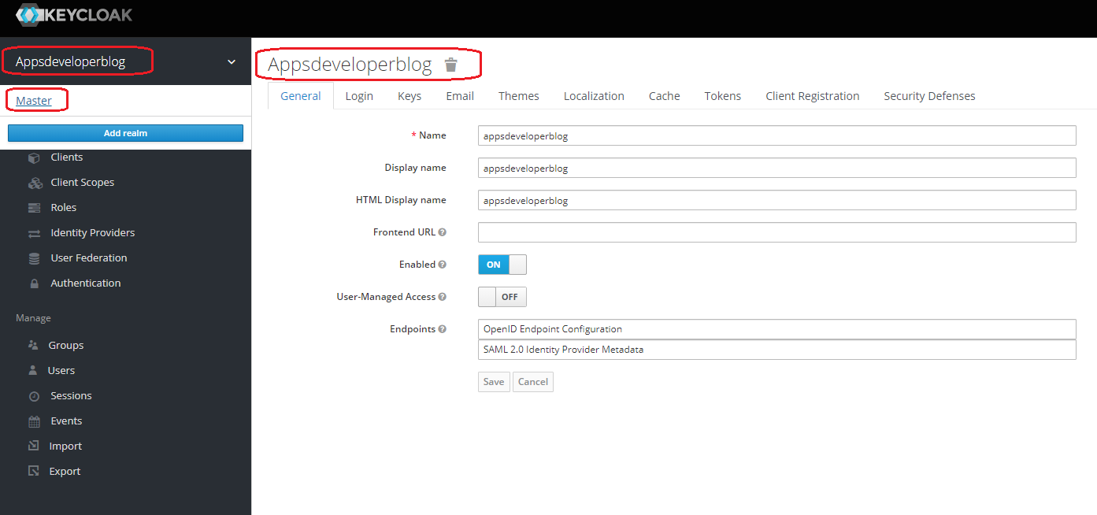

And now the new realm is created, automatically switched to this new realm. I can go back to Master and then from Master I can go back to appsdeveloperblog and then this new realm appsdeveloperblog. I can create as many regular users for my application as I need.

### Creating a new User

Now, we have created a new realm, we can create as many users for our application as needed and to create a new user, how will you go to users section?

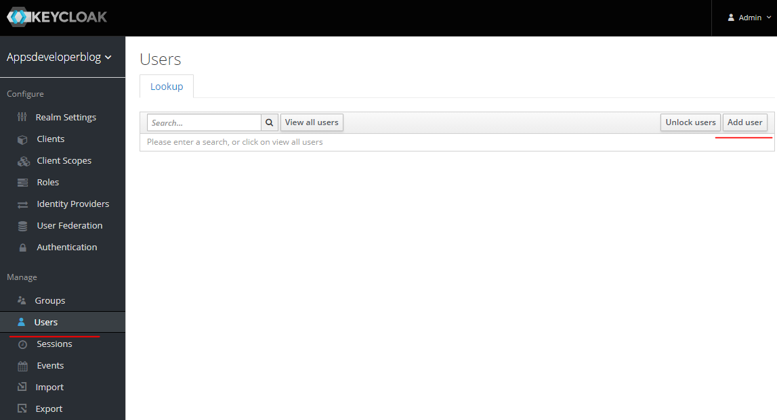

|  |  |
| --- | --- |
| And here I can search for all users or I can create a new one by clicking on add user button. Here, I want you to fill in the form, provide user name, email, first name, last name. So let me do it quickly. If you want to disable user for now, you can disable this option, and if you know who the user is and you know the email address provided in the form, this belonged to this user, then you can enable the email where you find option.  Otherwise, you might want to keep this off and specify one of the required actions, which can be, for example, to make user verify their email address. All right. So once the form is filled, then click on Save and the new user is created. |  |

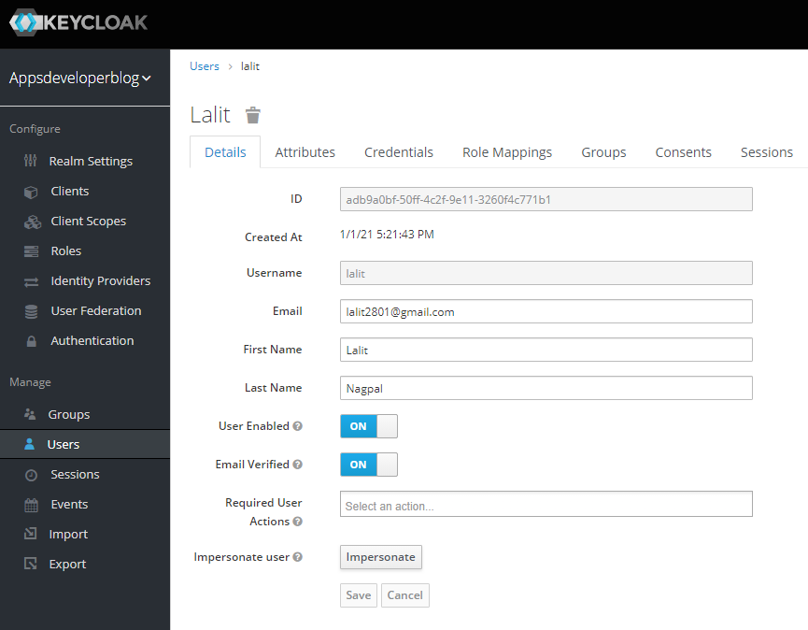

Now I will switch to credential tab and create a password for this user. In the password is set to temporary, then the user will need to change this password when they login the next time.

|  |  |
| --- | --- |
| All right, so click set the password and the user is created. Now, there are different ways how to create the new user account. It can be created by an admin user here in Keycloak Server and admin user can also use a terminal window to create a new user account with a command line interface. And Keycloak also provides a REST API to let you register new user accounts by sending HTTP post request from a client application like mobile app or web page, for example. But once user is created, if needed, you might want them to log into their account on server and let's say update their password, for example, and to log in to Keycloak server with user account, users can use the following you around. So it's going to be http and then the domain name of your server. |  |

In my case, Keycloak server is running on http://localhost:8180/OAuth/realms/appsdeveloperblog and then hit enter.

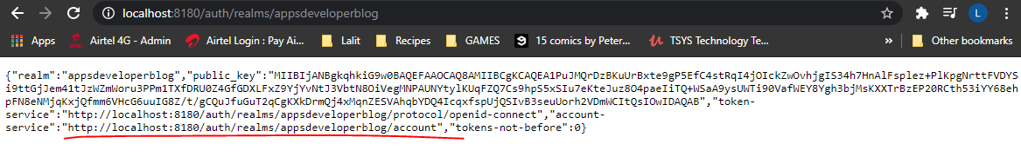

On going to the account service at <http://localhost:8180/auth/realms/appsdeveloperblog/account> we get the following screen

|  |  |
| --- | --- |
|  | And here we'll need to use user's credentials. So the user I have created has a user name lalit and then a password as password and click on login. Now, because the password they have created was only temporary. I'll need to change my password on first user again, so now I will come up with a new password. And login, again. And here we go. I looked into my account and have access to my details. |

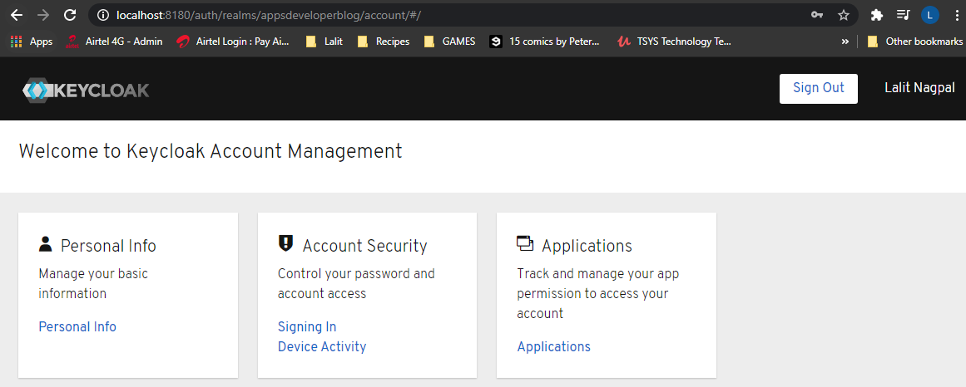

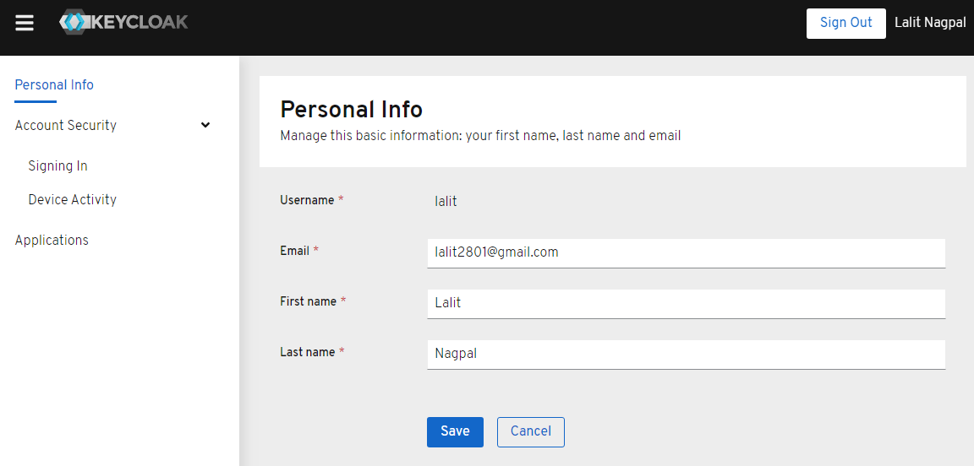

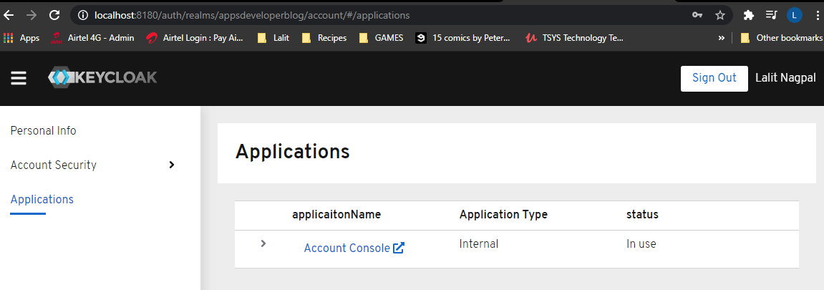

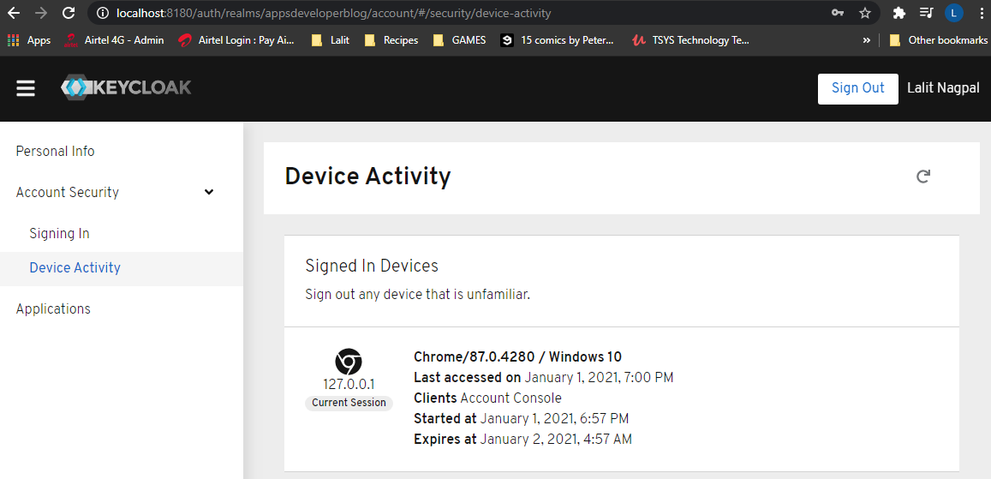

### Creating a new OAuth Client Application

Lets see how to create a new OAuth client application in Keycloak, and to create a new OAuth client application you'll need to log in to Keycloak server with an admin username and password and then select Realm for which the client application will need to be created. All right. So let's log in first. I will login with user name and password of admin user.

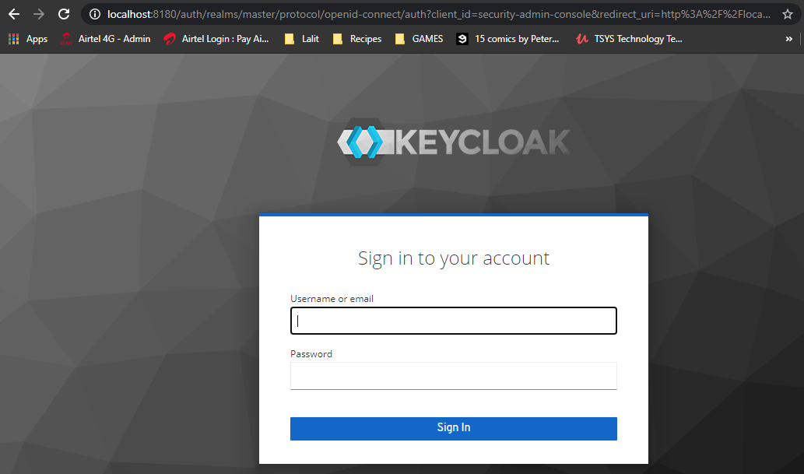

I'm successfully logged in the realm, my need is already selected, but there are more realms in the list you have then select the one for which you want to create the new client application. Right. And to create a new client application, go to Clients section I have already selected and look for a create button which is under the time of recording this video, is right above the client's table here in the upper right corner. So click on Create Button.

|  |  |
| --- | --- |
|  | The form is very simple. I will only need to provide client id here and this is the client id that will need to be used in authorization flows. So create one for the standard flow, which is OAuth Authorization Code Grant type and we'll call it for photo-app-code-flow-client. There are a couple of protocols to select from. One is Open ID connect and another is SAML. I'm not going to talk about SAML and will continue with the Open ID connect. |

|  |  |
| --- | --- |
| And this is it for now. Let's click on Save Button. And the client application is great. Now, there are plenty of settings that it has which can be configured, and I'm not going to go through every single one of them in details. Of course, will just cover those that we will need to make our code work. So by default, these client application is already configured to work with the standard authorization code grant type. It is because the standard flow is enabled and there is only one required field, which is a redirect URI, that I will need to provide in this form to be able to save it. |  |

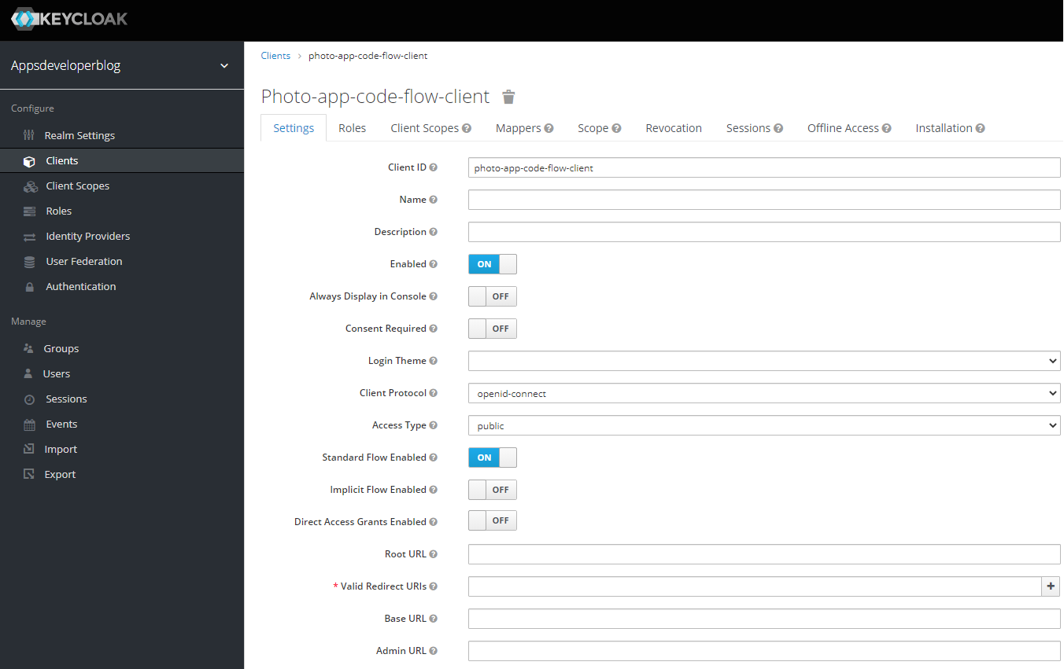

The client ID is provided in the very first field here. This is the client ID that I need to be using in the authorization flow. Later we will see how to generate client secret. And if we look through the form, I see that this client application is enabled by default. If you have more than one client application and then you can disable one that you don't need. You can choose if consent is required or if the consent is not required. The protocol is Open ID and currently this client application is public. If you recall from one of the early lessons where we talked about the difference between public OAuth client applications and confidential OAuth client application, the public clients are those that cannot guarantee confidentiality of their secret key. And an example of such application is a single page JavaScript application. Because any developer can view its source code, the client application cannot use the secret key. And because this application is currently set to public, there is no filter in this form with a secret key available to us. And I'll show you how to generate security soon. And next, we have three different control options to enable or disable one of the whole authorization grant types for the authorization code grant type. We will need to have a standard for option to be enabled. And the other two, we can keep disabled. So I will disable the direct access grant by clicking on this control option. And if you move mouse over the question mark, it will tell you more about this option.

|  |  |
| --- | --- |
| And it is said here that this option enables or disables the password credentials grant type. All right. So the only required field in this form now is voluntary directory. And this, as you arrive with the authorization server, will redirect next after user successfully authenticates with this server. I do not have a client application like a website or mobile app ready to provide a proper URL here. |  |

So I'll just provide a temporary one here, for example, http://localhost:8180/callback. So once the user successfully authenticates, the authorization server will redirect to this URL and it will attach the authorization code to this URL. All right. So now I can save changes in this form and then generate a secret key for this client. The changes are saved. Let's continue.

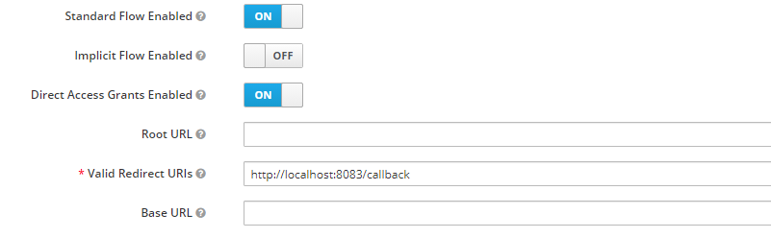

### Configuring Client Application Secrets

We have created a new client application, but this time it is a public type application and for public type applications, it does not even allow to generate client secret file. So to generate the client's secret value, we will need to change the type of this application from public to confidential and then save the settings. And now if we scroll up at the top here, we should have a new tab, which is called credentials.

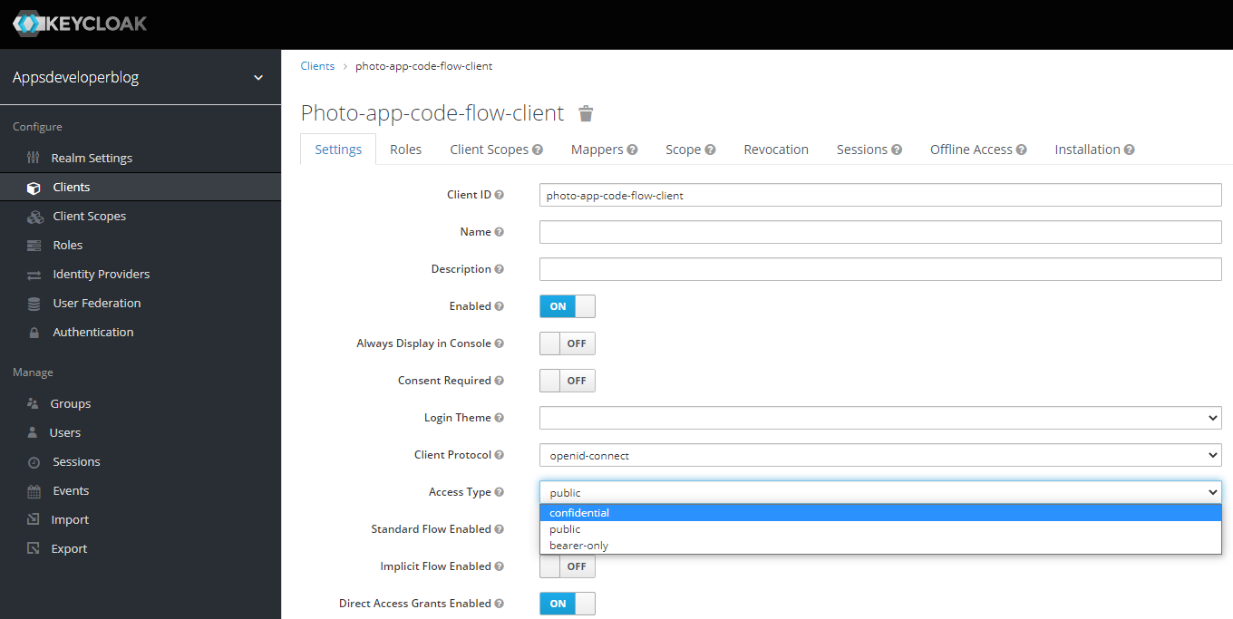

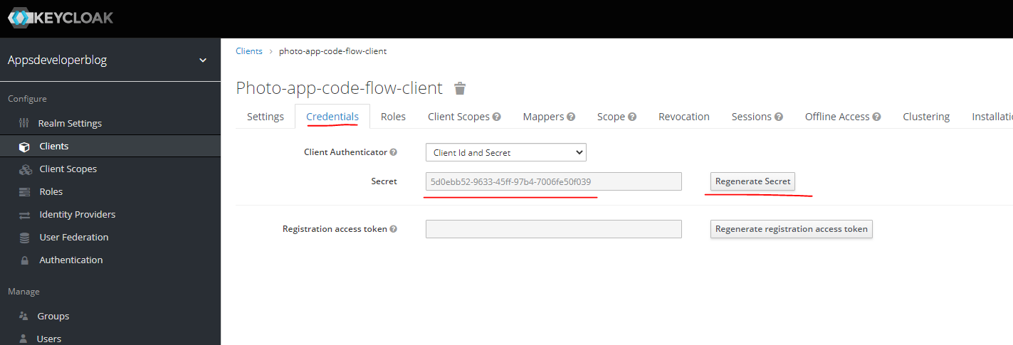

Now, if I switch to this tab here, I can copy the client secret value or it can regenerate it. So if I click to regenerate, it generates a new value. Right. So now we have a client secret value here at the top. We have client ID or if I switch the settings here, I have client ID, all lower case characters.

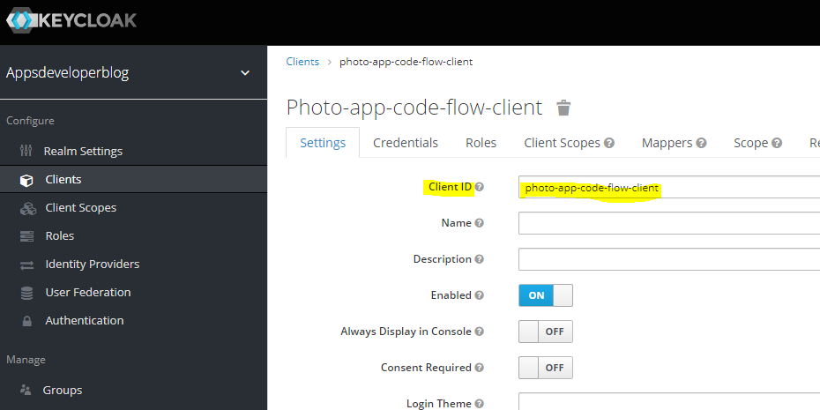

And that one, we have an old client application created. We have client ID and we have client secret. We can try performing one of authorization flows.

### Requesting Access & Refresh Token

When we access the realm like this – <http://localhost:8180/auth/realms/lalits-realm>

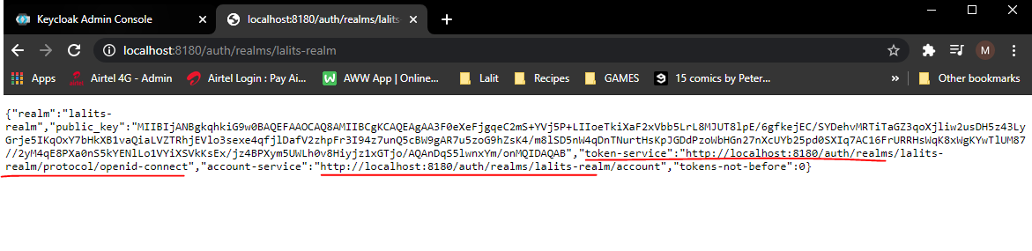

* It gives us two URLs here
* The account-service URL allows us to login to the account of the user

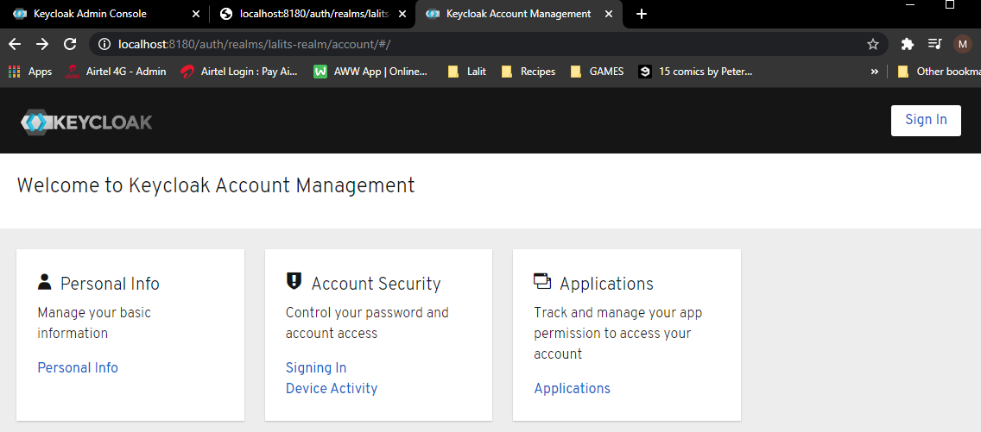

* The 2nd url i.e. the token service endpoint can be used to get the authorization token – just append **auth** to it at the end and add it to the GET URL in screenshot below where we are preparing the URL to request for access token.

Let's try using this new credentials and perform OAuth authorization code flow. I will bring in Postman and here I have a request to perform the OAuth Authorization Code, the response type in this request is code. So what I need to do is I will go to my OAuth client application and then we'll switch to settings and I will copy the client ID and I will replace the client that I have used in this request with the client from my new application. The response time is going to be called the scope and it is going to be Open ID and profile. The redirect URI here will need to match the value that we have specified in the OAuth client application. So if this redirect URL does not match the value we provided, then the request will not work. All right. So I will copy this file. You and I will paste it into my request, the value of state that we will leave as unchanged. I'm not going to validate it when the request comes back, so I'll just leave it.

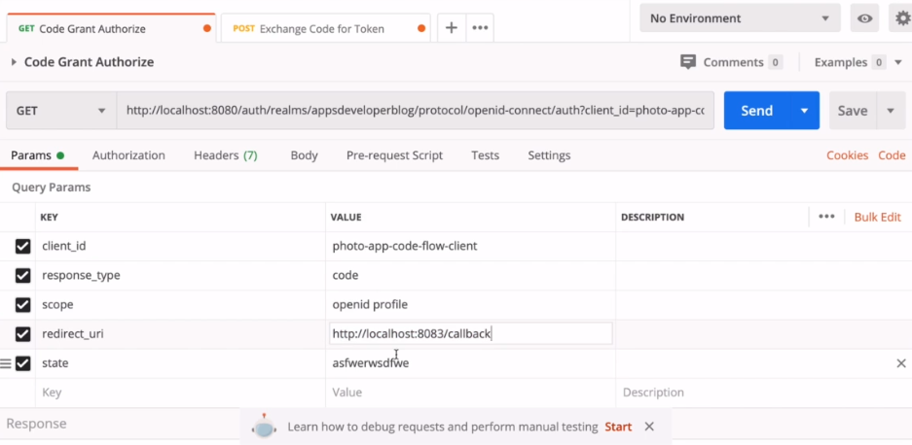

All right. So now I will copy the request URL including all of its request parameters, and I will bring a browser window and we will execute this request.

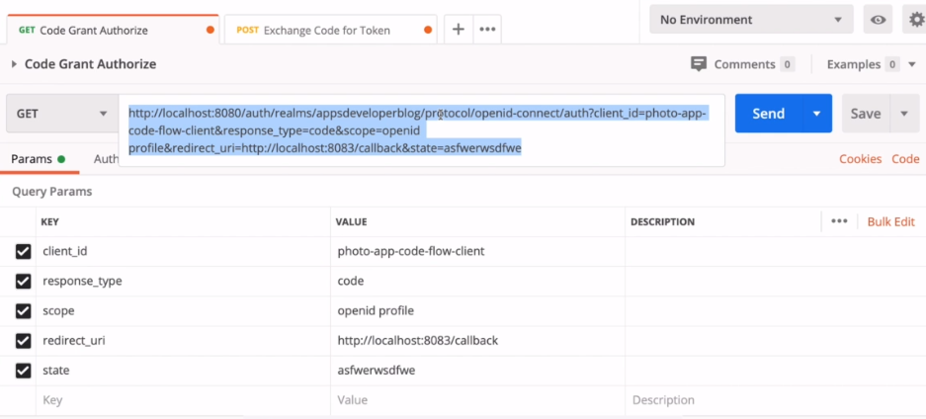

So now I'm invited to authenticate the user. I have a user with username lalit and password. That authentication is successful and I am redirected to a call back URI, the authorization server will also attach authorization code to this URL and I can copy it from the address bar here.

<http://localhost:8180/auth/realms/appsdeveloperblog/protocol/openid-connect/auth?client_id=photo-app-code-flow-client&response_type=code&scope=openid> profile&redirect_uri=http://localhost:8083/callback&state=asfwerwsdfwe

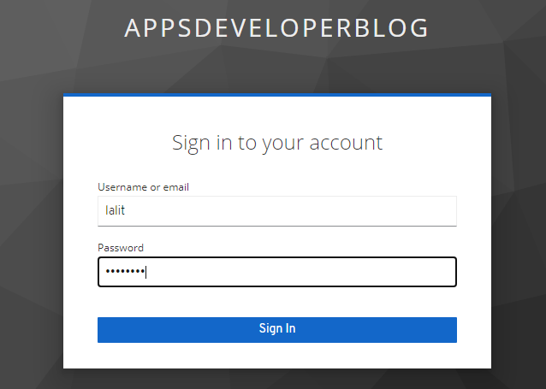

It redirected us to the following page

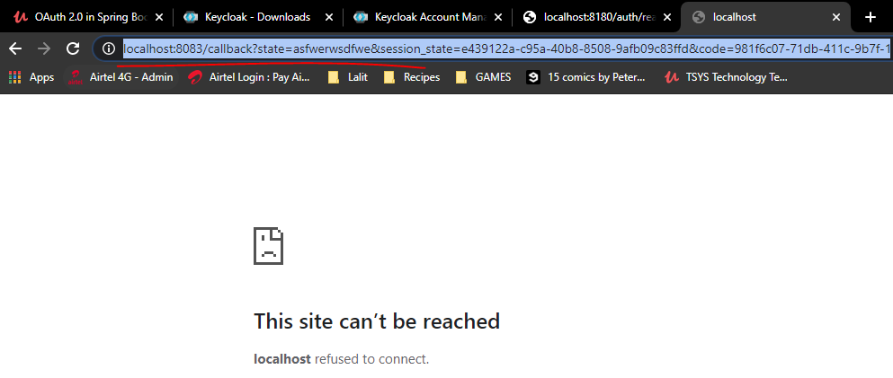

We got a redirect here and the redirect URL has the authorization code appended to it

Before we use the authorization code from the redirect url, to find out the url where we would request for access token

Remember when we access the realm like this – <http://localhost:8180/auth/realms/lalits-realm>



It gives us two URLs here

Use the token service url ( 1st url ) and just append **token** to it at the end in screenshot below where we are requesting for the access token.

And I will go back to my postman and will open the post request that will be used to exchange this authorization code for an access token.

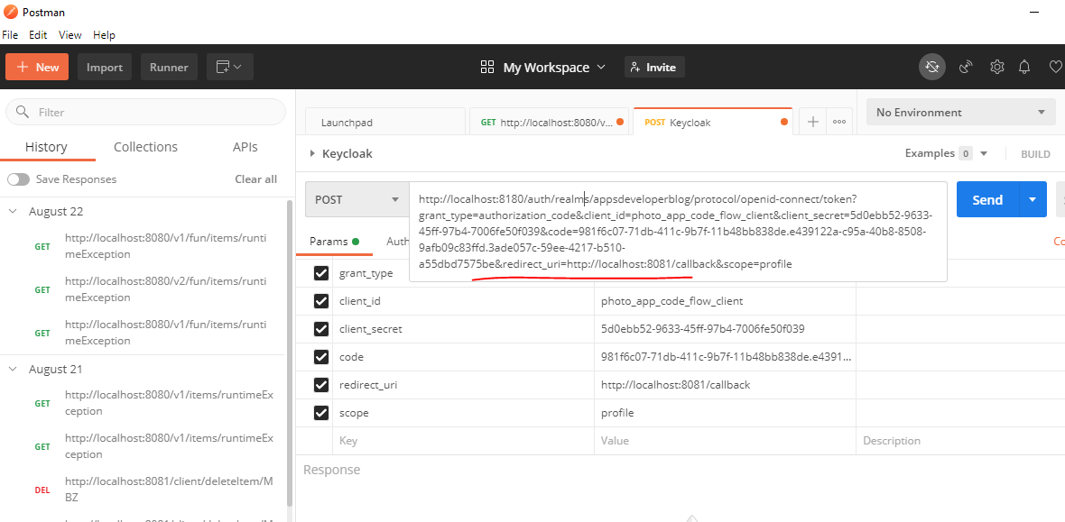

Since I have just copied it, I will go into my code request parameter and replace the old code with the new one ( brown highlighted in redirect URL after code= ). And now I will need to provide correct client ID and client secret that I have generated from my application. So I will go back to my Keycloak admin panel and I will copy the client id of this application and paste into my request and I will copy the client secret as well.

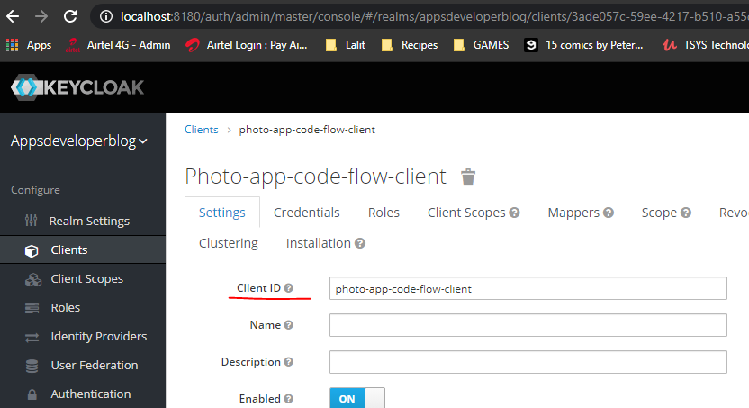 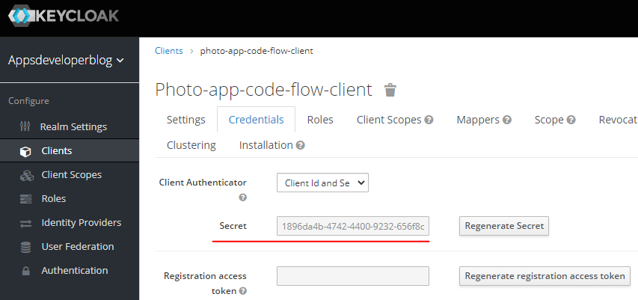

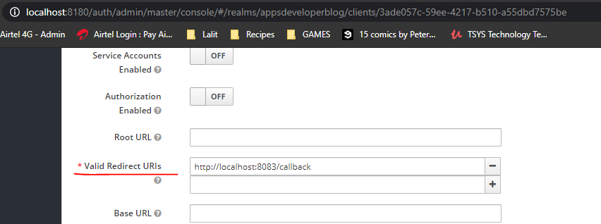

And replace the old value with a new value like this, the scope values. I will also copy from my previous request it was openid and profile. So I pasted here and the redirect URI, I will also need to match, so I will copy the redirect URL, I have used in the previous request to acquire this authorization code and that will paste it here.

Like this. All right, so now let's try exchanging this authorization code for an access token. I got back error code not valid, let's have a look. The code is not valid. Most likely my authorization code is now expired.

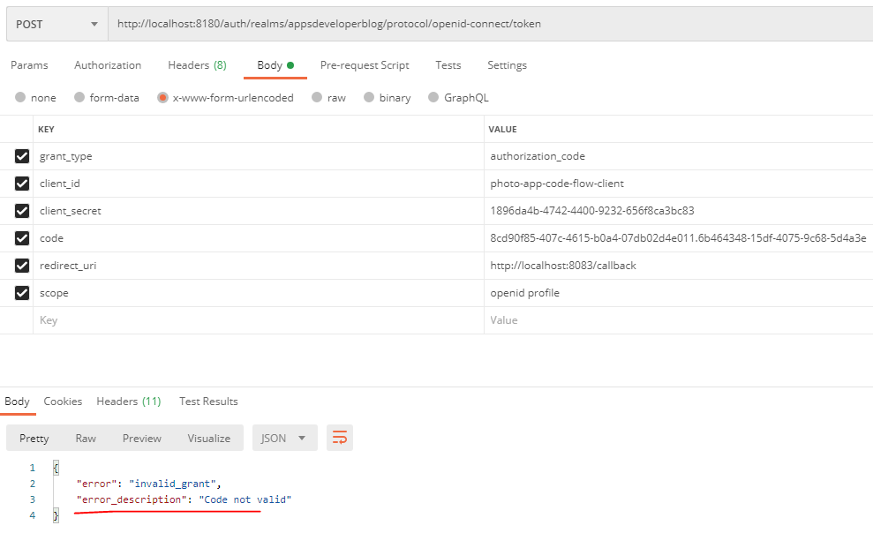

Let me try repeating the steps, but a little bit faster. So I will go back and copy this request parameters, open them in the browser window I got generated a new code I will copied. Go back to my request and exchange this code for an access token.

Request this again - <http://localhost:8180/auth/realms/appsdeveloperblog/protocol/openid-connect/auth?client_id=photo-app-code-flow-client&response_type=code&scope=openid> profile&redirect_uri=http://localhost:8083/callback&state=asfwerwsdfwe

It will authenticate us and redirect us – the redirected url is as below

<http://localhost:8083/callback?state=asfwerwsdfwe&session_state=6b464348-15df-4075-9c68-5d4a3e8f1890&code=95594fcd-9a84-4f93-8954-d581ab7a0a2f.6b464348-15df-4075-9c68-5d4a3e8f1890.3ade057c-59ee-4217-b510-a55dbd7575be>

And now I have a piece that is 200, which is OK, and I have my access token and they should have an ID token as well. Here we go.

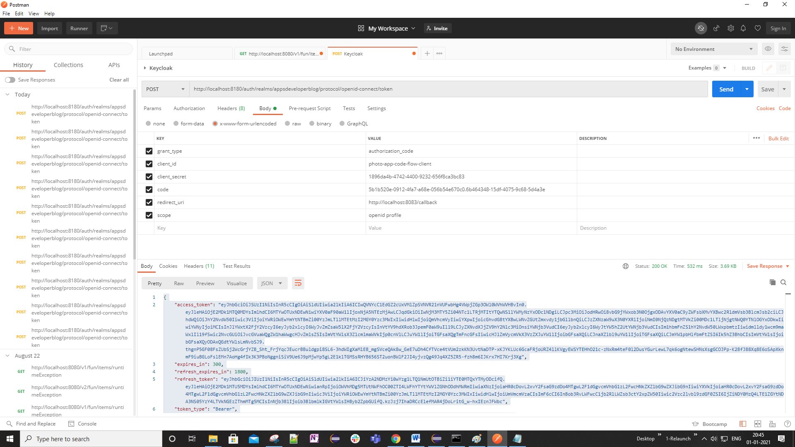

Note that the code here does not have Bearer space before it – i.e. used for the Access Token, not here

The response is as below

{

"access_token": "eyJhbGciOiJSUzI1NiIsInR5cCIgOiAiSldUIiwia2lkIiA6ICIwQVNYcC1EdGZ2cUxVMlZpSVNVR21nVUFwbHg4VWpjZGp3OWl0WVhWVHBvIn0….-3hdWIgXaMlEB_mgSVceQAk8w_GeE7uDh4CfTVce4tVUm2zkKN3UvtNaDTP-xKJYKLUc6GcaFRjoURZ4llKVgyEWSYTEHhO21c-zNxRm4teF0l2DusYGurLewL7qk6ogNtewSHNsXsgGCOJPp-K28fJ88Xq8E6oSApXknmF9iuBGLoFslEMn7AoHg4fIk3K3PBoNggniSiV9Ue6J9pMjwYp5gL2E1klTGMSsRHYB656ST2uonBWlF2JI4yjvzQg49Jq4XZ5ZR5-fzh8m6IJKrx7HI7Krj3Xg",

"expires_in": 300,

"refresh_expires_in": 1800,

"refresh_token": "eyJhbGciOiJIUzI1NiIsInR5cCIgOiAiSldUIiwia2lkIiA6ICJiYzA2NDMzYi0wYzg1LTQ1NmUtOTBiZi1iYTE0MTQxYTMyODcifQ.eyJleHAiOjE2MDk1M…Y0MzQ4LTE1ZGYtNDA3NS05YzY4LTVkNGEzZThmMTg5MCIsInNjb3BlIjoib3BlbmlkIGVtYWlsIHByb2ZpbGUifQ.kzJzj7IhaDRCcElefMAR4jDoLritG_w-hxIEznJFWbc",

"token_type": "Bearer",

"id_token": "eyJhbGciOiJSUzI1NiIsInR5cCIgOiAiSldUIiwia2lkIiA6ICIwQVNYcC1EdGZ2cUxVMlZpSVNVR21nVUFwbHg4VWpjZGp3OWl0WVhWVHBvIn0….-6UttjFRtr-upOZAxhbU2pEKHJ0UUV4TgvCcDDwN7WyuzriUT6BZs7N-rRyNfpXnGc05i-Rd7I3pQpVVyyUhQoXLBT6TNzezNueY_cfpoMYnZDJH9hwAC1YPwpNbwrUePUdbjBfbB-NL97DjCDkTpxY3CnWA-I2ci8RatIHPQwEPj6nMaUr9QmR2QTF6ilmyNvL04d27JpT5GWwF9Ldv1ZA",

"not-before-policy": 0,

"session_state": "6b464348-15df-4075-9c68-5d4a3e8f1890",

"scope": "openid email profile"

}

So everything worked. We were able to perform OAuth authorization code grant type request using the credentials of our new application that we have registered with the Keycloak server.

Enable/ Disable OAuth 2.0 Authorization Flow

We have registered a new confidential type client application and we have used it to perform the OAuth authorization code grant flow, and if needed, we can use this application with other OAuth Grant types that are supported by Keycloak. And you can find grant types that are supported by Keycloak on this same setting page right under the access type drop down menu. Here we have a switch controls to enable or disable a specific runtime.

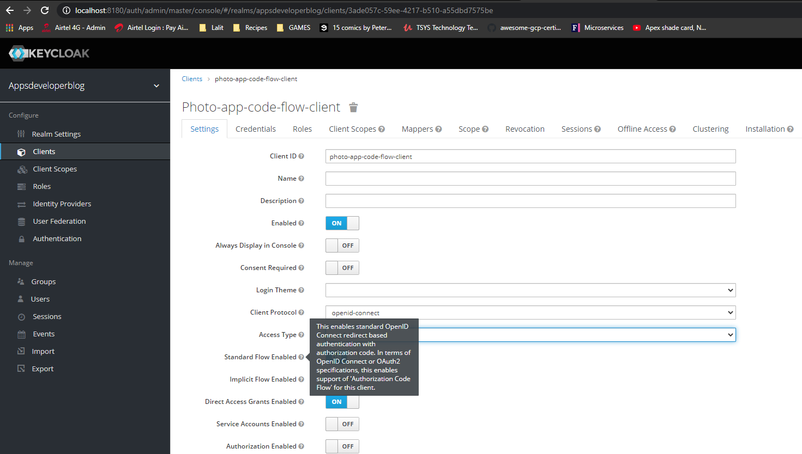

For example, currently we have the standard flow enabled. I can disable it or animal with the switch control. And if you move over the question mark, a little help tooltip will pop up and I can read from this particular helpful tip that this option enables or disables the authorization code runtime and this same option, the standard flow and PKCE enhanced authorization code type as well. But for the PKCE Enhanced Code Runtime, there is one more additional settings that you will need to enable. And to do that, you will need to scroll down the page until the advanced section here expanded and specify which code challenge that you want to use for PKCE Exchange Authorization Code to make your application more secure.

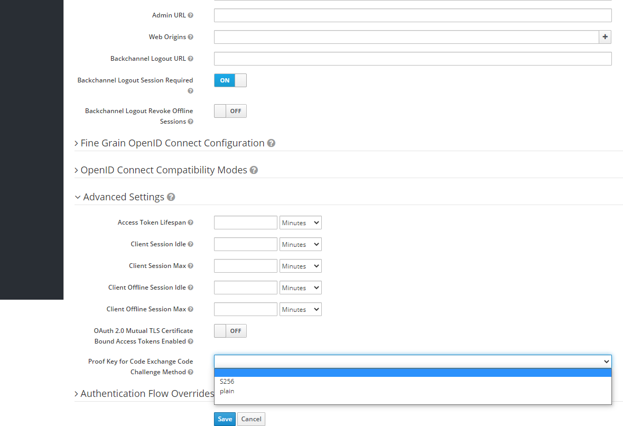

Select as 256. And if none of the values from these dropdown is selected ( blank option ) or if an empty option is selected, then the PKCE exchange code grant type will not work. All right. So let's select the as 256 option and let's go back to our control options on the top to enable or disable the implicit flow. Use this option.

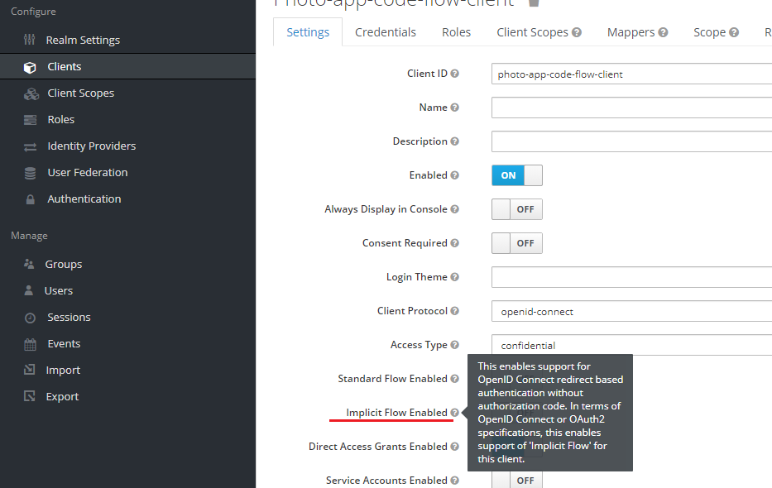

The Direct Access grant type enables or disable password credentials grant type.

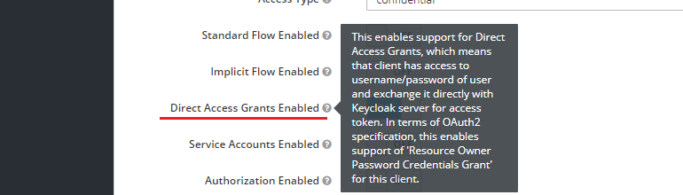

And the service accounts and the enable the client credentials grant type.

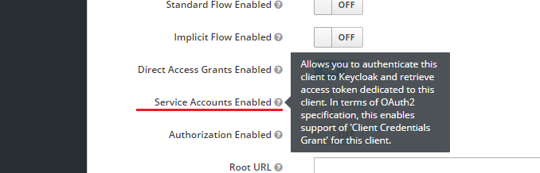

All right, so now you know how to enable or disable a specific authorization for OAuth application. And until you make changes to the speech, don't forget to scroll down and click on Save Button.

### OAuth 2.0 Client Scopes

When a request authorization server issues us a access token, the client application might include a scope request parameter that can contain one or multiple scope files, for example, in this http request we included scope request parameter and we provided two scope values one is open ID and one is profile. With the scope request parameter we request authorization server to give us an access token that will allow our client application to access the type of user information specified with the scope request parameter. For example, if the client application provides one more request parameter like email address or even phone number, then and that means that we are requesting authorization server to issue as an access token, which will allow client application to access user's email address and phone number. All right. So when we installed Keycloak Server and if we go to client scope section on the left side, you'll see a list of scopes that have been already created for us.

address, email, microprofile-jwt, offline_access, phone, profile, role_list, roles, web-origins

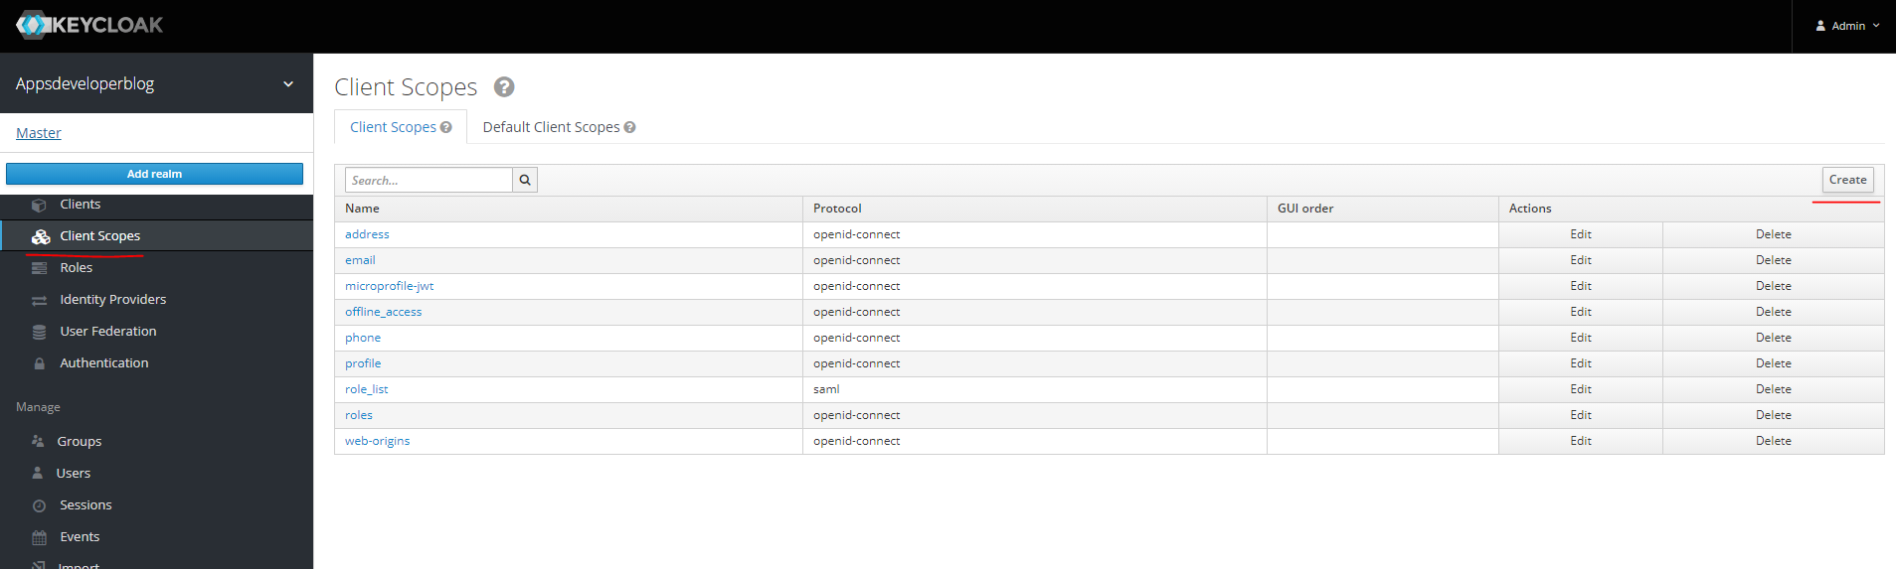

And if we need to create our own custom scope values, we can do so by clicking on the create button, which is here in the upper right corner, and we can create a new scope. Most of the values here this list is to support open connect and some of protocols. Scope's like address, email, microprofile-jwt, offline_access, phone, profile, role_list, roles, web-origins these are scopes defined in Open ID Connect protocol. Any authorization server that supports Open ID connect will also support these scopes. So here in this list we create or we edit existing client scopes and to make our client application be able to access one of these scopes, we will need to go back to our client application onto the list of clients, and then I will select the client application that we have created and then switch to client scope section here on the top and under the setup tab we can make some scope's to be assigned to this client application by default, by including them into this list.

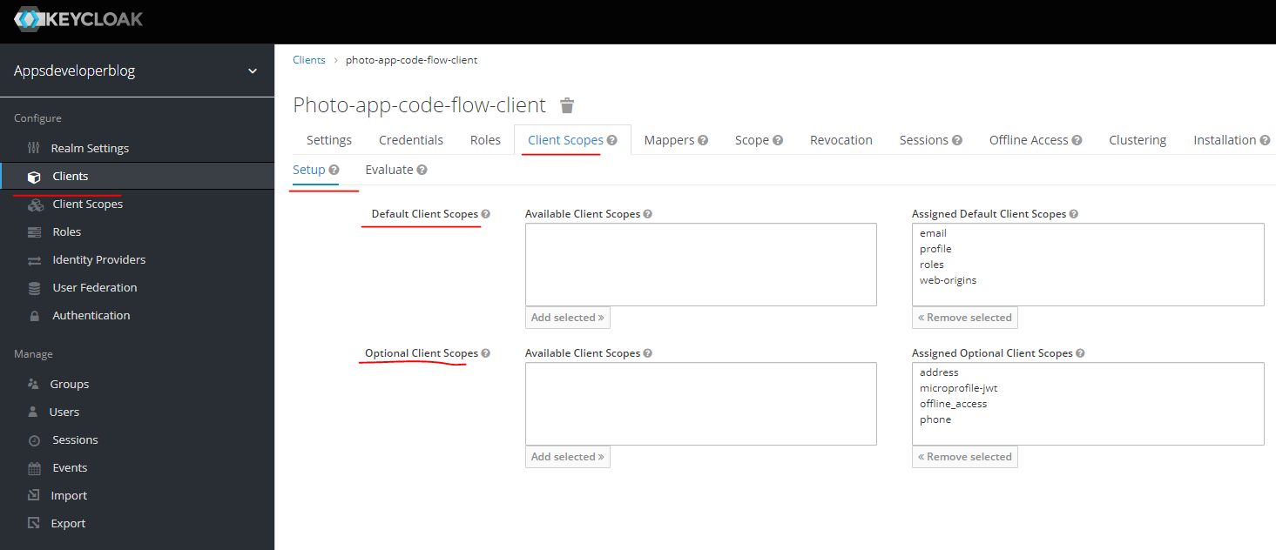

And we can make some scope's to be available only on request by including them into this optional Clines list. Any scope can be added to this list or removed from this list by using these buttons. For example, if I want to remove a scope from this list, I will select a scope and then click on remove button and it goes to the box on the left. It's not deleted completely. It is just removed from this list. And if I want to bring it back, I will select the scope and then click on add select it and it goes back to the list of scopes. So currently these client application scope values are supported by default. email, profile, roles and web-origins.

This means that even if the request for an access token does not include, for example, email, profile or roles in the request, then the access token that is generated for this request will still be able to access information defined with these scope. This is because these scopes are granted to this client application by default and the below list here that is called optional client scopes. To access information defined with this the client application will need to include one or all of these scopes. And the request when it sends a request for an access token, it will include this request parameter and then it will need to include one or multiple scopes defined in this list and the scope values they will need to be separated with a space just like we did here in the Postman request.

We have separated openid and profile with a space. So these are optional polls, and if one of these scopes is not included in the request, then the access token generated for this request, it will not be able to access information defined with the scope. For example, if we want to prevent a kind application to get an access token that allows it to access user's phone number, then we will simply remove a phone number from the list of these optional scopes. And now the phone number is removed from the default values and it is removed from optional list of scope values. And now, because the phone number is not on the list of scopes that are supported by default and the phone number is not in the list of scopes that are granted, if specifically requested in the request client application will not be able to access user's phone number with the access token generated for this application, unless, of course, the phone number is somehow programmatically included by the developer resource server into a response.

## Resource Server

### Introduction

So what is the resource server and when is it used, in this slide on the left side, I have a user and this is a person who is using either a website or a mobile application to access their data or resources in both terms, a users called resource owner. Then I have a client application, which can be a mobile app and web application or even a desktop application. So we have a user or a resource owner who is using a client application to get access to the data that they own. And then we have a resource server, which is an application that is going to provide the user with requested information. So the Resource Server in both terms is a Springboot application that a client application can communicate with to store or update or get requested information from. And usually this spring boot application, exposes some websites endpoints that the client application can send http request to, for example, a client application can send http get request to request a list of albums. So the resource server is an application that accepts this http request and returns a response. You can think of resource server as a simple Spring MVC application. It can be Spring MVC Web application, or it can be a single, monolithic, restful web service application that exposes web service endpoints, one webservice endpoint returns a list of albums. And other endpoint will return a list of photos. Spring application can be a very small Spring boot micro service application.

|  |  |
| --- | --- |
| So we call this Spring boot application and OAuth resource server when we add to it the resource server configuration. And we need to protect user resources, to make sure that only unauthorized users can access these resources. Some web service endpoints that resource server exposes, they can be public and available to all users, but usually most of webservice endpoints that the resource server exposes, will require a client application to provide an access token. And this access token, can be issued by authorization server only if users successfully authenticate with it. |  |

So the OAuth configuration that we add to our regular spring boot application to make it OAuth Resource server, in simple words, it will help us to verify the access token with the authorization server automatically, if an access token is missing or if it is invalid, the resource server will not return the requested resource or will not perform the requested operation. All right. So let's continue and let's learn how to configure our Spring application to be a resource server.

### Creating Project

Resource server is a Spring Boot application, and to create a new resource server, we will need to simply create a new Spring boot application and we'll need to add to it an additional dependency. So let's do that or create a new Spring Boot project using start.spring.io in the browser window.

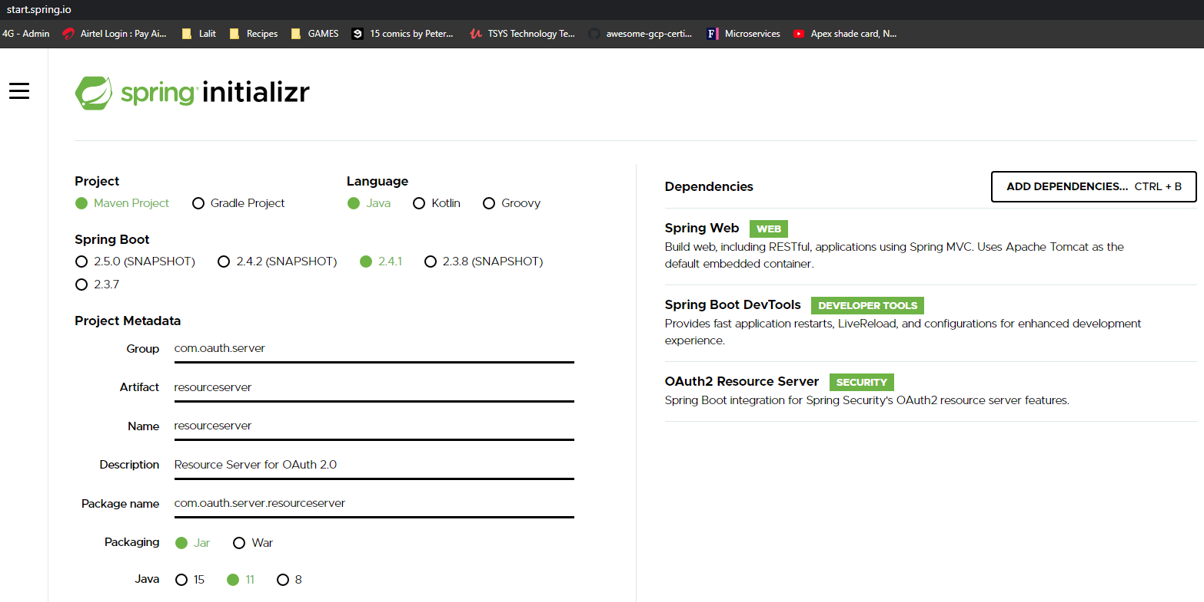

Dependencies selected are

**Spring Web** - Build web, including RESTful, applications using Spring MVC. Uses Apache Tomcat as the default embedded container.

**Spring Boot DevTools** - Provides fast application restarts, LiveReload, and configurations for enhanced development experience.

**OAuth2 Resource Server** - Spring Boot integration for Spring Security's OAuth2 resource server features.

So our basic resource server project is ready to be generated.

Change the port number in the application.properties

**application.properties**

server.port=9080

**pom.xml file**

<?xml version=*"1.0"* encoding=*"UTF-8"*?>

<project xmlns=*"http://maven.apache.org/POM/4.0.0"* xmlns:xsi=*"http://www.w3.org/2001/XMLSchema-instance"*

xsi:schemaLocation=*"http://maven.apache.org/POM/4.0.0 https://maven.apache.org/xsd/maven-4.0.0.xsd"*>

<modelVersion>4.0.0</modelVersion>

<parent>

<groupId>org.springframework.boot</groupId>

<artifactId>spring-boot-starter-parent</artifactId>

<version>2.4.1</version>

<relativePath/> <!-- lookup parent from repository -->

</parent>

<groupId>com.oauth.server</groupId>

<artifactId>resourceserver</artifactId>

<version>0.0.1-SNAPSHOT</version>

<name>resourceserver</name>

<description>Resource Server for OAuth 2.0</description>

<properties>

<java.version>11</java.version>

</properties>

<dependencies>

<dependency>

<groupId>org.springframework.boot</groupId>

<artifactId>spring-boot-starter-oauth2-resource-server</artifactId>

</dependency>

<dependency>

<groupId>org.springframework.boot</groupId>

<artifactId>spring-boot-starter-web</artifactId>

</dependency>

<dependency>

<groupId>org.springframework.boot</groupId>

<artifactId>spring-boot-devtools</artifactId>

<scope>runtime</scope>

<optional>true</optional>

</dependency>

<dependency>

<groupId>org.springframework.boot</groupId>

<artifactId>spring-boot-starter-test</artifactId>

<scope>test</scope>

</dependency>

</dependencies>

<build>

<plugins>

<plugin>

<groupId>org.springframework.boot</groupId>

<artifactId>spring-boot-maven-plugin</artifactId>

</plugin>

</plugins>

</build>

</project>

spring-boot-starter-oauth2-resource-server dependency brings in the spring security dependencies.

Now, this dependency brings in in security dependencies and because it brings in in security, any webservice endpoints in this project becomes secure. Now to access any webservice endpoint in this project, the user will need to be first authenticated.

Create a Rest Controller

package com.oauth.server.resourceserver.controllers;

import org.springframework.web.bind.annotation.GetMapping;

import org.springframework.web.bind.annotation.RequestMapping;

import org.springframework.web.bind.annotation.RestController;

@RestController

@RequestMapping("/users")

public class UsersController {

@GetMapping("/status/check")

public String status() {

return "Working...";

}

}

I will create a request mapping for this controller class, and I will start by adding a annotation @RequestMapping. And the mapping will be "/users". All right, so any request that will be sent to any of the webservice endpoints that I'm going to define in this class will need to start with a path that begins with /users.

Now we will define our first endpoint called status. Add the @GetMapping("/status/check") annotation. To get to this endpoint the user has to request for <http://localhost:9080/users/status/check>

So first of all, let's see if this UsersController class and let's try running this project and see how it works.

2021-01-02 13:27:59.069 INFO 2464 --- [ restartedMain] w.s.c.ServletWebServerApplicationContext : Root WebApplicationContext: initialization completed in 1106 ms

2021-01-02 13:27:59.251 INFO 2464 --- [ restartedMain] o.s.s.concurrent.ThreadPoolTaskExecutor : Initializing ExecutorService 'applicationTaskExecutor'

2021-01-02 13:27:59.424 INFO 2464 --- [ restartedMain] .s.s.UserDetailsServiceAutoConfiguration :

Using generated security password: 5fa06362-f551-4c8a-9f1c-7993ebe92f00

2021-01-02 13:27:59.514 INFO 2464 --- [ restartedMain] o.s.s.web.DefaultSecurityFilterChain : Will secure any request with [org.springframework.security.web.context.request.async.WebAsyncManagerIntegrationFilter@bd1f48d, org.springframework.security.web.context.SecurityContextPersistenceFilter@456a8377, org.springframework.security.web.header.HeaderWriterFilter@7c48da71, org.springframework.security.web.csrf.CsrfFilter@5663bd3a, org.springframework.security.web.authentication.logout.LogoutFilter@54ad5332, org.springframework.security.web.authentication.UsernamePasswordAuthenticationFilter@584ae601, org.springframework.security.web.authentication.ui.DefaultLoginPageGeneratingFilter@874358, org.springframework.security.web.authentication.ui.DefaultLogoutPageGeneratingFilter@45c3fff7, org.springframework.security.web.authentication.www.BasicAuthenticationFilter@1b6969ed, org.springframework.security.web.savedrequest.RequestCacheAwareFilter@61aca81f, org.springframework.security.web.servletapi.SecurityContextHolderAwareRequestFilter@55a38525, org.springframework.security.web.authentication.AnonymousAuthenticationFilter@15b5d0a3, org.springframework.security.web.session.SessionManagementFilter@2d9fb8be, org.springframework.security.web.access.ExceptionTranslationFilter@34a961b7, org.springframework.security.web.access.intercept.FilterSecurityInterceptor@3e6c8863]

2021-01-02 13:27:59.572 INFO 2464 --- [ restartedMain] o.s.b.d.a.OptionalLiveReloadServer : LiveReload server is running on port 35729

2021-01-02 13:27:59.610 INFO 2464 --- [ restartedMain] o.s.b.w.embedded.tomcat.TomcatWebServer : Tomcat started on port(s): 9080 (http) with context path ''

2021-01-02 13:27:59.622 INFO 2464 --- [ restartedMain] c.o.s.r.ResourceserverApplication : Started ResourceserverApplication in 2.045 seconds (JVM running for 2.485)

On accessing the application it is asking to login

|  |  |
| --- | --- |
|  |  |

Lets access the endpoint now

C:\Users\Dimpu> curl http://localhost:9080/users/status/check

{"timestamp":"2021-01-02T08:00:45.734+00:00","status":401,"error":"Unauthorized","message":"Unauthorized","path":"/users/status/check"}

We cannot access the endpoint, it is secured, we got a 401 Unauthorized message.

For client applications to be able to communicate with a resource server, they will need to include a valid access token that was generated by the authorisation server and to configure our resource server to validate the access token with the authorization server. We will need to hand one property to our application properties file. So the properties

**application.properties**

server.port=9080

spring.security.oauth2.resourceserver.jwt.issuer-uri=

http://localhost:8180/auth/realms/appsdeveloperblog

URI is pointing to my realm appsdeveloperblog that I have created in Keycloak server. Spring Security will use this property and the value of your URL that we provide here to discover the authorization servers, public keys and to validate the access token signature. The client application that was used to acquire an access token that has been validated must be registered with this keycloak realm. So if you intend to use Keycloak as an authorization server, then please make sure that you provide a correct realm here. appsdeveloperblog is the realm that I have created in my Keycloak server.

In your case, you have most likely created a realm with a different name. But if you're using a different authorization server, not Keycloak, then the issuer URI will be different. Another way to configure resource server and to validate the access token with the authorization server is to use the following property.

spring.security.oauth2.resourceserver.jwt.jwk-set-uri=http://localhost:8180/auth/realms/appsdeveloperblog/protocol/openid-connect/certs

And then the path that begins exactly the same. A path to your Keycloak realm. But then it continues with /protocol/openid-connect/certs. So this jwk-set-uri is pointing to the public key endpoint and if you open this service end point in the browser window, let's try doing this. I'll see JSON document containing information that will be used to validate the access token.

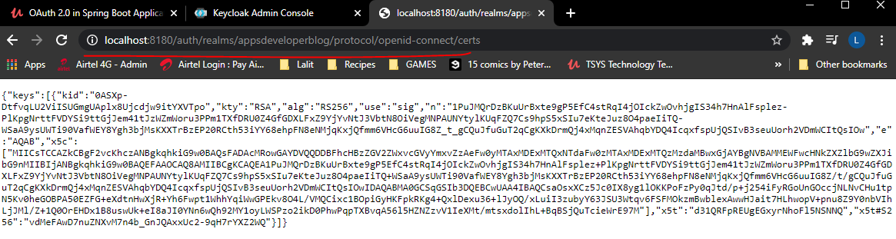

All right. So we can use either jwt.issuer_uri or the jwt.jwk-set-uri, in our application properties, we can use either one of these and we can use even both of them at the same time. But if we use both properties and one of the URIs here will be pointing to an incorrect realm, for example, then the validation of access token will fail. All right. So lets comment one of them and continue.

### Accessing with Access Token

Lets run the Keycloak server, then run the resource server, we will request an access token from our authorization server and then we will use this access token to access the protected webservice endpoint that our resource server exposes. So first, I will start up by the Authorization Keycloak server. My Keycloak server will start on default port at 8180 because of the offset of 100.

$ %KEYCLOAK_HOME%\bin\standalone.bat -Djboss.socket.binding.port-offset=100

Now we will start up my resource server. Resource server has started on Port 9080. All right, so now I will go back to my postman and here I will start up with the http get request to request an authorization code from my Keycloak server. So I will copy the request URL and we'll start up a new browser window. And I will paste it there. I will need to authenticate. And now authorization server has redirected me to a call back. All right, so I will copy the authorization code that it has attached and I will exchange this authorization code for an access token.

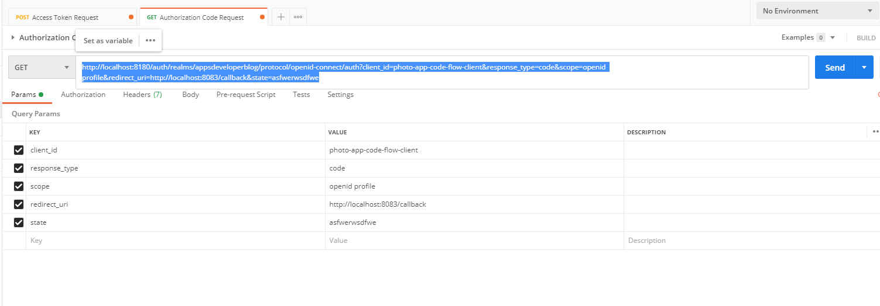

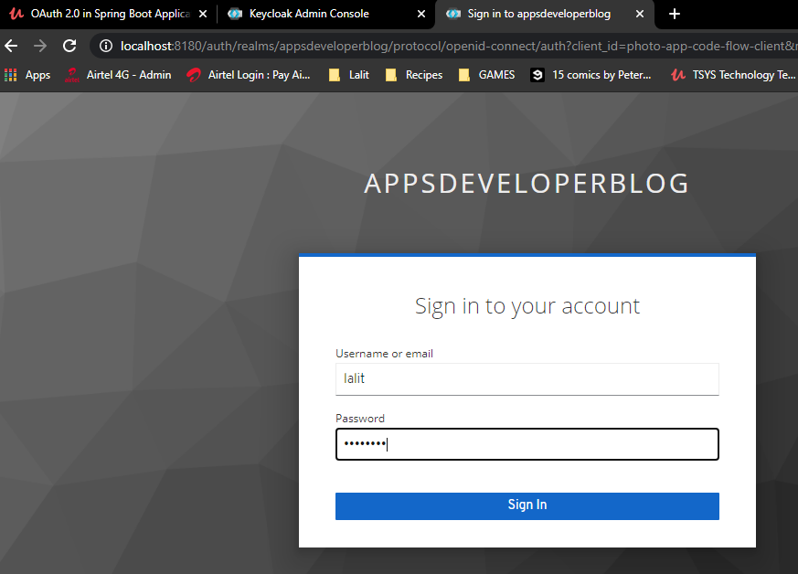 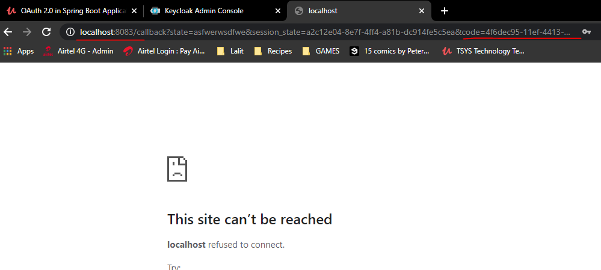

The url that it redirected us to is

http://localhost:8083/callback?state=asfwerwsdfwe&session_state=a2c12e04-8e7f-4ff4-a81b-dc914fe5c5ea&code=4f6dec95-11ef-4413-86e5-ee27fda67494.a2c12e04-8e7f-4ff4-a81b-dc914fe5c5ea.3ade057c-59ee-4217-b510-a55dbd7575be

So I will switch to a post request to exchange the authorization code for an access token, paste the authorization code here. And I will send this request. The response is successful. I got back my access token.

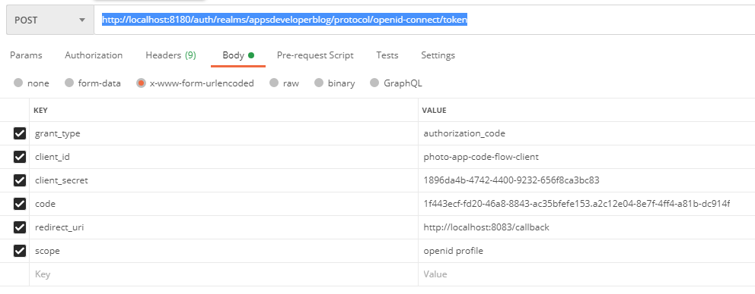

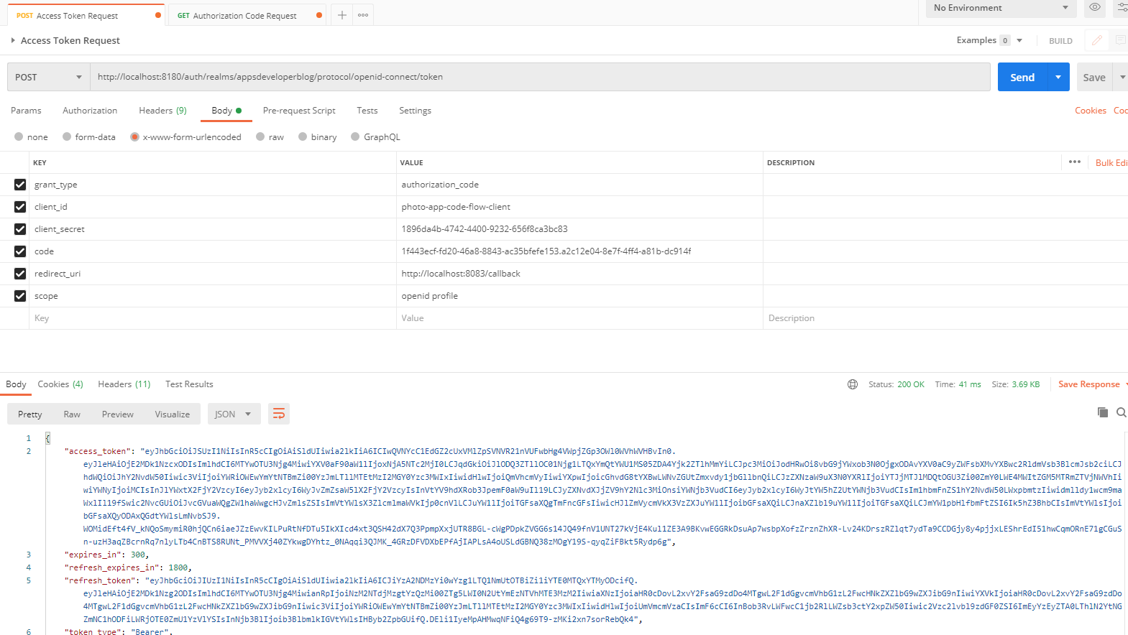

I will copy this access token and then I will use this access token for sending a request to the protected webservice endpoint, to my resource server that exposes my webservice endpoint, which is running on port 9080. So I will need to change the port number here. So it's going to be a get request sent to a resource server running on localhost 9080 and then webservice end point that my resource server exposes is /users/status/check. So if I send this request now, I should get back for one unauthorized status code. So let's try it. We get back unauthorized. Everything's OK now. I will switch to Headers tab now and I will provide an authorization header that will include an access token and it needs to start with Bearer space and then the value of the access token.

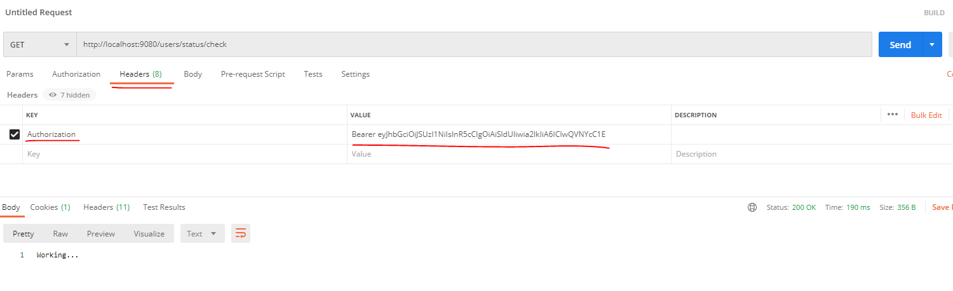

And let's try sending this request. And I get back be status 201 OK, and a valid response, working now. If I disable this authorization header and repeat this request, this request should be unauthorized. I got back some response and most likely it is because of cookies. So click on cookies. I will delete both of the cookies here. Now, I will repeat it again. And the request is unauthorized, I'll try it again, all is work now I will attach authorization header and I'll repeat this request one more time and it is working all so are basic where is working and it is able to successfully validate the provided access to.

### Accessing Principal & JWT Claims

JWT token contains a lot of information, and if you need to access that information in your code, then there is a way to do it. We can access an entire JWT token Itself, as well as any claims that it contains. To demonstrate this we will create a new REST controller class. I will put it into controllers package and I will call it TokenController. I will create a single webservice endpoint that will handle HTTP get request. So I'll create a simple method that will return us the token and we will call it getToken. And I will make it return something like this now when we send the request with an access token to a resource server behind the scenes, spring framework will do a lot of work. And if all is good, the result of that work will be another Authentication object, from which we can get the details of currently authenticated principal user and also the JWT Access token claims. To get all of the claims that access token contains into a single object. I will use a special notation called Authentication Principle. So what this annotation will do is, it will bind the details of currently authenticated principle into special JWT object, and from this JWT object we can get the access token itself and all the claims that they provided in the request access token it contains. Now, if we wanted to get an access token itself, then I can use an instance of this JWT token and call the method getToken value, like this and this will return an entire JWT access token. But if we look at other methods that this object provides, we will see that we can get from with all other details that our JWT token contains. We can get the audience, we can get a specific claim from it and lots of other useful information like when the JWT token is going to expire and so on. So we can give a specific information from this object or we can return them all in a single response.

package com.oauth.server.resourceserver.controllers;

import org.springframework.security.core.annotation.AuthenticationPrincipal;

import org.springframework.security.oauth2.jwt.Jwt;

import org.springframework.web.bind.annotation.RequestMapping;

import org.springframework.web.bind.annotation.RestController;

@RestController

@RequestMapping("/token")

public class TokenController {

public String getToken(@AuthenticationPrincipal Jwt jwt) {

return jwt.getTokenValue();

}

}

|  |  |
| --- | --- |
|  |  |

We can simply return an entire JWT object or we can wrap it into another object of our own. It could be an object of your custom class, for example, or simply come up with a custom key value pairs. Let's put it into a Map with a custom key for now. And to do that, I will use Collections.singleton method and and instead of returning a single token, I will use collection Singleton Map. That will contain a key called principal, and then the JWT object itself.

@RestController

@RequestMapping("/token")

public class TokenController {

public Map<String, Object> getToken(@AuthenticationPrincipal Jwt jwt) {

return Collections.*singletonMap*( "principal", jwt.getTokenValue() );

}

}

And because I am now returning not a single String, but a Map, I will replace this String with Map that will contain a string and an object.

**Generate the Authorization code**

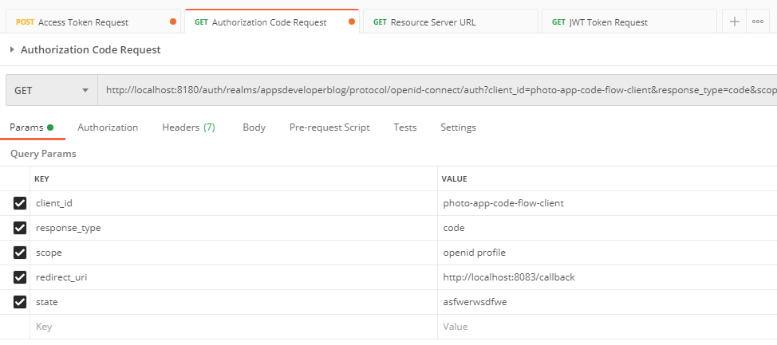

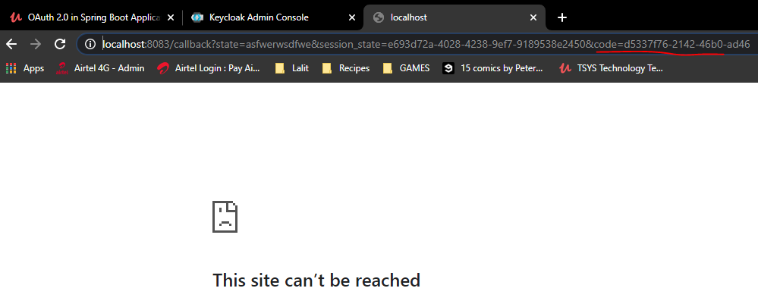

**Generate the Access Token** **now** using the code appended to the redirected URL above

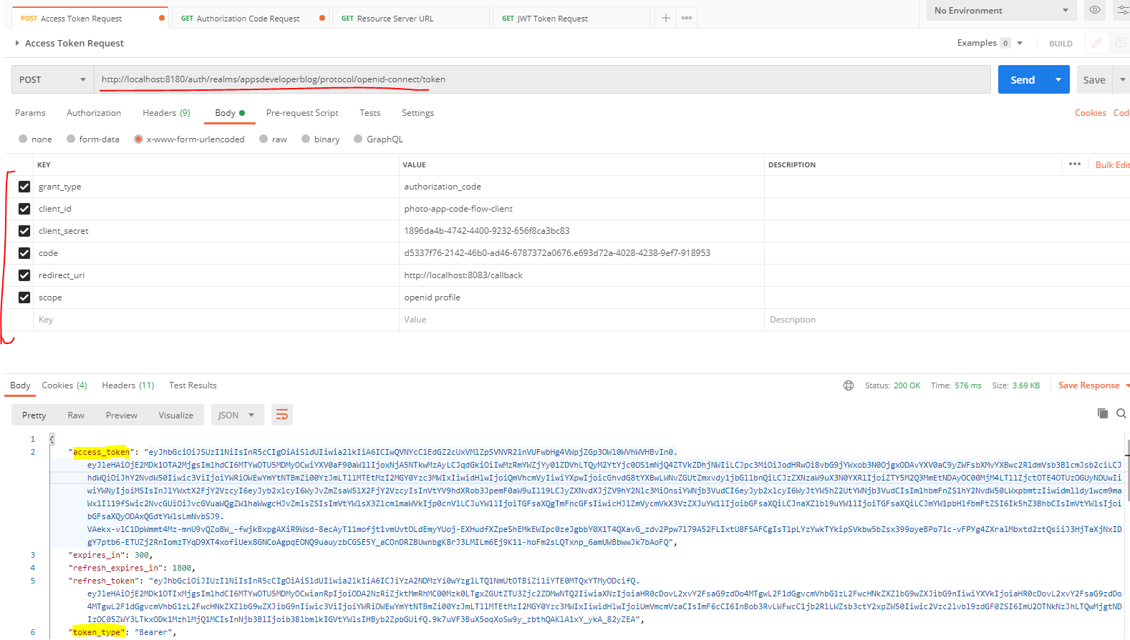

**Get the JWT Token now**

We will need to pass the access token in the Headers as Authorization else we will get a 401 – Unauthorized error.

Lets run and access this endpoint and see what we get

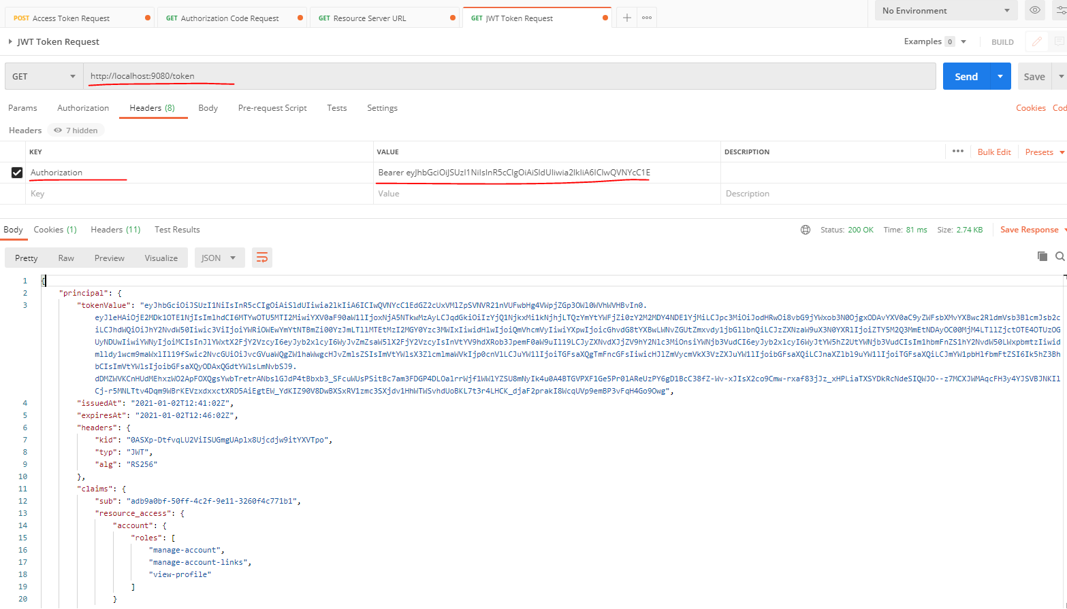

JWT Token received

{

"principal": {

"tokenValue": "eyJhbGciOiJSUzI1NiIsInR5cCIgOiAiSldUIiwia2lkIiA6ICIwQVNYcC1EdGZ2cUxVMlZpSVNVR21nVUFwbHg4VWpjZGp3OWl0WVhWVHBvIn0..dDMZWVKCnHUdMEhxzWO2ApFOXQgsYwbTretrANbslGJdP4tBbxb3_SFcuWUsPSitBc7am3FDGP4DLOalrrWjf1WWlYZSU8mNyIk4u0A4BTGVPXF1Ge5Pr0lAReUzPY6gD1BcC38fZ-Wv-xJIsX2co9Cmw-rxaf83jJz_xHPLiaTXSYDkRcNdeSIQWJO--z7MCXJWMAqcFH3y4YJSVBJNKIlCj-r5MNLTtv4Dqm9WBrKEVzxdxxctXRD5AiEgtEW_YdKIZ90V8DwBXSxRV1zmc3SXjdv1HhWTWSvhdUoBKL7t3r4LHCK_djaF2prakI8WcqUVp9emBP3vFqH4Go9Owg",

"issuedAt": "2021-01-02T12:41:02Z",

"expiresAt": "2021-01-02T12:46:02Z",

"headers": {

"kid": "0ASXp-DtfvqLU2ViISUGmgUAplx8Ujcdjw9itYXVTpo",

"typ": "JWT",

"alg": "RS256"

},

"claims": {

"sub": "adb9a0bf-50ff-4c2f-9e11-3260f4c771b1",

"resource_access": {

"account": {

"roles": [

"manage-account",

"manage-account-links",

"view-profile"

]

}

},

"email_verified": **true**,

"iss": "http://localhost:8180/auth/realms/appsdeveloperblog",

"typ": "Bearer",

"preferred_username": "lalit",

"given_name": "Lalit",

"aud": [

"account"

],

"acr": "0",

"realm_access": {

"roles": [

"offline_access",

"uma_authorization"

]

},

"azp": "photo-app-code-flow-client",

"auth_time": 1609590302,

"scope": "openid email profile",

"name": "Lalit Nagpal",

"exp": "2021-01-02T12:46:02Z",

"session_state": "e693d72a-4028-4238-9ef7-9189538e2450",

"iat": "2021-01-02T12:41:02Z",

"family_name": "Nagpal",

"jti": "3b456912-d68c-43bf-aacf-3cc6068415b3",

"email": "lalit2801@gmail.com"

},

"id": "3b456912-d68c-43bf-aacf-3cc6068415b3",

"audience": [

"account"

],

"subject": "adb9a0bf-50ff-4c2f-9e11-3260f4c771b1",

"notBefore": **null**,

"issuer": "http://localhost:8180/auth/realms/appsdeveloperblog"

}

}

And that JWT object has lots of fields. So one of those fields is token value that contains entire access token. And then every single claim that is available as a separate key. All right. So everything is working well and we now know how to get an access token in our resource server and how to get any detail from that access token using the authentication principle and annotation and the JWT object. And if you wanted to return the JWT object itself without putting it into a Map, it can do so as well. So instead of returning the Map that contains a key principle and an object, I could simply return the JWT itself like this. And then instead of creating a Map, I will return an instance of this JWT object like this. I can send this request. And then, I'll get the content of JWT object. So let's try sending this request. And here we go. The response is successful. There is no more key principle, and I got back the entire content of my gwg object. Scroll up a little bit and can see everything is here.

## Resource Server – Scope Based Access Control

### Introduction

Let us learn what is called as Scope Based Access Control and how to implement it in your application. And here is the definition, scope is a mechanism in place to to limit an applications access to users account and the application can request one or more scopes and this information is then presented to a user in the consent screen and the access token issued to the application. It will be limited to the scopes granted.

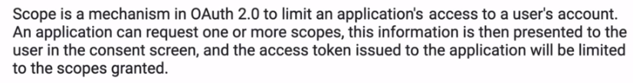

Let's have a look at a little diagram, on the left side we have a user who is using client application and this client application can be a website, It can be a desktop application or it can be a mobile application. And we have a photo albums, resource server and a client application can request a list of users photo albums from this resource server. And they can be different types of photo albums. They can be public photo albums, they can be private photo albums and they can be protected photo albums. So for a client application to be able to get a list of protected photo albums from the resource server, it will need to have an access token. And to get an access token, a client application needs to send the request to an authorization server first. In this initial request, the client application will need to include SCOPE request parameter and the scope request parameter can contain one or more scopes that will specify what kind of information this client application would like to access.

In this particular example my client application is including three different scopes and each scope is separated with space. And to have an access to a list of protected photo albums, my client application will need to include a protected photo albums scope. So authorization server will then need to ask user permission to issue an access token like this so it will redirect user to a log in page to let them authenticate first. And if they provide that username and password is correct and the user successfully authenticate the authorization server will then present user with a consent screen where a user will need to confirm that they allow this particular client application to access a list of albums on their behalf. If user provides their consent and proceeds, then the authorization server will generate an access token that can be used to request user resources allowed by this access token. All right, so the access token itself, it will not contain a list of protected photo albums. But if user permits this client application to access they are protected for albums, then the access token will contain some information that this user has granted their permission to access a list of what the albums on their behalf.

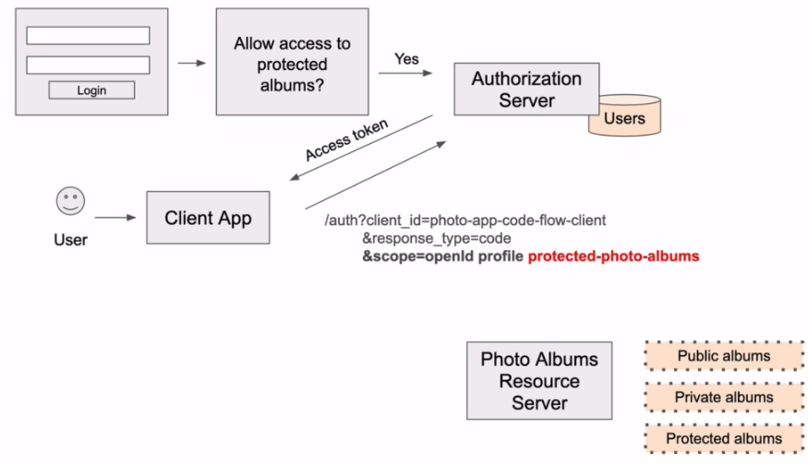

Now, the protected for the album scope is just an example of a custom scope name that a photo albums application might have. And it is a scope name that I have just created for this line. So if your application does not work with four albums, then you will not even have the scope. So it is a custom scope and for your application you will need to create customs scopes that suits your needs. But if you are authorization server, it does support open ID connect protocol then there will be certain scopes that will be supported by all servers conforming to this protocol. And you can try and see how they work without creating any customs scopes. All right. So in previous video lessons and in this slide as well, I have used scopes like openid and profile.

Let's have a quick look at this tool. So here's the same diagram with initial request sent by our client application to Authorization server with three different scopes, the first two scopes, they are open ID scopes and they will be supported by all authorization servers that support Open ID Connect.

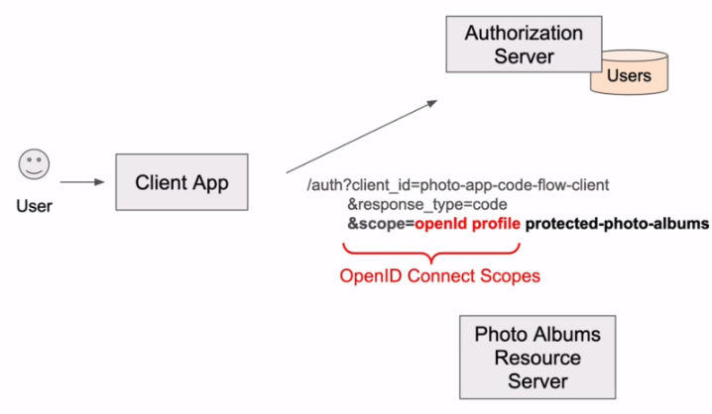

And to refresh on this a little bit Open ID connect is a layer on top of OAuth authorization framework and it enables client applications to verify the identity of a user as well as obtain some basic information about the end user. So with these two particular scopes openid and profile, I would like my client application to obtain user profile information. These are openid connect standard scopes and the first one, which is called openid, it informs the authorization server that the client application is making an open id connect request. And this will also make the authorization server additionally return an access token and ID token. And the ID token will contain user information specified by this scope. All right. So the second scope value, which is called profile, it tells the authorization server that the client application, would like to have an access to a user profile details and in open ID connect, user profile information contains the following. It contains name, family name, given the middle name, nickname and so on, but it does not contain email address. Email is a separate scope.

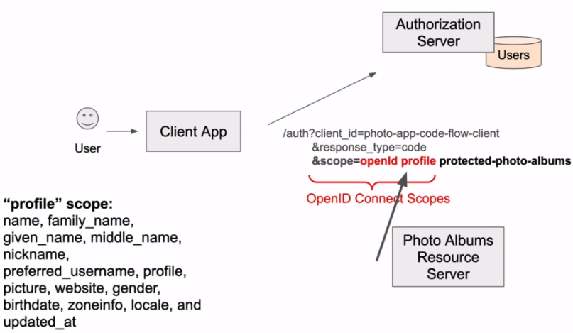

So here's an example of open id connect standard scopes that can be used to access information about the user, the first scope with a value openid, it will tell authorization server that client application is making an open id connect request.

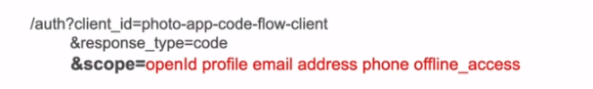

The second scope value is profile and what the scope the client application will be able to access user's first name, last name, nickname, birthdate and so on. The next scope is email, and the scope will allow client application to get user's email address and also information. If this email address has been verified or not, the next scope is address. And this scope allows client application to get different details about users to address, the next value in the authentication request is phone and the scope value will allow client application to get user's phone number and also information, if this phone number has been verified or not. And the final scope and the list is offline access, which will inform authorization server that client application would also like to get a refresh token and this refresh token can be used to refresh access token.

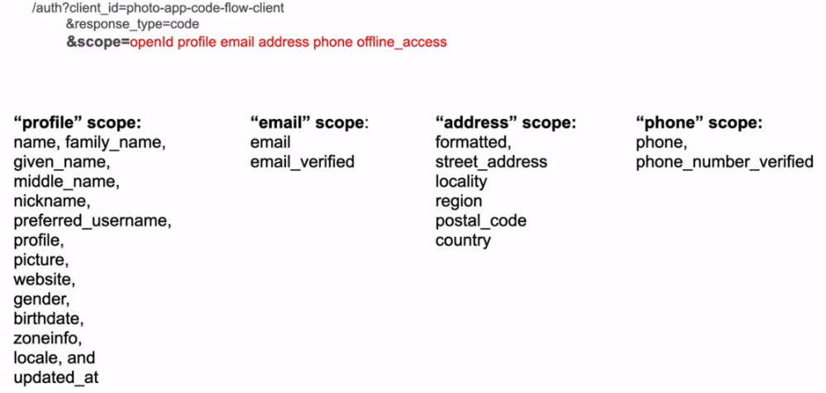

Right. So as you can see, scope's, they are being used to request that the server to generate an access token that will allow for an application to communicate with protected resource server endpoints and request information that is defined by access scopes. These scopes here on my slide, they are standard, open and connect scope's. But the information, the return can be configured on the server side and you can also define your custom scopes. All right. So once you have an access token that was generated with a support for one or all of the scopes, you should be able to get user information from either ID Token or by sending the request to a user information webservice endpoint that your authorization server will expose. And to get this information from authorization server, you'll need to send HTTP, get request to a /userinfo webservice endpoint

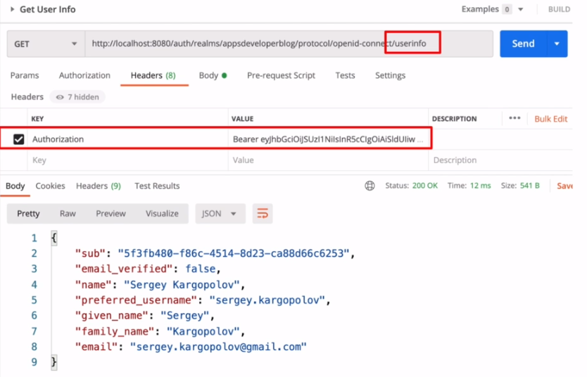

and you'll need to include a valid access token that was generated for the requested openid Connect Scope. And then if all is okay in response back, you will get requested user information.

Now, the /userinfo webservice endpoint is not something that I have created manually and it will be provided by your OAuth server as part of the specification. But the complete URL to this webservice endpoint, it might differ for different servers. For example, for Keycloak server, this URL will start with auth/realms/<realm name>/protocol/openid-connect/userinfo.

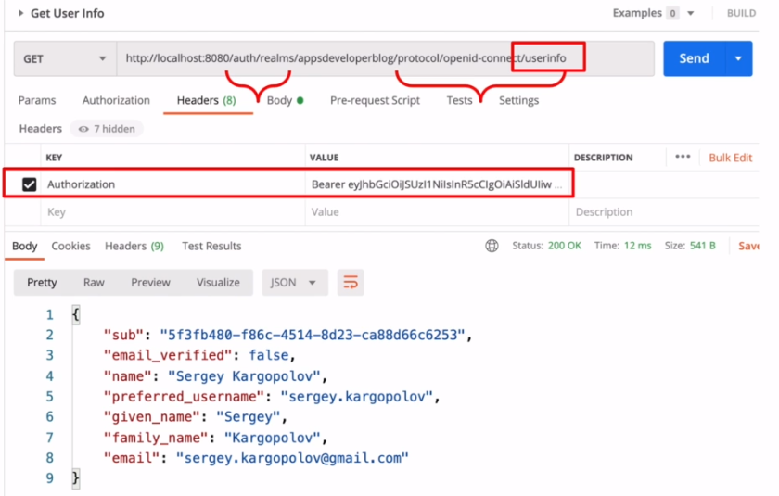

We will now learn how to configure a specific webservice endpoint in your resource server to return information only if the provided access token does contain the access code.

|  |  |
| --- | --- |
| If webservice endpoint does not contain the requested scope, then the request will be forbidden. Otherwise the request will be successful and the requested information will be returned back. |  |

### Create WebSecurityConfigurerAdapter and enable Web Security

We will now create a new class that will extend WebSecurityConfigurerAdapter, and we will enable web security in our application. So let's start by creating a new class.

|  |  |
| --- | --- |
|  | I will call this class WebSecurity and I will put this class into a new package called security. Now, it is very important that this class WebSecurity is a support package to your main application package. So I'm not creating an entirely new package outside of the root package of my application. I'm creating it as a package. All right.  So it's going to be a security class, which is going to be inside of a security package. I'm naming my package security, but you can give it any other name. And we have a new class now to enable web security in our application. I will use a special annotation that is called @EnableWebSecurity. Now that the WebSecurity is enabled, we can configure security in our application on a very granular level, we can provide security configuration for all or a specific webservice endpoints on and to help us configure WebSecurity on a very granular level in our application, we will need to make this class extend the WebSecurityConfigureAdapter. So I will need to make it extend WebSecurityConfigureAdapter class. Like this, and I will need to import it. So now we have a need to have security in our application and we have made this class extend, the WebSecurityConfigureAdapter and after and now we can start configuring the security in our application. |

**WebSecurity.java**

package com.oauth.server.resourceserver.security;

import org.springframework.security.config.annotation.web.configuration.EnableWebSecurity;

import org.springframework.security.config.annotation.web.configuration.WebSecurityConfigurerAdapter;

@EnableWebSecurity

public class WebSecurity extends WebSecurityConfigurerAdapter {

}

To configure websecurity, we will need to provide implementation for the configure method and the WebSecurityConfigureAdapter does already provide us with a default implementation of security that we can look up. So if we hold come on button on my keyboard and click on the WebSecurityConfigureAdapter, and if I go to its declaration, I can search and configure method. It's called configure and then it takes in HTTPSecurity.

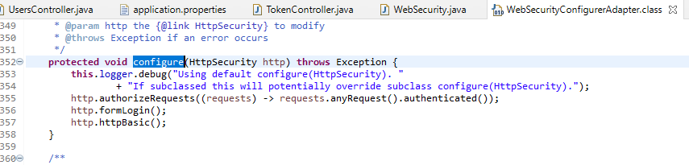

And if I open the HTTPSecurity class and if I search for it, I'll find a method that is called configuration security and it provides a default security configuration so I can cope with this default implementation of configure method. Go back to my Web security class and pasted here. Now, this default configuration makes sure that every HTTP request to our application is authenticated, but it is authenticated with the form based login and http basic authentication. But at this moment, we do not want this basic configuration. And this is why we are going to override this method with a special annotation that's called @Override.

package com.oauth.server.resourceserver.security;

import org.apache.commons.logging.Log;

import org.apache.commons.logging.LogFactory;

import org.springframework.security.config.annotation.web.builders.HttpSecurity;

import org.springframework.security.config.annotation.web.configuration.EnableWebSecurity;

import org.springframework.security.config.annotation.web.configuration.WebSecurityConfigurerAdapter;

@EnableWebSecurity

public class WebSecurity extends WebSecurityConfigurerAdapter {

private final Log logger = LogFactory.*getLog*(WebSecurityConfigurerAdapter.class);

@Override

protected void configure(HttpSecurity http) throws Exception {

this.logger.debug("Using default configure(HttpSecurity). "

+ "If subclassed this will potentially override subclass configure(HttpSecurity).");

http.authorizeRequests((requests) -> requests.anyRequest().authenticated());

~~http.formLogin();~~

~~http.httpBasic();~~

}

}

And now we can provide our own Http Security Configuration and we'll do the longer part of it, and the first half of security will leave unchanged for now. I still want all HTTP requests to my application be authenticated and authorized. But instead of a simple form login and basic authentication, I will use the OAuth 2 and JWT tokens and to configure HTTP security to use OAuth and JWT functionality we'll delete formLogin and httpBasic and instead I will do this.

http.authorizeRequests( (requests) -> requests

.anyRequest()

.authenticated() )

.oauth2ResourceServer()

.jwt();

Just changed this slightly and we have it like this now

@Override

protected void configure(HttpSecurity http) throws Exception {

this.logger.debug("Using our custom configure method of WebSecurity");

http.authorizeRequests()

.anyRequest()

.authenticated()

.and()

.oauth2ResourceServer()

.jwt();

}

So this will make the framework to do a lot of work behind the scenes for us. It will create the Bearer Token authentication filter that will intercept the requests and it will extract the authorization before a token and it will expect that token to be JWT rather than a packet token. And that will use that JWT token to see if it's valid. Now, we have an error here and it says that it cannot reduce the visibility. All right. So this method needs to be protected. All right. So first half of which HTTP security configuration is ready. Let's now configure a scope based access for our Web Service Endpoint.

### Configure Scope Based Access Control

The basic http security we have created so far is applied to all HTTP requests sent to our application and to all webservice endpoints, we can narrow down issues, security configuration to specific webservice endpoint and to a specific HTTP method that is used to access this webservice endpoint. For example, let's provide a security configuration that will make sure that HTTP get request sent to users webservice endpoint will be allowed only if user has granted a profile scope of access when client application requested an access token. And to do that, we will inject and ant matcher method right after the authorized request method here. All right, so the ant matcher method here will tell Sprint security to apply the security configuration, only you request is HTTP GET request and if the request is sent to a certain point, that is for /users. If this pattern matches, then Spring security will need to check of the currently authenticated user has an authority to access information that is available with the profile scope access level.

So the Spring security will inspect and validate the provided JWT access token. It will check if the access token is valid and if so, it will create a principal user authentication object from the information that JWT token contains. And if the JWT token was granted the profile level scope of access, then the request will be permitted. All right. And the scope prefix here it is must-to-have, because when Spring security creates a list of authorities based on the scopes that are included in the access token, it will append the SCOPE_ prefix to each scope that it finds. So each scope value in the list of authorities will have this SCOPE_ prefix. But we do not need to provide the specifics when we include scope on a HTTP request.

package com.oauth.server.resourceserver.security;

import org.apache.commons.logging.Log;

import org.apache.commons.logging.LogFactory;

import org.springframework.http.HttpMethod;

import org.springframework.security.config.annotation.web.builders.HttpSecurity;

import org.springframework.security.config.annotation.web.configuration.EnableWebSecurity;

import org.springframework.security.config.annotation.web.configuration.WebSecurityConfigurerAdapter;

@EnableWebSecurity

public class WebSecurity extends WebSecurityConfigurerAdapter {

private final Log logger = LogFactory.*getLog*(WebSecurityConfigurerAdapter.class);

@Override

protected void configure(HttpSecurity http) throws Exception {

this.logger.debug("Using our custom configure method of WebSecurity");

http.authorizeRequests()

.antMatchers(HttpMethod.*GET*, "/users")

.hasAuthority("SCOPE_profile")

.anyRequest()

.authenticated()

.and()

.oauth2ResourceServer()

.jwt();

}

}

Before I try how this works, I will go to the controller class and we'll make sure that the webservice endpoint that I have configured here /users does exist. So we will go to the controler package. And the only webservice endpoint that I have is for /users for /users/status/check. I do not have I get mapping for only /users. So let me change that. I will go back to my WebSecurity and will update the pattern in the antMatcher to /users/status/check.

http.authorizeRequests()

.antMatchers(HttpMethod.*GET*, "/users**/status/check**")

.hasAuthority("SCOPE_profile")

.anyRequest()

.authenticated()

.and()

.oauth2ResourceServer()

.jwt();

Now I can start my application and try sending request to this webservice endpoint. My server has started. Lets go to Postman and will send the request to request authorization code, and before I do that, I will make sure that the scope here does not include profile. And I will also need to make sure that my authorization server does not grant profile access level by default. So I will bring in a browser window. I will log in and to my server. And we'll go to list of clients, open up the client application that I'm using to send this request, I will go to Client Scope's and I will check the list of scopes that are assigned by default. And I see that profile and the list of scopes that is assigned by default. I will remove that.

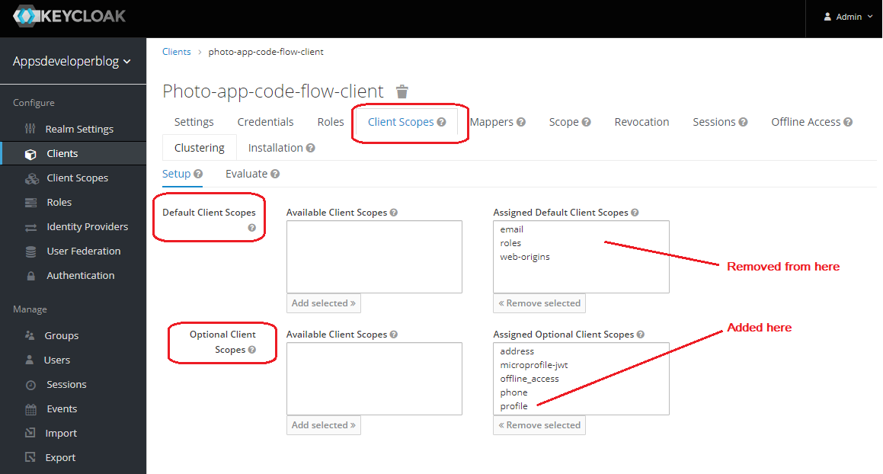

I will remove profile, and I will include profile as a scope file that can be requested optionally like this. Now the profile will not be granted by default to access token, but if needed, a client application can request an access token with a profile scope of access. All right. So now let me go back to Postman and I will request your mail. And we'll ask authorization server, to give me an authorization code to exchange it for an access token.

We have removed profile from here

<http://localhost:8180/auth/realms/appsdeveloperblog/protocol/openid-connect/auth?client_id=photo-app-code-flow-client&response_type=code&scope=openid&redirect_uri=http://localhost:8083/callback&state=asfwerwsdfwe>

Redirected URL

http://localhost:8083/callback?state=asfwerwsdfwe&session_state=47a9f337-a1f3-4842-aba2-de9a98b46693&**code=606535cb-9328-4381-ac62-3104da973a3e.47a9f337-a1f3-4842-aba2-de9a98b46693.3ade057c-59ee-4217-b510-a55dbd7575be**

All right, we are redirected after the login, the authorization code is attached to the redirected URL. I will copy it and I will go back to postman and then we'll exchange it for an access token. So I will paste the new authorization code, send the request. A request is successful. I have my access token and I will copy this access token.

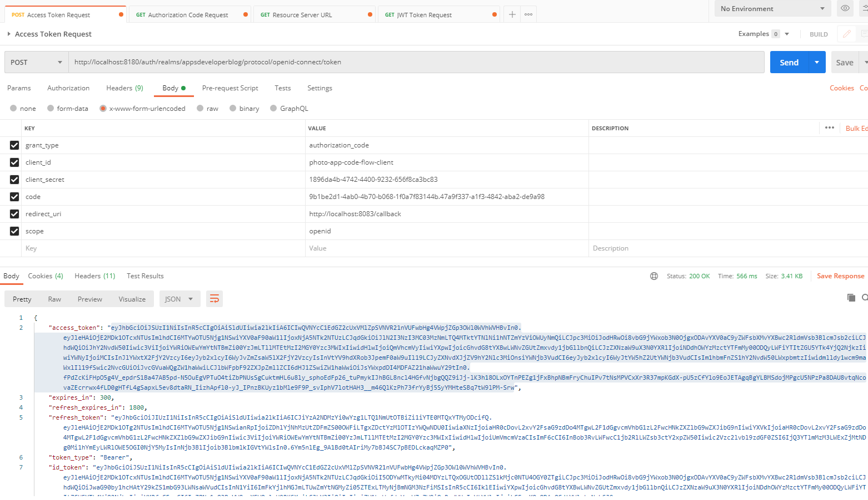

And we will use the access token for requesting to users/status/check. So it needs to be HTTP get request. And now I will paste a valid access token. And we'll send this HTTP request. And the request is forbidden.

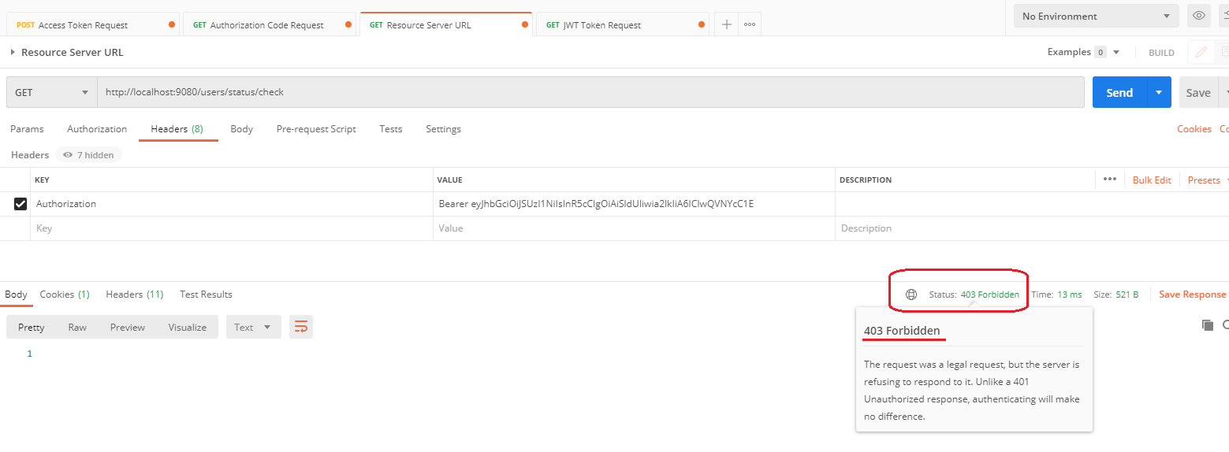

All right, so it looks like it's working now, let's try acquiring a new access token, but this time we will include profile scope of access.

Using Proper Scopes

I will go back to HTTP Get request to request authorization code, but this time I will include a scope of access that I want to be granted to an access token. So additionally to openid, I will include profile.

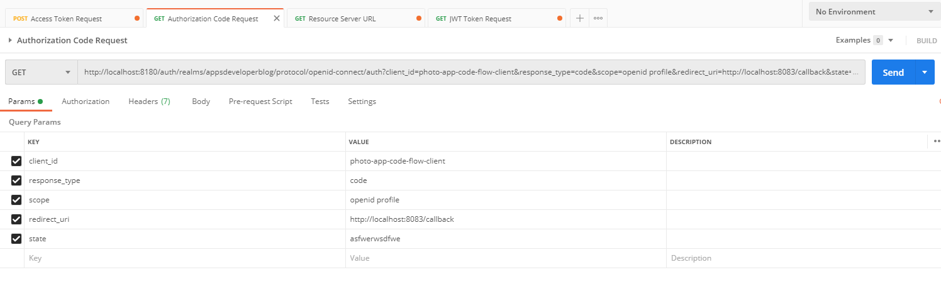

If we missed any steps above we could get

http://localhost:8083/callback?error=invalid_request&error_description=Invalid+scopes%3A+openid+profile&state=asfwerwsdfwe

Now, I will copy the URL go back to my browser window, request an authorization code, copy the new code and I will exchange it for an access token. Send the request. The request is successful.

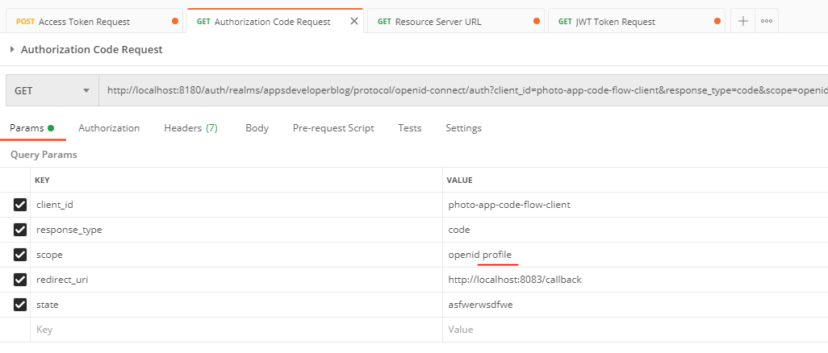

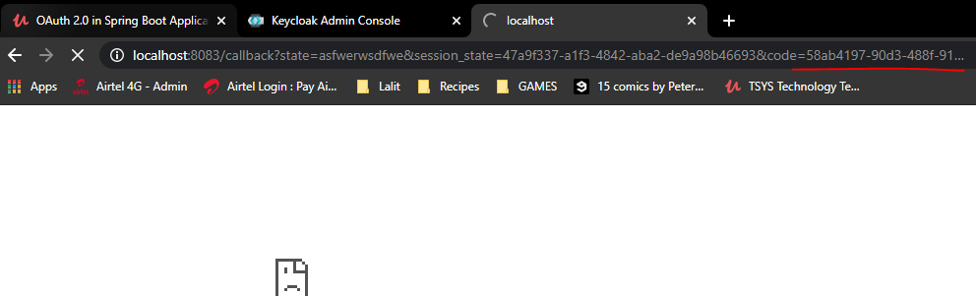

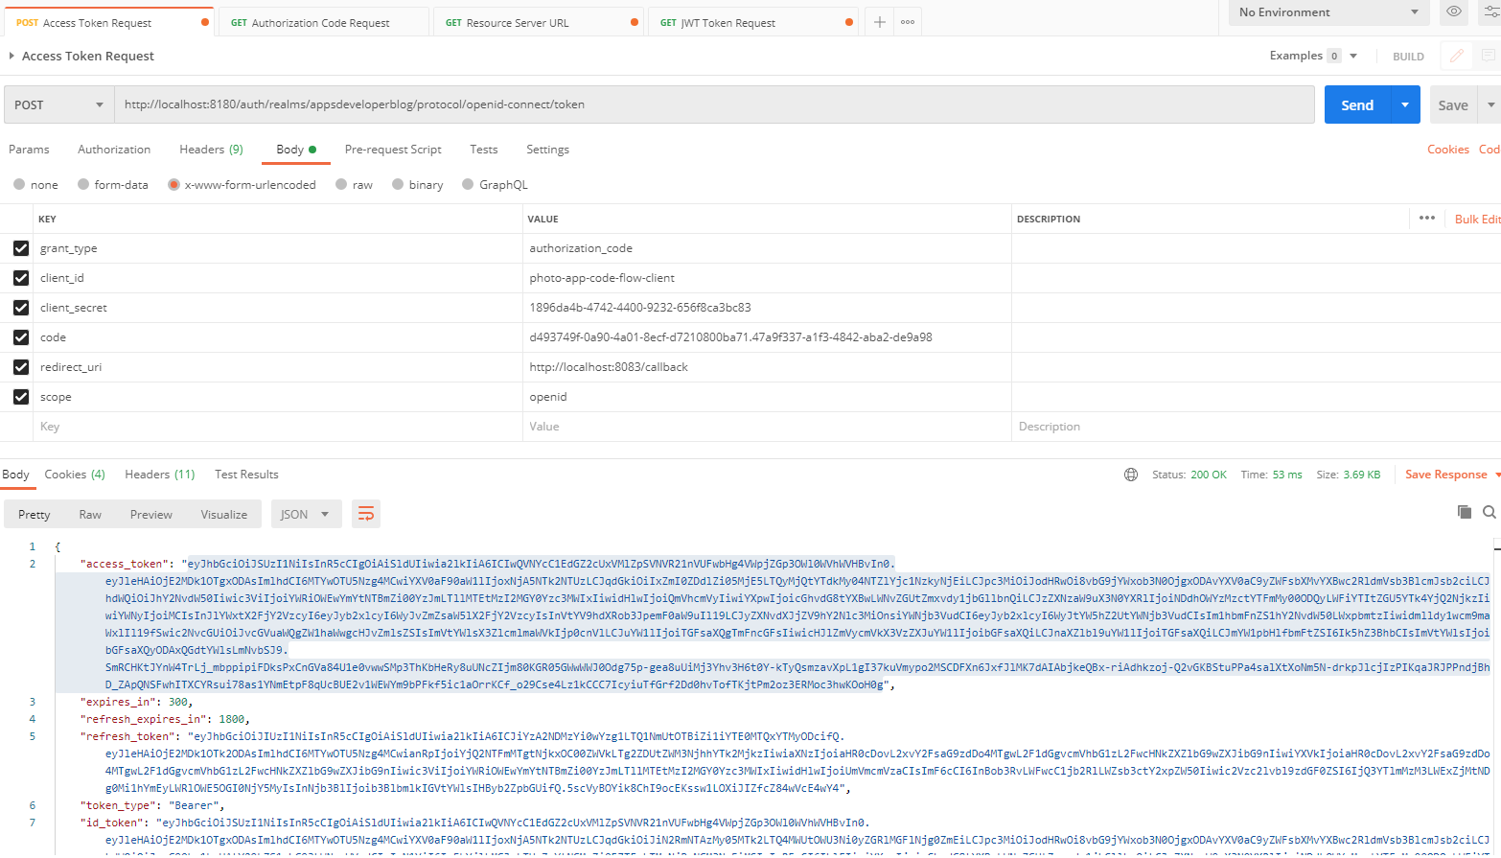

I have my new access token. And now I will go to my request to forward slash users for social status, check and paste a new access token. That was granted to access profile scope information. All right, now let's try and we'll get a successful response, right. So it is working.

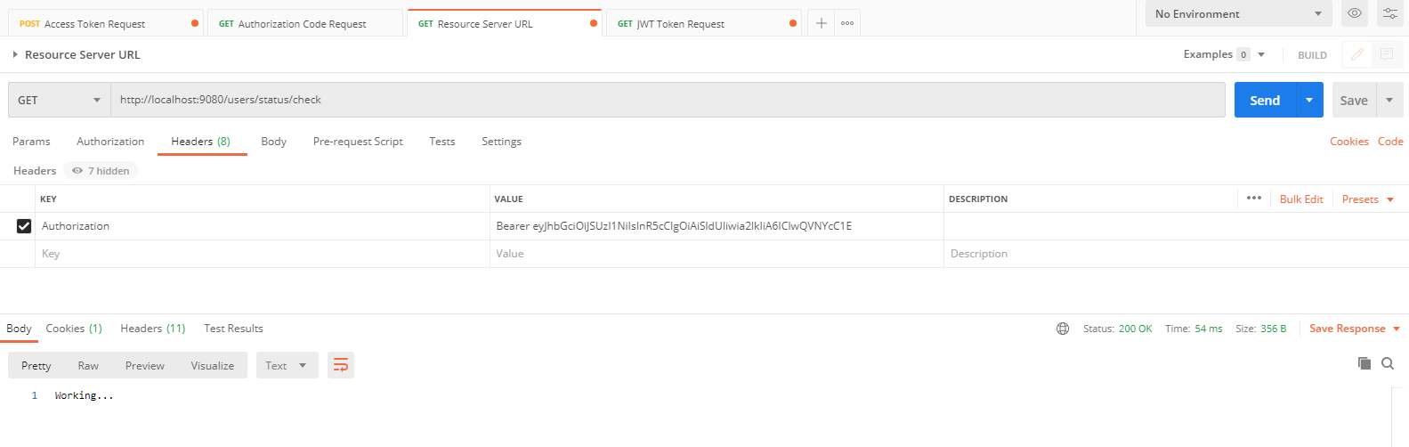

## Role Based Access Control with Keycloak

Lets learn what is role and authorities, how they work in a Spring application and also how to configure your resource server to validate user role. So what is roles and authorities and how does role differ from authority. Technically in spring framework there is not much difference between a role and an authority, and at this moment there is really no API that spring framework offers to separately create a role and separately create an authority.

Let me first introduce you to a logical difference between a role and an authority and describe how developers organize roles and authorities in their software and then will come back and compare it to the way how Spring framework differentiates a role from an authority. So how do sort of developers most of the time organized roles and authorities?

Let's say you are developing a software application and people who will use your application are usually called users. This users may have different roles in the system. For example, one of them can be a regular user while another one can be an admin user. And you as a system owner can have a role of super admin, so users in your system can have different roles. One user has a role user, another user has a role of admin, and another user has a role of super admin. And each user role can have different privileges assigned to it. For example, a regular user might have a privilege to view its own profile details or a view public profile details of another user. And it can have a privilege to edit, but it can edit only its own profile it has. A user with admin role however, additionally to being able to edit its own profile details can also edit profile details of other users and admin role can have a privilege or an authority to delete another user. As you can see, the roles differ from each other not only in the way they're called, but also in the list of privileges that they have.

A privilege is also called authority. So we can say that a user who is in the role of admin has more authority than a regular user. And in Java code, when we use Spring security framework, we will use a word authority or a granted authority rather than a word privilege. So as we go on, the terminology that I will use will be a role and authority rather than a role and a privilege. And finally, a role super admin can have even more authority as a user who is assigned a role of super admin can create, edit and delete other admins in the system as well. All right. So I hope you get an idea of what is a role and what is an authority and role is a collection of authorities.

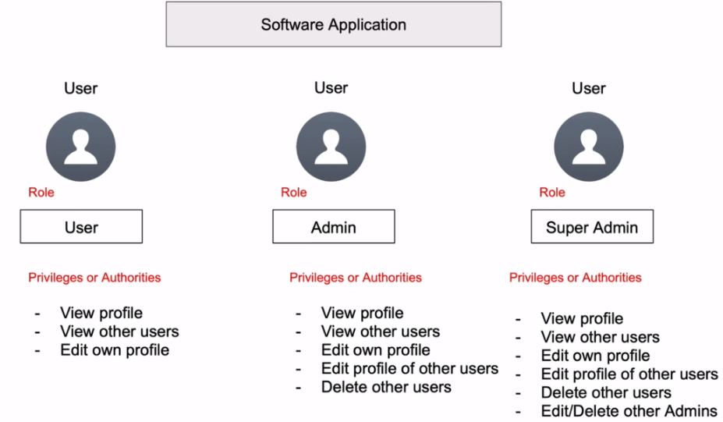

And one role can have more or less authorities then in another role in the system. And does a user who is assigned a particular role can do more or less than a user with a different role? But what's interesting actually is that for a supreme framework, there is not much a difference between a role and authority. And technically, Spring framework does not offer an API to separately create user role. And then to add to that user role a list of different authorities and Spring security rules and authorities are in the single list. We can keep roles and authority separately in the database. But when we read them from a database, we put them into a single list and it then becomes a single collection of granted authorities. And the only difference between different roles and authorities is just their names.

When creating a role name, developers add the prefix RULE_ to it, and technically for a Spring framework this name role_ admin can be both a role name and an authority name. When checking is currently logged in, user has an admin role granted to it. Developers can use the hasRole() function and as a rule name provide only ADMIN without the prefix ROLE_. This is because Spring framework will add the prefix ROLE_ to it automatically. But we can also achieve the same result and check if the currently logged in user has a ROLE_ADMIN granted to them by using sprint security function called hasAuthority. And in this case we will need to provide a complete full name, including the ROLE_ prefix. And this is because in the case of hasAuthority function, spring framework will not add the prefix. Both functions will use the same source to look for an authority or a role. So when either of these two functions is used, it will use the same collection of granted authorities that we will need to create and give it.

|  |  |
| --- | --- |
| It is just the hasRole function will append the prefix automatically and hasAuthority function will not append any prefix and will look for an exact match. So when creating Roles, developers usually always add a prefix ROLE_ and when creating authorities, developers do not use any prefix and name their authorities any way. It makes sense. For example, read, write, delete or read_authority, write_authority or delete_authority in Java code. |  |

Both roles and authorities will need to be put into a single collection of granted authority data type and then the following lessons you will learn how to do it. So let's continue and let's learn how to configure our resource server to validate user role.

Source code

Resource Server - Before adding Role-based access control

<https://github.com/simplyi/ResourceServer/tree/before-adding-role-based-acceess-control>

Resource Server - After adding Role-based access control

<https://github.com/simplyi/ResourceServer/tree/after-adding-role-based-acceess-control>

### Creating User Role

We will create and assign to a user a new role and to create a new role, I will need to sign into my Keycloak server with an admin username and password and when signed in I will need to go to the Role section on the left side and to create a new Role, I will need to create a new Role with a name developer.

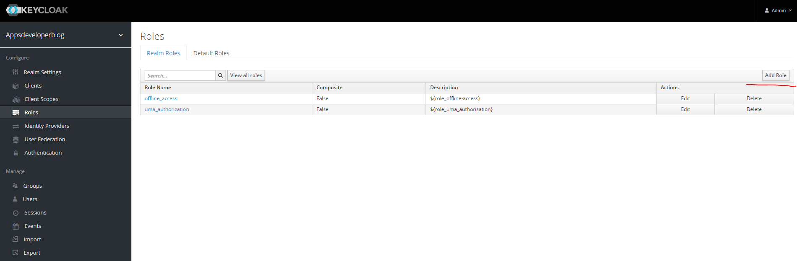

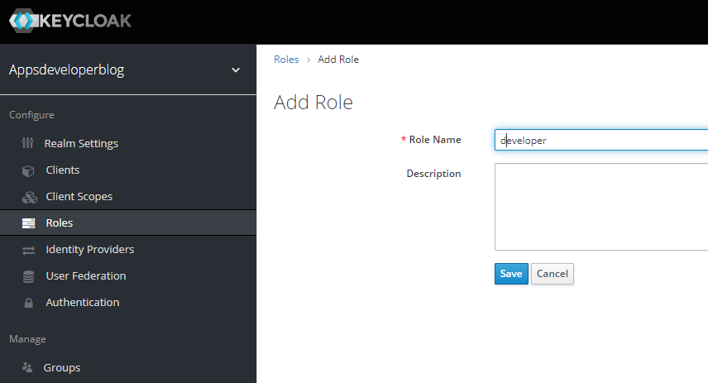 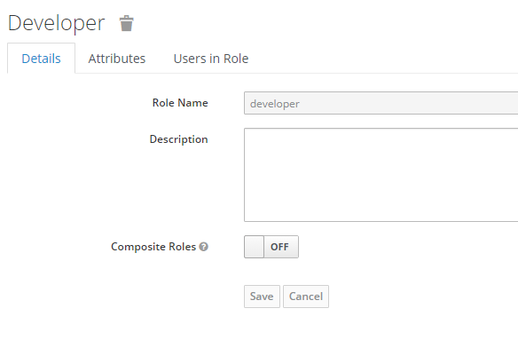

And we'll click on Save Now want to have created a new role. Right side screenshot is after it gets created.

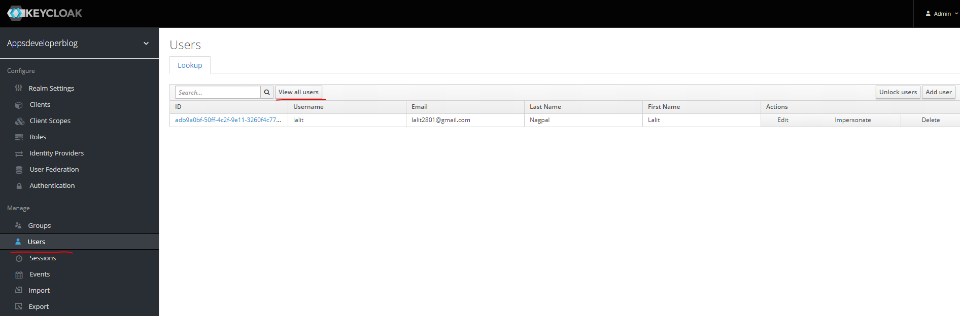

I will need to assign this role to one of my users. And to do that, I will go to a list of users on the left side here, users and will select a user. If you don’t see any users here, click on the View all Users button. I want to assign this role, click on the user id and you are take to the screen below. I will select the one that is called role mapping.

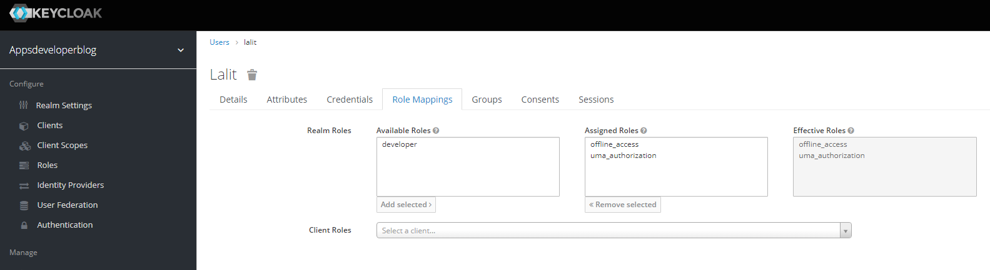

And here on the left side, I have a list of goals that I can select from and assigned to this user, and on the right side, I have a list of Roles that are already assigned to this user. So I will select a role I have created and I will assign this role to this user by clicking on this Add Selected button. And this is it. And your role has been assigned to this user and it's ready to be used.

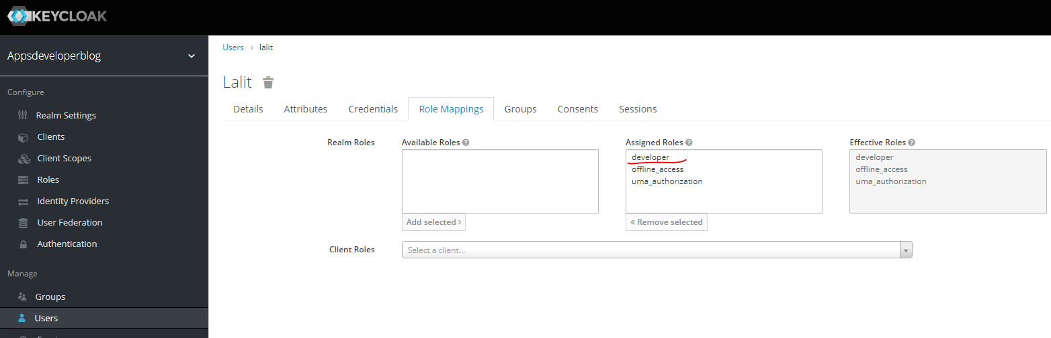

Securing endpoints to a Role

To secure websites endpoint to a user with a specific role, we can use a special method called hasRole. And provide the Role name that they can get indicated user must have to be able to access the service endpoint. For example, a Role developer, if you want to support multiple roles, then there is a method called hasAnyRole. And this method accepts multiple roles. I'll just need to separate them with a coma, for example, one role will be a developer role, another role will be user like this.

@Override

protected void configure(HttpSecurity http) throws Exception {

this.logger.debug("Using our custom configure method of WebSecurity");

http.authorizeRequests()

.antMatchers(HttpMethod.*GET*, "/users/status/check")

//.hasAuthority("SCOPE_profile")

//.hasRole("developer")

.hasAnyRole("developer", "user")

.anyRequest()

.authenticated()

.and()

.oauth2ResourceServer()

.jwt();

}

Now, I do not have multiple roles, so I will comment out hasAnyRole method and I will continue with the hasRole.

@Override

protected void configure(HttpSecurity http) throws Exception {

this.logger.debug("Using our custom configure method of WebSecurity");

http.authorizeRequests()

.antMatchers(HttpMethod.*GET*, "/users/status/check")

.hasRole("developer")

.anyRequest()

.authenticated()

.and()

.oauth2ResourceServer()

.jwt();

}

Notice that when using hasRole method, we do not need to attach the prefix ROLE_ to a role. This is one little difference between the hasAuthority and the hasRole methods. When using hasAuthority method, we needed to provide the prefix SCOPE_ and then the authority name. But when using hasRole or hasAnyRole methods, we do not need to attach prefix anymore. And if we do attach prefix, like for example, if I had a prefix ROLE_developer, then things will not work, right. So when using hasRole or hasAnyRole methods do not attach the underscore prefix to a role.

Now when it comes to Roles, then the way they look in the access token might depend on the way a particular identity provider server has built that access token. Therefore, Spring framework provides us with a way to create a Convertor class which we can use to access the access token and then read list of rules from that access token and then convert each roll into a granted authority. If I run my application now as it is and use an access token that Keycloak server has created, my application will not be able to read that list of rules and the request will be forbidden. Later will show you how to create the converter class and convert a list of rules that we will read from Global Access Token into a list of granted authorities that Spring framework can understand.

Creating Role Converter Class

The convertor class can be used to access a list of claims in the JWT access token and convert user role into a granted authority object, and you can use this class not only with Keycloak, but also with any other identity provider server to help you access the JWT access token, read a specific claim from it and then do some custom conversion with that claim. All right. So I'm going to create a new class inside of security package. And I will call it KeycloakRoleConverter and click on Finish. Now, this class will need to implement a special interface called Convertor. This interface allows us to convert a source object into a target object, the object will be the JWT object and the target object will be a collection of granted authorities.

All right, because this is an interface, my class now needs to implement one of the requirements and I will add unimplemented methods and the method that we will need to implement to make all of it work is called convert. It takes in the JWT object that will contain a set of claims. Using this object, we can access any claim that our JWT access token contains and it returns back a collection of Granted Authorities. So the source object is our JWT token and the destination object is our collection of granted authorities.

package com.oauth.server.resourceserver.security;

import java.util.Collection;

import org.springframework.core.convert.converter.Converter;

import org.springframework.security.core.GrantedAuthority;

import org.springframework.security.oauth2.jwt.Jwt;

public class KeycloakRoleConverter implements Converter<Jwt, Collection<GrantedAuthority>> {

@Override

public Collection<GrantedAuthority> convert(Jwt source) {

// TODO Auto-generated method stub

return null;

}

}

Lets implement the convert method, we have access to the JWT object and from this JWT object, we can get access to the token itself or we can reach this specific claim that this JWT token contains. Now we're interested in finding user roles and to find user roles in the JWT token, I can decode it and then see how user rules are stored about the JWT token. I will bring in a new browser window. And I will open the website that is called jwt.io. And I can use this website to debug JWT token and have a look into its details. Let me bring in Postman and from Postman Client, I will copied JWT token. And I will paste it into a left section here into this text box and on the right side I can see the details of my access token in one of our previous videos.

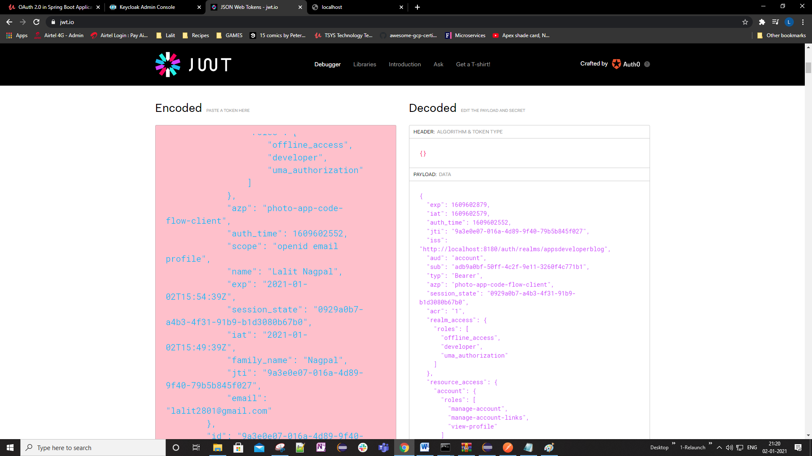

Since we have created a new role called developer, we have created that role on the realm level and then we have assigned this role to a user that we have. So to find this role, I will need to look for realm_access json object. Roles defined on the realm level can be assigned to any user created in that realm and can be read by a client application registered with this realm. So I will work with the realm_access json object, and I see that the developer role is defined here. So to read this developer role, I will need to use realm_access json key. This will give me a json object and from this case, an object. I can get user roles which will give me a json array and then I can convert this summary into a collection of granted authority objects that the convert method must return. If I go back to convert method, it must return a collection of granted authority objects. All right, so let's use the JWT object that we have received has a method argument in this method to convert realm level user roles into a collection of granted authority objects.

We will finalise our convert method.

public class KeycloakRoleConverter implements Converter<Jwt, Collection<GrantedAuthority>> {

@Override

public Collection<GrantedAuthority> convert(Jwt jwt) {

Map<String, Object> realmAccess = (Map<String, Object>)jwt.getClaims().get("realm_access");

if (null == realmAccess || realmAccess.isEmpty()) {

return new ArrayList();

}

Collection<GrantedAuthority> listOfGrantedAuthority = ((List<String>)realmAccess.get("roles"))

.stream()

.map(roleName -> "ROLE_" + roleName)

.map(SimpleGrantedAuthority::new)

.collect(Collectors.toList());

return listOfGrantedAuthority;

}

}

I will add a ROLE_ prefix to each role name, and the result will be assigned to an object that I have called listOfGrantedAuthority. That is a collection of granted authority objects. And this is it.

Now that we have the convertor class, we will need to register it with HTTP security and to do that go to WebSecurity class and we'll create a new instance of JWTAuthenticationConvertor class. And that will give it our custom convertor object. I'll use an instance of JWTAuthenticationConverter and call a method that is called setJwtGrantedAuthoritiesConverter. And there is a parameter to this method that will pass a new instance of my KeycloakRoleConverter class. And now I will register the JWTAuthenticationConverter with HTTP security like this, all right, so we have registered our authentication converter class with HTTP security and we are ready now to run our application and see if it works.

import org.apache.commons.logging.Log;

import org.apache.commons.logging.LogFactory;

import org.springframework.http.HttpMethod;

import org.springframework.security.config.annotation.web.builders.HttpSecurity;

import org.springframework.security.config.annotation.web.configuration.EnableWebSecurity;

import org.springframework.security.config.annotation.web.configuration.WebSecurityConfigurerAdapter;

import org.springframework.security.oauth2.server.resource.authentication.JwtAuthenticationConverter;

@EnableWebSecurity

public class WebSecurity extends WebSecurityConfigurerAdapter {

private final Log logger = LogFactory.*getLog*(WebSecurityConfigurerAdapter.class);

@Override

protected void configure(HttpSecurity http) throws Exception {

this.logger.debug("Using our custom configure method of WebSecurity");

JwtAuthenticationConverter jwtAuthenticationConverter = new JwtAuthenticationConverter();

jwtAuthenticationConverter.setJwtGrantedAuthoritiesConverter(new KeycloakRoleConverter());

http.authorizeRequests()

.antMatchers(HttpMethod.*GET*, "/users/status/check")

.hasAnyRole("developer", "user")

.anyRequest()

.authenticated()

.and()

.oauth2ResourceServer()

.jwt()

.jwtAuthenticationConverter(jwtAuthenticationConverter);

}

}

We have considered the HTTP security in our resources server to allow HTTP get requests sent to /user/status/check endpoint to be performed only by those users who have developer role. To see if this works, I will now run my application. I will request a new access token with user credentials that does have a developer role assigned. And then I will send the request to my users status, check webservice endpoint to see if it works. And then if it does work, I will change the role name and I will repeat the request to see if it still works. All right. So let's start Resource Server first. And I will bring in Postman. And will copy request URL and will bring a new browser window? Pasted here and request a new authorization code

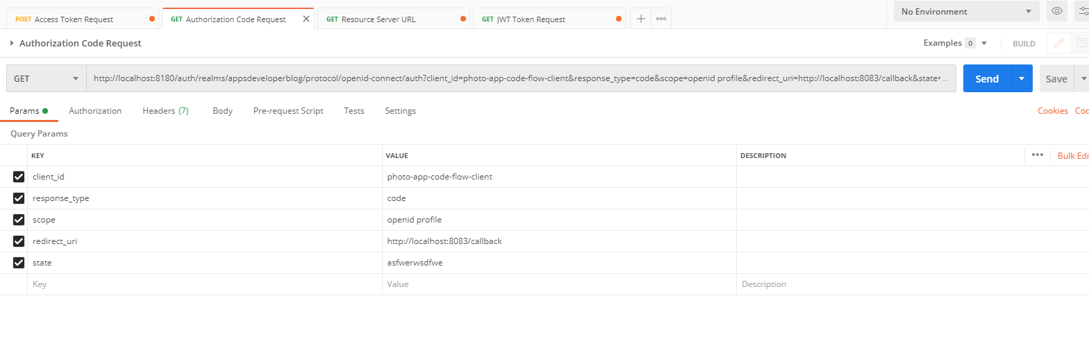

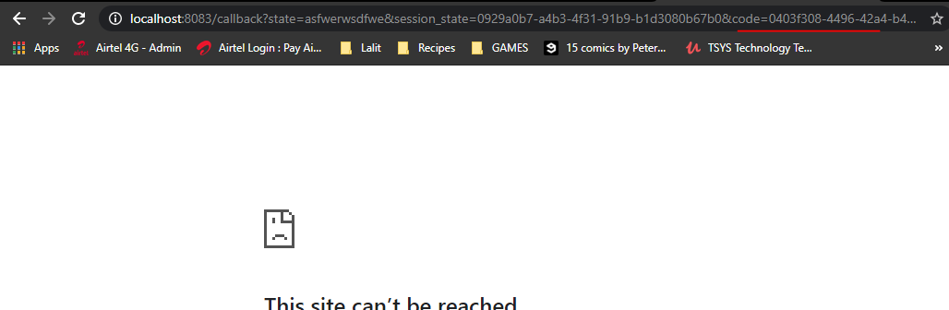

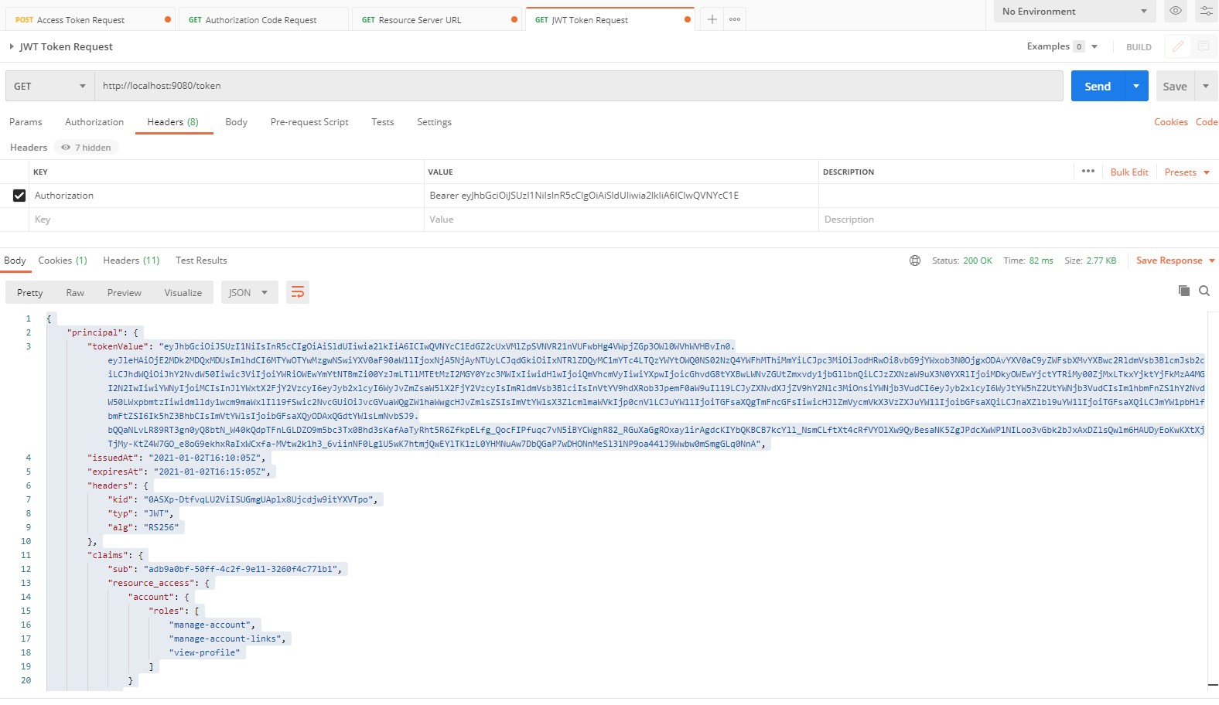

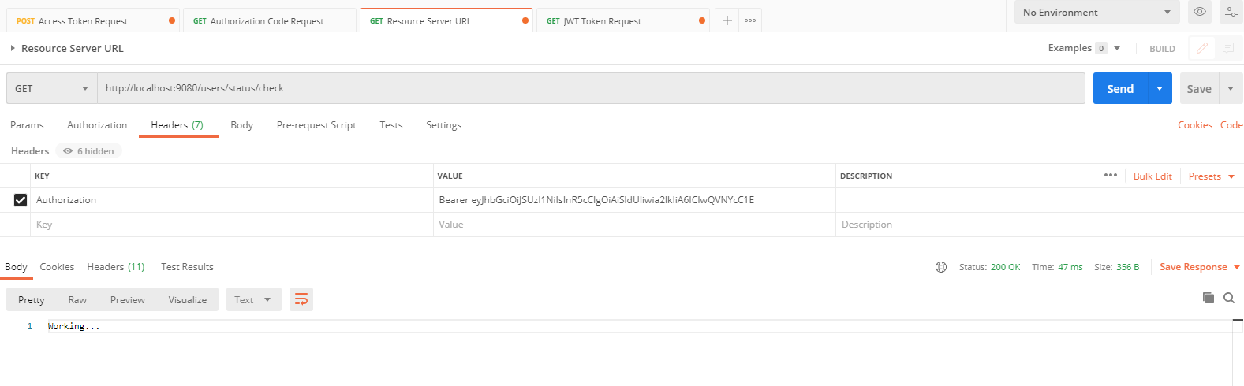

And it's working all right, so I will do now

I will go back to my resource server and I will change the developer role. Let's say it's not a developer, but a user. My resource server has just restarted and try repeating in this request. And the request is now forbidden. All right, so it looks like it is working. I'll go back to my resource server and we'll provide a correct role here, save it, with my resource server will now restart. And I will repeat this request to see if it works. And now it is working. Now, I have used the hasRole function and notice that I did not need to attach the scope, underscore prefix. This is because when using hasRole Spring security will attach to this prefix automatically. If you use the hasAuthority function, then you will need to attach that prefix manually so I can comment out the hasRole and then use hasAuthority. And in this case I will need to attach the prefix before the role name like this ROLE_ and then a correct role developer. Now my resource server will restart and I can try send in their request and it should still work. All right, so it's working, if I provide incorrect role, it should not allow this request. All right, and the request is forbidden, so everything is working well, I will bring things back to as they were before, will comment out has authority and will use hasRole. Now, I will repeat the request and it is working.

## Method Level Security

We will use method level security to protect some of our webservice endpoints. With this level of security, we can use annotations above the method name to deny or allow the execution of that method based on the certain conditions, for example, we can use a security annotation to allow on the users with specific role or a specific authority to invoke this method. All other users will be denied access and there will not be allowed to invoke the method.

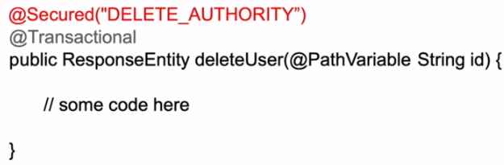

You can use security annotations not only in the controller class where we have the request mapping methods, but you can also use them in the service class if needed. And in the code snippet that you see a method of security annotation is used and it is called @Secured annotation. The annotations being used above the method name, which is called delete user. And this annotation will allow the delete user method be executed only by authenticated user who has the delete authority granted to them.

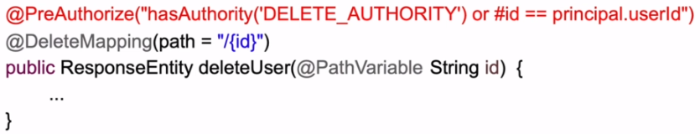

There are other security annotations that you will also learn to use in one of the following videos and one of them is @PreAuthorized, the @PreAuthorized annotation is more advanced, and it supports the expression based access control. With this annotation, you can use a simple but very powerful expression language to create expressions for more advanced scenarios. For example, in the code snippet that you see, the @PreAuthorization notation has an expression to allow the delete user method be executed by users who have the delete authority or by a currently authenticated user whose user ID matches the user ID, which was passed in as a URL path variable. In other words, you can create an expression which will allow user profile to be deleted only by users with admin authority or by user who actually owns this user profile. All other users will be denied access.

|  |  |
| --- | --- |
| And then there is a annotation called @PostAuthorized, this annotation will allow a method to execute first and only then after the method is executed, the security expression will evaluate. Notice that this annotation will have access to a return object. By accessing a return object, we can validate if the information that this method is going to return is allowed to be returned for a currently logged in using. |  |

The word return object, which is used in the security expression, is a built in feature and no matter how the object returned by our method is called to access that object in a security expression, we use the reserve word, which is called return object. For example, in the code snippet that you see on the screen because it uses the PostAuthorize annotation and method will be allowed to be executed first. But the return value of user data type will be returned only if the currently logged in user has an admin role or if the currently logged in user does actually own this information.

Security annotations and the expression based access control can also be used on the class level, for example, in the code snippet on the screen, the unsecured annotation is used above the class name. In this case, all the methods in the class will be affected by this annotation. However, if there's another annotation which is above the method name, then that annotation will have a higher priority. This is because annotations above the method name have higher priority than annotations used above the class name.

|  |  |
| --- | --- |
|  | We will not cover all security annotations and all possible security expressions that can be used with this annotations, and after watching the video lessons in this section, you will realize that your project does need to use that level of security on more advanced level.  Then we encourage you to have a look at this section in spring documentation that covers expression based access, control, the knowledge that you will gain from the lessons and this section and the information that you will get from spring recommendation will give you a very good insight on what else can be done with security expressions for your project. All right.  So let's move on and let's learn how to enable method level security in our Spring Bootmaker series and learn how to use if you use foreign patients. |

| **Common built-in expressions** | |
| --- | --- |
| **Expression** | **Description** |
| hasRole(String role) | Returns true if the current principal has the specified role.  For example, hasRole('admin')  By default if the supplied role does not start with 'ROLE_' it will be added. This can be customized by modifying the defaultRolePrefix on DefaultWebSecurityExpressionHandler. |
| hasAnyRole(String…​ roles) | Returns true if the current principal has any of the supplied roles (given as a comma-separated list of strings).  For example, hasAnyRole('admin', 'user')  By default if the supplied role does not start with 'ROLE_' it will be added. This can be customized by modifying the defaultRolePrefix on DefaultWebSecurityExpressionHandler. |
| hasAuthority(String authority) | Returns true if the current principal has the specified authority.  For example, hasAuthority('read') |
| hasAnyAuthority(String…​ authorities) | Returns true if the current principal has any of the supplied authorities (given as a comma-separated list of strings)  For example, hasAnyAuthority('read', 'write') |
| principal | Allows direct access to the principal object representing the current user |
| authentication | Allows direct access to the current Authentication object obtained from the SecurityContext |
| permitAll | Always evaluates to true |
| denyAll | Always evaluates to false |
| isAnonymous() | Returns true if the current principal is an anonymous user |
| isRememberMe() | Returns true if the current principal is a remember-me user |
| isAuthenticated() | Returns true if the user is not anonymous |
| isFullyAuthenticated() | Returns true if the user is not an anonymous or a remember-me user |
| hasPermission(Object target, Object permission) | Returns true if the user has access to the provided target for the given permission. For example, hasPermission(domainObject, 'read') |
| hasPermission(Object targetId, String targetType, Object permission) | Returns true if the user has access to the provided target for the given permission. For example, hasPermission(1, 'com.example.domain.Message', 'read') |

Source code

**Resource Server - Before adding method-level security code**

<https://github.com/simplyi/ResourceServer/tree/resourceserver-before-adding-method-level-security>

**Resource Server - After adding method-level security code**

<https://github.com/simplyi/ResourceServer/tree/resourceserver-after-adding-method-level-security>

Enable Method Level Security

We will enable the method level security in our project and to enable method of security in our Spring Boot application, we will need to enable a special annotation to one of our configuration files. @EnableWebSecurity annotation for example. The configuration files are updated with @Configuration annotation like this. And our Web security class is also configuration class because it does not already have had @EnableWebSecurity annotation, which is a configuration annotation because it already includes the @Configuration annotation.

So we can use this WebSecurity class to enable web security by adding a special annotation called @EnableGlobalMethodSecurity. By adding another special annotation, which is called @EnableGlobalMethodSecurity. So if not using the @EnableGlobalMethodSecurity in a WebSecurity class that already has @EnableWebSecurity annotation, we can add this annotation @EnableGlobalMethodSecurity to any other class you have in your application that is annotated with @Configuration annotation. All right.

So we have added @EnableGlobalMethodSecurity annotation, and this annotation allows us to turn on or enable certain security annotations, for example, we will look at security annotation that is called @Secured, and to enable the security annotation, I can use a special property that the @EnableGlobalMethodSecurity annotation has and it is called security, I will add it in parenthesis, securedEnabled=true. So this property securedEnabled=true will enable the @Secured annotation and we can start using this @Secured annotation above the methods in the Controller class or above the methods in the service layer class.

//@Secured

@EnableGlobalMethodSecurity(securedEnabled=true)

@EnableWebSecurity

public class WebSecurity extends WebSecurityConfigurerAdapter {

private final Log logger = LogFactory.*getLog*(WebSecurityConfigurerAdapter.class);

@Override

protected void configure(HttpSecurity http) throws Exception {

this.logger.debug("Using our custom configure method of WebSecurity");

JwtAuthenticationConverter jwtAuthenticationConverter = new JwtAuthenticationConverter();

jwtAuthenticationConverter.setJwtGrantedAuthoritiesConverter(new KeycloakRoleConverter());

http.authorizeRequests()

.antMatchers(HttpMethod.*GET*, "/users/status/check")

// .hasAuthority("SCOPE_profile")

.hasRole("developer")

//.hasAnyRole("developer", "user")

.anyRequest()

.authenticated()

.and()

.oauth2ResourceServer()

.jwt();

}

}

All right. So let me delete this annotation from here and let's continue.

@Secured Annotation Example

Lets try out the @Secured annotation. And to do that, I'll go to the Controller class inside of controller package. And we will create a new webservice endpoint that will be responsible for handling delete method requests. All right, so here we have a very simple method that will be triggered with HTTP delete method request sent to a webservice endpoint that starts with a /users/{id}. I have used delete mapping because I want this method to be triggered when a delete request is sent, and as a path variable here I am providing a value that is going to be some kind of user ID and whatever value is included in the URL path variable, it will be read from that URL path as a variable. So the method name deleteUser can be any other name and the result of this method will just be a hardcoded string “delete user with an ID “ + id that was provided as a path variable. This method will not delete any user, will not do any business logic. It will just return a string value. To read the value of user ID that is provided in the request and to inject it into a method as another argument, I will use the @PathVariable annotation and I will call my method argument with the same name as a path variable here. All right.

**UsersController.java**

@RestController

@RequestMapping("/users")

public class UsersController {

@GetMapping("/status/check")

public String status() {

return "Working...";

}

@DeleteMapping(path = "/{id}")

public String deleteUser(@PathVariable String id) {

return "Deleted user with id: " + id;

}

}

So to secure this method and to make sure that this method can be called only by users who have a specific role, I will annotate this method with @Secured security annotation like this, I will need to improve the annotation and as a value, these annotation takes a authority name, so I'll need to use parentheses and in double quotes I'll need to provide an authority name. Let's have a quick look at the Web security file. So earlier, we have tried to secure the user's for its status check webservice endpoint to users with a developer authority. Since we already have the developer role created and we have it assigned to our test user, let's use this same developer role with the @Secured. So go back to my controller class and in double quotes here, I'll need to provide an authority to name that starts with a prefix, because it is a role I will need to start it with a ROLE_ and then the role name exactly as it appears in the JWT Access Token. In my case, the role code is developer. So now let's see what changes and let's try running this application and see if it works.

**UsersController.java**

import org.springframework.security.access.annotation.Secured;

import org.springframework.web.bind.annotation.DeleteMapping;

import org.springframework.web.bind.annotation.GetMapping;

import org.springframework.web.bind.annotation.PathVariable;

import org.springframework.web.bind.annotation.RequestMapping;

import org.springframework.web.bind.annotation.RestController;

@RestController

@RequestMapping("/users")

public class UsersController {

@GetMapping("/status/check")

public String status() {

return "Working...";

}

@Secured("ROLE_developer")

@DeleteMapping(path = "/{id}")

public String deleteUser(@PathVariable String id) {

return "Deleted user with id: " + id;

}

}

**WebSecurity.java**

package com.oauth.server.resourceserver.security;

import org.apache.commons.logging.Log;

import org.apache.commons.logging.LogFactory;

import org.springframework.http.HttpMethod;

import org.springframework.security.config.annotation.method.configuration.EnableGlobalMethodSecurity;

import org.springframework.security.config.annotation.web.builders.HttpSecurity;

import org.springframework.security.config.annotation.web.configuration.EnableWebSecurity;

import org.springframework.security.config.annotation.web.configuration.WebSecurityConfigurerAdapter;

import org.springframework.security.oauth2.server.resource.authentication.JwtAuthenticationConverter;

@EnableGlobalMethodSecurity(securedEnabled=true)

@EnableWebSecurity

public class WebSecurity extends WebSecurityConfigurerAdapter {

private final Log logger = LogFactory.getLog(WebSecurityConfigurerAdapter.class);

@Override

protected void configure(HttpSecurity http) throws Exception {

this.logger.debug("Using our custom configure method of WebSecurity");

JwtAuthenticationConverter jwtAuthenticationConverter = new JwtAuthenticationConverter();

jwtAuthenticationConverter.setJwtGrantedAuthoritiesConverter(new KeycloakRoleConverter());

http.authorizeRequests()

.antMatchers(HttpMethod.GET, "/users/status/check")

.hasRole("developer")

.anyRequest()

.authenticated()

.and()

.oauth2ResourceServer()

.jwt()

.jwtAuthenticationConverter(jwtAuthenticationConverter);

}

}

**KeycloakConverter.java**

package com.oauth.server.resourceserver.security;

import java.util.ArrayList;

import java.util.Collection;

import java.util.List;

import java.util.Map;

import java.util.stream.Collectors;

import org.springframework.core.convert.converter.Converter;

import org.springframework.security.core.GrantedAuthority;

import org.springframework.security.core.authority.SimpleGrantedAuthority;

import org.springframework.security.oauth2.jwt.Jwt;

public class KeycloakRoleConverter implements Converter<Jwt, Collection<GrantedAuthority>> {

@Override

public Collection<GrantedAuthority> convert(Jwt jwt) {

Map<String, Object> realmAccess = (Map<String, Object>)jwt.getClaims().get("realm_access");

System.out.println("KeycloakRoleConverted called");

if (null == realmAccess || realmAccess.isEmpty()) {

return new ArrayList();

}

Collection<GrantedAuthority> returnValue = ((List<String>)realmAccess.get("roles"))

.stream()

.map(roleName -> "ROLE_" + roleName)

.map(SimpleGrantedAuthority::new)

.collect(Collectors.toList());

System.out.println("Granted Authoritites -> "+returnValue);

return returnValue;

}

}

So I will start up my resource server. And now I will switch to Postman. And I will request a new authorization code.

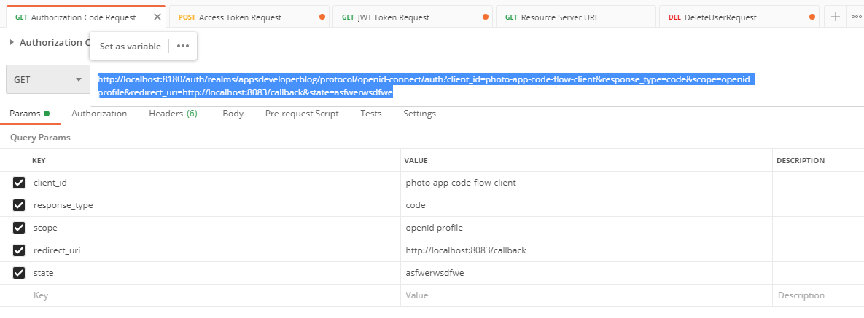

I have the code and now I will exchange it for an access token. I have my access token.

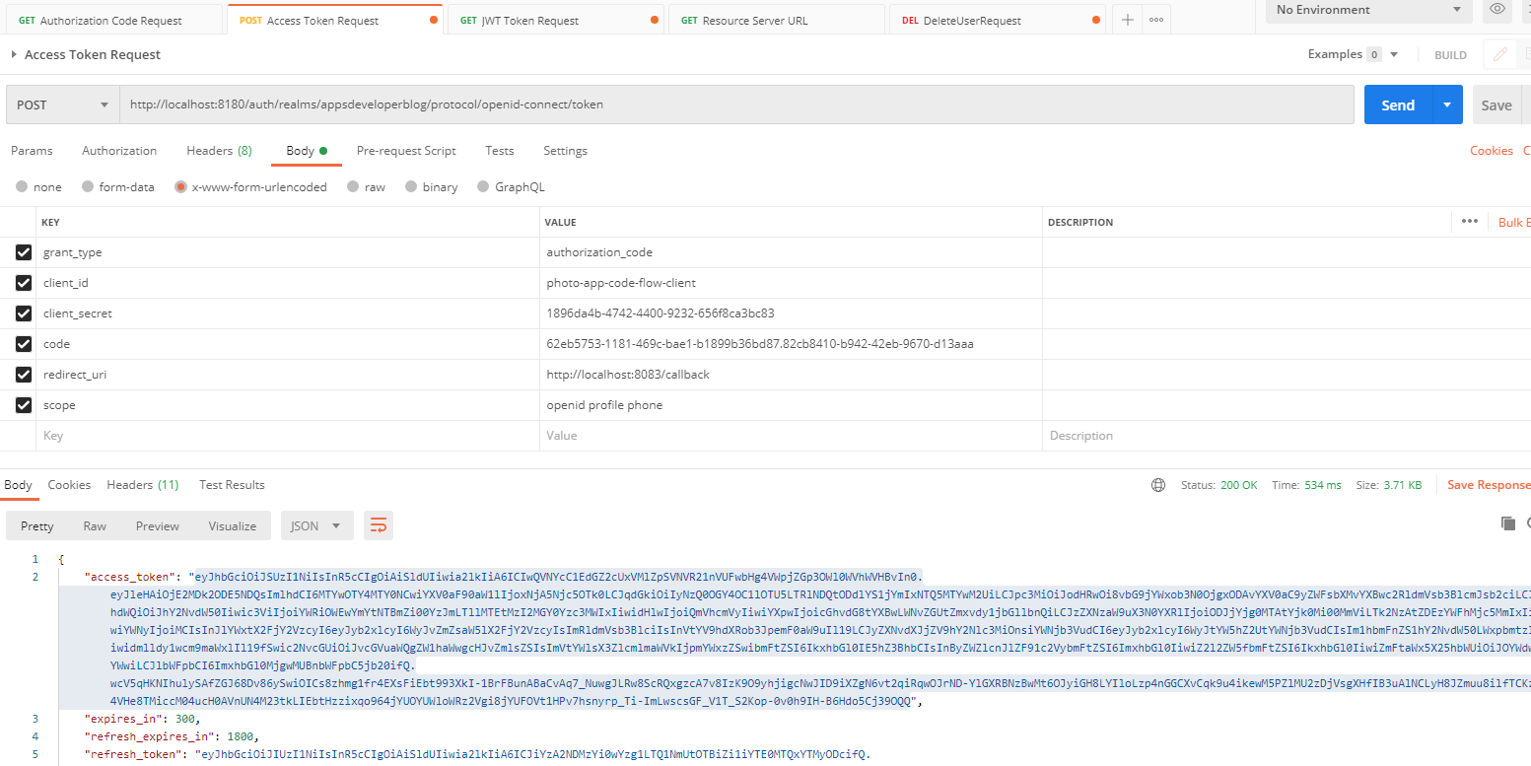

Lets use this to fire a delete request now. We will use any random id after /users as it is just going to return a message – no real business logic there. Now I will need to provide authorization headers, so I'll switch to headers and I will provide authorization header, that will need to start with the Bearer and then space and access token that have just acquired.

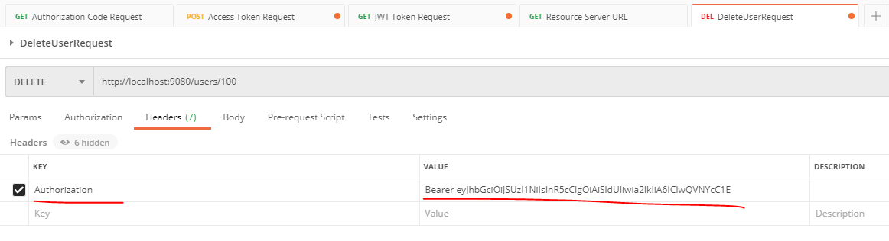

All right. So let's try sending this request. And it worked

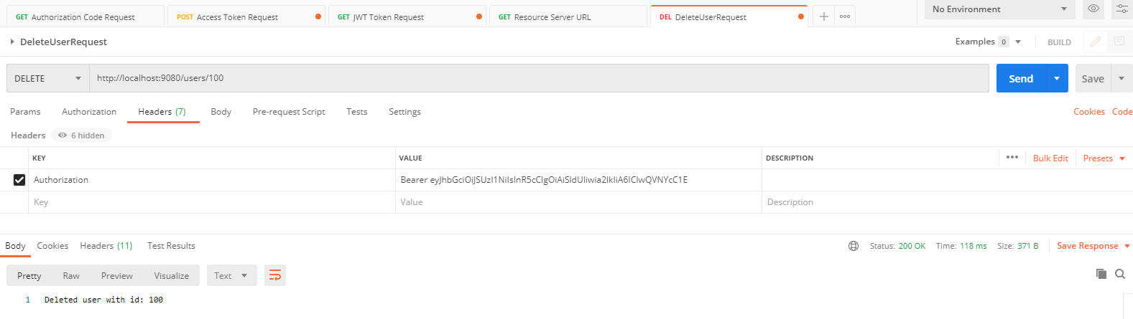

All right. So now let's go back to our controller class and let's try changing the developer of let's say it is not a developer, but some other role, for example, user. Let me save it. It will restart my resource server. And now if I try sending this request, it should not work because this request is allowed only to users who have a user role. But my access token does not contain user role. It contains a developer. So this request should be forbidden. Let me try sending it. And the request is forbidden. All right, so it is working.

package com.oauth.server.resourceserver.controllers;

import org.springframework.security.access.annotation.Secured;

import org.springframework.web.bind.annotation.DeleteMapping;

import org.springframework.web.bind.annotation.GetMapping;

import org.springframework.web.bind.annotation.PathVariable;

import org.springframework.web.bind.annotation.RequestMapping;

import org.springframework.web.bind.annotation.RestController;

@RestController

@RequestMapping("/users")

public class UsersController {

@GetMapping("/status/check")

public String status() {

return "Working...";

}

@Secured("ROLE_**user**")

@DeleteMapping(path = "/{id}")

public String deleteUser(@PathVariable String id) {

return "Deleted user with id: " + id;

}

}

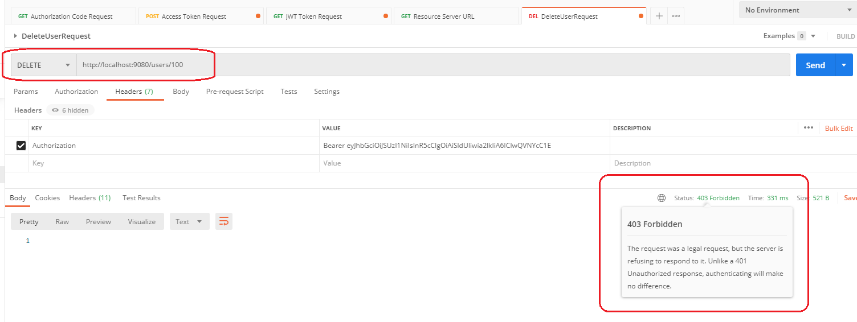

Let's bring back our developer. I'll say it again if we start our resource server and we can try sending this request, which should work. All right, so everything is working, and you now know how to use the Secured annotation and secure your web service endpoints through users who have a specific authority.

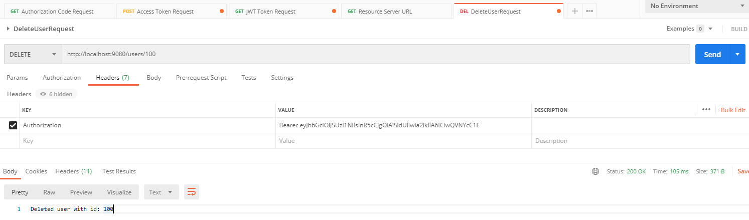

@PreAuthorized Annotation

Lets learn how the preauthorization annotation works, and we will start by enabling @PreAuthorized annotation in our application and to enable this annotation in my Springboot application, I'll go to a WebSecurity class where I have the @EnableGlobalMethodSecurity annotation and to enable the @PreAuthorization annotation we will make use of the @EnableGlobalMethodSecurity annotation one more time. I will add a comma and we'll add prePostEnabled equals true like this. And this prePostEnabled property will actually enable two annotations, one annotation called @PreAuthorize and the other annotation is called @PostAuthorize. Let's now go back to a controller class and add the annotation above the delete user method. I will comment the @Secured annotation and we will add @PreAuthorize annotation like this.

**WebSecurity.java**

package com.oauth.server.resourceserver.security;

import org.apache.commons.logging.Log;

import org.apache.commons.logging.LogFactory;

import org.springframework.http.HttpMethod;

import org.springframework.security.config.annotation.method.configuration.EnableGlobalMethodSecurity;

import org.springframework.security.config.annotation.web.builders.HttpSecurity;

import org.springframework.security.config.annotation.web.configuration.EnableWebSecurity;

import org.springframework.security.config.annotation.web.configuration.WebSecurityConfigurerAdapter;

import org.springframework.security.oauth2.server.resource.authentication.JwtAuthenticationConverter;

//@Secured

@EnableGlobalMethodSecurity(securedEnabled=true, prePostEnabled=true)

@EnableWebSecurity

public class WebSecurity extends WebSecurityConfigurerAdapter {

private final Log logger = LogFactory.getLog(WebSecurityConfigurerAdapter.class);

@Override

protected void configure(HttpSecurity http) throws Exception {

this.logger.debug("Using our custom configure method of WebSecurity");

JwtAuthenticationConverter jwtAuthenticationConverter = new JwtAuthenticationConverter();

jwtAuthenticationConverter.setJwtGrantedAuthoritiesConverter(new KeycloakRoleConverter());

http.authorizeRequests()

.antMatchers(HttpMethod.GET, "/users/status/check")

.hasRole("developer")

.anyRequest()

.authenticated()

.and()

.oauth2ResourceServer()

.jwt()

.jwtAuthenticationConverter(jwtAuthenticationConverter);

}

}

And the other information that we have just enabled is called @PostAuthorize. The difference between these two annotations is that the @PreAuthorization decides whether a method can actually be invoked or not, and if the expression that we are going to write inside the @PreAuthorization suggests that the content invoking user is not allowed to execute this method, then the method will not be invoked at all. The @PostAuthorization works slightly different. In case of post authorization, the method will be invoked and the validation security expression will take place already after the method is executed. Have a look at how the post authorization works in the later lesson. And for now, let's focus on how the @PreAuthorization annotation works. So I will delete the @PostAuthorization, we will add parentheses and then double quotes for the @PreAuthorization annotation. And inside of the double quotes here I can write an access control expression. And this is also how the @PreAuthorization annotation differs from @Secured annotation. The @PreAuthorization annotation supports this method security expressions that make our @PreAuthorize annotation much more powerful. Let's have a look at one, for example.

**UsersController.java**

package com.oauth.server.resourceserver.controllers;

import org.springframework.security.access.prepost.PostAuthorize;

import org.springframework.security.access.prepost.PreAuthorize;

import org.springframework.web.bind.annotation.DeleteMapping;

import org.springframework.web.bind.annotation.GetMapping;

import org.springframework.web.bind.annotation.PathVariable;

import org.springframework.web.bind.annotation.RequestMapping;

import org.springframework.web.bind.annotation.RestController;

@RestController

@RequestMapping("/users")

public class UsersController {

@GetMapping("/status/check")

public String status() {

return "Working...";

}

// @Secured("ROLE_developer")

@PreAuthorize("hasRole('developer')")

@DeleteMapping(path = "/{id}")

public String deleteUser(@PathVariable String id) {

return "Deleted user with id: " + id;

}

}

So instead of the double quotes, I'll write a security expression that will make my @PreAuthorization annoation work, just like the @Secured annotation currently works. Notice the difference now, the annotation allows us to write security expressions that can make use of functions like, for example, hasRole and when using the hasRole function, we do not need to use the ROLE_ prefix anymore. And this is because in case of hasRole function, Spring framework will add the ROLE_ prefix automatically for us. All right. And if we wanted to use the authority name, for example, instead, then we can write another expression that will make use of the hasAuthority function. I will do with this and will write hasAuthority. And in single quotes I need to spell out an authority name, and this time I will need to start with ROLE_ and then roll name.

//@Secured("ROLE_developer")

//@PreAuthorize("hasRole('developer')")

@PreAuthorize("hasAuthority('ROLE_developer')")

@DeleteMapping(path = "/{id}")

**public** String deleteUser(@PathVariable String id) {

**return** "Deleted user with id: " + id;

}

And now if I save and run the application, this method that handles HTTP delete request and because it is annotated with @PreAuthorization annotation and has this security expression, it will only execute if the current authenticated user has a developer role assigned to them. Let me fix a little typo and extra parenthesis. Now, I'm not going to run this application now because in the following lesson, I want to enhance the security expression a little bit. But if you want to see how the @PreAuthorization annotation works at this point, then please go ahead, run your application and give it a try.

Enhancing the Security Expression in @PreAuthorization

Lets enhance the security expression we used with the @PreAuthorization annotation, and we will also learn how to access method documents and how to access the details of authenticated principal user. All right. Let's try the security expression that allows us to execute this deleteUser method only by those users who have developer role or by a user who actually owns this user profile. So first part of the expression we already know how to write we can use hasAuthority or hasRole and then in single quotes provide a real name, which is in our case, developer. But if user doesn't have a developer role assigned to them, then we want to make sure that on the user who owns this profile is allowed to invoke this method. And the way we can do it is to make sure that the id of the currently logged in user matches the id used in the URL path.

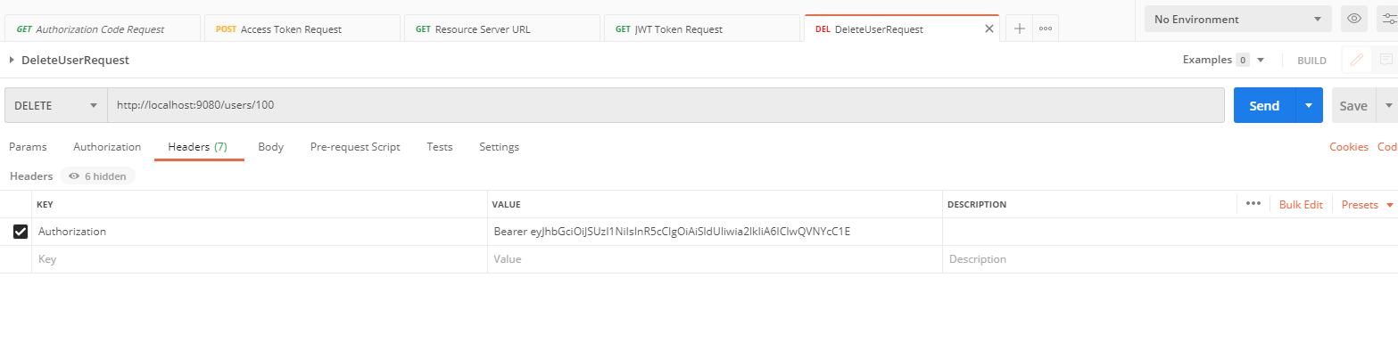

Let's have a look at the request, for that we can use to invoke this method. I'll bring my postman and then I will switch to HTTP delete request. So this is an example of HTTP delete request. I have selected delete method from the list of HTTP methods and then the URL to this web service endpoint will be the localhost port number on which my resource server is running and then the users, which is a mapping in my rest controller and then I need to provide a user id, which is an id of a resource that I want to delete. I want to delete a user with this id. So let's now go back to our code and learn how we can read this user id value from request URL and to inject it into our delete user method as an argument, we provide a path URL mapping here in the delete mapping annotation and then in the method argument we use @PathVariable annotation to specify that we want to path variable with this name. So the name of the method argument here, which is called ID, matches the path variable, which is also called id. And to make our method level security expression to read the method argument, we will need to use the number assigned and the name of the method argument that we want to use. For example, in the security expression, I can say this method is allowed to execute if currently authenticated user has a ‘developer’ role or if the method argument which is called id and I need to start the expression with the number sign, id is equal to the user id specified in the JWT token. All right. So let's decode the JWT token and see how the user id is stored there.

@RestController

@RequestMapping("/users")

**public** **class** UsersController {

@GetMapping("/status/check")

**public** String status() {

**return** "Working...";

}

// @Secured("ROLE_developer")

//@PreAuthorize("hasRole('developer')")

@PreAuthorize("hasAuthority('ROLE_developer') or #id == ")

@DeleteMapping(path = "/{id}")

**public** String deleteUser(@PathVariable String id) {

**return** "Deleted user with id: " + id;

}

}

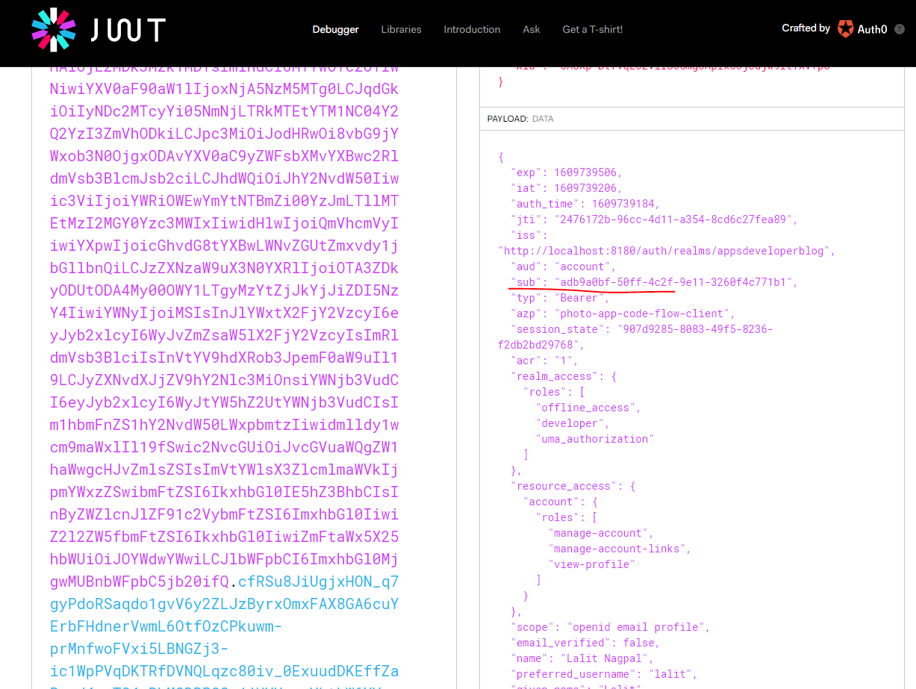

I will bring back my postman and then we'll grab the JWT token and I will decode it and we'll bring in a new browser window. And then I will go to jwt.io. And I will decode it. And on the right side here, I have the payload of my JWT access token and to find the value of user id in this JWT access token, we need to look for a key called sub, this one. The sub key stands for subject, whom the token refers to, and most of the time it is equal to user id. So from this JWT access token, we need to read the value of JWT subject. All right. So let's go back to our code and see how we can read this one. To inject the JWT object into our method as method argument, we can use a special annotation called @AuthenticationPrinciple. And then we can use the JWT object to read this subject value by calling method getSubject. So the string that this method will return, you will say delete it, use it with an I.D. and JWT subject. And then plus JWT, which is my method argument, and then .getSubject.

So now that we have JWT object injected as a method argument, we can also access it in our security expression using the number sign. So I will go back to my security expression and I will use the number sign. And then my method argument is called jwt. So I will use it here jwt. And then I will put a dot and I will access the property of this jwt object, which is called subject. All right. So this security expression will make our method execute only if the currently authenticated user is assigned a develor role or if the id path variable is equal to the user id or to the subject value specified in the JWT access token. All right. So now let's run our application and see if it works.

**import** org.springframework.security.access.prepost.PreAuthorize;

**import** org.springframework.security.core.annotation.AuthenticationPrincipal;

**import** org.springframework.security.oauth2.jwt.Jwt;

**import** org.springframework.web.bind.annotation.DeleteMapping;

**import** org.springframework.web.bind.annotation.GetMapping;

**import** org.springframework.web.bind.annotation.PathVariable;

**import** org.springframework.web.bind.annotation.RequestMapping;

**import** org.springframework.web.bind.annotation.RestController;

@RestController

@RequestMapping("/users")

**public** **class** UsersController {

@GetMapping("/status/check")

**public** String status() {

**return** "Working...";

}

// @Secured("ROLE_developer")

//@PreAuthorize("hasRole('developer')")

@PreAuthorize("hasAuthority('ROLE_developer') or #id == #jwt.subject")

@DeleteMapping(path = "/{id}")

**public** String deleteUser(@PathVariable String id, @AuthenticationPrincipal Jwt jwt) {

**return** "Deleted user with id: " + id + " and JWT subject " + jwt.getSubject();

}

}

Lets try it out

Request for Authorization Code

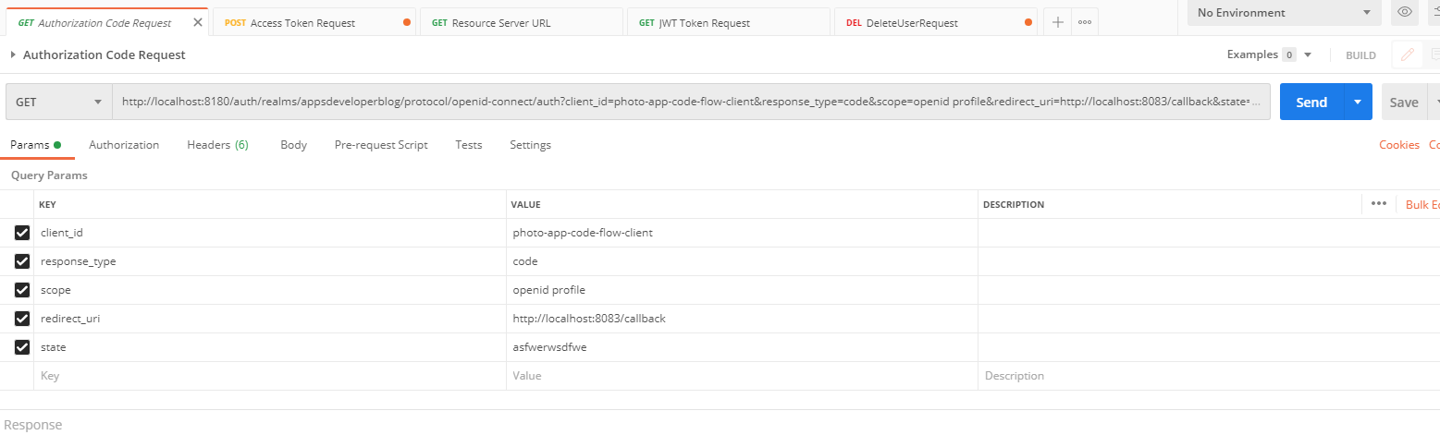

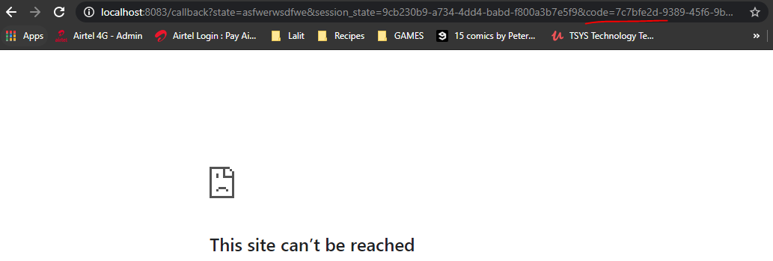

Request for Access Token

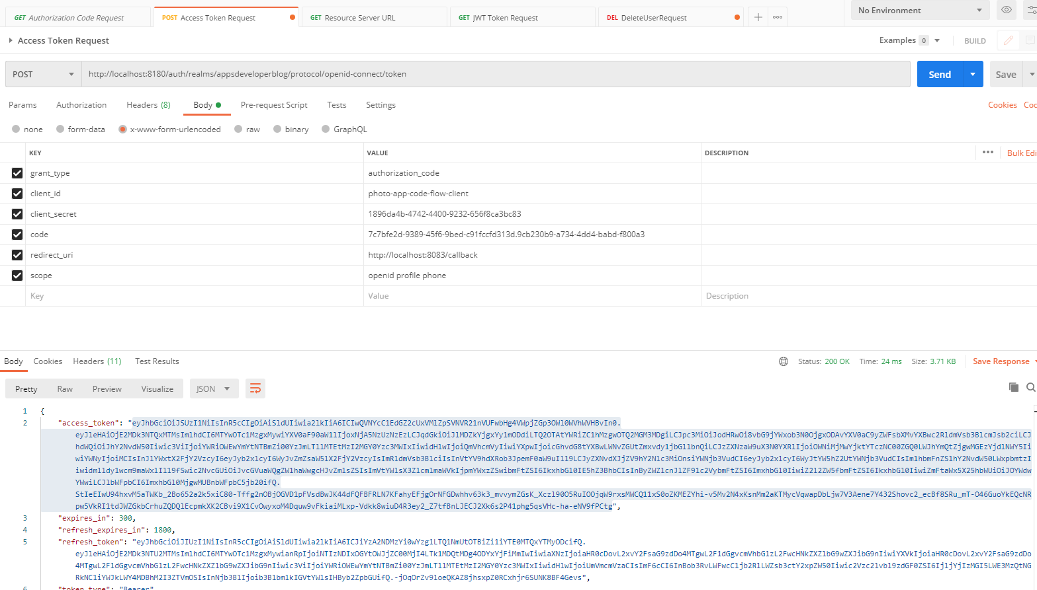

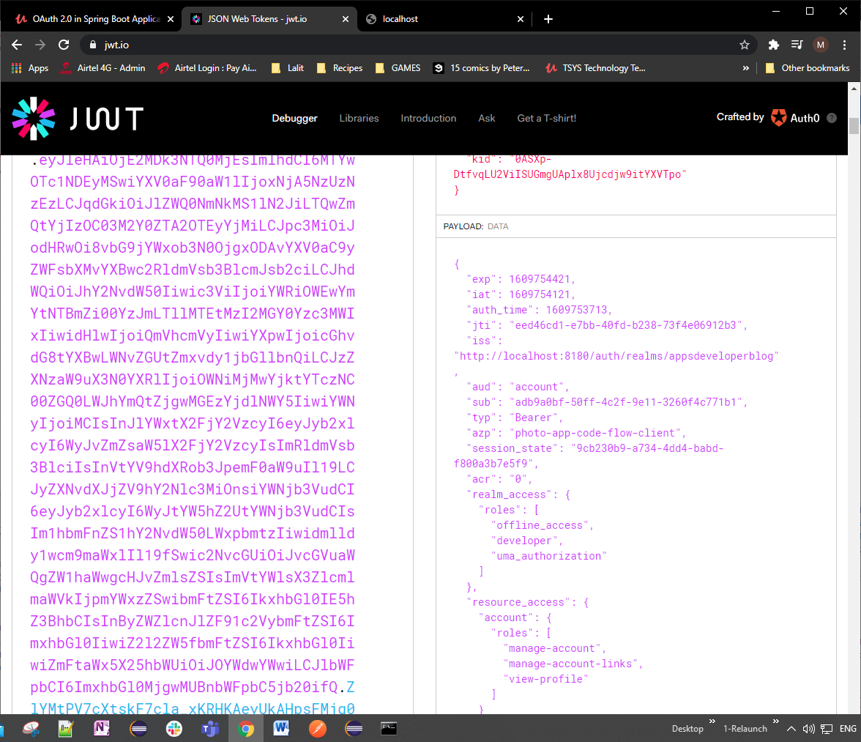

Pick up the id from sub and put that in the delete user REST call URL

Request for Delete User

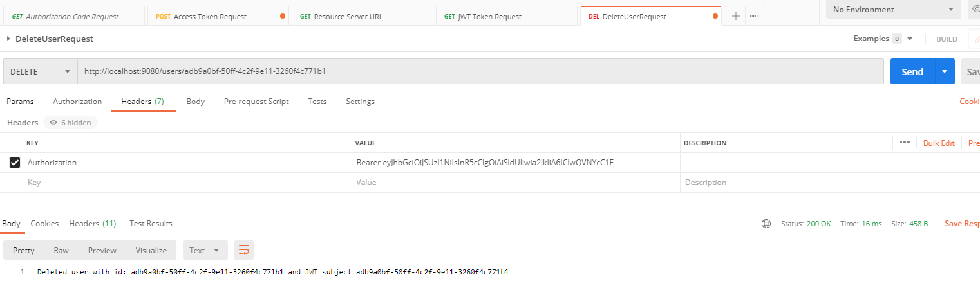

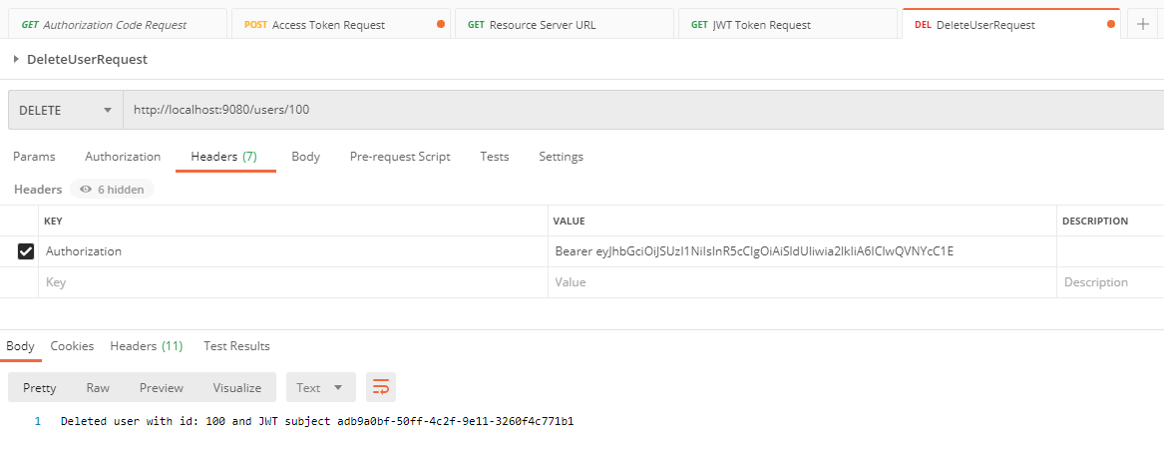

This worked even after changing the PreAuthorize role to ROLE_user, when we sent the same id as that in the Token.

import org.springframework.security.access.prepost.PreAuthorize;

import org.springframework.security.core.annotation.AuthenticationPrincipal;

import org.springframework.security.oauth2.jwt.Jwt;

import org.springframework.web.bind.annotation.DeleteMapping;

import org.springframework.web.bind.annotation.GetMapping;

import org.springframework.web.bind.annotation.PathVariable;

import org.springframework.web.bind.annotation.RequestMapping;

import org.springframework.web.bind.annotation.RestController;

@RestController

@RequestMapping("/users")

public class UsersController {

@GetMapping("/status/check")

public String status() {

return "Working...";

}

//@Secured("ROLE_developer")

//@PreAuthorize("hasRole('developer')")

@PreAuthorize("hasAuthority('ROLE_user') or #id == #jwt.subject")

@DeleteMapping(path = "/{id}")

public String deleteUser(@PathVariable String id, @AuthenticationPrincipal Jwt jwt) {

jwt.getClaims().entrySet().iterator().forEachRemaining( ks ->

System.*out*.println(ks.getKey() + " - " + ks.getValue()));

return "Deleted user with id: " + id + " and JWT subject " + jwt.getSubject();

}

}

Does not work when we don’t use the same id as in the token, example used as 100 here

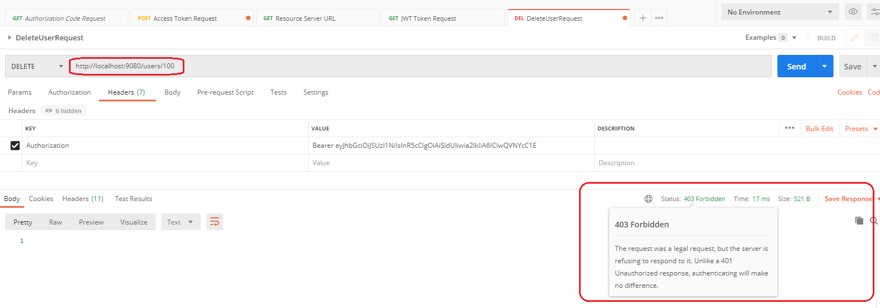

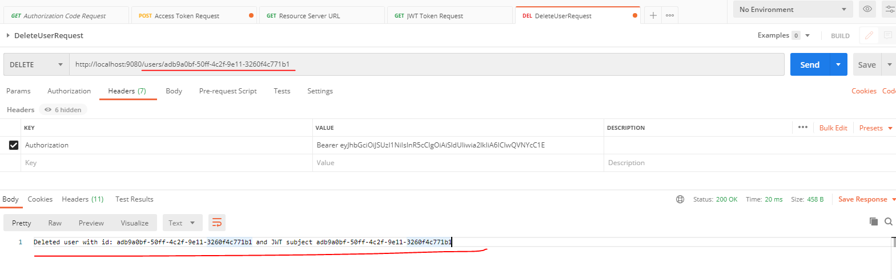

Delete the role check from @PreAuthorization annotation as follows

@RestController

@RequestMapping("/users")

public class UsersController {

@GetMapping("/status/check")

public String status() {

return "Working...";

}

// @Secured("ROLE_developer")

//@PreAuthorize("hasRole('developer')")

@PreAuthorize("~~hasAuthority('ROLE_developer') or~~ #id == #jwt.subject")

@DeleteMapping(path = "/{id}")

public String deleteUser(@PathVariable String id, @AuthenticationPrincipal Jwt jwt) {

jwt.getClaims().entrySet().iterator().forEachRemaining( ks -> System.*out*.println(ks.getKey() + "- " + ks.getValue()));

return "Deleted user with id: " + id + " and JWT subject " + jwt.getSubject();

}

}

Restart the resource server and try accessing some id other than that in the JWT Token and it should fail

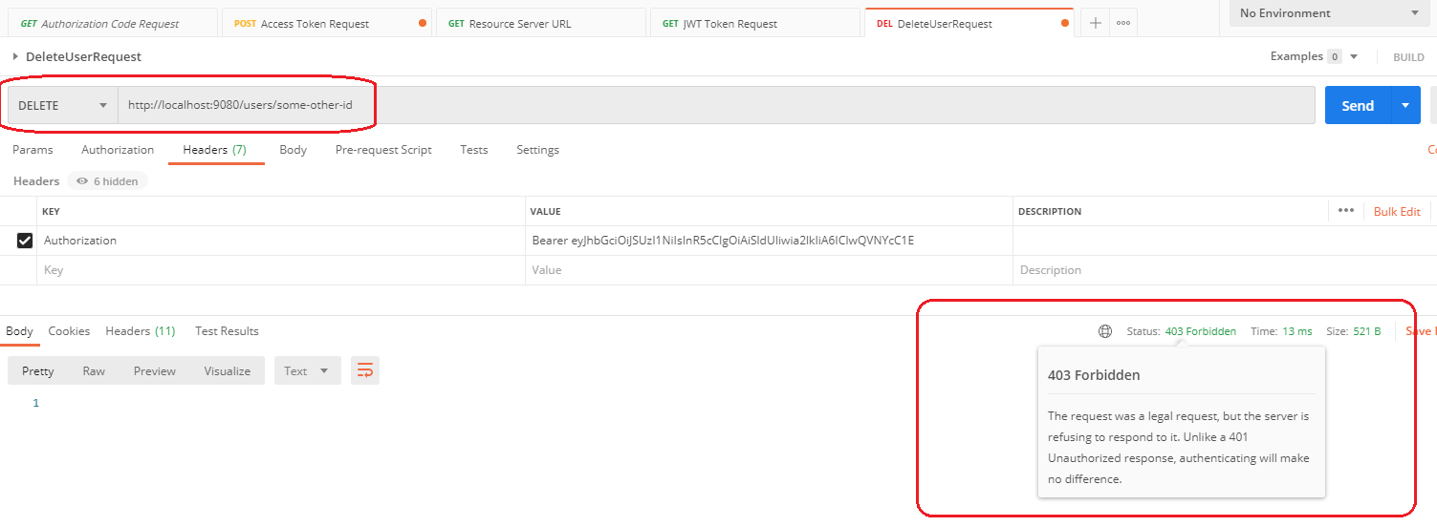

And this other code that we added printed the following

jwt.getClaims().entrySet().iterator().forEachRemaining( ks ->

System.*out*.println(ks.getKey() + " - " + ks.getValue()));

Granted Authoritites -> [ROLE_offline_access, ROLE_developer, ROLE_uma_authorization]

sub- adb9a0bf-50ff-4c2f-9e11-3260f4c771b1

resource_access- {"account":{"roles":["manage-account","manage-account-links","view-profile"]}}

email_verified- false

iss- http://localhost:8180/auth/realms/appsdeveloperblog

typ- Bearer

preferred_username- lalit

given_name- Lalit

aud- [account]

acr- 0

realm_access- {"roles":["offline_access","developer","uma_authorization"]}

azp- photo-app-code-flow-client

auth_time- 1609753713

scope- openid email profile

name- Lalit Nagpal

exp- 2021-01-04T10:09:05Z

session_state- 9cb230b9-a734-4dd4-babd-f800a3b7e5f9

iat- 2021-01-04T10:04:05Z

family_name- Nagpal

jti- 5740e91b-d867-44d0-b1bb-2d154c7468c7

email- lalit2801@gmail.com

KeycloakRoleConverted called

Granted Authoritites -> [ROLE_offline_access, ROLE_developer, ROLE_uma_authorization]

KeycloakRoleConverted called

Granted Authoritites -> [ROLE_offline_access, ROLE_developer, ROLE_uma_authorization]

sub- adb9a0bf-50ff-4c2f-9e11-3260f4c771b1

resource_access- {"account":{"roles":["manage-account","manage-account-links","view-profile"]}}

email_verified- false

iss- http://localhost:8180/auth/realms/appsdeveloperblog

typ- Bearer

preferred_username- lalit

given_name- Lalit

aud- [account]

acr- 0

realm_access- {"roles":["offline_access","developer","uma_authorization"]}

azp- photo-app-code-flow-client

auth_time- 1609753713

scope- openid email profile

name- Lalit Nagpal

exp- 2021-01-04T10:12:39Z

session_state- 9cb230b9-a734-4dd4-babd-f800a3b7e5f9

iat- 2021-01-04T10:07:39Z

family_name- Nagpal

jti- a39d0dc9-97c2-45dd-9fde-2522c819fbe5

email- [lalit2801@gmail.com](mailto:lalit2801@gmail.com)

Creating getUser() to be used with @PostAuthorize

We will create a new webservice endpoint to be used with the @PostAuthorize annotation, I have my users controller class open and here we have a deleteUser method that is used with @PreAuthorization attention. I'm not going to use @PreAuthorization with delete method that I will need to create a new one. And this is because if I use @PostAuthorization with delete user method, then the method will be first executed, the user record will be deleted and only then then the security expression will be evaluated.

So I will use @PostAuthorization with a different method that I will need to create. Let's create a very simple method that returns userDetails. Now I will need to return user details instead of returning a string only to create a user object and then return that user object. So I will come up with a new class. I will go to my resource server source/main/java folder and then I'll return a new class.

package com.oauth.server.resourceserver.response;

public class UserRest {

private String userFirstName;

private String userLastName;

private String userId;

public UserRest(String userFirstName, String userLastName, String userId) {

this.userFirstName = userFirstName;

this.userLastName = userLastName;

this.userId = userId;

}

public String getUserFirstName() { return userFirstName; }

public void setUserFirstName(String userFirstName) { this.userFirstName = userFirstName; }

public String getUserLastName() { return userLastName; }

public void setUserLastName(String userLastName) { this.userLastName = userLastName; }

public String getUserId() { return userId; }

public void setUserId(String userId) { this.userId = userId; }

}

Lets return the UserRest instance from the getUser method now instead of the hard coded String

@RestController

@RequestMapping("/users")

public class UsersController {

@GetMapping("/status/check")

public String status() {

return "Working...";

}

@PreAuthorize("#id == #jwt.subject")

@DeleteMapping(path = "/{id}")

public String deleteUser(@PathVariable String id, @AuthenticationPrincipal Jwt jwt) {

return "Deleted user with id: " + id + " and JWT subject " + jwt.getSubject();

}

@GetMapping(path = "/{id}")

public UserRest getUser(@PathVariable String id, @AuthenticationPrincipal Jwt jwt) {

return new UserRest("Lalit", "Nagpal", "");

}

}

In the WebSecurity class we had enabled both @PreAuthorization and @PostAuthorization using the annotation with prePostEnabled = true

package com.oauth.server.resourceserver.security;

import org.apache.commons.logging.Log;

import org.apache.commons.logging.LogFactory;

import org.springframework.http.HttpMethod;

import org.springframework.security.config.annotation.method.configuration.EnableGlobalMethodSecurity;

import org.springframework.security.config.annotation.web.builders.HttpSecurity;

import org.springframework.security.config.annotation.web.configuration.EnableWebSecurity;

import org.springframework.security.config.annotation.web.configuration.WebSecurityConfigurerAdapter;

import org.springframework.security.oauth2.server.resource.authentication.JwtAuthenticationConverter;

//@Secured

@EnableGlobalMethodSecurity(securedEnabled=true, prePostEnabled=true)

@EnableWebSecurity

public class WebSecurity extends WebSecurityConfigurerAdapter {

private final Log logger = LogFactory.getLog(WebSecurityConfigurerAdapter.class);

@Override

protected void configure(HttpSecurity http) throws Exception {

this.logger.debug("Using our custom configure method of WebSecurity");

JwtAuthenticationConverter jwtAuthenticationConverter = new JwtAuthenticationConverter();

jwtAuthenticationConverter.setJwtGrantedAuthoritiesConverter(new KeycloakRoleConverter());

http.authorizeRequests()

.antMatchers(HttpMethod.GET, "/users/status/check")

.hasRole("developer")

.anyRequest()

.authenticated()

.and()

.oauth2ResourceServer()

.jwt()

.jwtAuthenticationConverter(jwtAuthenticationConverter);

}

}

The @PostAuthorization annotation has an access to a return object, which in our case, userRest. And to access the returned object and the security expression, we will use a reserved keyword for it that is called returnObject, and then we can access any properties of this object. And because this method returns an object of userRest type, I know that it has property user id because if I go into a userRest, it has a property userID, userFirstName and userLastName so I can access userID from return home, checked like this. And now I will need to compare these value of users to a user ID value that the JWT access token contains so add == sign. And we already know how to access user ID value that is inside of our JWT token. To do that, I will use the number assigned and then I will access the JWT object, which is available as a method argument in our case using a method here. And then I will access the property of my JWT object, which is called subject, because subject is most of the time user id and this is it. So now we have an example of our little getUser method ready and let's run our application and let's see the security expression in this @PostAuthorization works.

Because we are hard coding the user details values that the user method returns. And I do not read user details from an actual users database before running this application, I'll need to acquire an access token and then look up the user and the value that it contains and put it into my userRest object here. So let's get an access token first. I'll bring up my postman. I will switch to a request to request an authorization code, I will copy the request and I will bring up a new browser window. Now I'll need to authenticate. And the indication is successful and I have my authorization code, I will copy it and I will exchange it for an access token. Send the request and the request is successful. I have my access token, I will copy it and now I will debug this access token. I'll bring up a new browser window. And we'll open JWT, I hope, and we'll look up a user id, that this access token contains, so I will place the value of my access token on on the right side here. I will look up for a field that is called subject. So this is the user id, that this access token contains. I will copy it. And now I will go back to my project and I will paste user id here so that my userRest object contains the value of user ID and it can be compared here. All right. So now I will save this changes and I will start up my resource server.

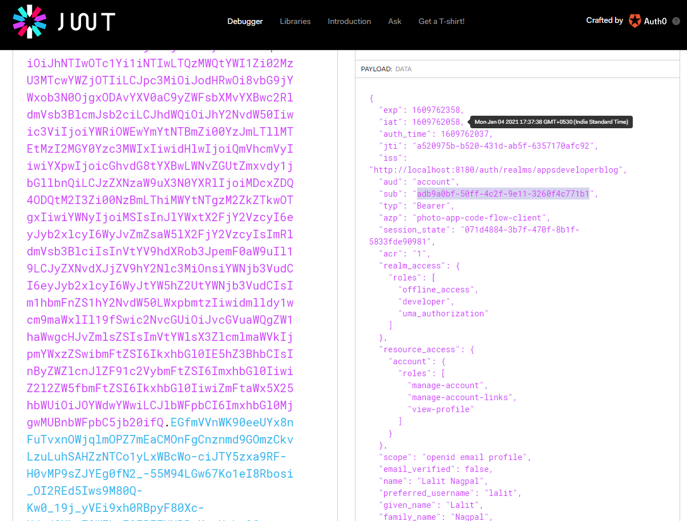

My resource server is up again, I will go back to postmen and get the authorization code and then using that create the access token. We will put the access token with Bearer <access-token> in the headers as Autorization. All right. So now let's send this request. And it worked, I got back a response that contains user details and correct user ID.

package com.oauth.server.resourceserver.controllers;

import org.springframework.security.access.prepost.PostAuthorize;

import org.springframework.security.access.prepost.PreAuthorize;

import org.springframework.security.core.annotation.AuthenticationPrincipal;

import org.springframework.security.oauth2.jwt.Jwt;

import org.springframework.web.bind.annotation.DeleteMapping;

import org.springframework.web.bind.annotation.GetMapping;

import org.springframework.web.bind.annotation.PathVariable;

import org.springframework.web.bind.annotation.RequestMapping;

import org.springframework.web.bind.annotation.RestController;

import com.oauth.server.resourceserver.response.UserRest;

@RestController

@RequestMapping("/users")

public class UsersController {

@GetMapping("/status/check")

public String status() {

return "Working...";

}

@PreAuthorize("#id == #jwt.subject")

@DeleteMapping(path = "/{id}")

public String deleteUser(@PathVariable String id, @AuthenticationPrincipal Jwt jwt) {

return "Deleted user with id: " + id + " and JWT subject " + jwt.getSubject();

}

@PostAuthorize("returnObject.userId == #jwt.subject")

@GetMapping(path = "/{id}")

public UserRest getUser(@PathVariable String id, @AuthenticationPrincipal Jwt jwt) {

return new UserRest("Lalit", "Nagpal", "adb9a0bf-50ff-4c2f-9e11-3260f4c771b1");

}

}

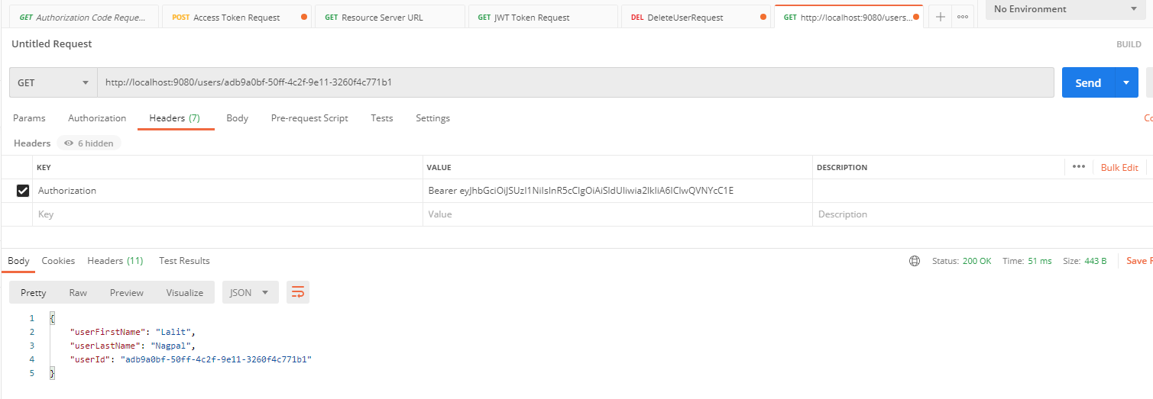

Now, if I change user id, that the user restObject is going to return. If I delete a couple of characters from here ( from the instance of userRequest that we are creating since we are comparing the userRest.id with the JWT user id), then security expression should validate to false because the value of user id that this return object contains will not be equal to the value of user id that JWT access token contains. All right. Now I have saved changes. My resource server has restarted and I'll go back to postmen and I will repeat this kids request. And here we go. The request is forbidden.

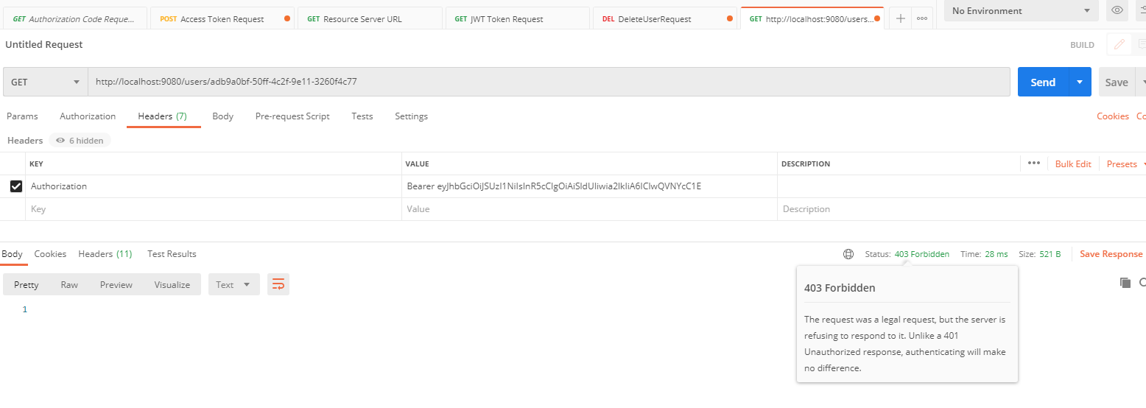

All right, so if I go back to my project and if I want the two characters I have deleted from the user, I'd say with my research server will restart. And now I can repeat the request and the request will be authorized. I think that's all right, so it is working and you now know how to @PostAuthorization annotation to protect your webservice endpoints.

## Resource Server behind API Gateway

We will learn how to put multiple resources behind a single API Gateway. Until now, we have considered an architecture in which we have a user who is using a client application, client application redirects user to identity provider server so the user can authenticate with it and acquire and access token. Then the client application will use this access token to communicate with the resource server to perform an operation on user's behalf. And this architecture, we have a single resource server, but in modern applications there can be more than one resource server. Each resource server is a small and standalone Spring boot application that is running on its own port number. One resource server can be running on port number eighty one eighty one. Another resource server will be right on port number 8180, for example, and another resource server will be running on Port 8093 in more than 10 applications. This small standalone resource servers are known as micro services. And if one Microservice is overloaded with traffic or goes down, for example, then additional micro services can be started to help our application continue to work and still respond to incoming requests. And this brings us to another architecture.

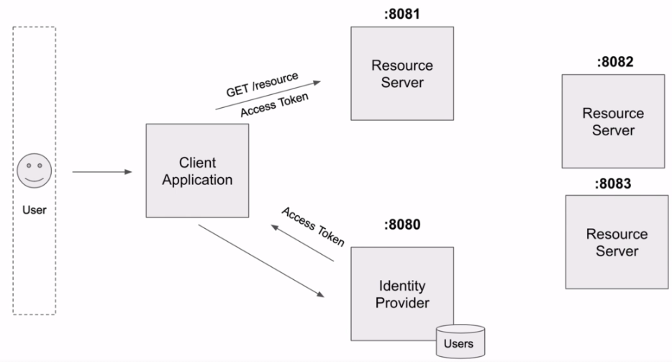

When Server side Application has multiple resource servers or multiple micro services, these micro services are placed behind an API gateway. An API Gateway, then acts as a single point of entry to our many micro services. And a client application does not need to deal with many different port numbers. If our API gateway is running on point 80, for example, then a client application will be communicating with our micro services via a single port at the API. Gateway will receive http requests and it will route it to a destination microservices. There are many different gateways available on the market and they can be configured in many different ways. And in the following lessons, I'm going to use Spring Cloud API Gateway and it will be a very basic configuration. At this time my API gateway will simply route any income http requests to a destination Microservice.

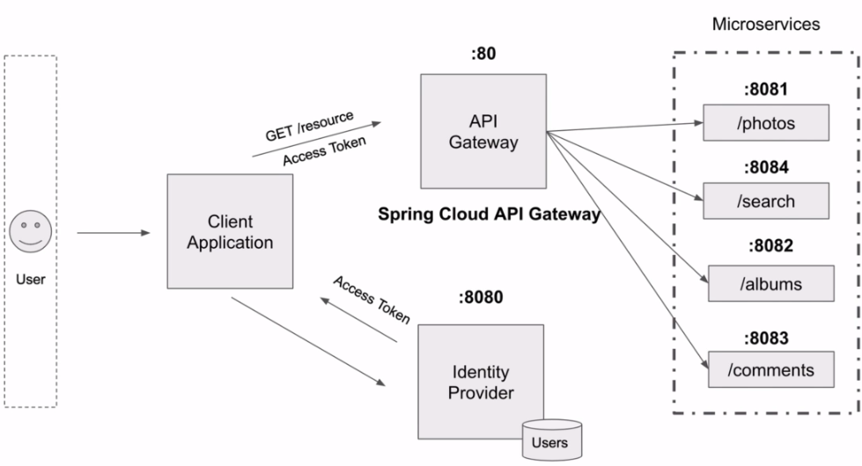

And in later lessons you will learn how to configure API Gateway to work with a Discovery Service and to do load balancing to equally distribute requests between multiple instances of running micro services. One important point to mention here is that my identity server, will not be running behind an API gateway. So to acquire an access token, my client application will need to communicate directly with an identity provider server. But if needed, you can design your system the way when an identity provider server also runs behind an API gateway. But at this moment we will configure only our micro services to be behind an API and gateway. This will help our application still work and still respond to http requests, even if one of running microservices goes down.

So here's how our architecture will work once we included the Spring Cloud API Gateway. We will have six participants and we have a user on the left side. Next, we have a client application than we have for a Spring Cloud API Gateway. Then we have Identity Provider server. And then we have a couple of Spring Boot micro services. And each Microservice will be configured as a Spring Boot resource server. The flow will start with user requesting a resource using a client application. Now, depending on the type of client application, I'll need to use a relevant to a client application OAuth authorization flow. I do not have a website or mobile application created at this moment. So to demonstrate how my micro services that are behind an API Gateway work via the authorization server, I will use Postman as a client application and to acquire an access token, I will use OAuth password grant type so a client application will need to communicate with a destination my services via an API Gateway. It will send the request to a Microservice A via the API Gateway. Spring cloud gateway will receive this request and it will route this request to Microservice A.

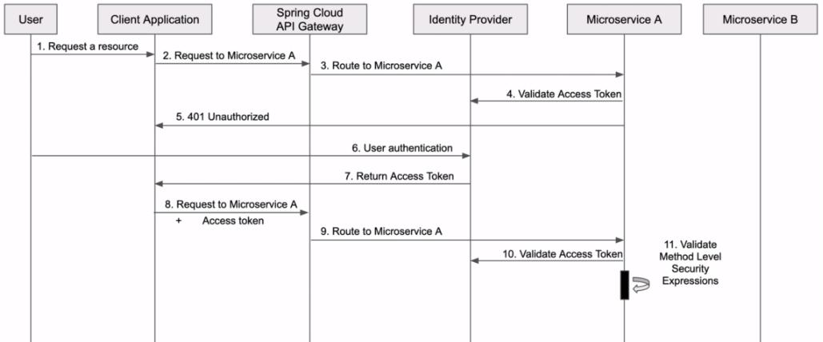

Microservice A will be configured as a resource server that validates provided access token with an identity provider. If access token is invalid or is not provided, user will get back 401 unauthorized status code in response. For a client application to acquire access token from an identity provider server, it will need to perform one of our authorization flows and during these steps user will need to authenticate. Once the user authentication is performed using either authorization code grant type or password gramt type, my client application will get back in response an access token. So now when the client application has an access token, it will send the request to Microservice A again but this time it will include an access token and authorization header. Spring Cloud API Gateway will route this request to Microservice A. Microservice A will try to validate access token with identity provider. And if identity provider successfully validates access token, then MicroService can process the request and perform more granular authorization by running method level security expressions and check user for whom this access token is issued, does have an authority to perform the requested operation. And if all is good, the request will be processed and operation will be performed and then our Microservice will return back a response.

## Spring Cloud API Gateway

Spring Cloud Gateway features:

* Built on Spring Framework 5, Project Reactor and Spring Boot 2.0
* Able to match routes on any request attribute.
* Predicates and filters are specific to routes.
* Circuit Breaker integration.
* Spring Cloud DiscoveryClient integration
* Easy to write Predicates and Filters
* Request Rate Limiting
* Path Rewriting

@SpringBootApplication

public class DemogatewayApplication {

@Bean

public RouteLocator customRouteLocator(RouteLocatorBuilder builder) {

return builder.routes()

.route("path_route", r -> r.path("/get")

.uri("http://httpbin.org"))

.route("host_route", r -> r.host("*.myhost.org")

.uri("http://httpbin.org"))

.route("rewrite_route", r -> r.host("*.rewrite.org")

.filters(f -> f.rewritePath("/foo/(?<segment>.*)", "/${segment}"))

.uri("http://httpbin.org"))

.route("hystrix_route", r -> r.host("*.hystrix.org")

.filters(f -> f.hystrix(c -> c.setName("slowcmd")))

.uri("http://httpbin.org"))

.route("hystrix_fallback_route", r -> r.host("*.hystrixfallback.org")

.filters(f -> f.hystrix(c -> c.setName("slowcmd").

setFallbackUri("forward:/hystrixfallback")))

.uri("http://httpbin.org"))

.route("limit_route", r -> r

.host("*.limited.org").and().path("/anything/**")

.filters(f -> f.requestRateLimiter(c -> c.setRateLimiter(redisRateLimiter())))

.uri("http://httpbin.org"))

.build();

}

}

More details here:

<https://spring.io/guides/gs/gateway/>

<https://docs.spring.io/spring-cloud-gateway/docs/3.0.0-SNAPSHOT/reference/html/>

We are going to create a new Spring Boot project using start.spring.io.

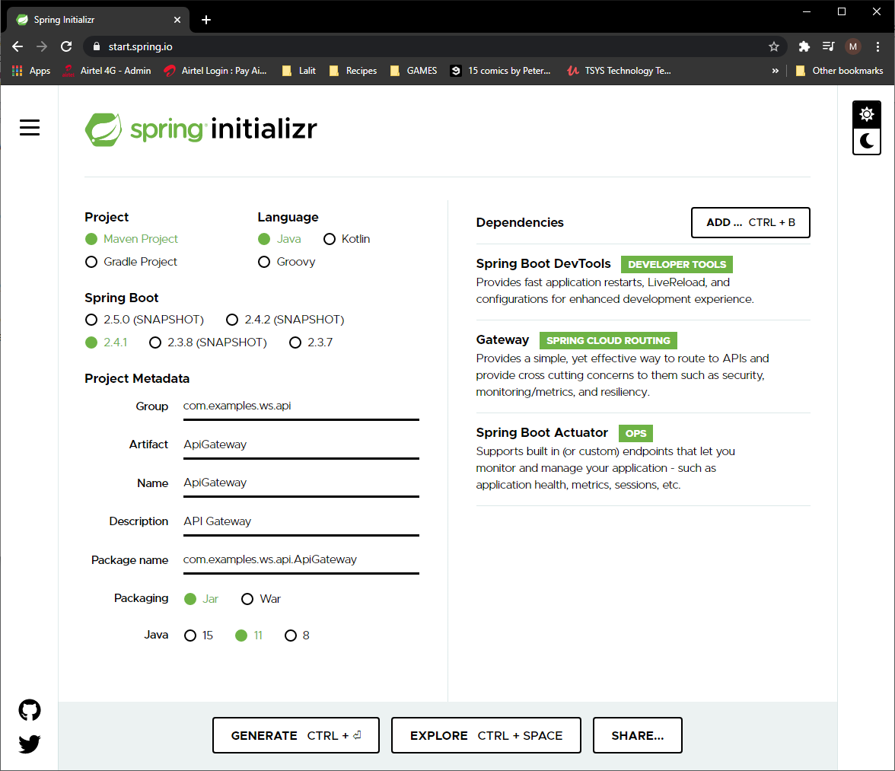

All right. So project is ready to be generated and then when your spring cloudy gateway project is downloaded as a zip, import it to Eclipse. So I have two projects now a resource server and spring cloud api gateway next to each other.

Lets learn how to configure a route in Spring Cloud API Gateway, and by configuring a route, we tell spring cloud api gateway to route a request to a destination resource server or a microservice that is running behind the Spring Cloud API Gateway. To configure our spring cloud API Gateway we will open application.properties file. And as a first configuration property, I'll provide the port number on which I want my spring cloud api gateway to run. Otherwise it will start up on a default port number, which will be 80 and it is already taken. So to configure server port number on which I want my Spring Cloud API Gateway to run, I will use this server port property. I will eventually make my API Gateway run on Port 8080, but during the development time, I usually give it a different port number and currently the default port number 8080 is taken by my authorization server and the port number 8181 is taken by my resource server. So I will make my API Gateway run on port number 8182 and if you like, you can make your applications run on different port numbers. Later, I will also make my resource server, for example, start up on the random port number rather than on a fixed port number at 8180. But for now, I'll keep things as it is and I will start my API gateway on port 8082.

Like this, and because Spring Cloud API Gateway can have more than one routes in square brackets, we will need to provide an index of route, for example, zero. So it's like an array of objects and the first index in an array is zero. And when we need to configure a second round, I will make this index one and for the next route on my index to hold it. So it will start with zero and the first property that I will need to configure is route id and as a value, I'll give it the name that will describe a certain point that I want a request to be routed to. For example, if this route is to have a web service end point that is called /albums, then I will give it a name albums. At this moment I do not have a working album service, but I do have a few sample of certain end points that we have created. For example, we have a certain point called /users/status/check. It is a demo webservice endpoint that we have created. It doesn't do anything, just returns a string value. So for this web service endpoint, I'll create a endpoint that is called users-status-check, something like this. The next route property is URI. And here we need to provide a URI to our website. At some point it can be a URI under which this resource server is registered to a discovery service. And we'll talk about Discovery serious a bit later. And it can be an IP address or hostname of the destination web series end point. For example, HTTP localhost port number on which my resource server or mciro service is running. I have my resource server running on port 8180 and the next route property is called predicates. There can be more than one predicate. So in the square brackets I will also provide an index of the first predicate and these are Java eight predicates and they will be used to match http request using headers or methods and then route the request to a destination. You're right. It's like an if statement. If condition matches, then route this request to destination. You're right. And for this example, I will use a path predicate that will be equal to /users/status/check.

**application.properties**

server.port=8082

spring.cloud.gateway.routes[0].id = users-status-check

spring.cloud.gateway.routes[0].uri = http://localhost:8180

spring.cloud.gateway.routes[0].predicates[0] = Path=/users/status/check

spring.cloud.gateway.routes[0].predicates[1] = Method=GET

spring.cloud.gateway.routes[0].filters[0] = RemoveRequestHeader=Cookie

So with this predicate, if the request path matches the /users/status/check, then my Spring Cloud API gateway will route this http request to the destination URI which is in this case will be starting from http://localhost:8180/users/status/check. All right. And we can also create another predicate. I will copy this and paste, and that's going to be my second predicate. So I will use one equals and this time I will use method predicate that will be equal to HTTP GET. Now after adding this predicate the Spring Cloud API Gateway will route the HTTP requests only if both conditions are true. If the request path matches the users status check and if the HTTP method that is used is HTTP GET. If I send it as a post request then my Spring Cloud API Gateway will not route this request. All right. And then there are different filters that can be applied when a routing requests via API Gateway. I will use filters, and filters is also a list, so I will use square brackets and then provide index of a very first filter equals. And one of the filters that we can apply is to remove all user cookies. Downstream Microservices might not need user cookies at all and all, they need JWT access token so we can apply a filter that removes the request header called cookie. Like this, all right, so this is a very simple example of a route configuration, there can be other filters applied and there can be other routes created. But for this simple use case, the route configuration we have created is enough. Let's try a run in this application and see if it works.

pom.xml

<?xml version="1.0" encoding="UTF-8"?>

<project xmlns="http://maven.apache.org/POM/4.0.0" xmlns:xsi="http://www.w3.org/2001/XMLSchema-instance"

xsi:schemaLocation="http://maven.apache.org/POM/4.0.0 https://maven.apache.org/xsd/maven-4.0.0.xsd">

<modelVersion>4.0.0</modelVersion>

<parent>

<groupId>org.springframework.boot</groupId>

<artifactId>spring-boot-starter-parent</artifactId>

<version>2.4.1</version>

<relativePath/> <!-- lookup parent from repository -->

</parent>

<groupId>com.examples.ws.api</groupId>

<artifactId>4-api-gateway</artifactId>

<version>0.0.1-SNAPSHOT</version>

<name>4-api-gateway</name>

<description>4-api-gateway</description>

<properties>

<java.version>11</java.version>

<spring-cloud.version>2020.0.0</spring-cloud.version>

</properties>

<dependencies>

<dependency>

<groupId>org.springframework.boot</groupId>

<artifactId>spring-boot-starter-actuator</artifactId>

</dependency>

<dependency>

<groupId>org.springframework.cloud</groupId>

<artifactId>spring-cloud-starter-gateway</artifactId>

</dependency>

<dependency>

<groupId>org.springframework.boot</groupId>

<artifactId>spring-boot-devtools</artifactId>

<scope>runtime</scope>

<optional>true</optional>

</dependency>

<dependency>

<groupId>org.springframework.boot</groupId>

<artifactId>spring-boot-starter-test</artifactId>

<scope>test</scope>

</dependency>

</dependencies>

<dependencyManagement>

<dependencies>

<dependency>

<groupId>org.springframework.cloud</groupId>

<artifactId>spring-cloud-dependencies</artifactId>

<version>${spring-cloud.version}</version>

<type>pom</type>

<scope>import</scope>

</dependency>

</dependencies>

</dependencyManagement>

<build>

<plugins>

<plugin>

<groupId>org.springframework.boot</groupId>

<artifactId>spring-boot-maven-plugin</artifactId>

</plugin>

</plugins>

</build>

<repositories>

<repository>

<id>spring-milestones</id>

<name>Spring Milestones</name>

<url>https://repo.spring.io/milestone</url>

</repository>

</repositories>

</project>

Before running this make sure that the authorization keycloak server ( running on port # 8180 ) and the Resource server ( running on port # 9080 ) both are is running.

. ____ _ __ _ _

/\\ / ___'_ __ _ _(_)_ __ __ _ \ \ \ \

( ( )\___ | '_ | '_| | '_ \/ _` | \ \ \ \

\\/ ___)| |_)| | | | | || (_| | ) ) ) )

' |____| .__|_| |_|_| |_\__, | / / / /

=========|_|==============|___/=/_/_/_/

:: Spring Boot :: (v2.4.1)

2021-01-05 07:55:26.046 INFO 12468 --- [ restartedMain] c.e.w.a.A.ApiGatewayApplication : Starting ApiGatewayApplication using Java 14 on DESKTOP-PEI24P3 with PID 12468 (D:\2-Workspace\Spring-OAuth\spring-oauth-2\4-api-gateway\target\classes started by Dimpu in D:\2-Workspace\Spring-OAuth\spring-oauth-2\4-api-gateway)

2021-01-05 07:55:26.049 INFO 12468 --- [ restartedMain] c.e.w.a.A.ApiGatewayApplication : No active profile set, falling back to default profiles: default

2021-01-05 07:55:26.104 INFO 12468 --- [ restartedMain] .e.DevToolsPropertyDefaultsPostProcessor : Devtools property defaults active! Set 'spring.devtools.add-properties' to 'false' to disable

2021-01-05 07:55:26.104 INFO 12468 --- [ restartedMain] .e.DevToolsPropertyDefaultsPostProcessor : For additional web related logging consider setting the 'logging.level.web' property to 'DEBUG'

2021-01-05 07:55:27.116 INFO 12468 --- [ restartedMain] o.s.cloud.context.scope.GenericScope : BeanFactory id=e1994ccb-e321-37e2-96c6-1d7c4c0a8c49

2021-01-05 07:55:27.974 INFO 12468 --- [ restartedMain] o.s.c.g.r.RouteDefinitionRouteLocator : Loaded RoutePredicateFactory [After]

2021-01-05 07:55:27.975 INFO 12468 --- [ restartedMain] o.s.c.g.r.RouteDefinitionRouteLocator : Loaded RoutePredicateFactory [Before]

2021-01-05 07:55:27.975 INFO 12468 --- [ restartedMain] o.s.c.g.r.RouteDefinitionRouteLocator : Loaded RoutePredicateFactory [Between]

2021-01-05 07:55:27.975 INFO 12468 --- [ restartedMain] o.s.c.g.r.RouteDefinitionRouteLocator : Loaded RoutePredicateFactory [Cookie]

2021-01-05 07:55:27.975 INFO 12468 --- [ restartedMain] o.s.c.g.r.RouteDefinitionRouteLocator : Loaded RoutePredicateFactory [Header]

2021-01-05 07:55:27.975 INFO 12468 --- [ restartedMain] o.s.c.g.r.RouteDefinitionRouteLocator : Loaded RoutePredicateFactory [Host]

2021-01-05 07:55:27.975 INFO 12468 --- [ restartedMain] o.s.c.g.r.RouteDefinitionRouteLocator : Loaded RoutePredicateFactory [Method]

2021-01-05 07:55:27.975 INFO 12468 --- [ restartedMain] o.s.c.g.r.RouteDefinitionRouteLocator : Loaded RoutePredicateFactory [Path]

2021-01-05 07:55:27.975 INFO 12468 --- [ restartedMain] o.s.c.g.r.RouteDefinitionRouteLocator : Loaded RoutePredicateFactory [Query]

2021-01-05 07:55:27.975 INFO 12468 --- [ restartedMain] o.s.c.g.r.RouteDefinitionRouteLocator : Loaded RoutePredicateFactory [ReadBody]

2021-01-05 07:55:27.975 INFO 12468 --- [ restartedMain] o.s.c.g.r.RouteDefinitionRouteLocator : Loaded RoutePredicateFactory [RemoteAddr]

2021-01-05 07:55:27.975 INFO 12468 --- [ restartedMain] o.s.c.g.r.RouteDefinitionRouteLocator : Loaded RoutePredicateFactory [Weight]

2021-01-05 07:55:27.975 INFO 12468 --- [ restartedMain] o.s.c.g.r.RouteDefinitionRouteLocator : Loaded RoutePredicateFactory [CloudFoundryRouteService]

2021-01-05 07:55:28.335 INFO 12468 --- [ restartedMain] o.s.b.a.e.web.EndpointLinksResolver : Exposing 2 endpoint(s) beneath base path '/actuator'

2021-01-05 07:55:28.474 INFO 12468 --- [ restartedMain] o.s.b.d.a.OptionalLiveReloadServer : LiveReload server is running on port 35729

2021-01-05 07:55:28.672 INFO 12468 --- [ restartedMain] o.s.b.web.embedded.netty.NettyWebServer : Netty started on port(s): 8182

2021-01-05 07:55:28.887 INFO 12468 --- [ restartedMain] c.e.w.a.A.ApiGatewayApplication : Started ApiGatewayApplication in 3.297 seconds (JVM running for 3.875)

Lets access the /users/status/check endpoint via the URL of the API Gateway, so that it can route the request

<http://localhost:8182/users/status/check> ( API Gateway is running on port # 8182 )

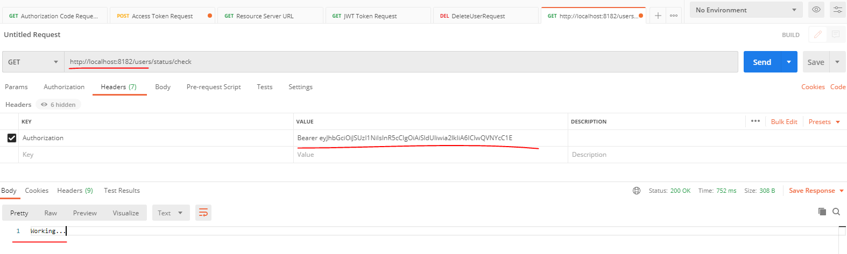

If we make a change to the predicate then the URL from the API Gateway will not match the URL and the request will fail.

**application.properties**

server.port=8082

spring.cloud.gateway.routes[0].id = users-status-check

spring.cloud.gateway.routes[0].uri = http://localhost:8180

spring.cloud.gateway.routes[0].predicates[0] = Path=/users/status/chk

spring.cloud.gateway.routes[0].predicates[1] = Method=GET

spring.cloud.gateway.routes[0].filters[0] = RemoveRequestHeader=Cookie

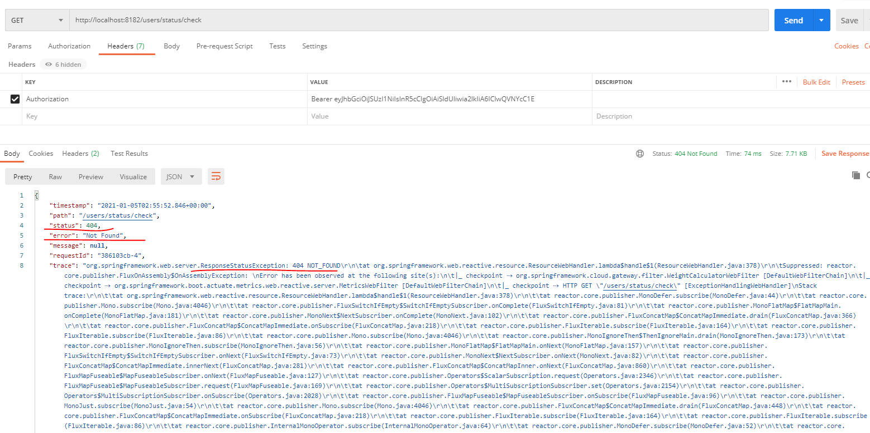

### Multiple Resource Server

To demonstrate how to make our sprinklered API gateway routing requests to different research servers, we have created two more projects that are very simple and are very similar to the resource server that we already have.

photos-resource-server code

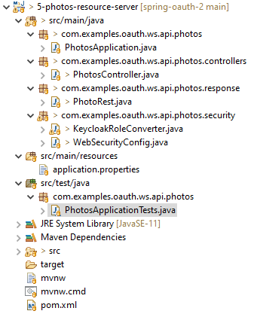

If I open the application properties file here, I have defined a custom port number. Now, the Photos resource server will start up on port at 8090 and then I have defined a couple of configuration properties that are related to resource server, communicating with my authorization server. I'm not going to discuss them now because we have already discussed both of these properties earlier.

**application.properties**

server.port = 8090

**PhotosApplication.java**

package com.examples.oauth.ws.api.photos;

import org.springframework.boot.SpringApplication;

import org.springframework.boot.autoconfigure.SpringBootApplication;

@SpringBootApplication

public class PhotosApplication {

public static void main(String[] args) {

SpringApplication.run(PhotosApplication.class, args);

}

}

**WebSecurityConfig.java**

package com.examples.oauth.ws.api.photos.security;

import org.springframework.http.HttpMethod;

import org.springframework.security.config.annotation.method.configuration.EnableGlobalMethodSecurity;

import org.springframework.security.config.annotation.web.builders.HttpSecurity;

import org.springframework.security.config.annotation.web.configuration.EnableWebSecurity;

import org.springframework.security.config.annotation.web.configuration.WebSecurityConfigurerAdapter;

import org.springframework.security.config.http.SessionCreationPolicy;

import org.springframework.security.oauth2.server.resource.authentication.JwtAuthenticationConverter;

@EnableGlobalMethodSecurity(securedEnabled = true, prePostEnabled = true)

@EnableWebSecurity

public class WebSecurityConfig extends WebSecurityConfigurerAdapter {

@Override

protected void configure(HttpSecurity http) throws Exception {

JwtAuthenticationConverter jwtAuthenticationConverter = new JwtAuthenticationConverter();

// delegate to custom converter

jwtAuthenticationConverter.setJwtGrantedAuthoritiesConverter(new KeycloakRoleConverter());

http.authorizeRequests()

.antMatchers(HttpMethod.GET, "/photos/**")

.hasAuthority("ROLE_developer")

.anyRequest()

.authenticated()

.and()

.oauth2ResourceServer()

.jwt()

.jwtAuthenticationConverter(jwtAuthenticationConverter); // apply jwt converter;

http.sessionManagement().sessionCreationPolicy(SessionCreationPolicy.STATELESS);

}

}

**KeycloakRoleConverter.java**

package com.examples.oauth.ws.api.photos.security;

import java.util.ArrayList;

import java.util.Collection;

import java.util.List;

import java.util.Map;

import java.util.stream.Collectors;

import org.springframework.core.convert.converter.Converter;

import org.springframework.security.core.GrantedAuthority;

import org.springframework.security.core.authority.SimpleGrantedAuthority;

import org.springframework.security.oauth2.jwt.Jwt;

public class KeycloakRoleConverter implements Converter<Jwt, Collection<GrantedAuthority>> {

@Override

public Collection<GrantedAuthority> convert(final Jwt jwt) {

Map<String, Object> realmAccess = (Map<String, Object>) jwt.getClaims().get("realm_access");

if (realmAccess == null || realmAccess.isEmpty()) {

return new ArrayList<>();

}

Collection<GrantedAuthority> returnValue = ((List<String>) realmAccess.get("roles"))

.stream().map(roleName -> "ROLE_" + roleName)

.map(SimpleGrantedAuthority::new)

.collect(Collectors.toList());

return returnValue;

}

}

**PhotosController.java**

package com.examples.oauth.ws.api.photos.controllers;

import java.util.Arrays;

import java.util.List;

import org.springframework.web.bind.annotation.GetMapping;

import org.springframework.web.bind.annotation.RequestMapping;

import org.springframework.web.bind.annotation.RestController;

import com.examples.oauth.ws.api.photos.response.PhotoRest;

@RestController

@RequestMapping("/photos")

public class PhotosController {

@GetMapping

public List<PhotoRest> getPhotos() {

PhotoRest photo1 = new PhotoRest();

photo1.setAlbumId("albumIdHere");

photo1.setPhotoId("1");

photo1.setUserId("1");

photo1.setPhotoTitle("Photo 1 title");

photo1.setPhotoDescription("Photo 1 description");

photo1.setPhotoUrl("Photo 1 URL");

PhotoRest photo2 = new PhotoRest();

photo2.setAlbumId("albumIdHere");

photo2.setPhotoId("2");

photo2.setUserId("1");

photo2.setPhotoTitle("Photo 2 title");

photo2.setPhotoDescription("Photo 2 description");

photo2.setPhotoUrl("Photo 2 URL");

return Arrays.asList(photo1, photo2);

}

}

**PhotoRest.java**

package com.examples.oauth.ws.api.photos.response;

public class PhotoRest {

private String userId;

private String photoId;

private String albumId;

private String photoTitle;

private String photoDescription;

private String photoUrl;

public String getUserId() { return userId; }

public void setUserId(String userId) { this.userId = userId; }

public String getPhotoId() { return photoId; }

public void setPhotoId(String photoId) { this.photoId = photoId; }

public String getAlbumId() { return albumId; }

public void setAlbumId(String albumId) { this.albumId = albumId; }

public String getPhotoTitle() { return photoTitle; }

public void setPhotoTitle(String photoTitle) { this.photoTitle = photoTitle; }

public String getPhotoDescription() { return photoDescription; }

public void setPhotoDescription(String photoDescription) {

this.photoDescription = photoDescription;

}

public String getPhotoUrl() { return photoUrl; }

public void setPhotoUrl(String photoUrl) { this.photoUrl = photoUrl; }

}

albums-resource-server code

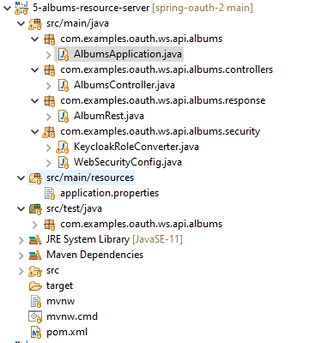

If I open the application properties file here, I have defined a custom port number. Now, the Albums resource server will start up on port at 8091 and then I have defined a couple of configuration properties that are related to resource server, communicating with my authorization server. I'm not going to discuss them now because we have already discussed both of these properties earlier.

**application.properties**

server.port = 8091

#OAuth2 Related

#spring.security.oauth2.resourceserver.jwt.issuer-uri = http://localhost:8080/auth/realms/appsdeveloperblog

spring.security.oauth2.resourceserver.jwt.jwk-set-uri = http://localhost:8080/auth/realms/appsdeveloperblog/protocol/openid-connect/certs

**AlbumsApplication.java**

package com.examples.oauth.ws.api.albums;

import org.springframework.boot.SpringApplication;

import org.springframework.boot.autoconfigure.SpringBootApplication;

@SpringBootApplication

public class AlbumsApplication {

public static void main(String[] args) {

SpringApplication.run(AlbumsApplication.class, args);

}

}

**WebSecurityConfig.java**

package com.examples.oauth.ws.api.albums.security;

import org.springframework.http.HttpMethod;

import org.springframework.security.config.annotation.method.configuration.EnableGlobalMethodSecurity;

import org.springframework.security.config.annotation.web.builders.HttpSecurity;

import org.springframework.security.config.annotation.web.configuration.EnableWebSecurity;

import org.springframework.security.config.annotation.web.configuration.WebSecurityConfigurerAdapter;

import org.springframework.security.config.http.SessionCreationPolicy;

import org.springframework.security.oauth2.server.resource.authentication.JwtAuthenticationConverter;

@EnableGlobalMethodSecurity(securedEnabled = true, prePostEnabled = true)

@EnableWebSecurity

public class WebSecurityConfig extends WebSecurityConfigurerAdapter {

@Override

protected void configure(HttpSecurity http) throws Exception {

JwtAuthenticationConverter jwtAuthenticationConverter = new JwtAuthenticationConverter();

// delegate to custom converter

jwtAuthenticationConverter.setJwtGrantedAuthoritiesConverter(new KeycloakRoleConverter());

http.authorizeRequests()

.antMatchers(HttpMethod.GET, "/photos/**")

.hasAuthority("ROLE_developer")

.anyRequest()

.authenticated()

.and()

.oauth2ResourceServer()

.jwt()

.jwtAuthenticationConverter(jwtAuthenticationConverter); // apply jwt converter;

http.sessionManagement().sessionCreationPolicy(SessionCreationPolicy.STATELESS);

}

}

**KeycloakRoleConverter.java**

package com.examples.oauth.ws.api.albums.security;

import java.util.ArrayList;

import java.util.Collection;

import java.util.List;

import java.util.Map;

import java.util.stream.Collectors;

import org.springframework.core.convert.converter.Converter;

import org.springframework.security.core.GrantedAuthority;

import org.springframework.security.core.authority.SimpleGrantedAuthority;

import org.springframework.security.oauth2.jwt.Jwt;

public class KeycloakRoleConverter implements Converter<Jwt, Collection<GrantedAuthority>> {

@Override

public Collection<GrantedAuthority> convert(final Jwt jwt) {

Map<String, Object> realmAccess = (Map<String, Object>) jwt.getClaims().get("realm_access");

if (realmAccess == null || realmAccess.isEmpty()) {

return new ArrayList<>();

}

Collection<GrantedAuthority> returnValue = ((List<String>) realmAccess.get("roles"))

.stream()

.map(roleName -> "ROLE_" + roleName)

.map(SimpleGrantedAuthority::new)

.collect(Collectors.toList());

return returnValue;

}

}

**AlbumsController.java**

package com.examples.oauth.ws.api.albums.controllers;

import java.util.Arrays;

import java.util.List;

import org.springframework.web.bind.annotation.GetMapping;

import org.springframework.web.bind.annotation.RequestMapping;

import org.springframework.web.bind.annotation.RestController;

import com.examples.oauth.ws.api.albums.response.AlbumRest;

@RestController

@RequestMapping("/albums")

public class AlbumsController {

@GetMapping

public List<AlbumRest> getAlbums() {

AlbumRest album1 = new AlbumRest();

album1.setAlbumId("albumIdHere");

album1.setUserId("1");

album1.setAlbumTitle("Album 1 title");

album1.setAlbumDescription("Album 1 description");

album1.setAlbumUrl("Album 1 URL");

AlbumRest album2 = new AlbumRest();

album2.setAlbumId("albumIdHere");

album2.setUserId("2");

album2.setAlbumTitle("Album 2 title");

album2.setAlbumDescription("Album 2 description");

album2.setAlbumUrl("Album 2 URL");

return Arrays.asList(album1, album2);

}

}

**AlbumRest.java**

package com.examples.oauth.ws.api.albums.response;

public class AlbumRest {

private String userId;

private String albumId;

private String albumTitle;

private String albumDescription;

private String albumUrl;

// setters and getters after this

}

Resource Server communicate with authorization server using the entry in application.properties.

spring.security.oauth2.resourceserver.jwt.jwk-set-uri = <http://localhost:8080/auth/realms/appsdeveloperblog/protocol/openid-connect/certs>

Let's now configure our API gateway to routing requests to this to resource service as well.

Api-gateway source code

**application.properties**

server.port=8182

spring.cloud.gateway.routes[0].id = users-status-check

spring.cloud.gateway.routes[0].uri = http://localhost:8190

spring.cloud.gateway.routes[0].predicates[0]=Path=/users/status/check

spring.cloud.gateway.routes[0].predicates[1]=Method=GET

spring.cloud.gateway.routes[0].filters[0]=RemoveRequestHeader=Cookie

spring.cloud.gateway.routes[1].id = albums

spring.cloud.gateway.routes[1].uri = http://localhost:8191

spring.cloud.gateway.routes[1].predicates[0]=Path=/albums

spring.cloud.gateway.routes[1].predicates[1]=Method=GET

spring.cloud.gateway.routes[1].filters[0]=RemoveRequestHeader=Cookie

spring.cloud.gateway.routes[2].id = photos

spring.cloud.gateway.routes[2].uri = http://localhost:8190

spring.cloud.gateway.routes[2].predicates[0]=Path=/photos

spring.cloud.gateway.routes[2].predicates[1]=Method=GET

spring.cloud.gateway.routes[2].filters[0]=RemoveRequestHeader=Cookie

**ApiGatewayApplication.java**

package com.examples.oauth.ws.api.ApiGateway;

import org.springframework.boot.SpringApplication;

import org.springframework.boot.autoconfigure.SpringBootApplication;

@SpringBootApplication

public class ApiGatewayApplication {

public static void main(String[] args) {

SpringApplication.run(ApiGatewayApplication.class, args);

}

}

**pom.xml**

<?xml version="1.0" encoding="UTF-8"?>

<project xmlns="http://maven.apache.org/POM/4.0.0" xmlns:xsi="http://www.w3.org/2001/XMLSchema-instance"

xsi:schemaLocation="http://maven.apache.org/POM/4.0.0 https://maven.apache.org/xsd/maven-4.0.0.xsd">

<modelVersion>4.0.0</modelVersion>

<parent>

<groupId>org.springframework.boot</groupId>

<artifactId>spring-boot-starter-parent</artifactId>

<version>2.4.1</version>

<relativePath/> <!-- lookup parent from repository -->

</parent>

<groupId>com.examples.ws.api</groupId>

<artifactId>5-api-gateway</artifactId>

<version>0.0.1-SNAPSHOT</version>

<name>5-api-gateway</name>

<description>5-api-gateway</description>

<properties>

<java.version>11</java.version>

<spring-cloud.version>2020.0.0</spring-cloud.version>

</properties>

<dependencies>

<dependency>

<groupId>org.springframework.boot</groupId>

<artifactId>spring-boot-starter-actuator</artifactId>

</dependency>

<dependency>

<groupId>org.springframework.cloud</groupId>

<artifactId>spring-cloud-starter-gateway</artifactId>

</dependency>

<dependency>

<groupId>org.springframework.boot</groupId>

<artifactId>spring-boot-devtools</artifactId>

<scope>runtime</scope>

<optional>true</optional>

</dependency>

<dependency>

<groupId>org.springframework.boot</groupId>

<artifactId>spring-boot-starter-test</artifactId>

<scope>test</scope>

</dependency>

</dependencies>

<dependencyManagement>

<dependencies>

<dependency>

<groupId>org.springframework.cloud</groupId>

<artifactId>spring-cloud-dependencies</artifactId>

<version>${spring-cloud.version}</version>

<type>pom</type>

<scope>import</scope>

</dependency>

</dependencies>

</dependencyManagement>

<build>

<plugins>

<plugin>

<groupId>org.springframework.boot</groupId>

<artifactId>spring-boot-maven-plugin</artifactId>

</plugin>

</plugins>

</build>

<repositories>

<repository>

<id>spring-milestones</id>

<name>Spring Milestones</name>

<url>https://repo.spring.io/milestone</url>

</repository>

</repositories>

</project>

We are going to try configure two new routes that we have configured work and if are behind it, we will route the requests to albums and to look for this resource server. I will start up all the resource servers that I have. I will start the albums resource server. I will start up for those resources server. And that will start of the original resources that we have created. All right, so all three resource servers are running and each is running as a separate project on its own port. No, I will now startup API Gateway. And they will bring in postman.

Get the authorization code

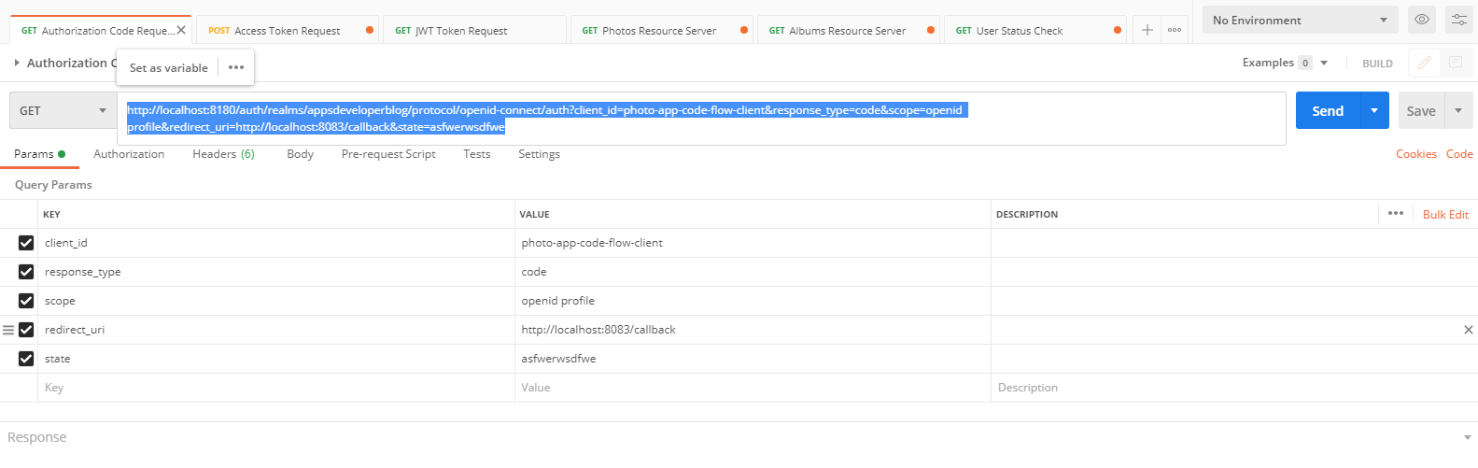

Get the Access token

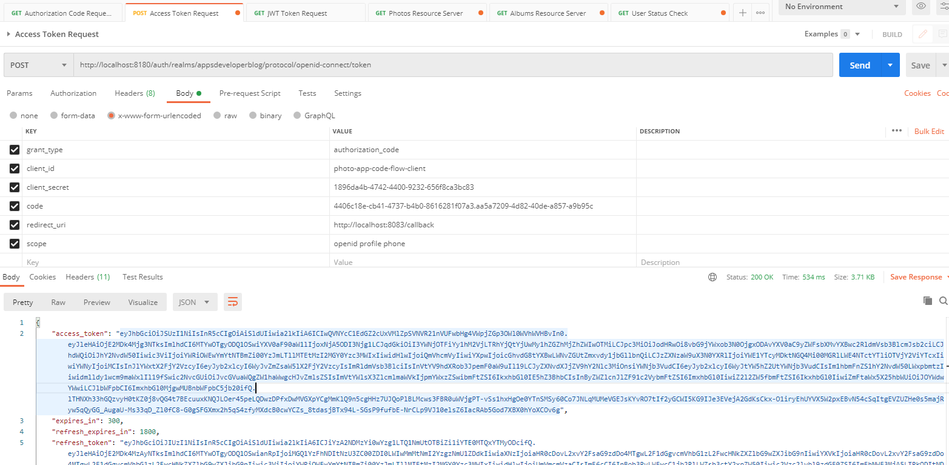

Pass the access token as Authorization in the Headers tab when sending GET request to each Resource Server endpoint

Access the three Resource server endpoints via the URL of API Gateway and let it route to them

<http://localhost:8182/albums>

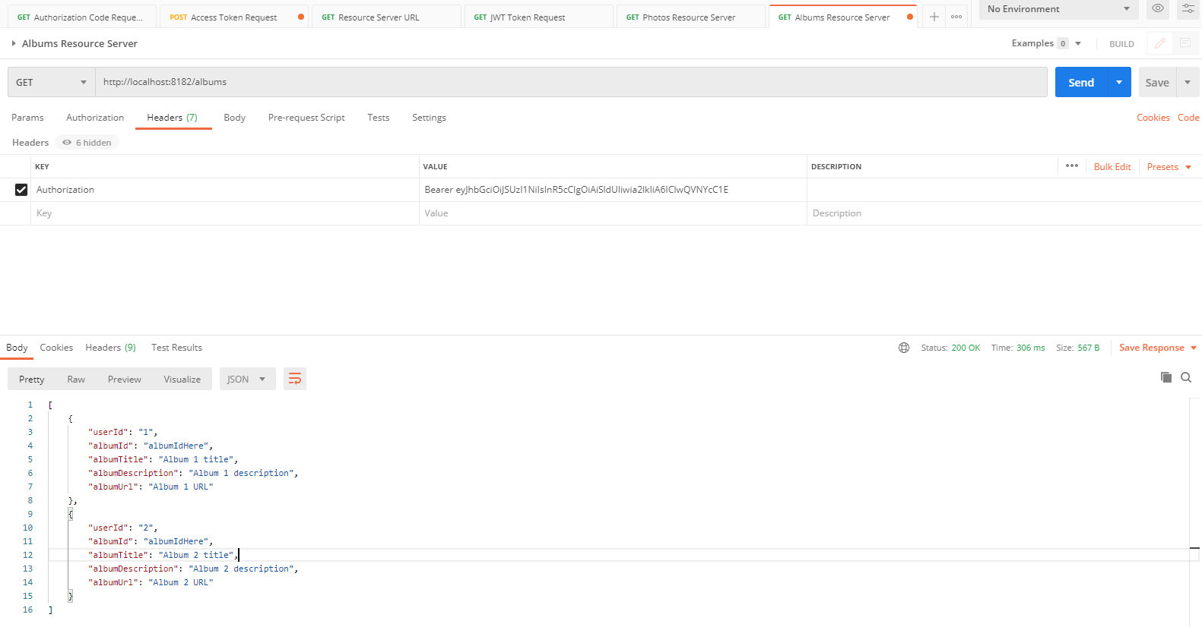

<http://localhost:8182/photos>

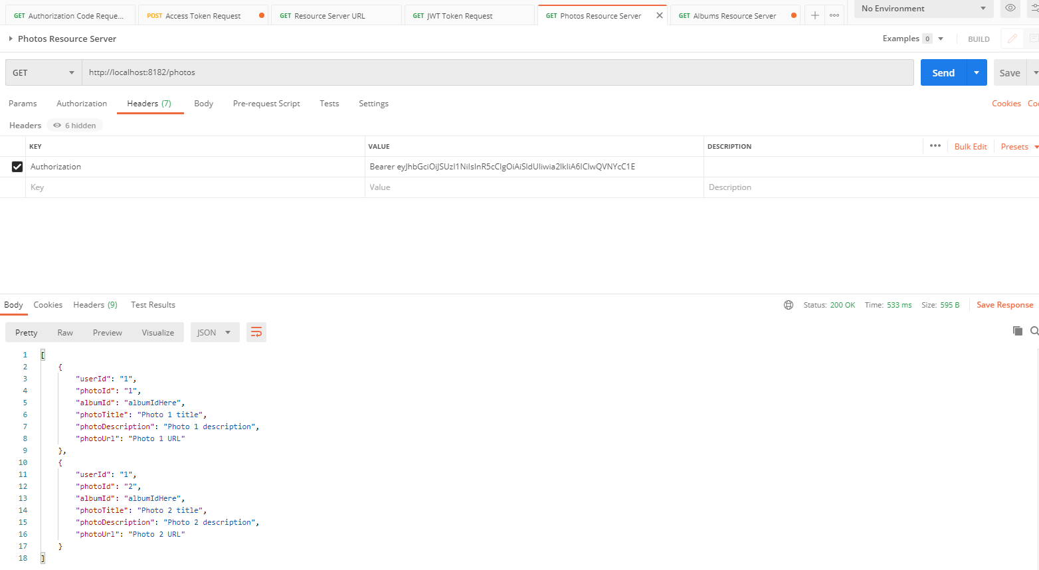

<http://localhost:8182/users/status/check>

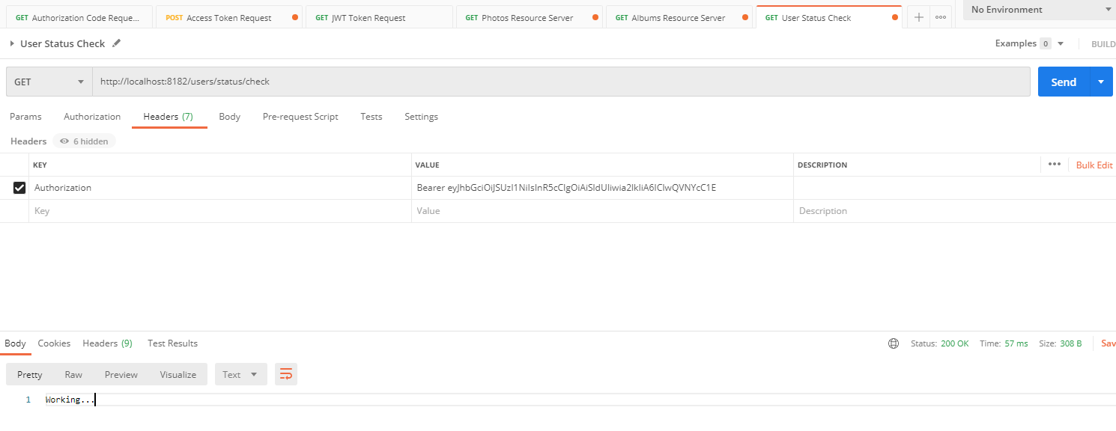

Note: 8182 is the port of the API Gateway that is routing to the two resource servers endpoints of /album , /photos and /users/status/check are actually running on port 8190 and 8191 and 9080 on separate Resource servers respectively.

And this time I will send this http post request to the token web service endpoint using the password grant type to acquire and access token. Because I'm using the password grant type, I will get an access token quicker right away. So let's try it. The request is not successful. I get back a bad request as my client is not allowed for direct access grant, and this is because Password Grant type is not enabled in my client's application. I'll need to go to my authorization.

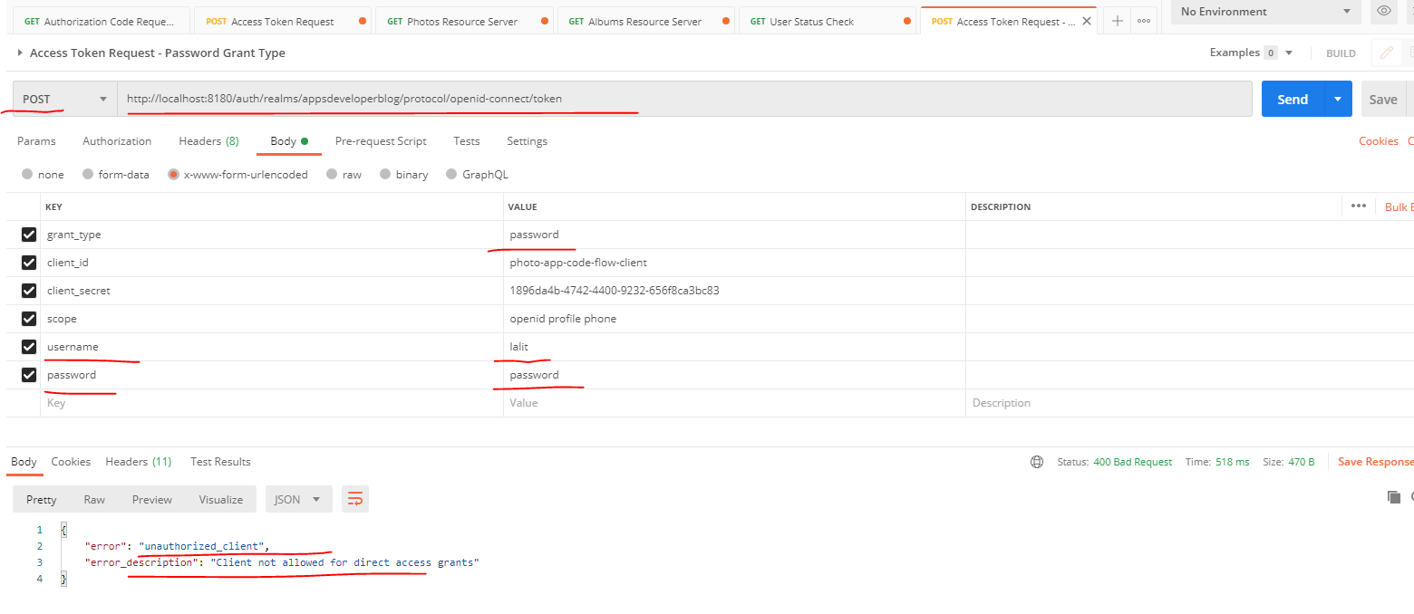

We will have to look into the keycloak authorization server admin console that is running on port 8180. Go to administration console and login as an admin. Go to clients and click on the this request and I will scroll down to find direct access grant, which supports the password grant. So I will enable it scroll down safe settings.

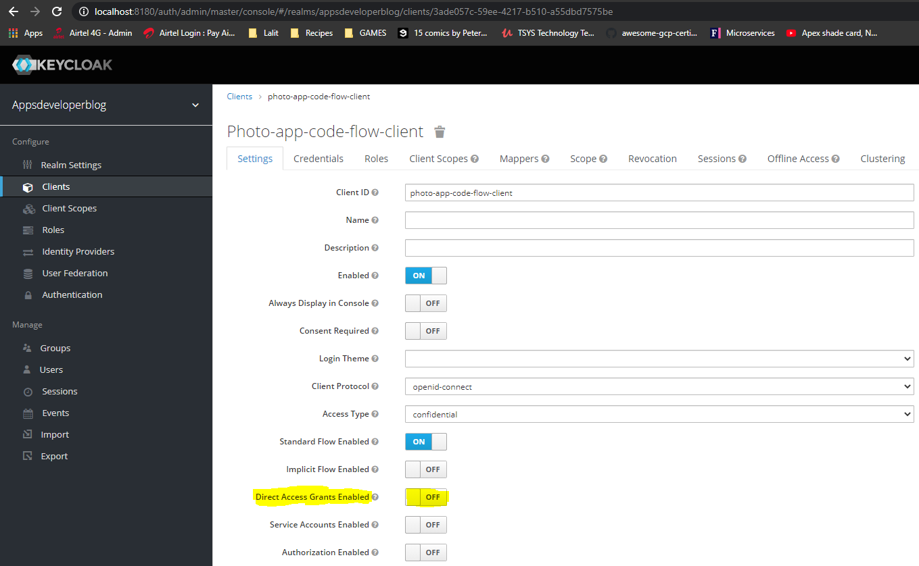

Turn that setting ON and click on the Save button

And now I will go back to my postman and I will repeat the request. And this time it worked. I can get my access token right away, so I'll copy it and I'll create a new type and they will try and send in a request to the resource servers. If I go back to my Spring Boot album's resource server running on Port 8190 and localhost and then the request path should be for this album. Now I'll need to switch to headers and provide authorization.

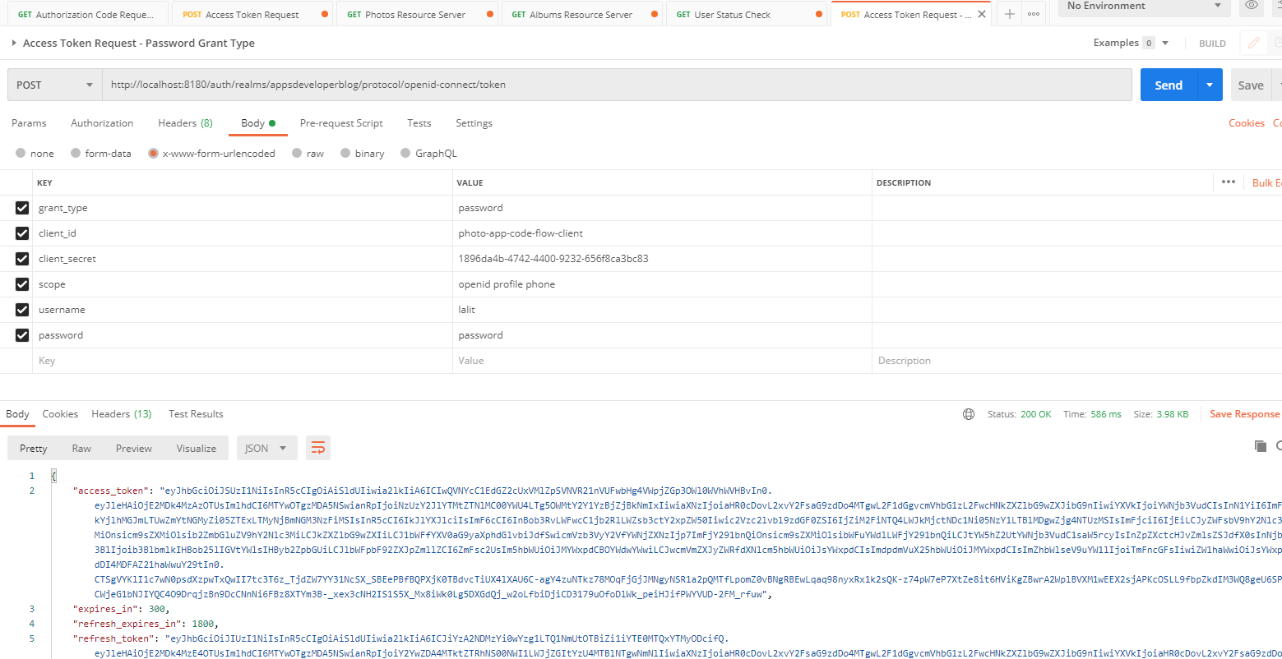

Provide this as Bearer space and then paste the access token. The request is successful, and I see that my album's resource is running, but I want to be sending a request to album to source server via an API gateway. So this request will need to go through. And the API gateway, I'll go and look up a number of my API gateway, the portal numbers 8182 and I will replace the portal number and will try sending this request via API Gateway. All right. And it still works.

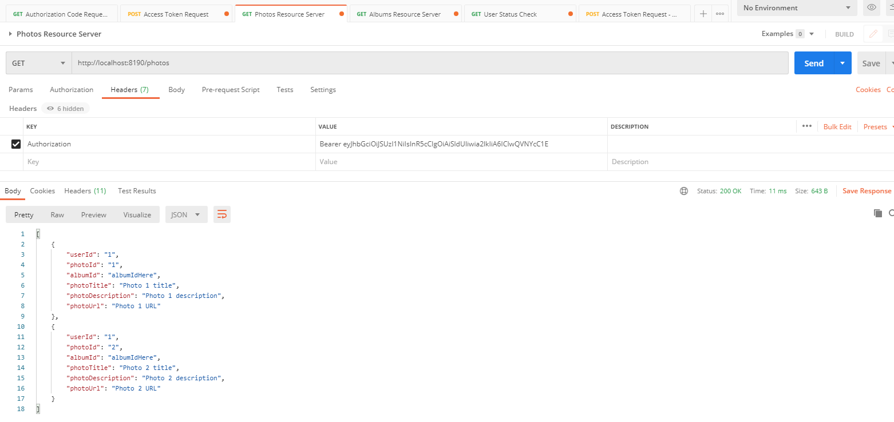

Now let's try sending a request to Photo Resource Server via the API Gateway. Also, I'm going to change port to 8182 which is the port of the API gateway and the rest of the URL is the same. Let's send in it. And the is successful, I got back, the response.

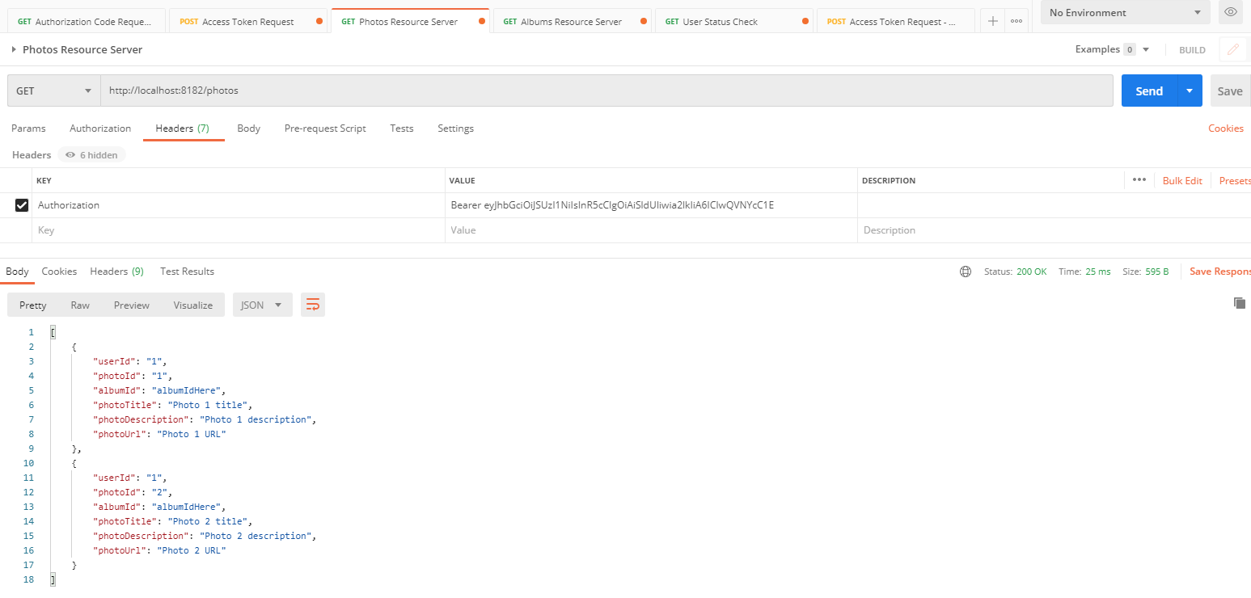

Now let's try accessing the third resource that we have also through API and Gateway, and that one is available under users status check. Now let's try sending it. And this one worked as well. All right, so we were able to access all three resource servers via a single API gateway.

## Eureka Discovery Service

Lets learn about what Eureka Discovery Service is and how to create and also how to start up your own Discovery service. When working with Eureka Discovery Service, you might hear that it is also referred to as Spring Cloud Netflix Eureka. And this is because Eureka Discovery Service is actually a project which Netflix has built for their own needs and until now is actively using it. And I'm sure you have heard of Netflix, they very popular movie streaming service. And today, lots of people in the world are using Netflix to watch movies at home. So Netflix has built Eureka for their own needs. And later, Eureka became part of Spring Cloud and is now being used not only by Netflix, but also by hundreds of other companies and developers around the world. So what does Eureka do? Eureka helps Micro services find each other or discover each other.

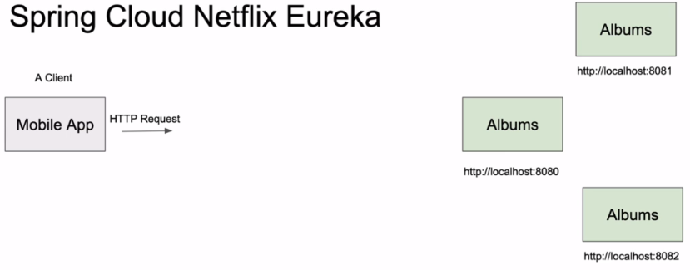

Let's say you have a client application, a mobile app, and let's say we have a Microservice created and it's called Albums Microservice. So if a client application wants to communicate with Advanced Microservice, it needs to know its address. And the address usually looks like domain name or an IP address and then a port number. So for a client application to be able to send that request to almost Microservices, it needs to know its address, IP address and port number. So what we can do here is we can hardcode the address of our service on the client application side and then their mobile application will be able to communicate with Albums microservice, is just fine. It knows its IP address and it knows its port number. But if we need to scale up and start more instances of almost Microservice, each instance of albums or accessories will start on its own port number, which means it's going to be a different address. Our mobile application does not know this new poll numbers, and it's not able to send http requests to this new instances of albus microservice because it doesn't know its port numbers. It will continue to communicate with only one albums microservice for which we hard coded the address and port that it is aware of.

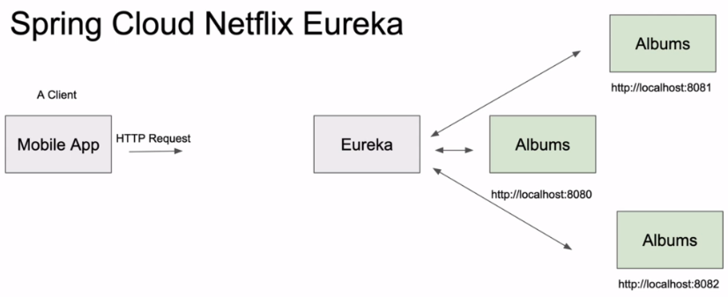

And here comes the Eureka Discovery Service. When each of those microservices starts, it will register itself with Eureka Discovery Service. So Eureka will now know the address of each Microservice. And if there are three instances of albums micro service , then Eureka will know address and port of each of them. This is because one new instance of Albums MicroService starts up. It will register itself with Eureka and you do not need to open Eureka configuration file and manually configure the address and port its using. So if the new application increases and you need to start up 10 more instances of Albums service, you can easily do that. And each Microservice will register with Eureka itself and Eureka will know where it is located. It will know its IP address and port number. Similarly, when you do not need so many instances of albums microservice anymore, you can stop some of them. And when you stop not needed Microservices, their location will be removed from Eureka Discovery services automatically. You do not need to update configuration files manually to remove this microservices. So this helps us to quickly scale our application up and down as needed without manually configuring and removing the location of each Microservice from a discovery service. Then we add into our architecture an API Gateway, which also acts as a load balancer.

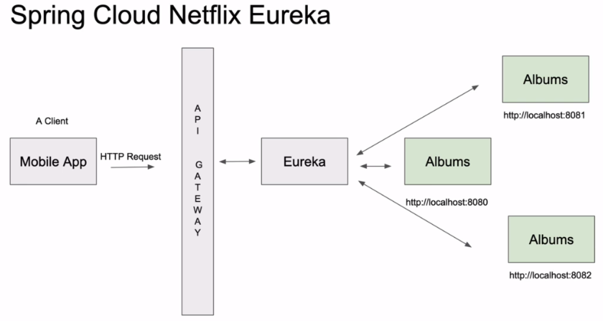

Eureka Discovery Service will tell our API gateway about the location of each instance of albums and accessories. So our client application will send the request to an Albums MicroService via API Gateway. Our API gateway will be aware of all the IP addresses and port numbers on which Albums Micro Service is running, and this is because it will fetch this information from Eureka and then our API Gateway will balance the load. And on this Microservices as needed, it will equally distribute the load between the running instances of albums Microservices. I'll show you how to configure Eureka and how to configure album service to make it all work together. And I will also show you how to make it work with a load balancer as we move on.

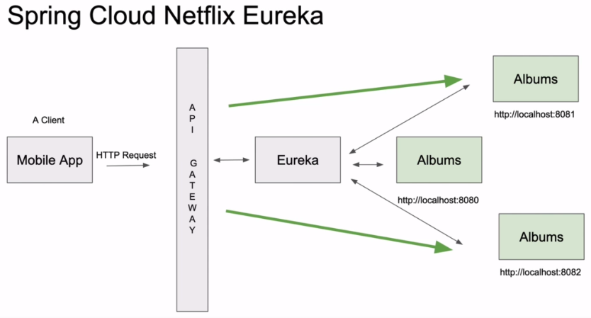

Features of Spring Cloud Netflix – Eureka Discovery Server

Spring Cloud Netflix features:

* Service Discovery: Eureka instances can be registered and clients can discover the instances using Spring-managed beans
* Service Discovery: an embedded Eureka server can be created with declarative Java configuration
* Circuit Breaker: Hystrix clients can be built with a simple annotation-driven method decorator
* Circuit Breaker: embedded Hystrix dashboard with declarative Java configuration
* Declarative REST Client: Feign creates a dynamic implementation of an interface decorated with JAX-RS or Spring MVC annotations
* Client Side Load Balancer: Ribbon
* External Configuration: a bridge from the Spring Environment to Archaius (enables native configuration of Netflix components using Spring Boot conventions)
* Router and Filter: automatic registration of Zuul filters, and a simple convention over configuration approach to reverse proxy creation

**Getting Started**

As long as Spring Cloud Netflix and Eureka Core are on the classpath any Spring Boot application with @EnableEurekaClient will try to contact a Eureka server on [http://localhost:8761](http://localhost:8761/) (the default value of eureka.client.serviceUrl.defaultZone):

@SpringBootApplication

@EnableEurekaClient

@RestController

public class Application {

@RequestMapping("/")

public String home() {

return "Hello World";

}

public static void main(String[] args) {

SpringApplication.run(Application.class, args);

}

}

To run your own server use the spring-cloud-starter-netflix-eureka-server dependency and @EnableEurekaServer.

More details here:

<https://docs.spring.io/spring-cloud-netflix/docs/3.0.0-SNAPSHOT/reference/html/>

**Creating the Project for Eureka Discovery**

Generate the project from start.spring.io

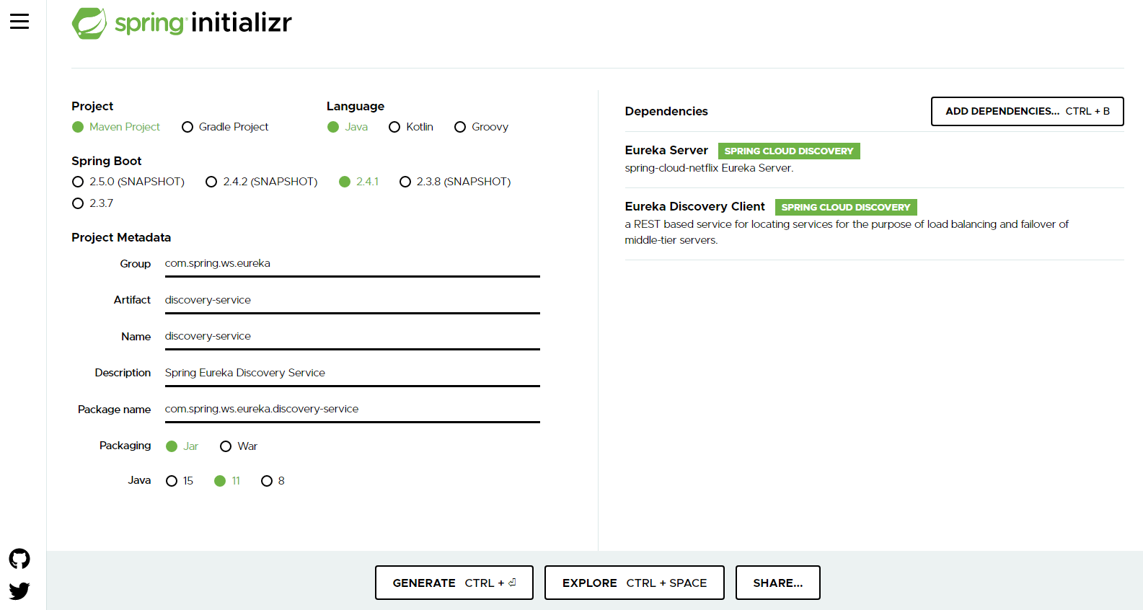

pom.xml

<?xml version=*"1.0"* encoding=*"UTF-8"*?>

<project xmlns=*"http://maven.apache.org/POM/4.0.0"* xmlns:xsi=*"http://www.w3.org/2001/XMLSchema-instance"*

xsi:schemaLocation=*"http://maven.apache.org/POM/4.0.0 https://maven.apache.org/xsd/maven-4.0.0.xsd"*>

<modelVersion>4.0.0</modelVersion>

<parent>

<groupId>org.springframework.boot</groupId>

<artifactId>spring-boot-starter-parent</artifactId>

<version>2.4.1</version>

<relativePath/> <!-- lookup parent from repository -->

</parent>

<groupId>com.spring.ws.eureka</groupId>

<artifactId>6-discovery-service</artifactId>

<version>0.0.1-SNAPSHOT</version>

<name>6-discovery-service</name>

<description>Spring Eureka Discovery Service</description>

<properties>

<java.version>11</java.version>

<spring-cloud.version>2020.0.0</spring-cloud.version>

</properties>

<dependencies>

<dependency>

<groupId>org.springframework.cloud</groupId>

<artifactId>spring-cloud-starter-netflix-eureka-client</artifactId>

</dependency>

<dependency>

<groupId>org.springframework.cloud</groupId>

<artifactId>spring-cloud-starter-netflix-eureka-server</artifactId>

</dependency>

<dependency>

<groupId>com.sun.jersey.contribs</groupId>

<artifactId>jersey-apache-client4</artifactId>

<version>1.19.4</version>

</dependency>

<dependency>

<groupId>org.springframework.boot</groupId>

<artifactId>spring-boot-starter-test</artifactId>

<scope>test</scope>

</dependency>

</dependencies>

<dependencyManagement>

<dependencies>

<dependency>

<groupId>org.springframework.cloud</groupId>

<artifactId>spring-cloud-dependencies</artifactId>

<version>${spring-cloud.version}</version>

<type>pom</type>

<scope>import</scope>

</dependency>

</dependencies>

</dependencyManagement>

<build>

<plugins>

<plugin>

<groupId>org.springframework.boot</groupId>

<artifactId>spring-boot-maven-plugin</artifactId>

</plugin>

</plugins>

</build>

<repositories>

<repository>

<id>spring-milestones</id>

<name>Spring Milestones</name>

<url>https://repo.spring.io/milestone</url>

</repository>

</repositories>

</project>

In the application.properties file capture the following

**application.properties**

server.port = 9081

spring.application.name = discoveryservice

eureka.client.registerWithEureka = false

eureka.client.fetchRegistry = false

logging.level.com.netflix.eureka = OFF

logging.level.com.netflix.discovery = OFF

The second property is to define application name, although it is better to move this property to a bootstrap properties file. And this is because this property is used a lot in spring cloud and often in the earliest phases of application configuration. So I'll create the new file called Bootstrap Properties in the same folder resources. It should be called bootstrap.properties.

In the main Application enable eureka server using the annotation

**Application.java**

package com.spring.ws.eureka.discoveryservice;

import org.springframework.boot.SpringApplication;

import org.springframework.boot.autoconfigure.SpringBootApplication;

import org.springframework.cloud.netflix.eureka.server.EnableEurekaServer;

@SpringBootApplication

@EnableEurekaServer

public class Application {

public static void main(String[] args) {

SpringApplication.run(Application.class, args);

}

}

**bootstrap.properties**

spring.application.name = discoveryservice

Eureka client register with Eureka equals false. This is the specify that this Eureka client should not register with other Eureka service by default. Eureka also tries to register itself so it will need to disable this property for now as well. If there are more than one instance of Eureka running, then Eureka instances they can register with each other. But because at this moment we are going to start only one instance of Eureka server. I'm setting this property to false. The eureka.client.fetchRegistry is to tell Eureka client not to fetch the registry from other Eureka instances. Now, if I run my application now with these three properties defined only, I will eventually see exceptions in the log file. And this is because when the registry starts, it will complain that there are no replica nodes to which eureka can connect. In production environment, you will want more than one instance of eureka. So even though we have specified that the eureka client should not register with other Eureka service, there will still be exceptions thrown. So when you're working with a single Eureka instance only, you can turn off this logging. And this is also mentioned in Spring Eureka documentation as well. And this is why I have the following two properties set off. All right. So now I can see my application properties file and I can try running Eureka service. I'll run it a spring boot application. Click on OK. And now, my sprint boot application started will bring in a new browser window. And I will open localhost and then port number on which my eureka is running, which is 8010 and hit enter and here's my Eureka dashboard.

Build the project

. ____ _ __ _ _

/\\ / ___'_ __ _ _(_)_ __ __ _ \ \ \ \

( ( )\___ | '_ | '_| | '_ \/ _` | \ \ \ \

\\/ ___)| |_)| | | | | || (_| | ) ) ) )

' |____| .__|_| |_|_| |_\__, | / / / /

=========|_|==============|___/=/_/_/_/

:: Spring Boot :: (v2.4.1)

2021-01-05 14:19:13.162 INFO 11060 --- [ main] c.s.w.e.discoveryservice.Application : Starting Application using Java 14 on DESKTOP-PEI24P3 with PID 11060 (D:\2-Workspace\Spring-OAuth\spring-oauth-2\6-discovery-service\target\classes started by Dimpu in D:\2-Workspace\Spring-OAuth\spring-oauth-2\6-discovery-service)

2021-01-05 14:19:13.167 INFO 11060 --- [ main] c.s.w.e.discoveryservice.Application : No active profile set, falling back to default profiles: default

2021-01-05 14:19:15.186 INFO 11060 --- [ main] o.s.cloud.context.scope.GenericScope : BeanFactory id=a4e86483-f2b3-3668-b8e2-d970d8effca5

2021-01-05 14:19:15.736 INFO 11060 --- [ main] o.s.b.w.embedded.tomcat.TomcatWebServer : Tomcat initialized with port(s): 9081 (http)

2021-01-05 14:19:15.750 INFO 11060 --- [ main] o.apache.catalina.core.StandardService : Starting service [Tomcat]

2021-01-05 14:19:15.750 INFO 11060 --- [ main] org.apache.catalina.core.StandardEngine : Starting Servlet engine: [Apache Tomcat/9.0.41]

2021-01-05 14:19:16.053 INFO 11060 --- [ main] o.a.c.c.C.[Tomcat].[localhost].[/] : Initializing Spring embedded WebApplicationContext

2021-01-05 14:19:16.053 INFO 11060 --- [ main] w.s.c.ServletWebServerApplicationContext : Root WebApplicationContext: initialization completed in 2791 ms

2021-01-05 14:19:17.047 INFO 11060 --- [ main] c.s.j.s.i.a.WebApplicationImpl : Initiating Jersey application, version 'Jersey: 1.19.4 05/24/2017 03:20 PM'

2021-01-05 14:19:18.520 INFO 11060 --- [ main] o.s.s.concurrent.ThreadPoolTaskExecutor : Initializing ExecutorService 'applicationTaskExecutor'

2021-01-05 14:19:19.504 INFO 11060 --- [ main] DiscoveryClientOptionalArgsConfiguration : Eureka HTTP Client uses Jersey

2021-01-05 14:19:19.635 WARN 11060 --- [ main] iguration$LoadBalancerCaffeineWarnLogger : Spring Cloud LoadBalancer is currently working with the default cache. You can switch to using Caffeine cache, by adding it to the classpath.

2021-01-05 14:19:19.666 INFO 11060 --- [ main] o.s.c.n.eureka.InstanceInfoFactory : Setting initial instance status as: STARTING

2021-01-05 14:19:20.339 INFO 11060 --- [ main] o.s.b.a.e.web.EndpointLinksResolver : Exposing 2 endpoint(s) beneath base path '/actuator'

2021-01-05 14:19:20.383 INFO 11060 --- [ main] o.s.c.n.e.s.EurekaServiceRegistry : Registering application DISCOVERYSERVICE with eureka with status UP

2021-01-05 14:19:20.387 INFO 11060 --- [ Thread-9] o.s.c.n.e.server.EurekaServerBootstrap : Setting the eureka configuration..

2021-01-05 14:19:20.405 INFO 11060 --- [ Thread-9] o.s.c.n.e.server.EurekaServerBootstrap : isAws returned false

2021-01-05 14:19:20.406 INFO 11060 --- [ Thread-9] o.s.c.n.e.server.EurekaServerBootstrap : Initialized server context

2021-01-05 14:19:20.436 INFO 11060 --- [ Thread-9] e.s.EurekaServerInitializerConfiguration : Started Eureka Server

2021-01-05 14:19:20.450 INFO 11060 --- [ main] o.s.b.w.embedded.tomcat.TomcatWebServer : Tomcat started on port(s): 9081 (http) with context path ''

2021-01-05 14:19:20.451 INFO 11060 --- [ main] .s.c.n.e.s.EurekaAutoServiceRegistration : Updating port to 9081

2021-01-05 14:19:20.629 INFO 11060 --- [ main] c.s.w.e.discoveryservice.Application : Started Application in 8.305 seconds (JVM running for 9.182)

**Access the Eureka Registry Dashboard**

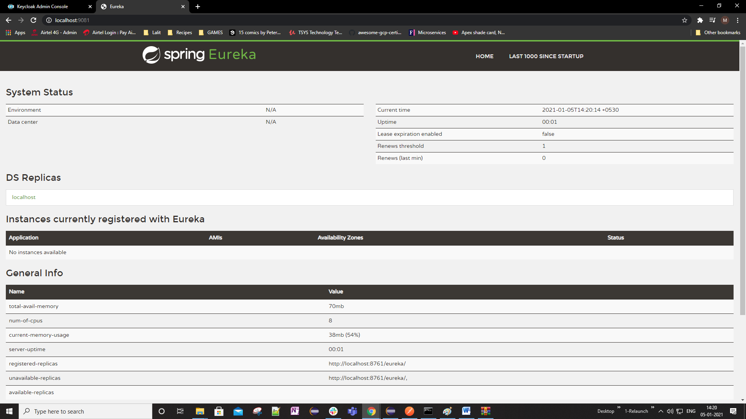

### Eureka Client

We are going to configure our resource server so that when it starts up, it registers itself with Eureka and for the resource servers to be able to register itself with Eureka. It will need to be configured as a Eureka client. At this moment, none of my resources servers are configured as Eureka client, so I'll need to pick one. For example, I'll pick the original resource server that they have and configure it is as Eureka client. And to do that, I'll need to open its XML file and add a new dependency here for Eureka client.

And if I open a similar file of my Eureka Discovery service, then here I have two dependencies. One is Netflix Eureka client and another is Netflix Eureka server. So to make my resource server be a Eureka client, I'll simply need to add this dependency to a pom.xml of my resource server.

In the users-resource-server modified the pom.xml file as below ( added the blue highlighted portions )

<?xml version=*"1.0"* encoding=*"UTF-8"*?>

<project xmlns=*"http://maven.apache.org/POM/4.0.0"* xmlns:xsi=*"http://www.w3.org/2001/XMLSchema-instance"*

xsi:schemaLocation=*"http://maven.apache.org/POM/4.0.0 https://maven.apache.org/xsd/maven-4.0.0.xsd"*>

<modelVersion>4.0.0</modelVersion>

<parent>

<groupId>org.springframework.boot</groupId>

<artifactId>spring-boot-starter-parent</artifactId>

<version>2.4.1</version>

<relativePath/> <!-- lookup parent from repository -->

</parent>

<groupId>com.oauth.server</groupId>

<artifactId>5-users-resource-server</artifactId>

<version>0.0.1-SNAPSHOT</version>

<name>5-users-resource-server</name>

<description>Resource Server for OAuth 2.0</description>

<properties>

<java.version>11</java.version>

<spring-cloud.version>Hoxton.SR7</spring-cloud.version>

</properties>

<dependencies>

<dependency>

<groupId>org.springframework.boot</groupId>

<artifactId>spring-boot-starter-oauth2-resource-server</artifactId>

</dependency>

<dependency>

<groupId>org.springframework.boot</groupId>

<artifactId>spring-boot-starter-web</artifactId>

</dependency>

<dependency>

<groupId>org.springframework.cloud</groupId>

<artifactId>spring-cloud-starter-netflix-eureka-client</artifactId>

</dependency>

<dependency>

<groupId>org.springframework.boot</groupId>

<artifactId>spring-boot-devtools</artifactId>

<scope>runtime</scope>

<optional>true</optional>

</dependency>

<dependency>

<groupId>org.springframework.boot</groupId>

<artifactId>spring-boot-starter-test</artifactId>

<scope>test</scope>

</dependency>

</dependencies>

<dependencyManagement>

<dependencies>

<dependency>

<groupId>org.springframework.cloud</groupId>

<artifactId>spring-cloud-dependencies</artifactId>

<version>${spring-cloud.version}</version>

<type>pom</type>

<scope>import</scope>

</dependency>

</dependencies>

</dependencyManagement>

<build>

<plugins>

<plugin>

<groupId>org.springframework.boot</groupId>

<artifactId>spring-boot-maven-plugin</artifactId>

</plugin>

</plugins>

</build>

<repositories>

<repository>

<id>spring-milestones</id>

<name>Spring Milestones</name>

<url>https://repo.spring.io/milestone</url>

</repository>

</repositories>

</project>

Enable the Discovery client and provide the configuration now

In the main application

package com.oauth.server.resourceserver;

import org.springframework.boot.SpringApplication;

import org.springframework.boot.autoconfigure.SpringBootApplication;

import org.springframework.cloud.netflix.eureka.EnableEurekaClient;

@SpringBootApplication

@EnableEurekaClient

public class ResourceserverApplication {

public static void main(String[] args) {

SpringApplication.run(ResourceserverApplication.class, args);

}

}

To help my client discover Eureka server, we will have to tell it where to find the Eureka server.

eureka.client.serviceUrl.defaultZone = <http://localhost:8010/eureka>

**application.properties**

server.port=9080

spring.security.oauth2.resourceserver.jwt.issuer-uri=http://localhost:8180/auth/realms/appsdeveloperblog

eureka.client.serviceUrl.defaultZone = <http://localhost:8010/eureka>

Although because I have not specified the application name yet, this resource server will appear in Eureka Dashboard with a name unknown. So to make this resource appear in your record with a proper name, I can either add a new property here, which is called spring application dot name equals, or I can create a new bootstrap.properties file and specify the application name there. And although it will work if I specify application name here, it is recommended to do it and the bootstrap properties file.

**bootstrap.properties**

spring.application.name=users-resource-service

If the name is not reflecting then put this property in the application.properties file and then it starts showing

So I will provide this property in the bootstrap.properties and I will create a new property file in the same folder resources. Make this quick and finish and paste this properly here, and I will call it demo resource server and save it, I'll go back to my application properties file and save it as well. Now, my basic configuration of Eureka client is complete and I'm good to start it and see how it works.

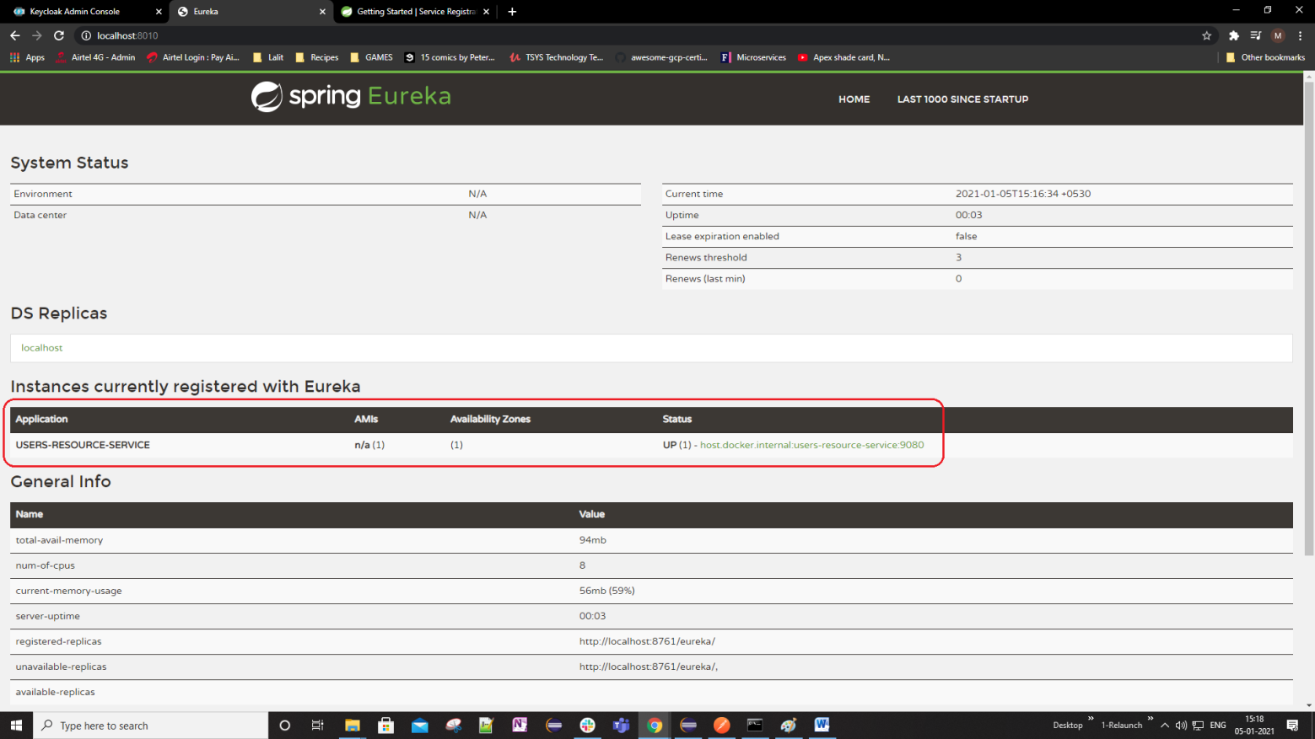

We have added 2 more projects

photos-resource-server

albums-resource-server

changes are the same

* In the pom.xml file adding the dependency, version, dependencyManagement and repository, also added the jersey dependency as eureka uses that and breaks without that dependency
* In the application.properties and bootstrap.properties ( not really picking up when specified just here ) – added the spring.application.name
* In the main application added the @EnableEurekaClient annotation
* In the application.properties added the configuration for

eureka.client.serviceUrl.defaultZone = <http://localhost:8010/eureka>

spring.application.name = users-resource-service

The resource server configuration we have already specified in the application.properties

spring.security.oauth2.resourceserver.jwt.issuer-uri=http://localhost:8180/auth/realms/appsdeveloperblog

Ran all the 3 servers after this and we have each of them showing up

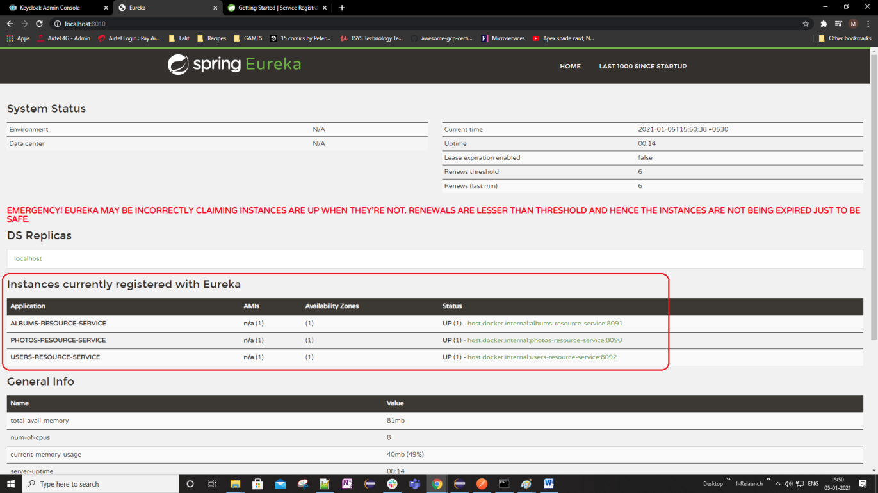

### Load Balancing

Lets learn how to start up multiple resources behind an API Gateway and how to configure Spring Cloud API Gateway to load balanced http requests and more on this running multiple resource servers. So here's how it is going to look. We will configure resource server to run on a random port number and this will allow us to start up multiple instances of the same resource server, each running on a unique port number. So it is going to be the same resource server, same springboot application, but each running on its own port number. Because each resource server is configured as Eureka client.

|  |  |
| --- | --- |
|  | When it starts up, it will register its location with Eureka Discovery Service and Eureka will know the IP address and the port number of each instance of our resource server. We will then configure Spring Cloud API Gateway to also work with Eureka and this will make or Spring Cloud API Gateway fetch the location of each of these resource service from Eureka. |

Our Spring Cloud API Gateway will also know the location of each of the running instance of our resource server. If we start a new instance of resource server, it will also automatically register itself with discovery service and within a few seconds our Spring Cloud Gateway will also become aware of the IP address and the port number on which this new instance of resource server is running.

|  |  |
| --- | --- |
| We will then configure routes in our Spring Cloud API Gateway to use a special load balancing prefix together with the resource server name and then each of this resource server is registered with eureka registry service and this will make this spring cloud API Gateway to use its built in a load balancing client to equally balance the incoming http requests amont the running instances of our resource server. All right, so let's continue and let's learn how to do it. |  |

Now, how do we start the Spring Boot application on a random port. Now, I will open up my demo resource server and I will open up its application properties from the port number on which this resource server will work. If I run this application is hard coded here with the server.port property. If I run this application now, it will start on port number 8181. If I want to run two instances of this resource server, then I need to make sure that each of them runs on a unique port. Now, this is because the port number is taken by one application, then no other application can use that port. And if I run the second application, it will fail to start because the port number is taken. Let's try, I will start up this resource server on port at 8081. My application is up and running, and if I look on the port number on which it has started, it has started on port number 8081. I will start up a second instance of this same resource server. And the second instance has failed to start, and this is because Port 8081 is already in use.

One of the ways to start more than one instance of this same application is to simply update the port number manually. If one instance of this application is running on Port 8081, then to start a second instance of this application on 8082. And then the third instance on port 8083 and so on. Although this will work eventually, it becomes very difficult to manage this port numbers and it becomes very hard to track which port number has become available and can be reused by another resource. So to make our application automatically pick up an available port number itself, we can set the port number to zero. I will change this to 0. Now if I run this application twice, each of my application will start on a random port number. What port number that's going to be, I do not know. But what's important is that the port number will be available. I can start multiple instances of this or so similar and all of them will have registered with Eureka Discovery Server with its own port number. And my load balancer will be able to balance the http requests on the running instances.

2021-01-05 16:43:22.930 INFO 7760 --- [ restartedMain] o.s.b.w.embedded.tomcat.TomcatWebServer : Tomcat initialized with port(s): 0 (http)

2021-01-05 16:45:04.720 INFO 13468 --- [ restartedMain] o.s.b.w.embedded.tomcat.TomcatWebServer : Tomcat started on port(s): 8802 (http) with context path ''

2021-01-05 16:46:02.361 INFO 13512 --- [ restartedMain] o.s.b.w.embedded.tomcat.TomcatWebServer : Tomcat started on port(s): 9039 (http) with context path ''

If one of the instances of this resource server goes down, then I do not need to know what port number it was using and what port number has become available. If I need to start one more instance of this resource server, I can simply run it again on Port number zero. Now, even though I have hardcoded port zero here in application properties file if needed, I can always override this port number zero to any other port number I choose by starting this application in the terminal window and then pass a specific port number I need as a command line argument. All right. So the port number is set to zero. I will save changes in this application properties file and I will run a second instance of it. And the second instance of the spring application has started on port 60620, I can start one more instance and this instance will start on its own port number, and if I look it up. This one has started on sixty thousand eight hundred and fourteen, each port number is unique, random and is available. All right. So both instances of this resource server are running on their unique port numbers. And we now know how to start more than one instance of our application. But this is not all. There is one more property that we need to configure and we will talk about it in the following chapters.

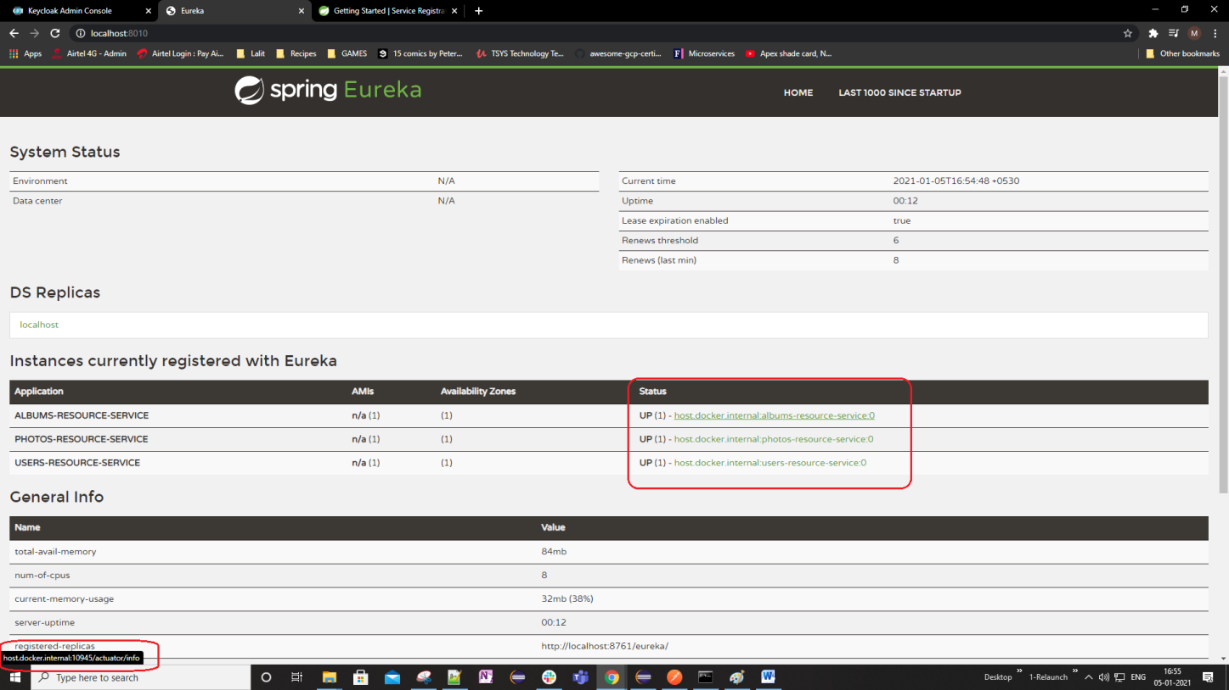

Lets learn how to make multiple instances of the same Springboot application register with Eureka Discovery Service. Let's have a look at how things work now. I will start Eureka and then I will start two instances of my Resource Server and I will check how these two instances look in the Eureka Dashboard. So I will bring up my Eureka Discovery Service first. And now I will start one instance of resource server. My resource server has started on port 8849. Now, I can bring up your Eureka dashboard. And see how this resource has registered with Eureka, my eureka is running on localhost port number 8010. And here I have one resource server and now registered. And if I click on this link here, it will bring up a new browser tab. And I can see the port number here as well. Hovering on the green links to the right in the status column will reveal the url and thus the port on which the resource server is running. So lets run another new instance of this same resource server.

Now, the second instance has started, I can look up with support number and it has started on point number five five five twenty nine. Now let's go back to Eureka. And refresh this page now, I can still see one instance, and if I click on this link here, I will see the port number, which is now the port number of the second instance that has started. So I have started two instances, but in the Eureka dashboard, but only one instance is available in the Eureka registry. Let's fix that. And to fix that, I will need to go back to my code, open up application properties, file of my resource server, and I will need to add one more property here to specify a unique Eureka instance ID. What can hard code a unique value here, or we can make the system said to be randomly generated for us and the way to properly do this by using the following. So this expression here will make a unique instance and the value will consist of two parts, the left side of this expression.

**application.properties**

server.port = 0

eureka.client.serviceUrl.defaultZone = http://localhost:8010/eureka

spring.application.name = albums-resource-service

eureka.instance.instance-id = ${spring.application.name}:${instanceId:${random.value}}

#OAuth2 Related

#spring.security.oauth2.resourceserver.jwt.issuer-uri = http://localhost:8080/auth/realms/appsdeveloperblog

spring.security.oauth2.resourceserver.jwt.jwk-set-uri = http://localhost:8080/auth/realms/appsdeveloperblog/protocol/openid-connect/certs

It is going to be a current springboot application, it starts with spring application, the second part generates a random value, and I'm going to show you how to use both of these values. All right. So now that I have added a new property, I will save application properties file and I will actually stop everything. I will stop Eureka or stop the resource server and I will start fresh. Like this now I will start the Discovery Service. And now I will start a resource server. Now, I will go back to my Eureka dashboard. Refresh the page. All right, and now I have instances running, but it is generated slightly different on the left side. I have application name, which is my Resource server, and on the right side, they have a randomly generated instance number. Now, I will go back to my project and I will start up a second instance of my resource server. A second instance has started. I'll go back to my Eureka dashboard and I'll refresh this page. Now, I have two instances up and running. I can see it here.

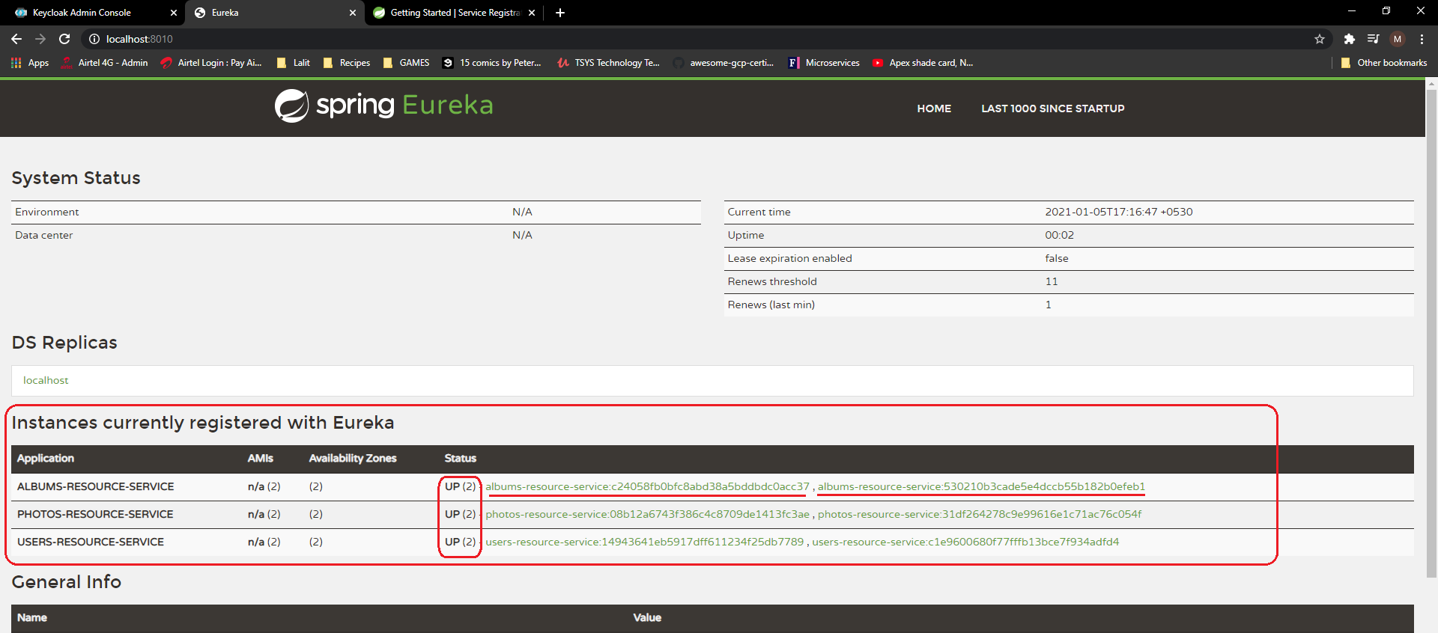

Two instances are up and running. And the instance I need values consist of on the left side application name, and on the right side. I have a uniquely generated random value. So that worked. Let's start the third instance. But this time will pass in a constant value as a command line argument. Instead of using this randomly generated what to do that I will go back to project. I will open properties of my project or look up the location where it is located it and I will bring in a new terminal window.

I will change directory to the resource server folder. I will list files here so that I can see pom.xml, and now I will package this project using even command maven package. And now I will start up a new instance of this application and that will pass an instance id as a command line argument, and to do that, we will use MAVEN command

$ mvn spring-boot:run –Dspring-boot.run.arguments=--instanceId=lalit

If I go back to my application, the argument name is instant id, so copied and pasted here in the command and I will give it some name like for example lalit my name. Right and I will hit enter to run the Spring Boot application. My application is up and running and then we'll go back to Eureka Dashboard. And that will refresh this page. And now I have three instances upon the second instance has an application name and the randomly generated value, the third one has also a randomly generated value, but the first one is in the least here has my name instead of randomly generated value. All right. So that also worked. And we now have three instances up and running and registered with Eureka Registry. Let's continue.

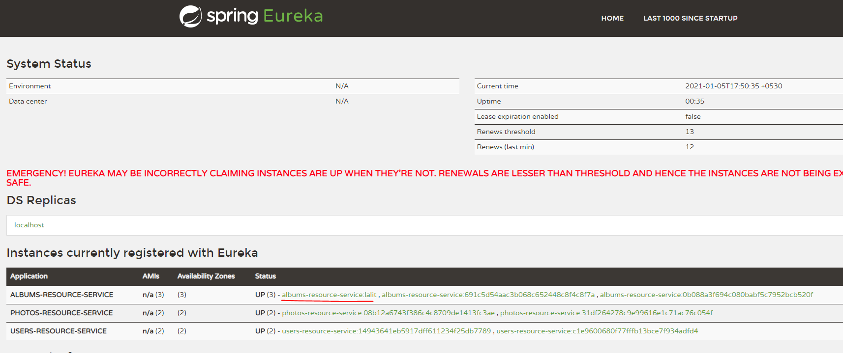

The 3rd instance that we ran from the command line has replaced the random number at the end with the instanceId that we passed in the mvn command line argument “lalit”

### Configuring API Gateway as Eureka Client

For API Gateway to be able to work with Eureka and fetch a registry, it will also need to be configured as a Eureka client. So we will configure the API gateway to be Eureka client. And by now you should already know how to configure Spring boot application to be recognized, this and do configuration yourself or you can follow me along. All right. So for me to configure this project, this Eureka client, I will first need to add to my API Gateway project, Eureka client dependency. And I'll take that dependency from Maven Repository.

Now, I'll go back to my project, open my API gateway, open its pom.xml file and I will add this dependencym may be right after the spring boot cloud starter gateway here. I'll just need to remove the version. And from my source code.

So I will close this file and I will open up application properties file. And I like to own this property at the top here. And the property is called eureka.client.service.defaultZone. And my eureka is running on localhost port 8010 and there will need to provide context path <http://localhost:8010> and slash Eureka like this <http://localhost:8010/eureka>. Now, when Spring API Gateway starts up and registers with Eureka, it will be available on Eureka dashboard. But we need to give it application name because otherwise it will appear in the list of applications registered with Eureka as an unknown application. So to give my Spring Cloud API Gateway, get an application, I will save changes to application properties and then will create a new file in src/main/resources. Right next to my Application Properties file, I'll create a new file called Bootstrap Properties. Click on finish, and in this file, I will define application there, and it starts with spring.

**application.properties**

server.port=8182

spring.cloud.gateway.routes[0].id = users-status-check

spring.cloud.gateway.routes[0].uri = http://localhost:9080

spring.cloud.gateway.routes[0].predicates[0]=Path=/users/status/check

spring.cloud.gateway.routes[0].predicates[1]=Method=GET

spring.cloud.gateway.routes[0].filters[0]=RemoveRequestHeader=Cookie

spring.cloud.gateway.routes[1].id = albums

spring.cloud.gateway.routes[1].uri = http://localhost:8191

spring.cloud.gateway.routes[1].predicates[0]=Path=/albums

spring.cloud.gateway.routes[1].predicates[1]=Method=GET

spring.cloud.gateway.routes[1].filters[0]=RemoveRequestHeader=Cookie

spring.cloud.gateway.routes[2].id = photos

spring.cloud.gateway.routes[2].uri = http://localhost:8190

spring.cloud.gateway.routes[2].predicates[0]=Path=/photos

spring.cloud.gateway.routes[2].predicates[1]=Method=GET

spring.cloud.gateway.routes[2].filters[0]=RemoveRequestHeader=Cookie

eureka.client.serviceUrl.defaultZone = http://localhost:8010/eureka

spring.application.name = my-api-gateway

We register with Eureka and be able to feature three is three. So let's see how it works. Let's run Eureka and API Gateway and see if our API gateway appears in your dashboard. So I will first start up my Eureka Discovery Service. My application has started and I will bring a new browser window. And I will open up your dashboard, Eureka is running on localhost port 8010, turn and hit enter. And here's my Eureka dashboard and I have my API Gateway up and running as well. So everything is working as expected.

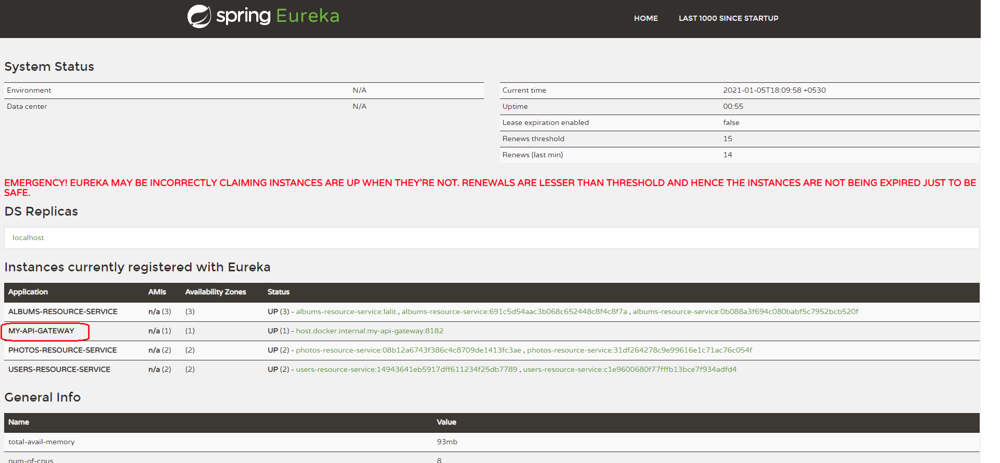

### Configuring API Gateway Routes

We have a few routes configured in our Spring Cloud Gateway.

server.port=8182

spring.cloud.gateway.routes[0].id = users-status-check

spring.cloud.gateway.routes[0].uri = http://localhost:8192

spring.cloud.gateway.routes[0].predicates[0]=Path=/users/status/check

spring.cloud.gateway.routes[0].predicates[1]=Method=GET

spring.cloud.gateway.routes[0].filters[0]=RemoveRequestHeader=Cookie

spring.cloud.gateway.routes[1].id = albums

spring.cloud.gateway.routes[1].uri = http://localhost:8191

spring.cloud.gateway.routes[1].predicates[0]=Path=/albums

spring.cloud.gateway.routes[1].predicates[1]=Method=GET

spring.cloud.gateway.routes[1].filters[0]=RemoveRequestHeader=Cookie

spring.cloud.gateway.routes[2].id = photos

spring.cloud.gateway.routes[2].uri = http://localhost:8190

spring.cloud.gateway.routes[2].predicates[0]=Path=/photos

spring.cloud.gateway.routes[2].predicates[1]=Method=GET

spring.cloud.gateway.routes[2].filters[0]=RemoveRequestHeader=Cookie

eureka.client.serviceUrl.defaultZone = http://localhost:8010/eureka

spring.application.name = my-api-gateway

To make spring cloud gateway use the load balance and route the http requests to one of the running instances of Spring Boot application instead of specifying a complete URL here in the form of http localhost and port no, we will need to specify a URI using the following schema and it starts with lb://. I'll need to specify a name of Spring Boot Application under which it is registered with Eureka Discovery Service. So this route here is to our web service end point user/status/check that is exposed by a demo resource server. And if I open up the demo resource server and look up its application name and bootstrap properties, the application name is users-resource-service.

Users resource service – application.properties file

server.port=0

spring.security.oauth2.resourceserver.jwt.issuer-uri=http://localhost:8180/auth/realms/appsdeveloperblog

eureka.client.serviceUrl.defaultZone = http://localhost:8010/eureka

eureka.instance.instance-id = ${spring.application.name}:${instanceId:${random.value}}

spring.application.name = users-resource-service

So I will copy and pasted here like this.

server.port=8182

spring.cloud.gateway.routes[0].id = users-status-check

spring.cloud.gateway.routes[0].uri = lb://users-resource-service

spring.cloud.gateway.routes[0].predicates[0]=Path=/users/status/check

spring.cloud.gateway.routes[0].predicates[1]=Method=GET

spring.cloud.gateway.routes[0].filters[0]=RemoveRequestHeader=Cookie

spring.cloud.gateway.routes[1].id = albums

spring.cloud.gateway.routes[1].uri = lb://albums-resource-service

spring.cloud.gateway.routes[1].predicates[0]=Path=/albums

spring.cloud.gateway.routes[1].predicates[1]=Method=GET

spring.cloud.gateway.routes[1].filters[0]=RemoveRequestHeader=Cookie

spring.cloud.gateway.routes[2].id = photos

spring.cloud.gateway.routes[2].uri = lb://photos-resource-service

spring.cloud.gateway.routes[2].predicates[0]=Path=/photos

spring.cloud.gateway.routes[2].predicates[1]=Method=GET

spring.cloud.gateway.routes[2].filters[0]=RemoveRequestHeader=Cookie

eureka.client.serviceUrl.defaultZone = http://localhost:8010/eureka

spring.application.name = my-api-gateway

So if the URI schema starts with lb:// then Spring Cloud Gateway will use the built in load balance client to resolve the name and actual port number. And this details Spring Cloud API Gateway will take from Eureka Discovery Service. It will fetch from Eureka all the running instances of our Resource server and when balancing http requests among these instances, it will use the host and the port number under which these instances are registered with Eureka. So this is the only change that we need to do at this moment to make our Spring Cloud API Gateway to use the default built in load balancer client and to do the load balancing for us, lets update for other resource servers as well. Now I will save application properties file and my Cloud API Gateway is ready to be started.

### Return the Running Port

Before starting up our API gateway and trying to how the load balancing works, let's update one of our web service end points to return the port number from which the response was served. This will help us know which instance of resource server has received and processed the request. And we'll experiment with the users-resource-service server with the user's status check web service endpoint. So I will open up demo resource server and I will open up its controller class. The one that has user status check web service end point here, I will update this web service and make it return the port number on which this particular instance of my resource server is running.

If I have multiple instances of this resource server running, then each instance will run on its own unique port number and the web service end point will return the port number on which it is right. So to get the value of a port number on which this resource is running, I'll need to inject an environment object into this controller class and then use it to get the running port number and to inject an environment object, I will use the autowired annotation we will declare environment property. Once, I have injected an instance of my environment object. I can use it to access the running port. So when a request to a web service end point that starts with user/status/check is sent I am going to print the port number, and then we'll use an instance of environment object, and then I will get the property with a key that is called local.server.port. And I will update the value, say as “Working on port: “. So now when this web service end point gets a request, it should return a string working on port and then the running port. No, let's try how it works.

Controller class of Users Status Resource Project

@RestController

@RequestMapping("/users")

public class UsersController {

@Autowired

Environment environment;

@GetMapping("/status/check")

public String status() {

return "Working on port number -> " + environment.getProperty("local.server.port");

}

@PreAuthorize("#id == #jwt.subject")

@DeleteMapping(path = "/{id}")

public String deleteUser(@PathVariable String id, @AuthenticationPrincipal Jwt jwt) {

return "Deleted user with id: " + id + " and JWT subject " + jwt.getSubject();

}

@PostAuthorize("returnObject.userId == #jwt.subject")

@GetMapping(path = "/{id}")

public UserRest getUser(@PathVariable String id, @AuthenticationPrincipal Jwt jwt) {

return new UserRest("Lalit", "Nagpal", "adb9a0bf-50ff-4c2f-9e11-3260f4c7");

}

}

Trying this out now

Get the Authorization Code

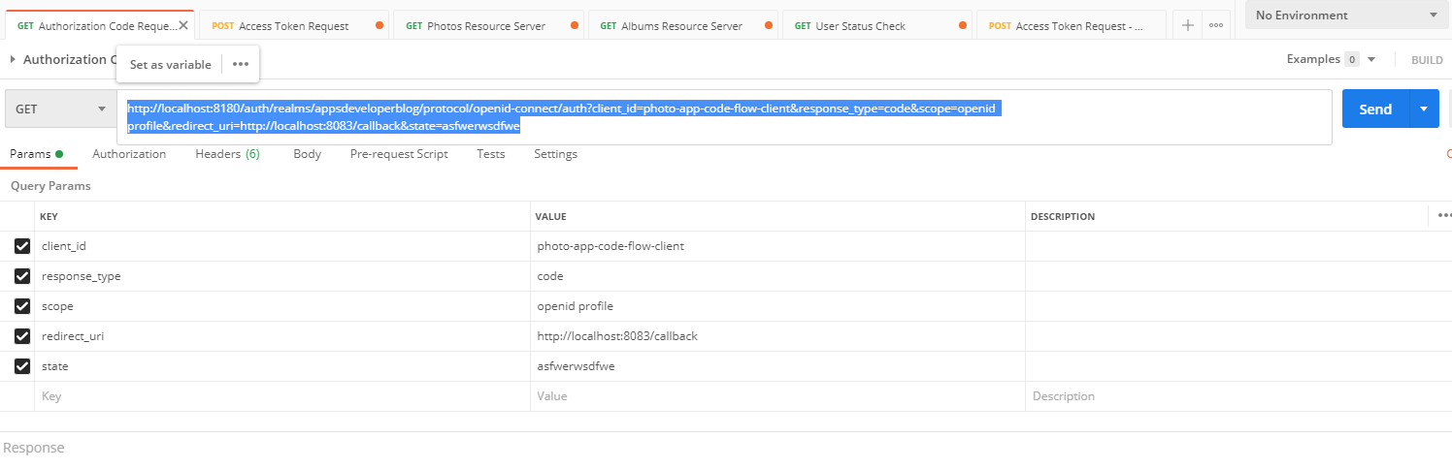

Get the access token now

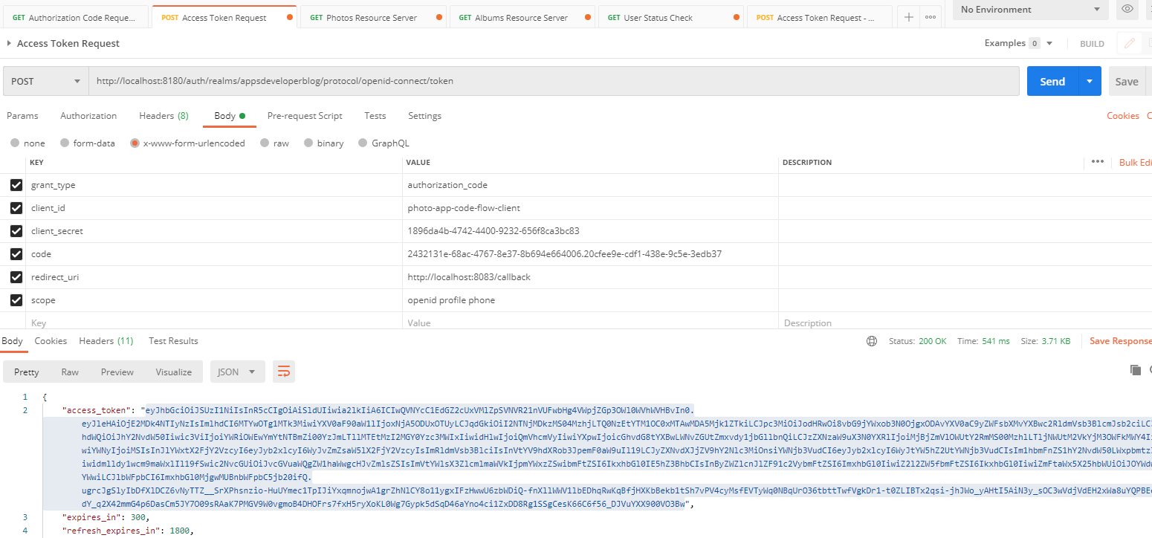

Make the requests now, passing the access token ( try multiple times to see the load balancing being done )

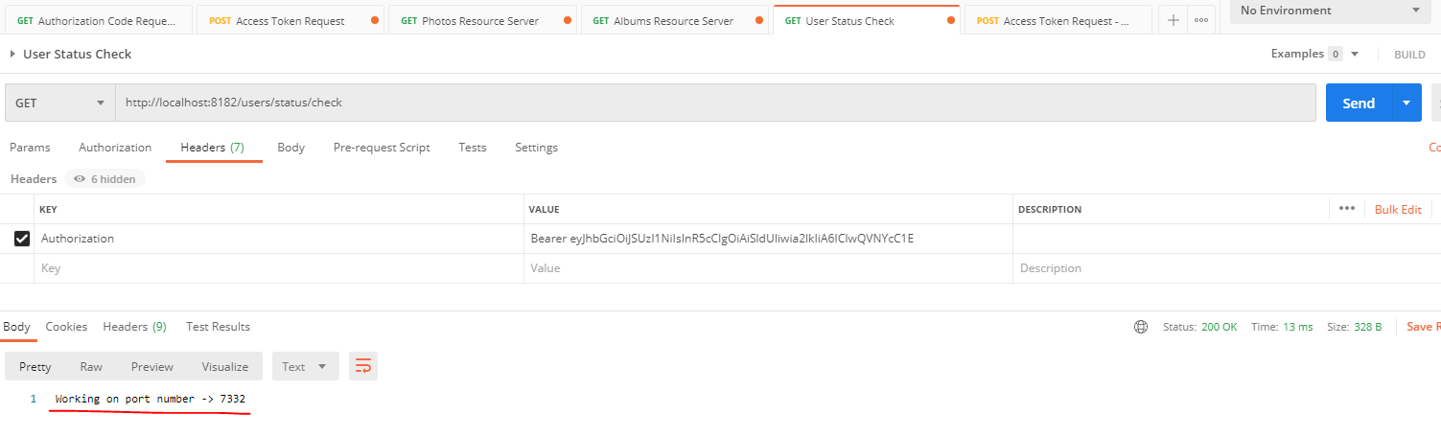

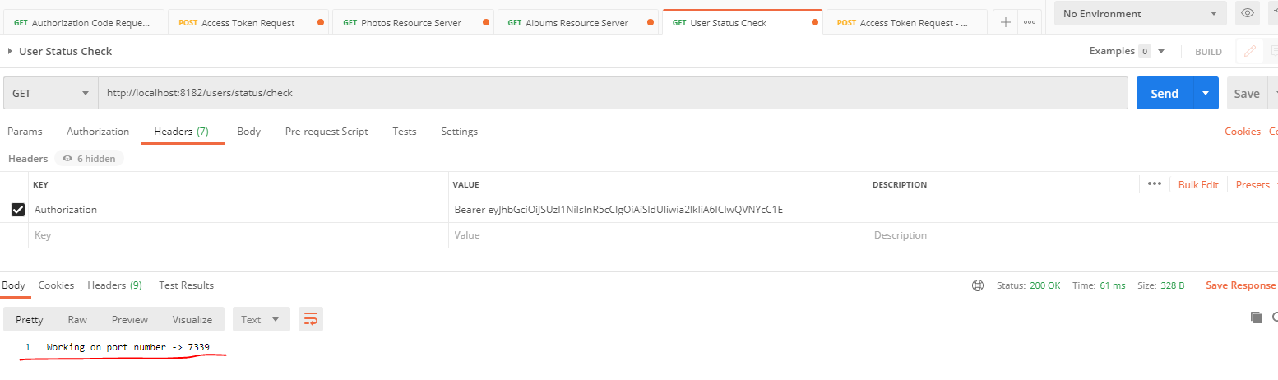

Being sent at port 7332 and then 7339 – it is equally balancing the requests now between the 2 Resource Servers.

This was our state when we ran this

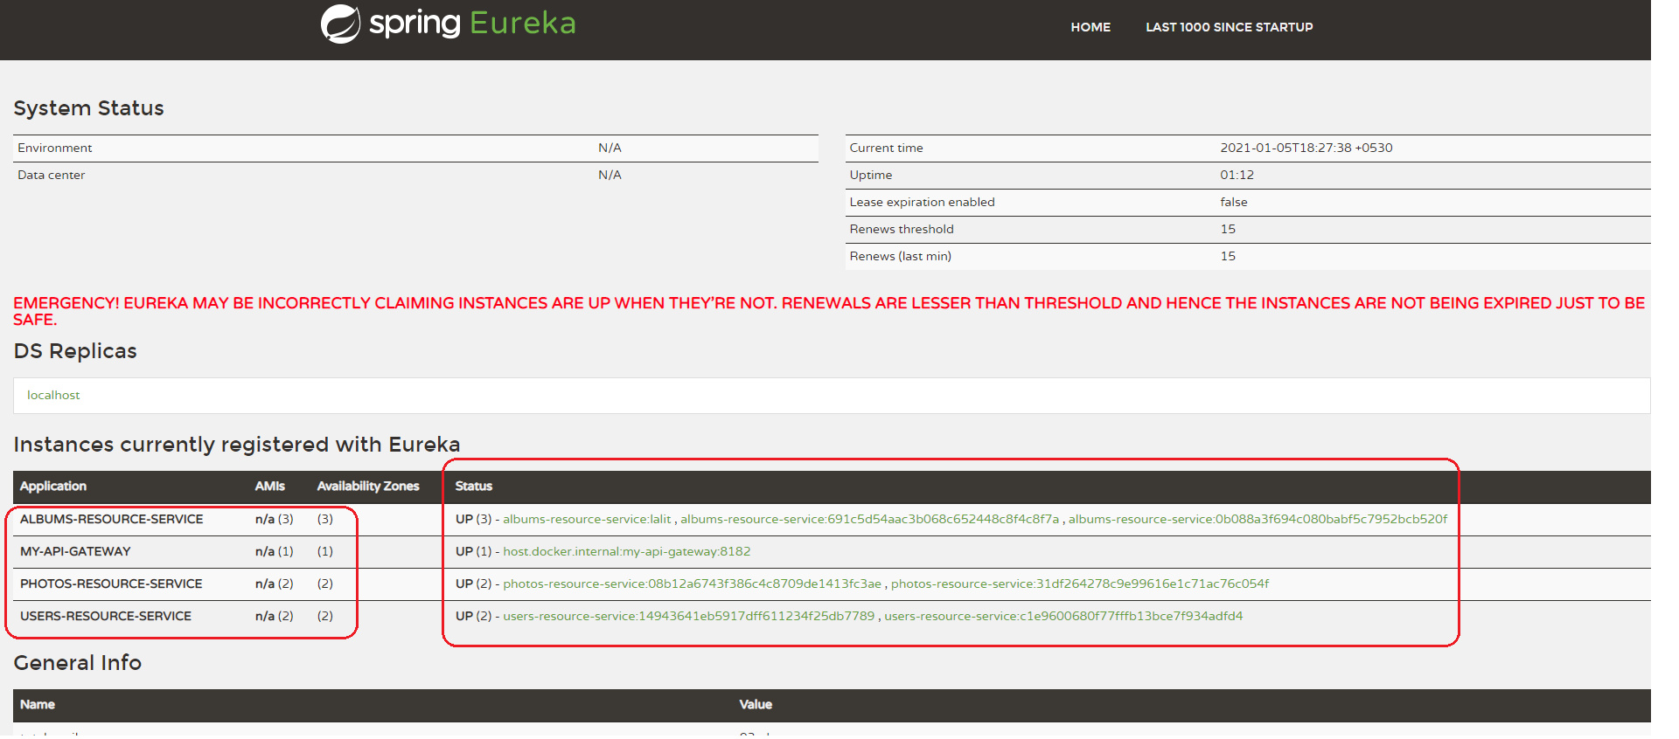

## OAuth 2 - MVC Web App

Lets learn how to create a very simple Spring Boot web application and configure it to use OAuth. So what I'm going to do first is I'm going to create a very simple Spring Boot Web application with one controller class and one Web page that will display a list of Albums when requested. This first example will be very simple and it will just help us to get started. We will then improve this example and we will make our Web application request a list of Albums from a protected health resource server. So before my Web application can get a list of albums from a protected albums resource server, it will need to authenticate user and acquire an access token. To do that, I will configure my Spring Boot application to communicate with authorization server. And once we have this configuration in place, if user is not authenticated, then they will be redirected to a page first.

|  |  |
| --- | --- |
|  | And then once a user has successfully logged in with their username and password, they will be able to get the requested list of albums to display list of albums. This time we will not return a list of albums hardcoded in the application itself, but we will make our Web application request this list of albums from an album through Resource Server by sending a request. We have Spring Cloud API Gateway and because our albums resource server is also a secure resource to get a list of Albums from our Spring boot web application we will need to include in this request a valid access token. All right, so let's learn how to implement this. |

Create a new Spring Boot Project

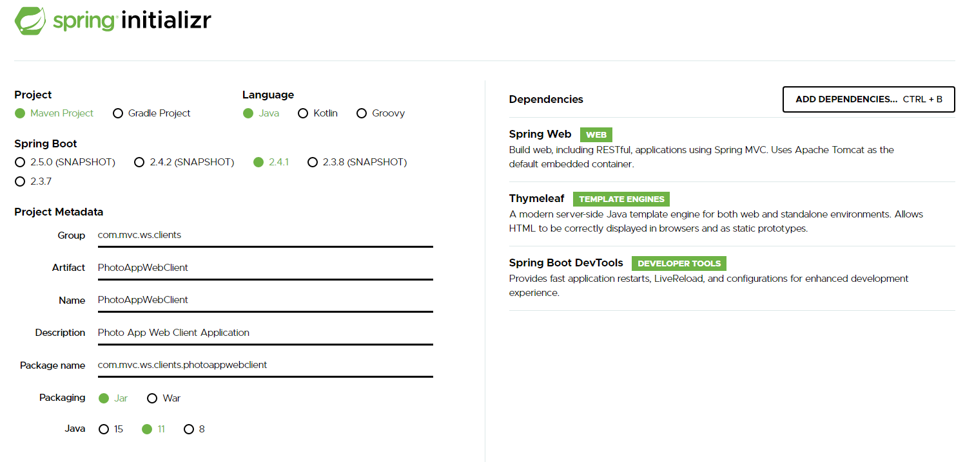

Dependencies of Web, Thymeleaf and DevTools added

Create a Controller class

package com.mvc.ws.clients.photoappwebclient.controllers;

import java.util.Arrays;

import java.util.List;

import org.springframework.beans.factory.annotation.Autowired;

import org.springframework.core.ParameterizedTypeReference;

import org.springframework.http.HttpEntity;

import org.springframework.http.HttpHeaders;

import org.springframework.http.HttpMethod;

import org.springframework.http.ResponseEntity;

import org.springframework.security.core.Authentication;

import org.springframework.security.core.annotation.AuthenticationPrincipal;

import org.springframework.security.core.context.SecurityContextHolder;

import org.springframework.security.oauth2.client.OAuth2AuthorizedClient;

import org.springframework.security.oauth2.client.OAuth2AuthorizedClientService;

import org.springframework.security.oauth2.client.authentication.OAuth2AuthenticationToken;

import org.springframework.security.oauth2.core.oidc.OidcIdToken;

import org.springframework.security.oauth2.core.oidc.user.OidcUser;

import org.springframework.stereotype.Controller;

import org.springframework.ui.Model;

import org.springframework.web.bind.annotation.GetMapping;

import org.springframework.web.client.RestTemplate;

import com.mvc.ws.clients.photoappwebclient.response.AlbumRest;

@Controller

public class AlbumsController {

@GetMapping("/albums")

public String getAlbums(Model model) {

AlbumRest album = new AlbumRest();

album.setAlbumId("albumOne");

album.setAlbumTitle("Album one title");

album.setAlbumUrl("http://localhost:8082/albums/1");

AlbumRest album2 = new AlbumRest();

album2.setAlbumId("albumTwo");

album2.setAlbumTitle("Album two title");

album2.setAlbumUrl("http://localhost:8082/albums/2");

model.addAttribute("albums", albums);

return "albums";

}

}

We have a get mapping for the getAlbums to make it a endpoint that can return Albums to us. We are returning some Albums here, the data is hard code for now, just to simulate. We are adding the list of albums to the model.addAttribute with name “albums”

**Displaying Albums on a HTML Page**

Create the Thymeleaf Page - albums.html

<!DOCTYPE html SYSTEM "http://www.thymeleaf.org/dtd/xhtml1-strict-thymeleaf-4.dtd">

<html xmlns=*"http://www.w3.org/1999/xhtml"*

xmlns:th=*"http://www.thymeleaf.org"*>

<head>

<meta charset=*"UTF-8"*>

<title>Insert title here</title>

</head>

<body>

<h1>Albums page</h1>

<div th:if=*"${albums.empty}"*>

<div>No albums found</div>

</div>

<div th:each="album : ${albums}">

<p><span th:text=*"${album.albumTitle}"*></span></p>

</div>

</body>

</html>

${albums} here should match the albums being returned from AlbumsController -> getAlbums()

**application.properties**

server.port = 8087

So this works for now, we can access the albums page and can see the hard coded albums being return to us.

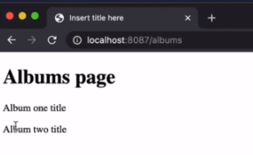

Add the Oauth 2 dependencies to the project now

<?xml version=*"1.0"* encoding=*"UTF-8"*?>

<project xmlns=*"http://maven.apache.org/POM/4.0.0"*

xmlns:xsi=*"http://www.w3.org/2001/XMLSchema-instance"*

xsi:schemaLocation=*"http://maven.apache.org/POM/4.0.0 https://maven.apache.org/xsd/maven-4.0.0.xsd"*>

<modelVersion>4.0.0</modelVersion>

<parent>

<groupId>org.springframework.boot</groupId>

<artifactId>spring-boot-starter-parent</artifactId>

<version>2.3.3.RELEASE</version>

<relativePath /> <!-- lookup parent from repository -->

</parent>

<groupId>com.mvc.ws.clients</groupId>

<artifactId>8-photoappwebclient-rest-template</artifactId>

<version>0.0.1-SNAPSHOT</version>

<name>8-photoappwebclient-rest-template</name>

<description>Photo app web client application</description>

<properties>

<java.version>11</java.version>

</properties>

<dependencies>

<dependency>

<groupId>org.springframework.boot</groupId>

<artifactId>spring-boot-starter-thymeleaf</artifactId>

</dependency>

<dependency>

<groupId>org.springframework.boot</groupId>

<artifactId>spring-boot-starter-web</artifactId>

</dependency>

<!-- https://mvnrepository.com/artifact/org.springframework.boot/spring-boot-starter-oauth2-client -->

<dependency>

<groupId>org.springframework.boot</groupId>

<artifactId>spring-boot-starter-oauth2-client</artifactId>

</dependency>

<dependency>

<groupId>org.springframework.boot</groupId>

<artifactId>spring-boot-devtools</artifactId>

<scope>runtime</scope>

<optional>true</optional>

</dependency>

<dependency>

<groupId>org.springframework.boot</groupId>

<artifactId>spring-boot-starter-test</artifactId>

<scope>test</scope>

<exclusions>

<exclusion>

<groupId>org.junit.vintage</groupId>

<artifactId>junit-vintage-engine</artifactId>

</exclusion>

</exclusions>

</dependency>

</dependencies>

<build>

<plugins>

<plugin>

<groupId>org.springframework.boot</groupId>

<artifactId>spring-boot-maven-plugin</artifactId>

</plugin>

</plugins>

</build>

</project>

This is all I need to do for now to start configuring my Web client application as oauth 2 client and write some of related code in it.

To configure OAuth 2 in our client application, and this will make or kind application redirect the user to an authorization server to authenticate, and then we will be able to read the token or JWT access token and make our client application communicate with protected resource servers by including the authorization access token in the authorization headers. So to configure the OAuth 2 properties, I will need to open the application.properties file of my photo client application and we'll provide a few configuration properties. I will place them in and I will walk you through. Now, each of these properties that I have just pasted is used to configure the OAuth 2 client. And this is why each of these properties has a prefix spring.security.oath2.client and registration. So this prefix here is exactly the same in each of these configuration properties. The value that comes after the prefix mywebclient here is a registration id and registration is a unique identifier for these client registration. So if you have multiple oauth clients registrations, for example, then this id, it will be different for each client.

**application.properties**

server.port = 8087

spring.security.oauth2.client.registration.**mywebclient**.client-id = photo-app-webclient

spring.security.oauth2.client.registration.**mywebclient**.client-secret = 5065bd8e-7cee-4f7a-b0d3-3848dce5010c

spring.security.oauth2.client.registration.**mywebclient**.scope = openid, profile, roles

spring.security.oauth2.client.registration.**mywebclient**.authorization-grant-type = authorization_code

spring.security.oauth2.client.registration.**mywebclient**.redirect-uri = http://localhost:8087/login/oauth2/code/mywebclient

In my case, as a registration id value. I've used mywebclient. But in your case you can come up with a different data, like, for example, my app or music shop or something related to your project. All right. So now the value of each of these client properties are unique to a client application that you have registered in your authorization server. And this time I'm using Keycloak as my identity provider server. So the values I have used here, they are related and they're relevant to the oauth client application that I have registered in my Keycloak server. So in my Keycloak server, I have registered a new client application with an ID photo-app-web-client. I've generated a new secret key for it and I've used these credentials here. And these properties file if you need to learn how to register and your client with Keycloak watch video in one of the previous sections and this video, of course, on how to do it. All right. So now when my first client application, when this project will be communicating with Keycloak, it will need to request an access token. And when requesting that access token, it will need to include certain scopes in the request. So the scopes that I need for this client application are provided here open ID profile and roles. The application might need to provide different scopes with this same request and my Keycloak server to provide me with an ID token. This is why I'm including openid scope and also include claims that contain user profile information and also user roles.

**application.properties**

server.port = 8087

spring.security.oauth2.client.registration.**mywebclient**.client-id = photo-app-webclient

spring.security.oauth2.client.registration.**mywebclient**.client-secret = 5065bd8e-7cee-4f7a-b0d3-3848dce5010c

spring.security.oauth2.client.registration.**mywebclient**.scope = openid, profile, roles

spring.security.oauth2.client.registration.**mywebclient**.authorization-grant-type = authorization_code

spring.security.oauth2.client.registration.**mywebclient**.redirect-uri =

http://localhost:8087/login/oauth2/code/mywebclient

If you need to review information about Open ID Connect and the ID token and the standard claims and the information that it can provide, please review a video of this in one of the previous sections that talks about open ID connect, and ID token. So with the next property, I'm specifying which oauth authorization flow this client application will use. And finally the redirect Uri that they have configured in my Keycloak for these auth client application. Now, it is very important to provide a correct value here for the redirect URI because otherwise things will not work. OK, so let me scroll to the right a little bit. The first part here in the redirect URI http localhost and port number is the domain name and the number on which this particular client application is running.

So I have photoappwebclient and it is running on localhost port number 8087. And this is why I provided http localhost port number 8087 as a redirect URI here. And I have also configured this same redirect URI right in my Keycloak server. The next part that starts with /login/oauth2/code this part will be the same for almost all of the authorization servers that you will use for a Keycloak, Google or Facebook. So you should not change this part and have it as a login/oauth2/code. The last part here, which is mywebclient, is the registration id, which I have used in each configuration property here, mywebclient, mywebclient, mywebclient. So each configuration property here has this registration ID. So I have used this same registration and in the redirect your home. Right. So this is it for now for the clients registration. Lets go ahead and configure the OAuth 2 provider properties.

### OAuth 2 Provider Properties

In this lesson, we will finalize the OAuth 2 configuration of our Web client application and we will add the provider configuration properties and we'll place them in here. Have a look at them in details, we can type thing from the screen or you can copy these properties from the project that I'm attaching with this video.

spring.security.oauth2.client.provider.**mywebclient**.authorization-uri =

http://localhost:8080/auth/realms/appsdeveloperblog/protocol/openid-connect/auth

spring.security.oauth2.client.provider.**mywebclient**.token-uri =

http://localhost:8080/auth/realms/appsdeveloperblog/protocol/openid-connect/token

spring.security.oauth2.client.provider.**mywebclient**.jwk-set-uri=

http://localhost:8080/auth/realms/appsdeveloperblog/protocol/openid-connect/certs

spring.security.oauth2.client.provider.**mywebclient**.user-info-uri =

http://localhost:8080/auth/realms/appsdeveloperblog/protocol/openid-connect/userinfo

spring.security.oauth2.client.provider.**mywebclient**.user-name-attribute = preferred_username

So these properties are needed for our Web client application to communicate with authorization providers. And I'm currently using Keycloak authorization and identity provider. But there is also an authorization provider like Google and there is also Facebook and Microsoft, and there is one from OCTA and others. So the property keys here will be the same for all of the OAuth authorization providers, but their values will differ. So the values that I have provided for each of these properties are unique to Keycloak. And if you look at the URI that I use in each property, it starts with the localhost and port number 8080. And this is because my Keycloak server is running on localhost:8080. In your case, it might be the same or it might be different. So please provide here the domain and the port number on which your authorization server is running in the deal. That will most likely be different in your URI is the real name.

In my case I have provided appsdeveloperblog as a real name here and this is because in my case I have configured every a realm called appsdeveloperblog. But if you have configured a Keycloak realm with a different name, then you must use that name in each right here and all other details they will be the same. And if you need to review how to create Keycloak realm, please refer to one of the previous video lessons in this video, of course, where we have created a Keycloak realm. With these properties, we have specified an end point to authenticate with the authorization server, a URL to acquire and access token, a URL endpoint to verify the signature of an access token and the URL endpoint containing user information. And finally, we have mapped the preferred user name token claim to a user name attribute. And this is all that we needed to do to configure our Web client application to work with OAuth 2 provider. So I will save application properties file and let's continue.

### Reading JWT Access Token

Lets learn how to get the JWT access token value, which you can then use in HTTP requests to other protected resource servers. All right. So how the successful authentication with the OAuth 2 identity provider server, like, for example, Keycloak or Facebook or a Google server. In the security context of your Web application, there will be an Authentication object created. So to get access to our JWT access token, we will need to use that authentication object. And there are different ways of how to get that authentication object. And one of the ways is to simply inject it into a method. The new controller class has a method argument so I can use my getAlbums method and then inject the authentication object this way.

@Controller

public class AlbumsController {

@GetMapping("/albums")

public String getAlbums(Model model,

@AuthenticationPrincipal OidcUser principal) {

. . .

}

And I'm ready to use it or because the authentication object is in the SecurityContextHolder we can also get it right away from there. So we will access SecurityContextHolder and from that you will need to get context and from the context, you need to get authentication like this and this will return you an authentication object, so you can simply assign it to an object with the name of your choice. I'm not going to use two authentication objects, so I will delete one and will remain this the variable back to authentication. So these are authentication objects.

Authentication authentication = SecurityContextHolder.*getContext*().getAuthentication();

OAuth2AuthenticationToken oauthToken = (OAuth2AuthenticationToken) authentication;

It will actually be an OAuth 2 Authentication object. So we will need to cast this object to an OAuth2AuthenticationToken. And I'm ready to use the Authentication token. All right, so these OAuth token objects, will need to be used together with OAuth2AuthorizationClientService and the client servers will be already available in your application and automatically as well. We don't need to create this OAuth2AuthorizationClientService ourselves because there is a lot of things that Spring framework does for us behind the scenes automatically. So to get hold of this client service object we will simply need to Autowire it into our controller class.

package com.mvc.ws.clients.photoappwebclient.controllers;

import java.util.List;

import org.springframework.beans.factory.annotation.Autowired;

import org.springframework.core.ParameterizedTypeReference;

import org.springframework.http.HttpEntity;

import org.springframework.http.HttpHeaders;

import org.springframework.http.HttpMethod;

import org.springframework.http.ResponseEntity;

import org.springframework.security.core.Authentication;

import org.springframework.security.core.annotation.AuthenticationPrincipal;

import org.springframework.security.core.context.SecurityContextHolder;

import org.springframework.security.crypto.codec.Base64;

import org.springframework.security.oauth2.client.OAuth2AuthorizedClient;

import org.springframework.security.oauth2.client.OAuth2AuthorizedClientService;

import org.springframework.security.oauth2.client.authentication.OAuth2AuthenticationToken;

import org.springframework.security.oauth2.core.oidc.OidcIdToken;

import org.springframework.security.oauth2.core.oidc.user.OidcUser;

import org.springframework.stereotype.Controller;

import org.springframework.ui.Model;

import org.springframework.web.bind.annotation.GetMapping;

import org.springframework.web.client.RestTemplate;

import com.mvc.ws.clients.photoappwebclient.response.AlbumRest;

@Controller

public class AlbumsController {

@Autowired

OAuth2AuthorizedClientService oauth2ClientService;

@Autowired

RestTemplate restTemplate;

@GetMapping("/test")

public String test() {

return "tested";

}

@GetMapping("/albums")

public String getAlbums(Model model,

@AuthenticationPrincipal OidcUser principal) {

System.out.println("getAlbums called ");

Authentication authentication = SecurityContextHolder.getContext().getAuthentication();

System.out.println("Authentication " + authentication.getName());

OAuth2AuthenticationToken oauthToken = (OAuth2AuthenticationToken) authentication;

OAuth2AuthorizedClient oauth2Client = oauth2ClientService.loadAuthorizedClient(

oauthToken.getAuthorizedClientRegistrationId(), oauthToken.getName());

String jwtAccessToken = oauth2Client.getAccessToken().getTokenValue();

System.out.println("jwtAccessToken = " + jwtAccessToken);

System.out.println("Principal = " + principal);

OidcIdToken idToken = principal.getIdToken();

String idTokenValue = idToken.getTokenValue();

System.out.println("idTokenValue = " + idTokenValue);

AlbumRest album = new AlbumRest();

album.setAlbumId("albumOne");

album.setAlbumTitle("Album one title");

album.setAlbumUrl("http://localhost:8082/albums/1");

AlbumRest album2 = new AlbumRest();

album2.setAlbumId("albumTwo");

album2.setAlbumTitle("Album two title");

album2.setAlbumUrl("http://localhost:8082/albums/2");

List<AlbumRest> albums = List.of(album, album2);

model.addAttribute("albums", albums);

return "albums";

}

}

And now we have the ClientService and the OAuth2AuthenticationToken, we can use them together to get the value of JWT access token and first step will be to get the OAuth 2 client object. So I will use an instance of my OAuthClientService. And that will allow me to load the authorized client and I will need to give it a registration ID and this is OAuth 2 client registration ID and we can get it from OAuth token by calling getAuthorizedClientRegistrationId and the second parameter is user's username, so we can also get it from OAuthToken. This call to loadAuthorizedClient method will give us an object of OAuth2AuthorizedClient. And I'm now ready to use OAuth2AuthorizedClient to get the JWT access token and here's how to do it.

String jwtAccessToken = oauth2Client.getAccessToken().getTokenValue();

System.*out*.println("jwtAccessToken = " + jwtAccessToken);

. . .

I will use an instance of the client and I can go get access token. And from this access token, I can get the token value itself like this. And that's going to be a string value, which is going to be my JWT access token. Like this, and I can now print out the JWT access token to see how it looks. All right, so now let's run this application and see how it works, I will save my albums controller class. Now I'm ready to run it and run as a springboot application. My application is up and running now, I'll bring in a new browser window. And I will go to http://localhost:8087/albums. I'm redirected to authenticate, I will authenticate. It was my albums page, so so far everything is working. Well, let's have a look at the console and here we have the JWT access token printed above the principal and above the token.

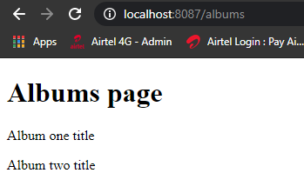

2021-01-07 08:28:39.036 INFO 3252 --- [nio-8087-exec-1] o.s.web.servlet.DispatcherServlet : Completed initialization in 5 ms

getAlbums called

Authentication lalit

oauthToken lalit oauthToken.getAuthorizedClientRegistrationId() mywebclient

oauth2Client org.springframework.security.oauth2.client.OAuth2AuthorizedClient@6990127d

jwtAccessToken = eyJhbGciOiJSUzI1NiIsInR5cCIgOiAiSldUIiwia2lkIiA6ICJzVm1qNGluTlU5S2VvbDJRNVktSVFsTVlRTVk3NzJ6TU1VMFJ3UF9NUTJFIn0..Ok8upWITXt2hwdSl94crzjzUPdj9P_yXenUVvPgqFFlT5-j3x5JcJ9xeSpbygUzjvRpECydYw8F0sItci33CpLyY4Q7MpXYllIY-b3o3TNL4pCa1UWCrc5KYR6ITG3y_aXeCCjXy-KKhF_GbPMpau9iahzLSUTjm6fyK72NMEoJwbY_C2HxCpYWaT6mqXcPCPCst6htWBSxLrkkq15hvh_m5nBEcxEFygsfyIoyv4QY1WPWFiUeAeu_YGF_Mey7Lwuy-BbgsRbic97VOWvp7Nbl7AVPFlohcykBT03wKJRuhSCTkgl9Bc-KKuTfpc2vr0qp-s5j9smWwP24R1ux1vQ

Principal = Name: [lalit], Granted Authorities: [[ROLE_USER, SCOPE_email, SCOPE_openid, SCOPE_profile]], User Attributes: [{at_hash=d_u-D_TdyuIZj1H1cGi_1A, sub=76f083ea-d4ea-48f2-8c24-251bc981b971, email_verified=true, iss=http://localhost:8180/auth/realms/appsdeveloperblog, typ=ID, preferred_username=lalit, given_name=Lalit, nonce=kzNs1z3-VdcEfyIK-P6tZolhi2rd_iPnPQY05pMOo_w, aud=[photo-app-code-flow-client], acr=1, azp=photo-app-code-flow-client, auth_time=2021-01-07T02:58:43Z, name=Lalit Nagpal, exp=2021-01-07T03:03:43Z, session_state=58def388-ce2d-46e2-9736-62bd12c8255f, family_name=Nagpal, iat=2021-01-07T02:58:43Z, email=lalit2801@gmail.com, jti=cdfedab4-fc7c-48ec-a9bb-4492276187f7}]

idTokenValue = eyJhbGciOiJSUzI1NiIsInR5cCIgOiAiSldUIiwia2lkIiA6ICJzVm1qNGluTlU5S2VvbDJRNVktSVFsTVlRTVk3NzJ6TU1VMFJ3UF9NUTJFIn0..T5QR0p6qNTce7B4yo7wH-xqkNteOa0HusivW4VV_ZiXu8OtQSxCJFRgNH-gg7iArafsdYvi147ztd_Tjd5oDSjc_42FqbeXpjocPZjZMNyQ_F0GkJhG4_yI16QyeW91a6IkPWqojLmc2Nw7N7o5hKEgWrbtb1T-7v-KHSVvBIXx3W9gJjDIMbimrtvUhkoYOX2AwYSg4MoBS7eNX0A7DeVW9R7OCYkpcU3ueGd__iMziYiCFfI7CGx_f2VM9nm_e1GetCAs7kKaEl9YUsvfnTGL07W_WLhwxsgE2_7944ReC06R7wFS1L99nHiKpNfT77zwhf-_WPsEd8PJFPMqm1g

2021-01-07 08:29:56.415 INFO 3252 --- [ Thread-1] o.s.s.concurrent.ThreadPoolTaskExecutor : Shutting down ExecutorService 'applicationTaskExecutor'

Well, so it looks like a correct base64 encoded key, the access token, which if needed, we can copy. And decode using online tool so I can take it and go to a new browser window, open up jwtio. Pasted here. And prevue on the right side. All right, so everything is working well, let's continue.

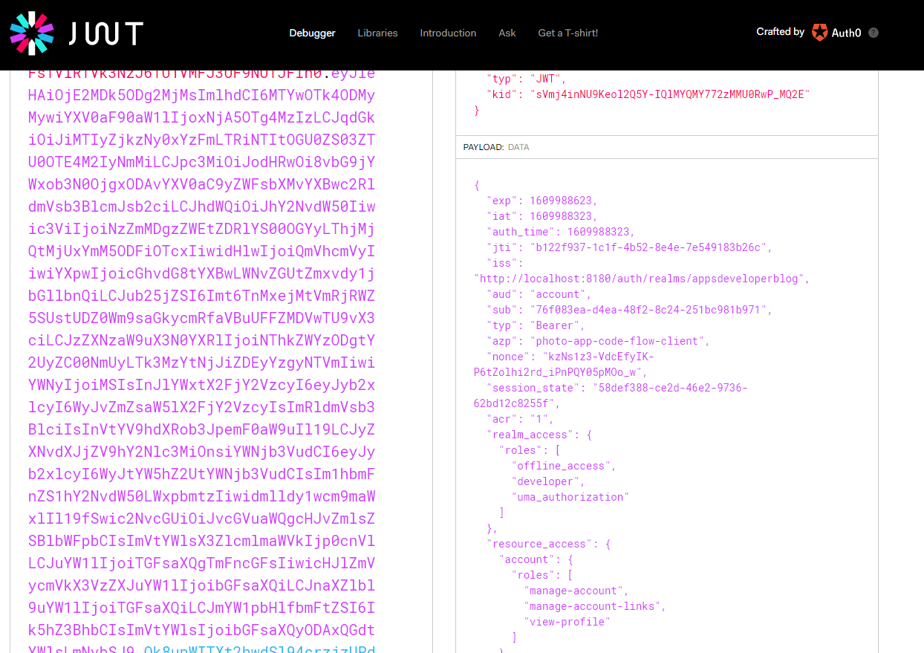

### HTTP Request to an Internal Resource Server

Lets send a http request to a protected resource server to get a list of albums. Currently our getAlbums method returns a list of albums which is hard coded. But now we will request this list of albums from a protected OAuth Resource Server. And because it is a protected oauth resource server, we will need to include a valid access token when sending a request to get this list of albums. All right, so let's do it. Lets comment out, this hard coded list of albums and add new code. So to send http get request to albums resources, I will use a rest template. And if you're not familiar with this template, then I encourage you to Google for it and learn more about it. But briefly, it is a central Spring class that allows us to send http requests and get back the http response and have the details of http response available to us as java objects. All right. So let's try using it. I will of the Autowire, an instance of RestTemplate and I will use the @Autowire annotation. So this Rest endpoint object, it offers us an exchange method and this exchange method takes a number of parameters. I'll pick the one that accepts URL and should implement it and response entity.

@Controller

public class AlbumsController {

@Autowired

OAuth2AuthorizedClientService oauth2ClientService;

@Autowired

RestTemplate restTemplate;

@GetMapping("/albums")

public String getAlbums(Model model,

@AuthenticationPrincipal OidcUser principal) {

Authentication authentication = SecurityContextHolder.getContext().getAuthentication();

OAuth2AuthenticationToken oauthToken = (OAuth2AuthenticationToken) authentication;

OAuth2AuthorizedClient oauth2Client = oauth2ClientService.loadAuthorizedClient(

oauthToken.getAuthorizedClientRegistrationId(), oauthToken.getName());

String jwtAccessToken = oauth2Client.getAccessToken().getTokenValue();

System.*out*.println("jwtAccessToken = " + jwtAccessToken);

System.*out*.println("Principal = " + principal);

OidcIdToken idToken = principal.getIdToken();

String idTokenValue = idToken.getTokenValue();

System.*out*.println("idTokenValue = " + idTokenValue);

String url = "http://localhost:8082/albums";

HttpHeaders headers = new HttpHeaders();

headers.add("Authorization", "Bearer " + jwtAccessToken);

HttpEntity<List<AlbumRest>> entity = new HttpEntity<>(headers);

ResponseEntity<List<AlbumRest>> responseEntity = restTemplate.exchange(url, HttpMethod.*GET*,

entity, new ParameterizedTypeReference<List<AlbumRest>>() {});

List<AlbumRest> albums = responseEntity.getBody();

model.addAttribute("albums", albums);

return "albums";

}

So pick the one that takes the values - first value that exchange method takes in is URL, please note that this URL is the url of the albums webservice endpoint that goes through the API Gateway. So the point number two that I'm using in this euro is the point number of my API gateway and the forwards that humans use. The request my that I've created in my API gateway to round this request to albums resource server All right, so the next parameter that exchange method takes in is the type of HTTP method that needs to be executed. And I'm going to send HTTP GET. Now, the next request parameter is Http request entity, and this entity is an entity object that can contain a http header for example. I'm not going to send anything in the body of a request, but I will need to include JWT access token in the authorization header of this HTTP get request. So first of all, we will create the Headers object. And I will add that the JWT token to the headers object. So we'll use the method and the first parameter here is the name of name of the http header and for the authorization, whether it should be authorization and the value is Bearer space and then access token, which we already have as jwtAccessToken above.

So the same syntaxes that we have used when sending request using Postman. There, we used to create authorization header and then add a value which starts with Bearer and then space and the value of access token. Now we have headers object and I added it to a request entity, and to do that I will create an instance of HttpEntity object first and they will use a constructor that takes in request headers as an argument. We will give it the HttpHeaders object. And now I can take this entity object and give it to exchange it as the next parameter like this. And finally, we need to tell our rest endpoint the response data type. And in response back, we expect a list of Albums and each one Album record will be an object of AlbumRest data type. We already have AlbumRest data type. We already have a class that is called AlbumRest. So I will use exactly the same class here. And the way we specify data type is by creating an object of ParameterizedTypeReference. And this ParameterizedTypeReference is used to pass generic type information, so I will pass in the List<AlbumRest> like this and this one is a little bit tricky. I will need to add parentheses because I'm creating a new object and then opening and closing curly brackets like this.

new ParameterizedTypeReference<List<AlbumRest>>() {}

So when this request executed, it will return back a response entity. So we'll need to assign the result of this request to a response entity, object that will contain a list of albums.

ResponseEntity<List<AlbumRest>> responseEntity = restTemplate.exchange(url, HttpMethod.*GET*,

entity, new ParameterizedTypeReference<List<AlbumRest>>() {});

And to get albums released from this response entity, I can use the getBody method, so I will use an instance of response entity and then I will call the getBody method. And this call to getBody method will give me a list of objects that are of AlbumRest data type. And now when I have a list of albums, I can pass it on to my HTML page to be displayed, so I will take this list of albums or bring back the model and attribute one of code.

List<AlbumRest> albums = responseEntity.getBody();

model.addAttribute("albums", albums);

And then instead of adding hardcoded list of albums, I will give it the album subject that contains the list of albums received from a remote albums resource server. All right. So let's save this and let's run our application and see how it works. But before doing it, I have an underlining is just check it. It says HttpEntity it is a road type, reference to generic should be parameterized. I will provide it List of Albums here and that should fix it. So let's run it now and see if it works.

HttpEntity<List<AlbumRest>> entity = new HttpEntity<>(headers);

So right now we have 4 services

8-discovery-service - Eureka Server ( Discovery Service ) running on port # 8010

8-albums-resource-server-eureka-client – Eureka Client – Running on random port

Eureka Authorization Server is running on port # 8180

8-api-gateway-eureka-client – Api Gateway running on port # 8182

8-photoappwebclient-rest-template – Rest Client invoking albums microservice via the API Gateway – running on port 8087

All right, so we have implemented a very simple Web application that uses the REST Template from the client to request a list of albums from a separately running Albums Resource Server. And because the resource server that we have is protected resource server, we needed to write code to include authorization access token into HTTP header of that request. It works well, but if we need to send the request to a different web service end point that our resource server exposes, we will need to again write code to attach an access token to that request as well. And we will need to do it every time our web application communicates with the resource server. There is a way to configure our HTTP client to include an access token for each http request separately. We will then not need to write code to include an access token for each http request separately. We could do it with rest template as well but unfortunately they provided OAuth support for REST template Client has also been deprecated and we do not have it anymore with Sprint Security five. So in applications that OAuth 2 and Sprint Security 5 framework, we will need to use a different http client that is called the WebClient. And the next step for us will be to update the configure dependencies of our application to include Web client support.

#### Errors - This needs debugging

### WebClient Approach

WebClient is a part of Spring Reactive framework and spring webflux libraries, so to make our project be able to use Web client, we will need to add this framework webflux dependancy. And to do that, we will go to pom.xml file and I will add a new dependancy. And this is because web client comes from a reactive framework and reactor and that is a new runtime which provides an asynchronous and non block runtime that supports reactive streams back pressure for client and server over the range of different protocols like UDP, TCP and HTTP. So we'll need to add a reactor netty dependency as well and there will place the new dependency right here with me for my my code and the reactor netty dependency has group io.projectreactor.netty and the artifact is reactor-netty. All right, so now one of our dependencies are in place. We can start using web client.

pom.xml

<?xml version=*"1.0"* encoding=*"UTF-8"*?>

<project xmlns=*"http://maven.apache.org/POM/4.0.0"*

xmlns:xsi=*"http://www.w3.org/2001/XMLSchema-instance"*

xsi:schemaLocation=*"http://maven.apache.org/POM/4.0.0 https://maven.apache.org/xsd/maven-4.0.0.xsd"*>

<modelVersion>4.0.0</modelVersion>

<parent>

<groupId>org.springframework.boot</groupId>

<artifactId>spring-boot-starter-parent</artifactId>

<version>2.3.3.RELEASE</version>

<relativePath /> <!-- lookup parent from repository -->

</parent>

<groupId>com.mvc.ws.clients</groupId>

<artifactId>8-photoappwebclient-rest-template</artifactId>

<version>0.0.1-SNAPSHOT</version>

<name>8-photoappwebclient-rest-template</name>

<description>Photo app web client application</description>

<properties>

<java.version>11</java.version>

</properties>

<dependencies>

<dependency>

<groupId>org.springframework.boot</groupId>

<artifactId>spring-boot-starter-thymeleaf</artifactId>

</dependency>

<dependency>

<groupId>org.springframework.boot</groupId>

<artifactId>spring-boot-starter-web</artifactId>

</dependency>

<!-- https://mvnrepository.com/artifact/org.springframework.boot/spring-boot-starter-oauth2-client -->

<dependency>

<groupId>org.springframework.boot</groupId>

<artifactId>spring-boot-starter-oauth2-client</artifactId>

</dependency>

<dependency>

<groupId>org.springframework</groupId>

<artifactId>spring-webflux</artifactId>

</dependency>

<dependency>

<groupId>io.projectreactor.netty</groupId>

<artifactId>reactor-netty</artifactId>

</dependency>

<dependency>

<groupId>org.springframework.boot</groupId>

<artifactId>spring-boot-devtools</artifactId>

<scope>runtime</scope>

<optional>true</optional>

</dependency>

<dependency>

<groupId>org.springframework.boot</groupId>

<artifactId>spring-boot-starter-test</artifactId>

<scope>test</scope>

<exclusions>

<exclusion>

<groupId>org.junit.vintage</groupId>

<artifactId>junit-vintage-engine</artifactId>

</exclusion>

</exclusions>

</dependency>

</dependencies>

<build>

<plugins>

<plugin>

<groupId>org.springframework.boot</groupId>

<artifactId>spring-boot-maven-plugin</artifactId>

</plugin>

</plugins>

</build>

</project>

**Create WebClient Bean**

Before we can inject an instance of a WebClient object into our controller class, we'll need to create and then instance of it and make it available in application context. So let's do that. I will go to my WebClient project, open up its main application class file here where I have the public static void main and below the function that creates a new instance of this template. I will add a new function. So that will be

package com.mvc.ws.clients.photoappwebclient;

import org.springframework.boot.SpringApplication;

import org.springframework.boot.autoconfigure.SpringBootApplication;

import org.springframework.context.annotation.Bean;

import org.springframework.web.client.RestTemplate;

import org.springframework.web.reactive.function.client.WebClient;

@SpringBootApplication

public class PhotoAppWebClientApplication {

public static void main(String[] args) {

SpringApplication.run(PhotoAppWebClientApplication.class, args);

}

@Bean

public RestTemplate getRestTemplate() {

return new RestTemplate();

}

@Bean

public WebClient webClient() {

return WebClient.builder().build();

}

}

This object, however, is not yet configured to be used with a OAuth 2. So to configure a web client, object to work with or still will need to create a new filter object and apply its configuration to our WebClient object. And it is this filter that will include an access token and to every request that this will client object will send. And the good news is that we do not need to create this filter ourselves, these spring framework that has already provided with a ready to use class.

ServletOAuth2AuthorizedClientExchangeFilterFunction oauth2 =

new ServletOAuth2AuthorizedClientExchangeFilterFunction();

So the name of the class is very long. So the name of the class that we'll need to use is ServletOAuth2AuthorizedClientExchangeFilterFunction. This class depends on two other objects that I will need to inject, and the first object that I will need to inject is clientRegistrationRepository. And I will use the same name for the variable. So this client registration repository is a repository of the registered OAuth clients now, now that we have injected it we will need to also inject it as a parameter through this filter function like this. And the second object that I will need to inject into my client is of data type OAuth2AuthorizedClientRepository. And OAuth2AuthorizedClientRepository, it stores information about the clients that have already been authorized. Now, when they have its object, I will also include it as a parameter to my filter function as a second parameter like this.

@Bean

public WebClient webClient(ClientRegistrationRepository clientRegistrationRepository,

OAuth2AuthorizedClientRepository oAuth2AuthorizedClientRepository) {

ServletOAuth2AuthorizedClientExchangeFilterFunction oauth2 =

new ServletOAuth2AuthorizedClientExchangeFilterFunction(

clientRegistrationRepository, oAuth2AuthorizedClientRepository);

oAuth2.setDefaultOAuth2AuthorizedClient(true);

return WebClient.builder().build();

}

So now we need to use this OAuth object and call this default OAuth to authorize client function with a value of true.

oAuth2.setDefaultOAuth2AuthorizedClient(true);

And this will make it to automatically detect the client configuration that he needs to use based on the current authentication object. All right. And finally, we will need to apply this OAuth 2 configuration to our Web client object and to do that right after the builder.

return WebClient.builder().apply(oAuth2.oauth2Configuration()).build();

So this configuration will make an access token be included into every single request that is sent using this WebClient object. But be careful not to use this WebClient object to communicate with other third party web services, because otherwise you will send out the user's AccessToken to a third party Web service and an access token will become compromised. So if you need your application to send http requests to other third party web services, use a different object of http client. All right. So now we have our WebClient object that we can inject it into a controller class and use it to communicate with a protected resource center that we have.

The complete class now

package com.mvc.ws.clients.photoappwebclient;

import org.springframework.boot.SpringApplication;

import org.springframework.boot.autoconfigure.SpringBootApplication;

import org.springframework.context.annotation.Bean;

import org.springframework.security.oauth2.client.registration.ClientRegistrationRepository;

import org.springframework.security.oauth2.client.web.OAuth2AuthorizedClientRepository;

import org.springframework.security.oauth2.client.web.reactive.function.client.ServletOAuth2AuthorizedClientExchangeFilterFunction;

import org.springframework.web.client.RestTemplate;

import org.springframework.web.reactive.function.client.WebClient;

@SpringBootApplication

public class PhotoAppWebClientApplication {

public static void main(String[] args) {

SpringApplication.run(PhotoAppWebClientApplication.class, args);

}

@Bean

public RestTemplate getRestTemplate() {

return new RestTemplate();

}

@Bean

public WebClient webClient(ClientRegistrationRepository clientRegistrationRepository,

OAuth2AuthorizedClientRepository oAuth2AuthorizedClientRepository) {

ServletOAuth2AuthorizedClientExchangeFilterFunction oAuth2 =

new ServletOAuth2AuthorizedClientExchangeFilterFunction(clientRegistrationRepository,

oAuth2AuthorizedClientRepository);

oAuth2.setDefaultOAuth2AuthorizedClient(true);

return WebClient.builder().apply(oAuth2.oauth2Configuration()).build();

}

}

Now, that we have a WebClient bean, we can get it Autowired to our control class, so let's do that first and we'll go to my AlbumsController class and I will wire my WebClient. I don't need the RestTemplate now, so I will remove that. And I'm going to use it now, the OAuth 2 configuration that we have provided when creating this WebClient bean will add the access token to a request for us. So all this code that I have that reads an access token and adds the access control token to the header etc. I don't need it anymore so I can delete it.

So now I will use my WebClient object to fetch a list of albums from a resource server. I will use get and then URI. And I will use this string http localhost port number of my Spring Cloud API Gateway and then /albums. Then I will use retrieve the bodyToMono. And because I need to read a list of albums from http response I'll need to provide Parameterized type here. And finally, I will block now, if you're using that client in a reactive stream, then you would not normally block here. But for this example, it's okay to block. All right.

package com.mvc.ws.clients.photoappwebclient.controllers;

import java.util.List;

import org.springframework.beans.factory.annotation.Autowired;

import org.springframework.core.ParameterizedTypeReference;

import org.springframework.http.HttpEntity;

import org.springframework.http.HttpHeaders;

import org.springframework.security.core.Authentication;

import org.springframework.security.core.annotation.AuthenticationPrincipal;

import org.springframework.security.core.context.SecurityContextHolder;

import org.springframework.security.oauth2.client.OAuth2AuthorizedClient;

import org.springframework.security.oauth2.client.OAuth2AuthorizedClientService;

import org.springframework.security.oauth2.client.authentication.OAuth2AuthenticationToken;

import org.springframework.security.oauth2.core.oidc.OidcIdToken;

import org.springframework.security.oauth2.core.oidc.user.OidcUser;

import org.springframework.stereotype.Controller;

import org.springframework.ui.Model;

import org.springframework.web.bind.annotation.GetMapping;

import org.springframework.web.reactive.function.client.WebClient;

import com.mvc.ws.clients.photoappwebclient.response.AlbumRest;

@Controller

public class AlbumsController {

@Autowired

OAuth2AuthorizedClientService oauth2ClientService;

@Autowired

WebClient webClient;

@GetMapping("/test")

public String test() {

return "tested";

}

@GetMapping("/albums")

public String getAlbums(Model model,

@AuthenticationPrincipal OidcUser principal) {

System.out.println("getAlbums called ");

String url = "http://localhost:8182/albums";

List<AlbumRest> albums = webClient.get()

.uri(url)

.retrieve()

.bodyToMono(new ParameterizedTypeReference<List<AlbumRest>>() { })

.block();

model.addAttribute("albums", albums);

return "albums";

}

}

All right. And this is it. This is all I needed to do to make my Web client to send the request to a protected albums resource center and feature list of albums. So let's try how it works in this form.

To see if my client is able to fetch a list of albums from a protected album resource, I I'll start up all of my projects first. So our first discovery Service then the albums resource server then the gateway. And finally, the photo client application. Now, while my projects are running, I will bring a new browser window and request for http://localhost:8087/albums. I'm redirected to authorization server to authenticate, so I will provide my username and password. And login. And here we go, Authentications successful and I see a list of albums that was returned from protected Albums Resource Server, and this means that my Web client was able to successfully fetch a list of albums from a resource server. And this would not work if an access token was not included in the authorization header. All right. So everything is working well and we now know how to use WebClient instead of Rest Template and we know how to configure Web client so that an access token is automatically included into each request that our client is making.

#### Errors - This needs debugging

## OAuth 2 – Social Login

Lets learn how to configure your Spring Boot application to enable users to log in to your Web application with their Facebook or Google accounts, or even let users login into your application with another external authentication provider, like, for example, Okta or KeyCloak. So here's what we are going to build in the lessons we're going to create a new spring and we see web application with two legitimate pages. One page will be public and protected page, and it will be available to anybody. Another page will be secured with or through, and this page will open only if user successfully logs in with their username and password. So you will learn how to configure sprint security in your web application to let user login with their Facebook account or Google account, and also how to let users log in with their external OAuth 2 authentication providers like, for example, OCTA. And when user attempts to access the protected page on your website, then if we configure our application to support Google login and if user has not yet authenticated, then he or she will be redirected to Google login to login with their Google username and password. The authentication will take place on Google site and user will need to provide their Google username and password and the ones that successfully log in, the protected page will load. Or if we configure our application to support authentication provider, then one user tries to access protected page and they are not yet authenticated. Then user will be redirected to Okta for authentication and once the user successfully logs in with their Okta credentials, then they will be redirected back to our web application and the protected page will load. All right, so let's learn how to do it.

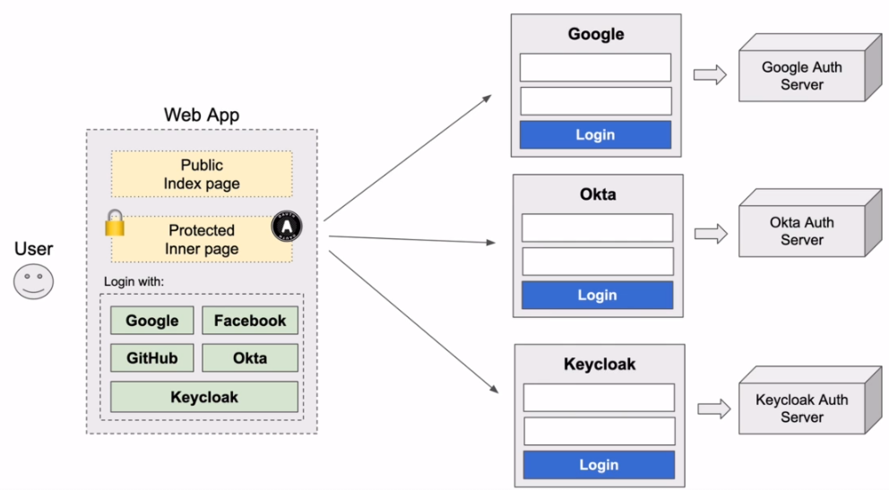

I'm going to create a new Spring MVC Web application, and if you already have a new web application, you will use or you simply want to continue using existing web application that you have, then please go ahead and skip this video lesson. But in this video, I will create a new project with the needed dependencies for it. So I will bring up a new browser window. And will open up start.spring.io here. Now I'm ready to add dependencies and it already suggests me to select Spring Boot Dev Tools. This is going to be a Web application, so the next dependancy that I will add will be Spring Web. Now, I will also use the theamleaf template engine, so I will look for spring boot starter theamleaf. And finally, I will add the OAuth to support dependancy into my application, so I will look for OAuth client. And then will bring into my project spring security dependencies and everything else that is needed to secure my application with OAuth 2. All right. So now I will click on generate a new project, and then I will incorporate this newly generated Mavin project into my development environment.

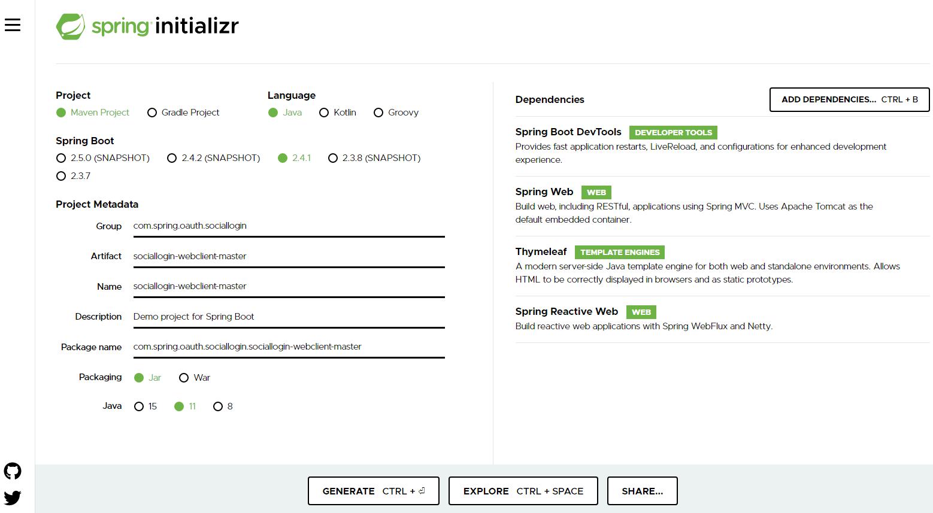

### Protected Resource Controller Class

I'm going to create a protected home page ressource, it is going to be this resource page that can be accessed only by authenticated user. We will work on http security configuration a little bit later in a different lesson. But in this lesson, will create a controller class that will handle http request. It will then try to read the name of the currently authenticated user and it will then pass this name to be displayed in HTML page that will be rendered with a thymeleaf template engine. So let's create a controller class.

All right, so I will annotate it with a controller annotation and I will input this controller annotation. Next, I will create a method that will be executed when home html page is requested, so I'll create a public void method that will call it display homepage. And to me, this method is triggered when a user tries to open the forward /home url path in their browser window. Annotate this method with a @GetMapping. And now to make this method, to be able to access the details of currently authenticated user, inject into this method OAuth2User object, and the way we do it is with the help with @AuthenticationPrincipal annotation. And that will help me to inject both to user and it will assign it to a principle object like this. And now we can check if this principal object is not null and if it is not null, then I can access its attributes.

package com.appsdeveloperblog.clients.sociallogin.SocialLoginWebClient.controllers;

import org.springframework.security.core.annotation.AuthenticationPrincipal;

import org.springframework.security.oauth2.core.user.OAuth2User;

import org.springframework.stereotype.Controller;

import org.springframework.ui.Model;

import org.springframework.web.bind.annotation.GetMapping;

@Controller

public class HomePageController {

@GetMapping("/home")

public String displayHomePage(Model model, @AuthenticationPrincipal OAuth2User principal) {

if (principal != null) {

String name = principal.getAttribute("name");

model.addAttribute("name",name);

}

return "home";

}

}

The attribute that I want to get is name. Again, but I will try to read the name attribute and I will assign it to a name like this, now I need to pass this name of a principle user to be rendered in HTML view page and to do that, that will first inject the model object. And now I can add the name to my model object and I will use model and then add an attribute and this attribute will take a key value pairs. So the key will be name, and the value that it will hold will be name object that we have like this. And finally, I will make this method to return the name of the view that will be responsible for displaying this information. So I will add the return value. And the name of the View will be home, so home is going to be the name of the HTML page that I will need to create. But now, because my method now returns string value, I'll need to change the return data type from void to string. All right. So this is it. My method is ready, lets create an html page to display the name of the principal user if it is available.

Lets create an HTML page that will be protected page and it will display only if the user is authenticated. So I will go to my project, social login web client and their source, the resources folder. I will select templates folder and inside of templates folder. I will create a new HTML file. And the reason I called it home.html is because the view name that I am returning in controller should match that.

<!DOCTYPE html SYSTEM "http://www.thymeleaf.org/dtd/xhtml1-strict-thymeleaf-4.dtd">

<html xmlns=*"http://www.w3.org/1999/xhtml"*

xmlns:th=*"http://www.thymeleaf.org"*>

<head>

<meta charset=*"UTF-8"*>

<title>Insert title here</title>

</head>

<body>

<div>Welcome <span th:text = *"${name}"*/></div>

<div><a href=*"/logout"*>Logout</a></div>

</body>

</html>

Lets create one more controller class and also HTML page, and this resource is going to be publicly available to all users. It will be available even to the users who are not authenticated now because we have added oath to kind dependancy to our project. All resource pages that we create will require user indication automatically. But in the following video, listen, we will configure sprint security so that user authentication is not required to access this page.

**IndexPageController.java**

package com.appsdeveloperblog.clients.sociallogin.SocialLoginWebClient.controllers;

import org.springframework.stereotype.Controller;

import org.springframework.ui.Model;

import org.springframework.web.bind.annotation.GetMapping;

@Controller

public class IndexPageController {

@GetMapping("/")

public String displayIndexPage(Model model) {

return "index";

}

}

**index.html**

<!DOCTYPE html>

<html>

<head>

<meta charset="UTF-8">

<title>Insert title here</title>

</head>

<body>

<div> <a href="/home">Home page</a> </div>

</body>

</html>

**Configure Http Security now for this application**

We will configure HTTP security of our Web application and we will enable the OAuth 2 login. So to do that or create a new Java class that extends WebSecurityConfigurerAdapter and enables the Web Security. So I'll go to my project and create a new class. And we'll put it into a package security. And I will call this new class Web security. To configure http security I need to make this class extend the WebSecurityCconfigurerAdapter. And we'll need to add @EnableWebSecurity by adding the this annotation above the class name. To configure HTTP security, I will need to override one method in this class, it is protected void the method is called configure and it takes one argument, which is HTTP security object. And it can throw an exception.

package com.appsdeveloperblog.clients.sociallogin.SocialLoginWebClient.security;

import org.springframework.beans.factory.annotation.Autowired;

import org.springframework.security.config.annotation.web.builders.HttpSecurity;

import org.springframework.security.config.annotation.web.configuration.EnableWebSecurity;

import org.springframework.security.config.annotation.web.configuration.WebSecurityConfigurerAdapter;

@EnableWebSecurity

public class WebSecurity extends WebSecurityConfigurerAdapter {

@Override

protected void configure(HttpSecurity http) throws Exception {

}

}

So here in this method, we can configure ant matchers and enable the OAuth 2 authentication. So to configure http security, I will start with HTTP object and authorize request and I'll simply say that any request should be authenticated. And as an authentication, I will use the OAuth 2 login. This configuration will make sure that any requests to my application is authenticated and it is a OAuth 2 authentcation that will be used and to make our index page public and not require authentication. I will add an ant matcher to allow all requests to the root path and then will use permit. All right, so now any request sent to root path will be allowed and will not require authentcation, but a request sent to a /home or anything after /home will require the user to authenticate. All right. So we are done here, but we are not yet ready to run our application. And this is because even though we enabled OAuth 2 login, we have not configured any authentication providers yet. Our application simply does not know yet where to redirect user for authentication. Let's work on that next.

@EnableWebSecurity

public class WebSecurity extends WebSecurityConfigurerAdapter {

@Override

protected void configure(HttpSecurity http) throws Exception {

http.authorizeRequests()

.antMatchers("/").permitAll()

.anyRequest().authenticated()

.and().oauth2Login()

**OAuth2 Client and Provider Configuration**

We are going to update application properties, file of our Web application, and we will enable the login with one of the external authentication providers, like, for example, Google or Facebook, lets open application properties file. I will go to src/main/resources and then application properties. So in one of the previous video lessons, when we needed to configure our Web client application to work with Keycloak server to let our application redirect user to Keycloak for authentication, we needed to configure the following configuration properties that we've used then.

spring.security.oauth2.client.registration.mywebclient.client-id = photo-app-code-flow-client

spring.security.oauth2.client.registration.mywebclient.client-secret = fbe025be-a329-4161-9036-a17e8c1b4212

spring.security.oauth2.client.registration.mywebclient.scope = openid, profile, roles

spring.security.oauth2.client.registration.mywebclient.authorization-grant-type = authorization_code

spring.security.oauth2.client.registration.mywebclient.redirect-uri = http://localhost:8087/login/oauth2/code/mywebclient

spring.security.oauth2.client.provider.mywebclient.authorization-uri =

http://localhost:8180/auth/realms/appsdeveloperblog/protocol/openid-connect/auth

spring.security.oauth2.client.provider.mywebclient.token-uri =

http://localhost:8180/auth/realms/appsdeveloperblog/protocol/openid-connect/token

spring.security.oauth2.client.provider.mywebclient.jwk-set-

uri=http://localhost:8180/auth/realms/appsdeveloperblog/protocol/openid-connect/certs

spring.security.oauth2.client.provider.mywebclient.user-info-uri =

http://localhost:8180/auth/realms/appsdeveloperblog/protocol/openid-connect/userinfo

spring.security.oauth2.client.provider.mywebclient.user-name-attribute = preferred_username

So here we have two major sections. We have client registration details and then we have provider registration details. So first we have configured the OAuth 2 client by providing the client id and then client secret, scope, authorization grant type and then redirect URI and then we needed to configure provider details by configuring a set of URI. We needed to tell our application the authorization URI that is pointing to Keycloak server the token URI that is pointed to our Keycloak server and user details URI and so on. Now when it comes to very large worldwide authentication providers like Google, Facebook and even GitHub, we do not need to provide all of this configuration details to configure provider anymore. And this is because Google and Facebook there are so large and there are thousands of applications in the world that authenticate with Google and Facebook. And these URIs, the token URI, the authorization uri etc they are already very well known and they almost never change. So because these URIs almost never change for a Google and Facebook and GitHub, to make it easier for us developers Spring framework has pre configured all of these configuration details. And for Google and Facebook and also for GitHub, we now do not need to provide these details anymore. If needed, we can still include this configuration properties and override the provided basic framework configuration, but otherwise we can skip it.

So what I can do, I can simply delete the entire provider section and then can also delete almost entire client registration section and leave just these to the client and client secret configuration to configure my application to work with Google authentication service, for example. So what will change here in this configuration properties is that instead of providing a custom registration ID, instead of mywebclient I will need to provide Google and here for the client secret, I will need to provide and Google and this is a pre configured registration id.

spring.security.oauth2.client.registration.google.client-id=

spring.security.oauth2.client.registration.google.client-secret=

If I make a typo here, then Spring framework will not be able to find pre-configured configuration details for Google. So this is how it will look for Google. Now, this will not be correct because I do not have a Google application yet. So to configure my application to authenticate with Google, I will use these two configuration properties. If I want my application to redirect user to Facebook for authentication, I will provide the same configuration properties, but I will change the registration id from Google to Facebook like this.

spring.security.oauth2.client.registration.facebook.client-id=

spring.security.oauth2.client.registration.facebook.client-secret=

So for Google, that is Google and for Facebook, the registration is Facebook, and for github, the registration id is simply GitHub. So I will change Facebook to GitHub like this.

spring.security.oauth2.client.registration.github.client-id=

spring.security.oauth2.client.registration. github.client-secret=

If needed we can configure all the configuration properties that I have deleted, but otherwise, Spring framework has them pre configured for us and all we need to do is to configure client id and client secret. And this is because client id and client secret values are unique per application and Spring framework simply could not reconfigure those details for us because each application will have different client id and client secret key different. All right. So let's comment about all of them, except maybe facebook and let's learn how to give the client id and the client secret values for facebook. Once we provide these values here then we will be able to run our application and our application will then redirect user for authentication with Facebook.

**application.properties**

#spring.security.oauth2.client.registration.google.client-id =

#spring.security.oauth2.client.registration.google.client-secret =

#spring.security.oauth2.client.registration.facebook.client-id =

#spring.security.oauth2.client.registration.facebook.client-secret =

#spring.security.oauth2.client.registration.github.client-id =

#spring.security.oauth2.client.registration.github.client-secret =

spring.security.oauth2.client.registration.okta.client-id =

spring.security.oauth2.client.registration.okta.client-secret =

spring.security.oauth2.client.registration.okta.scope=openid,profile

spring.security.oauth2.client.provider.okta.issuer-uri=

To get Facebook a client ID and Facebook client secret values, we'll need to create a new Facebook app. So let's do that. I will open up a new browser window. And I will go to developers.facebook.com. Here, I will need to log in first and the login button is in the top right corner here. I will login with my Facebook account. And once logged in, I will need to go to my apps section, which is again in the top right corner here.

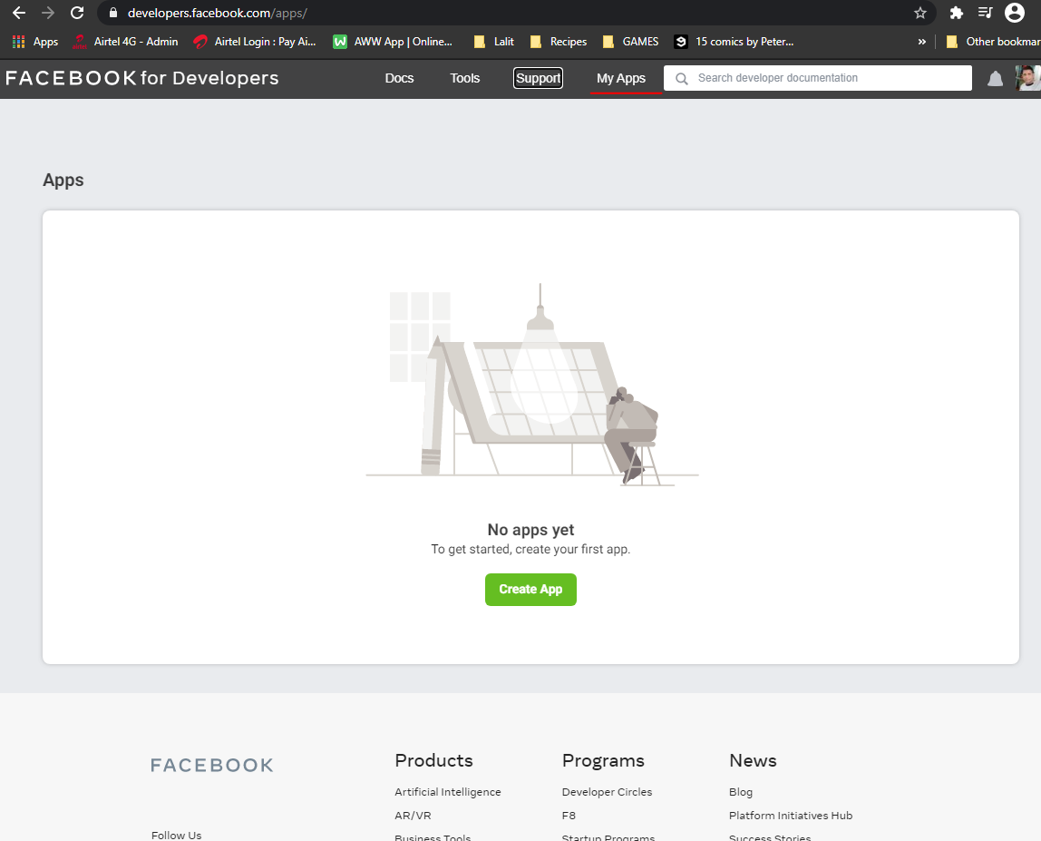

And once the page loads to create a new app, I will click on this green button here to create app. And from this list of options, manage business integration, integrate a third party, build or connect a game etc I will click an option that says for Something else.

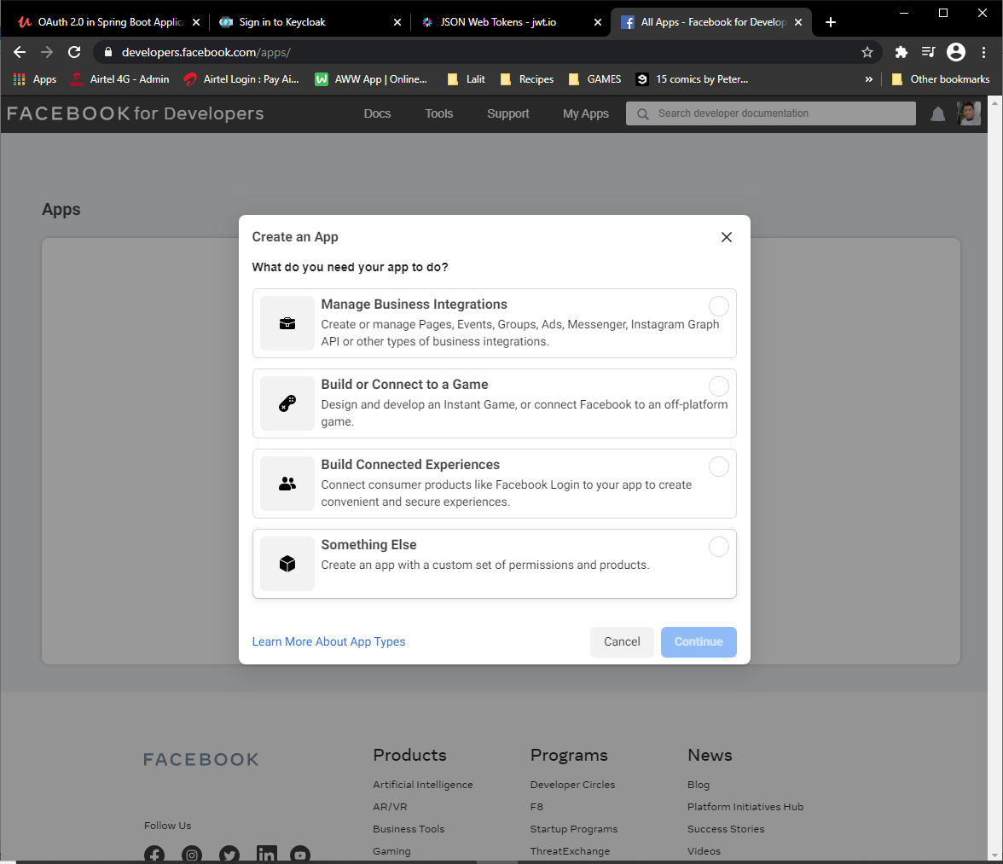

Here, I will provide the name of my app, I will call it social login example, and it will click on Create API. All right, so I have my app created

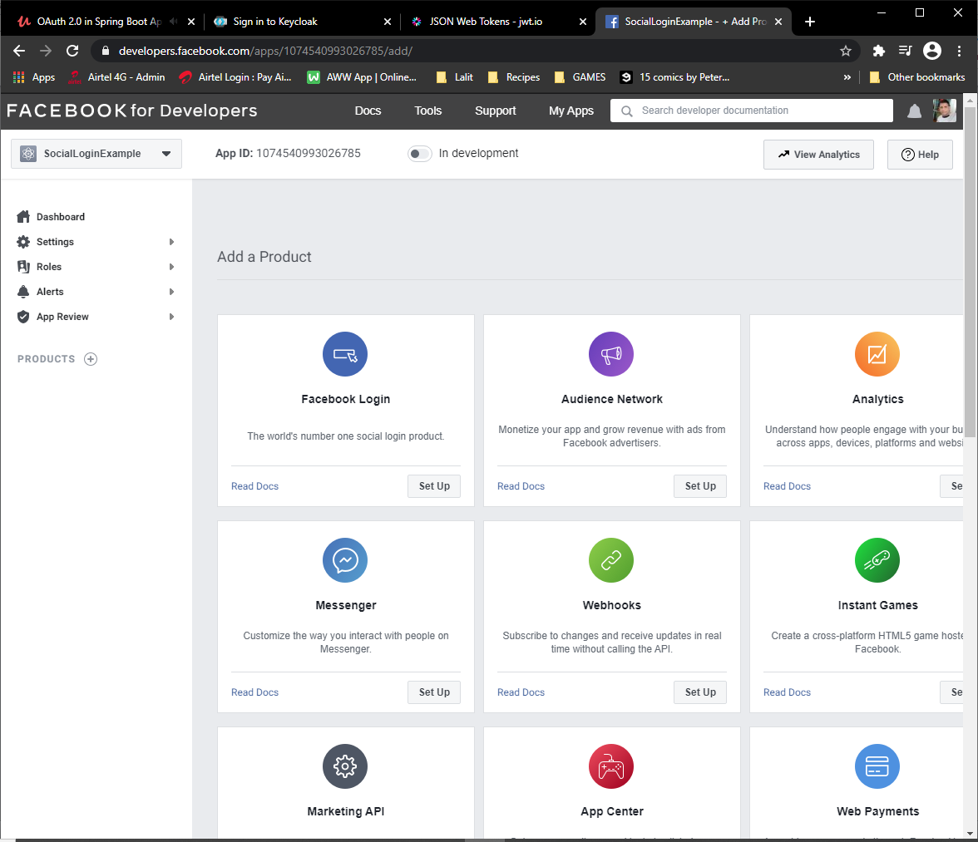

To find the facebook app, cliend ID and client secret values, I need to go to Settings section, which is on the left side here, and then click on Basic. And here at the top, I have the secret, so I will copy them. And this is how I can save my application properties file. And now if I run this application and attempt to access the page, it should redirect me to Facebook for authentication.

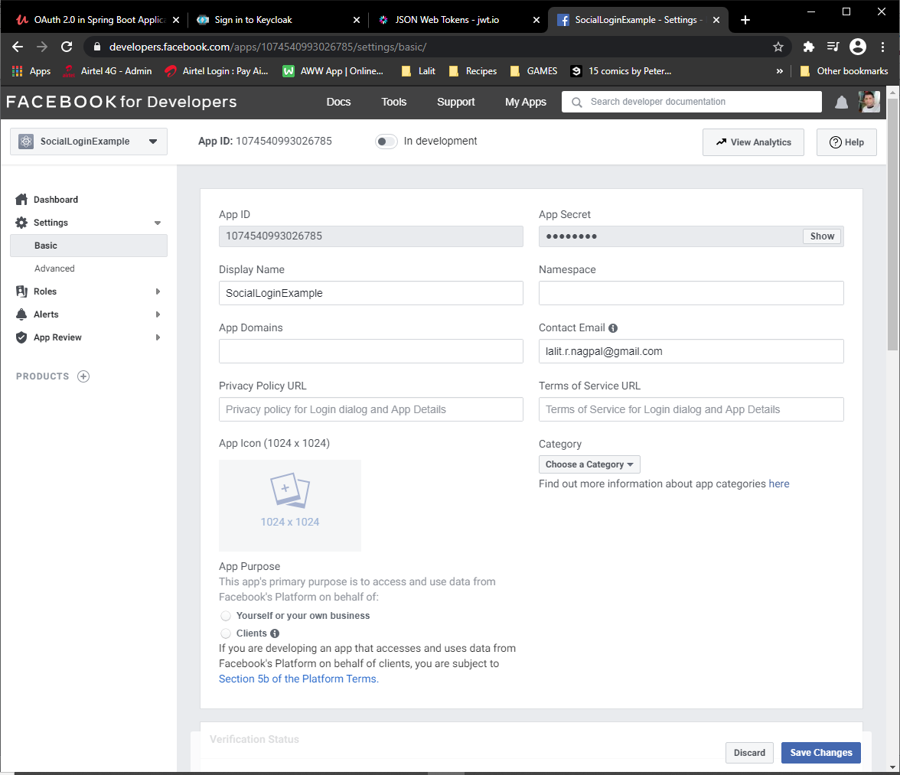

Now use these as client-id and client-secret and then hit <http://localhost:8080> it will show the index.html page first and if you click on the home link it will ask you for a facebook login and after login with facebook it will ask for consent and once consent is provide it will take us to the home page.

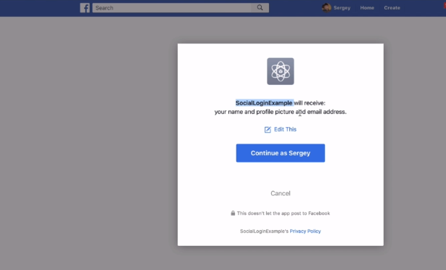

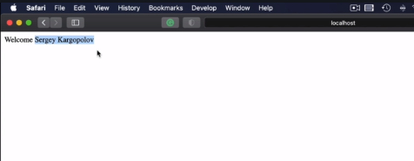

**Google Login**

Go to the console.developers.google.com link and authenticate with google.

You will see the below page then

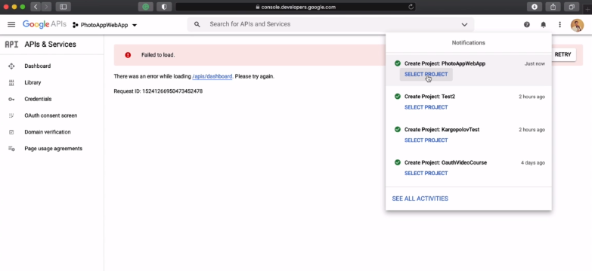

Create a new project here.

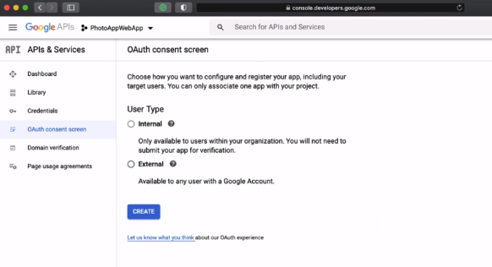

Choose External users here.

On the OAuth consent screen provide the App Name and the user support email id

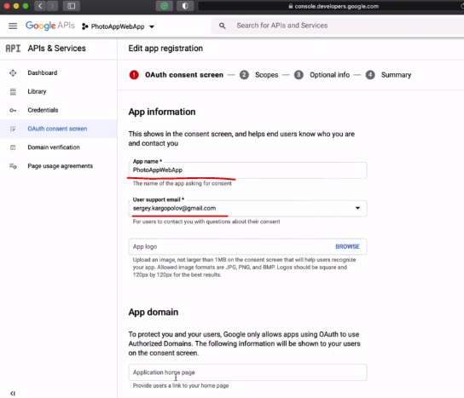

Skip the rest of the information and provide the developer contact information

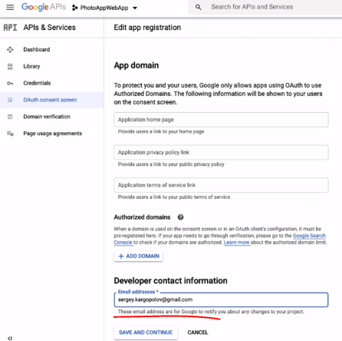

So now is the time to provide scopes and scopes, have permissions that I request user to give to my application so that it can access information on user's behalf. Google group scopes into three categories. They are nonsensitive, sensitive and restricted scopes for this demonstration. I'm not going to request any restricted or sensitive scopes. I will click on ADD or remove Scopes Button and here I have a list of available scopes to me because I have not added any Google APIs to my project. I did not have Gmail or Google Maps API.

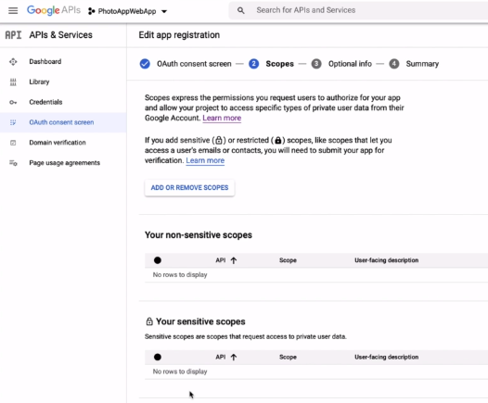

I see a very short list of scopes that are available, but if I go in and Google APIs to my project, then I will have a longer list of scopes for my application. I do not need any Google API and the only scope that I'm interested in is an open ended scope. So I will select the scope and I will click on update button. The scope has been added to the list of nonsensitive scopes and I'm going to continue to scroll down, click on Save and Continue.

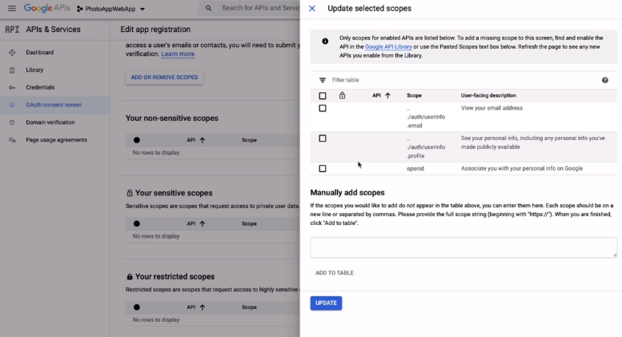

And now I'm asked to provide some more information about my app again, because this is just a test project. I'll not be submitting this project for review with Google. I will leave all of this form fields empty. But again, if you're working on a real answer for your organization, then please fill in this form because Google has a little note here at the top that information you provide in this form will help speed up the review process for your app.

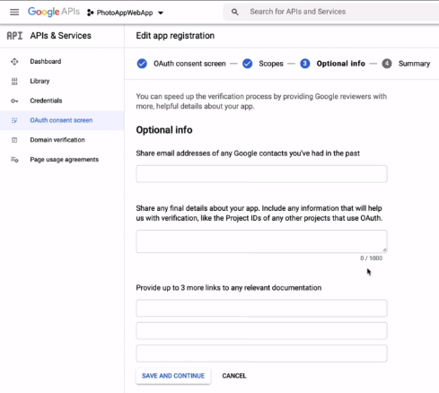

All right. So I will click on Save and Continue. And here on this page, I can review the consent screen details and if needed, I can click on edit button here and make some corrections. But otherwise, at the bottom of this page, I have a back to dashboard button, which I'm going to click and go back to my consents screen.

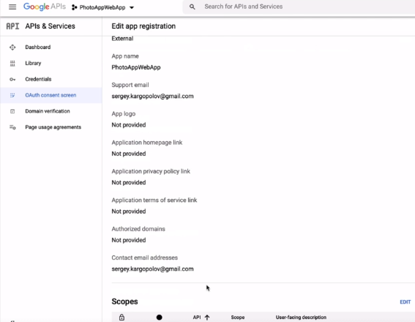

So I want to have configured the screen. I can continue and configure our credentials.

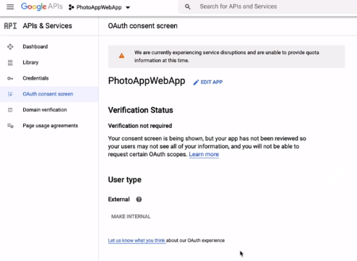

On the left side navigation panel here, I have credentials link. I'll go back to this section and the the message is now gone. So I'll click on this plus button to create credentials. And from this list here, I will select OAuth Client.

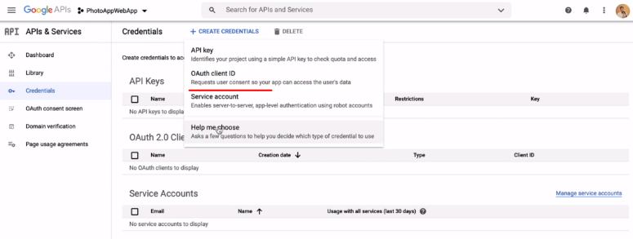

|  |  |
| --- | --- |
| Now, I want you to select the type of application I'm working on application, so I will select a Web application from the drop down menu. I'm going to edit to give my Web client a name.  And again, I will use the same name for app Web app. I will skip the authorized JavaScript origin section and I will provide the authorized redirect URI.  So I'll click on this button on your right and the URI for my application because it is running on localhost. I will type <http://localhost:8080/login/oauth2/code/google>  If your application is running on a domain name, then you will need to provide that domain name and the number here instead of localhost and the next part which starts with login/oauth2/code/google.  This part will not change and it will stay the same regardless of what domain name you use localhost or an actual domain name of your application. |  |

So long as it is for /login/oauth2/code/google and then click on create.

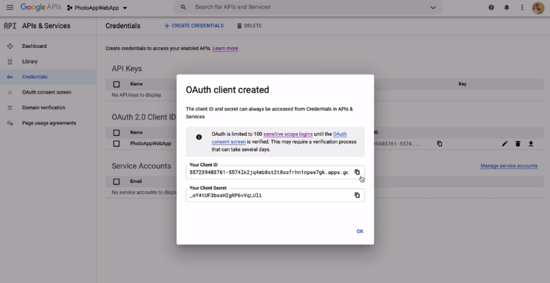

And now the client is created and we have his credentials and I can copy the client id and paste it into my project, so for the configuration properties, for Google login, I will remove comments and as a client and I will provide the value that I have just copied. And now I will copy the client secret and will paste that here as well. I will comment about Facebook configuration details for now and later I will come back to it. All right. So we have our client ID and client secret for google.

On accessing <http://localhost:8080> you are shown the non protected index page, clicking on the home link asks for google sign in.

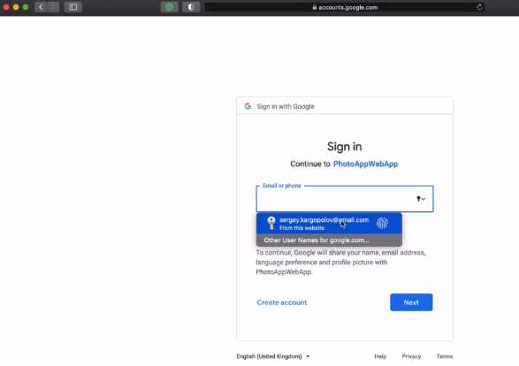 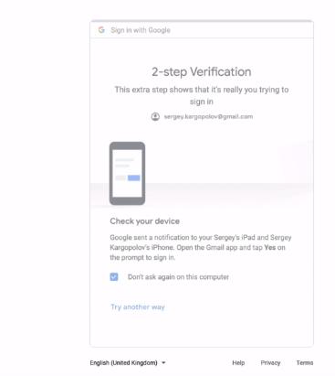

A dual step verification is done and we are redirected to the home page on local.

### Working with Okta

OK, there is another very popular authentication provider that is being used for custom application development and just like Keycloak it is also an identity and access management solution, except that, Okta is cloud based. If Keycloak is open source and we can use Keycloak in a Docker container on our local computer, then Okta is a professional and cloud based identity and access management solution that is available to us as a cloud service.

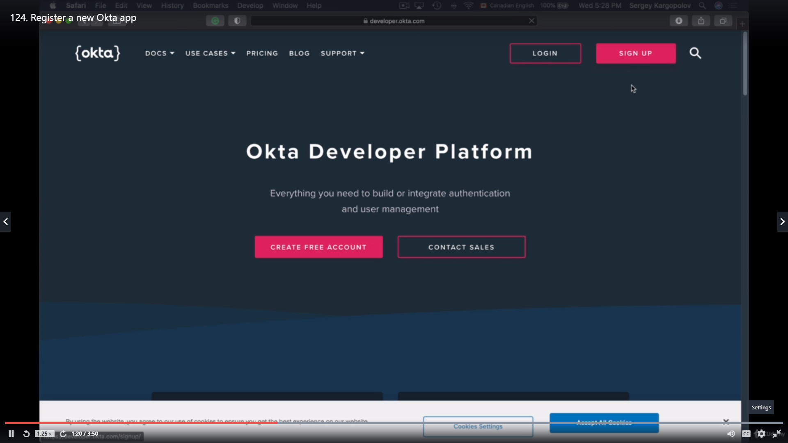

Configuration for Okta could also be pre configured just like they are for Facebook and Google, but the issuer URI in OCTA might differ. So we'll need to do this configuration ourselves. All right, so let's try configuring our application to work with OCTA. To get a client id and security for Okta, you will need to register a new developer account with OCTA. Or of course if you have one, use your existing account and then we will need to log in with that developer account and register. And you are. So to get client id and secret key, I will need to start a new private window and then I will need to go to developer.okta.com.

If you do not have an account, you will need to sign up for a new account. And once you sign up and activate your developer account, you need to click on this login button to in. Now to login, you will need to use a domain name that you will receive in your email. I don't know what that domain name will be. It is different for every account, but it will end either with .com or .emea or okta.com. In my case, the domain name that I was issued is ending with the dot com.

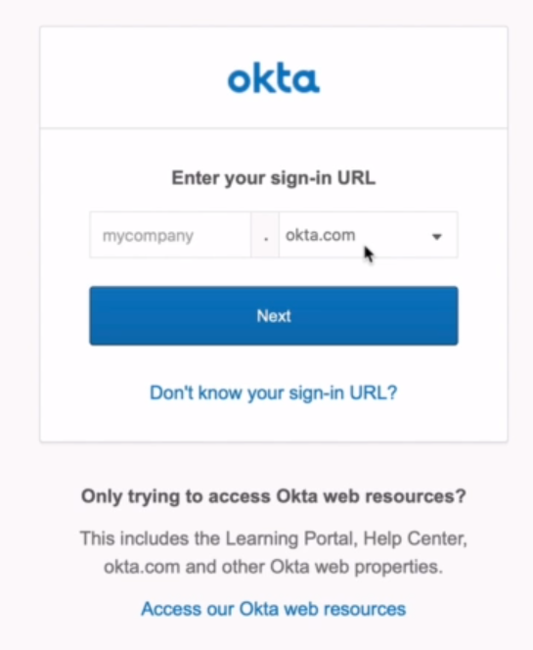 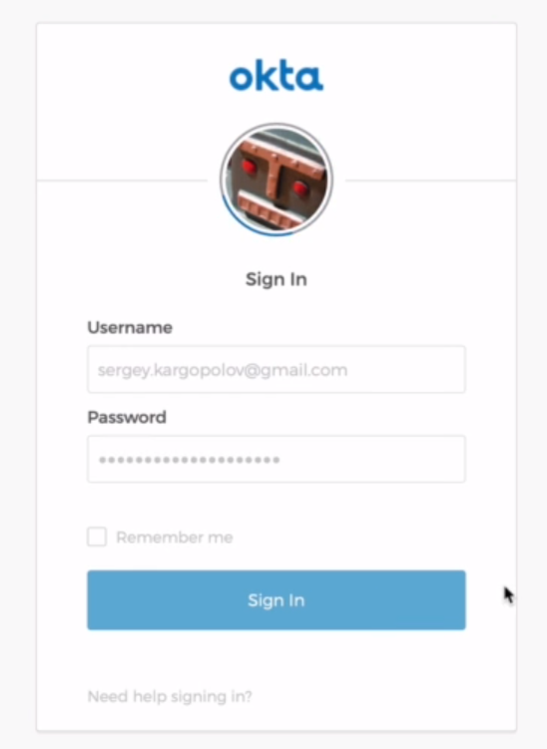

So I'll need to provide a subdomain, which I also have received an email from OCTA. I will copy and paste it here and click on next. And now I will need to provide my Okta developer's account. And here's my OCTA developers dashboard to create a new application, I want you to click on this application link.

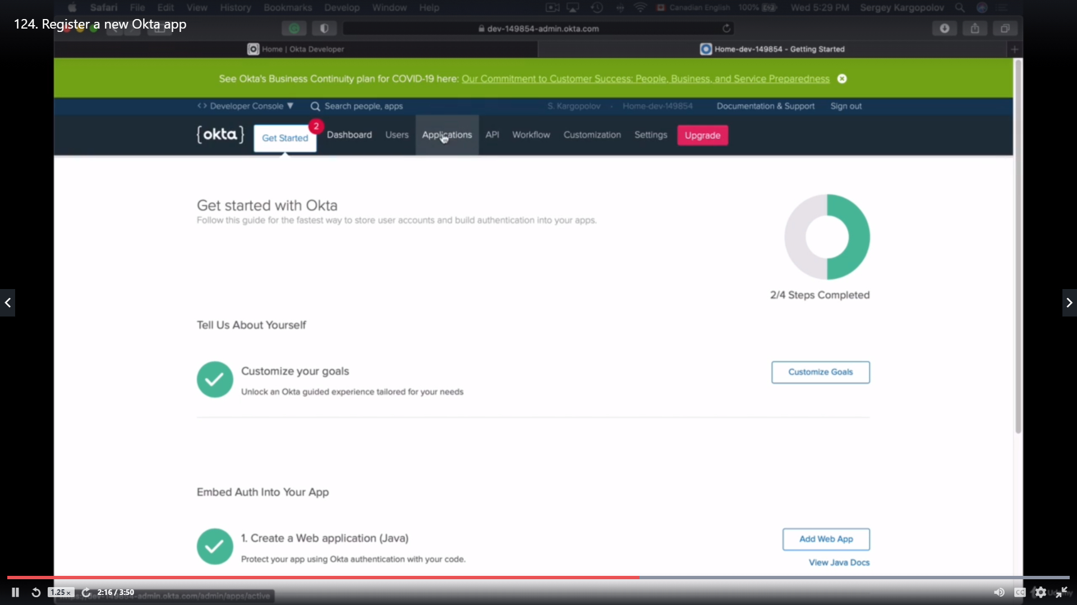

I don't have any applications created in this account. So to add an application, I'll click on this green button and application. And because I'm working on Web application, I will select the platform here.

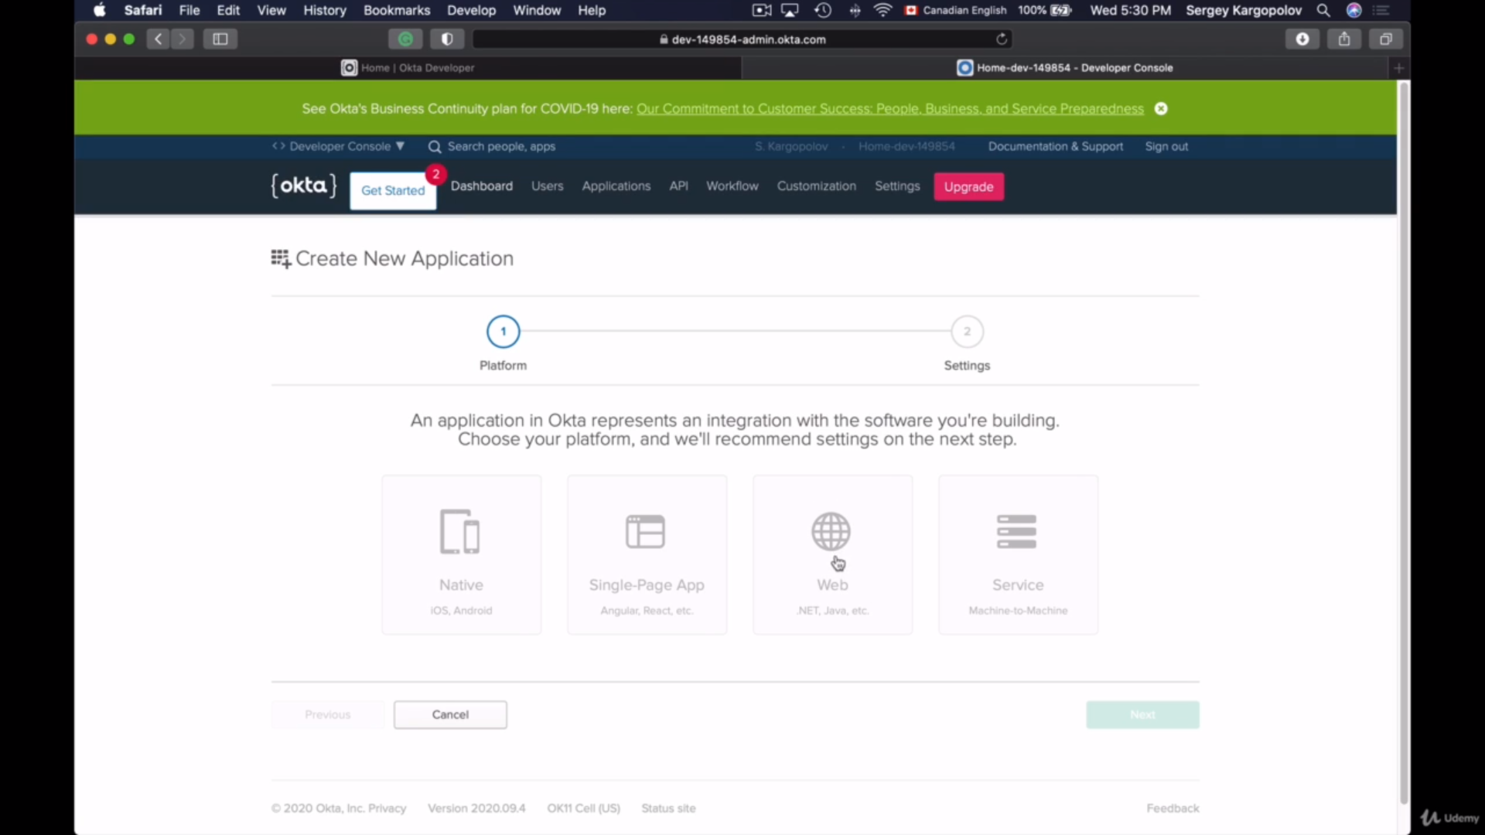

Click on Next and now I'll need to provide my application settings. First entry is my application name PhotoAppWebApp. I'm writing my application on localhost, so localhost:8080, but the login redirect URI will be different. The first part of it will stay the same. http://localhost:8080. This is because I'm writing my application localhost, but the ending of it will be different and it will be very similar to the one that we have used for Google. So it will be /login/oauth/code/okta. When we were configuring signing in with Google account, we used google here, but for octa it is octa. This is actually all we need to change for localhost applications. I'll scroll down and click on Done button.

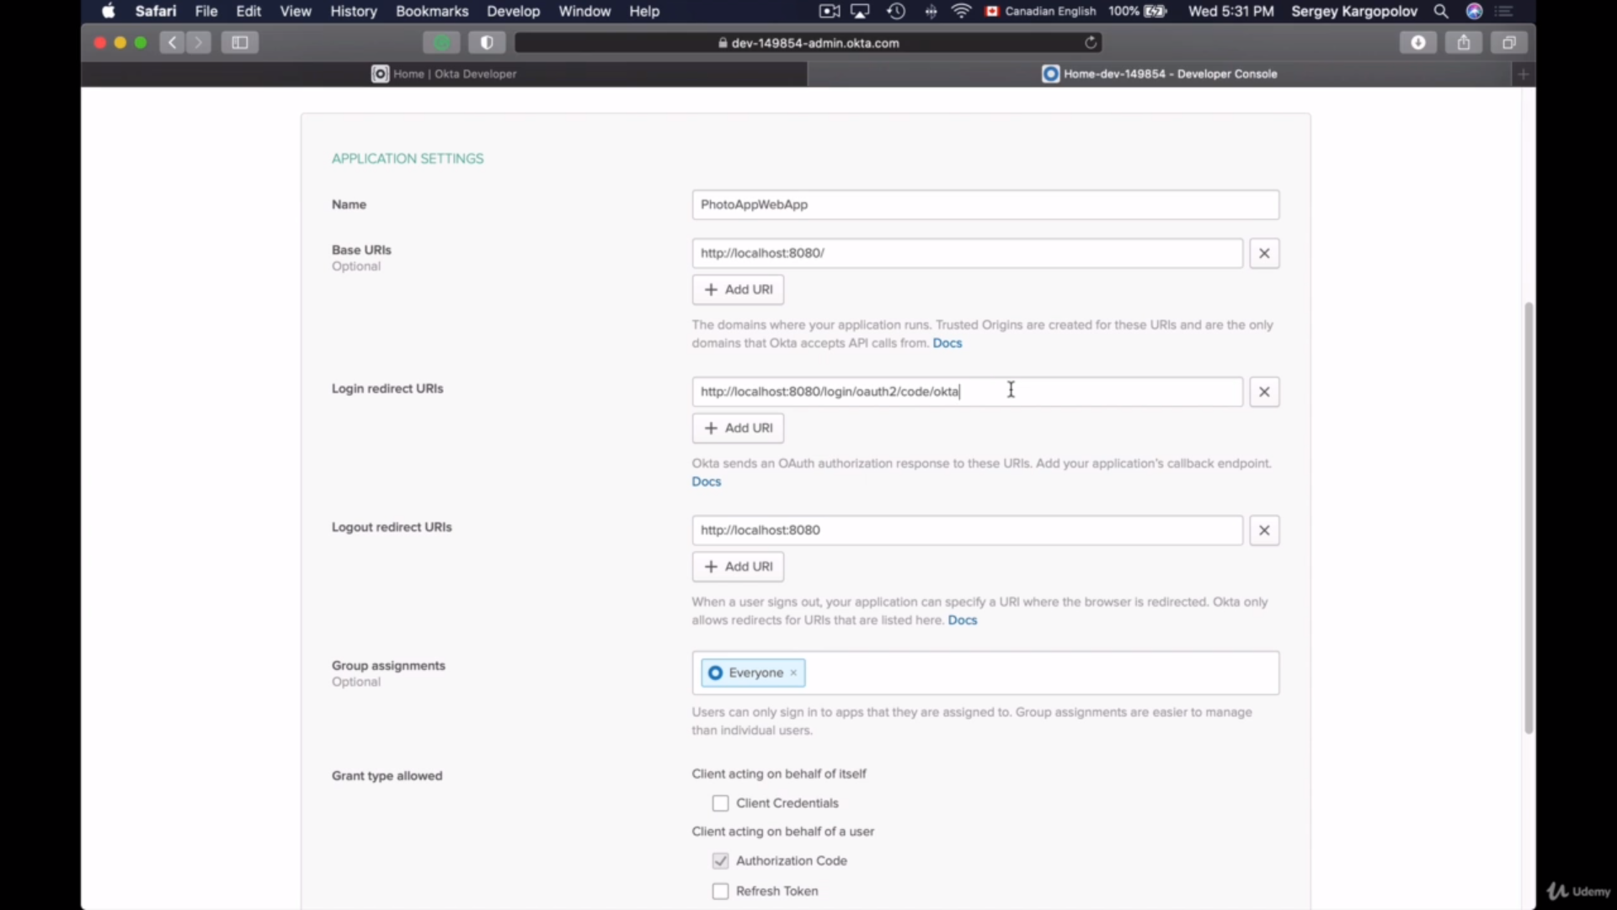

And so I have my application created, I can review general settings, but if I scroll down, I will already have the client credentials that I can use in my application.

Configure OKTA properties now

This is very important because if we do not provide up to here, then Sprint framework will not be able to find other pre configured OKTA configuration properties for us.

So now let's call it client aid and clean cichlid values from OCTA that we have created. I will go back to my browser window and I will copy client id and client secret.

spring.security.oauth2.client.registration.okta.client-id = 408026580472403

spring.security.oauth2.client.registration.okta.client-secret = 8ad50615b8a978083571d14454d9f565

spring.security.oauth2.client.registration.okta.scope = openid,profile

spring.security.oauth2.client.provider.okta.issuer-uri =

And then the two scopes that I need are openid, profile. And the second configuration property that I also need to additionally configure for Okta is the issue where you are. Issuer id is part of the provider registration, so its configuration property is a little bit different.

It starts with spring.security.oauth2.client just the same as it starts for the registration section. But then instead of registration, it goes provider and then okta and then issuer-uri and we need to explicitly configure the value here.

When we have created a new OCTA account, we have received an email and in that email there was a domain name that we were asked to use to be able to sign into OCTA. So we'll need to use this domain name as part of URI. I will copy and paste the URI that I need to use and the first part of it is https and then this subdomain is the value that I have received in my email and it is the value that have used when I need to sign it into my OCTA developer account and then we need to /oauth2/default. This should be enough for sign-in to OCTA

Run the application now – the home page comes up with the home link as it is unprotected, click on the home page link and that is protected so takes you to the OKTA site for sign in.

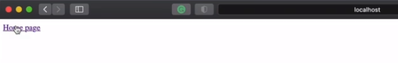

|  |  |
| --- | --- |
|  |  |

### Configuring Logout Functionality

We will enable the logout functionality in our Web application, and to do that, that will open up WebSecurity.java file that extends to WebSecurityConfigurerAdapter and that has this configuration. So to enable logout, I will add a new line here. And right after the oath 2 login, I will add . and then will type and start a new line .logout like this. So this will enable the Log-On functionality, although once the user logs out of our application, we will need them to be redirected to either index page or our website or to a login page again, or to display a confirmation page that they log on to successful. So to configure a page where users should be redirected next after the logout, we can use the following configuration and a new line again and then .logout and here in double quotes, we can provide a url path where we want this user to be redirected.

@EnableWebSecurity

public class WebSecurity extends WebSecurityConfigurerAdapter {

@Autowired

ClientRegistrationRepository clientRegistrationRepository;

@Override

protected void configure(HttpSecurity http) throws Exception {

http.authorizeRequests()

.antMatchers("/").permitAll()

.anyRequest().authenticated()

.and().oauth2Login()

.and()

.logout()

//.logoutSuccessUrl("/")

.logoutSuccessHandler(oidcLogoutSuccessHandler())

.invalidateHttpSession(true)

.clearAuthentication(true)

.deleteCookies("JSESSIONID");

}

private OidcClientInitiatedLogoutSuccessHandler oidcLogoutSuccessHandler() {

OidcClientInitiatedLogoutSuccessHandler successHandler =

new OidcClientInitiatedLogoutSuccessHandler(clientRegistrationRepository);

successHandler.setPostLogoutRedirectUri("http://localhost:8080/");

return successHandler;

}

I will use / and in case of this configuration, once user looks out, then he or she will be redirected to the index page of our application. And if we want them to be redirected to another html page, then we can specify the name of that same page here. For example, a page with the name youareloggedout.html. I like users to be redirected back to index page, so I will delete the name of the HTML page and will leave just the force that will make users to be redirected back to the index page of my website. There are also a few additional helpful functions that you might want to use here, and the first one is invalidate HTTP session. So lets add that and say true for that. So this one will invalidate the session on user successful account and Spring security will involve decision by default. So if this is what you want, then you can skip this function call. But if you do need to keep session valid, then you simply provide force here. All right. One session to be invalidated. I will provide through the next called clearAuthentication and this one also accepts a boolean value true. And this function call will clear authentication object. And this is also a default behavior of spring framework. When user logs out, the authentication will be cleared. The next one is delete cookies and this one can accept multiple parameters, each in double quotes separated by comma. If you need to delete a specific cookie, then you can use this function called deleteCookies. And instead of the double quotes, you will provide a name of the cookie that you want to delete. For example, if I want to delete JSESSIONID, then I will type the name of the cookie here. If it is only one cookie that I want to delete, then will provide only one cookie name here. Otherwise I can provide multiple parameters. All right, so I will leave decision on. We can also configure success handlers here, but I'll do it in one of the following lessons. Let's now create a logout thing and try how this works.

We have a logout link in the home.html page that we had created.

<div>

<a href="/logout">Logout</a>

</div>

When we click on the logout link after we have logged in. We are asked to confirm if we want to logout.

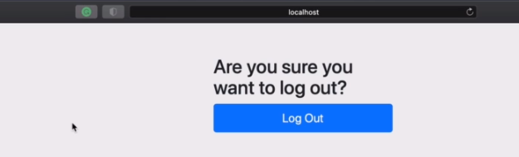

We haven’t created this, this comes out of Spring framework and is availabel to use, we are logged out on clicking this.

Click on home page again and we are asked for authentication again.

When I click on the link to open protected page again, Spring Framework does redirect me to OCTA for authentication. But because the session with OCTA is still valid, OCTA did not require me to explicitly provide username and password. And this exact behavior will happen for Facebook and Google login as well. User will be logged out of our website, but they will not be logged out of their Google or of their Facebook account. And if we want to logout user of their Google or their Facebook account, then we will need to write an additional code that will be specific for an API of that particular authentication. Provide some authentication providers like Okta and Keycloak, they do have built in support to end session with AuthenticationServer. So if needed, we can easily configure our application to log user out of our website as well as any session with OCTA. And in this case, when User looks out of our website, their session with authentication server will also end and they will be asked to provide their username and password again if they try to request protected page.

### OIDC End Sesion Endpoint

You will learn about the End session EndPoint that is specified in the open id connect protocol and you'll learn how to configure your application to let users and their session with the authentication provider server and thus logout of it as well. This will help us implement a single logout functionality that helps users to log out from both from our app as well as from the authentication server that was used to authenticate user. Authentication service providers that support open id connect might also support open id connect session management functionality and will provide a special web series end point that allows client applications to perform logout an end user session. So when a session endpoint is supported right after user logs out of our application, it will redirect browser to the end session end point that is exposed by authentication service. And this will end user session. Once user session with the authentication service provider is ended, user will be redirected back to a post logout URL that is specified in the request. And here on my site I have an example of a request to end session end point and the request parameters that this request will need to have.

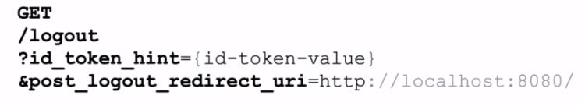

The request will contain two parameters id token and post logout redirect url, we do not have to worry about the ID token spring framework will read the id token from that authentication object for us and it will attach the value of ID token to this URL for us as well. But we will need to specify the post logout redirect-url ourselves and I'll show you how to the post logout redirect url is where a user needs to be redirected next after they are logged out from the application server. To learn if the oauth 2 authentication provider, you use support end session endpoint. You can check its Open ID configuration and discovery Document. Every authentication provider that supports open id connect exposes this document and you can view it in the browser and it will always have the following URL format that you see on my slide. It starts with the base server URL, which is different for different servers, but the ending of it will always stay the same. For example, in case of my OCTA developers account, the URL of the Open ID configuration discovery document looks like this. It starts with the base url role of the authentication server I used to log in to my org the developer account and this will be different in your case, but the last part of the URL will be the same for everybody.

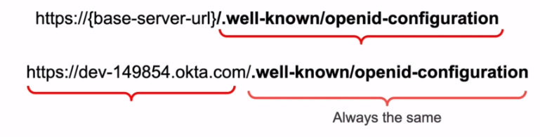

If you're using Keycloak server running on localhost, then the URL of the Open id configuration document will look like this. It will start with the domain and the port number. It will then include the name of the keycloak realm you have created and it will end with the open id configuration end point that will always be the same.

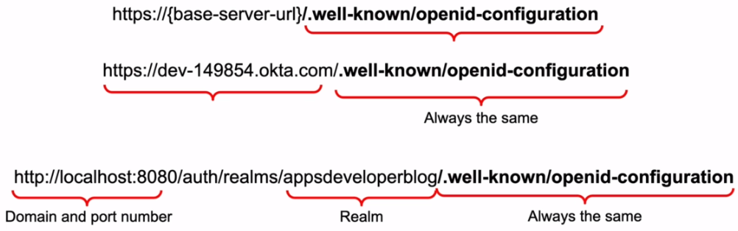

All right. So if you open this URL in a browser window, you will see a JSON document that will tell you if the authentication server that you use does support end session endpoint. For example, if I open open id configuration discovery document of my Keycloak server running on localhost, I see that the end session and point is supported. But if this value is omitted, then the end session endpoint is not supported. And Okta authentication server does also support and end session endpoint so we can end user session with Okta as well. All right. So let's learn how to configure our application to call this transition endpoint.

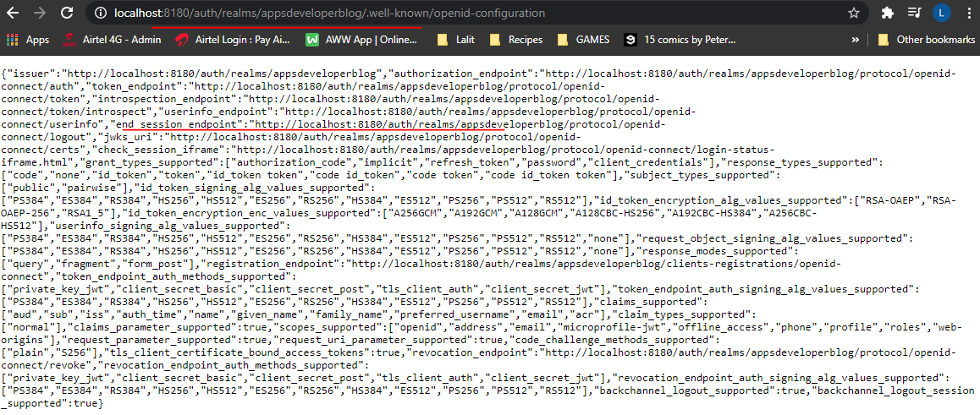

Implementing OidcClientInitiatedLogoutSuccessHandler

To make your application call the end point session endand point on successful logout from our application, we will need to register a logout success handler. So because I'm going to use the logout success handler, I will need to comment about the logout success URL like this and I will and do it and will have registered logoutSuccessHandler and the code of my lgout success handler. I will move to a different function that I will call oidcLlogoutSuccessHandler. And this is what we do in this function. We are creating a new instance of OIDCClient initiated logoutSuccessHandler, and it will need to take in one object as a parameter. And this is client registration repository, which I will simply autowire into my web security class.

@EnableWebSecurity

public class WebSecurity extends WebSecurityConfigurerAdapter {

@Autowired

ClientRegistrationRepository clientRegistrationRepository;

@Override

protected void configure(HttpSecurity http) throws Exception {

http.authorizeRequests()

.antMatchers("/").permitAll()

.anyRequest().authenticated()

.and().oauth2Login()

.and()

.logout()

//.logoutSuccessUrl("/")

.logoutSuccessHandler(oidcLogoutSuccessHandler())

.invalidateHttpSession(true)

.clearAuthentication(true)

.deleteCookies("JSESSIONID");

}

private OidcClientInitiatedLogoutSuccessHandler oidcLogoutSuccessHandler() {

OidcClientInitiatedLogoutSuccessHandler successHandler =

new OidcClientInitiatedLogoutSuccessHandler(clientRegistrationRepository);

successHandler.setPostLogoutRedirectUri("http://localhost:8080/");

return successHandler;

}

}

So the client registration repository here, the details of this clientRegistrationRepository, will be read from the application properties file by spring framework and based on the configured client handler that we have spring framework will be able to figure out the end session end point to use. And as always, spring framework will do all the heavy lifting for us. We do not need to look up the end session endpoint ourselves and we do not need to read and attach the value of a token as a request parameter to this session and point you around, although it will be done by spring framework. But we will need to Spring framework where we want user to be redirected next after they have been logged out. And this is done with the help of this set Post Logout Redirect to a function that takes the URL of the page where we want users to be redirected next after they have been logged out because my application is running on localhost and providing here localhost support number on which my application is running and then the route path on which the index page of my application is available and this is it. Now we can try writing our application and see how they log in and logout with OCTA works now.

So now logout takes us to the index page and when we click on home page again it asks us to authenticate again. I'm redirected to OCTA for authentication, and this time because the session with authentication server is ended, I do need to provide my username and password again to be able to access protected page.

## Keycloak Remote User Authentication

Lets learn how to configure your Keycloak server to read user authentication details from a remote storage. Kickoff comes with its own a database called H2. And when we use the clock to create a new user or to edit existing user details, Keycloak will use its own database now because H2 database is not very good to use in production. We can make Keycloak use a different database instead. For example, we can make Keycloak use MySQL database server instead of the database and all the data that we create or edit using Keycloak will now be stored in this new database server, this structure database tables and the way information is stored and organized there will be according to the way how Keycloak does it. So when we create the new user using Keycloak administration console, the user credentials will be stored in this Keycloak database. And when we log in to Keycloak with our user credentials, Keycloak will read the user name and password from this database. Now, sometimes we need to use Keycloak with already existing project and that already existing project does already have a database with many users. And for this existing project, we want to enable growth and we want to use Keycloak. So when users redirected to Keycloak for authentication, we want Keycloak to authenticate user using user details that are stored in our own remote database.

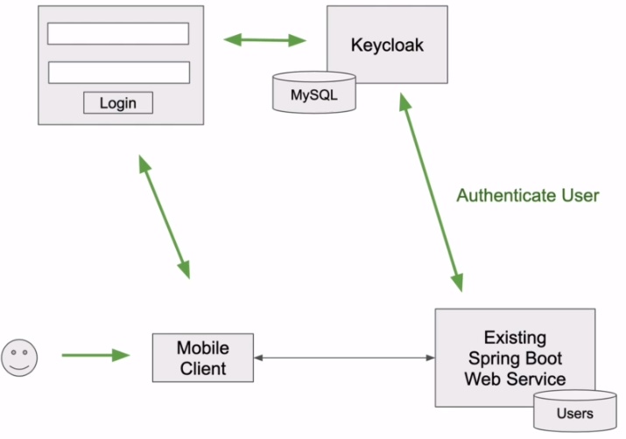

Keycloak is designed to cover most use cases without requiring custom code, but it is also customizable and to achieve customization, Keycloak has a number of service provider interfaces or SPI, for which we can provide our own implementation. For example, when we want to make Keycloak authenticated user whose user credentials are stored in an external database, we can implement what is called user storage API or user storage service provider interface. And it is a special interface that allows us to breach an external user storage and the internal user object model that key uses to log in users and manage them using storage SPI implementation will be a code that we will write, package and archive and deploy to Keycloak server however. When running user storage SPI, we can write Java code that connects to an external database directly using JDBC URL regular details and then validate a password on the key clock site. Or we can write Java code that communicates with our database via a very small Microservice.

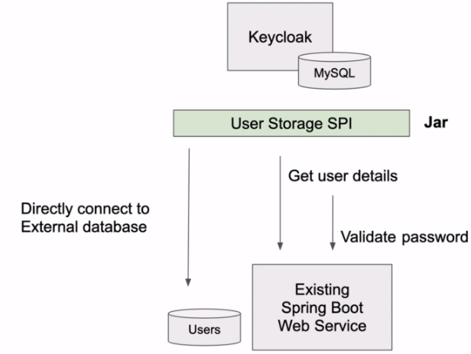

Our Java code will send the http get request to fetch the details and when it needs to validate user password, it will send another http post request to validate if the provided user password is correct, which one of these two approaches you choose will most likely depend either on your personal preferences or on the project's specifics. But both of them can work in the following video lessons. I'll show you how to implement the user storage API interface, how to package it into jar archive and how to deploy it into Keycloak. And I will show you how to make your user storage SPI authenticate user by sending HTTP requests to an external microservice. I personally like this approach better because in this case I do not need to make a server be aware of username and password to my external database. If you prefer to retrieve the details from an external database directly and validate the encrypted user password on the key alongside, then you can do that as well. The goal of this section is to show you how to implement, how to package and how to deploy the user storage API to Keycloak. And once you know that, you can then use your favorite approach to connect and read data from a database. All right. So let's learn how to do it.

Create the Project

In this new project, we will need to write some Java code to implement remote user storage provider. We will then build this project and package our code into jar file and then deploy that file to a Keycloak. And lets create a new project that we will use to implement the remote user storage provider.

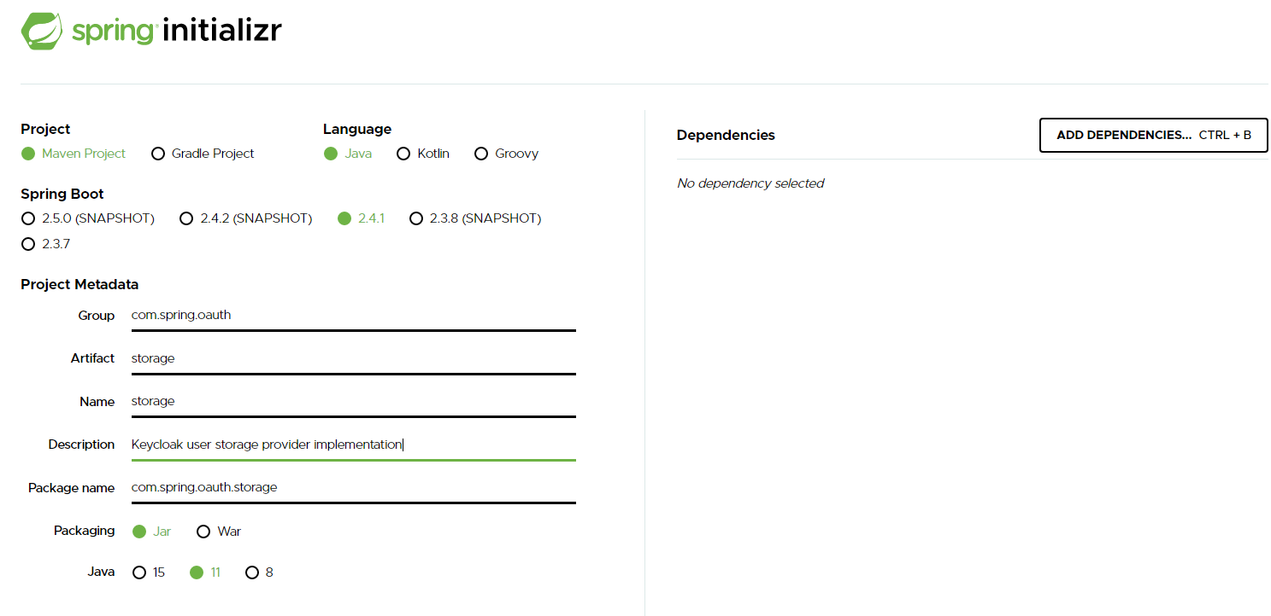

There are no dependencies of Keycloak that can be found here, so for dependencies lets leave that with nothing

Find the depenency for keycloak server spi from maven central

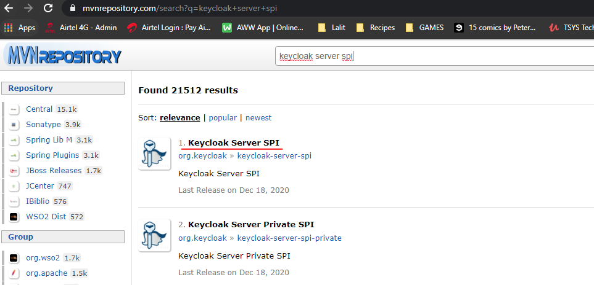

In the pom.xml file provide the following dependencies

<?xml version="1.0" encoding="UTF-8"?>

<project xmlns="http://maven.apache.org/POM/4.0.0" xmlns:xsi="http://www.w3.org/2001/XMLSchema-instance"

xsi:schemaLocation="http://maven.apache.org/POM/4.0.0 https://maven.apache.org/xsd/maven-4.0.0.xsd">

<modelVersion>4.0.0</modelVersion>

<parent>

<groupId>org.springframework.boot</groupId>

<artifactId>spring-boot-starter-parent</artifactId>

<version>2.4.1</version>

<relativePath/> <!-- lookup parent from repository -->

</parent>

<groupId>com.spring.oauth</groupId>

<artifactId>11-keycloak-user-storage-spi</artifactId>

<version>0.0.1-SNAPSHOT</version>

<name>11-keycloak-user-storage-spi</name>

<description>Keycloak user storage provider implementation</description>

<properties>

<java.version>11</java.version>

</properties>

<dependencies>

<dependency>

<groupId>org.springframework.boot</groupId>

<artifactId>spring-boot-starter</artifactId>

</dependency>

<dependency>

<groupId>org.keycloak</groupId>

<artifactId>keycloak-server-spi</artifactId>

<version>12.0.1</version>

<scope>provided</scope>

</dependency>

<dependency>

<groupId>org.springframework.boot</groupId>

<artifactId>spring-boot-starter-test</artifactId>

<scope>test</scope>

</dependency>

</dependencies>

<build>

<plugins>

<plugin>

<groupId>org.springframework.boot</groupId>

<artifactId>spring-boot-maven-plugin</artifactId>

</plugin>

</plugins>

</build>

</project>

Creating RemoteUserStorageProvider class

We're going to create a provider class that will provide implementation for a few very important Keycloak service provider interfaces.

|  |  |
| --- | --- |
| We see that this interface does not provide any methods for locating or for validating user credentials. This interface is a base requirement for SPI, but it does have a few very useful methods like this close method or if get into the UserStorageProvider interface class and look at it, there are a few pre remove methods and they're useful for clean up.  For example, we can implement this method if we want to do some clean up when her real name is removed or if we implement this method, then we can do some cleanup if group is removed and this one rule is removed and so on. |  |

But in this section we will not be working with this method. And the good news is that we can leave this method and implement it. So for now, I will not even provide implementation for the close at all. Just save the file and make my remote user storage provider implement a different interface. To look up user details from a remote storage, we will need to implement UserLookupProvider interface. Lets implement this now, this interface is very helpful and it provides us with different methods that we can implement to lookup the details. For example, we can lookup user details by user ID, We can look up user details by user name, and we can look up user details from our remote storage by user email. And in the following lessons, we will implement one of these methods to look up user details from a remote storage site. And for us to be able to validate user credentials, we will need to make this class implement one more interface. And it is called CredentialsInputData interface. So I will add comma and we will add one more interface CredentialInputValidator interface and I will add and implement methods. And this interface invites me to override, a few more methods now to help Keycloak authenticate user who is trying to log in, we will need to provide implementation for this as a valid method.

import org.keycloak.models.RealmModel;

import org.keycloak.models.UserModel;

import org.keycloak.storage.UserStorageProvider;

import org.keycloak.storage.user.UserLookupProvider;

public class RemoteUserStorageProvider implements UserStorageProvider, UserLookupProvider, CredentialInputValidator {

@Override

public void close() {

}

@Override

public UserModel getUserById(String id, RealmModel realm) {

return null;

}

@Override

public UserModel getUserByUsername(String username, RealmModel realm) {

return null;

}

@Override

public UserModel getUserByEmail(String email, RealmModel realm) {

return null;

}

@Override

public boolean supportsCredentialType(String credentialType) {

return false;

}

@Override

public boolean isConfiguredFor(RealmModel realm, UserModel user, String credentialType) {

return false;

}

@Override

public boolean isValid(RealmModel realm, UserModel user, CredentialInput credentialInput) {

return false;

}

}

We will need to make sure that the password that was provided by user who is trying to login on the login screen that this password matches the password that we have stored in our remote user database. This method returns boolean value, and if this method returns true, then Keycloak assumes that the provided user password is correct and user will be successfully authenticated. And if you lookup Keycloak implementation on user storage SPI, then you will find other S.P.I interfaces than this class can implement as well. But these three interfaces use a storage provider, user lookup provider and credential input validator interface. These three are the minimum three interfaces that we will need to implement to let Keycloak hook up user details from a remote storage and then validate user credentials. So in one of the following lessons, we will come back to this class once again and we will do some more work on it. But for now, let's leave it as is and let's continue to the next lesson.

**Creating RemoteUserStorageProviderFactory class**

We will create a new Java class that will be called RemoteUserStorageProviderFactory, and it will be used to create an instance of the remote user storage provider class

package com.spring.oauth.keycloakuserstoragespi;

import org.keycloak.component.ComponentModel;

import org.keycloak.models.KeycloakSession;

import org.keycloak.storage.UserStorageProviderFactory;

public class RemoteUserStorageProviderFactory implements UserStorageProviderFactory<RemoteUserStorageProvider> {

@Override

public RemoteUserStorageProvider create(KeycloakSession session, ComponentModel model) {

return null;

}

@Override

public String getId() {

return null;

}

}

Once we are done with the implementation of this remote user storage provider interface, I'll show you how to enable it using Keycloak admin panel and this is where its id value will also display and the create method here is where we are going to create a new instance of remote user storage provider class.

public class RemoteUserStorageProvider implements UserStorageProvider, UserLookupProvider, CredentialInputValidator {

private KeycloakSession session;

private ComponentModel model;

public RemoteUserStorageProvider(KeycloakSession session, ComponentModel model) {

super();

this.session = session;

this.model = model;

}

@Override

public void close() {

}

@Override

public UserModel getUserById(String id, RealmModel realm) {

return null;

}

@Override

public UserModel getUserByUsername(String username, RealmModel realm) {

return null;

}

@Override

public UserModel getUserByEmail(String email, RealmModel realm) {

return null;

}

@Override

public boolean supportsCredentialType(String credentialType) {

return false;

}

@Override

public boolean isConfiguredFor(RealmModel realm, UserModel user, String credentialType) {

return false;

}

@Override

public boolean isValid(RealmModel realm, UserModel user, CredentialInput credentialInput) {

return false;

}

}

I will create a new instance of remote user storage provider and I will pass to that user storage provider these two object session and model. Now the remote user storage provider class that we have created in previous lesson does not have constructor that takes in session and model object. Let's create this constructor now.

Now, let's go back to remove the storage provider factory class and let's provide the provider id value here. So the id value that will be returned from this method, it will identify the factory in runtime and it is a stream value. So I can give it a custom stream, for example, my remote, my skill, user storage provider. And to do that I will declare a new property at the top of the class. And I will give it a value. Now, I will take the property name that I have just created and I will return it from the getId method. All right. So we have our basic remote as a storage provider, factory class created.

package com.spring.oauth.keycloakuserstoragespi;

import org.keycloak.component.ComponentModel;

import org.keycloak.models.KeycloakSession;

import org.keycloak.storage.UserStorageProviderFactory;

public class RemoteUserStorageProviderFactory

implements UserStorageProviderFactory<RemoteUserStorageProvider> {

public static final String PROVIDER_NAME = "my-remote-sql-user-storage-provider";

@Override

public RemoteUserStorageProvider create(KeycloakSession session, ComponentModel model) {

return new RemoteUserStorageProvider(session, model);

}

@Override

public String getId() {

return PROVIDER_NAME;

}

}

Adding Keycloak Core Dependency

Now that we have created a remote user storage provider, factory class, we have a little error message and it's pointing to the package.

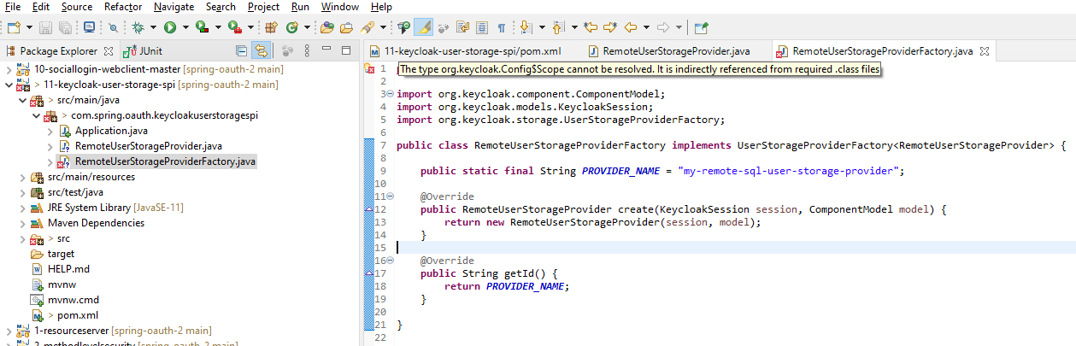

If I move mouse over the bulb, it says that the type or keycloak config scope cannot be resolved. It is indirectly referenced from required class. And it is a little bit confusing because it's pointing to a package. And in fact, if I clean and build this maven project, the build will be successful and there will be no errors. But to fix this error message, I will need to add one more dependency to pom.xml file final of this project. And to do that I will open a similar file and then I will go and bring up a new browser window and go to maven repository and I will search for keycloak core. The very first search result we look for is the one that I need, I will pick the latest version, copy it.

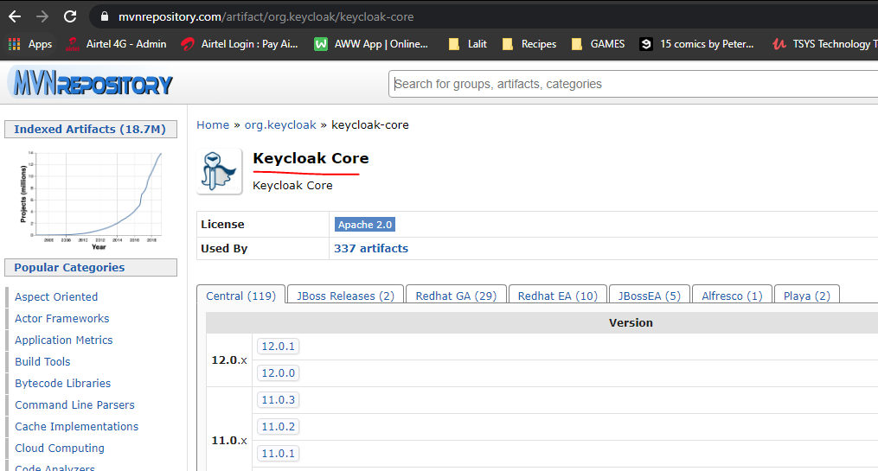

<dependency>

<groupId>org.keycloak</groupId>

<artifactId>keycloak-core</artifactId>

<version>12.0.1</version>

</dependency>

The error message is now gone.

### Solution Overview

All right, so now that we have created basic classes that are needed to implement remote use of storage provider functionality, let's start working on a code that will fetch you the details from remote storage. I will switch to remote user storage provider and here to fetch you the details, we will need to provide implementation for one of this methods, getUser ById, getUserByUserName, or getUserByEmail address. In my previous code examples in this video, of course, I've used email address. So I will provide implementation for the getUserByEmail address method and to feature the details from a remote storage. I will also use user email address. But if you prefer to use the details by user name, for example, then you can also add to that. All right. So before we actually start writing code, let's review one more time how exactly we are going to feature the details from remote storage.

|  |  |
| --- | --- |
| User details in remote storage are most likely stored in a database, so we will need to read Java code to read the details from a database. But there are different ways how we can do it. One way is to make our use of the users storage SPI and get the details directly from remote database. Another way is to make our user storage SPI fetch details from the same database. But by sending request to a microservice, which one of the ways you choose to go is up to you. And it will most likely depend on the current architecture that you have. I will go with the microservices to fetch the details by email. |  |

I will make my remote user storage provider class send the request to a service and to validate user password.I will also send the request to the microservice so my external microservice will be responsible for connecting to a database for fetching user details using email address from that database, and it will be responsible for validating user password.

And one of the advantages of using this approach is that I can securely store username and password that I needed to connect to a database in the Spring Cloud Vault or use Spring Cloud Encryption and configure my microservice to fetch username and password from Spring Cloud Config. This way, the database access credentials are securely stalled and they are centralized. If I need, I can start multiple instances of my microservice and then all of them will have access to a database, for access credentials. And also this way I will not need to make my Keycloak server be aware of username and user password to my users database. But if you still prefer to make your user storage SPI to directly connect to a remote database, you can also do that from this user storage space code. All right. So let's continue and let's learn how to implement the solution, but using the micro services front.

Remote Users Webservice Overview

Here is an overview of the legacy users WebService that they have created for demonstration purposes, I didn't have this project implemented yet into my development environment. So I will do it first.

Get the project from: <https://github.com/simplyi/LegacyUsersWebService>

|  |  |
| --- | --- |
| So this is a very simple, restful web service application built with Spring Boot. And it is this web service that handles http requests from remote user storage SPI provider.  And this web service connects to user database, that features user details from the database and also validates if they provided on the Keycloak password matches the one that I have stored in my database. Because this is a demonstration project. It is very much simplified. For example, it stores user data in H2 database and the database connection details are in application properties file. Here they are. And they can be easily configured to work with a different database server.  **application.properties**  server.port=8099  spring.h2.console.enabled=true  spring.datasource.username=sergey  spring.datasource.password=sergey  spring.datasource.url=jdbc:h2:mem:testdb  spring.datasource.driverClassName=org.h2.Driver  spring.jpa.database-platform=org.hibernate.dialect.H2Dialect |  |

The current configuration that I have here is for H2 database, but you will most likely want to make it work with a different database so that you have, and to make it work with your database server, you will simply need to update these properties and then also update, for example, file with a dependency for the database server that you are going to use. All right. So if I open a single file of this project, the only dependency that I have here for the database is the H2 database.

<?xml version=*"1.0"* encoding=*"UTF-8"*?>

<project xmlns=*"http://maven.apache.org/POM/4.0.0"*

xmlns:xsi=*"http://www.w3.org/2001/XMLSchema-instance"*

xsi:schemaLocation=*"http://maven.apache.org/POM/4.0.0 https://maven.apache.org/xsd/maven-4.0.0.xsd"*>

<modelVersion>4.0.0</modelVersion>

<parent>

<groupId>org.springframework.boot</groupId>

<artifactId>spring-boot-starter-parent</artifactId>

<version>2.3.5.RELEASE</version>

<relativePath /> <!-- lookup parent from repository -->

</parent>

<groupId>com.appsdeveloperblog.tutorials</groupId>

<artifactId>11-legacyuserswebservice-main</artifactId>

<version>0.0.1-SNAPSHOT</version>

<name>11-legacyuserswebservice-main</name>

<description>11-legacyuserswebservice-main</description>

<properties>

<java.version>11</java.version>

</properties>

<dependencies>

<dependency>

<groupId>org.springframework.boot</groupId>

<artifactId>spring-boot-starter-web</artifactId>

</dependency>

<dependency>

<groupId>org.springframework.boot</groupId>

<artifactId>spring-boot-starter-data-jpa</artifactId>

</dependency>

<dependency>

<groupId>org.springframework.boot</groupId>

<artifactId>spring-boot-devtools</artifactId>

<scope>runtime</scope>

<optional>true</optional>

</dependency>

<dependency>

<groupId>org.springframework.boot</groupId>

<artifactId>spring-boot-starter-security</artifactId>

</dependency>

<dependency>

<groupId>com.h2database</groupId>

<artifactId>h2</artifactId>

<scope>runtime</scope>

</dependency>

<dependency>

<groupId>org.springframework.boot</groupId>

<artifactId>spring-boot-starter-test</artifactId>

<scope>test</scope>

<exclusions>

<exclusion>

<groupId>org.junit.vintage</groupId>

<artifactId>junit-vintage-engine</artifactId>

</exclusion>

</exclusions>

</dependency>

</dependencies>

<build>

<plugins>

<plugin>

<groupId>org.springframework.boot</groupId>

<artifactId>spring-boot-maven-plugin</artifactId>

</plugin>

</plugins>

</build>

</project>

Now, when this web series application starts up, it creates one user and it's towards it in H2 database. But if I need, I can easily create more users. The place where it does it is in the initial setup, the Java file that is in the root package and here it is. So when applications start up, it will create a user entity object and it will store that entity object in the database to store and to read users from a database.

package com.appsdeveloperblog.tutorials.legacyusersservice;

import javax.transaction.Transactional;

import org.springframework.beans.factory.annotation.Autowired;

import org.springframework.boot.context.event.ApplicationReadyEvent;

import org.springframework.context.event.EventListener;

import org.springframework.security.crypto.bcrypt.BCryptPasswordEncoder;

import org.springframework.stereotype.Component;

import com.appsdeveloperblog.tutorials.legacyusersservice.data.UserEntity;

import com.appsdeveloperblog.tutorials.legacyusersservice.data.UsersRepository;

@Component

public class InitialSetup {

@Autowired

UsersRepository usersRepository;

@Autowired

BCryptPasswordEncoder bCryptPasswordEncoder;

@EventListener

@Transactional

public void onApplicationEvent(ApplicationReadyEvent event) {

UserEntity user = new UserEntity(

1L,

"qswe3mg84mfjtu",

"Sergey",

"Kargopolov",

"test2@test.com",

bCryptPasswordEncoder.encode("sergey"),

"",

false);

usersRepository.save(user);

}

}

I use Spring data JPA framework. The JPA repository is the autowired here and to persist user entity, object and database. I simply call save method on this repository object and the spring Data JPA framework will store use it to a database for me. Now notice that I also use decrypt password encoded here to encode the raw password. So Decrypt Password Encoder is used to encrypt or encode user password so that it is stored in a database encrypted. We never had to use a password in database as clear text and I'm pretty confident that user's password is also stored encrypted in your database as well. bCryptPasswordEncoder is a very popular way to encode password and screen project, and the chances that you're also using basically password for encoding in your project are very high. Now, when this web service application receives, they should request the request is handled by a rest controller and I have it inside controllers package. This controller exposes two endpoints one and point to handle HTTP get request to fetch the details and another endpoint that handles HTTP post request to verify user password when HTTP get request to fetch user details is handled.

package com.appsdeveloperblog.tutorials.legacyusersservice.controllers;

import org.springframework.beans.factory.annotation.Autowired;

import org.springframework.web.bind.annotation.GetMapping;

import org.springframework.web.bind.annotation.PathVariable;

import org.springframework.web.bind.annotation.PostMapping;

import org.springframework.web.bind.annotation.RequestBody;

import org.springframework.web.bind.annotation.RequestMapping;

import org.springframework.web.bind.annotation.RestController;

import com.appsdeveloperblog.tutorials.legacyusersservice.service.UsersService;

import com.appsdeveloperblog.tutorials.legacyusersservice.response.UserRest;

import com.appsdeveloperblog.tutorials.legacyusersservice.response.VerifyPasswordResponse;

@RestController

@RequestMapping("/users")

public class UsersController {

@Autowired

UsersService usersService;

@GetMapping("/{userName}")

public UserRest getUser(@PathVariable("userName") String userName) {

return usersService.getUserDetails(userName);

}

@PostMapping("/{userName}/verify-password")

public VerifyPasswordResponse verifyUserPassword(@PathVariable("userName") String userName,

@RequestBody String password) {

VerifyPasswordResponse returnValue = new VerifyPasswordResponse(false);

UserRest user = usersService.getUserDetails(userName, password);

if (user != null) {

returnValue.setResult(true);

}

return returnValue;

}

}

This REST controller class uses user service object. That is autowired here in this class. And users service object has a method to get user details that accepts a single parameter, which is user name, or in my case, it is going to be email address, if I go in to get you the details, method implementation and look at it, it takes in user email address as a method argument, and then it uses Users Repository to find users by email. If user is not found, it will return an empty object. But if a user is found, it will then use BeanUtils to copy the needed properties from an entity object into a return value object, which is user rest and return it back to a controller class.

**UsersService.java**

package com.appsdeveloperblog.tutorials.legacyusersservice.service;

import com.appsdeveloperblog.tutorials.legacyusersservice.response.UserRest;

public interface UsersService {

UserRest getUserDetails(String userName, String password);

UserRest getUserDetails(String userName);

}

**UsersServiceImpl.java**

package com.appsdeveloperblog.tutorials.legacyusersservice.service;

import org.springframework.beans.BeanUtils;

import org.springframework.security.crypto.bcrypt.BCryptPasswordEncoder;

import org.springframework.stereotype.Service;

import com.appsdeveloperblog.tutorials.legacyusersservice.data.UserEntity;

import com.appsdeveloperblog.tutorials.legacyusersservice.data.UsersRepository;

import com.appsdeveloperblog.tutorials.legacyusersservice.response.UserRest;

@Service

public class UsersServiceImpl implements UsersService {

private UsersRepository usersRepository;

private BCryptPasswordEncoder bCryptPasswordEncoder;

public UsersServiceImpl(UsersRepository usersRepository,

BCryptPasswordEncoder bCryptPasswordEncoder) {

this.usersRepository = usersRepository;

this.bCryptPasswordEncoder = bCryptPasswordEncoder;

}

@Override

public UserRest getUserDetails(String userName) {

UserRest returnValue = new UserRest();

UserEntity userEntity = usersRepository.findByEmail(userName);

if (userEntity == null) {

return returnValue;

}

BeanUtils.copyProperties(userEntity, returnValue);

return returnValue;

}

@Override

public UserRest getUserDetails(String userName, String password) {

UserRest returnValue = null;

UserEntity userEntity = usersRepository.findByEmail(userName);

if (userEntity == null) {

return returnValue;

}

if (bCryptPasswordEncoder.matches(password,

userEntity.getEncryptedPassword())) {

System.out.println("password matches!!!");

returnValue = new UserRest();

BeanUtils.copyProperties(userEntity, returnValue);

}

return returnValue;

}

}

**UsersRepository.java**

package com.appsdeveloperblog.tutorials.legacyusersservice.data;

import org.springframework.data.jpa.repository.JpaRepository;

import org.springframework.stereotype.Repository;

@Repository

public interface UsersRepository extends JpaRepository<UserEntity, Long> {

UserEntity findByEmail(String email);

}

The main class

package com.appsdeveloperblog.tutorials.legacyusersservice;

import org.springframework.boot.SpringApplication;

import org.springframework.boot.autoconfigure.SpringBootApplication;

import org.springframework.context.annotation.Bean;

import org.springframework.security.crypto.bcrypt.BCryptPasswordEncoder;

@SpringBootApplication

public class LegacyUsersService {

public static void main(String[] args) {

SpringApplication.run(LegacyUsersService.class, args);

}

@Bean

public BCryptPasswordEncoder bCryptPasswordEncoder() {

return new BCryptPasswordEncoder();

}

}

Now the reason I copy properties here from entity to object and to use a rest object is to make sure that I do not return an entire entity object back as response. And this is because an entity object may contain sensitive information that I might not want to return back in response. For example, I do not want to return back the database id or user's password. And because UserRest clause does not have this field user password and database ID will not be copied from entity object into UserRest and they will not be returned back in response. But if you do need to return an entire entity object, including all the sensitive information that it might have, then you can just return an entire entity object from this method. All right. So let's go back to our controller class one more time and have a look at the second webservice endpoint, which handles http post request and it verifies user password. Now, this method accepts two arguments, username and password, and then it also uses user service object. And it has a method to get you the details that takes in user name and password. So if I go into user details method and open up its implementation, I see that it first fetches user details from database by using user email. If data is not found, it returns null, but if user with this email address is found, it then uses bCryptPasswordEncode object, which is also autowired into this user service implementation class here, or I should have said injected using dependency injection. And then they basically bcryptPasswordEncoder has a method that is called matches. This method takes in raw password, which is not encrypted. This password was sent to us from Keycloak by our remote user storage provider and it will be compared with the encrypted password that we have in the database.

The bCryptPasswordEncoder object will encode the raw password and will do the heavy lifting. It will compare the two passwords and make sure that they match. If they do match, then I create a new instance of user object and I copy the needed fields from entity object into a return value, which is user. All right. So let's go back to our controller class one more time here. Once I receive user details, I check them for null and if user details are not null, I use this verify password response class as a return object. And this is a custom class that they have created. If I open it up and has a single field which stores a boolean value, if user with provided email address and password was found in the database, then this property will be set to true in a method in the controller class here and this object verify password result will be returned back in response and it will be handled in our remote user storage SPI provider.

package com.appsdeveloperblog.tutorials.legacyusersservice.response;

public class VerifyPasswordResponse {

private boolean result;

public VerifyPasswordResponse(boolean result) { this.result = result; }

public boolean getResult() { return result; }

public void setResult(boolean result) { this.result = result; }

}

Alright, and basically this is it. I think I have now mentioned all the important parts of this website application.

The WebSecurity.java class

package com.appsdeveloperblog.tutorials.legacyusersservice.security;

import org.springframework.security.config.annotation.web.builders.HttpSecurity;

import org.springframework.security.config.annotation.web.configuration.EnableWebSecurity;

import org.springframework.security.config.annotation.web.configuration.WebSecurityConfigurerAdapter;

import org.springframework.security.config.http.SessionCreationPolicy;

@EnableWebSecurity

public class WebSecurity extends WebSecurityConfigurerAdapter {

@Override

protected void configure(HttpSecurity http) throws Exception {

http

.cors().and()

.csrf().disable().authorizeRequests()

.antMatchers("/users/**")

.hasIpAddress("127.0.0.1")

.antMatchers("/h2-console/**").permitAll()

.anyRequest().authenticated().and()

.sessionManagement()

.sessionCreationPolicy(SessionCreationPolicy.STATELESS);

http.headers().frameOptions().disable();

}

}

**RESTEasy Http Client Dependency**

To send a request to a restful webservice from Keycloak environment, we can make use of rest easy client, and if you're not familiar with rest easy, then I encourage you to Google and learn more about it. But as I use it, I'll try to make things as easy as possible and I'll try to explain all important details. All right. So to make rest easy HTP client available to our code, we'll need to add one more dependency to a pom.xml file of our remote user storage provider project and to find this dependency. And we'll open up a new browser window. And I will go to maven repository.com and I will search for Keycloak Rest Services. And the very first search result is what I need pick up

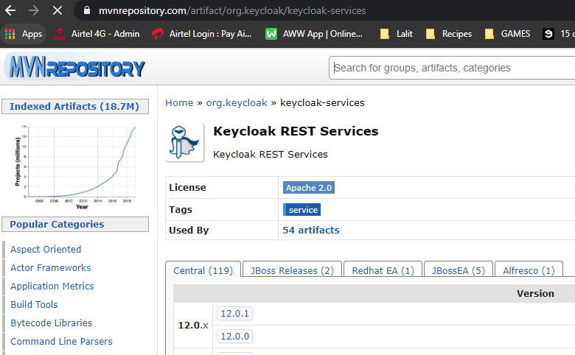

<dependency>

<groupId>org.keycloak</groupId>

<artifactId>keycloak-services</artifactId>

<version>12.0.1</version>

<scope>provided</scope>

</dependency>

**Implement Users API Service**

We will create a rest easy client interface in which we will define HTTP calls to external webservice. So let's create a new java interface. I will select a root package, choose a new interface. And I will call this interface user's API service or remote user service. And click on Finish, so in this interface, we'll need to define http calls because that our client can make and I'll start with http call to fetch user details to features the details, my rest easy client will need to make http get request. So I will start with JAX RS annotation that is called get.

Now http requests are sent to a specific URL path, the base URL that contains the domain name and the port no we will define a different place. But here we will need to define in just a path to a web service endpoint. The root path to users web service endpoint that have created starts with /users. And it is going to be the same for any request that my client will make. So I will declare it right above the interface name using @Path annotation like this and then double quote, I will provide the path to a certain point users like this. Now I will need the input path and it should come from javax.rs.ws.Path. And I can also configure the JSON content type and the accept headers right away as well, and to specify that all methods in this interface will expect back in response JSON content type or use jax rs annotation that is called @Consumes. And in parentheses, I'll specify the media type. Now let's import @Consumer annotation. So when request is built, this will at the accepted the handler with vaule APPLICATION_JSON.

Now if my rest easy http client needs to to send http post request to be put request service endpoint and in the body of this request it will need to include JSON payload. Then they can also use @Produce annotation and this will result in a content type http header added to a request. And I can and @Produce annotation right here as well. And as a media type, I will also use APPLICATION_JSON. Now for this particular HTTP GET method I'm not going to send a JSON payload in the body of http request and I do not really need this annotation at this moment. So I will comment out this for now and will enable it a little bit later when I add the HTTP post. So let's define Java method called getDetails. I will add it right below the @GET annotation. Now, for my remote webservice to be able to fetch the details, I want you to give it user's username and I will also include username as a path parameter. So for rest easy http client to be able to include username as a url parameter, I will first need to make this method accept username and I will do it as a method argument. So I will use path parameter annotation and inside of parentheses I will specify username and then data type of my argument and the name of the argument. And now I'll need to define url path and inject into that url path the value of username. And we do it with the @Path annotation and I will add it right above the method name. And in parentheses and double quotes, starting with @Path(/{"username"}).

So when request is sent the URL path will start with /users and then they will continue with the username and this username will be replaced with the actual user name of the user. All right. And finally, we will need to define the return type, so when this method is executed, it will get back to the details as JSON object in the body of the http response. The JAX RS framework can convert that JSON object into Java object. But we need to specify which class, the framework should use to map user details from the JSON response object into Java Object. So let's ask JAX RS to convert to the details from JSON String into Java object of user data type. So as a return data type, I will use user. Now, I do not have this User java class and my code will not compile. But we will create this user Java class. All right, so now let's @PathParam annotation and complete this method.

package com.spring.oauth.keycloakuserstoragespi;

import javax.ws.rs.Consumes;

import javax.ws.rs.GET;

import javax.ws.rs.Path;

import javax.ws.rs.PathParam;

import javax.ws.rs.core.MediaType;

@Path("/users")

@Consumes( MediaType.APPLICATION_JSON )

//@Produces( MediaType.APPLICATION_JSON )

public interface UsersApiService {

@GET

@Path("/{username}")

User getUserDetails(@PathParam("username") String username);

}

Lets create a user Java class here and this class will be used by JAX RS framework when converting JSON response received in the response body into the object of this user class. And this conversion will be done for us automatically. We do not need to do it manually, but we do need to provide here a valid Java class. When this http request is executed, the rest easy client will receive back from the web service and endpoint JSON stream containing user details. And for JAX RS framework to map user details from JSON Stream into this user object, it needs to make sure that the class fields in the user object match the property fields in the JSON document. If the class fields match those that are in the JSON document, then they will be mapped. Otherwise there will be an error. All right. So one way to make sure that fields in the class match. Those that are in the JSON stream is to manually copy each field name from JSON stream into this Java class. That's one way. Another way to do it is to simply copy the source code of user class from the Web service itself. And this is what I'm going to do. I will go to my legacy users webservice and I will find rest controller. And I will look for a method that returns user details this one.

import org.springframework.beans.factory.annotation.Autowired;

import org.springframework.web.bind.annotation.GetMapping;

import org.springframework.web.bind.annotation.PathVariable;

import org.springframework.web.bind.annotation.PostMapping;

import org.springframework.web.bind.annotation.RequestBody;

import org.springframework.web.bind.annotation.RequestMapping;

import org.springframework.web.bind.annotation.RestController;

**UsersController.java**

import com.appsdeveloperblog.tutorials.legacyusersservice.service.UsersService;

import com.appsdeveloperblog.tutorials.legacyusersservice.response.UserRest;

import com.appsdeveloperblog.tutorials.legacyusersservice.response.VerifyPasswordResponse;

@RestController

@RequestMapping("/users")

public class UsersController {

@Autowired

UsersService usersService;

@GetMapping("/{userName}")

public UserRest getUser(@PathVariable("userName") String userName) {

return usersService.getUserDetails(userName);

}

. . .

}

**UserRest.java**

package com.appsdeveloperblog.tutorials.legacyusersservice.response;

public class UserRest {

private String firstName;

private String lastName;

private String email;

private String userName;

private String userId;

public UserRest() {

}

public UserRest(String firstName, String lastName, String email, String userName,

String userId) {

this.firstName = firstName;

this.lastName = lastName;

this.email = email;

this.userName = userName;

this.userId = userId;

}

... setters and getters

}

So this method will return an object of UserRest class. So an object of this UserRest class will be converted into JSON and it will be sent back in the response. The JSONs stream that will be sent in the response will contain this information. So what I'm going to do, I will copy these fields and I will close this class and I will place them into my user class like this. And now I can generate getters/ setters and simply use this class.

package com.spring.oauth.keycloakuserstoragespi;

public class User {

private String firstName;

private String lastName;

private String email;

private String userName;

private String userId;

public User() { }

public User(String userId, String firstName, String lastName, String userName, String email) {

super();

this.userId = userId;

this.firstName = firstName;

this.lastName = lastName;

this.userName = userName;

this.email = email;

}

. . . getters/ setters

}

The user class is ready, and when the remote end point responds back with the JSON stream containing user details with thse fields, it will be converted for me from JSON String into an object of user class automatically. And I do not need to make this conversion manually. All right.

We're going to add a new method to our user API service interface, and this method will be used to help our remote users storage provider verify user password with a remote webservice endpoint, if the remote webservice endpoint successfully verifies user password, then the Keycloak will successfully authenticate the user. All right. So let's create this new HTTP method. And now that you are already familiar with how the rest easy client works, I'll just copy and paste a little code snippet and I will walk you through.

package com.spring.oauth.keycloakuserstoragespi;

import javax.ws.rs.Consumes;

import javax.ws.rs.GET;

import javax.ws.rs.POST;

import javax.ws.rs.Path;

import javax.ws.rs.PathParam;

import javax.ws.rs.core.MediaType;

@Path("/users")

@Consumes( MediaType.APPLICATION_JSON )

//@Produces( MediaType.APPLICATION_JSON )

public interface UsersApiService {

@GET

@Path("/{username}")

User getUserDetails(@PathParam("username") String username);

@POST

@Path("/{username}/verify-password")

VerifyPasswordResponse verifyUserPassword(@PathParam("username") String username, String password);

}

So this method will be used to send the http post request, and this is why it is annotated with JAX RS post annotation. Next, we define a path to a certain endpoint that validates user password, and then we define a method signature that accepts username and password as method arguments and returns an object of VerifyPasswordResponse data type. So the username and password method arguments, these are the values that user inputs when they login into Keycloak and the VerifyPasswordResponse is a class that will be used by framework to convert the JSON stream, which our webservice endpoint response with into a Java object that we can use. All right. I do not have this class yet, so I will need to create it or I can simply copy it from my user's Web service project. So let's do that.

|  |  |
| --- | --- |
| package com.appsdeveloperblog.tutorials.legacyusersservice  .response;  public class VerifyPasswordResponse {  private boolean result;    public VerifyPasswordResponse(boolean result) {  this.result = result;  }  public boolean getResult() {  return result;  }    public void setResult(boolean result) {  this.result = result;  }  } |  |

Or maybe let me go to a controller class first. Here is the controller class. And here's the method that handles the HTTP post request and it verified user password. So when this method is done and the password is verified, it will respond back with VerifyPasswordResponse. So I will copy this class and I will paste it to my remote user storage provider project. All right. So this class is inside of response plan, which I'll simply copy it. And now I will go back to my remote user storage provider project, select a root package and I will simply paste it there.

Let me open it up, and this class simply accepts one value, which is a boolean value result, my Harrison point will respond back with the Jaeson string that contains result property and that result property will be either true or false. So the JSON string will be converted into an object on this class. And if result is set to true, then Keycloak will authenticate users successfully. If the result is set to false, then user authentication will not be successful. All right. So let's go back to a user's API service. And before we finish working with this interface, I will enable the @Producers annotation. I can even implement it at the interface level, and then it will be applicable to all methods in this interface. Or since I really needed for one HTTP post method, I can move it and declare at the method level. So what I can do, I can cut it from here and put @Post annotation like this, for example. All right. So it looks like our client is now ready and we can use it.

package com.spring.oauth.keycloakuserstoragespi;

import javax.ws.rs.Consumes;

import javax.ws.rs.GET;

import javax.ws.rs.POST;

import javax.ws.rs.Path;

import javax.ws.rs.PathParam;

import javax.ws.rs.core.MediaType;

@Path("/users")

@Consumes( MediaType.APPLICATION_JSON )

//@Produces( MediaType.APPLICATION_JSON )

public interface UsersApiService {

@GET

@Path("/{username}")

User getUserDetails(@PathParam("username") String username);

@POST

@Path("/{username}/verify-password")

VerifyPasswordResponse verifyUserPassword(@PathParam("username") String username, String password);

}

Building RESTEasy HTTP Client

So we are going to build the rest easy client class, that is going to use this interface user's API service and we'll make our rest easy http client available to our remote user storage provider class. So let's build the http client first. And to do that, I will go to a remote user storage provider factory class and, create a private function. This private function will accept string, which is going to be base uri of where our remote services hosted, and it will return an instance of object that implements users API service interface. And to build rest easy client we can use rest easy client builder. Let me import rest easy client builder. And now I should be able to call the build function on that, like this and this will return a new instance of rest easy client. I guess now let me put it to rest easy client. Next, we'll need to configure this object to use the target URI. And this is done by creating an object of rest easy with target. So on the new line here, I will use this client object and I will call target method, and I will need to give it the uri, which I have received as a method argument in this function. Right. And this one will return an instance of RestEasyWebTarget object.

Next, we need to use this WebTargetObject to build a proxy object based on the interface contracts specified in our users API service interface. Once the proxy object is built, we can then invoked methods on it, we will invoke the two methods that we have defined in this interface. And when each method is invoked on that Proxy object, it will be translated in a Http request based on how we have annotated that particular method in the user's API service interface. And then http request will be executed. All right. So to build a proxy object based on the user's API service interface and to finalize this method, I will use proxy builder class and I will return that object right away. So we'll use return and then I will use a target object and I will call proxy builder and I will need to give it user's API service class. And finally, I will call the build method. All right. So we have our http client ready now. Let's inject it into remote users storage provider object. And to do that, I will use constructor based dependency injection. And I will add one more argument to a constructor of my remote user storage provider class. So I will go there and I will first add of UserServiceApi, which is our interface. And I will add it to a constructor. Like this.

package com.spring.oauth.keycloakuserstoragespi;

import org.jboss.resteasy.client.jaxrs.ResteasyClient;

import org.jboss.resteasy.client.jaxrs.ResteasyClientBuilder;

import org.jboss.resteasy.client.jaxrs.ResteasyWebTarget;

import org.keycloak.component.ComponentModel;

import org.keycloak.models.KeycloakSession;

import org.keycloak.storage.UserStorageProviderFactory;

public class RemoteUserStorageProviderFactory implements UserStorageProviderFactory<RemoteUserStorageProvider> {

public static final String *PROVIDER_NAME* = "my-remote-sql-user-storage-provider";

@Override

public RemoteUserStorageProvider create(KeycloakSession session, ComponentModel model) {

return new RemoteUserStorageProvider(session, model);

}

@Override

public String getId() {

return *PROVIDER_NAME*;

}

private UsersApiService buildHttpClient(String uri) {

ResteasyClient client = new ResteasyClientBuilder().build();

ResteasyWebTarget target = client.target(uri);

return target.proxyBuilder(UsersApiService.class).classloader(UsersApiService.class

.getClassLoader()).build();

}

}

Now I will see changes to remove to the storage provider class and I will go back to a factory class and now I will inject my Resteasy Client here. And to do that, I will simply call the buildHttpClient function, and will need to give it the URL of where my webservice endpoint. So that will be stream and my web service is running on localhost and 8099. And to check that I can go to Legacy Users Service, open up application.properties in the legacyuserswebservice-main. And here's the port number on which my web service is running in 8099. All right, So now I will save changes to this file and all is looking good and we're good to continue.

**Implementing getUserByUserName method**

We will work with the provider class and we will provide implementation for the method that is called getUserByUserName. This method will use our rest easy http client, and it will send the request to a remote Web service endpoint to fetch user details. All right. So when we login to Keycloak, we can use either user name or email address and then password and hear in the provider class we can provide implementations for either getUseByUserName method or we can provide implementation for the getUserByEmailAddress with at least one of them must return a valid user model. This is a user model object that Keycloak can understand. If both of these methods return null, then user authentication will not be successful. But if at least one of this method returns a valid user model object, then Keycloak will attempt to validate user password next. So we will need to provide implementation for at least one of these methods. Now, when one of this method returns, the user model object, the user model object, it has multiple properties like, for example, use first name, last name, email address, user name and so on. So when user model object is returned, it should have at least user name properties set. All right. So because it wants at least username value said I will provide implementation for the getUserByUserName method, although technically I can use email address as username and provide implementation for the user by email address method.

And the implementation will be very, very simple. I will use the rest easy http client to fetch user details from my remote service endpoint, so I will use the user's service object that I have initialized in the constructor and then I will call a method on it that is called getUserDetails like this. This method will need to accept user name that I'm receiving from the method argument here like this. And this method will return back a user object. Now we need to check a user object is not null, and if it is not, then we can use this user object to create a user model object that will be returned from this method. All right. So now I will check for null. And if it is not null, then I will need to call a local function, let's say I will create a function that is called createUserModel. And this function will return a return value of using model data type. Let me define it right here. By default, it's going to be null and I will assign whatever my function createUserModel returns to this return value.

And when working with user model, I might need to use the username and realm. That I also receive as a method argument here, now, I do not have the createUserModel function, so let's create it. It accepts user name and real. And to create a model object, Keycloak has an adapter class, so I will use it and I will return an object of it right away, so I'll need to use return and then new AbstractUserAdapter object and this abstractUserAdapter client can take a few arguments, one of them is session, another one is realm and another one is model like this and the session object and the model object, they are injected in the constructor of our class. Here they are, the model and the session. All right.

package com.spring.oauth.keycloakuserstoragespi;

import org.keycloak.component.ComponentModel;

import org.keycloak.credential.CredentialInput;

import org.keycloak.credential.CredentialInputValidator;

import org.keycloak.models.KeycloakSession;

import org.keycloak.models.RealmModel;

import org.keycloak.models.UserModel;

import org.keycloak.storage.UserStorageProvider;

import org.keycloak.storage.adapter.AbstractUserAdapter;

import org.keycloak.storage.user.UserLookupProvider;

public class RemoteUserStorageProvider implements UserStorageProvider, UserLookupProvider, CredentialInputValidator {

private KeycloakSession session;

private ComponentModel model;

private UsersApiService usersService;

public RemoteUserStorageProvider(KeycloakSession session, ComponentModel model,

UsersApiService usersService) {

super();

this.session = session;

this.model = model;

this.usersService = usersService;

}

@Override

public void close() {

}

@Override

public UserModel getUserById(String id, RealmModel realm) {

return null;

}

@Override

public UserModel getUserByUsername(String username, RealmModel realm) {

UserModel returnValue = null;

User user = usersService.getUserDetails(username);

if (null != user) {

returnValue = createUserModel(username, realm);

}

return returnValue;

}

private UserModel createUserModel(String username, RealmModel realm) {

return new AbstractUserAdapter(session, realm, model) {

@Override

public String getUsername() {

// TODO Auto-generated method stub

return username;

}

};

}

@Override

public UserModel getUserByEmail(String email, RealmModel realm) { return null; }

@Override

public boolean supportsCredentialType(String credentialType) { return false; }

@Override

public boolean isConfiguredFor(RealmModel realm, UserModel user, String credentialType) {

return false;

}

@Override

public boolean isValid(RealmModel realm, UserModel user, CredentialInput credentialInput) {

return false;

}

}

So let's go back to our abstract user adapter class and we will need to provide its implementation here. Now, if I look at the abstract user adapter class, let me inputted first. If I hold come on button and click on it. It extends UserModel default methods and if I click on it, it implements UserModel. That's why we can successfully return an instance of abstract user model adapter because it implements user model.

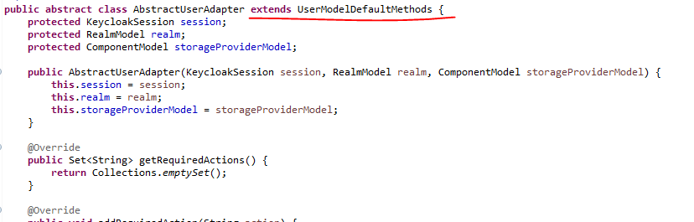

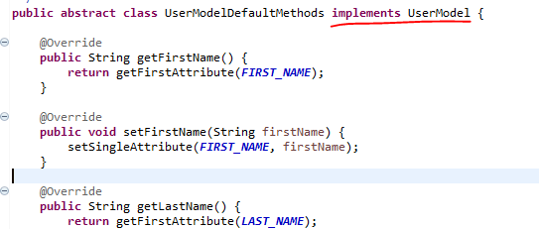

All right. So because user model objects should have at least user name properties, it will need to overwrite one of its methods that is called get user name. And it should return a user name and the value of user name we receive as a method argument here. All right. So I will just need to provide an override, annotation and semicolon here. And finally, I will need to return the return value object from the get user by user name method. So instead of returning null, I'll need to return the return value object like this. All right. So let's see if changes to this class and it looks like we are done with the gate user by username method.

Now that we have implemented the get user by user name method, it's time to start working on the isValid method and in my clients it is at the bottom of it here. So the isValid method will be invoked by Keycloak when it needs to verify user password. If this method returns true then users authentication will be successful. Otherwise, if this method returns false, then user authentication will not be successful. In this method, we will need to send a request to our remote webservice endpoint to let it validate the provided password. All right, so let's do that to send the request and we'll use the user's API service and we will call the verify user password method on it like this. Now, on the verify user password method takes in username and password, I can read user name from the user model object. It's called user, so I will use user object and then I will call method getUsername like this and we can read user password from the credentials input object. To do that we will use the credentials input and then I will call the method that is called getChallengeResponse this one and it will return the user password. The verifyUserPassword method will return an object of the verifyPasswordResponse data types so we will copy that and assign the return of value to an object of this data type like this.

Now we need to check if this VerifyPasswordResponse object is not null, and if it is not, then we can read the password verification result from it. So I'll check if it's not now. If it is null, I will simply return false. Otherwise, I will use it and from this object, I will get the result. For this method, the most difficult part is done.

**RemoteUserStorageProvider.java**

package com.spring.oauth.keycloakuserstoragespi;

import org.keycloak.component.ComponentModel;

import org.keycloak.credential.CredentialInput;

import org.keycloak.credential.CredentialInputValidator;

import org.keycloak.models.KeycloakSession;

import org.keycloak.models.RealmModel;

import org.keycloak.models.UserModel;

import org.keycloak.storage.UserStorageProvider;

import org.keycloak.storage.adapter.AbstractUserAdapter;

import org.keycloak.storage.user.UserLookupProvider;

public class RemoteUserStorageProvider implements UserStorageProvider, UserLookupProvider, CredentialInputValidator {

private KeycloakSession session;

private ComponentModel model;

private UsersApiService usersService;

public RemoteUserStorageProvider(KeycloakSession session, ComponentModel model,

UsersApiService usersService) {

super();

this.session = session;

this.model = model;

this.usersService = usersService;

}

@Override

public void close() {

}

@Override

public UserModel getUserById(String id, RealmModel realm) {

return null;

}

@Override

public UserModel getUserByUsername(String username, RealmModel realm) {

UserModel returnValue = null;

User user = usersService.getUserDetails(username);

if (null != user) {

returnValue = createUserModel(username, realm);

}

return returnValue;

}

private UserModel createUserModel(String username, RealmModel realm) {

return new AbstractUserAdapter(session, realm, model) {

@Override

public String getUsername() {

// TODO Auto-generated method stub

return username;

}

};

}

@Override

public UserModel getUserByEmail(String email, RealmModel realm) { return null; }

@Override

public boolean supportsCredentialType(String credentialType) { return false; }

@Override

public boolean isConfiguredFor(RealmModel realm, UserModel user, String credentialType) {

return false;

}

@Override

public boolean isValid(RealmModel realm, UserModel user, CredentialInput credentialInput) {

VerifyPasswordResponse verifyPasswordReponse =

usersService.verifyUserPassword(user.getUsername(), credentialInput.getChallengeResponse());

if (null == verifyPasswordReponse)

return false;

return verifyPasswordReponse.getResult();

}

}

Now, there are a couple of other small methods that we will also need to provide implementation for. And the first method is called supportsCredentialType, this one. And it is to check if the credential provider supports the given credential type, which is in our case, password. All right. So to do that, I will delete the todo and instead of returning false, I will return following PasswordCredentialModel.TYPE.equals(credentialType). So if this expression returns true, then password credential type is supported.

@Override

public boolean supportsCredentialType(String credentialType) {

return PasswordCredentialModel.*TYPE*.equals(credentialType);

}

And the second method is called isConfiguredFor and it is to check if the credentialType is configured for a given user and the implementation of both of these methods you can actually find in Keycloak documentation page. So I'll just copy and paste it from Keycloak documentation like this and it is making use of a private function getCredentialStore. So I will also bring it in like this and that will improve the user credential store. And we are done. All right, so now let's see if changes to this file and we are going to continue.

package com.spring.oauth.keycloakuserstoragespi;

import org.keycloak.component.ComponentModel;

import org.keycloak.credential.CredentialInput;

import org.keycloak.credential.CredentialInputValidator;

import org.keycloak.credential.UserCredentialStore;

import org.keycloak.models.KeycloakSession;

import org.keycloak.models.RealmModel;

import org.keycloak.models.UserModel;

import org.keycloak.models.credential.PasswordCredentialModel;

import org.keycloak.storage.UserStorageProvider;

import org.keycloak.storage.adapter.AbstractUserAdapter;

import org.keycloak.storage.user.UserLookupProvider;

public class RemoteUserStorageProvider implements UserStorageProvider, UserLookupProvider, CredentialInputValidator {

private KeycloakSession session;

private ComponentModel model;

private UsersApiService usersService;

public RemoteUserStorageProvider(KeycloakSession session, ComponentModel model, UsersApiService usersService) {

super();

this.session = session;

this.model = model;

this.usersService = usersService;

}

@Override

public void close() {

}

@Override

public UserModel getUserById(String id, RealmModel realm) {

return null;

}

@Override

public UserModel getUserByUsername(String username, RealmModel realm) {

UserModel returnValue = null;

User user = usersService.getUserDetails(username);

if (null != user) {

returnValue = createUserModel(username, realm);

}

return returnValue;

}

private UserModel createUserModel(String username, RealmModel realm) {

return new AbstractUserAdapter(session, realm, model) {

@Override

public String getUsername() {

// TODO Auto-generated method stub

return username;

}

};

}

@Override

public UserModel getUserByEmail(String email, RealmModel realm) {

return null;

}

@Override

public boolean supportsCredentialType(String credentialType) {

return PasswordCredentialModel.TYPE.equals(credentialType);

}

@Override

public boolean isConfiguredFor(RealmModel realm, UserModel user, String credentialType) {

if (!supportsCredentialType(credentialType)) {

return false;

}

return !getCredentialStore().getStoredCredentialsByType(realm, user, credentialType).isEmpty();

}

private UserCredentialStore getCredentialStore() {

return session.userCredentialManager();

}

@Override

public boolean isValid(RealmModel realm, UserModel user, CredentialInput credentialInput) {

VerifyPasswordResponse verifyPasswordReponse = usersService.verifyUserPassword(user.getUsername(), credentialInput.getChallengeResponse());

if (null == verifyPasswordReponse)

return false;

return verifyPasswordReponse.getResult();

}

}

These two methods implementation is provided here <https://www.keycloak.org/docs/latest/server_development/>

Packaging UserStorage Provider

We will package our SPI provider implementation so that it is ready to be deployed to Keycloak and the first step will be to create and place a new file into a file into meta-inf folder in our project. I do not have meta-inf folder, so I will need to create it. So let's do that. The META-INF folder will need to go into src/main/resources folder.Create another folder Services under the META-INF folder. We will need to create a new file with a very specific name. So let's do that or select services folder. Create a file name **org.keycloak.storage.UserStorageProviderFactory**

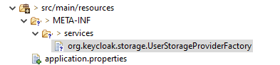

It is very important that the file name is exactly this. If this file name is called differently, then your package will not be successfully deployed to Keycloak. The deployment will fail. So please double check that the name is exactly like this. All right. So now let's click on finish to create this file. Now, inside of this file, we will need to add a complete name of our provider factory class. So the new factory class that we have created is called RemoteUserStorageProviderFactory. And its complete name will start with the package. So I will select and copy package name and then go back to my file that I have created and paste it here. Now go back to RemoteStorageProviderClass and copy the class name. So the complete name will start with the package name dot and then the class name RemoteUserStorageProviderFactory.

package com.spring.oauth.keycloakuserstoragespi;

import org.jboss.resteasy.client.jaxrs.ResteasyClient;

import org.jboss.resteasy.client.jaxrs.ResteasyClientBuilder;

import org.jboss.resteasy.client.jaxrs.ResteasyWebTarget;

import org.keycloak.component.ComponentModel;

import org.keycloak.models.KeycloakSession;

import org.keycloak.storage.UserStorageProviderFactory;

public class RemoteUserStorageProviderFactory implements UserStorageProviderFactory<RemoteUserStorageProvider> {

public static final String PROVIDER_NAME = "my-remote-sql-user-storage-provider";

@Override

public RemoteUserStorageProvider create(KeycloakSession session, ComponentModel model) {

return new RemoteUserStorageProvider(session, model, buildHttpClient("http://localhost:8099"));

}

@Override

public String getId() {

return PROVIDER_NAME;

}

private UsersApiService buildHttpClient(String uri) {

ResteasyClient client = new ResteasyClientBuilder().build();

ResteasyWebTarget target = client.target(uri);

return target.proxyBuilder(UsersApiService.class)

.classloader(UsersApiService.class.getClassLoader())

.build();

}

}

**META-INF/services/org.keycloak.storage.UserStorageProviderFactory file**

com.spring.oauth.keycloakuserstoragespi.RemoteUserStorageProviderFactory

Now we can save and close this file. In pom.xml example, scroll down at the very bottom where we have the build section and here in the build section, I like to make two changes. The first one is to configure the name of the file that will be built when the file is built. I like it to have a specific name and to pick up a name for this file. I will go back to provide their factory class and here at the top we have a provider name which is 'my-remote-sql-user-storage-provider'. So I like to use this name, although this is optional and if you do not want to do that, you can skip it. So I'll go back to pom.xml and to the build section in it at the bottom. I will add a final name and paste the same here. The second change is to comment out the maven plugin section.

<?xml version=*"1.0"* encoding=*"UTF-8"*?>

<project xmlns=*"http://maven.apache.org/POM/4.0.0"* xmlns:xsi=*"http://www.w3.org/2001/XMLSchema-instance"*

xsi:schemaLocation=*"http://maven.apache.org/POM/4.0.0 https://maven.apache.org/xsd/maven-4.0.0.xsd"*>

<modelVersion>4.0.0</modelVersion>

<parent>

<groupId>org.springframework.boot</groupId>

<artifactId>spring-boot-starter-parent</artifactId>

<version>2.4.1</version>

<relativePath/> <!-- lookup parent from repository -->

</parent>

<groupId>com.spring.oauth</groupId>

<artifactId>11-keycloak-user-storage-spi</artifactId>

<version>0.0.1-SNAPSHOT</version>

<name>11-keycloak-user-storage-spi</name>

<description>Keycloak user storage provider implementation</description>

<properties>

<java.version>11</java.version>

</properties>

<dependencies>

<dependency>

<groupId>org.springframework.boot</groupId>

<artifactId>spring-boot-starter</artifactId>

</dependency>

<dependency>

<groupId>org.keycloak</groupId>

<artifactId>keycloak-server-spi</artifactId>

<version>12.0.1</version>

<scope>provided</scope>

</dependency>

<dependency>

<groupId>org.keycloak</groupId>

<artifactId>keycloak-services</artifactId>

<version>12.0.1</version>

<scope>provided</scope>

</dependency>

<dependency>

<groupId>org.springframework.boot</groupId>

<artifactId>spring-boot-starter-test</artifactId>

<scope>test</scope>

</dependency>

</dependencies>

<build>

<finalName>my-remote-sql-user-storage-provider</finalName>

<!-- <plugins>

<plugin>

<groupId>org.springframework.boot</groupId>

<artifactId>spring-boot-maven-plugin</artifactId>

</plugin>

</plugins> -->

</build>

</project>

I've noticed that when I package the final jar file with this plug in, then it fails to be deployed to Keycloak. When I check this final structure of the file that gets generated, its final structure and the content is slightly different, organized and apparently Keycloak does not like it. So removing this plugin and packaging your file without this plugin helps me to produce general file that gets successfully deployed to Keycloak. All right. So save this and lets see if it works.

Build this project now.

D:\2-Workspace\Spring-OAuth\spring-oauth-2\11-keycloak-user-storage-spi>**mvn package**

D:\2-Workspace\Spring-OAuth\spring-oauth-2\11-keycloak-user-storage-spi>**dir target\*.jar**

Volume in drive D is New Volume

Volume Serial Number is 90EC-4C1B

Directory of D:\2-Workspace\Spring-OAuth\spring-oauth-2\11-keycloak-user-storage-spi\target

08-01-2021 12:15 9,413 **my-remote-sql-user-storage-provider.jar**

1 File(s) 9,413 bytes

0 Dir(s) 488,003,948,544 bytes free

Copy the current directory path

Copy the jar file into keycloak deployments folder

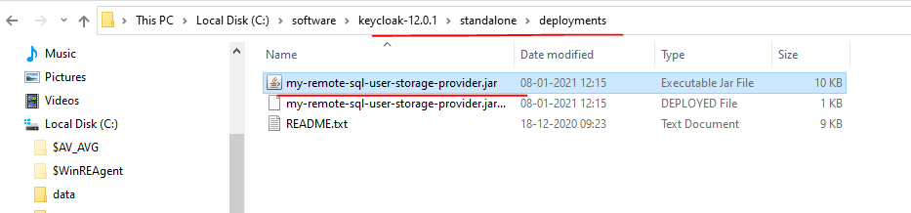

The running Keycloak console responds

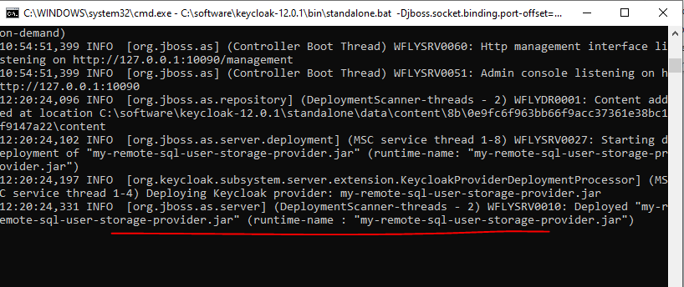

Go to the Keycloak admin console > your realm > User Federation

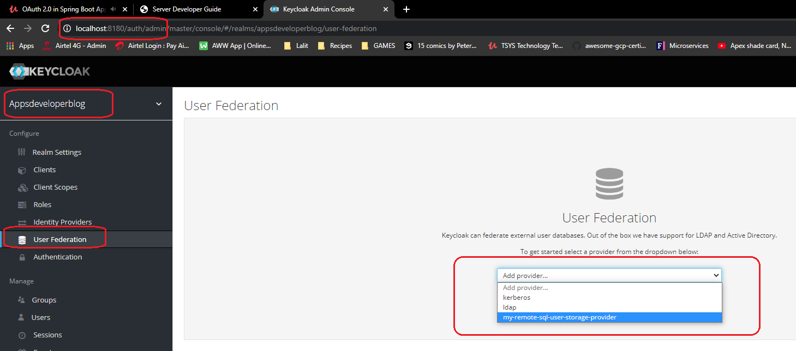

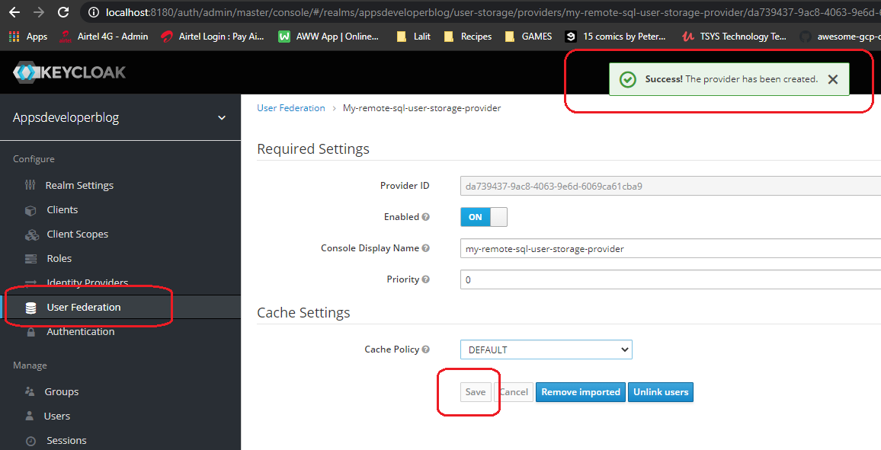

The file is deployed now

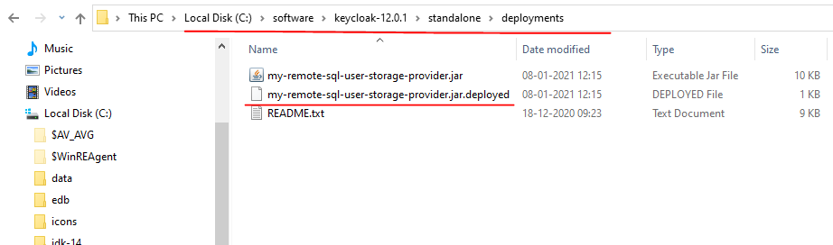

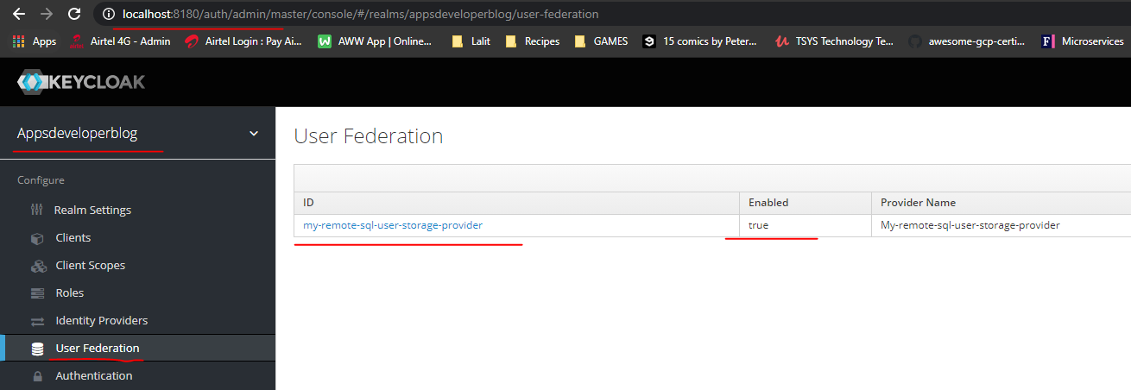

So it worked. Finally, the provider is deployed and we can now run our application and try authenticating with Keycloak,

using a user credentials that we have stored in a remote database and see if it works.

We will try if the remote storage provider implementation that we have created works and to do that and will first start up the Web service application that connect to users database is called Legacy Users Service, and we'll start it up as a springboot application. OK, so it's up and running and my server is also up and running on Port 9000, and they can try getting an access token for user whose credentials are stored in the remote database. Now, when my Web service application starts up, it creates one new user. Let's have a look at its user credentials. And it does so in a file named that is called Initial Setup Java. Here, when an application event function is called, it will create a new user with user name test2@test.com and password to get that is encrypted and stored in a database. So I will use this user credentials to authenticate. Now I will bring in Postman.

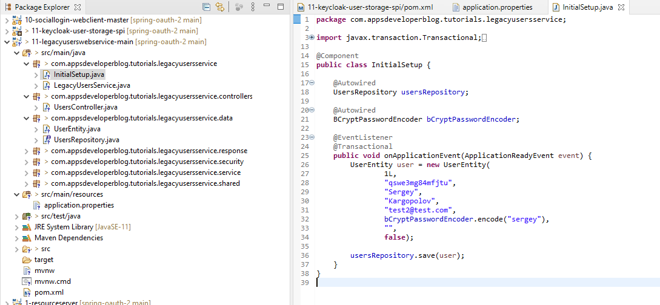

And I will copy this http request details that users authorization grant flow. This is one of those requests that we have used in previous lessons. And when this request is executed before Keycloak issues an authorization code, it will prompt user for authentication. So let's bring in a new browser window and execute this request. All right, so now to authenticate, I will use user credentials that are stored in the database and these are test2@test.com and password Serguei.

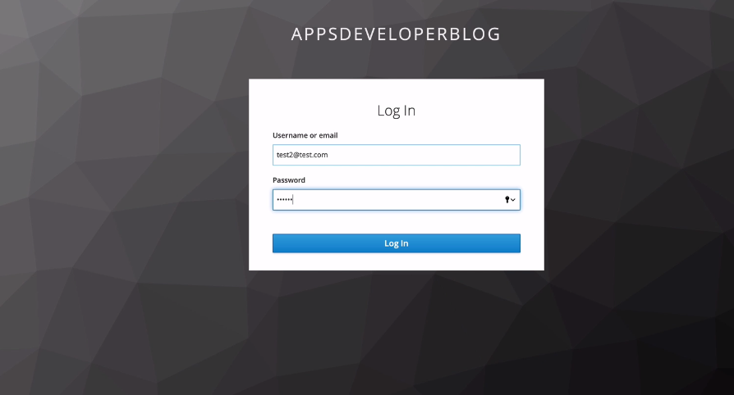

Now for these authentication to work, you will first look for user credentials and its own database. And if it does not find this user in its own database, then it will check if there is a user storage provider and that it can use to authenticate this user. And this is one quick look will use the remote user storage provider implementation that we have created and deployed. All right. So let's see if it works. I will click on Login Button and we got an error.

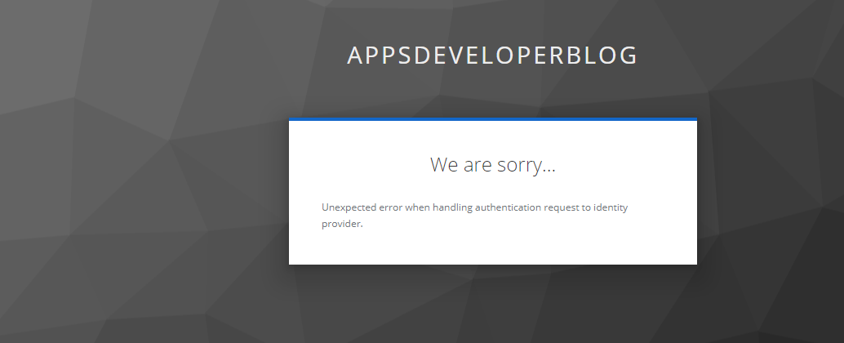

Now let's look at Tool Suite and we got a message that password matches. The message is printed. So that means that a request to get user details did work and then request to verify. Password also did work because we got a message printed that password is matching. Now let's look at the terminal window and here's my key clock and here's an error. It says that the mismatched input exception cannot construct the instance of VerifyPasswordResponse. So this must be on the a more user storage provide implementation that we have. Let's look at this file, VerifyPasswordResponse. So I will go to my Verify PasswordResponse that is inside of the remote user storage provider project. And I see that it doesn't have a default constructor. This is why. So let's create the default constructor. No args constructor.

package com.spring.oauth.keycloakuserstoragespi;

public class VerifyPasswordResponse {

private boolean result;

public VerifyPasswordResponse() {

}

public VerifyPasswordResponse(boolean result) {

this.result = result;

}

public boolean getResult() {

return result;

}

public void setResult(boolean result) {

this.result = result;

}

}

Let's save it and let's quickly rebuild this project. So I will go back to a terminal window and I will repackage my remote use of storage provider implementation. OK, so they built a successful I will bring in find their window and I will it the new jar file and paste it into a quick look deployment's folder. Like this, and that will really point. Now I can go back to Postman, copy this request and try executing it one more time. Let's try to authenticate. In. And this time it worked. Let's look on the address bar and the cop killer was executed successfully and here is our authorization code. All right. So authentication is successful and the Keycloak issued us an authorization code in which we can exchange for an access token, and this is it.

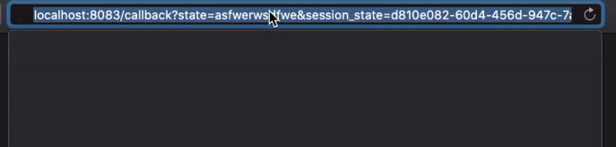

Now you know how to implement your own use of storage provider. You know how to deploy to Keycloak. And you now know how to let it authenticate users using credentials stored in the remote database.